Norman Portfolio 3: Rochester Castle

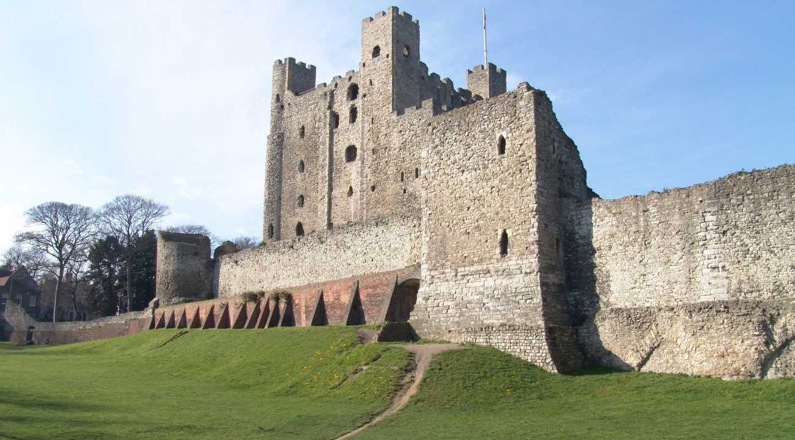
The Normans built many castles both during and after their conquests in Northern France, Italy, England, and Wales. They were intended to be places of intimidation and fear for the local populace, and strongholds and places of security for the Normans who invaded. This portfolio piece will look at one particular castle, Rochester Castle, and examine why it is a Norman castle by looking at its architecture and design to answer the question as to why the Normans built castles, and what their influence was on the local population.

The photograph that shall be analysed is the picture taken above of Rochester Castle. According to English Heritage, the organisation responsible for looking after historic sites around England, the castle was built by William of Corbeil, Archbishop of Canterbury, in 1127, after being encouraged to do so by King Henry I. The castle was later used by rebellious barons as a stronghold against King John, who destroyed one of the towers, and was later rebuilt by King Henry III and King Edward I.
The picture itself is one taken of the main keep of Rochester castle, the square central building, and of a curtain wall surrounding the keep and inner courtyard. The picture quite clearly shows the tower that was destroyed during King John’s siege on the far left of the keep. Comparatively to the other two towers visible, the rebuilt section is not of a square Norman design, rather it is a semi-circular High Medieval design used by later Kings of England and all throughout Europe, as the design is far stronger against projectiles and mines than the typical square Norman design, as highlighted by the fact that the original was destroyed.
The picture highlights one of the key features of Norman architecture and castle building; the keep. The keep is the central part of a castle, where the lord or garrison commander lives with their family, where their soldiers sleep and eat, and where the last defensible position of the castle is located. The keep is the most imposing part of a Norman castle, as it can often be seen for many miles around and lets the local population know that the Normans are their new rulers. Similar designs of keeps can be seen throughout England and Wales, including Dover castle, the Tower of London, and, to an extent, Cardiff castle, although the design was changed slightly. All of the examples stated have been added to and improved over the hundreds of years they have stood, but there is still much resemblance to Norman architecture if one looks close enough.
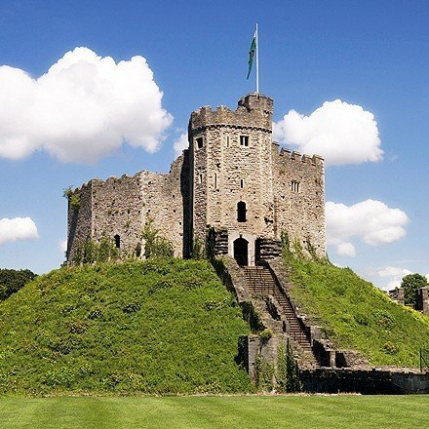
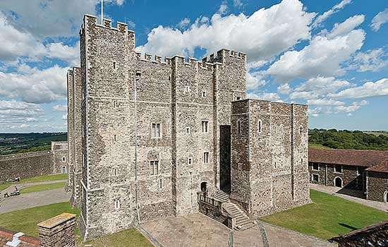
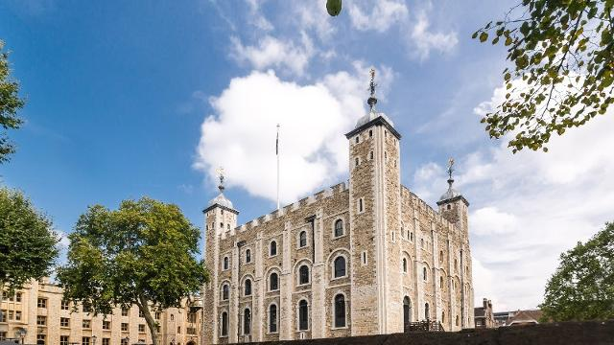

What often made Norman castles quite imposing was the size of the keep. The keep would often be built on a raised platform of earth, so as to make it seem even taller and grandiose. This design is based off of an earlier design for castles, the ‘motte and bailey’ style of fortification. The motte was an area of raised earth that a large wooden tower was constructed upon and the bailey was an area of flat ground where buildings would be constructed for the local inhabitants to live in. This design can be seen echoed in the picture of Rochester castle, as the keep is on a raised platform of earth and the entire site is surrounded by a curtain wall, exactly like a bailey.

What is most peculiar about the picture provided of Rochester castle is a strange set of arches in the bottom right of the image. These arches lead one to speculate many different theories as to their uses. Firstly, they could simply be water ways that were bricked over at some point during the rebuilding work, either by King Henry III or King Edward I. However, this leads to further questions as to why they were there in the first place, as they would be a severe weakness to the castles outer defences. Secondly, arches are often used to hold something up, be it a bridge or a doorway. If that is so, then why are arches half buried under earth and bricked shut? From the scale of the windows in the tower to their left, they are too small for a person to fit comfortably through, so they may not have been typical doorways. Lastly, they could simply be an architectural design to add some features to the curtain wall, rather than keeping it a clean wall. However, this seems quite counterproductive, as not only would it be a waste of time and resources, but it would also give attackers a foothold if they were to try and climb the wall. There does not seem to be any logical reason for them to be there.
To conclude, the Normans built their castles during and after their conquests to keep order among the local population. They used square keeps built atop mounds of earth to incite fear among the people and as a way of letting them know that the Normans were there to stay as their new rulers. Rochester is no different than any other Norman fortification in that regard and remains standing to this day as a part of British history.

Bibliography
Books
Snow, Dan, Battle Castles (London: HarperPress, 2012)
Pictures
"Dover Castle | English Heritage", English-Heritage.Org.Uk <http://www.english-heritage.org.uk/visit/places/dover-castle/> [accessed 3 December 2017]
"HM Tower Of London", Visitlondon.Com <https://www.visitlondon.com/things-to-do/place/22249-hm-tower-of-london> [accessed 3 December 2017]
"Interactive Map", Cardiffcastle.Com <http://www.cardiffcastle.com/interactive-map/norman-keep/> [accessed 3 December 2017]
"Rochester Castle | English Heritage", English-Heritage.Org.Uk <http://www.english-heritage.org.uk/visit/places/rochester-castle/> [accessed 3 December 2017]
"Rochester Castle | Norman Connections | Discover Norman History", Normanconnections.Com <http://www.normanconnections.com/en/norman-sites/rochester-castle/> [accessed 3 December 2017]

Figure 1: "Rochester Castle | Norman Connections | Discover Norman History", Normanconnections.Com <http://www.normanconnections.com/en/norman-sites/rochester-castle/> [accessed 3 December 2017].
"Rochester Castle | English Heritage", English-Heritage.Org.Uk <http://www.english-heritage.org.uk/visit/places/rochester-castle/> [accessed 3 December 2017].
Ibid
Figure 2: "Dover Castle | English Heritage", English-Heritage.Org.Uk <http://www.english-heritage.org.uk/visit/places/dover-castle/> [accessed 3 December 2017]. Figure 3: "Interactive Map", Cardiffcastle.Com <http://www.cardiffcastle.com/interactive-map/norman-keep/> [accessed 3 December 2017]. Figure 4: "HM Tower Of London", Visitlondon.Com <https://www.visitlondon.com/things-to-do/place/22249-hm-tower-of-london> [accessed 3 December 2017].
Figure 1: "Rochester Castle | Norman Connections | Discover Norman History", Normanconnections.Com <http://www.normanconnections.com/en/norman-sites/rochester-castle/> [accessed 3 December 2017].

