Strategic Management for SMEs

Executive Summary
Strategic management for small and medium-sized enterprises (SMEs) is all about making smart decisions to help these businesses succeed and grow. The report has described the strategic decision to visit the vision, mission, and value of Unlimited Fashion. It includes different activities of business firms such as setting clear goals, exploring the market, recognizing competitive advantages, and creating plans to achieve the success of goals. The report has explained the environmental analysis tool to identify the huge picture of Unlimited Fashion. SMEs think strategically to stay competitive, adapt to changes, and make effective use of their available resources. It has highlighted the different stakeholders and the power to identify the most suitable way to improve organizational performance. Unlimited Fashion focus on identifying the challenges that negatively affect the strategic decision. This report also discusses the importance of strategic management in small-sized enterprises.

Table of Contents
Introduction 4
Company Overview (Unlimited Fashion) 5
Current Strategic Direction 6
Environmental Scanning Tools 8
Strategic Growth Choice for SMEs in Market 13
Stakeholder Analysis 19
Recommendation 21
Conclusion 22
Reference List 23

Introduction
Small and medium-sized enterprises (SMEs) are no longer exempt from environmental concerns (Yoo, 2023). In the past, strategic decisions related to the environment were often limited to large organizations. This report shows the concept of strategic management and its importance in small and medium-sized enterprises or SMEs. It provides the overall direction and identifies the enterprise objectives and vision of Unlimited Fashion. The report has explained the environmental scanning tool for internal and external to accomplish the desired outcome. However, now SMEs are recognizing the importance of incorporating environmental factors into their decision-making processes. All sizes of industries and organizations are becoming more aware of their impact on the environment. Like, Unlimited Fashion Group in this enterprise strategic management plays an essential role in the success of its business operations. They use strategic management to make decisions about their business operations, strategies marketing, and expansion plans. It helps SMEs to identify new opportunities, understand customer needs, and stay ahead of the competition. Therefore, it plays a key role in all types of firms, institutes, and enterprises.

Company Overview (Unlimited Fashion)
Unlimited Fashion is a family-owned firm that was started in London. It is one of the leading manufacturers of garments in the UK. The headquarters of this organization is situated in London, UK. It is a private limited company with over 50 years of experience in the industry which is based in London. The founding year of Unlimited Fashion is 1960s (Unlimited Fashion, 2023). This organization offers high-quality products to its customers that are stitched with keen observation. It is a clothing producer in London which covers the area of 5000sq foot in London. The workforce of this firm is limited but it working effectively with this limited workforce. Unlimited Fashion in the UK is a trendy and innovative fashion brand that offers a wide range of stylish garments and accessories. The Company is known for its assurance to provide fashionable and affordable clothes for all fashion supporters. Unlimited Fashion is ready to express and adopt new styles.
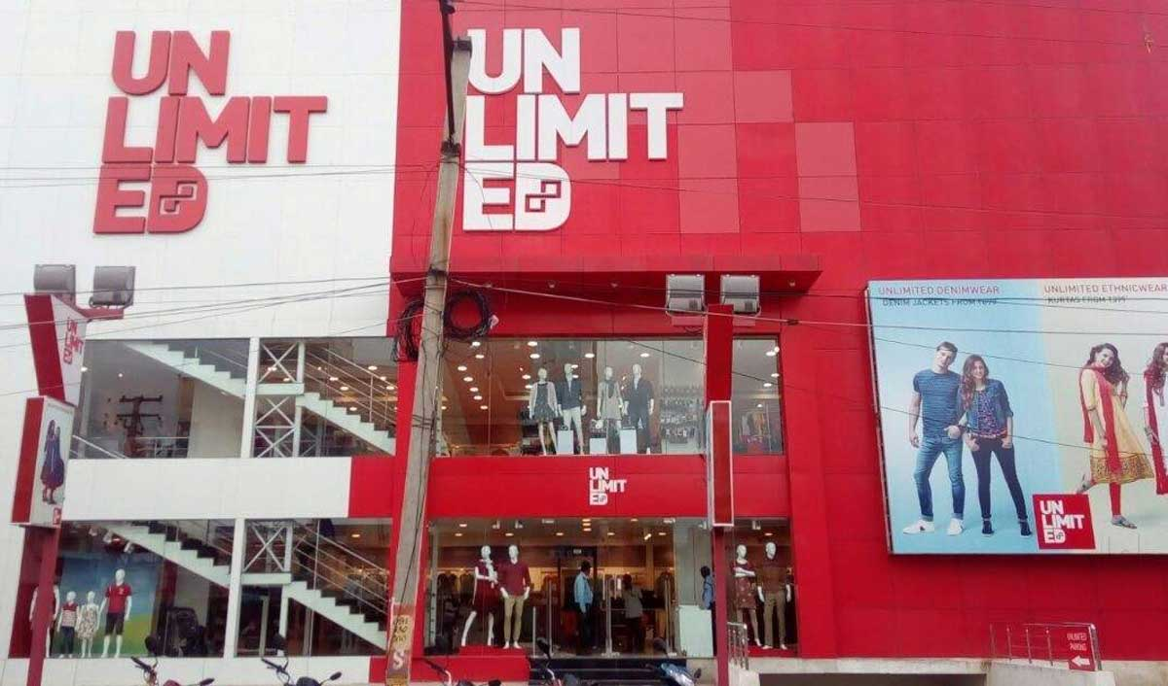
Source: (Unlimited Fashion, 2023)

Current Strategic Direction
Simply, strategic direction refers to a foundational idea or action that allows for greater consistency in strategy over time. Unlimited Fashion's main purpose is to achieve a vision and help fulfill the goals of its managerial strategy (Yoo, 2023). The Company mainly focuses on the journey of an independent organization and goes deeper into the mission and vision for organizational growth. Apart from this, Unlimited Fashion Journey revolved around the setting of artist design and fashionable clothes at the best cost. The Company mainly focuses on launching a marketing campaign for the festive season for every consumer. Unlimited Fashion translates the campaign thoughts a fashion is ageless, looking special, fashion is looking great, and effortless for organizational growth (Islam and Rafi, 2023).
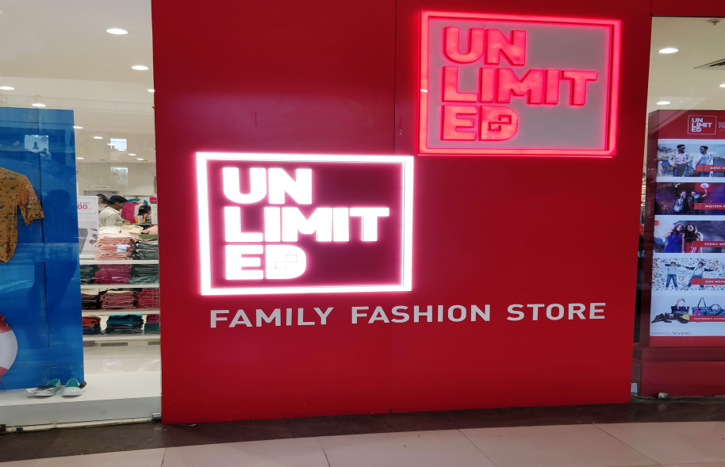
Source: (Anyanwu and Chiana, 2022)
- Vision: The Company's main vision is to love tailoring and passion for quality craftsmanship (McGowan and Conlan, 2023). Unlimited Fashion mainly focuses on carefully crafted with quality sewn into every stitch.
- Mission: Unlimited Fashion's main mission is to create innovative cost-effective products and solutions (Unlimited Fashion, 2023). The Company makes sure of exceptional service to their customer for organizational growth. Unlimited Fashion excellent feeling for extraordinary work and linkage to privilege.
- Values: Unlimited Fashion values our clients and provides the best service possible as evidenced by our large high-end clients. The Company mainly focuses on the customer and can be concerned in every stage of the manufacturing process. Unlimited Fashion mainly focuses on flexible and accommodating suppliers for quick service (Anyanwu and Chiana, 2022). The Company engages in the production of all garments at the best cost to meet the customer demand. The product will cover fashion and fashion accessories for men, women, and children to fulfill the customer requirements effectively.
- Goals and Objective: Unlimited Fashion store mainly focuses on launching its new campaign for its first television commercial (Selau and Horn, 2022). Through this fashion market, Unlimited Fashion mainly focuses on the vivid expression of individuality for every consumer. Through television commercials, Unlimited Fashion mainly focuses on launching a marketing campaign to cater to fashion needs and find their style for organizational growth.

Environmental Scanning Tools
It is an amazing tool of strategic planning that is used to identify and assess all elements that affect the environment of the business goal success. Organizations use tools for the analysis of the internal and external environmental factors of the business environment (Yoo, 2023). Environmental scanning tool is useful for the business concerns for identifying positive and negative impacts on the business. Unlimited Fashion Group is identifying its challenges and new opportunities in the marketplace by examining both internal and external factors like the economy, availability of workforce, technology management, etc (Le Feber and Smit, 2023). Several factors are allocated accurately by the management of the firm through environmental analysis that makes the business successful. In the below PESTEL, SWOT, and VRIN analysis of leading garments producers Unlimited Fashion, in London is explained:
PESTLE Analysis of Unlimited Fashion
Unlimited Fashion mainly focuses on adopting PESTLE analysis to identify the ups and downs faced by the organization (Anyanwu and Chiana, 2022). The Company professionals decide the fashion industry with the help of this model. Through this model, Unlimited Fashion mainly focuses on recognizing the economic condition and needs for organizational growth.
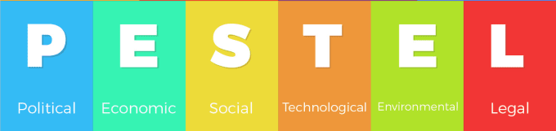
Source: (Le Feber and Smit, 2023)
- Political Factor: In the changing situation, the Government of London focuses on local and central regulations that influence organizational activities. The government does not allow Unlimited Fashion to import raw materials for the production of stylish clothes at an affordable rate (Liu, 2022). Social media influencers of Unlimited Fashion play an essential role in marketing various fashion brands. The government also banned to import animal animal-related raw materials for clothing purposes. Unlimited Fashion also understands the local regulatory and governing bodies to maintain stability in the marketplace.
- Economic Factor: Economic forces have a huge effect on the firm and its success in the handmade industry. The Company mainly focuses on the unemployment rate and important forces of the particular industry to improve the customer experience (Islam and Rafi, 2023). Unlimited Fashion grabs the attention of those people who want trendy clothes to fulfill the customer's requirements. The Company mainly depends on new trends to improve the customer experience. Unlimited fashion also saves time and money for customers of the entire fashion industry.
- Social Factor: It involves social norms, regulations, and ideologies that play a crucial role in organizational growth. Unlimited Fashion mainly depends on trends and fashionable clothes at affordable rates to fulfill the customer demand. Nowadays, humans have become a social creature (Yoo, 2023). The Company going to style its clothes and accessories to change the fashion sense of customers. Currently, Unlimited Fashion demands dresses suitable for function and are not similar to anyone. It is not easy for Unlimited Fashion to find out suitable platform to survive in the marketplace.
- Technological Factor: Today, Unlimited Fashion mainly focuses on the development of advanced technology to improve organizational performance. The Company does not focus on proper marketing to promote the products or services for better growth in the competitive fashion industry (Anyanwu and Chiana, 2022). Unlimited Fashion adopts an online shopping channel and marketplace to save lots of time and energy for organizational enlargement. It is an easy way to access the fashion industry through online channels. It plays a significant role in boosting the already booming fashion industry (Nkang, 2023). To survive in the market, the Manager of Unlimited Fashion is motivated to develop social media channels to improve the customer experience.
- Legal Factor: It is forces implemented in society for betterment and growth in the marketplace. Laws make sure for the safety of consumers, companies, and manufacturers to maintain their brand image (Selau and Horn, 2022). Thus, it is a legal force to cause a shift in the fashion industry. Unlimited Fashion mainly focuses on worker rights and safety to offer the best quality of products or services. Moreover, the Company mainly focuses on following the rules and regulations to maintain its brand value might go downhill.
- Environmental Factor: The Company mainly focuses on being environment-friendly to improve organizational growth. Unlimited Fashion focuses on access use of transportation during product manufacturing (Le Feber and Smit, 2023). During heavy manufacturing, the Company tries to emit harmful gases into the environment. Moreover, Unlimited Fashion mainly focuses on the quality of products or services to overcome health and environmental issues.
SWOT Analysis of Unlimited Fashion
It is a strategic tool used to identify the organizational strengths and weaknesses in the context of the fashion industry (Lowe, 2023). Unlimited Fashion mainly focuses on reviewing and assessing the internal capacities to explore organizational goals. The Company is organized for optimally exploiting and mitigating the organizational risk.
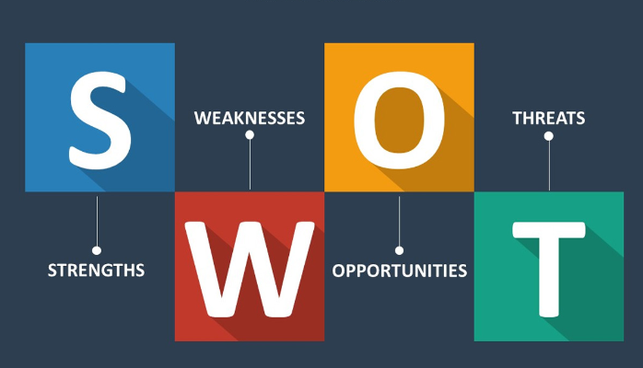
Source: (Beelen et al., 2023)
- Strengths: The Company mainly focuses on distinct patterns, fabric, and trimming provided to carry out sampling or production. Unlimited Fashion's main strength is to design unique products to satisfy customer needs (Yoo, 2023). The Company also monitors all production, from sampling to production to a dedicated team. Unlimited Fashion mainly focuses on manufacturing quality products or services to meet all sizing requirements. The Company mainly focuses on using quality material and the best machinery to fit the customer needs.
- Weaknesses: Unlimited Fashion has restricted patient protection for new development of clothes. The Company lags in customer service and innovation in the marketplace. Unlimited Fashion does not focus on a managerial review alone, which often leads to preferential treatment and favoritism within the organization (Anyanwu and Chiana, 2022). The Company does not focus on succession planning to earn a premium amount through ales (Schabasser, 2023). To deal with the changing environment, the Manager of Unlimited Fashion explores the blue ocean to operate the industry and create new opportunities. The Company does not maintain the position of brand is indistinct and bewilderment among customers. Unlimited Fashion does not introduce green fashion to improve the organizational value.
- Opportunities: To become successful, the Manager of Unlimited Fashion develops strong partnerships with local and global organizations for further expansion. For organizational growth, Unlimited Fashion focuses on digital channels to make decisions, and focuses on organizational opportunities for future success (Le Feber and Smit, 2023). Nowadays, the CRM system is improved by Unlimited Fashion to improve consumer value for better success in the fashion industry. Apart from this, the Company mainly focuses on building a high-service culture to improve the customer journey and quick service.
- Threats: In the fashion world, Unlimited Fashion faced tough competition with local and international clothing brands. Zara, Mango, M&S, and Sainsbury faced tough competition for Unlimited Fashion in the fashion world (Ande and SE, 2023). The current market is saturated with similar products and companies that are restricted in the marketplace. The Company is not able to compete with price and challenges in the context of green consumption. In the same way, Unlimited Fashion is not able to understand the changing behavior and habits of customers.
VRIN Analysis of Unlimited Fashion
It is a strategic analysis used for accessing and evaluating the resources of the firm and determining its strategic edge (Liu, 2022). The Company mainly focuses on strategic tools facilitating long-term development. Unlimited Fashion focuses on the development of competitive strategies based on core strengths and resources to survive in a competitive marketplace.
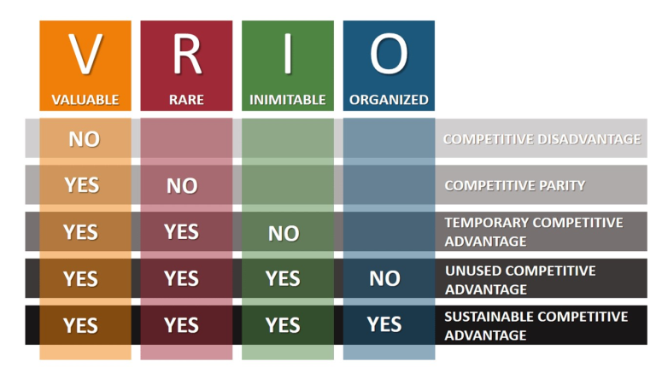
Source: (Anyanwu and Chiana, 2022)
- Valuable: The manager of Unlimited Fashion explores new market opportunities to grow the business (Beelen et al., 2023). The Company mainly focuses on a brand image that is unique and has high brand integrity to accomplish the desired outcome. To become successful, Unlimited Fashion enjoys high brand recognition and positive brand equality for organizational success.
- Rare: High competencies are rare in nature and affect the organizational value. Unlimited Fashion operates in multiple countries and regions to expand its customer base as well as international exposure (Le Feber and Smit, 2023). The Company mainly focuses on innovation to resolve the organizational problem.
- Inimitable: Unlimited Fashion mainly focuses on offering quality products or services to meet customer demand. The Company focuses on consistent quality to lead to repeat customers and increase consumption (Schabasser, 2023). The manager of Unlimited Fashion focuses on marketing communication to accomplish long-term goals. Moreover, the firm mainly focuses on a competitive pricing strategy to accomplish the desired objective and maintain its brand image.
- Organized: Unlimited Fashion is not used by competitive players in the fashion industry. The Company mainly focuses on exploiting market opportunities to maintain its brand strength and acquisition to gain a competitive advantage (Lowe, 2023). Unlimited Fashion mainly focuses on technological development and smooth management for organizational success. The Company focuses on substantial investment in research and management to improve consumer behavior.

Strategic Growth Choice for SMEs in the Market
Strategic management and planning allow firms to stay strong in the competition of the marketplace. It helps the organizations hold and develop existing resources and workforce effectively (Siddiqui and Marciniak, 2023). Unlimited Fashion chooses strategies according to the necessities and objectives of businesses. Such strategies are explained below that are adopted by the organization for the success of the existing business:
Porter Generic Strategy
Porter's competitive strategies are widely recognized and utilized by organizations to enhance their sales and overall business performance. This framework provides valuable tools and understandings for effective management and growth of the business (Unlimited Fashion, 2023). It enables businesses to create sustainable activities that give them a competitive edge in the market. There are three main types of Porter's competitive strategies:
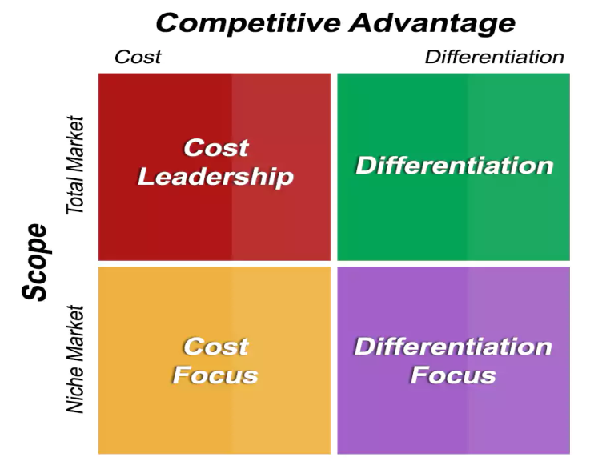
Source: (Le Feber and Smit, 2023)
- Cost leadership: One of the important parts of Porter’s strategy is cost leadership. Effective leadership focuses on cost control and tries to generate new strategies and profitable opportunities in the market by influencing low-cost strategies (Schabasser, 2023). In second step, focuses on increasing the brand value in the market through attracting consumers and creating a strong customer base.
- Differentiation: This term suggests that a company makes itself differ from other existing companies in the market. Organizations are adopting this method to make their products specific from other available products in the marketplace (Anyanwu and Chiana, 2022). To target the audience according to their strategic estimation offer unique goods and services to their consumers in the market. This is providing the advantage to the firm to make its specific image among customers.
- Focus: This strategy involves targeting a specific market segment or niche and modifying goods or services. It modifies its products to meet the specific needs and preferences of that segment, allowing the organizations to give their best in a focused area (Beelen et al., 2023). The focus strategy method includes both cost leadership and differentiation strategy and facilitates options for the companies to choose according to the niche of the market. Companies under this strategy are focused on both the lowest cost and best value of the price of the product.
Unlimited Fashion adopted the differentiation strategy to differentiate their clothing item and products from existing competitors. The Company mainly focuses on the strategy of manufacturing unique products at the best cost to fulfill customer demand (Tam and Lung, 2023). Unlimited Fashion focuses on trends, current resources, and efforts to innovate to target audiences for organizational growth.

Ansoff Growth Matrix
This is the fundamental framework that is introduced by businesses worldwide. This method is also known as market expansion web. This is used by the management team of Unlimited Fashion; it helps the managers organize and arrange all the important factors and resources accurately. Moreover, it is also used by the analyst community to help in planning and estimating the creativities of business success (Unlimited Fashion, 2023). This strategy covers the key points that are important for the success of any business such as product modification and modernization, market development, diversification, etc. This strategy was introduced by mathematician and business manager H. Igor Ansoff and is applied in business and industries as an analysis tool. The matrix growth strategy analyzed the external and internal factors of the business environments that affect the success and growth of the business. It provides a framework to examine and plan for growth in a structured manner (Ande and SE, 2023). There are four growth strategies within the Ansoff Growth Matrix are following:
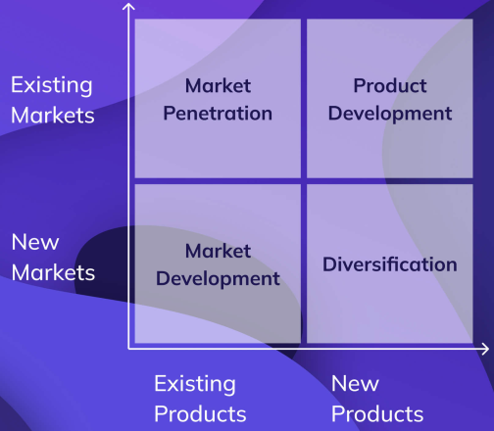
Source: (Tam and Lung, 2023)
- Market Penetration: This strategy mainly focuses on expanding market share by selling more existing products to existing customers (Anyanwu and Chiana, 2022). It includes procedures such as promotional campaigns, loyalty programs, or improving customer service to encourage repeat purchases. Under this, it offers discounts and attractive schemes to its existing consumers to encourage sales.
- Market Development: Under this strategy, businesses search to enter new markets with their existing products (Siddiqui and Marciniak, 2023). This could involve the expansion of geographical areas, targeting new customer segments, and discovering different distribution channels. The Company identifies new opportunities and new markets for growing sales of existing products.
- Product Development: This strategy includes the procedure of creating and introducing new products or services to existing markets (Schabasser, 2023). It allows businesses to influence their existing customer base and brand reputation through offering advanced or improved products. Companies are following this strategy to recognize their brand in the minds of consumers.
- Diversification: This strategy involves entering new markets with new products or services (Beelen et al., 2023). It can be related to the diversification of all factors. Where the new products or new markets both are lump-sum connected to the previous business. On the other hand, unrelated diversification is where the new products or markets are entirely different.
Unlimited Fashion mainly focuses on adopting and selling new or improved products or services in the current marketplace. The Company focuses on upgrading its fashion style and trendy items to grab the attention of the audience (Tam and Lung, 2023). Apart from this, Unlimited Fashion offer seasonal discount, and coupons, and recapture the interest of customer for organizational enlargement. The Company always tries to bring modifications to its products or services to become successful in the marketplace (Nkang, 2023). The Company decided to adopt a product development strategy to survive in the fashion world.
Bowman’s Strategic Clock Model
This is a comprehensive and utilizing strategic tool that offers several options for positioning the image within the market (Ande and SE, 2023). Bowman's Strategic Clock Model is based on the price of the products and their supposed value as well. This model of strategic growth works in a way to identify and figure out the position of an enterprise within a marketplace. In this model, the success of a business is classified in different terms such as low price and low value-added, low price, differentiation, risky high margins, monopoly pricing, and so on. Additionally, it is also determined based on the hybrid position between low price and differentiation factors (Dalirazar and Sabzi, 2023). When this strategy is successfully done it provides huge gains to the organization and others who are related to business. Under this framework, eight positions across the clock highlights the success of different strategy in the marketplace.
- Low price and low value-added: It is all about the quantity selling of goods and services of the organization (Siddiqui and Marciniak, 2023). In this the value of the products is low and the supposed price point is lowest possible. This combination of marketing provides a competitive advantage on the strategy clock. This helps the firms that it target price-sensitive customers who select cost over other factors.
- Low price: likewise, to its name, this strategy is about estimating the lowest price for the purchasers in the market (Anyanwu and Chiana, 2022). This position underlines offering products or services at the lowest price. However, companies are maintaining a reasonable level of observed value. It aims to attract price-conscious customers without compromising quality. Because of the low price margin, this is a key to being successful.
- Hybrid: This hybrid position combines features of both low-cost and differentiation strategies (Dalirazar and Sabzi, 2023). It is offering goods or services with a decent balance of price and perceived value. The success of this strategy is attempting to boost selling while maintaining margins.
- Differentiation: This strategy position focuses on offering unique and differentiated goods or services with a higher perceived value (Tam and Lung, 2023). It targets customers who are willing to pay a premium for distinctive features or superior quality. It helps to sell their products at a high margin but with a unique and specific quality.
- Focus Differentiation: Under this strategy, companies focus on the niche of the market. Moreover, it is providing highly differentiated goods or services and so on (Schabasser, 2023). It is tailored to meet their specific needs and preferences.
- Risky High Margins: This position aims to charge a higher price for goods and services that offer a standard level of value (McGowan and Conlan, 2023). It is targeting customers who are ready to pay a premium for convenience, brand reputation, or other factors. Companies sell their products at the highest value in the market.
- Monopoly: This position involves charging a higher price for products or services with a lower perceived value (Liu, 2022). Companies signally control the overall market and control the price and products.
- Low of Market Share: This position offers products or services with a lower perceived value at a higher price (Beelen et al., 2023). Companies have the lowest market share or are in the worst position in the existing market. The company chose this strategy to make a new market with a new price level among consumers.
Therefore, Unlimited Fashion Group has to use this strategy and offer low-priced, unique products to its customers in the market. It states that the company produces unique products and services in the market (Siddiqui and Marciniak, 2023). With low cost and good quality, it attracts consumers more than its competitors in the market. It provides a visual representation of various strategic options that a company can adopt to gain a competitive advantage in the market. Through this strategy, the Manager of Unlimited Fashion relaunches products or services to improve the customer experience (Nkang, 2023). The Company mainly focuses on adding new features to its trendy clothes and fashionable styles at the best cost to satisfy customer demand.

Stakeholder Analysis
Stakeholder analysis is a project management strategy to identify and understand all individuals and groups' vested interest in the project. Through this analysis, the Company mainly focuses on identifying the stakeholder interest in the management of operations (Schabasser, 2023). To become successful, Unlimited Fashion develops a strategy to support organizational needs. The Company mainly focuses on stakeholder management to determine the key players for organizational growth. It is very significant to guide the project from the start to finish the desired task.
Stakeholder Matrix
It is an invaluable exercise for any stakeholder management team (Selau and Horn, 2022). The Company mainly focuses on the stakeholder matrix to visualize the evolving relationship to understand the power or influence of the organizational project. Unlimited Fashion mainly focuses on accessible points of reference for organizational success.
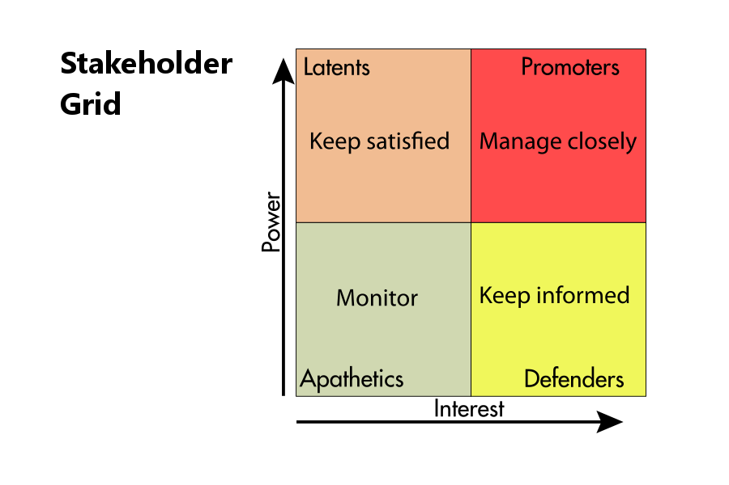
Source: (McGowan and Conlan, 2023)
In project management, the Manager of Unlimited Fashion mainly focuses on identifying stakeholders to become successful in the market (Tam and Lung, 2023). With this analysis, Unlimited Fashion needs to manage the information in the matrix and create stakeholders for organizational success. The Company mainly focuses on the stakeholder matrix to work more effectively with organizational stakeholders.
- High Power, Low Interest: It typically wants to keep satisfied for organizational growth. It could be CEO of the Unlimited Fashion or the accounting employees responsible for setting the budget. The Company mainly focuses on being involved in the project, while their position gives them lots of influence over it.
- Low Interest, Low Power: It includes stakeholders who probably need to monitor the organizational performance (Siddiqui and Marciniak, 2023). The Company needs to track the employees and manage the outside consultation. Unlimited Fashion contribution to manage the task-oriented and administrative ability.
- High Power, High Interest: Stakeholder wants to manage the organizational ability for organizational growth. The Company mainly focuses on the supervisor and head of department to accomplish the organizational goals (McGowan and Conlan, 2023). Apart from this, Unlimited Fashion mainly focuses on the overseas direction of the project to become successful in the marketplace.
- Low Power, High Interest: It includes people to keep informed about the changing environment. Managers of Unlimited Fashion focus on creative teams to improve the performance of team members (Beelen et al., 2023). The Company mainly focuses on a project involving or affecting the person while having little control over its direction.
Suitable, Feasible, and Acceptable
In the fashion industry, Unlimited Fashion mainly focuses on the development of projects to resolve organizational problems (Schabasser, 2023). The Company mainly focuses on suitability, feasibility, and acceptability to resolve the problem and gain a competitive edge. The manager of Unlimited Fashion needs to evaluate the proposed strategy and internal as well as external environment to improve the organizational performance. Through the SFA model, Unlimited Fashion would focus on understanding the perspective of different stakeholders to measure organizational performance (Tam and Lung, 2023). The Company mainly focuses on practical matters in the context of resources and capabilities to gain a competitive edge. Moreover, the Manager of Unlimited Fashion focuses on considered expectations to satisfy the demand of potential customers effectively. In feasibility, Unlimited Fashion mainly focuses on managing the finances, people, and skills to deliver strategy for organizational development (Dalirazar and Sabzi, 2023).

Recommendation
Unlimited Fashion should focus on strategic planning to deliver positive growth in the marketplace. The Company mainly focuses on fashion technology and is making waves in the fashion industry to fulfill customer demand (Selau and Horn, 2022). In the blog post, Unlimited Fashion must develop fashion careers and sustainable fashion in the work of humans. The Company mainly focuses on technology development and fashion production in a particular technology. Unlimited Fashion mainly lots of fashion technology to improve the sustainability of clothing items or manufacturing procedures for organizational development. Ethical and sustainable practice and creative skill is to improve organizational performance (Beelen et al., 2023). The Company mainly focuses on launching new clothing and stylish designs to fulfill the customer demand effectively.

Conclusion
In conclusion, the report has examined the current strategic direction and identifies the direction of Unlimited Fashion. The report has evaluated environmental scanning tools like PESTLE, VRIN, and SWOT analysis to identify the forces that affect organizational performance. It has examined the Porter generic strategies, and Ansoff matrix to accomplish desired goals. Unlimited Fashion stakeholder analysis and identification of the expectation to improve the organizational performance. The report has provided suggestions to improve organizational performance. It has analyzed the implementation of the SFA model or strategy to survive in the fashion industry.

Reference List
Ande, D.F. and SE, M., 2023. Understanding Porter's Business Strategy and its Implementation on Tourism Industry A Literature Review Approach.
Anyanwu, E.C. and Chiana, C.A., 2022. Socio-Cultural Influences on Fashion Consumption Behaviour of University Students. ARRUS Journal of Social Sciences and Humanities, 2(1), pp.47-65.
Beelen, K., Lawrence, J., Wilson, D.C. and Beavan, D., 2023. Bias and representativeness in digitized newspaper collections: Introducing the environmental scan. Digital Scholarship in the Humanities, 38(1), pp.1-22.
Dalirazar, S. and Sabzi, Z., 2023. Strategic analysis of barriers and solutions to the development of sustainable buildings using the PESTLE technique. International Journal of Construction Management, 23(1), pp.167-181.
Home (no date) Unlimited Fashion. Available at: https://unlimitedfashion.co.uk/ (Accessed: 23 November 2023).
Islam, T. and Rafi, A.S., 2023. Global Market and Comprehensive Scenario of Apparel Industry-SWOT Analysis. Multidisciplinary Joint Akseprin Journal, 1(1), pp.20-29.
Le Feber, N. and Smit, M.J., 2023. Fashion Companies Pioneering with Eco-Innovations in the Swedish Fashion Industry: Motivations, Resources, and Cooperation. Circular Economy and Sustainability, pp.1-21.
Liu, J., 2022, December. Research on the Business Strategy and Deficiency of the Fast Fashion Industry to Enhance Development Case Study of Shein. In 2022 2nd International Conference on Economic Development and Business Culture (ICEDBC 2022) (pp. 1794-1801). Atlantis Press.
Lowe, A., 2023. Fashion Brand Management: Plan, Scale, and Market a Successful Fashion Business. Kogan Page Publishers.
McGowan, K. and Conlan, E., 2023. Exploring the Current and Future Potential of Fashion Rental and Resale in the UK: A Case Study on ACS Clothing. In Pioneering New Perspectives in the Fashion Industry: Disruption, Diversity and Sustainable Innovation (pp. 185-194). Emerald Publishing Limited.
Nkang, C.N., 2023. PESTLE Analysis Report for BAE Systems: Integrating Cloud Technology in the Defence Sector.
Schabasser, C., 2023. Strategic analysis of product variety and supply chain complexity in the fast fashion apparel industry (Doctoral dissertation, soe).
Selau, B.S. and Horn, B.S., 2022, July. Collection Development Strategy for Fashion Retail. In International Fashion and Design Congress (pp. 312-322). Cham: Springer International Publishing.
Siddiqui, N.Q. and Marciniak, R., 2023. Modesty as a Fashion Growth Opportunity? Exploring the Potential of Fashion, Sustainability, Production, Value, and Marketing. In Pioneering New Perspectives in the Fashion Industry: Disruption, Diversity and Sustainable Innovation (pp. 127-137). Emerald Publishing Limited.
Tam, F.Y. and Lung, J.W., 2023. Impact of COVID-19 and innovative ideas for a sustainable fashion supply chain in the future. foresight, 25(2), pp.225-248.
Yoo, J.J., 2023. Visual strategies of luxury and fast fashion brands on Instagram and their effects on user engagement. Journal of Retailing and Consumer Services, 75, p.103517.

