Module: Independent Project
Module code: LCLM6005
Element 3
Topic: Investigating the importance of cybersecurity tactics for minimising the cyberattacks in the UK retail sector: A case study of Marks & Spencer (M&S)
Student Name: Ana Maria Dogaru
Student ID: 2111954

Element 3: Summary of Methodology and Research Findings
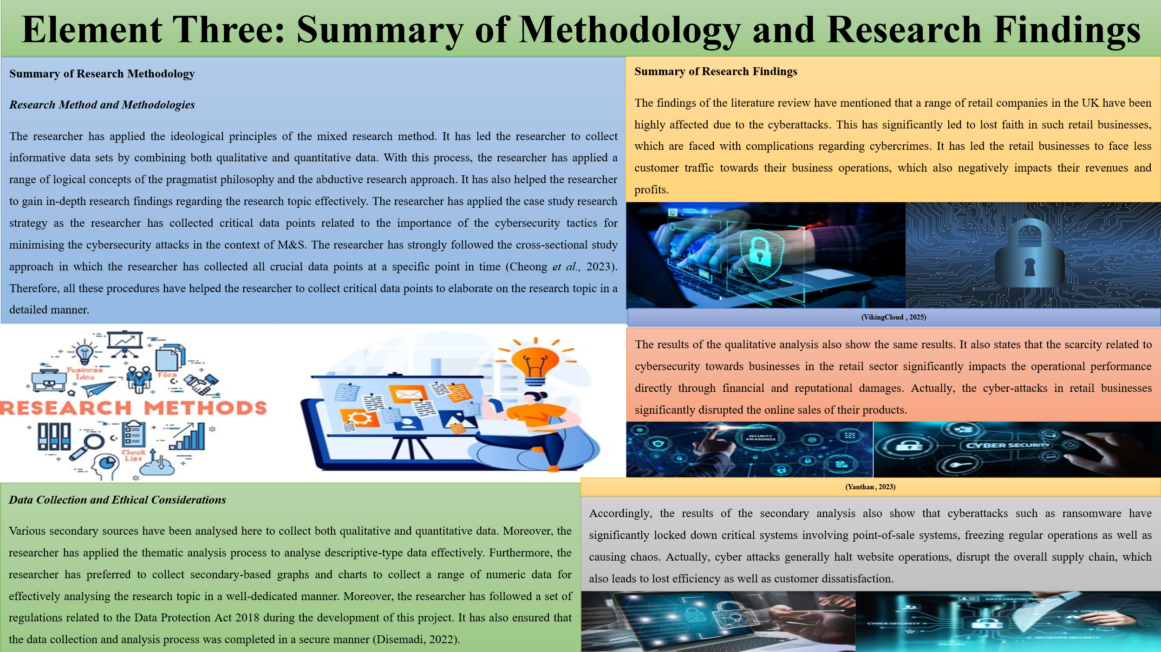
Summary of Research Methodology
Research Method and Methodologies
The researcher has applied the ideological principles of the mixed research method. It has led the researcher to collect informative data sets by combining both qualitative and quantitative data. With this process, the researcher has applied a range of logical concepts of the pragmatist philosophy and the abductive research approach. It has also helped the researcher to gain in-depth research findings regarding the research topic effectively. The researcher has applied the case study research strategy as the researcher has collected critical data points related to the importance of the cybersecurity tactics for minimising the cybersecurity attacks in the context of M&S. The researcher has strongly followed the cross-sectional study approach in which the researcher has collected all crucial data points at a specific point in time (Cheong et al., 2023). Therefore, all these procedures have helped the researcher to collect critical data points to elaborate on the research topic in a detailed manner.
Data Collection and Ethical Considerations
Various secondary sources have been analysed here to collect both qualitative and quantitative data. Moreover, the researcher has applied the thematic analysis process to analyse descriptive-type data effectively. Furthermore, the researcher has preferred to collect secondary-based graphs and charts to collect a range of numeric data for effectively analysing the research topic in a well-dedicated manner. Moreover, the researcher has followed a set of regulations related to the Data Protection Act 2018 during the development of this project. It has also ensured that the data collection and analysis process was completed in a secure manner (Disemadi, 2022).
Summary of Research Findings
The findings of the literature review have mentioned that a range of retail companies in the UK have been highly affected due to the cyberattacks. This has significantly led to lost faith in such retail businesses, which are faced with complications regarding cybercrimes. It has led the retail businesses to face less customer traffic towards their business operations, which also negatively impacts their revenues and profits. The results of the qualitative analysis also show the same results. It also states that the scarcity related to cybersecurity towards businesses in the retail sector significantly impacts the operational performance directly through financial and reputational damages. Actually, the cyber-attacks in retail businesses significantly disrupted the online sales of their products. Accordingly, the results of the secondary analysis also show that cyberattacks such as ransomware have significantly locked down critical systems involving point-of-sale systems, freezing regular operations as well as causing chaos. Actually, cyber-attacks generally halt website operations, disrupt the overall supply chain, which also leads to lost efficiency as well as customer dissatisfaction. Therefore, retail businesses have to take some significant strategies to educate employees on how to recognise phishing emails as well as other social engineering tactics. Moreover, they have to develop and constantly update a plan for how to respond to any kind of security incidents to reduce damage as well as restore operations immediately. It may help them to reduce the chances of cyber-attacks.

References

Cheong, H.I., Lyons, A., Houghton, R. and Majumdar, A., (2023). Secondary qualitative research methodology using online data within the context of social sciences. International Journal of Qualitative Methods, 22, p.16094069231180160.
Disemadi, H.S., (2022). Lenses of legal research: A descriptive essay on legal research methodologies. Journal of Judicial Review, 24(2), pp.289-304.

