STUDENT NAME: | AFZAL AHMED
STUDENT NUMBER: | 1806872
LECTURER NAME: | BALENDRAN KANDASAMY
MODULE TITLE: | Digital Skills and Research Methods
MODULE CODE: | BMSK4003

Table of contents:
Introduction………………………………………………………………………………………………………….Page 2
Evaluating the effectiveness of the use of modern technologies.………………………….Page 2 - 7
Exploring social media as a tool – Facebook…………………………………………………….……Page 8
Evidences of my online presence………………………………………………………………………….Page 9
Conclusion…………………………………………………………………………………………………………….Page 9
References……………………………………………………………………………………………………………Page 10

Introduction:
This assignment will give an insight of how modern technology is relevant and important within a workplace. Starting with an introduction, then evaluation of two technologies, exploring social media and presenting my online presence. Finally ending with a conclusion and references. For businesses to keep up with the fast-paced operations of today, modern technology makes these processes quicker, easier and helps organise tasks better. Technology has transformed the way we shop, the way we do research and the way businesses operate. Furthermore, social media platforms have transformed the way we interact with one another and it has spilled over into the workplace.

Evaluating the effectiveness of the use of modern technologies:
Modern technology is very important for business and everyday use. Whether we like it or not, the role of technology in business and home is expanding and will only keep growing in the future. Technology increases efficiency, new innovations protect important documentation, employees can be better equipped to be successful at their job, people can be more engaged and can help save time, energy and money. The examples that can be used to accomplish the above are technologies such as: email and cloud file storage which use applications called google drive, one drive and drop box. Furthermore, software’s and tools can be used for web conferencing for example WhatsApp, skype and WeChat. Devices are now small enough to take with you anywhere, such as: laptops, tablets and smartphones. This has made working efficiently easier and faster than ever before.

Technology one - Cloud services:
A cloud service is any service made available to users on demand via the internet’s cloud computing provider’s server. Furthermore, it can be broken down into four types of services such as software, data, platforms and storage. I will be discussing the last service I have mentioned - cloud storage. Cloud storage is data, which can be stored on a cloud-based system, allowing you to access from anywhere in the world with internet connection on devices such as: a computer, laptop, tablet or smartphone. To be able to have access to a cloud service you will need to provide your personal information, email address and create a secure password.

Advantages and disadvantages of cloud storage:
ADVANTAGES | DISADVANTAGES
This is allowing companies to work remotely from anywhere in the world where there is internet connection. | Security is the number one concern when it comes to any activity on cloud-based storages. Platforms’ do use encryption to secure files and offer two step verification and captcha codes to prevent any hacks. Apart from this there is not much security. Other ways to secure a device is to install an antivirus software and save a backup of work on a portable hard disk, e.g. USB
It reduces paperwork and filing, additionally, files can be saved and shared securely with strong passwords. | Another drawback is there is no access without internet connection unless files are downloaded onto a hard drive.
Clouds storage also saves storage space on all devices and prevents losing data in a disaster situation, for example a fire or flooding. | Finally, another issue could be low bandwidth, this leads to slow connection and can disturb a presentation or slow a task down. (Gildred, 2018)

One Drive VS Google Drive:
OneDrive and Google Drive are two cloud-based storage services. Starting with OneDrive, formerly known as ‘SkyDrive’ was launched in 2014. On the other hand, Google Drive was launched in 2012. These services are available for free and can be upgraded for a monthly fee.

Storage Price Plans:
Monthly Fee | OneDrive storage | Google Drive storage
FREE | 5GB | 15GB
£1.59 | 50GB | N/A
£1.99 | N/A | 100GB

Compatibility:
OneDrive | Google Drive
One drive allows you to store any file type and organise them by file type. OneDrive is already integrated with Microsoft office and built into Windows 8 and 10. Likewise, it is compatible with Mac OS X, Android, iOS and Window Phone. These integrations can be accesses via web app, desktop app and mobile app. (Microsoft, 2018). | Likewise, it is also compatible with Mac OS X, Android, iOS. You can use Google Drive to store any type of file, share files with others and use the Google Drive suites to edit any documents. Google Drive can also be accessed via web app, desktop app and mobile app. (Google Drive, 2018).

Synching Comparison:
OneDrive | Google Drive
Wherever you are logged in you can upload files or folders of up to 10gb in size and is automatically sorted. | Once logged in to Google Drive, you can upload individual files of up to 5gb, create files, folders and organise. New files can be created using google docs, sheets, slides, forms and drawings.
Files can be accessed anywhere including on game consoles such as the Xbox 360 and Xbox one. | From your desktop, you can drag and drop files in a folder on your desktop and then sync them into your cloud. These files can then be accessed on any device with the app installed or a web browser.
Attaching files in cloud to email is simple, also automatically organises photos into folders or galleries based on location and date. Additionally, captions can be added, tags and posts can be uploaded straight to Facebook and other social media platforms. | Google drive allows you to attach and save documents directly through it, any files can be shared and edited via an invitation link or you can invite others to collaborate on a document or file. This is extremely helpful when sending a file to several people working together on a project.
Microsoft office is compatible with OneDrive which makes sharing and editing documents, spreadsheets and PowerPoint slide shows via email or link. This also allows live collaboration for Office 365 users (Gildred, 2018). | Google drive is a great place to store photos and can be easily accessed, they are organised by where you took them and who is in the photos. (Gildred, 2018).

My recommendation:
Ultimately, the difference between these two providers are not much at all. They do offer some unique features, but both works just as well as the other. Personally, I use google drive for work, I feel like I can store and share data easily and have also connected a domain to create a work email, it is afzal@dandhmedical.com. I have managed to create a small work force and we all are connected to Gsuite which integrates well with google drive. Once our company grows, we may consider OneDrive, I have noticed larger organisation tend to use them, even the university use OneDrive and I have taken advantage of this by uploading assignments and having ready to submit. The Gsuite application is easy to upload and save as well as compatible with Microsoft OneDrive so I am comfortable using both, but for now google drive is my recommendation.

Technology two - Web conferencing:
Web conferencing is when we can share real time information and content over two or more computer screens, mobile phones or tablets via applications which are web based such as: WhatsApp and skype. Most web-based software’s support voice and video conferencing which enables us to hold business meetings, seminars, online tuition and even job interviews. Most web conferencing platforms are available via a web browser but downloading and installing an application like WhatsApp and skype enables us to take full advantage of all features such as: voice and video conferencing and content sharing live.

ADVANTAGES | DISADVANTAGES
Save time and money, we no longer have to travel to work or even another country to hold important meetings or seminars. This is the perfect solution for businesses to be able to hold meetings at the click of a button. (Lombardo 2018). | Not all web conferencing platforms is free. Even though it may reduce travel expenses and office cost, some platforms have limited capability and charge for additional large file sharing.
File and screen sharing are available with most web conferencing provider, making sure that everyone is on the same page throughout a meeting is now so much easier. | Less personal – Sitting in front of a screen with a webcam and microphone will not have the same personal touch as sitting around a table with people.
Working from anywhere in the world is now possible. Even if one was on holiday, if there was an emergency meeting, we can now log in and not miss any crucial information. | Due to sharing capability, it is possible for private information to be reached by the public by screens not being logged out from or left open. Sometimes this will need to be done on multiple devices. There is also the risk of security online with hackers. If a hacker gains access to a private conference and leaks information, it can really damage a business.
Flexibility – this now allows meetings to be held instantly on short notice, people can now attend meetings regardless of where they are. | Bad or slow internet can be a real issue. If this fails, we could miss an important part of a conversation (Lombardo 2018).

WhatsApp vs Skype:
Skype and WhatsApp are both free messenger, video and voice calling online tools. Originally skype was a computer to computer app that could call other phones, on the other hand, WhatsApp was launched originally for the mobile phone market.

COMPARISONS | WHATSAPP | SKYPE
FEATURES | Can be used for group messaging, phone calls, voice calls (in app). | Skype can be used on multiple devices with one account whereas WhatsApp does not have this feature.
Platforms | Both WhatsApp and Skype are compatible with IOS, Android, Blackberry, Windows phone, Google, Mac OS X, Linux and Web browsers.
Videos | Can be used for video calls, free and paid members have access. | Skype can do live video streaming whereas WhatsApp does not have this feature.
Sharing | Many different types of sharing can be done such as: file uploads, photo uploads, video uploads, contacts, animated, gifs, voice messages and location sharing. | Skype has all the same features apart from location sharing.

My recommendation:
I use both apps for personal and business use. Similarly, both also can be used internationally so I can stay in communication anywhere in the world. If I must share work, conduct conference calls or meetings then skype would be more suitable. However, for a day to day web conferencing or communication app, WhatsApp wins my vote. In terms of a user-friendly app, it is more recognised and most people with a smartphone will have it downloaded.

Exploring social media as a tool – Facebook:
https://www.facebook.com/Anker.fans/
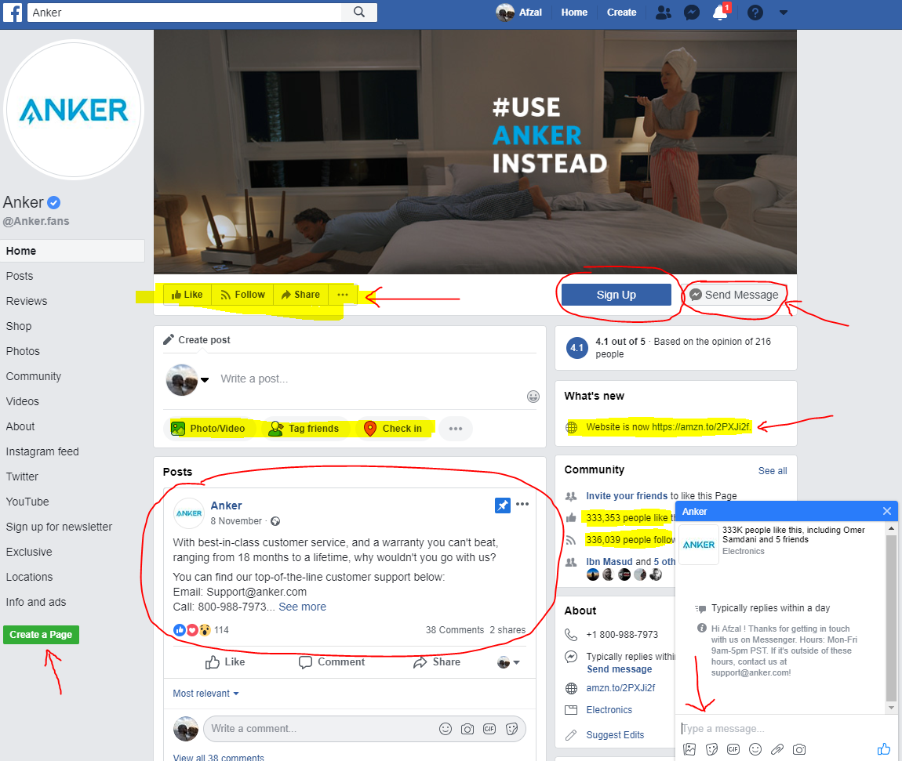
Social media can now be used as a tool for marketing, information gathering and communication. Businesses can now use Facebook to advertise on the palm of our hands. In the image above there are many examples where a post can be written and shared with everyone online. In the image, there is a warranty offered, customer service number and also a live chat option enabling plenty of opportunities to engage with customers. The company Anker has acquired over three hundred thousand followers just via Facebook, in addition you can see external links to their website which will direct customers to purchase directly from there.
Subsequently, customer data is then collected, and the demographics can be targeted to exactly to a person’s interests even further. Facebook allows advertising on their system as well as their latest technology - Facebook messenger bots. This enables companies to personally engage with customers and build a subscribers list. They can add each person into a “VIP list” and send out special discounts and promotions. (Newberry C, 2018).

Evidences of my online presence:
My Facebook profile for social media:
https://www.facebook.com/100009303682755


My Twitter ID:
https://twitter.com/afzal983



My LinkedIn profile for career:
www.linkedin.com/in/afzalahmed1983
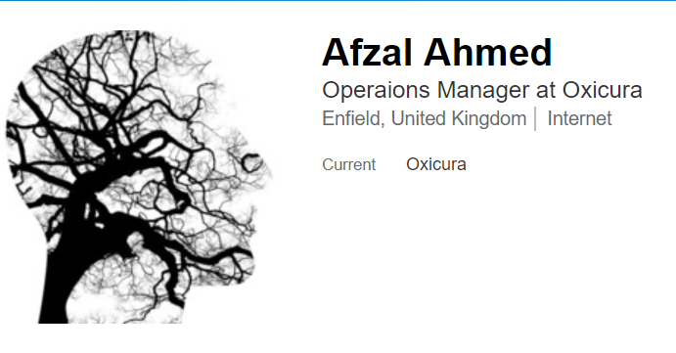

Conclusion:

In conclusion, this report has explained about the effectiveness of the use of modern technologies within the workplace. I have managed to Evaluate the effectiveness of the use of modern technologies outlining the advantages and disadvantage of using them with any concerns and was able to give examples related to the workplace. Two technologies, cloud services and web conferencing were analysed and from each technology two providers were compared; one drive and google drive and WhatsApp and skype. Furthermore, I have given my recommendations and the reasons why. In addition, social media was explored as a tool. Facebook is the example I chose, which enabled me to explain about information gathering, marketing and communication via Facebook for businesses, along with evidence of my own online presence, Facebook, Twitter and LinkedIn.

References:

Beal, V. (2005) - Types of internet communications [Online]. Available at: https://www.webopedia.com/DidYouKnow/Internet/internet_communications.asp# (Accessed: 12 December 2018)
Dukes, E. (2014) - 5 ways technology has changed the modern workplace [Online]. Available at: https://www.iofficecorp.com/blog/4-ways-technology-has-changed-the-modern-workplace (Accesses :12 December 2018)
Adams, R.L, (2017) - 10 marketing strategies to fuel your business growth [Online]. Available at: https://www.entrepreneur.com/article/299335 (Accessed: 12 December 2018)
Microsoft (2018) - OneDrive [Online]. Available at: https://products.office.com/en-gb/onedrive-for-business/online-cloud-storage (Accessed 13 December 2018)
Google Drive (2018) A safe place for all your files [Online], Available at: https://www.google.com/drive/ (Accessed 13 December 2018)
Gildred, J. (2018) - Google Drive vs OneDrive: Which One is Better? [Online]. Available at: https://www.cloudwards.net/google-drive-vs-onedrive/ (Accessed: 13 December 2018)
Lombardo, C.R, (2018) - 8 advantages and disadvantages of online conferencing [Online]. Available at: https://connectusfund.org/8-advantages-and-disadvantages-of-online-conferencing (Accessed: 13 December 2018)
Hutt, M. (2017) - Skype vs WhatsApp: 2018 Comparison [Online], Available at: https://www.eztalks.com/video-conference/skype-vs-whatsapp-which-is-better.html (Accessed: 13 December 2018)
Newberry, C (2018) - 23 Benefits of Social Media for Business [Online]. Available from: https://blog.hootsuite.com/social-media-for-business/ (Accessed: 13 December 2018)

