

Assignment Title: Entrepreneurship Assessment - 1

Student Name: Krupaben Hasmukhbhai Dhameliya

Student Id: 2207957

Module Name: Entrepreneurship

Module code: LCMB7004
Lecturer Name: Gladius Kulothungan

Word count: 2500 words

Submission Date: 5th May 2023

Table of Contents

- Introduction………………………………………………………………..... 3
- Conceptual Foundation of Enterprise and Entrepreneurship………………... 3
- Analysis and critical evaluation of concepts of Enterprise and Entrepreneurship from the perspective of an Entrepreneur……………......... 4
- The conceptual foundation of personality traits theories with examples….... 5
- Critical evaluation of traits, characteristics, attributes and motivation of an Entrepreneur……………………………………………………………….... 6
- The conceptual foundation of for-profit and nonprofit small organisations with examples……………………………………………………………….. 7
- Analysis and critical analysis of for-profit and nonprofit small organisations with relevant examples……………………………………………………… 9
- Critical analysis of Entrepreneur's values and beliefs of for-profit and non-profit organisations small organisation with examples……………………. 10
- Conclusion…………………………………………………………………. 11
- References…………………………………………………………………. 12

Introduction
Enterprise refers to the process of creating, managing, and operating a business adventure to generate winnings or provide products or services to adjoining customer needs. It involves distinguishing opportunities, picking calculated risks, and managing resources to reach business objectives. Enterprises can be of various sizes and types, ranging from small-scale businesses to large multinational corporations. They can run in different sectors such as manufacturing, services, technology, and agriculture, among others. Entrepreneurship, on the other hand, refers to the activity of creating, developing, and managing a byplay venture by an individual or a group of individuals who are volition to undergo risks and innovate (Frese, 2009). It involves identifying opportunities, developing business models, mobilising resources, and managing the undefined to accomplish sustainable growth and profitability. Entrepreneurs the individuals who are often claimed to be primary risk-takers, innovators and visionaries of the future who are interested in creating new products as well as services and markets (Urbano et al, 2020). They have a huge role in improving the lives of people and creating economic development in different areas.

Conceptual Foundation of Enterprise and Entrepreneurship
The conceptual foundation of enterprise and entrepreneurship involves identifying opportunities, taking calculated risks, and managing resources to accomplish byplay objectives. It is an approach to business that focuses on innovation, creativity, and the ability to adapt to ever-changing commercialised conditions (Loukusa, 2022). In the modern font economy, entrepreneurship and enterprise are essential drivers of economic increase and development, creating jobs and generating wealth (Kautonen et al., 2015). One example of entrepreneurship is the story of Innocent Drinks, a beverage company that was founded by three friends in 1998. They started by merchandising smoothies at a music festival and grew the business by identifying opportunities in the wellness and wellness market (Fafa, 2022). They innovated by developing new flavours and using property packaging, and today Innocent Drinks is one of the largest smoothie brands in the UK.

Another example of entrepreneurship is the story of Graze, a snack delivery service that was founded in 2008. Graze identified an opportunity in the market for healthy snacks that could be delivered to customers' homes and workplaces. They developed a subscription service that allowed customers to customise their snack boxes and old data analytics to individualise recommendations.
In terms of enterprise, the UK is home to several prosperous companies that have grown by identifying opportunities and managing resources effectively. For instance, Rolls-Royce is considered to be a global leader in the area of aerospace and automobile industries as it has a strong tradition which goes back up to 100 years. This company has been able to accomplish success by investing in the areas of research and development through which they have been able to put up ground-breaking technology and maintain the supply chain.

Entrepreneurship and enterprise are essential drivers of economic growth and development. The UK provides some examples of successful businesses that have applied the abstract foundation of enterprise and entrepreneurship to achieve success (Klofsten et al., 2019). Another example of enterprise is John Lewis, a department store that was founded in 1864. John Lewis has achieved success by focusing on client service and managing its operations efficiently. They have as well developed a unique possession structure, where all employees are partners in the byplay and share in the profits. These examples demonstrate the grandness of distinguishing opportunities, taking calculated risks, and managing resources effectively to achieve business objectives.

Analysis and critical evaluation of concepts of enterprise and entrepreneurship from the perspective of an entrepreneur
As an entrepreneur, it is important to understand that the concepts of enterprise and entrepreneurship are requisite for edifice and growing a successful business. This includes the identification of opportunities and managing resources effectively, while entrepreneurship involves picking calculated risks and innovating to produce value for customers. One of the key challenges of entrepreneurship is the need to balance risk-taking with wise decision-making. It is important to take calculated risks, it is also essential to wangle resources effectively and minimise potential losses. This requires a deep sympathy for the market and a willingness to conform to dynamic conditions (Johnson, Maitland and Torday, 2021). Another challenge of entrepreneurship is the requirement to innovate and differentiate in a crowded market. Successful entrepreneurs need to be able to identify gaps in the market and develop free products or services that meet customer needs. This requires creativity and the power to think outside the box.
From the perspective of entrepreneurs like Mark Zuckerberg and Jeff Bezos the concept of enterprise is particularly important for managing resources effectively. This includes managing cash flow, inventory, and man resources (Chow, 2020). Effective resource direction is essential for ensuring that the business can run expeditiously and sustainably over the year term.

The concepts of enterprise and entrepreneurship are essential for building and maturing a successful business (Frese, 2009). For being an entrepreneur it is very important to focus on taking decisions which balance out the risks and also maintain Innovation and management of resources. The concerns of entrepreneurship are often challenging. However, it has also rewarded the individuals who have been able to create a mind-set that makes them predict the future (Guinan, Parise and Langowitz, 2019). Success can only be gained if a person is well experienced and also learns continuously.

The conceptual foundation of personality traits theories with examples
Personality traits theories propose that individuals own a set of prudent characteristics or traits that influence their behaviour, thoughts, and emotions. These traits are thought to be relatively stable across time and situations, and they can be second-hand to predict and undefined somebody's differences in behaviour. The FFM proposes that there are five broad dimensions of personality: openness to experience, conscientiousness, extraversion, agreeableness, and neuroticism. Research has consistently shown that these dimensions are robust and generalizable across cultures and age groups.

For example, a man who scores high in openness will have characteristics like being curious, imaginative, and open-minded. They are people who enjoy trying fresh things and exploring unusual ideas. On the other hand, it is likely to be organised, responsible, and reliable (Lavi, Rosenblatt and Gilead, 2022). They are bound to be good at planning and prioritising tasks, and they may take appreciation for their work.

Another personality trait theory is the HEXACO model, which proposes that there are six dimensions of personality: honesty-humility, emotionality, extraversion, agreeableness, conscientiousness, and openness to experience (Ashton and Lee, 2020). The HEXACO simulation is similar to the FFM and simply includes an additional dimension of honesty-humility, which is thought to shine a person's tendency to be modest, sincere, and fair-minded. For example, a person who scores high on honesty-humility is likely to be humble and true in their interactions with others. These individuals are not much interested in wagering in unethical behaviour or to exploit others for personal gain. A person is highly ranked on emotionality, they are expected to be subjected to experiencing anxiety, fear, and strange negative emotions.

Personality traits theories propose that individuals possess a typeset of enduring characteristics or traits that influence their behaviour, thoughts, and emotions. The FFM and HEXACO model are two examples of personality traits theories that provide a framework for sympathy for individual differences in behaviour (McCrae, 2022). These theories have important implications for understanding personality development, unhealthy health, and other types of interactions.

Critical evaluation of traits, characteristics, attributes and motivation of an entrepreneur
Traits, characteristics, attributes, and motivation are key factors that contribute to the success of an entrepreneur. This critical evaluation will provide these factors in undefined and their relevance to entrepreneurship.

Traits: Trait theory proposes that careful innate characteristics and traits are essential for entrepreneurship. Entrepreneurs are often delineated as risk-takers, proactive, and innovative. As an entrepreneur, it is important to have higher levels of self-efficacy which refer to the individual's ability to succeed in a task that is presumed. These traits have a strong role in entrepreneurship and research has shown that this can help an individual in gaining success in their future lives (Kimmitt, Muñoz and Newbery, 2020). Other factors which involve the development of an entrepreneur concern the environment and resources accessible to them.

Characteristics: Characteristics such as resilience, perseverance, and adaptability are crucial for entrepreneurs. There are some specific characteristics including resilience, perseverance and adaptability which are crucial for entrepreneurs. Resilience refers to the ability of an individual to eliminate the negatives from setbacks and get ready for the next challenges. The concept of persistence states that an individual lead to stick to a task or goal even if they face certain obstacles. If an individual is adaptable then they can have the ability to adjust to numerous changes within the environment (Bradley et al., 2021). These characteristics are vital in entrepreneurship, as the way of life to success is often marked by setbacks and unexpected obstacles.

Attributes: Entrepreneurial attributes admit a strong work ethic, creativity, and the power to spot and capitalise on opportunities. A strong process ethic is essential for entrepreneurs as they have many long hours and look at numerous challenges.

Creativity is important for an entrepreneur as it helps them to develop new products as well as services and strategies for making a business successful (Luo, 2021). This provides individuals with the power to capitalise on opportunities and allows them to take advantage of the recent trends and limitations in the market.

Motivation: Entrepreneurial motivation is often motivated by a desire for autonomy, achievement, and recognition. Autonomy allows entrepreneurs to control their destiny, piece achievement and realisation provide a sense of accomplishment and satisfaction. However, research has also shown that financial clarity is an important motivator for entrepreneurs (Werdhiastutie, Suhariadi and Partiwi, 2020). While monetary rewards are not the only need for entrepreneurship, they are essential to the success of a business.

Conceptual: Traits, characteristics, attributes, and motivation are essential factors that contribute to the success of an entrepreneur. However, these factors alone are not sufficient for predicting enterprising success. Other factors, such as the entrepreneur's environment and the resources available to them, are also important. As such, entrepreneurship is an undefined and dynamic domain that requires a combination of factors to be successful.

The conceptual foundation of for-profit and non-profit small organisations with examples
The conceptual foundation regarding for-profit and non-profit organisations is completely dependent upon their objectives and sources of support. In the case of for-profit organisations their objective is to generate the highest amount of profit for their owners and shareholders whereas in the case of non-profit organisations, they are focused on providing public benefit without generating any kind of rewards for their owners.

For-profit organisations typically raise working capital by issuing stock or taking out-of-the-closet loans from banks and investors (Philip and Arrowsmith, 2021). The ultimate destination is to earn profits for their owners, shareholders, or investors. Examples of for-profit organisations admit Morrison’s and Certify.

Non-profit organisations do not have any specific owners or shareholders as they are mostly managed and funded by grants and donations. It is fully dependent upon the philanthropic support received by it. The objective of a non-profit organisation is to create a social benefit including education, healthcare and protection of the environment (Green et al., 2021). Examples of non-profit organisations include the Red Cross, Doctors Without Borders.

Non-profit organisations are also subject to certain legal and task regulations, such as requirements to register annual reports and maintain careful levels of transparency. These regulations ensure that non-profit organisations are accountable to their donors and the public. While for-profit organisations are primarily focused on generating profits for their owners, they are also involved in setting responsibility initiatives and corporate philanthropy. Non-profit organisations can also generate income through fee-for-service programs, social undefined ventures, or by charging for their services.

The conceptual foundation of for-profit and non-profit organisations is supported by their various missions, objectives, and funding sources (Treinta et al., 2020). While for-profit organisations aim to generate profits for their owners or shareholders, non-profit organisations aim to provide a social or public benefit without generating profits for their owners.

Analysis and critical analysis of for-profit and non-profit small organisations with relevant examples
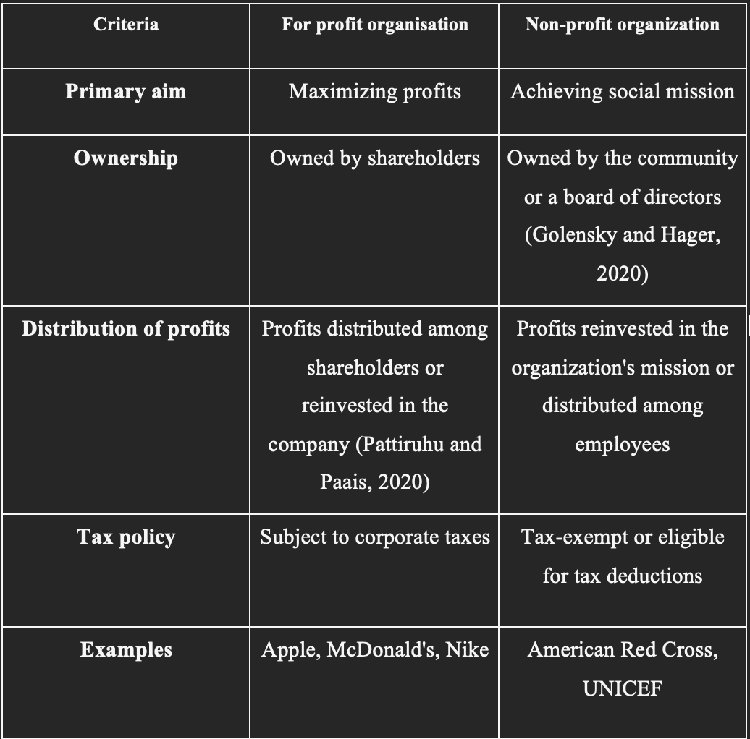

For-profit organisations and non-profit organisations have distinguishable differences in their objectives and funding sources, which are supposed to have implications for their operations and decision-making processes.

In terms of profit organisations are primarily focused on generating profits for their owners or shareholders. This means that they prioritise maximising revenue and minimising costs to step-up profits. For instance, Morrison’s in the retail sector is rising exponentially however they have been criticised for poor working conditions (Paulino, 2022). The company privatises the amount of profit earned by them over the conditions of their workers.

Non-profit organisations, on the other hand, are focused on providing social or public benefits. This often means that they prioritise their mission and the impact they have on bon ton over generating profits. For instance, doctors without borders is also a non-profit organisation that has the simple aim of providing medical assistance to individuals who are vulnerable to conflict, epidemics and natural disasters. This organisation does not have any source of income as they realise the donations and philanthropic support. To fund their proceedings, they are subjected to provide medical assistance rather than generating any kind of profit.

While for-profit organisations can engage in social responsibility initiatives, such as charitable donations or environmental sustainability efforts, their primary objective is still to give profits. Non-profit organisations have a valid legality of using resources to promote the well-being of society. This can limit the scope of developing the activities related to revenue generation (Ko and Liu, 2021). For-profit and non-profit organisations have distinct objectives and their sources of funding are also different from each other. For-profit organisations prioritise generating winnings for their owners or shareholders, piece non-profit organisations prioritise providing a social or public benefit. Examples such as Morrison’s plc and Doctors Without Borders spotlight the contrasting approaches and implications of these organisational types.

Critical analysis of entrepreneur's values and beliefs of for-profit and not for-profit organisations small organisation with examples
There is a difference between the values and beliefs of entrepreneurs involving profitable and non-profitable organisations. It is dependent upon a general factor which includes the culture of the company as well as the structure based on which the decision-making is taking place. They may place a high value on innovation, and risk-taking, and fight for undefined growth and step-up revenue. For instance, the founder of Airbnb has always believed, for earning profits it is very important to disturb the current structure of their hotels as they have created a platform which focuses on home sharing and this has helped them in generating more revenues and subsidiaries (Muñoz and Kimmitt, 2019). However, these non-profit entrepreneurs are mostly driven by a sense of well-being or passion to put up social justice for the community.

Further, they may prioritise values such as compassion, empathy, and collaboration to reach their mission. For example, the founder of TOMS Shoes, Blake Mycoskie, believed in creating a business that would not only generate profits but also provide shoes to children in need, aligning his subjective values with the company's mission. For example, a small for-profit business that prioritises sustainability and eco-friendliness may attract customers who value these principles, leading to multiplied brand loyalty and customer engagement.

The values and beliefs of entrepreneurs in for-profit and non-profit organisations can have a significant impact on the organisation's trading operations and culture (Kruse and Rosing, 2023). Concerning the for-profit entrepreneurs who may prioritise financial success and innovation, non-profit entrepreneurs are often driven by a passion for social justice and collaboration.

Conclusion
In conclusion, small organisations a great deal rely heavily on the values and beliefs of their founders and leaders, which can shape the organisation's culture and decision-making processes. Examples such as Airbnb, TOMS Shoes, and small businesses that prioritise sustainability highlight the importance of orienting subjective values with the organisation's mission. It is also joint with subjective and professional personal development, as entrepreneurs instruct valuable skills such as leadership, problem-solving, and decision-making. Successful entrepreneurship requires a combination of creativity, passion, perseverance, and business acumen, as well as access to capital, markets, and support networks.

References

Ashton, M.C. and Lee, K., 2020. Objections to the HEXACO model of personality structure—And why those objections fail. European Journal of Personality, 34(4), pp.492-510.

Bradley, S.W., Kim, P.H., Klein, P.G., McMullen, J.S. and Wennberg, K., 2021. Policy for innovative entrepreneurship: Institutions, interventions, and societal challenges. Strategic Entrepreneurship Journal, 15(2), pp.167-184.

Chow, T.W., 2020. Leader versus manager: Lessons from top business executives. Annals of Management and Organization Research, 2(1), pp.53-65.

Fafa, K., 2022. Social Marketing campaigns and User Experience: A case study of Innocent Juice Company.

Frese, M. 2009. Toward a psychology of entrepreneurship - An action theory perspective. Found. Trends Entrep. 5, 435–494.
Golensky, M. and Hager, M., 2020. Strategic leadership and management in nonprofit organizations: Theory and practice. Oxford University Press.

Green, E., Ritchie, F., Bradley, P. and Parry, G., 2021. Financial resilience, income dependence and organisational survival in UK charities. Voluntas: international journal of voluntary and nonprofit organizations, pp.1-17.

Guinan, P.J., Parise, S. and Langowitz, N., 2019. Creating an innovative digital project team: Levers to enable digital transformation. Business Horizons, 62(6), pp.717-727.

Johnson, M.W., Maitland, E. and Torday, J., 2021. Covid-19 and the epigenetics of learning. Postdigital Science and Education, 3, pp.389-406.

Kimmitt, J., Muñoz, P. and Newbery, R., 2020. Poverty and the varieties of entrepreneurship in the pursuit of prosperity. Journal of Business Venturing, 35(4), p.105939.

Klofsten, M., Fayolle, A., Guerrero, M., Mian, S., Urbano, D. and Wright, M., 2019. The entrepreneurial university as driver for economic growth and social change-Key strategic challenges. Technological Forecasting and Social Change, 141, pp.149-158.

Kruse, P. and Rosing, F., 2023. An Experimental Investigation of Perceived Differences in Personality and Leadership Attributes of Social Entrepreneurs Compared to for Profit Entrepreneurs and Non-Profit Organisations Leaders. The Journal of Entrepreneurship

Ko, W.W. and Liu, G., 2021. The transformation from traditional nonprofit organizations to social enterprises: An institutional entrepreneurship perspective. Journal of Business Ethics, 171, pp.15-32.

Lavi, G., Rosenblatt, J. and Gilead, M., 2022. A prediction-focused approach to personality modeling. Scientific reports, 12(1), p.12650.

Luo, Y., 2021. New OLI advantages in digital globalization. International Business Review, 30(2), p.101797.

Muñoz, P. and Kimmitt, J., 2019. Social mission as competitive advantage: A configurational analysis of the strategic conditions of social entrepreneurship. Journal of Business Research, 101, pp.854-861.

Paulino, E.P., 2022. Amplifying organizational performance from business intelligence: Business analytics implementation in the retail industry. Journal of Entrepreneurship, Management and Innovation, 18(2), pp.69-104.

Philip, K. and Arrowsmith, J., 2021. The limits to employee involvement? Employee participation without HRM in a small not-for-profit organisation. Personnel Review, 50(2), pp.401-419.

Treinta, F.T., Moura, L.F., Almeida Prado Cestari, J.M., Pinheiro de Lima, E., Deschamps, F., Gouvea da Costa, S.E., Van Aken, E.M., Munik, J. and Leite, L.R., 2020. Design and implementation factors for performance measurement in non-profit organizations: A literature review. Frontiers in Psychology, 11, p.1799.

Urbano, D., Aparicio, S., and Audretsch, D. 2019. Twenty-five years of research on institutions, entrepreneurship, and economic growth: What has been learned? Small Bus. Econ. 53, 21–49

Werdhiastutie, A., Suhariadi, F. and Partiwi, S.G., 2020. Achievement motivation as antecedents of quality improvement of organizational human resources. Budapest International Research and Critics Institute-Journal (BIRCI-Journal) Volume, 3, pp.747-752.

