Application development
1650547
Kemi Adeyome
Habib Muin (P150191)
9/12/2019
Contents
1 Introduction 2
2 Application Development Concepts 2
2.1 Concepts 2
2.1.1 Mobile First 3
3 Requirements 5
4 Design and Implementation 6
5 Evaluation 9
Bibliography 10

Introduction

With mobile technologies becoming more advanced, responsive web applications are essentially to “staying ahead of the game”.
A student at UWTSD was given a task in order to create a website that is responsive. The website must be a minimum of 6 pages. All 6 pages that must work on different browsers as well as viewing platforms such as laptop, mobile and also tablets. The website had been created based on a tech company, but instead of a wide variety of technology, the site is specializing in gaming facilities.
The website that had been created by the individual implemented different functions. This was done by using JavaScript. Along the way, the website had been tested on different mediums of viewing platforms.

Application Development Concepts
When it comes to the concepts of application developments, it is important to take into consideration when making a website. Reason being, a well-developed website will be pleasant to viewers whereas a poor developed website can often put viewers off. Simplicity is the best way to keep visitors glued to a website is through valuable content, good organization and attractive design. Keeping a website simple and well organized. As well as consistent layout. A website layout is extremely important for usability. [1]
Prior to developing the website, in order to make sure the applications that needed to be create were right for the site, research had to be made on usability of a website, the design principles and also the visitors experience. After the research had been made, the information honed need to be applied into the application itself.

Concepts
First concept of application development is the design of the website. Websites that are not well designed tend to perform poorly and have sub-optimal Google Analytics metrics (e.g. high bounce rates, low time on site, low pages per visit and low conversions) [2]. There are many factors when it comes to good website design principles. Here below are a couple which ensure that the design is built well:
- Simplicity
These days there are many websites that are cluttered with animations, videos and great amounts of information. Having that many elements within a page can possibly lead to users being distracted from the actual purpose of the website itself.

Ensuring that the website is clean and simple will make the design of the site efficient and aesthetically pleasing. Having a clean and simple website would also allow the users to seamlessly navigate from page to page.

- Easy Loading
When it comes to loading a page, nobody enjoys waiting a while for the website to load up. To ensure that the load up time is decreased as much as possible, optimizing the sizes of the images as well as compressing the JavaScript, CSS and lastly the HTML will ensure that the speed at which the website loads is increased.

- Navigation
Easy navigation around a website is of the up-most importance when it comes to designing a website [3]. There have in fact been studies which show that users often stay spend increased time on a website that has easier navigation.

Mobile First
With the majority of internet usage coming from handheld devices, nearly 80% of internet usage is expected to have been mobile in 2018 [4]. it is important than a standardization for web development become adhered to. With mobile first, it means that with the design of the product, you initially start with the mobile version first and then expand its features in order to make a iPad or laptop / computer version.
The reason why “mobile first” is so important is because the usage of mobile browsing is increasing at a substantial rate.
Here bellow is a graph displaying the statistics of internet usage world wide between desktop users and mobile / tablet users.
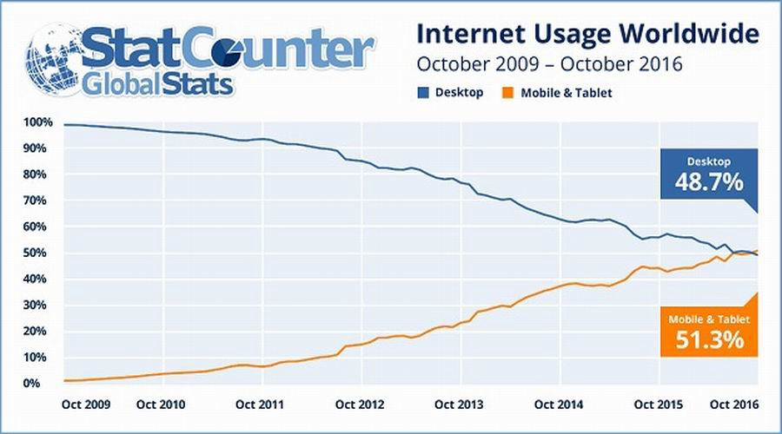
Around 2009, mobile internet usage started roughly around 0%. As the years went on, by the time we had reach 2016, exactly 7 years later the mobile usage went from 0% to 51.3%. So just under 4 billion individuals were utilising the internet from their mobile or tablet devices.
Compared to desktop or laptop users, from 2009 it started with near enough 100% of individuals using internet from desktops. 7 years later, the number decreased by 51.3%, meaning around 2.3 billion individuals are still using desktops for internet browsing compared to 6 billion.
Over the years, please are spending more and more time on their mobile or tablet devices for internet browsing. Here bellow is a chart which displays the time spent per adult user per day with Digital Media in America from 2008 – 2015:
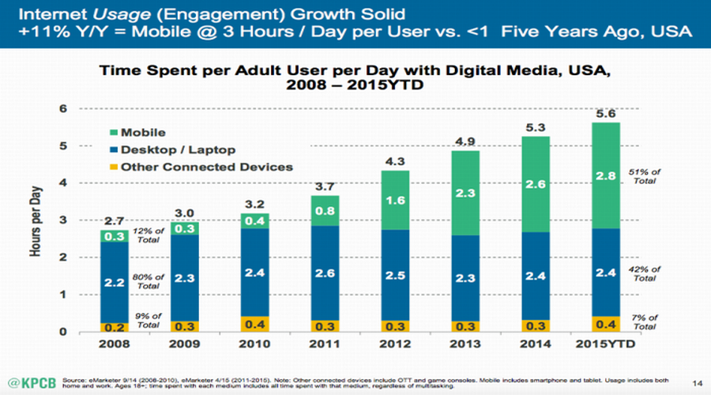
As you can tell by the chart, in 2008, desktop / laptop users were spending around 2 hours and 2 minutes roughly on internet browsing, which is 80% of the total out of mobile device users and other connected devices. Each year the desktop internet usage time had increased by 10 minutes from 2hrs 20mins, until reaching 2011. This is when the desktop time started to decrease, but this was only slightly but the users from 2008 to 2015 had dropped from 80% to 42%.
On the other hand, starting 2008, individuals on mobile browsing would spend roughly 30 minutes, which is only 12% of the total. There was not much increase after the following years with only 10-minute increase after 2 years but after 2010, the mobile users increased drastically. From 40 minutes per day to nearly 5 hours a day.
The use of mobile first started to increased as well as the sales of mobiles, specifically smart phones. Here bellow is a table of sold in early 2012 compared to desktops.
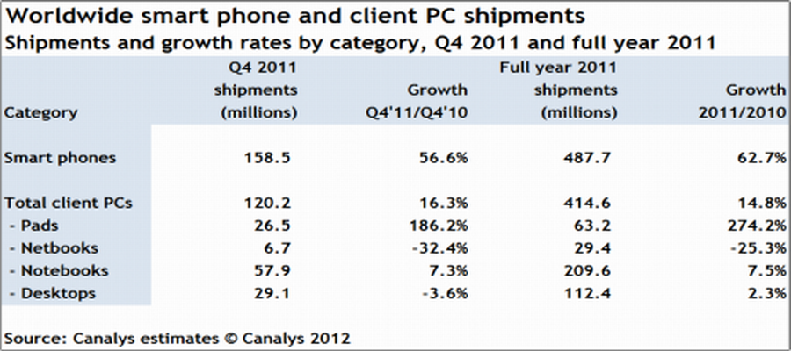
The exploding of mobile ends urges designers to pay attention to the mobile end and follow the “mobile first” rule in product design. [5]

3 Requirements
The website that had been implemented by the student consisted of HTML, JavaScript and CSS. The whole idea of the website was to display a fictional company’s business called ‘MTECH’’ in a digital format so that users can access it electronically whether on a desktop, laptop, mobile or tablet.
The purpose of the website and the audience its target towards are gaming enthusiast’s or individuals who are looking into gaming themselves. The website is quite unique compared to other tech websites on the internet because many tech websites have a wide variety of products. Such as ‘Curry’s PC World’ or ‘John Lewis’ for example, they have appliances, watches, tv’s and many more.
For gamers, there aren’t many websites specifically based on gaming, most of the times it’s just gaming companies advertising only their own products but MTECH takes the combination of different gaming desktops, gaming monitors and gaming setups and displays it under one website. This executes the user having to spend additional time looking for what they desire.
Every page of the website has a relevance. The website is made up of 6 pages. Home, About, Monitors, Computers, Location and lastly a contact page. Whether a viewer is looking to purchase a gaming product or curious on specs of certain products, the website will accommodate their needs. On the home page it gives a brief description of what the company is. The about page gives some information about the company, the monitors and computers have a selection of different gaming products, the location displays where about the company is based and last the contact page displays a form for the user to fill if they need too.

4 Design and Implementation

Tabs



Each page of the website has its own specific icon within the tab. This allows the user to know which page they are on if they go off the window and also it makes the look of the tab pleasing.



Bellow is the line of code that was used in order to implement the icon within the tab.

Navigation Bar
A responsive navigation bar has been created. The navigation bar allows the user to navigate from page to page within throughout the 6 pages.

Users can navigate from each page with the help of the navigation bar.
When the user clicks on “MTECH” it will bring them back to the home page.

Above is how the navigation bar look when the website has been open on full window on a desktop or laptop.

This is how the navigation will appear in tablet mode. As you can see the bar has been compressed into three horizonal lines.

The same response happens when in mobile mode.


However, during tablet and mobile mode when the user taps on the three horizontal line a drop out occurs displaying all 6 of the webpages one under the other.
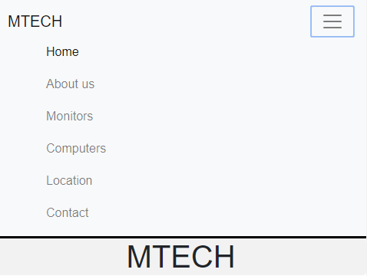

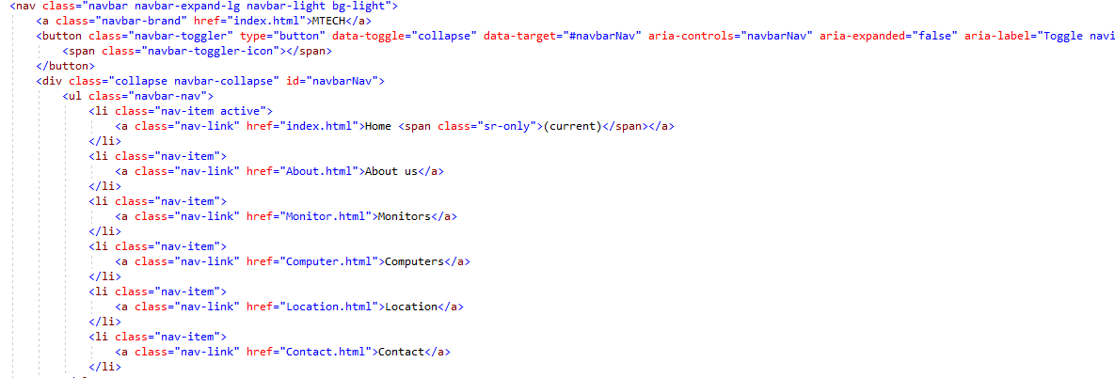
The code that was used in order to execute this was from bootstrap. The first few lines of code allows the navigation bar to be dynamic, giving it it’s responsiveness, which is essential for mobile first development.

Home Page
The homepage is the first page that opens up primarily. Under the navigation bar there are card decks. The card decks link to 3 sperate pages, which acts as a quick navigation.
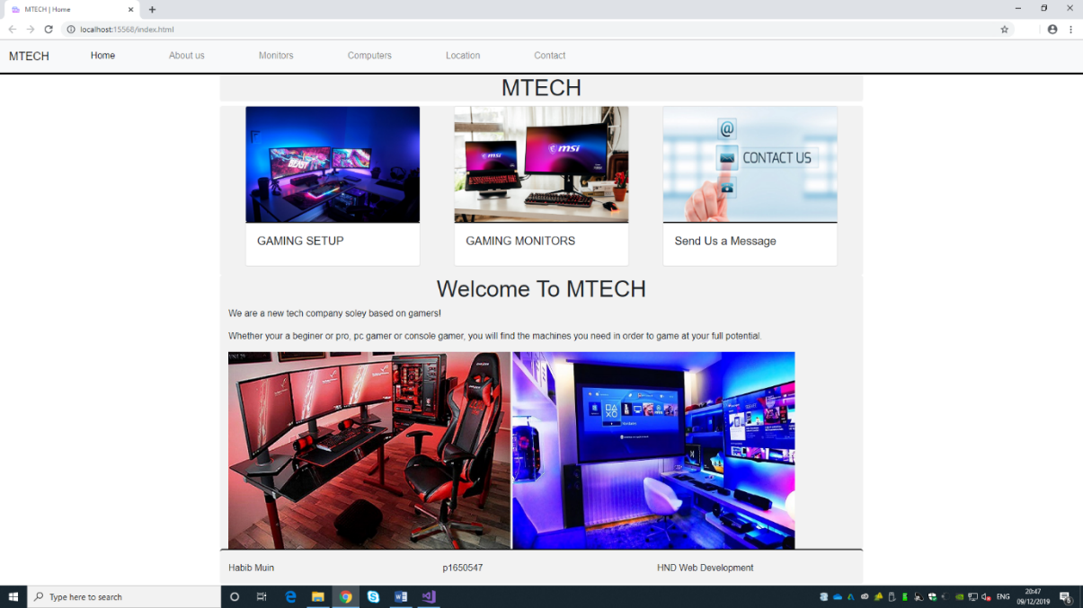
CARD DECKS

FOOTER

About Page
The about page gives the users an insight on the company and what its all about. This allows the user to feel more welcome and have a sense of comfort if they decided to purchase any products.

Monitor Page
Within this page there are multiple displays of gaming monitors, these monitors have all the specs listed underneath. This allows the user to have a look at different monitors and decide what would work best for their pc. i.e. …. FPS, Refresh rate, Sound Quality, resolution and size.

Computer Page
The computer page is similar to the monitors. The page displays a handful of gaming computer with pre-built components. There are similar gaming computers that have been displayed. The reason being is because the user may like the case but not the components inside. For example the “ “ has a different CPU and Graphics card compared. Each component within the cases of the computer will determine the performance that the user needs.
Location Page
On the location page, it displays some information on the where about of the company. As displayed on the page, it is currently under construction but once complete if users did feel the need to come in and view the products first hand they are perfectly able to do so.
Contact Page
The contact page displays a form for which the users can fill out if they have any questions, or problems with their product. The form is laid out in a simple format where the user would enter their names, email address, country and their message.

5 Evaluation

Overall, with the website, the developer of the site has made the web application responsive which makes the site to easily be viewed on either a laptop, desktop, mobile or tablet. The research and notes on application developments that the developer took prior to creating the website was able to finally execute a website for the fictionally company ‘MTECH’.
The overall aesthetics of the website is appealing and simple, however adding more JavaScript in order to make the website responsive on certain elements such as the images would make the site better. Also, the contact page form would not respond. Creating a business email in order to send the contact from user would make the website better.
Another factor that would make the website look better is having a hero banner across the top body of the main page under the navigation bar. Also creating a basket for which the users can select their products and input into the basket for purchase would be easier overall.

Bibliography

[1]. https://www.spritzweb.com/resources/good-website-characteristics.html
[2]. https://shortiedesigns.com/blog/10-top-principles-effective-web-design/
[3]. https://www.optimus01.co.za/importance-of-website-navigation/
[4]. https://techjury.net/stats-about/mobile-vs-desktop-usage/#gref
[5]. https://medium.com/@Vincentxia77/what-is-mobile-first-design-why-its-important-how-to-make-it-7d3cf2e29d00

