
Supporting young children’s Learning and Development during transitions
For Keyworkers in early years settings


Caroline Howells 1705829

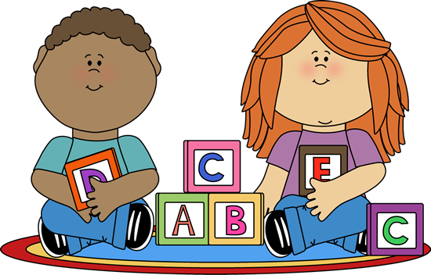

Contents
Introduction 2
Rationale 2
Transition 4
How to transition 6
John Bowlby 7
Urie Bronfenbrenner 8
Needs of the child 10
The role of the adult 11
Participation of the child 13
Inclusion 14
Interventions 15
Benefits of Play 16
Outcomes 17
Bibliography 19

Introduction
This handbook is for key workers in early years settings. The handbook will promote key workers understanding of the importance of effective communication for children between the ages of 22 and 24 months to support their learning and development during transition from the baby room to the over 2’s room of the early years setting.
The Common Core of Skills and Knowledge for the Children’s Workforce CWDC (2010) sets out the basic skills and knowledge that is essential that everyone who works with children and young people have. It is expected that all practitioners share the same common values to improve the life chances of all children in their care. There are six areas including supporting transitions.
The term Parent will be used throughout the handbook for any person who has parental responsibility for example, birth parent or other relatives, foster or adoptive parent.
Early years setting will be used to cover any setting that provides care for the child.
The term Practitioner will be used for any member of staff that provides care for the child in the early years setting.

Rationale
The aim of the handbook is to help practitioners to support children’s learning and development during transitions in the early years setting. The handbook will seek to do this by
- Explaining the term transitions
- Explaining how to support transitions
- Introduce key theorists in human development
- Identify the needs of the child
- Identify the role of adults
- How to ensure the child has participation
- Inclusion
- Interventions that can be used during transition
- The benefits of play
- Expected outcomes
Use of the handbook should support practitioners to provide a smooth and effective transistion for children from the baby room to the over 2’s room.
Doherty and Hughes (2009) that it is important that practitioners in the early years settings are aware and understand the full range of theories relating to child development as it is necessary to develop professional practice. By studying child development, it should also help the practitioner to appreciate that children develop holistically.

Transition
Children will encounter many transitions through childhood. The term transition can be used to refer to changes between services, schools. It can also be used to describe personal changes in a child or their circumstances CWDC (2010). For this handbook transitions are the period of time the child requires support as they transfer from the baby room to the over 2’s room in the early years setting.
Transitioning from one setting to another has been found to be stressful and challenging for young children, parents and practitioners; resulting in this being identified in research as one of the major challenges of early childhood. Ghaye & Pascal (1998), Meggit (2008).
Belfast Education and Library Board (2011)
Adams and Palakian (2010) suggest that infants learn best when they feel safe and secure therefore it is important that practitioners, the setting and parents work closely together to provide a safe and secure environment for the child.
Every child is unique and will experience transitions differently therefore it is important that transitions are planned and carried out in a way that meets the needs of each individual child. Adams and Palakian (2010) support planning ahead for transitions as it helps everyone involved to experience smooth and effective transitions.
CWDC (2010) acknowledge that children with disabilities or special educational needs and their parents may require additional support to manage transitions.
Dowling (2005) suggests that even a happy and contented child may feel emotionally challenged by transitions. They may have negative feelings which they are unable to express which results in their emotional well-being becoming insecure and this has a negative effect on their ability to learn.

Kanira and Ward (2016) acknowledge that change can be a pleasurable experience and therefore can benefit the child in many ways however they also acknowledge that transitions can be frightening for children and their families and unsuccessful transitions can have a negative effect on the child and their development causing long term problems.

Although children moving from the under 2’s room to the over 2’s room may have been at the setting for quite some time and used to the setting and the staff, it is still a major transition as the over 2’s room is a new environment, the staff are different and the routines will be new to the child.

How to transition
Adams and Palakian (2010) support planning ahead for transitions they advise that it is good practice t
o have meetings with the family and key workers. An example of this would be to set up a meeting with parents and the child’s keyworker in the baby room and the new keyworker in the over 2’s room. The meeting will be an opportunity for parents and the keyworkers to form a mutually respectful relationship, to share information, to discuss the child’s needs and set out clearly defined procedures for the transition.
In the baby room the child has a daily routine which is important as it allows them to know what is happening next. This routine will be disrupted during transitions, but keyworkers can minimises this by respectfully telling the child what is happening next even though they may be too young to respond verbally. It will help them to understand what is happening.
Between the ages of 18-24 months children’s speech is developing and they are learning new words rapidly however they may not have the ability to know what the words mean Keenan, Evans and Crowley (2016). Therefore, it is important to adapt communication style to meet the needs and abilities of the individual child. This can be obtained by the use of appropriate body language, eye contact, tone of voice, being sincere and sensitive to the child’s needs.

John Bowlby
John Bowlby is well known in child development for his work and research on the relationship between the caregiver and infant. Through his work he formulated the theory of attachment. Keenan, Evans and Crowley (2016) state that attachment theory focuses on the relationship between parent and the infant and how this attachment relationship impacts the child’s psychological development. Bowlby’s research led him to the belief that infants have an innate set of behaviours for survival. They have the need to be close to their caregivers and are born with the skills needed to seek out their caregiver to have their needs met. For example, crying when they are hungry.
However, Ainsworth et al 1978 citied in Keenan, Evans and Crowley (2016) point out that attachment is a two way process, it needs to be a relationship. The infant’s signals will be ineffective if the caregiver cannot interpret the infants signals and respond appropriately. Manning-Morton (2011) states that a secure attachment between the caregiver and infant is fundamental to the child’s mental health and ability to form positive relationships in the future. Gaze and touch are also important aspects of the attachment process.
Manning-Morton (2006) emotions have a positive role in cognitive and social development, being attuned to the child’s cues will help the practitioner to support the child’s development.

The majority of Bowlby’s research focuses on the attachment between mothers and infants however Bowlby recognized that attachments can be formed with other significant adults Keenan, Evans and Crowley (2016).

According to McLeod (2016) children thrive in loving and caring relationships in contrast insecure attachments can have a negative affect and are associated with delayed language and cognitive development. Children can have further issues with trusting others and forming positive relationships.

Urie Bronfenbrenner
Another influential theorist is Urie Bronfenbrenner. Bronfenbrenner 1979 cited in Pound (2016) developed the ecology systems model. Bronfenbrenner believed that the child does not exist in isolation but is at the centre of the ecological system model. The child sits at the centre surrounded by family, carers, friends and the community. Bronfenbrenner created a holistic model of child development which is still relevant today.

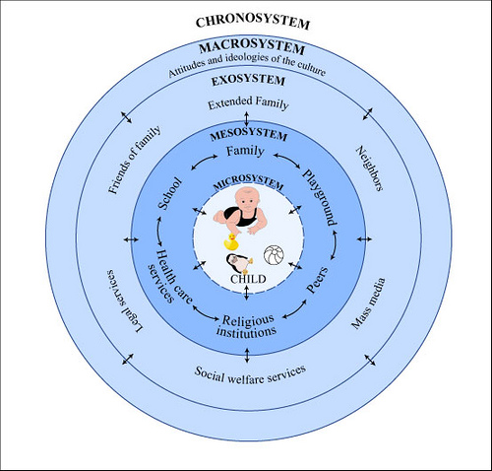

All forms of social interaction are connected. The five systems of his ecological theory are:
- Microsystem – The child’s immediate family.
- Mesosystem- The extended family and friends, neighbours, teachers, early years practitioners.
- Ecosystem- The cultural system outside of the child’s family, community, employment of parents.
- Macrosystem- The larger society in which the child lives.
- Chronosystem- Changes over time.
It could be suggested that early years practitioners fit into the Mesosystem and have an influence on the child as well as their parents.

Greenland (2016) suggests that Bronfenbrenner’s ecological theory suggests that practitioners need to look at the child life holistically and understand what influences their development to offer support to their individual needs. Doherty and Hughes (2009) agree that development does not happen in isolation but is continuous and individual to every child. For example, the environment in which the child lives can have influences on the child’s development.

Needs of the child
In times of transition children need to be supported to ensure a smooth and effective transition.
David (2009) argues that for emotional, social and personal development the child needs a sense of ‘belonging’ research suggests that babies and young children need important, loving and significant people in their lives and they need to feel a part of a family. The sense of belonging makes children more socially competent, confident and self-assured. Children may not have a traditional family, but society can support them to ensure they do feel that they are part of a family.
Dowling (2005) agrees that a young child’s self-esteem is dependent on the adults that care for them therefore it is essential that they feel loved, cared for and secure at this important time of their childhood.
Periods of transitions can be difficult for young children, they may experience negative emotions that can be difficult for example they may become withdrawn, be irritable, have tantrums or be aggressive Adams and Palakian (2010). Additionally, Dowling (2005) points out that it is believed that children with good self-esteem and self knowledge are better equipped to learn.

The role of the adult
Children should be supported through transitions by adults. This includes parents and caregivers, practitioners including keyworkers and other professionals who all have responsibilities for meeting the needs of the child.
Dunhill (2010) suggests that it is not enough for adults to work alongside each other they need to form effective partnerships in order to provide for the children’s needs, to support learning and development. To share concerns and issues and to work together to address any issues and concerns. Palaiogou and Hallowes (2010) agree that positive relationships with parents helps
with effective transitions. The National Minimum Standards for Regulated Childcare for children up to the age of 12 years (2016) emphasise the importance of ensuring all practitioners work in partnership with parents to ensure that the children’s individual needs are met.
Fitzgerald and Kay (2008) identify the following characteristics of effective communication are essential in creating an effective partnership
- Being an open and honest communicator
- Keeping information confidential when necessary
- Providing accurate and balanced information
- Sharing all news even when it is difficult and /or unpleasant
- Avoiding making assumptions
- Ensuring that agreed actions are followed up and completed
Fitzgerald and Kay (2008:14)
Palaiologou and Hallowes (2010) state that parents are also going through transitions at the same time as their children and are influenced by the child’s transition. Therefore, it can also be a very difficult and challenging time for the parents as well as the child. They can feel anxiety and unease at the time of transition. During this time parents may look to practitioners for support. Practitioners need to be mindful of this Kanira and Ward (2016) encourage collaborating with parents in a natural way by being respectful of parents, engaging with them and welcoming the parents into the setting. If a positive relationship has been developed between practitioners and parents this will help parents to feel more at ease during the transitions.
Manning-Morton (2011) identifies that the key person approach is now being effectively implemented in early years practice. The key person approach allows practitioners and children to develop strong effective relationships.
Veale (2016) agrees with this by stating that if the key person knows the child well they are able to detect when the child is unhappy or failing to thrive it is particularly important for children between the ages of 20 and 24 months because they are unable to communicate their feelings through speech and language. McLeod (2016) agrees that observation is a fundamental skill for practitioners to understand the child’s view when they cannot express themselves through language.

Pound (2016) suggests that it is extremely important that early years practitioners are pro active in developing opportunities for multi-agency working. She also suggest that despite the introduction of the Common Assessment Framework (2006) which supports practitioners to engage in multi-agency working in practice results are inconsistent.

Participation of the child
“Every child has the right to express their views, feelings and wishes in all matters affecting them, and to have their views considered and taken seriously” United Nations Convection on the Rights of the Child Article 12 (1989).
The DfE (2012) recognise that is important that early years practitioners support children to make choices. It is important that practitioners understand children’s perspectives and are able to link them with learning and development to meet the desired outcomes however Lancaster (2010) expects that adults take on the responsibility for decision making. An example of good practice would be to follow Shiers’s (2001) model of children’s participation which has 5 levels
- Children are listened to.
- Children are supported in expressing their views.
- Children’s views are taken into account
- Children are involved in decision making processes.
- Children share power and responsibility for decision making.

Palaiologou and Hallowes (2010) state that children should have active participation in the process of transitions. To ensure children are able to participate practitioners should listen to the children as the children are young the key person through observations should be aware of the child’s likes dislikes emotions how they are feeling. If the key worker has established a good relationship with the child, they would have developed trust and security. Plan appropriate activities to ensure the child feels important supported and their individual needs are met.
Elder (1995, 1998) life course theory cited in Keenan, Evans and Crowley (2016) fourth principle states that human beings have agency to develop a sense of agency in children practitioners should support children to make choices for themselves.

Inclusion
Nutbrown (1996) states that respectful educators will include all children regardless of their abilities and background. Practitioners should respect all children for who they.
The Welsh Assembly Government (2008) state that practitioners need to accept responsibility for enabling children to achieve best outcomes. Practitioners should identify barriers to inclusion to enable them to include all children in their provision. Practitioners should know how to recognise children’s individual needs and how to support them to achieve the best possible outcomes.

Interventions
CWDC (2010) suggest that transitions need to be planned, they need to be managed in a timely way and the planned process should be appropriate to the individual child’s age and stage of development. An example of how this could be achieved in the setting is Approximately 6 weeks before the child’s second birthday the setting will slowly start to transition the child to the over 2’s room. To support the child their keyworker will take them into the over 2’s room for short periods of time and stay with them. They will be introduced to the new key worker at this point who will also stay with the child for these visits. Over the 6 weeks the visits will slowly become longer as long as the child is happy. They will join in for a group morning story followed by group songs and movement activity. Coulter (1995) suggests that songs and movement are a good activity for young children as they are able to actively participate, and it enhances their ability to learn.
To help the child to transition to the over 2’s room the keyworker will take the child to the outdoor area after dinner to play with a small group of over 2’s the child may feel anxious at this new environment but as they are with their current key worker and new keyworker who they were introduced to in the morning, they should feel safe and supported.
Another example of good practice is the child’s current key worker will share all relevant information with the new key worker before the transition period starts and during the duration of the transition period. They will also pass on all the developmental records an any other important information such as medical conditions and allergies.
The child will continue visits into the over 2’s room until their second birthday, however the period of transition is determined according to the needs of the individual child so support will be extended if needed.

Benefits of Play
Children develop through play, play helps brain development, helps muscles to grow strong and encourages good social skills Sutton-Smith (1997).
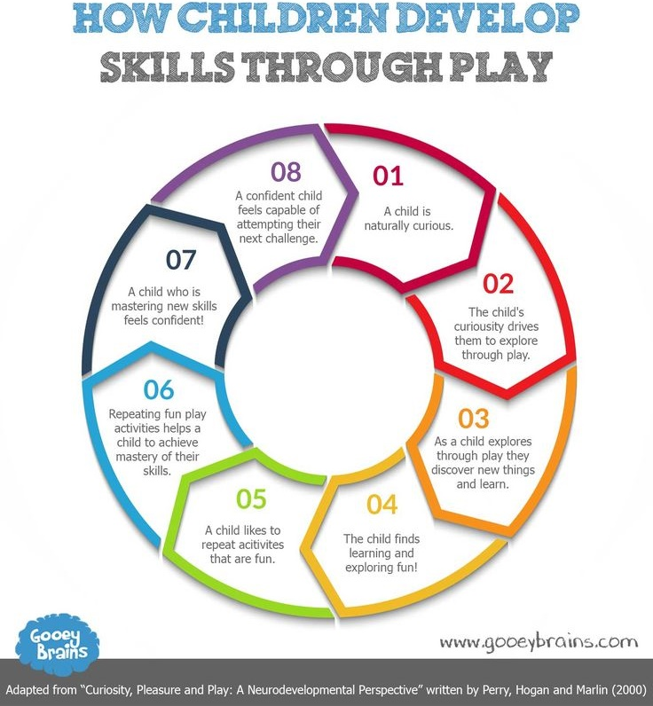

Outcomes
The government green paper Every Child Matters, Department for Education and Skills, (2003) sets out the governments approach to the well-being of children and young people from birth to age 19. Every Child Matters is an integral part of the Children Act 2004 its 5 outcomes are to ensure all children from birth to 19 years old are:
- Healthy
- Safe
- Enjoying and Achieving
- Make a contribution to the community
- Achieve an economic well-being
In order to help all children to achieve the 5 outcomes the DfES (2006) introduced the Common Assessment Framework (CAF) The aim was to encourage practitioners to identify the broader needs of the child. For practitioners to be able to identify early on if an individual child is unlikely to achieve the 5 outcomes without additional support. The DfES (2006) believed that before the Common Assessment Framework was introduced practitioners did not understand how to best support the individual child therefore not supporting them to achieve. The Common Assessment Frameworks common approach to the child’s assessment of needs should ensure practitioners are able to conduct good quality assessments and identify how they can support the child’s needs or recognise when they need to involve more specialist practitioners. Practitioners are supported to engage in Multi agency working and to share information appropriately.
Veale (2016) points out that the Common Assessment Framework mirrors Bronfenbrenner’s ecological systems model (1979) in that they agree with the need for multi-agency, interdisciplinary and integrated working to support children to achieve the five outcomes of Every Child Matters DfES (2003). The child needs to be seen as the centre of the ecological system and the whole system needs to be viewed in order to gain an holistic view of the child’s needs.
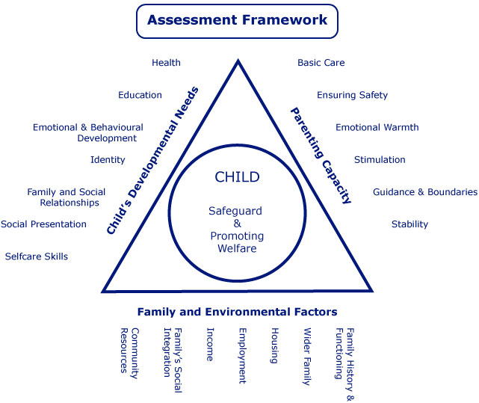
(Source Kirkless safeguarding children board 2013)
According to Marder (2008) the government to improve the outcomes for children with disabilities they also introduced plans for improving service provisions for disabled children and families entitled Aiming high for disabled children.
It is important that it is recognised early on if the child is having difficulties with the transition. As the child is still only 2 years old it is important that the key worker has an excellent relationship with the child, that they are attuned to their needs they should be able to recognise when the child is distressed. Through previous observations they know at what age and stage of development the child is at so will be able to see if they are regressing.

Having the mutual respectful relationship with parents means they can talk through any concerns either party has in confidence.

References
Adams, E. and Palakian, R (2010) ‘Movin’on: Supporting Transitions for Infants and Toddlers’ YC Young Children. Vol.65(3) pp.54-55
Childcare Development Division Education and Public Services (2016) National minimum standards for regulated childcare for children up to the age of 12 years. Cardiff: Welsh Assembly Government.
Children Act (2004), London: HMSO
Coulter, D

