Name of the Team: Team Coffee
Team Members
Student Name | Student ID
mARK WILLIAMS | 2022279
ASHLEY REES | 2009258
TIRION WALL | 2023509
JOSH archer | 2011907
Team Evaluation (Self Evaluate your Team)
 | Mark | Ashley |  | Tirion |  | Josh
Mark | 5 |  | 5 |  | 5 |  | 5
Ashley | 5 |  | 5 |  | 5 |  | 5
Tirion | 5 |  | 5 |  | 5 |  | 5
Josh | 5 |  | 5 |  | 5 |  | 5
Rate your Teams Contribution with a scale of 1 to 5 (1 No Contribution and 5 Excellent Contribution)
Add your comments on Team Evaluation: (Justify your evaluation)
Mark: Our team work exceptionally well together we each contributed parts to the overall task that helped each other understand the subject further for example Ashley assisted those of us who have less experience within Virtual Machines and guided us when the stages got a bit confusing. Tirion and Josh provided important screen shots that showed parts of the task steps that helped with writing up the assignment.
Ashley: The team worked well very well together, there was a good mixture of Cyber security and Software development. Each stream contributed differently to the overall creation of the assignment. Josh and Tirion provided the screenshots needed, while I helped with the technical side when setting up the servers and client systems through the type 2 hypervisor. Mark was then able to compile all the screenshots to create the group section of the assignment.
Tirion: Our team worked well together. Josh and I study Software Engineering, it was therefore really helpful to collaborate with Mark and Ashley who study Cyber Security as they have a good understanding on the topic. Ashley helped us troubleshoot problems we came across, Josh and I provided the screenshots and Mark put the screenshots together, created the layout and wrote the captions. We then all edited it together.

Josh: We all worked well as a team and due to us all coming from different disciplines we were all able to bring unique benefits to the team.
Mark was helpful when it came to trouble shooting a few problems for me. One of these was when I couldn’t figure out that when adjoining the domain and testing user logins, I kept getting an error message instead of being prompted to input an admin account details. Mark helped me trace the problem back to the incorrect value for the Preferred DNS Server. This then solved the problem.
Ashley was a great help especially in the early stages of setting up the VR Machines and different Server and Client accounts. As I didn’t come from a Network Operating Systems background, Ashley was able to help me understand the layout of what we are trying to do.
Tirion like myself came from a Software Engineering background. Tirion and I both set up the Type 2 Hypervisor platform based Virtualised network. This was to be able to provide us with valuable experiences in network operations and to also provide a back up to each other’s work in case one was lost or corrupted. Tirion and I also both provided the screenshots for the proof.

3/10/2023
ACCA5023 - Network Operating Systems and Services

Build, deploy, configure, and manage a Type 2 Hypervisor platform based Virtualised network
Ashley Rees

Table of Contents
1. Abstract 4
2. Introduction 4
3. Part 1 – (Task 1 & 2) 5
3.1 Task 1 - Building a virtual LAN using type 2 hypervisor management software 5
3.2 Task 2 - Deploying a network directory service and creating and understanding active directory network objects 13
4. Task 2 – Observation 23
5. Conclusion 27
6. Reflection on collaborative work 28
7. References 29

Abstract
This report will show and describe the steps and processes to building a virtual local area network (VLAN) using a type 2 hypervisor, deploying a network directory service and creating active directory network objects. The report provides a synopsis of virtual local area networks, type 1 and type 2 hypervisors including their uses, and the use of deploying a network directory service using an active directory.
The research proves that using a VLAN with a type 2 hypervisor provides benefits for managing a network, which include increased security, network management and flexibility. Active directory provides essential tools for maximizing network administration and simplifying network management for network administrators.

Introduction
Virtual local area networks (VLANs) are an essential service for network administrators to organise their networks. Using a VLAN, administrators can create and divide the network into subnets with added benefits of flexibility scalability and security. As well as VLANs, deploying a network management service such as Microsoft Active Directory included in Server 2019, can help network management.
The use of Active Directory and VLANs have become increasingly important in today’s network environments. Allowing network administrators to create multiple virtual servers on a single physical server, is a lot more beneficial as servers are often very expensive to purchase and run. Active directory allows network administrators to manage the devices and users on the network, giving relevant access when needed.
The aim of this report is to provide an in-depth overview of hypervisors, type 1 and 2, creating a VLAN as well as using and deploying a network directory service, using Microsoft Active directory. The report will talk about both the advantages and disadvantages that these tools provide for network administrators.

Part 1 – (Task 1 & 2)

3.1 Task 1 - Building a virtual LAN using type 2 hypervisor management software

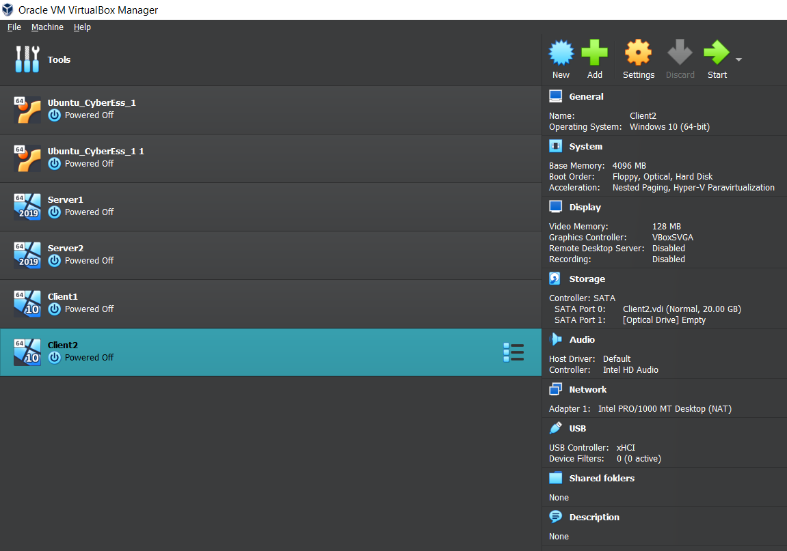
The above image shows Oracle VitualBox Manager with four Virtual Machines, two Client and two Server. The right side of the image shows the configurations for the client Virtual machines showing the systems base memory, operating system, and display settings all of which have been manually set to allow the virtual machine to run smoothly and connect to the server.

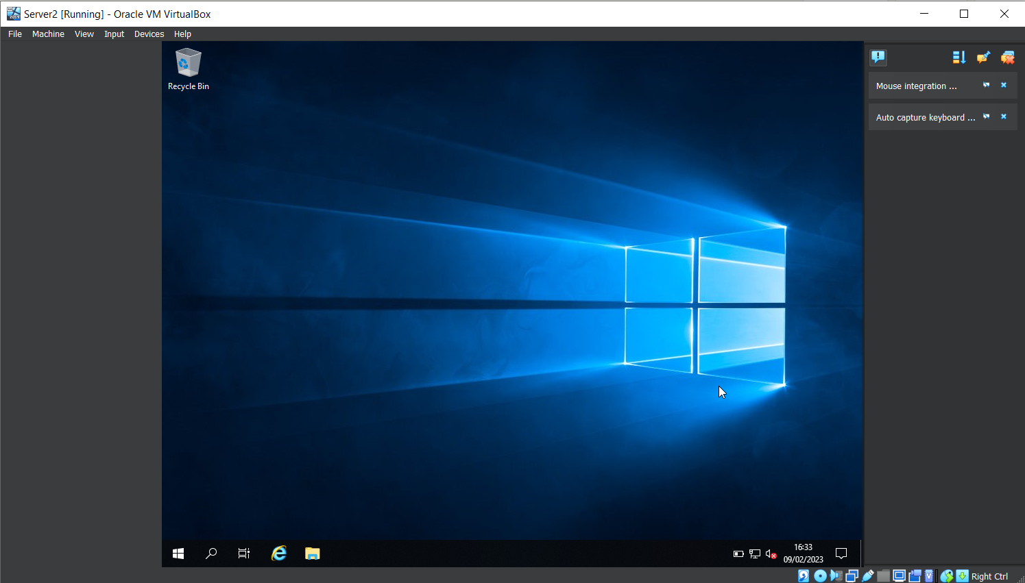
A view of first start up of the Virtual Machine for Server2 which displays like a regular computer would when first starting up, but this Virtual Machine has warnings and errors shown on the right hand side, customisable settings shown in the bottom right of the image and also has the ability to press certain combination of buttons such as alt + control and delete within the “Input” option at the top left.

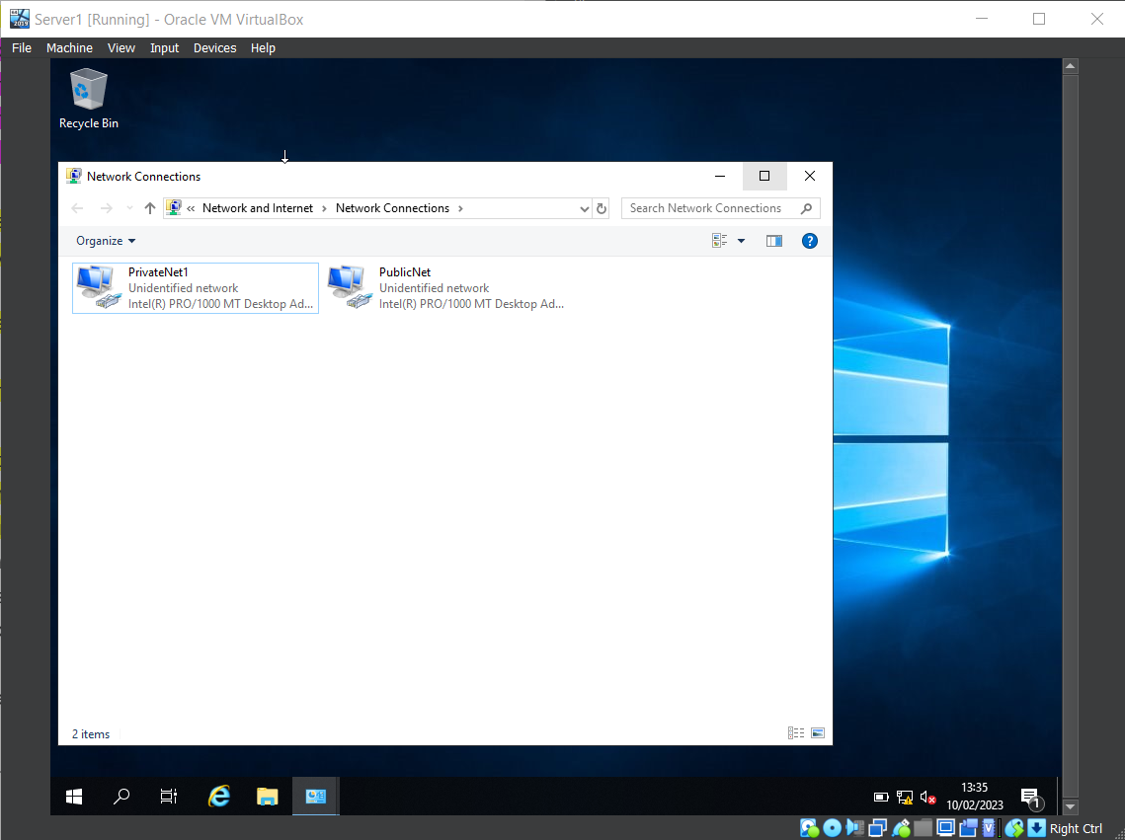
Within this image it shows the Network Connections for both PublicNet and PrivateNet1 this is done on both Server1 and Server2 Virtual machines and allows for the connection between server and client.

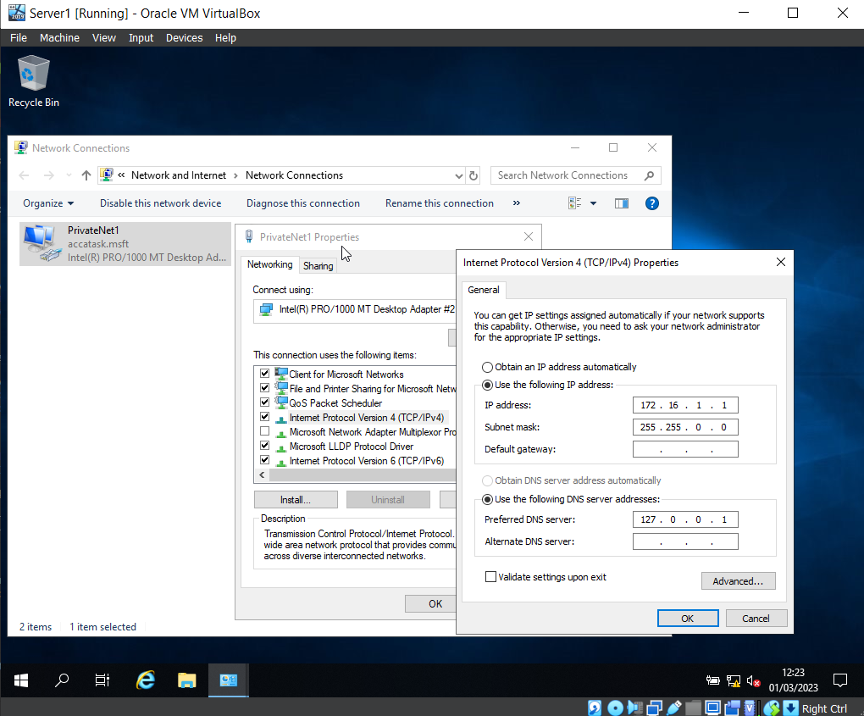
Following from the image above to make the Server and Client Virtual machine communicate there must be an IP address set for the machine. The above image shows the IP address and the Subnet Mask along with the Preferred DNS server which is used for later in the task.

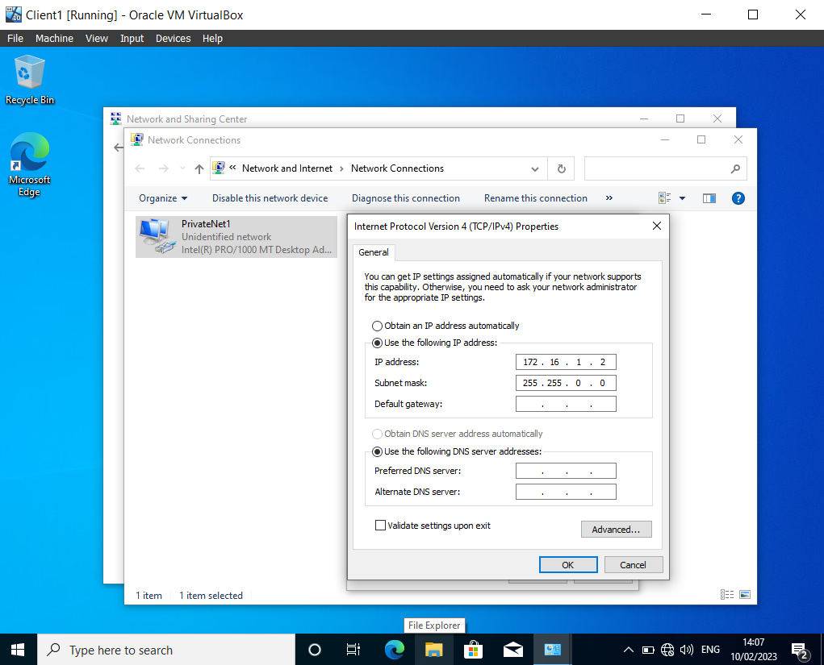
In the image shown above Client1 has been started and as mentioned in the images above to get the Server1 and Client1 virtual machines to communicate the Network Connection PrivateNet1 is created and as shown here the IP address and Subnet mask are inputted.

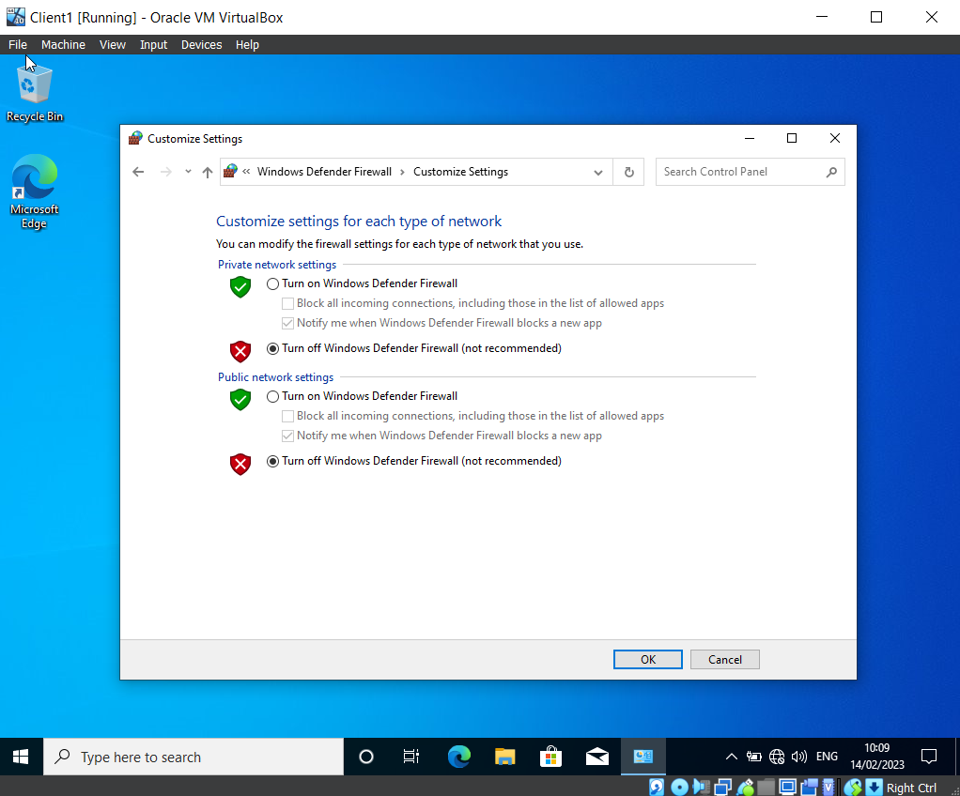
Firewall settings are turned off for the Client and Server Virtual machines to be able to communicate with each other the. The firewall will block incoming ping requests by default from unknown sources as a security measure because pings can be used maliciously.

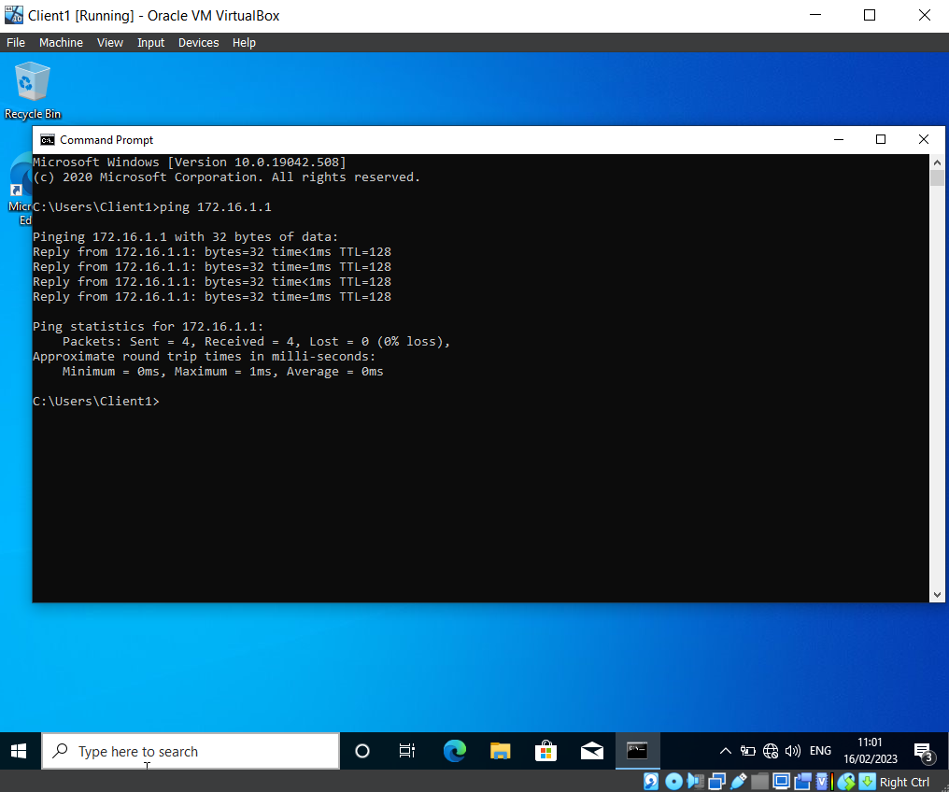Successful ping from Client1 to Server1 virtual machine, the image shows the reply time once the command for the server1 IP address to ping. Which shows that the steps followed within the pictures above have allowed the connection and communication of Server1 and Client1.

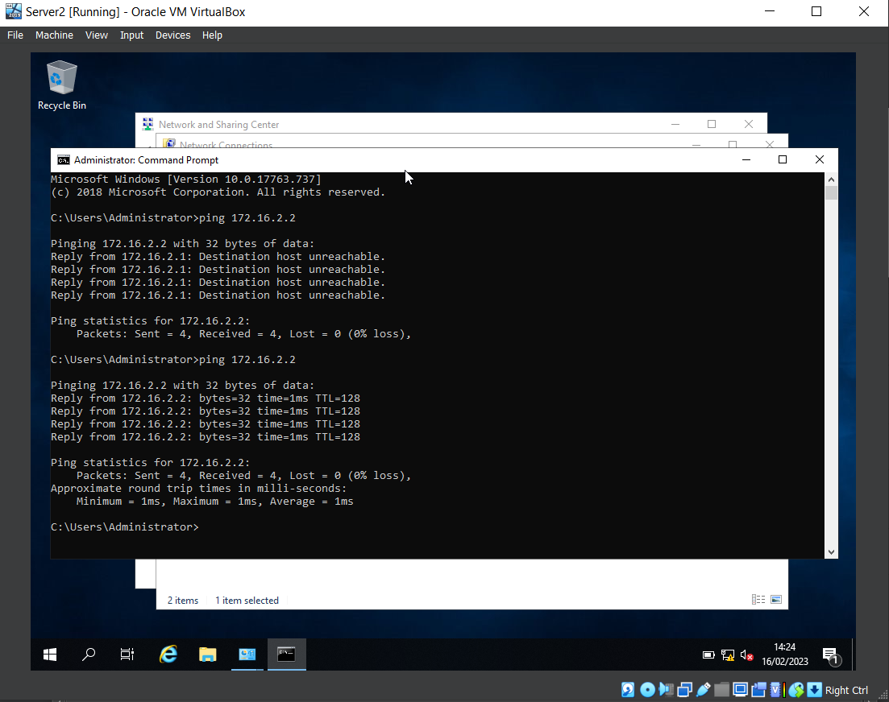Successful ping between Server2 and Client2 virtual machines showing that the setup with network connections was inputted correctly and shows that the IP address set for Client2 are correct.

3.2 Task 2 - Deploying a network directory service and creating and understanding active directory network objects

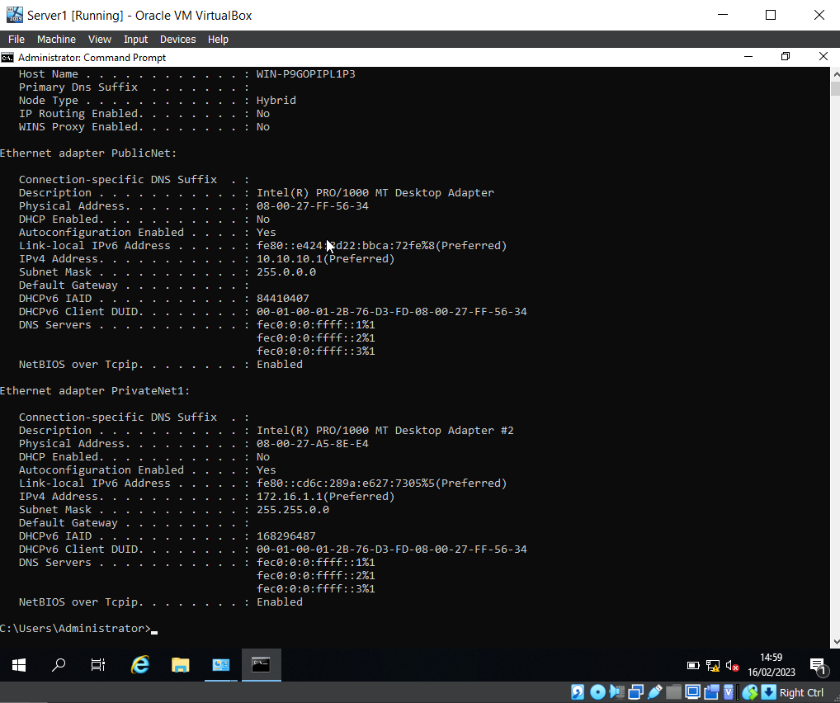
The following image shows that the DNS has not been set up and that the firewall is turned off along with the Server IP being Statically Defined. This confirms all of the steps taken in the task above and shown within the images are correct and confirmed.

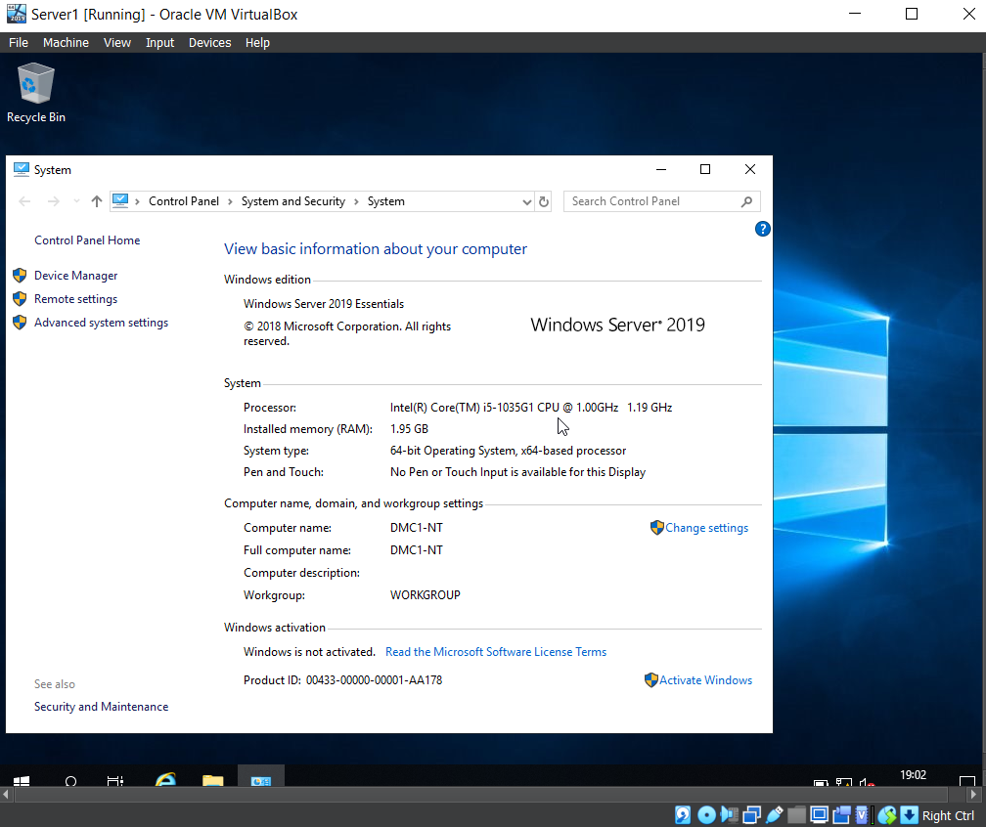 Showing within Server1 the Computer name has been changed to “DMC1-NT” within the control panel system settings.

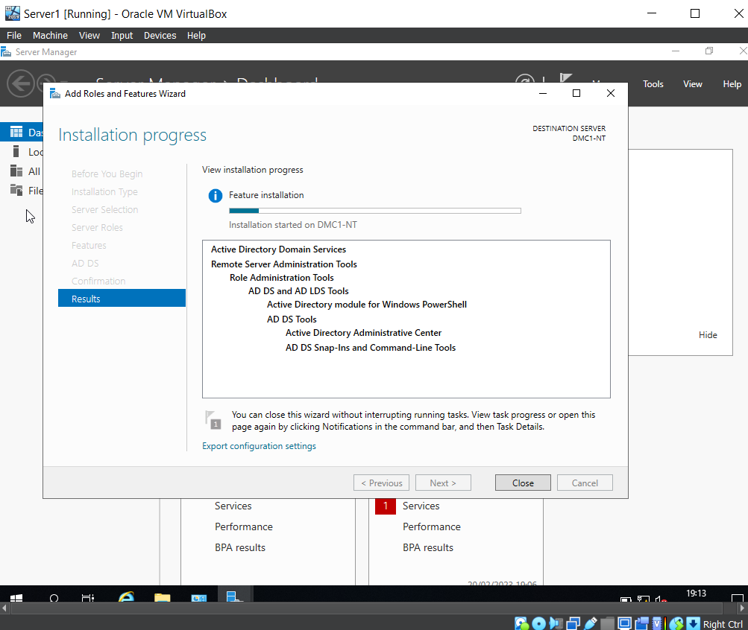Active Directory is a database that manages network resources such as computers and users. It allows for administration to restrict and grant access to all aspects of the network such as groups for specific access, security policies. My experience working within Digital Health Care of Wales active directory houses all of the NHS Nadex’s which are what staff use to log in and each Nadex will have groups that grant access for whichever department that staff member is apart.

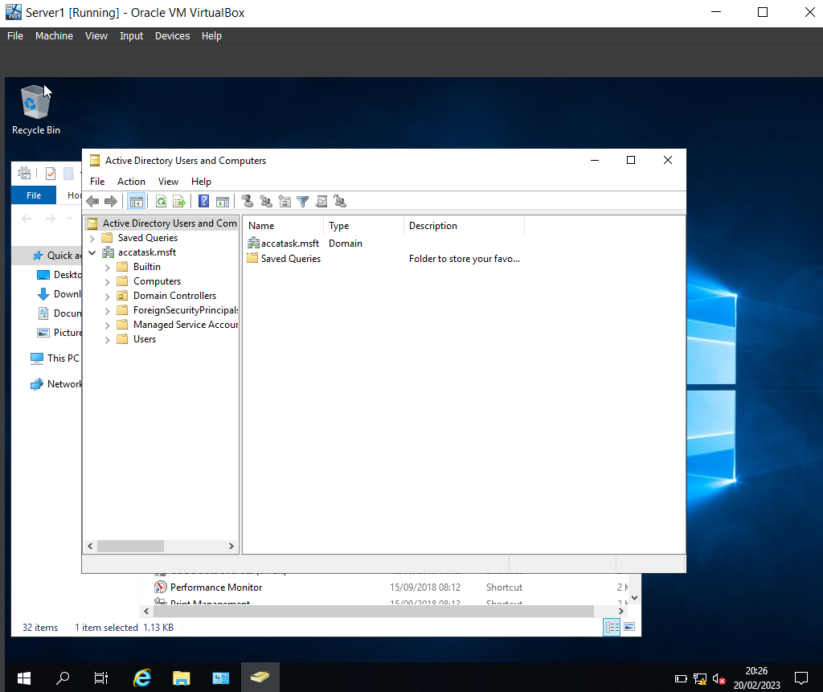
First time opening Active Directory within Server1, on the left hand side of the directory there are the folders for users and computers which allow for creating new users.

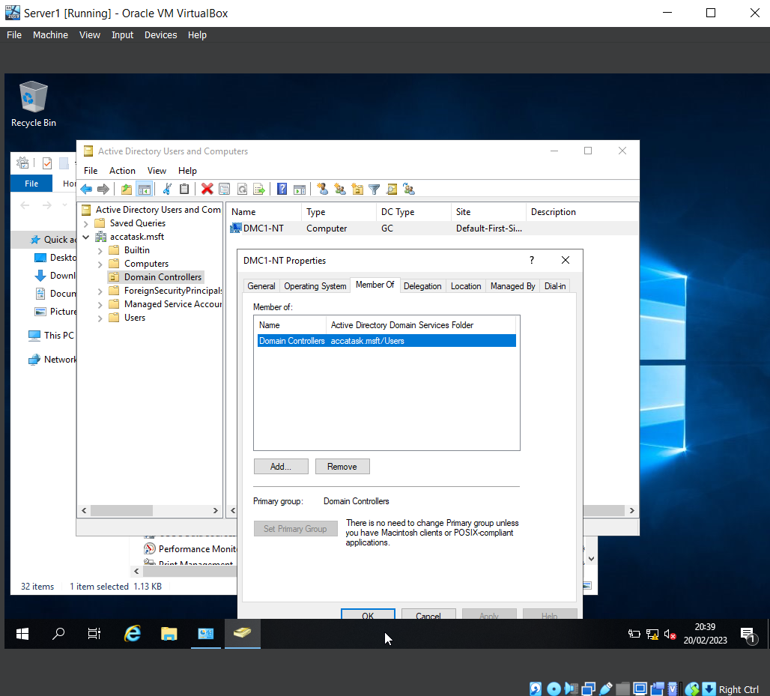The computer name “DMC1-NT” is shown in the image above inside of Active Directory it shows the “member of” group which grants the account access to certain things within the network here the domain controller has been set “accatask.msft”.

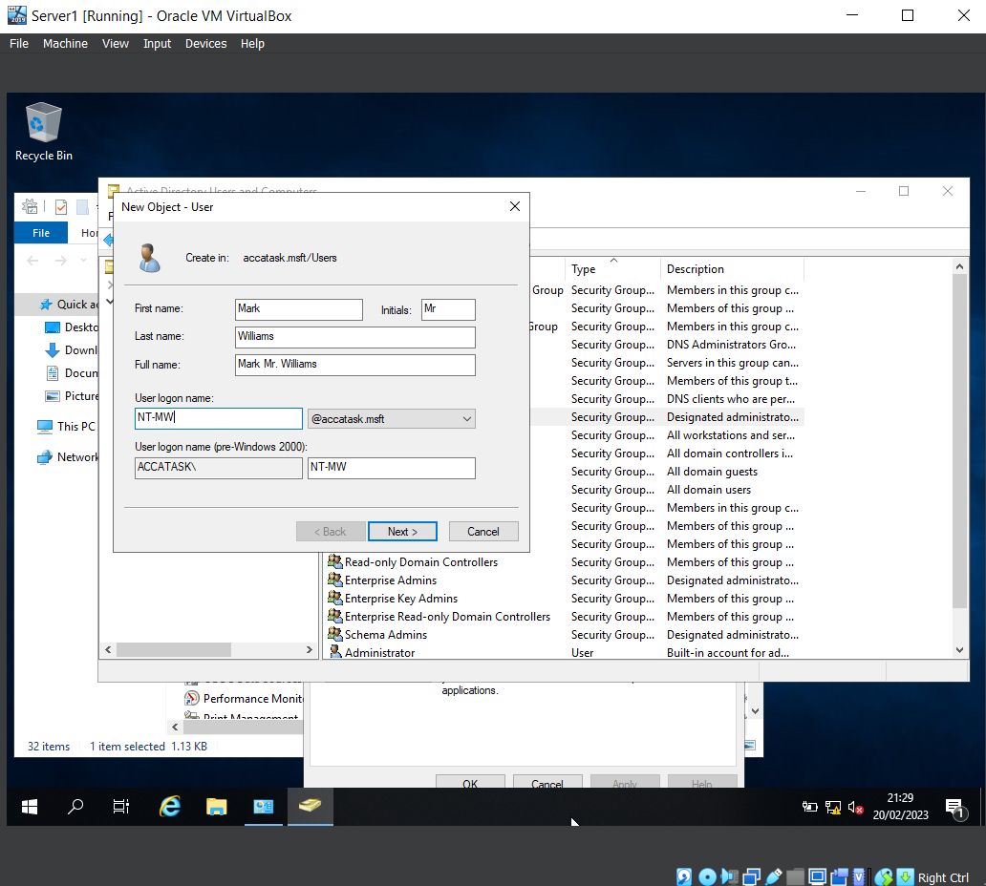Active Directory allows for the creation of users which will than grant access to the network. In this image it shows the users full name and what will be the account details that will be used to login.

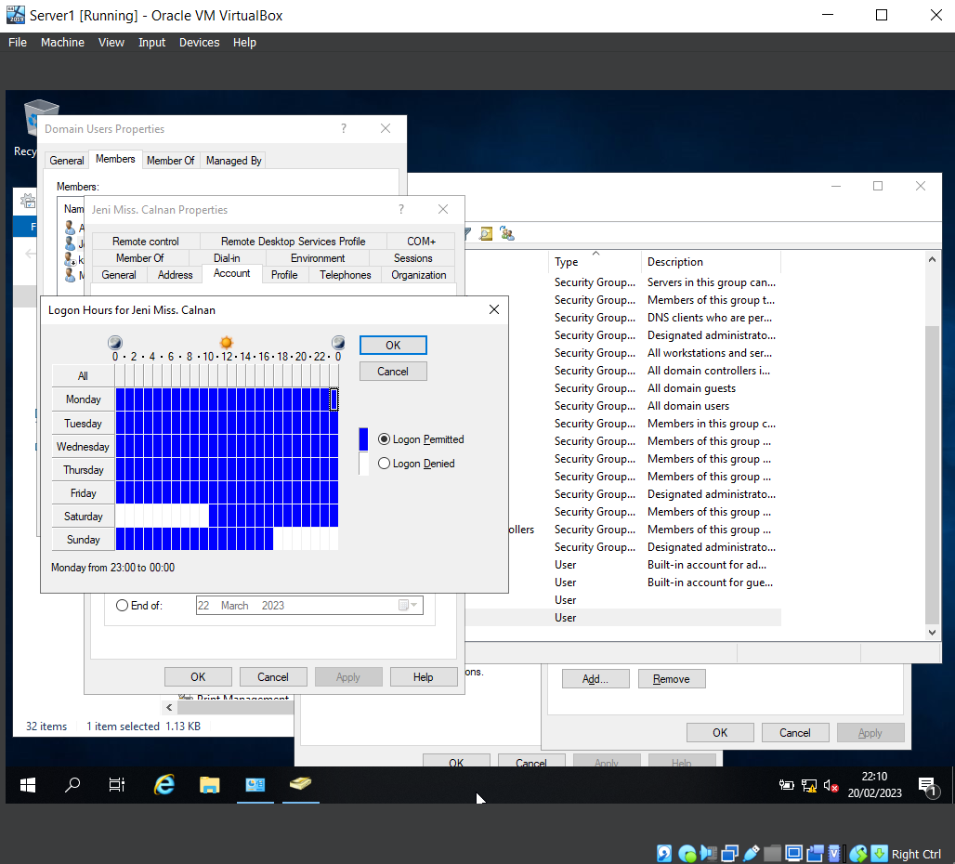A lot can be customized within Active Directory including the times users are able to log in stopping unauthorized access to the network certain times keeping the network safe from possible malicious attempts by users trying to gain access outside of office hours. The customization is simple the white boxes are to deny login at these times and days and the blue allows users to login.

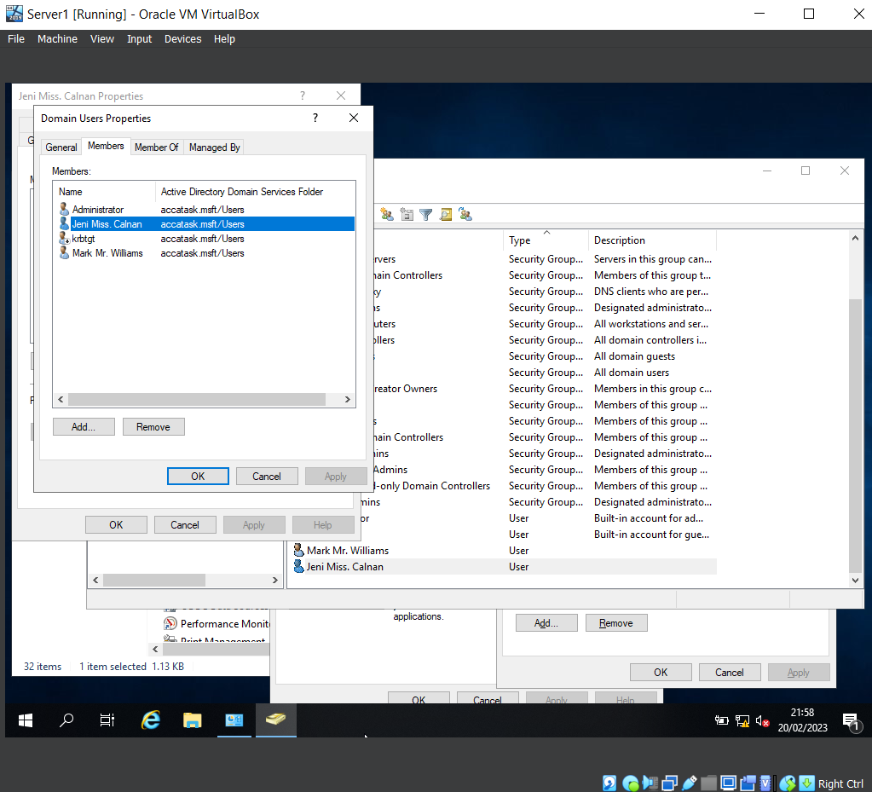The users created within Active Directory and placed within the “Domain Users” group will all appear when accessing the group as shown in the image above where all users that are in that group appear in the list of the “Members” tab inside “Domain Users” properties.

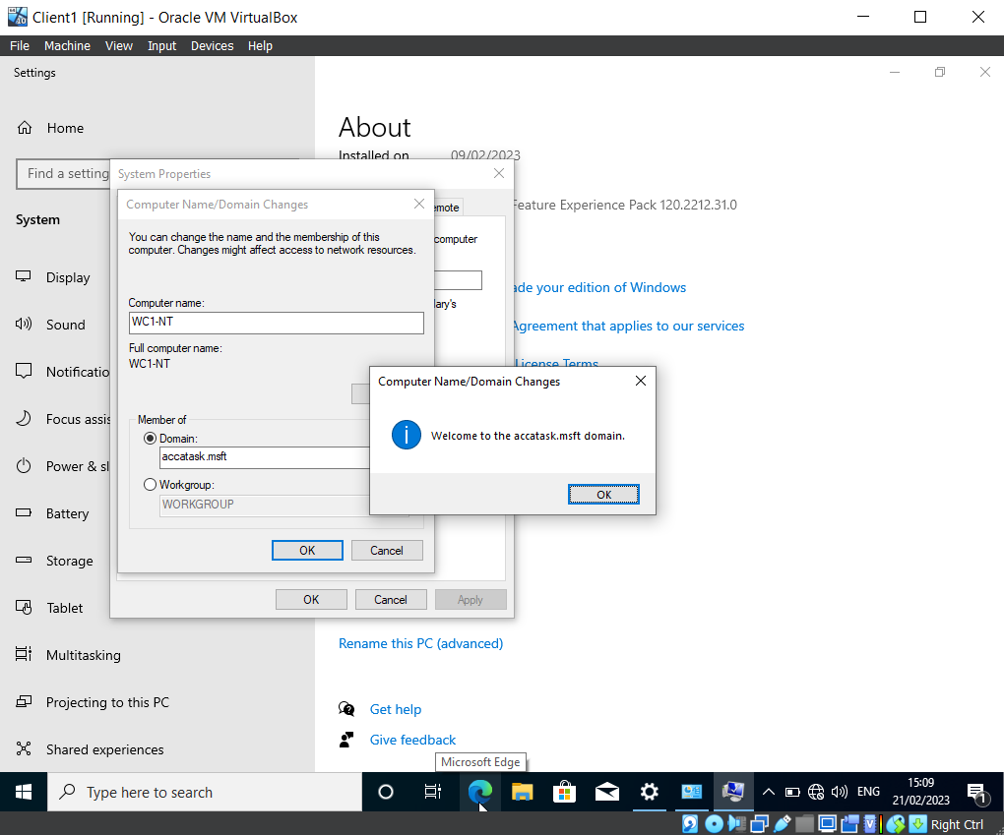Client1 Virtual Machine is connected to “accatask.msft” domain which allows for activate directory users and policies to be used within this computer.

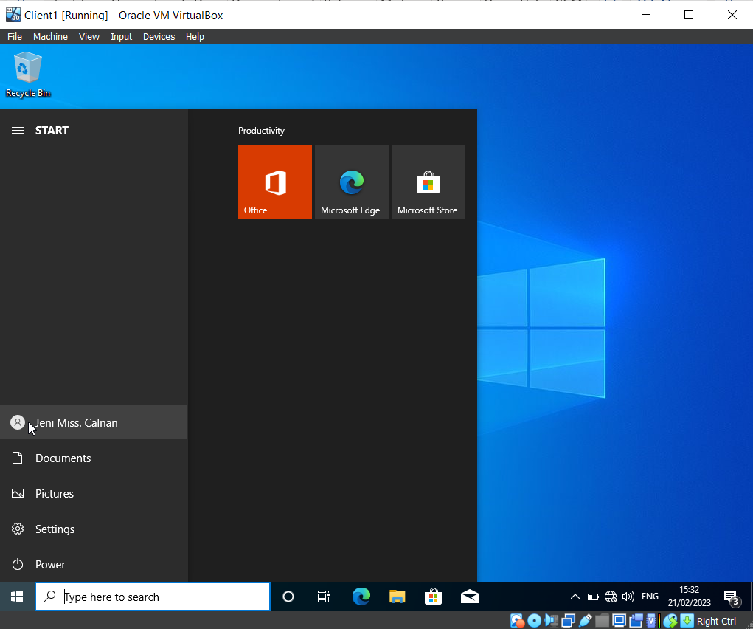Continuing from the above image Client1 is connected to the Active Directory and users are able to login as proven in the image above where a user created “NT-JC” has logged into the Virtual Machine because of the connection to the Active Directory and Network.

Task 2 – Observation

There are 2 types of hypervisors, each has its own purpose. The main difference between the 2 is how they interact with the hardware on which it sits.
Type 1 hypervisors run directly on a host systems hardware and do not require an operating system. Type 1 hypervisors are typically used on servers which are designed for enterprise-level virtualisation. Examples of type 1 hypervisors are Microsoft Hyper-V, Citrix XenServer and VMware.
The main advantage of type 1 hypervisors is that they sit directly on the hardware, are secure, reliable and do not use much of the performance of the system. They are designed to run multiple different servers or machines simultaneously. They provide a high level of confinement between the different virtual machines running on the same hardware. Type 1 hypervisors are less susceptible to security threats due to them having a typically smaller attack service.
The main disadvantage to a type 1 hypervisor is that it often needs a separate management device to control the host hardware and create the different virtual machines.

Type 2 hypervisors are different from type 1 hypervisors as they run on top of a current operating system. They are commonly used for desktop virtualisation, allowing users to also run multiple virtual machines on their own personal computers.
The main advantage of type 2 hypervisors is that they are much simpler to install and they do not require any specialist hardware or configuration. They are able to run on multiple operating systems, including Windows, Apple iOS and Linux-based systems. Type 2 hypervisors are mostly used for educational purposes, development and testing.
The main disadvantage of type 2 hypervisors is that it uses a lot of the resources of the computer which results in reduced performance. Examples of type 2 hypervisors are Oracle VirtualBox (used), VMware Workstation and Parallels Desktop.
As [1] E. Bauman, G. Ayoade, and Z. Lin state a hypervisor either runs on the host hardware (bare metal) or on another host operating system and allows a software-controlled later that resembled the host hardware. Depending on why is needed, they can be classified into two types, type 1 and type 2.

It can be summarised that the main difference between type 1 and type 1 hypervisors is their architecture and how they interact with the host hardware. Type 1 hypervisors run directly on the server (host system) and type 2 runs on top of operating systems. This is why a type 2 hosted hypervisor was used in tasks 1 and 2, as the network administrator needed to look at the benefits without having specialist server hardware.
Please see the below picture of how the 2 different hypervisors within the host system
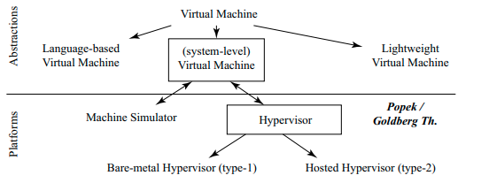
Figure 1 [ [2] Basic classification of virtual machines and the platforms that run them

Windows server 2019 was used and provides a simple and effective out-of-the-box experience (OOBE). Once the server or device is switched on for the first time you are prompted with a set of simple steps that will guide the system administrator through the process of configuring basic settings, such as network connections, and language selection. OOBE is designed to be user-friendly, even if the user does not have much technical knowledge.
Dynamic Host Configuration Protocol (DHCP), is a protocol used to assign IP addresses as well as other network information dynamically on a network. It is mostly used in local area networks (LANs), where a large number of computers or devices need to be connected to a network. However, DHCP can also be used in larger networks as it allows the network administrator to configure many devices a lot easier.
This enables a server that is on the network, which is called a DHCP server, to assign internet protocol (IP) addresses automatically to computers, laptops, and other devices to the network when they are connected. Once connected, the DHCP server allocates an IP address from a pool of addresses based on the type of network it is. As well as allocating IP addresses, DHCP can configure other services, such as Domain Name Servers (DNS), subnet masks and default gateways.

The service allows the network administrator a more streamlined and easier process of managing the addresses on the network, this alleviates the need to manually configure addresses on each device which would be very time-consuming. DHCP can lease IP addresses to devices, for a set period of time, if the device does not reconnect back to the network in that time then the IP address will be available to be allocated to another device that requests it. DHCP efficiently manages IP addresses by reassigning them to other devices as needed, this reduces the risk of network conflicts which can often cause issues in a network.
As it states on Microsoft [3] DHCP automatically provided an internet protocol as well as other related configuration information. Every device on a TCP/IP network must have a unique IP address in order to access the network. When DHCP is not enabled Ip addresses for new computers or computers that have moved from one subnet to another need to be configured manually. With DHCP enables, the entire process is automatic and is centrally managed.
As it explains on InfoSec Write-Ups [4] DNS is a naming convention that gives a simple way for users to communicate with devices connected to the internet, without having to remember IP addresses.

Active Directory (AD), is a service created and developed by Microsoft and is a part of their Server suite, the purpose is to manage and organize network resources. Allowing a location to store and managed user accounts, computers, printers and other network-attached devices. It is based on the lightweight directory access protocol which supports a range of authentication protocols, such as Secure Socket Layer (SSL), and transport layer security (TLS). AD has a hierarchical structure of trees, forests and domains, this allows for the management and organization of network resources across the entire network.
Please see figure 2 below, showing the features of active directory.
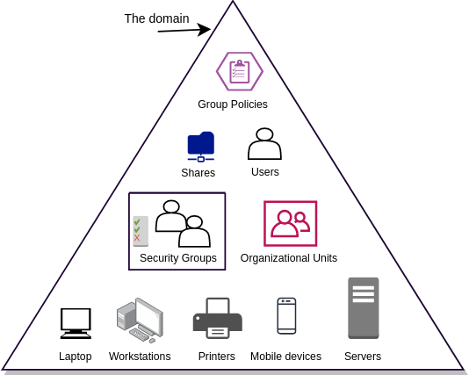
Figure 2 [8] Active Directory

Active directory has a lot of beneficial built-in features that make up active directory, such as domain, which is a logical grouping of network resources, such as computers, users, printers and other devices. It allows for centralised management of the network and provides authentication and authorization.
As [5] J. Arumugam and R. Balasubramani notes that, active directory is useful for organising network systems in a tiered structure for creating the foundation and storing information about objects such as users, computers printers and share folders. Active directory reduces cost on infrastructure and maintenance.
AD has forest, which is a collection of one or more domains, which share a common configuration and global catalogue. This allows the management of resources across multiple domains.
As is says from DNSstuff.com [6] inside the active directory structure, the AD forest can be considered as the most important logical container within the AD configuration. Simply because it houses all other users, domains, computers, group policies and any other network items of importance.
Organisation unit (OU) is a container object within a domain that allows for the management and organisation of the resources. This includes users, computers and groups. OUs allow a way to apply group policies to specific sets of resources.
Domain controller is a server that stores a copy of AD database which authenticates users and computers within the domain. It can also replicate changes to different domain controllers in the same domain.
As it says in the Windows Server 2019 administration fundamentals:
Active Directory is Microsoft's technology that represents a distributed database that stores objects in a hierarchical, structured, and secure format. AD's objects typically represent users, computers, peripheral devices, and network services. Each object is uniquely identified by its name and attributes. The domain, the forest, and the tree represent logical divisions of an AD infrastructure. An AD uses the following protocols and services:
- Lightweight Directory Access Protocol (LDAP) is used to access the directory
services data.
- Kerberos securely authenticates and proves the identity between users and
servers on the network.
- DNS is used to translate domain names into IP addresses.
An AD is managed through the following snap-ins in Microsoft Management Console
(MMC) (mmc.exe):
- Active Directory Administrative Center (dsac.exe), as shown in Figure 5.1, is
the one-stop place that is used to manage Windows Server's directory services.
- Active Directory Users and Computers (dsa.msc) is used to manage users,
computers, and relevant information.
- Active Directory Domains and Trusts (domain.msc) is used to manage
domains, trusts, and relevant information. [7]

In active directory, disaster recovery can be set up to ensure there is a backup of critical data, in the event of a system failure. It is best practice to ensure these backups are kept off-site to ensure business continuity. This can be setup to auto-complete at set intervals, for example at night when the system has minimum usage.
The use of ping is very effective while setting up and maintaining the network infrastructure, this is a useful tool for troubleshooting and whether a device has been set up correctly.
User and group management, Active directory servers are used to manage user accounts, groups and other AD objects. Network administrators need to ensure that policy and user group policies are applied across the entire directory service as well as access controls are properly configured to ensure the server is secure.

Conclusion

In conclusion, building and deploying this type of infrastructure is a complex task that required careful planning and implanting. Successfully implementing a network of this type would bring multiple benefits, such as scalability, security, manageability, and high performance.
In addition, deploying an active directory service will streamline network management, and improve security. It will accomplish this by creating an understanding of active directory network objects.
By implementing these tools and best practices, organisations can create a more secure and efficient network, which will support their expanding business needs.
The success of type 1 and type 2 hypervisor-based virtualised networks would be contingent on first identifying the needs, whether a type 1 or type 2 hypervisor is needed. Furthermore, the implementation would need to be effective while continually monitoring and maintaining the network infrastructure.

Reflection on collaborative work

To perform tasks 1 and 2, I worked as part of a team to build a virtual LAN using type 2 hypervisor management software as well as deploy a network directory service and create and understand active directory network objects. Throughout the tasks, the team worked closely together, sharing knowledge, experience and insights.
Looking back on the experience, the team noted that effective communication was key for the successful completion of the tasks.
It became apparent that the varied viewpoints in the cooperative procedure. By bringing individuals together with different skillsets, experiences, workstreams and methodologies the team was able to complete the task more effectively, leading to the completion.
Overall, the team worked well together, playing to each other’s strengths and weaknesses. Where needed able to fill the gaps of knowledge with the experience of others.

References

[1] | G. A. a. Z. L. E. Bauman, “A Survey on Hypervisor-Based Monitoring: Approaches,,” ACM computing surveys, vol. 48, pp. 12-13, 2016.
[2] | D. T. a. J. N. E. Bugnion, Hardware and Software Support for Virtualisation, Morgan & Claypool, 2017.
[3] | Mirosoft, “Dynamic Host Configuration Protocol (DHCP),” Microsoft, 29 July 2021. [Online]. Available: https://learn.microsoft.com/en-us/windows-server/networking/technologies/dhcp/dhcp-top. [Accessed 01 March 2023].
[4] | infosecwriteups, “DNS in Active Directory,” 3 July 2022. [Online]. Available: https://infosecwriteups.com/dns-in-active-directory-dcb93b10c3f3. [Accessed 02 March 2023].
[5] | J. A. a. R. Balasubramani, “Working Architecture of Active Directory Applications in Libraries,” Library Philosophy and Practice, pp. 1-7, 2019.
[6] | S. Contributor, “Active Directory Forest and Domain Guide + Best Tools,” DNS stuff, 16 December 2019. [Online]. Available: https://www.dnsstuff.com/active-directory-forest. [Accessed 01 March 2023].
[7] | B. Dauti, Windows Server 2019 Administration Fundamentals, 2019.
[8] | “Active Directory Fundamentals,” RootDSE, 13 June 2021. [Online]. Available: https://rootdse.org/posts/active-directory-basics-1/. [Accessed 01 03 2023].

