
Modern Business Intelligence Trends fOR RETAIL DECISION-MAKING



uNIVERSITY OF WALES TRINITY ST DAVIS
20 july 2024
Lecturer: Molly Jack
Student: Mihai Tilea (2124071)
Module: LCBB5000_LON
Contents
1. Introduction 3
2. BI Trends, Tools, and Applications, the Future for Business 3
2.1 Data Quality Management 4
2.2 Real-time Analytics 4
2.3 Predictive Analytics 4
2.4 Self-service BI Tools 4
2.5 Cloud-based BI Solutions 4
3. How BI Trends Can Help Make Timely and Effective Decisions 5
3.1 Data Quality Management 6
3.2 Real-time Analytics 6
3.3 Predictive Analytics 6
3.4 Self-service BI Tools 7
3.5 Cloud-based BI Solutions 7
4. Conclusion 8
References 9

1. Introduction
Business Intelligence (BI) transforms raw data into actionable insights, essential for modern retail businesses to stay competitive. BI tools and applications enable businesses to analyse data effectively, aiding in understanding customer preferences, optimizing supply chains, and improving operational efficiency (Wixom & Watson, 2010). The significance of BI in retail is underscored by its ability to facilitate informed decision-making, leading to enhanced customer satisfaction and increased profitability. The global BI market is projected to expand substantially, reflecting the increasing importance of data-driven decisions (Chen et al., 2012, p. 67).
This report critically evaluates why adopting modern BI trends, tools, and applications is crucial for the future of retail businesses. It will also justify how five specific BI trends can assist in making timely and effective decisions, supported by real-life examples and data.

2. BI Trends, Tools, and Applications, the Future for Business
Modern BI trends, tools, and applications are essential for businesses to stay competitive and relevant. The adoption of these technologies transforms how organizations handle data, making the decision-making process more efficient and accurate. Here, we will critically evaluate five key BI trends that are shaping the future of businesses, supported by real-life examples and data.

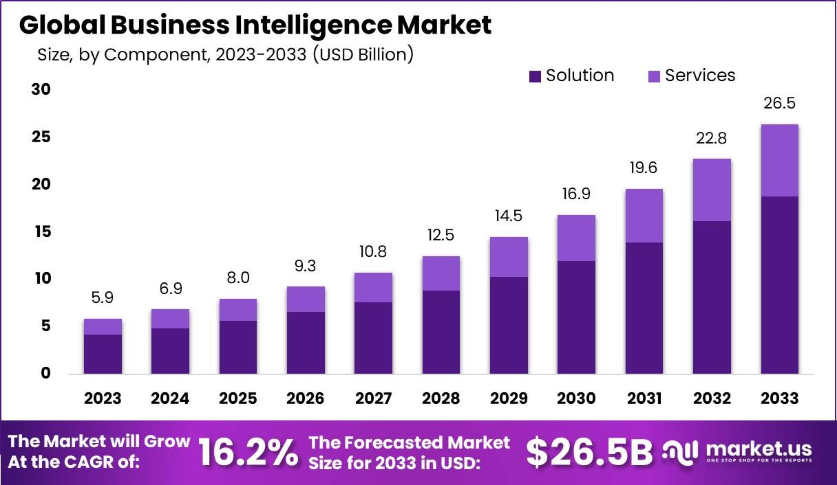

2.1 Data Quality Management
One of the major trends in BI is the focus on data quality management. High-quality data is crucial for accurate analysis and decision-making. Poor data quality can lead to incorrect insights and bad business decisions. For instance, Experian reported that 83% of businesses believe their revenue is affected by inaccurate or incomplete customer data (Experian, 2019). Implementing robust data quality management systems ensures that data is clean, consistent, and reliable, which is fundamental for effective BI.

2.2 Real-time Analytics
Real-time analytics allows businesses to process and analyse data as it is generated, which is vital for responding quickly to market changes and consumer behaviour. For example, Zara uses real-time analytics to manage its inventory and supply chain efficiently, enabling it to quickly restock popular items and reduce overstock (McAfee & Brynjolfsson, 2012). Real-time data processing helps businesses stay agile and make timely decisions that significantly impact their operations.

2.3 Predictive Analytics
Predictive analytics uses historical data, statistical algorithms, and machine learning techniques to predict future outcomes. This trend is particularly beneficial for retail businesses, as it helps forecast demand, manage inventory, and personalize marketing efforts. Target, for instance, uses predictive analytics to anticipate customer needs and personalize marketing campaigns, which has significantly increased its sales and customer loyalty (Davenport, 2014, p. 45). Predictive analytics provides businesses with a competitive advantage by enabling proactive decision-making.

2.4 Self-service BI Tools
Self-service BI tools empower non-technical users to access and analyse data without extensive IT support, allowing more employees to make data-driven decisions. For example, The Coca-Cola Company uses self-service BI tools to enable its marketing and sales teams to generate insights independently, which has streamlined operations and improved responsiveness to market trends (Deloitte, 2016). By making BI tools more accessible, businesses can foster a culture of data-driven decision-making across the organization.

2.5 Cloud-based BI Solutions
Cloud-based BI solutions offer scalability, flexibility, and cost-efficiency, making them attractive for businesses of all sizes. These solutions allow organizations to store and analyse large volumes of data without significant infrastructure investment. Netflix, for example, uses cloud-based BI to analyse viewer data, which helps in content recommendation and improving user experience (Amazon Web Services, 2020). Cloud BI solutions facilitate collaboration, as data and insights can be accessed from anywhere, promoting more informed and timely decision-making.

3. How BI Trends Can Help Make Timely and Effective Decisions
Business Intelligence (BI) trends play a critical role in enhancing decision-making processes in retail businesses. This chapter provides justifications for five specific BI trends and their positive and negative consequences in aiding business decision-makers to make timely and effective decisions.
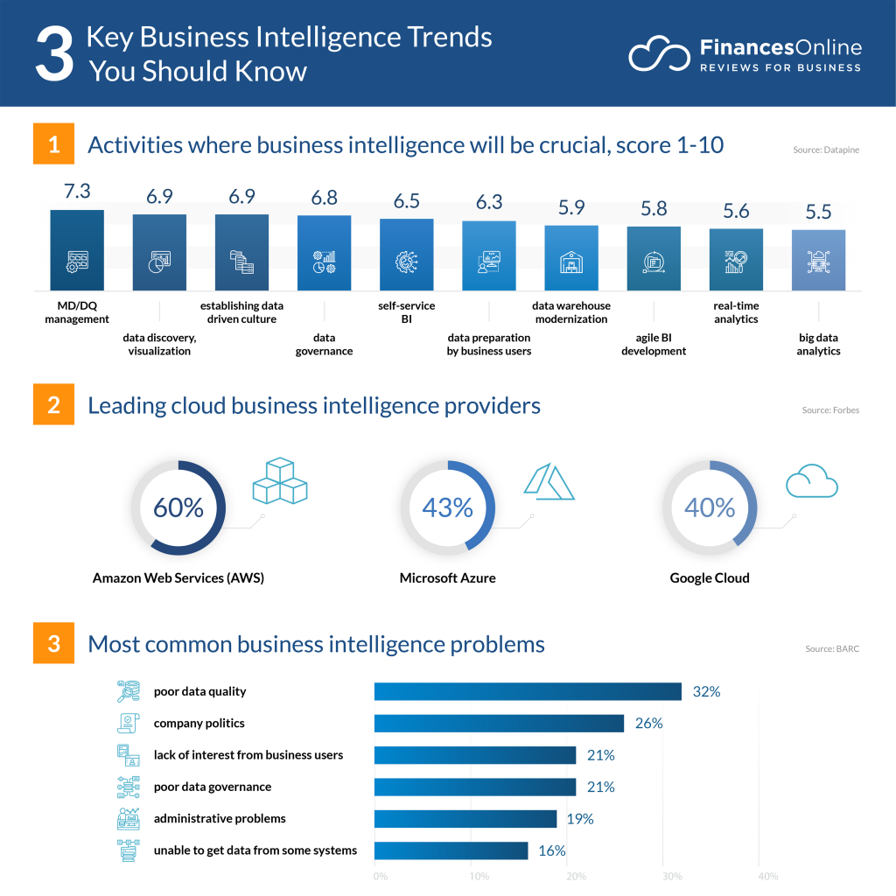

3.1 Data Quality Management
Data quality management ensures that the data used for decision-making is accurate, complete, and reliable. High-quality data leads to better analysis and more accurate insights, which are crucial for making informed decisions. For example, Procter & Gamble (P&G) implemented a robust data quality management system that significantly improved its decision-making capabilities across various departments, leading to better product development and marketing strategies (Redman, 2016).
Positive Consequences:
- Improved decision-making accuracy
- Enhanced operational efficiency
- Increased trust in data-driven insights
Negative Consequences:
- High initial implementation costs
- Continuous maintenance required to ensure data quality

3.2 Real-time Analytics
Real-time analytics allows businesses to analyse data as it is generated, providing immediate insights that can be acted upon quickly. For instance, Starbucks uses real-time analytics to personalize customer experiences through its mobile app, adjusting offers and recommendations based on current customer behaviour (Ransbotham et al., 2017).
Positive Consequences:
- Immediate response to market changes
- Enhanced customer engagement
- Improved inventory management
Negative Consequences:
- Requires significant investment in technology infrastructure
- Potential for data overload and analysis paralysis

3.3 Predictive Analytics
Predictive analytics uses historical data and machine learning algorithms to forecast future trends and behaviours. Walmart employs predictive analytics to optimize its supply chain, anticipating demand fluctuations and adjusting inventory levels accordingly (Hofmann & Rüsch, 2017).
Positive Consequences:
- Proactive decision-making
- Reduced inventory costs
- Enhanced customer satisfaction through better stock availability
Negative Consequences:
- Complexity in model development and maintenance
- Risk of relying too heavily on predictions without human oversight

3.4 Self-service BI Tools
Self-service BI tools enable non-technical users to access and analyse data independently, fostering a data-driven culture within the organization. For example, Cisco uses self-service BI tools to empower its employees, leading to more agile and informed decision-making processes (Richardson et al., 2017).
Positive Consequences:
- Increased data accessibility for all employees
- Faster decision-making processes
- Reduced burden on IT departments
Negative Consequences:
- Potential for misuse or misinterpretation of data
- Need for ongoing training and support for users

3.5 Cloud-based BI Solutions
Cloud-based BI solutions provide scalable and flexible platforms for data storage and analysis, making it easier for businesses to manage large volumes of data. For instance, Capital One utilizes cloud-based BI to analyse customer data and improve their financial services offerings (Gartner, 2020).
Positive Consequences:
- Cost-effective scalability
- Improved collaboration through accessible data
- Reduced need for on-premises infrastructure
Negative Consequences:
- Concerns over data security and privacy
- Dependence on internet connectivity for data access

4. Conclusion
The focus on data quality management ensures that businesses can rely on accurate, consistent, and complete data, which is foundational for making informed decisions. Real-time analytics enables businesses to respond promptly to market changes and customer behaviours, providing a competitive edge through agility and responsiveness. Predictive analytics allows businesses to anticipate future trends and make proactive decisions, enhancing efficiency and customer satisfaction.
Businesses must navigate the initial costs, ensure continuous data quality maintenance, manage the complexity of predictive models, and address concerns over data security and privacy in cloud environments. Despite these challenges, the benefits of adopting BI far outweigh the drawbacks, positioning businesses for sustained growth and competitive advantage.
In conclusion, the future of retail businesses is intrinsically linked to the effective adoption of modern BI trends, tools, and applications. By leveraging these technologies, businesses can enhance their decision-making capabilities, optimize operations, and ultimately achieve greater success in a dynamic market environment.

References
Amazon Web Services (2020) ‘Netflix uses AWS for nearly all its computing and storage needs’. Available at: https://aws.amazon.com/solutions/case-studies/netflix/ (Accessed: 16 July 2024).
Chen, H., Chiang, R.H. and Storey, V.C. (2012) ‘Business intelligence and analytics: From big data to big impact’, MIS Quarterly, 36(4), pp. 1165-1188.
Davenport, T.H. (2014) Big data at work: Dispelling the myths, uncovering the opportunities. Boston, MA: Harvard Business Review Press.
Deloitte (2016) ‘The Coca-Cola Company: Driving Marketing and Sales with Self-Service BI’. Available at: https://www2.deloitte.com/global/en/pages/consumer-business/articles/the-coca-cola-company.html (Accessed: 16 July 2024).
Experian (2019) ‘Data Quality Improvement: Key Findings and Best Practices’. Available at: https://www.experian.com/blogs/news/2019/02/data-quality-key-findings-and-best-practices/ (Accessed: 16 July 2024).
Gartner (2020) ‘Capital One transforms business intelligence with cloud solutions’. Available at: https://www.gartner.com/en/documents/3981275/capital-one-transforms-business-intelligence-with-cloud-solutions (Accessed: 15 July 2024).
Hofmann, E. and Rüsch, M. (2017) ‘Industry 4.0 and the current status as well as future prospects on logistics’, Computers in Industry, 89, pp. 23-34.
Maheshwari, A.K. (2015) Business intelligence and data mining. New York: Business Expert Press. Available at: [URL if applicable] (Accessed: [date]).
McAfee, A. and Brynjolfsson, E. (2012) ‘Big data: The management revolution’, Harvard Business Review, 90(10), pp. 60-68. Available at: https://hbr.org/2012/10/big-data-the-management-revolution (Accessed: 15 July 2024).
Ransbotham, S., Kiron, D. and Prentice, P.K. (2017) ‘Winning with data: How companies accelerate and outpace competition with analytics’, MIT Sloan Management Review, 58(2), pp. 23-30. Available at: https://sloanreview.mit.edu/article/winning-with-data/ (Accessed: 15 July 2024).
Redman, T.C. (2016) Data driven: Creating a data culture. Boston, MA: Harvard Business Review Press.
Richardson, S., Eid, T. and Thompson, J. (2017) ‘Cisco’s journey to self-service analytics’, Forrester Research. Available at: https://www.forrester.com/report/Ciscos-Journey-to-Self-Service-Analytics/RES136524 (Accessed: 16 July 2024).
Wixom, B.H. and Watson, H.J. (2010) ‘The BI-based organization’, International Journal of Business Intelligence Research, 1(1), pp. 13-28.

