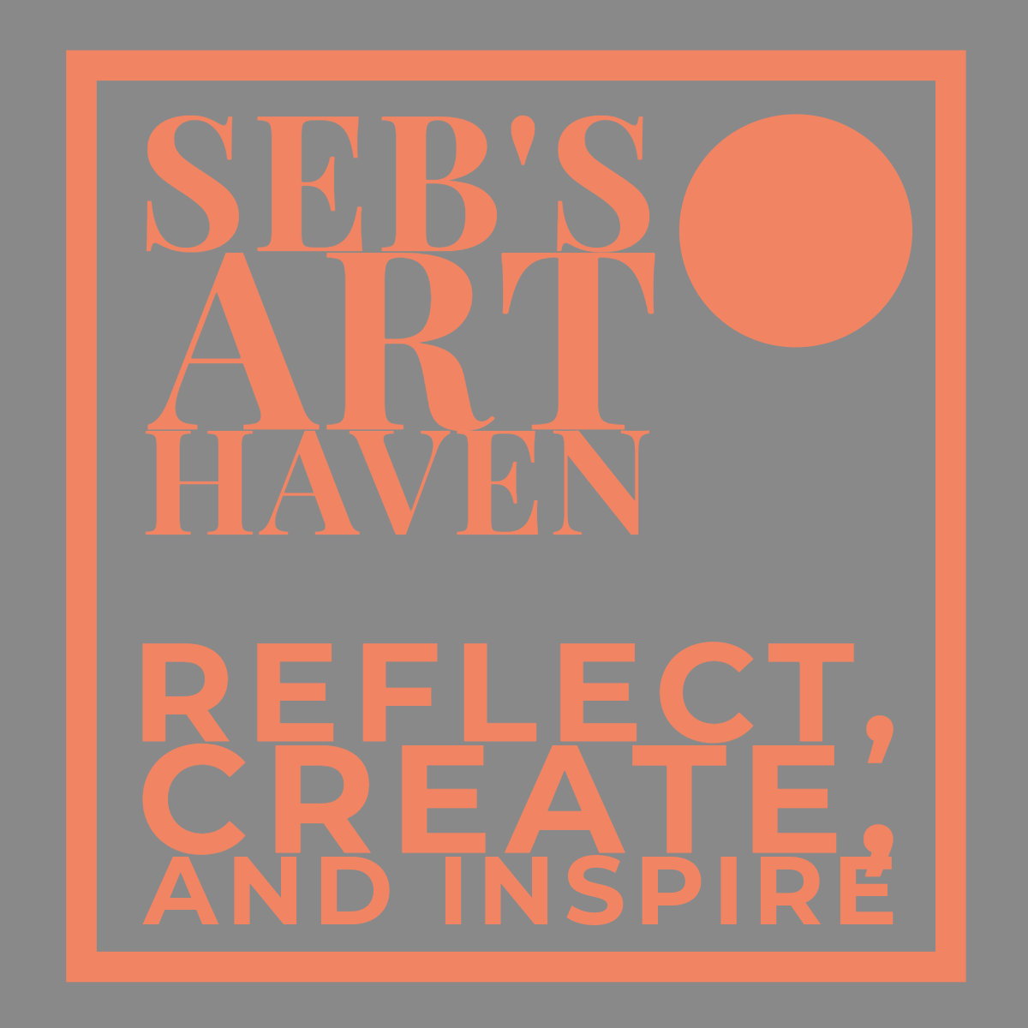  BUSINESS PLAN & REFLECTION | MODULE CODE: BMSW4011 LECTURER: MEL SQUIRE STUDENT: SEBASTIAN-LUCA KISS (2331017)

1. Business Name & Concept
Name: Seb’s Art Haven
Concept: Seb’s Art Haven is a unique and dynamic creative venue located in Cardiff. It operates as a coffee shop during the day and transitions into a bar and exhibition space in the evening. It hosts live music, art exhibitions, spoken word nights, and other cultural events that promote new and emerging talent.
The Story: This concept was inspired by a personal dream rooted in creative passion and a desire to foster artistic growth in the community. Despite Cardiff’s expanding art and music scene, affordable and inclusive venues remain scarce for lesser-known creatives (Visit Cardiff, 2023). This venture will fill that gap, giving creatives a platform while offering customers a culturally immersive experience through specialty drinks and artistic events.

2. Business Ownership
Structure: Private Limited Company (Ltd)
Rationale:
- Pros: Limited liability, credibility, tax efficiency, and easier access to funding (Jones & Taylor, 2020).
- Cons: Requires more administration, regular reporting, and compliance with stricter regulations (Burns, 2018).
This structure suits the business as it provides financial protection for the owner and allows for future investment opportunities (HMRC, 2023). It also helps create a trustworthy brand image from the outset.

3. Mission, Aims & USP
Mission Statement: To build a vibrant and inclusive cultural space in the heart of Cardiff, where the creative community can come together to express, engage, and grow.
Aims & Objectives:
- Establish a creative landmark in Cardiff within 12 months
- Host at least 12 exhibitions and 30+ live events in the first year
- Operate sustainably, using ethically sourced coffee and materials (Fairtrade UK, 2022)
- Reach financial break-even within 18–20 months
USP: The venue is not just a café or bar — it’s a living art space. Its flexible layout, rotating exhibitions, and event-driven focus make it more than a hospitality business; it becomes a cultural experience (Kotler & Keller, 2019).

4. Location & Rationale
Venue: 219–221 Newport Road, Cardiff (Rightmove, 2025)
- Annual Rent: £45,000
- Deposit Required: £11,250
- Rationale: Central location, near transport links and within walking distance of the city centre
- Property Attributes: Large windows, historic features, high ceilings — ideal for art display and sound acoustics
This location offers visibility, accessibility, and aesthetic value. Its proximity to student hubs, arts venues, and nightlife areas makes it well-positioned to attract both daytime and evening audiences (Cardiff Council, 2023).

5. Human Resources & Staffing Plan
Staffing Structure:
- 2 Baristas/Bartenders @ £24,000 each/year
- 1 Venue Manager @ £30,000/year
- 1 Marketing & Events Coordinator @ £28,000/year
- 2–3 Part-Time Event Staff @ £10/hr, 15 hrs/week
Total Annual Staffing Cost: ~£90,000 (ONS, 2023)
Staff will be recruited from local universities and creative circles (Cardiff University Careers, 2023). All team members will be cross-trained to ensure operational flexibility. The self-service model at the bar minimises overhead while maintaining efficiency and customer satisfaction.

6. Marketing & Promotion (7Ps)
- Product: Specialty coffee, craft cocktails, original artwork, curated music and performances
- Price: Moderate prices for coffee and drinks; ticketed events for evening shows
- Place: A visually striking and well-situated creative venue
- Promotion: Pre-launch teaser campaigns, artist collaborations, influencer partnerships
- People: Enthusiastic, trained staff passionate about art and community
- Process: Streamlined order-at-bar system; calendar-based event marketing
- Physical Evidence: Eye-catching interior, creative lighting, rotating exhibitions (Solomon et al., 2020)
Marketing Budget: £12,000 annually
- Grand opening: £3,500
- Digital ads & social media: £300/month
- Flyers, posters, and branded items: £2,000

7. Market Research
Primary Research:
A small survey conducted with 30 Cardiff locals showed that 70% would be interested in a venue combining art, live music, and casual drinks (YouGov, 2022). Many expressed frustration over the lack of accessible art spaces with a social atmosphere.
Secondary Research:
Mintel (2023) identified a gap in hybrid venues that combine hospitality with culture. As post-pandemic audiences increasingly seek experience-driven leisure, demand for multipurpose creative spaces is growing.
Application: Research validated the concept and influenced pricing strategy, venue size, and partnership ideas.

8. Financial Resources & Costs
Startup Costs (Leased Model):
- Lease deposit (3 months): £11,250
- Renovation & equipment: £30,000
- Initial stock (coffee, alcohol, supplies): £10,000
- Furniture & signage: £7,000
- Branding & marketing setup: £5,000
- Licenses, legal, insurance: £3,500
- Total: £66,750
Monthly Operating Costs:
- Rent: £3,750
- Staff: £7,500
- Utilities: £700
- Supplies/restocking: £1,200
- Marketing & PR: £1,000
- Total Monthly Cost: £14,150
Sources of Finance:
- £10,000 personal savings
- £25,000 startup loan
- £15,000 Creative Wales grant (Creative Wales, 2023)
- £20,000 from crowdfunding and community investors
Break-even forecast: Month 18–20 (SBA, 2023)

9. SWOT Analysis
Strengths |  | Weaknesses
Unique venue concept combining art and social space |  | No brand recognition at launch
Strong cultural interest in Cardiff |  | High initial cash outlay
Opportunities | Threats
Local artist partnerships, student collaborations | Economic uncertainty (OECD, 2023)
Growing demand for creative nightlife | Increasing rent or cost of supplies
Response Strategy: Mitigate risks by starting lean, focusing on low-cost marketing, and building loyal relationships with Cardiff’s artist communities.

References
- Burns, P. (2018) Entrepreneurship and Small Business. 5th edn. London: Palgrave Macmillan.
- HM Revenue & Customs (HMRC) (2023) Set up a private limited company. Available at: https://www.gov.uk/limited-company-formation
- Cardiff Council (2023) Business support and guidance. Available at: https://www.cardiff.gov.uk
- Creative Wales (2023) Funding and Support. Available at: https://www.creative.wales/funding-and-support
- Fairtrade Foundation (2022) Why Buy Fairtrade Coffee?. Available at: https://www.fairtrade.org.uk
- Office for National Statistics (ONS) (2023) Average UK Salaries 2023. Available at: https://www.ons.gov.uk
- Visit Cardiff (2023) Why Cardiff?. Available at: https://www.visitcardiff.com
- RICS (2022) Renovation Cost Guide. Available at: https://www.rics.org
- YouGov (2022) Coffee Shops & Creativity Survey. Available at: https://yougov.co.uk
- Mintel (2023) UK Bars & Pubs Report 2023. Summary: https://store.mintel.com
- OECD (2023) Impact of Economic Conditions on SMEs. Available at: https://www.oecd.org
- Porter, M.E. (2004) Competitive Advantage. New York: Free Press.
- Kotler, P. and Keller, K.L. (2019) Marketing Management. 15th edn. Pearson.
- Solomon, M. et al. (2020) Marketing: Real People, Real Choices. Pearson.
- SBA (2023) Break-Even and Startup Cost Guide. Available at: https://www.sba.gov

Reflection on the Experience of Creating a Business Plan
Intense, that is how I felt while trying to scrape everything together and create a solid business plan. This plan is not just an academic exercise but a reflection of a dream I had as an adolescent, full of creative and innovative ideas. Life often takes unexpected turns, forcing us to make decisions that may be inconvenient or even disheartening, but sometimes they are necessary. Nonetheless, working on this assignment rekindled my excitement and curiosity, even if it came with a touch of desperation due to the challenges I faced along the way.
Reflecting on the skills I acquired during this process, I realize that rather than learning entirely new skills, I was reminded of the ones I had developed over the years. Through volunteering at socio-cultural and art events, scouting, and working in care, I have built a foundation of essential abilities. These include being communicative, an active listener, confident, humble yet firm, a team worker, a leader, and a creative problem-solver. This course has tested these skills in an academic environment, allowing me to apply them in a structured and strategic way.
One of the key entrepreneurial traits I recognize in myself is resilience. Despite the setbacks and the overwhelming workload, I pushed through to complete this business plan. I have also shown adaptability, adjusting my approach based on research findings, financial constraints, and logistical considerations. Additionally, my problem-solving skills have come into play, as I have had to think critically about location, costs, staffing, and marketing strategies.
Another strong trait I possess is vision. This business idea is not just about making money, it’s about creating a space for artists, a community where creativity can thrive. Having a clear vision and a purpose-driven mindset is crucial for entrepreneurship. However, I recognize that while I have confidence, it is something that still needs strengthening. Confidence is a necessity, especially in business, where persuading investors, leading a team, and making bold decisions are everyday realities.
One area I need to develop further is my financial acumen. While I have a strong creative vision and leadership skills, I realized that understanding financial projections, investment strategies, and cost management is just as critical. To improve, I plan to take financial management courses and seek mentorship from experienced business professionals.
Overall, this business plan assignment has reinforced my belief that I have the necessary traits to be an entrepreneur, but there is always room for growth. With a strong drive, a creative vision, and a willingness to learn, I am confident that I can refine my skills and turn this idea into a reality.

