Motorcycle and Geometry Analysis and Dynamic Handling Investigation
Module: Motorcycle Engineering
Module Code: ACHA4003
Student Number: 1901571
Word Count: 1,587

This report will look at the Motorcycle and Geometry analysis of two motorcycles, the Honda CBR1000RR Fireblade and the Zero SR/F. This will be done through looking at the dimensions, geometry, maximum speed, chain size and the gear ratio of both bikes, as well as compare the geometry and the performance of both bikes. This report will later look at the two other motorcycles, in order to compare their performance and suitability.
1) Motorcycle Schematic Diagram for CBR1000RR and Zero SR/F Motorcycles.
The diagram below shows the Motorcycle Schematic Diagrams for CBR1000RR and the Zero SR/F as well as the centre of gravity for both.
Image 1 and 2: Schematic Diagrams for CBR1000RR, (Honda, 2006), (Honda, 2004)
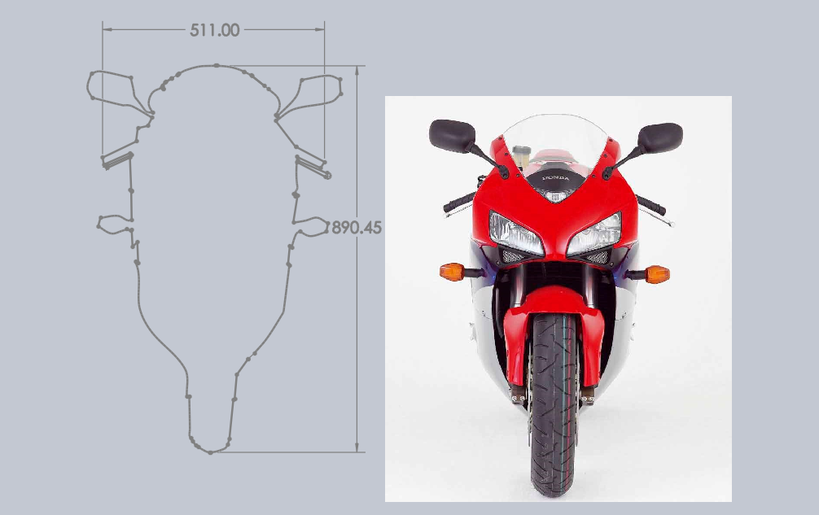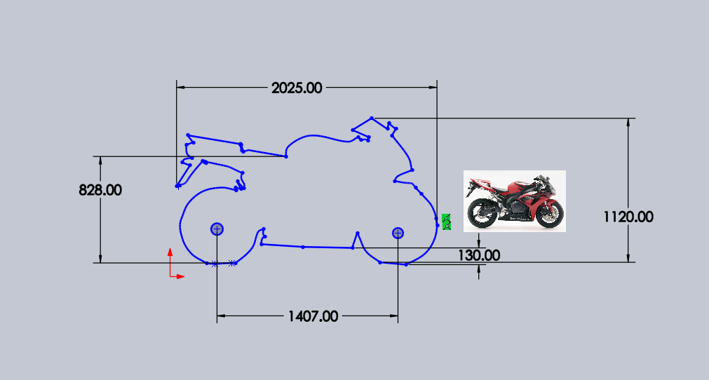

Image 3: Schematic Diagrams for Zero SR/F (Zero Motorcycles, 2021)
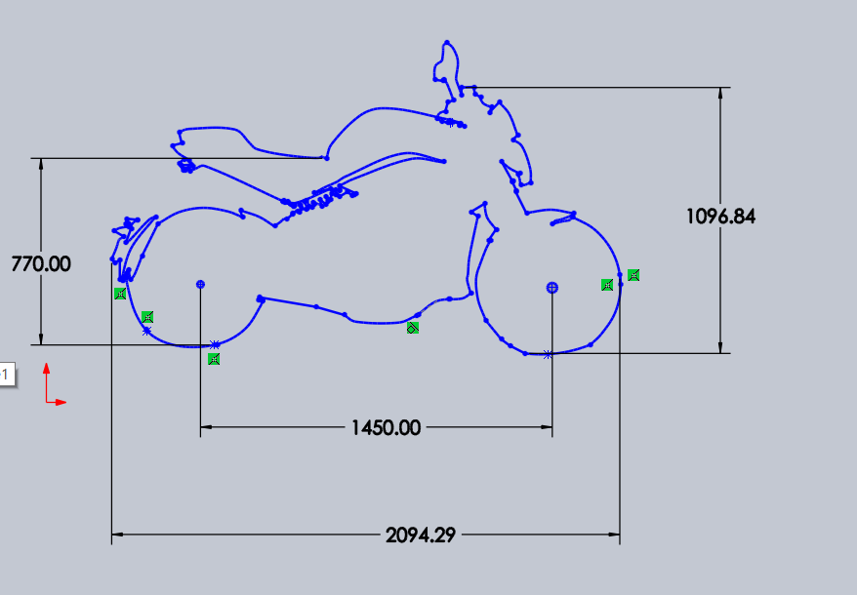

Table 1: Dimensions for CBR1000RR (Honda, 2006) and ZeroSR/F (Zero Motorcycles. 2021):
 | CBR1000RR Fireblade 2006 | Zero SR/F
Length | 2025mm | 2094mm
Height | 1120mm | 1096mm
Width | 720mm | N/A
Wheelbase | 1407mm | 1450mm
Ground Clearance | 130mm | 132mm
Seat Height | 828mm | 770mm (Low) 787mm (Standard)  810mm (Tall)
Rake Angle | 23.3º | 24.5º
Trail | 102 | 94mm

Image 3: Chain size of CBR1000RR (CaprinoMoto,2021)
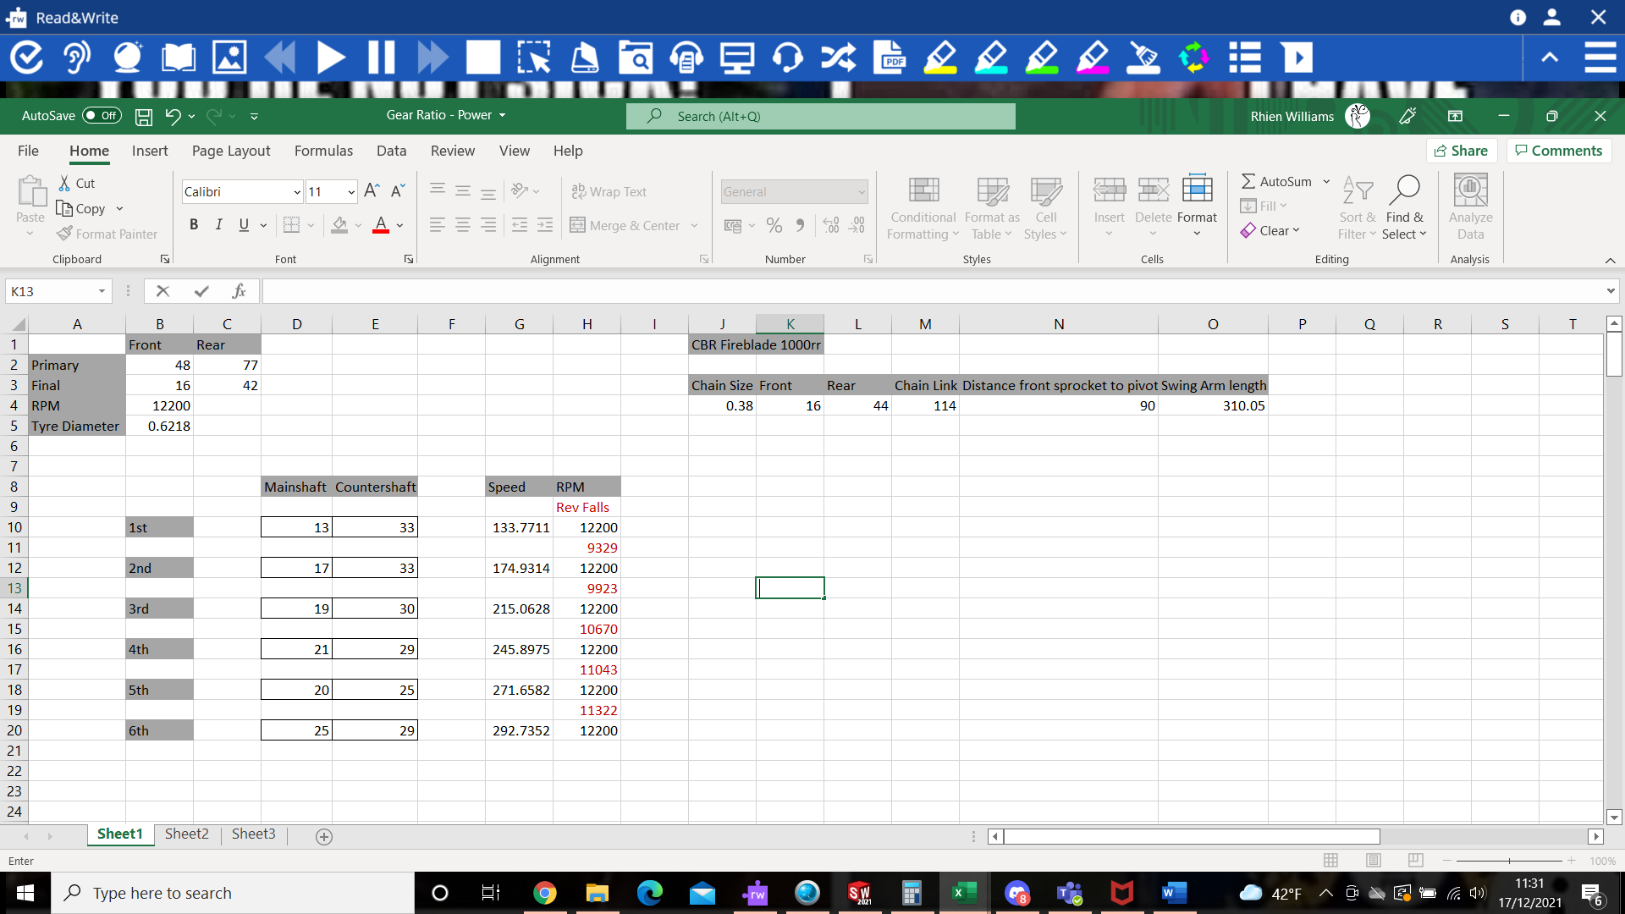
Image 4: Centre of Gravity for CBR1000RR (MotorcycleSpecs, 2019) and Zero SR/F (BikeZ, 2019)):
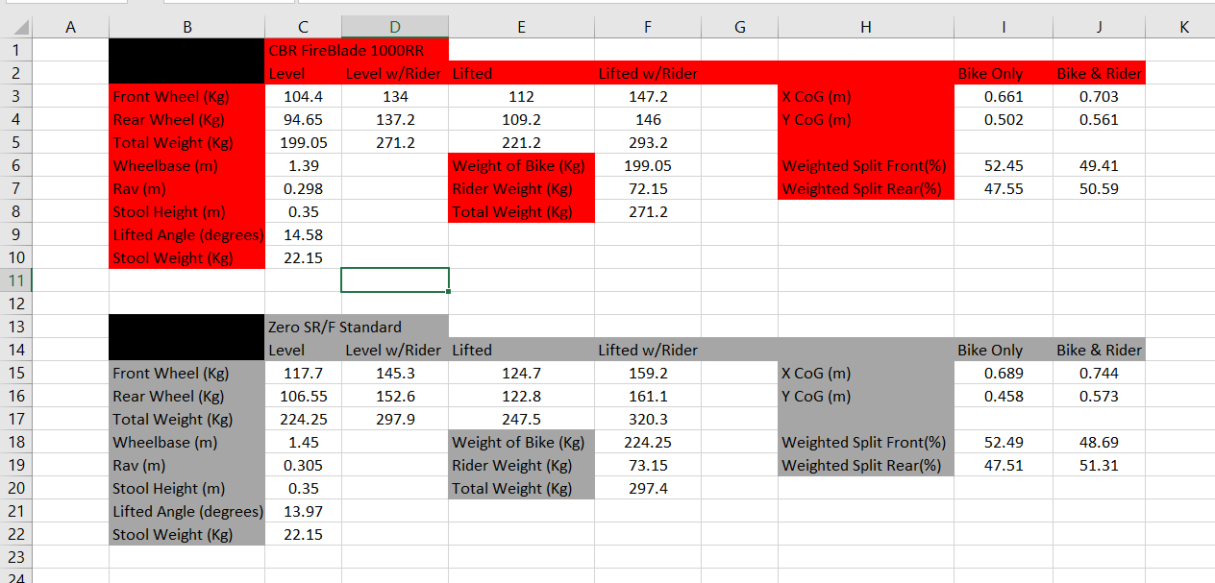
2) Gear Ratios and Maximum speed of CBR1000RR Fireblade.
This report will now show the gear ratios for the and the maximum speed for the CBR1000RR Fire blade.

Image 5: Gear Ratios and Maximum Speed for CBR1000RR (Honda, 2006):
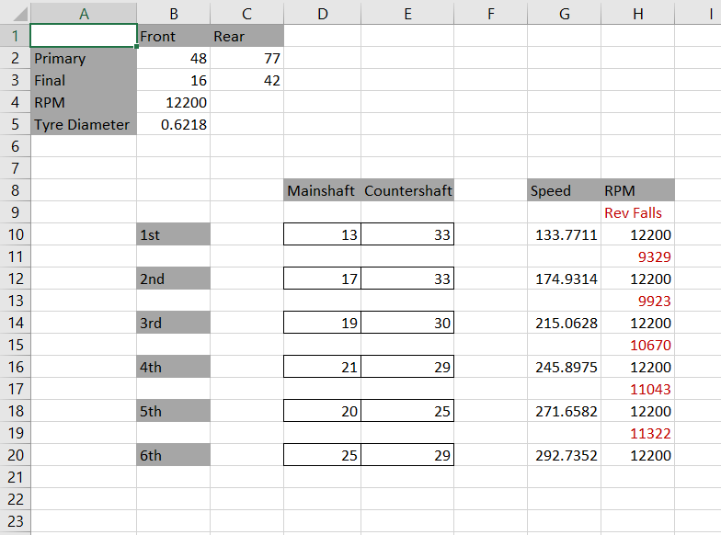
3) Handling characteristics of two machines previously analysed:
This section will focus on looking at the handling characteristics of the two motorcycles that have been previously looked at in order to compare and analyse the differences in their dynamic situations. The two motorcycles that will be looked at are the CBR1000RR Fire blade 2006 and the Zero SR/F.
Both of these bikes have different rake angles and the trails, with the CBR1000RR has a rake angle of 23.3º and a trail of 102mm whereas the Zero SR/F has a rake angle of 24.5º and a trail of 94mm. Both bikes have a same level chance of having the ability to steer easily and react quickly to change. With them both having either a higher rake angle or trail, which in turn could mean that they have the ability steer easily.
Thus, meaning that both bikes are more likely to move about a more, because of the differences in the weight distribution, and the affect that this has on the handling and the stability of the vehicle. For example, although the rake angle on the CBR1000RR is bigger, it is more likely to reach a faster speed. But as a result of the trail length, it means that the wheels are likely to be closer together, therefore creating a more unstable front end of the motorcycle. Thus meaning, that when the bike is moving, the front end is more likely to lift up, as there is a bigger weight distribution to the back of the vehicle compared to the front.
This would be more minimised on the Zero SR/F, as this motorcycle has a longer wheelbase, therefore meaning that it is more likely to stay flat on the surface as there is a more equal weight distribution across the whole of the bike, rather than it being concentrated to the front wheel. This is more clearly when looking at the example of chopper motorcycle bikes, as there have a large wheelbase, and thus meaning that it is more likely to stay on the ground with both wheels, however the long wheelbase makes it more notoriously difficult for it to turn.
When looking at the Zero SR/F, the trail is shorter, however the rake angle is larger therefore suggesting that there is a steering offset that allows for it to give it better handling around corners, as well as keeping the wheel base steadier on the rear line, thus giving it better handing and speed whilst going around corners. Therefore, helping to explain why the rake angle is higher on the CBR1000RR, but the Zero SR/F still has the smaller trail. Although, the zero has smaller trail, therefore it will be harder to handle on straights, it would be easier to turn corners. However, the longer wheel contradicts this situation, and thus somewhat overrides the advantages that had been given with higher rake angle. Therefore, suggesting that although it is a promising bike, there are number of issues that could be corrected in order for the bike to perform better under a set of certain characteristics.
Furthermore, the Zero SR/F is a commuting bike, whereas the CBR1000RR is sports bike, therefore the Zero SR/F does not need to have the ability to turn corners as quickly as the CBR1000RR does. The functionality of these bikes does though affect the frame size. For example, the CBR1000RR has a lower ground clearance, as this minimises the drag forces on the bike. Whereas the zero has a slightly higher ground clearance.
4) Geometry Data for 2 other modern motorcycles:
The two motorcycles have a variety of different functions, and thus exhibit different geometry dimensions, in order to suit the difference in its performance and ultimately what is needed to be achieved. The two motorcycles that will be studied are the MotoGP Monster Energy Yamaha R125 and the Motocross 2021 KX 450.
The design of these bikes is equally suited to the terrain that they ride but also the changes in the suspension and the performance of the bikes that are needed in order to the bike to succeed. The Rake Angle on the Yamaha 125 is 26º (Yamaha, 2019) whereas the rake angle on the Kawasaki 450 is that of 27.6º (Kawasaki, 2021). By the Motocross bike having a larger rake angle, this suggests that the bike has more stability, and therefore suggesting that weight of the rider lies at the back of the wheel, rather than focusing on the front of the wheel (Kawasaki, 2021). This is due to the difference in terrain, and the less contact to the ground for the motocross bike, which is needed less when compared to a road bike. The Yamaha MotoGP 125 has a lower rake angle, and thus the weight of the rider would be shifted more forward to the bike, which is a result of the need for the wheel to have more contact to the ground (Yamaha,2019).
With the KX450 having a bigger rake angle, the bike also has a longer trail, with it being 121.9mm (Kawasaki, 2021), thus meaning that it is more stable to off roading conditions, however it is not as suited to turning as well, or in sharp turning (Lai and Wan, 2003;46). This is compared to the Yamaha R125, which has a lower trail, thus meaning that although it is less stable in a straight line it is more suited to turning better and more easily.
The wheelbase of these bikes further helps to distinguish the differences in its performance, and the characteristics of the bike. For example, the Yamaha R125 has a wheelbase of 1325mm, thus meaning although it is easier to maneuverer on a road conditions at higher speeds, which includes when turning corners (BikesMedia, 2015). This is compared to the Kawasaki 450, which has a wheelbase of 1485.9mm, and thus meaning that although it is more stable compared to the MotoGP bike, and therefore better handling in a straight line although it is not as easy to maneuverer around corners as the Yamaha R125 (Kawasaki, 2021).
Finally, there is a variety of differences in the frame dimensions of the two bikes. The Yamaha R125 has an overall length of 1,990mm, an overall width of 755 mm, an Overall height 1,140 mm and a minimum ground clearance of 160mm (Yamaha,2019). Whereas the Kawasaki KX450 overall Length is 2184.mm, Overall Width of 820.42mm, Overall Height of 1264.92mm and a ground clearance of 340.36mm (Kawaski,2021). These differences in the frame dimensions can be attributed to numerous reasons. For instance, Motocross bikes need ground clearance to climb over the rough terrain, whereas with a road bike there is a less due to smooth tarmac. In comparison to road bikes which need a lower frame, in order to minimise instability when they reach top speeds whilst also being easier to manoeuvre in and out of corners quicker, this is not as required as much in motocross bikes, which although they are fast the need for top speeds is not as significant as the need for road bikes.
5) Recommendation to motorcycles that have been measured.
There are several ways in which the bikes have been measured could be improved. These include improving stability and speed, which would increase the performance and handlings of both vehicles. For example, by increasing the rake angle, and bring the trail out it would increase the stability and allow for the vehicles to perform better on straights (BikesMedia, 2015). However, this would ultimately hamper the speed of the vehicles and for its ability to turn smoothly around corners with minimal issues (BikesMedia, 2015).
For the CBR1000RR, there is the potential to move the offset close to the forks, which would of course mean the offset would be smaller, and reduce the trail (BikesMedia, 2015). Although, this will mean that it would not be as stable on the straights, but it would be far faster around the corners and perform better, by having good handling around corners.
There is also the ability to adjust the forks on both motorcycles, which have the ability to either make the bike more stable, by moving the axles back, or by making the biker have more responsive steering by moving the axles forward (Totalcontrol, 2020). However, it still important to consider moving around, and adjusting the geometry dimensions of the bike will affect and improve one area of the bike, but also affect another area of the bike and ultimately make it less effective.

Bibliography:
BikesMedia, ‘Significance Of Wheelbase In Motorcycling Explained’ (2015) URL: https://www.bikesmedia.in/reviews/significance-of-wheelbase-in-motorcycling-explained.html (Accessed 10th December 2021)
BikeZ ‘Zero SR-F 2019’ BikeZ (2020) URL: https://bikez.com/motorcycles/zero_sr-f_2019.php accessed 16th December 2021
CarprinoMoto ‘DID 530VX3 Chain & 16/44T Sprocket Kit Honda’ (2021) URL: https://www.carpimoto.it/en-BN/Bike_Honda_CBR-1000RR-04-05/Specific/Brand_DID/Drive-Transmission/Chain-Sprocket-Kit/7688_HO-0348--DID-530VX-Chain-16.htm (accessed 14th December 2021)
Honda, ‘Honda CBR1000RR 2004’ (2004) URL: https://www.carlsalter.com/mcpdf/Honda_CBR1000RR-2004.pdf (accessed 8th December 2021)
Honda ‘CBR1000RR – Specifications’ (2004) URL: https://hondanews.com/en-US/releases/cbr1000rr-specifications?l=en-US&mode=print (accessed 11h December)
Honda ‘2006 Honda CBR1000RR- Specifications’ (2005) URL: https://hondanews.com/en-US/powersports/releases/release-083d29efd84354eb903e05004c34c138-2006-honda-cbr1000rr-specifications (Accessed 8th December 2021)
Kawasaki ‘2021 KX 450 Model Specs’ (2021) URL: https://www.kawasaki.com/en-us/motorcycle/kx/full-size-mx/kx-450/2021-kx450 (Accessed 10th December 2021)
Laid, Hsien Chung, Liu, Jing-sin, Lee D.T and Wang, Li-Sheng ‘Design parameters study on the stability and perception of riding comfort of the electrical motorcycles under rider leaning’ Mechatronics (Volume 13, Issue 1) 2003
Motorcyclespecs ‘Honda CBR 1000RR Fireblade’ (2019) url: https://www.motorcyclespecs.co.za/model/Honda/honda_cbr1000rr_06.htm (accessed 11th December 2021)
OwnersManuals ‘2006 Honda CBR1000RR — Owner's Manual’ (2019) URL: https://ownersmanuals2.com/honda/cbr1000rr-2006-owners-manual-60919 (accessed 9th December 2021)
SuspensionSecrets ‘Motorcycle Front Geometry’ (2020) URL: https://suspensionsecrets.co.uk/motorcycle-front-geometry/ (accessed 12th December 2021)
Total Control Trainning ‘Improving Handling with Geometry’ (2020) URL: https://www.totalcontroltraining.net/blog/2020-01-03/improving-handling-with-geometry/5 (Accessed 10th December 2021)
Yamaha ‘R125 Monster Energy Yamaha MotoGP Edition’ URL: https://cdn2.yamaha-motor.eu/prod/product-assets/2019/YZF-R125SV/Factsheets/2019-YZF-R125SV_en.pdf (Accessed 10th December 2021)
Zero Motorcycles ‘Zero SR/F’ (2021) URL: https://www.zeromotorcycles.com/model/zero-srf (accessed 12th December 2021)

