6.0 Accommodation requirements

6.1 Space requirements - internal & external (car parking)

External works: -
As part of the external works, you have specified provisions to be made to create sculpture gardens during warmer seasons, in the proposed college square adjacent to the college as well as along the new riverside walk after its recent regeneration.
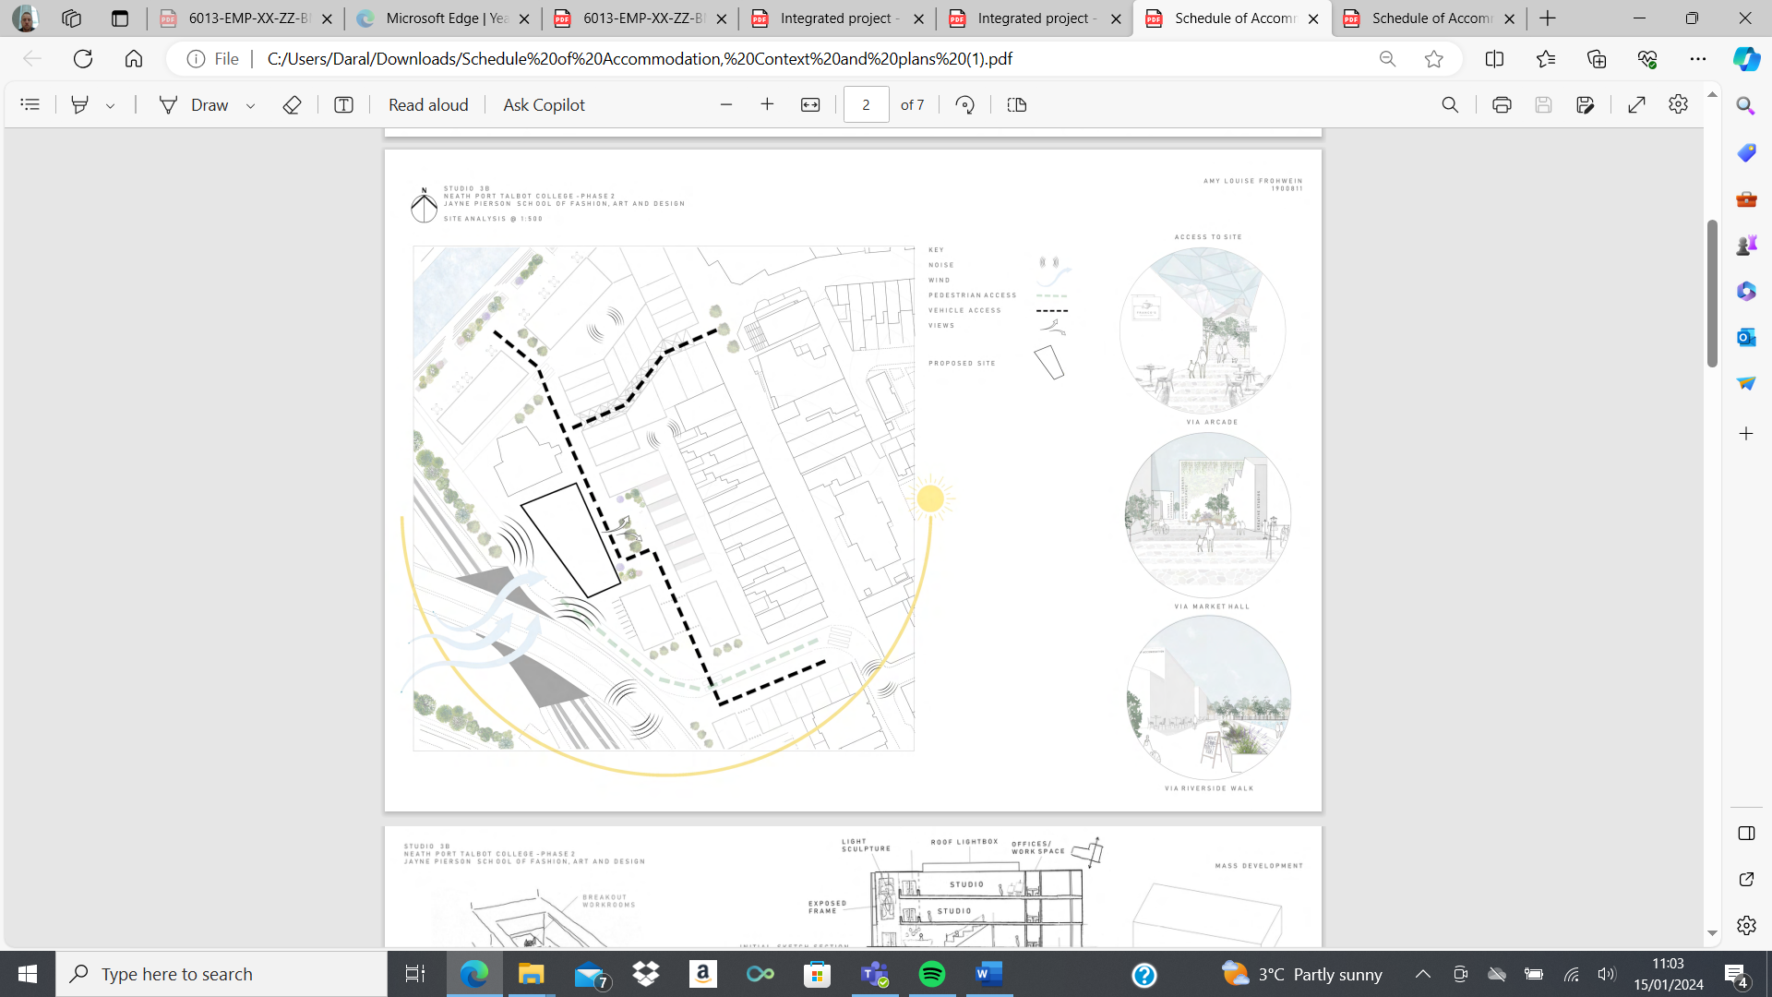
As part of our scope for the external works I have allowed a budget to cover works only to what you have stated in your brief. However, as there are other external works to be completed during the phasing of the project, I would suggest that you have one company that will lead the external works on completion of the building works as this could be more beneficial to yourselves regarding financial aspects and programming as these can both have major implications on a project if not co-ordinated correctly. Also due to the locality of our site and being Phase 2 of the project there is a high risk of us being delayed due to us not being able to carry out works when programmed or result in more charges to yourselves due to us having to extend our programme completion date.
The external facilities will be the final phase of the project therefore believe this would be the best option for the project.
The client has only given a general brief of the external facilities at this point, but I would presume that the area will be environmentally landscaped to incorporate a greater amount of sustainable and biodiverse methods which will come with a higher price.

Internal Facilities: -
Room |  |  | Area m2
Reception/forum 200m2
Exhibition space 200m2
Café (+ Kitchen) 80m2 (+20m2)
Toilets 80m2
Sculpture Studio 200m2
Metal Workshop 30m2
Wood Workshop 30m2
Cermaic Studio 150m2
Kiln Room 12m2
Textile Studios 500m2
Dying Lab 25m2
Lecture Hall 75m2
Meeting Room x2 20m2 x2
Private Studio 40m2
Photography Studio 150m2
Dark Room 12m2
Art Studio 200m2
Print Studio 200m2
Offices 25m2
Staff Room 12m2
Plant Room 20m2
Total Area 2441m2
Circulation 600m2
Total Area with Circulation 3041m2

Internal Facilities will require quite a large provisional sum due to the complexity of its layout and aesthetics. The layout and use of each room have entirely different requirements which will result in a higher end costing.

6.2 Comparison with similar schemes previously undertaken.

A similar scheme to the proposed is Ysgol Bae Baglan, below is an example of the use of a panelised system frame and glass which will give you an idea of how these materials are being used but incorporated will be the use of timber to its façade to create an environmentally, sustainable finish. Also, below is an example of a light sculpture which is to be situated in the main entrance.
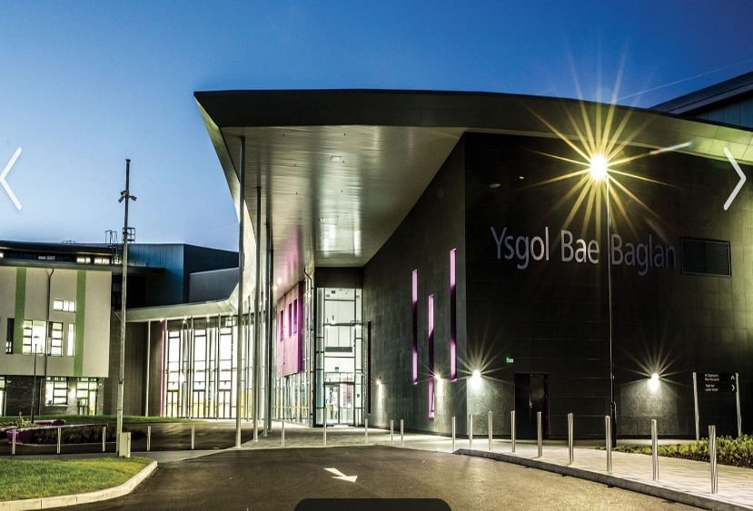
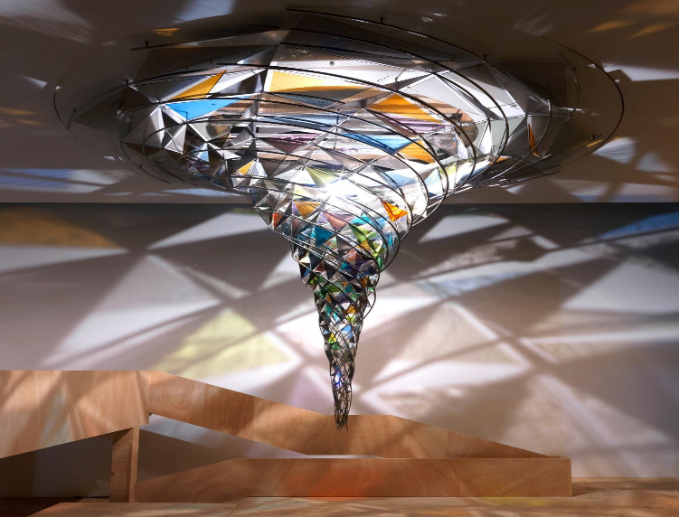

6.3 Services requirements.
The scheme has multiple rooms which have various technical equipment, both mechanical and Electrical. The need for soundproofing and light exposure is another important aspect of the project, again without any drawings and specifications at this point it is difficult to put a cost in for the materials and service requirements.

6.4 External works - infrastructure works, hard and soft landscaping
At present there are no reports on the land that have been carried out. The previous site was an industrial area so the need for intensive ground investigations will need to be carried out for us to ascertain the scope of works required for the substructure elements of the building.
All external facility works will be carried out to adjoin the existing highways with approval from the local council, as required by the S278 Works. All planning applications will be completed by us whilst adhering to The Highways Act 1980.

6.5 Equipment / fixed and loose furniture
All fixtures and fittings will be supplied by the contractor in line with the client’s brief. Full costings to be supplied when a full detailed design has been supplied.

6.6 Furnishings
All furnishings to be supplied by the contractor in line with the client’s brief. Full costings to be supplied when a full detailed design has been supplied.

6.7 Customer supplied equipment/ furniture.
At present we are not aware of any equipment/furniture being supplied by the client other than the possibility of existing art structures. This will need to be identified if we are to carry out any labour work for placement of structures for a rate to be applied for labour and time elements.

6.9 Access for disabled persons - ambulant/ wheelchair/ visually and hearing-impaired users/ elderly persons / young children
No additional services requested at this stage; design and costings will comply with Part M of the Building Regulations. The facility will be designed to accommodate disabled people as much as possible. All roads, pathways and pavements will be fully compliant to Part M to assist wheelchair users, visually impaired and those with hearing difficulties. The car park will include disabled car parking spaces with adequate surrounding space. Full detailed specification and design is required.

6.10 Security
Security facilities will need to be specified by the client as to what system and level of security is required. During the construction phase we will apply a figure for 24-hour on-site security.
6.11 Flexibility of use
Meeting rooms for rentable purposes to the public states that these are situated on the 1st and 2nd floor, however, on the drawing sketch these are positioned on the ground floor. This will need to be reviewed due to access issues and security purposes.
6.12 Phasing/decanting - temporary accommodation required?
There is a possibility that due to a large project that phasing and decanting will be required, unfortunately at this point in the project we are unable to comment and offer alternatives until we have a programme for the whole project.

Estimates- See Excel sheet

8.2 Works to be undertaken by contractor?
All works to be carried out by Alpha Design construction.
8.3 Maintenance costs
Maintenance fees to be applied following full detailed design. Assumption figure is 10% of the total price.
8.4 Whole Life Costs
Whole life costings to be applied following a full detail design, unable to provide an estimate at present.
8.5 Fees
All site investigation and surveys required shall be VAT inclusive.
8.6 VAT excluded
All VAT to be excluded from all estimates, but any items that require VAT will be charged at the standard rate of 20%.
8.7 Notes and exclusions:
At present the following applies:
- All included costs are subject to variation following design development.
- A risk allowance of 10% is included for this estimate.
- VAT is excluded from the estimate
- Local Authority Fees
- Building Regulation fees
- Party Wall Awards
- Acquisition & associated legal

