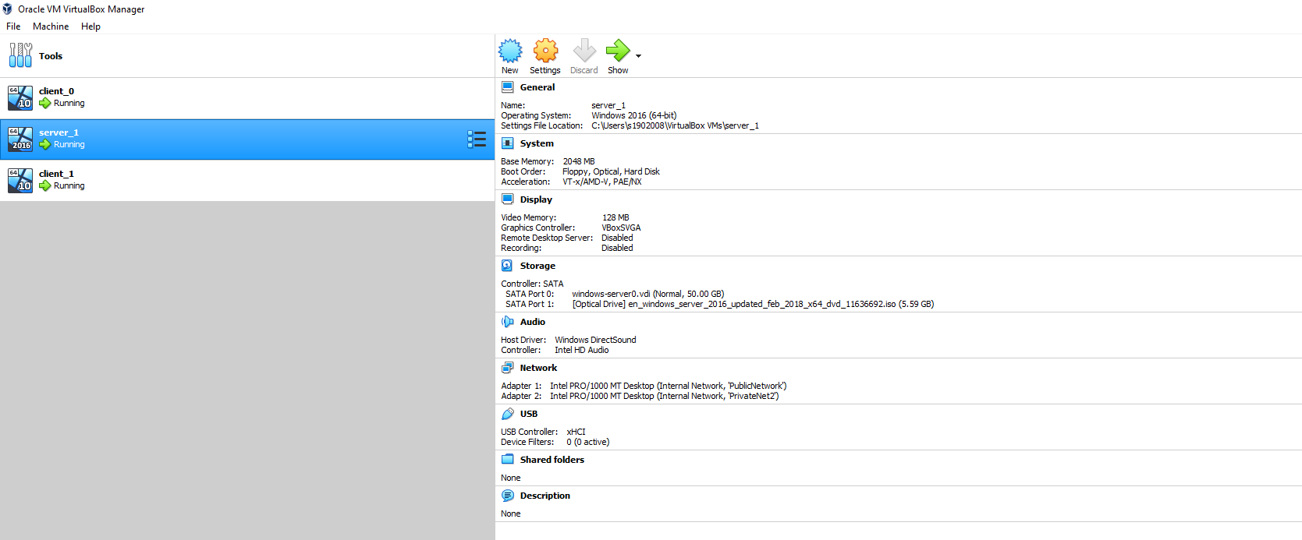
- Downloaded windows server 2016. Configured two adaption options to connect client PC’s.

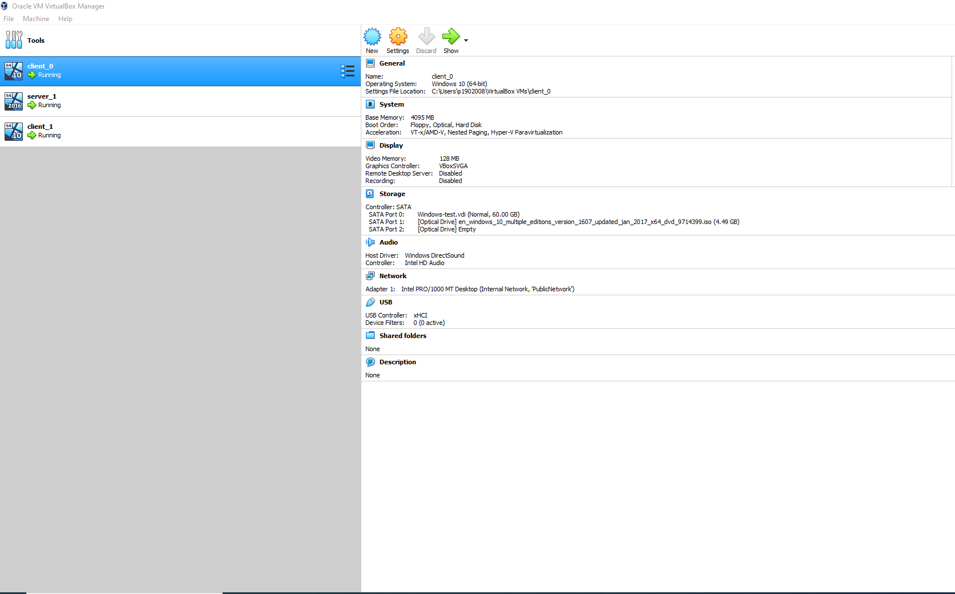
- Downloaded windows 10 on client_0 and client_1. Using the same adaptor of ‘publicNetwork’ to link to the server_1 on both machines, ensuring they are the same.

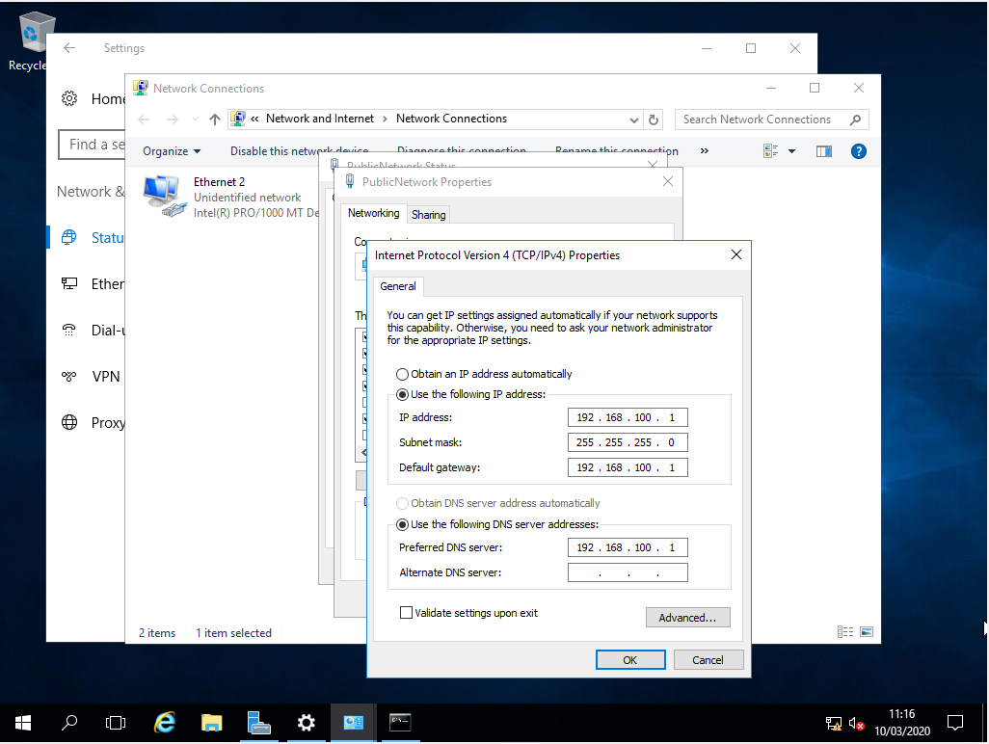
- Set ip4 protocols on server_0 within the ‘publicNetwork’ domain, set as the DNS gateway.
- Set the ip4 protocols for client_0 on the ‘publicNetwork’ connection. The DNS server is the ip address given for server_0 to ensure it connects to the same network.
- IP address: 192.168.100.3
- Subnet mask: 255.255.255.0
- Default gateway: 192.168.100.1

- Set the ip4 protocols for client_1. Following the same process as above, changing the IP address.
- IP address: 192.168.100.2
- Subnet mask: 255.255.255.0
- Default gateway: 192.168.100.1

- Check connection is live and sending packages between client_0 and server_0 by pinging the server IP address, 4 packages where sent and received with 0% lost meaning a successful connection was found.

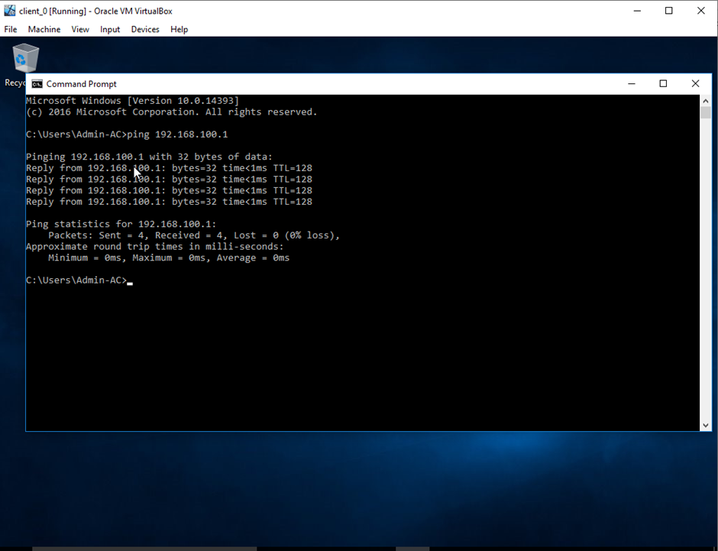

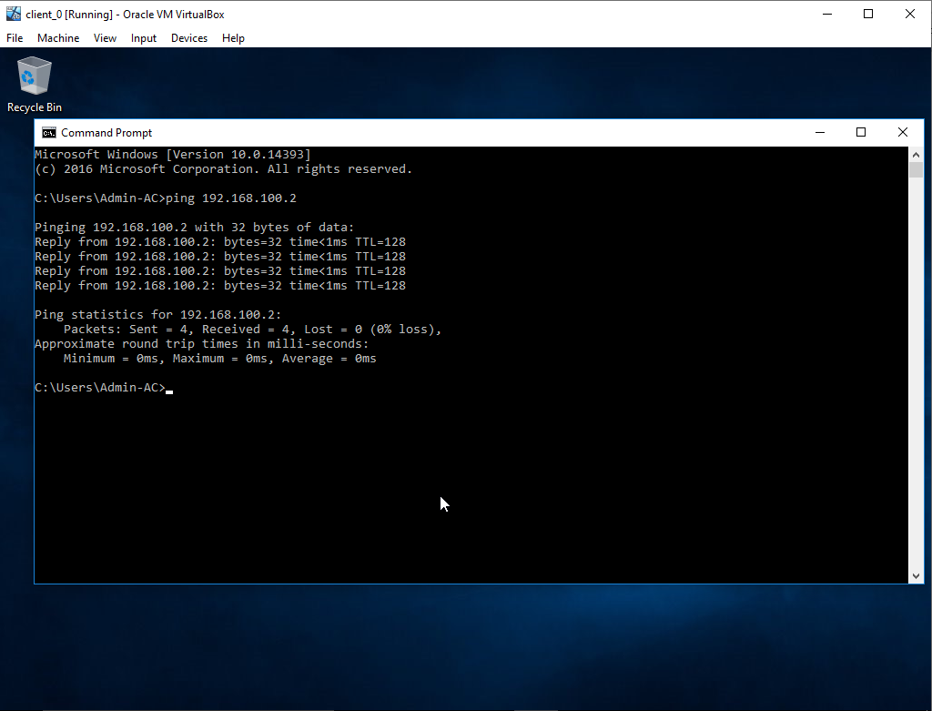
- Ping client_1 from client_0 checking the connection was successful between all devices connected to ‘publicNetwork’. The process and results where the same

- Following the same process as above I was able to check client_0 was also able to receive packages from client_1 and server_1. I am unable to provide screenshots of the result that occurred. If the connection was successful the output on the command prompt would be the same as the screenshot listed in step 7, the minor difference would be the IP address pinged.

- Once all devices where connected to the network, a domain controller was needed to create an Active Directory Domain. ‘DCPROMO’ no longer allows the admin to this via the command prompt in windows 16.
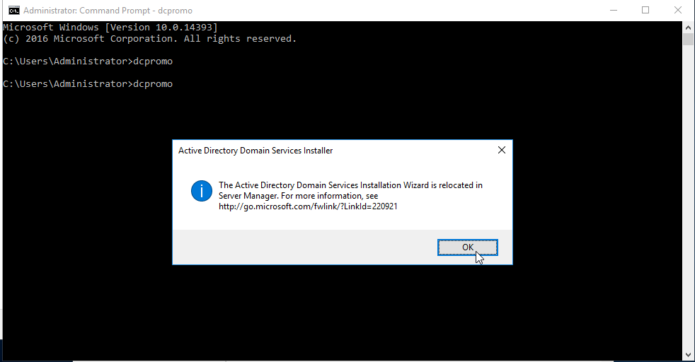

- As the prompt states, the set up for the domain controller is now located within the server management panel. First step was to add the role of a Domain controller to server_1.
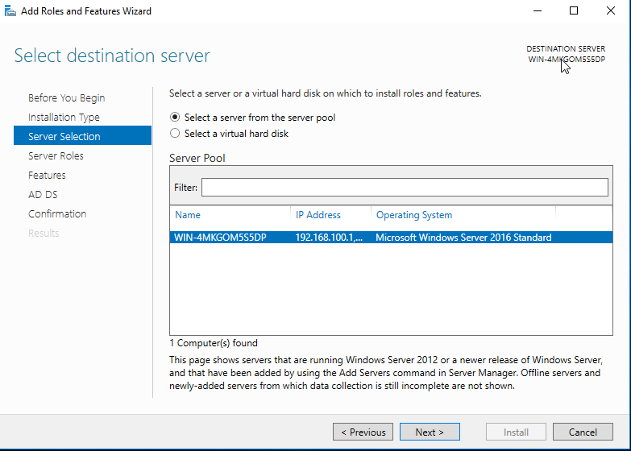

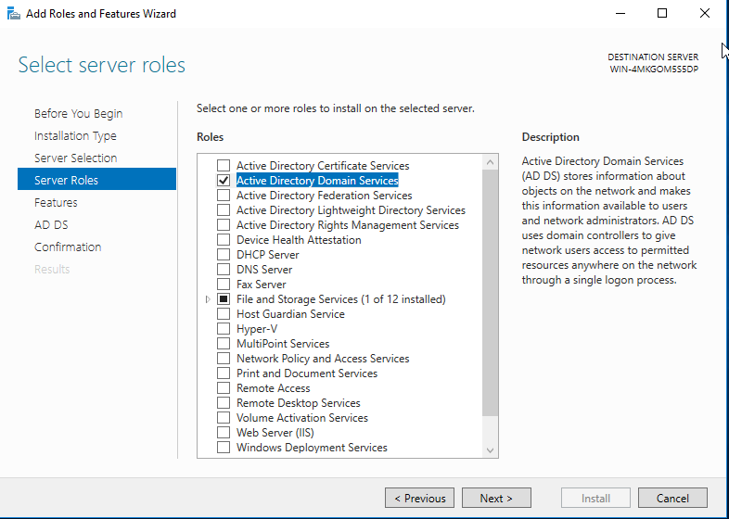
- Next I downloaded the ‘Active directory domain service’ this is needed to create a hierarchy model for the PC’s connected to the server and control the configuration of the clients.
- Once completed the setup, installation commenced. 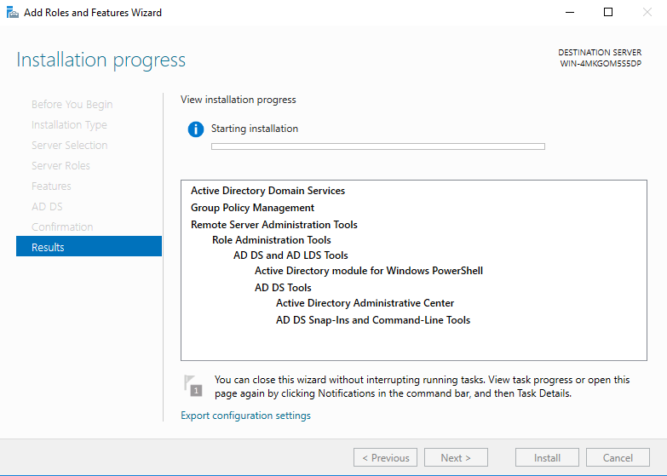
- Once the ‘active domain directory’ had finished installing, it needed configuring to create a domain in which server_1, is the controller, named uwtsd.com. 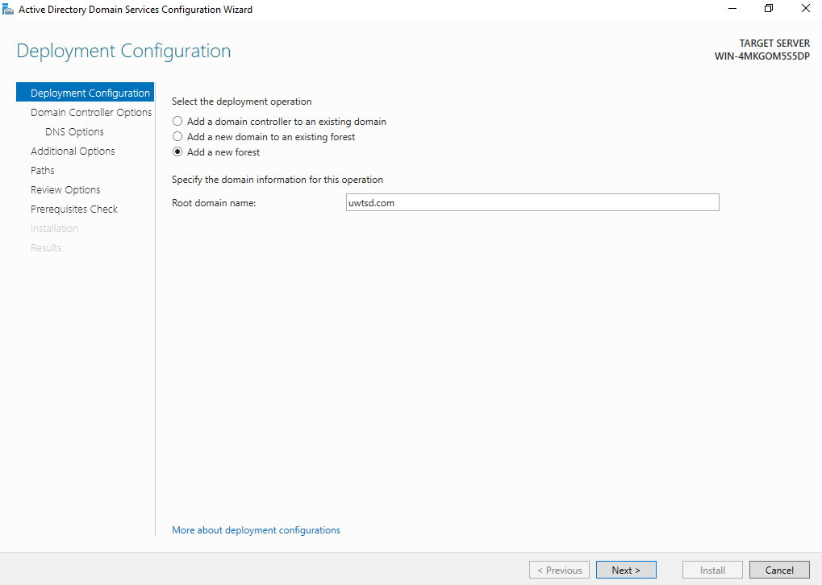
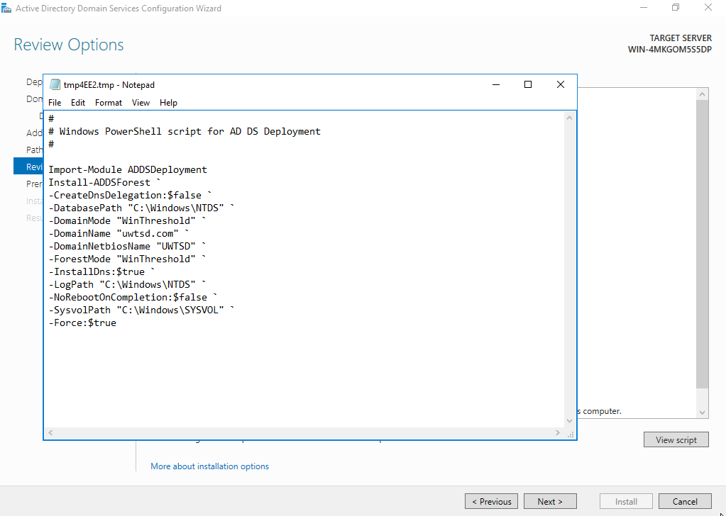
- Below is the screenshot of the forest configuration once setup was complete.
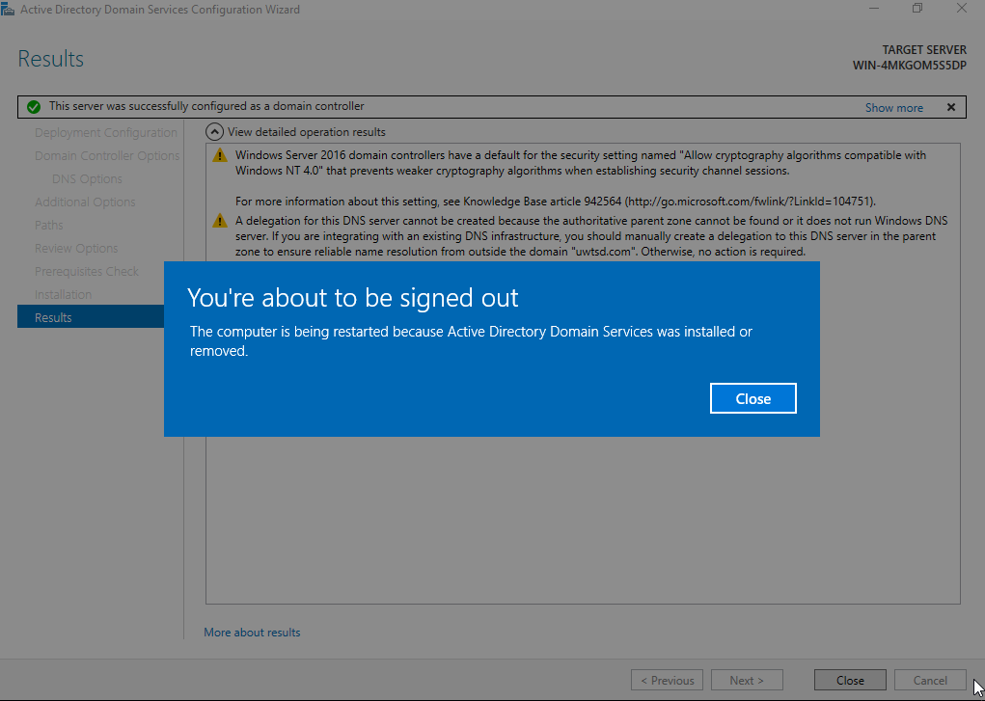
- Once the server was successfully configured as a domain controller and the forest domain was created, the server restarted to install the new configuration
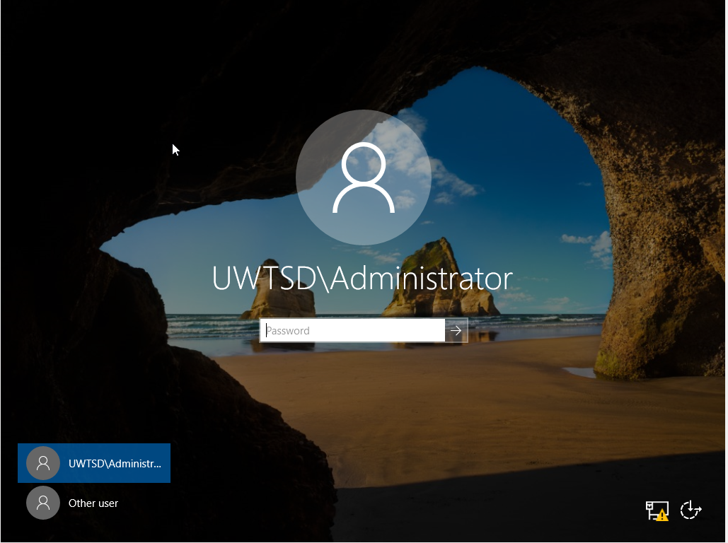
- Once the PC had restarted the login domain changed to UWTSD/admin. This means the configuration was successful and can now logon to the newly created domain as a administrator with the login credentials created when the server was first installed.

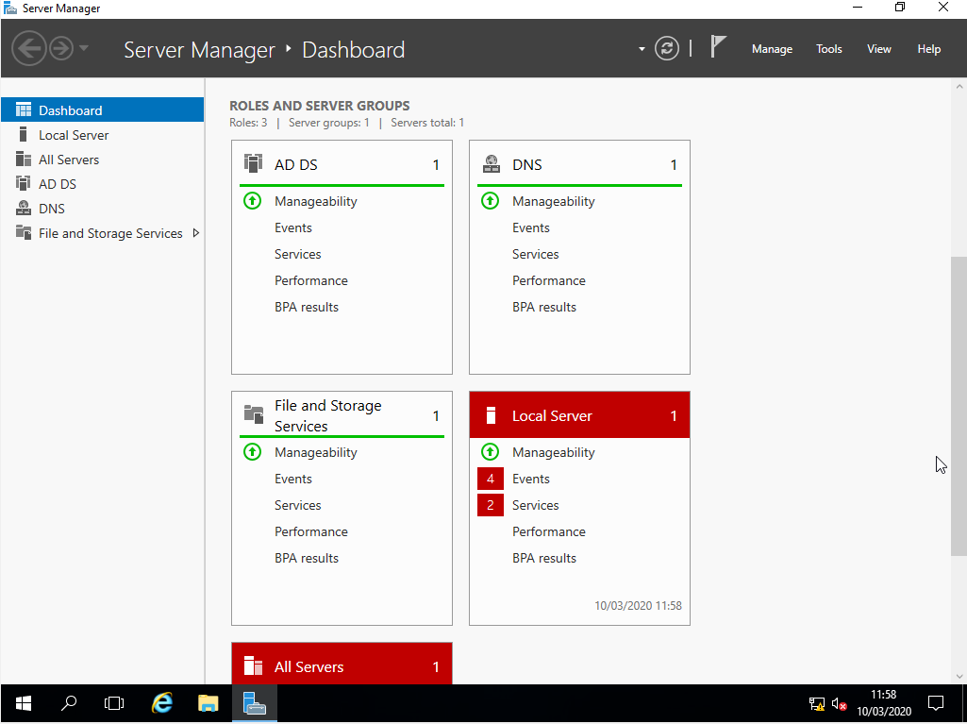
- Once logged on I checked the server configuration to validate the setup was successful. The server is now domain controller of 1 group ‘uwtsd’ and the DNS has successfully initialized.

- Next I added client_1 to the UWTSD domain, through the ‘active directory domain’ that was just installed.
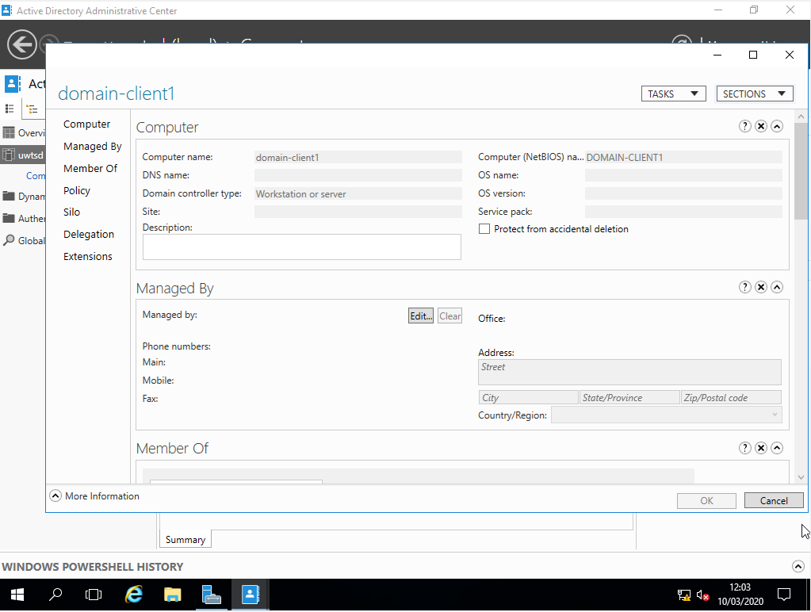

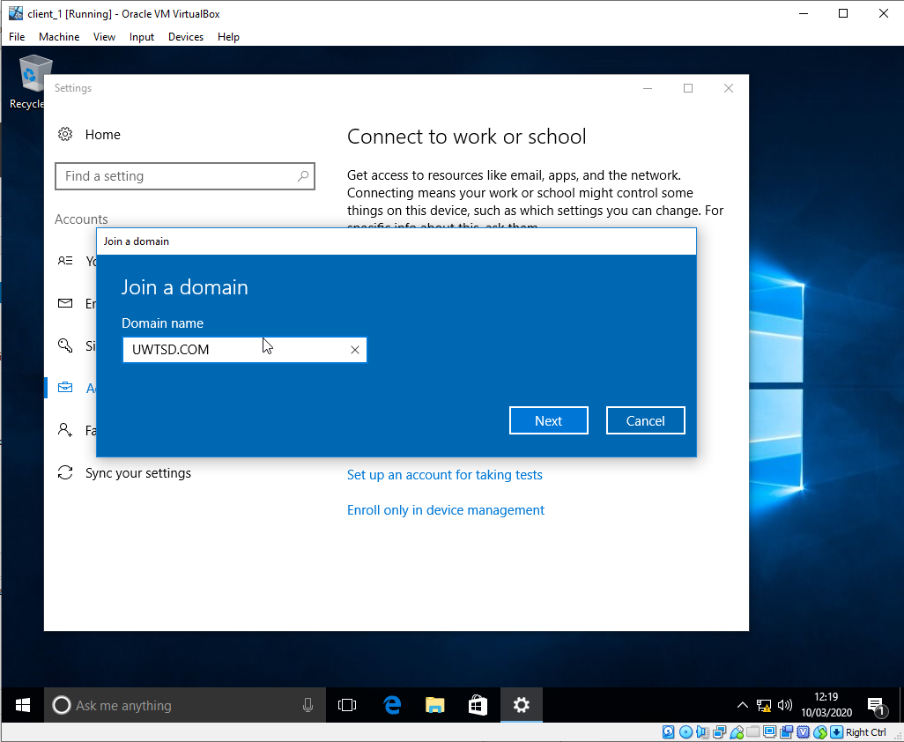
- Once the PC was added to the domain, client_1 needed to be connected to UWTSD.com, this was done via the settings on client_1. The domain was found.

- I was then prompted to set up the privileges and login details for the client_1 PC, I chose to have the account with administrator rights.
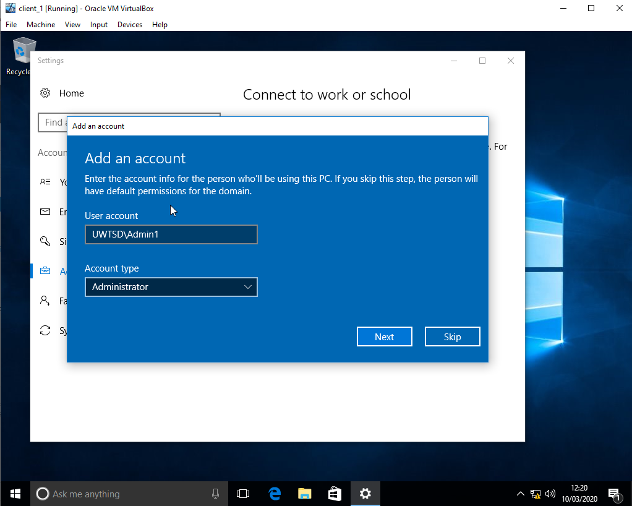

Observational Tasks
- Type 2 hypervisors are beneficial for software development and testing purposes, as well as small server deployment. there ability to duplicate and run off the existing operating system makes it easier to test results within different environments. The hypervisors sit’s on top of the operating system, making it slower and less secure as each VM will duplicate any security flaws that are within the baseline operating system. Oracle VirtualBox is open source and free meaning it is accessible and has a lot of support for all devices but can contain a lot of bugs. -make more succinct
- The active directory forest contains a collection of root domains, the root domains are the parent elements within the hierarchy. Each root domain has offspring or child elements. The parent and the child elements are the trees that are contained within the forest, these share a name space with each other but not with the forest . The forest is a secure area in which each root domain can harbour a trust relationship with other root domains within the network, meaning each tree can transfer files and information between them. There can be more then one forest within an active directory. These can also have trust privileges or can be set to private.
Active forest diagram
Trust relationship
FOREST
Tree
Tree
Root domain – Parent
Tree2.com
Subdomain – Child
Tree2.child2.com
Subdomain – Child
Tree2.child1.com
Root domain – Parent
Tree1.com
Subdomain – Child
Tree1.child1.com
Subdomain – Child
Tree1.child2.com

- There can only be one Primary domain controller within a domain. The domain controller is responsible for managing the authorization of users connected to the server. -reword
- If the primary domain controller is unavailable an administrator account can assign another machine within the domain to take over the responsibility of the PDC. – add more information

DHCP Part A – install server
The DHCP protocol is installed on the server machine within the domain in which it will be responsible for assigning dynamic IP addresses to the client machines. To configure this option within the TCP/IP protocol (internal networking software) We follow a similar process to that of the PDC. The ‘Select Network Connection Bindings screen’ is the section in which a static IP address must be given to the new DHCP server, this it what gives the DHCP server the scope of available IP address’s it can lease out to the client PC’s.
DHCP Part B – Lease IP address / DHCP scope
Once the DCHP Server has been configured, A scope needs to be created, the scope defines a valid range in which the IP addresses can be leased.
The subnet mask defines how many bits of the IP address are to be used within the IP address, 255.255.255.0 Means that the network prefix and subnet ID must be the same for each PC within the domain, this is equivalent of 24 bits.
For example, for this project the scope would start at 192.168.1.0.
192.168.1 is the subnet ID. Once the scope has been created client PC’s are able to request IP address for the server, before this can be tested, we need to ensure the client network options are configured to automatically retrieve IP address.
TALK ABOUT RESERVED IP ADDRESS
Part C – Testing lease
To test that all configuration has been successful we can use the command prompt to talk to the DCHP server.
Ipconfig/release – Sends a package to the DCHP server to clear the current IP address on the client PC, the package contains all current IP configuration on the client PC.
Ipconfig/renew – Sends a Discover message to the DCHP server, this alerts the DHCP that the client PC that sent the message is requesting to access the network and needs to be allocated an IP address. The DHCP sends an offer message which contains the IP address back to the client. The client can then accept the IP address and return an acceptance notice back to the DHCP server.
Ipconfig/all – Displays all network settings currently active on the machine. If the ‘renew’ was Successful, the IP address will be shown.
DHCP Part D – configure
Configuring the scope allows for the DHCP server to apply common setting to all of the client PC’s connected to the domain. In the scope configuration options, the server IP address will be configured as the default gateway. For example, the IP address of server_1 will be the default gateway of 192.168.100.1. The default gateway is used as the IP router in which all client PC’s will use when sending packages across the network and outside of the network.
Once the DHCP scope has been configured, we can test if the configuration was successful by repeating Part C.
Enabling the Routing and Remote Access Service on a Server
The RRAS can be used to implement many different features on the DHCP server. These include options such as allowing employees to work from home by connecting to the company network, e.g. remote working. Site-to-site connectivity, allowing for PC’s to connect to other offices within the same network.
It can also be used for setting up a LAN connection (Local area network). This will provide shared access across the network to certain files and settings that have been configured. A LAN connection can span from a few PC’s to other buildings within the area.

Add Routing Protocols on the Server and Add Two Routing Interfaces to the Routing Protocol on the Server

A routing protocol connects PC nodes to other nodes across various networks. Allowing them to communicate and send packages to one another. By adding the routing protocols to our server, this enables us to create a subnet ‘privateNet1’ as seen in screenshot 1, we can then ping the server on privateNet1 from publicNetwork, allowing shared access across numerous networks that are all connected by the LAN that we configured when enabling the RRAS.

