Internet Technology and Security

Synthesize a solution to a potential real-world scenario

ACCA4018

Harry Byrne

P133366

CONTENTS

Abstract 2

Introduction 3

Problem Formulation and Implementation 4

References 9

ABSTRACT

The ability to build a working BYOD network with as few security issues depend upon setting up the network with a qualified network engineer who not only physically makes access to the network as difficult as possible, but also puts in as many safeguards regarding turning off unused ports, password protection for not only staff and visitors on a lower level. Higher level access should only be granted to network administrators with password locked switches, routers, modems and obviously servers.
With the abundance of MDM software designed specifically to not only restrict access over the network and VPN it would be highly advisable to upgrade the system as soon as possible to cover lost technology, remote data wiping while also making multiplatform access and auto software updates easier for any network administrator.

INTRODUCTION
Scenario:
Hyper-fort is a consultancy company specializing in the energy sector. Hyper-fort has extensive presence around the globe. The company uses cloud services to deliver IT services to its staff and clients. It is estimated that almost 95% of the company's network is wireless based. The company also has a massive online presence and social media presence to promote its activities.

Because of its large staff and customer base, the company has recently come under immense pressure to allow both its staff and customers to use their personal devices to access the company's network/resources. Security of personal staff's data and client's data is the company's major concern. The company is also concerned about protecting its intellectual properties, which is worth billions.

You are an IT Security Consultant hired by Hyper-fort to recommend guidelines on a comprehensive security policy that covers all aspects of its enterprise network, including online and offline resources

- What type of data is retained by the mobile devices connecting to Hyper-fort network?
- What is the potential for data leakage when the participating devices leaves the office environment?
- How to address the blending of personal and business usage when devices are in office.
- What strategy to deploy to deal with different brands of devices.
- What strategy to deploy to deal with different Operating System platforms.
- What strategy to deploy to deal with different application on user devices.
- What mitigating strategy will be deployed when the owner of a participating device leaves their employment or the device is lost, stolen, or fails.

Problem Formulation and implementation

Hyper-Fort are joining an increasing number of companies to join the BYOD concept of IT within business. To make an effective network, it is assumed that a proficient network engineer has installed the servers, intranet, extranet as well as a cloud based VPN with a firewall system. BYOD is a trend that organizations are being forced to contend with. With consumer penetration of smart devices (i.e. smartphones, tab devices, etc.) reaching critical mass, organizations are having to find ways to address the use
of these personal devices in the workplace.[1]
The Intranet is the system based within Hyper-Fort for the staff to access the company’s network while the Extranet would be a means for customers and possibly suppliers to access aspects of Hyper-Forts network. The VPN would be used as a means for remote access from outside of Hyper-fort to access the network.
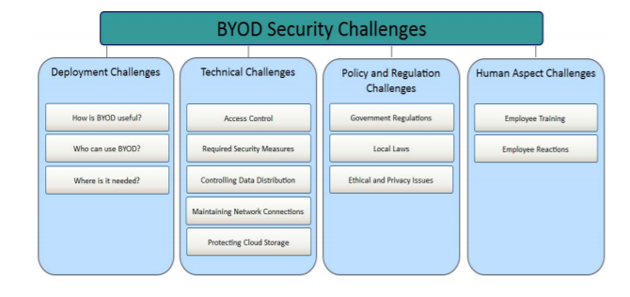[2]

If a remote user is accessing the VPN, how do we stop them downloading sensitive data?
Intranet for staff, Extranet for customers/clients
The three predominant protocols deemed apt for Hyper-Fort BYOD are an employee code of conduct, management rules followed by security systems within the network.

EMPLOYEE CODE OF CONDUCT AND MANAGEMENT RULES
This would set up a legal agreement between the employee and Hyper-Fort to ensure the legality of the usage of the network within the laws of the U.K. It also must contain:
- Training and guidance regarding the safe use and storage of passwords.
- To constantly update software on their devices when prompted to plug known operating system security flaws.
- All devices have ‘find my device' software, along with remote VPN wiping software.
- Antivirus and malware software should also be installed on all BOYD hardware for staff.
- If member of staff is sacked, how do you remove their data and access? There is a method of remote wiping over a VPN if a member of staff is fired or a piece of mobile technology is stolen. Remote wiping is the final reactive solution that is triggered when a device is lost, stolen or the owner separates from the company. The technique involves logging into, then removing all company applications and data residing on the device[2].

SECURITY SYSTEMS WITHIN THE NETWORK
It is assumed the network has been installed by a proficient network engineer. It is often assumed that network security is only based upon a software basis, but often physical means are needed too, such as having no empty uncovered active ports on routers or switches, and as seen below in my simulation there is an RFID reader access to the server room.
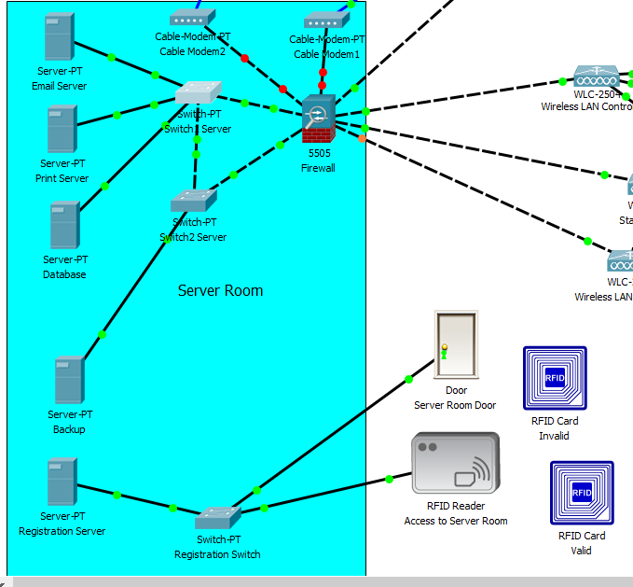

The first process completed after the virtual building of the network was to add passwords to the staff and visitors wireless access points. This was done via the settings on the config menu under Port 1. WPW-PSK short for Wi-Fi Protected Access Pre-Shared Key) had to be enabled. To encrypt a network with WPA2-PSK instead of providing the router with an encryption key, a plain-English passphrase between 8 and 63 characters long is used. Using a technology called TKIP (for Temporal Key Integrity Protocol) which scrambles the keys using a hashing algorithm.

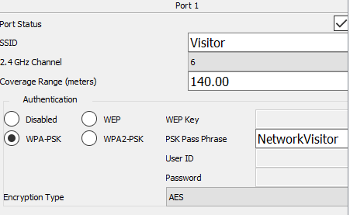

A simple flow chart to show the password access to the network is shown below.
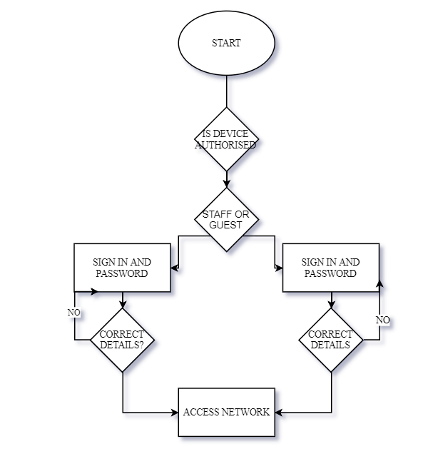

The main barrier to unwanted network access is to password protect all switches, modems and routers. This is done on the simulation by accessing the local console screen on each switch and modem and following the code below.
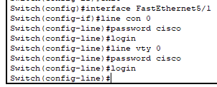
Unfortunately, the firewall was locked in the simulation as that is covered in further levels of study so the simulation is not working as it should.

A major point for a BYOD system would be deciding on what MDM (mobile device management software) to choose. MDM’s are often used in conjunction with a tool such as a MAM (mobile application management). The archicture of a typical MDM are as follows.
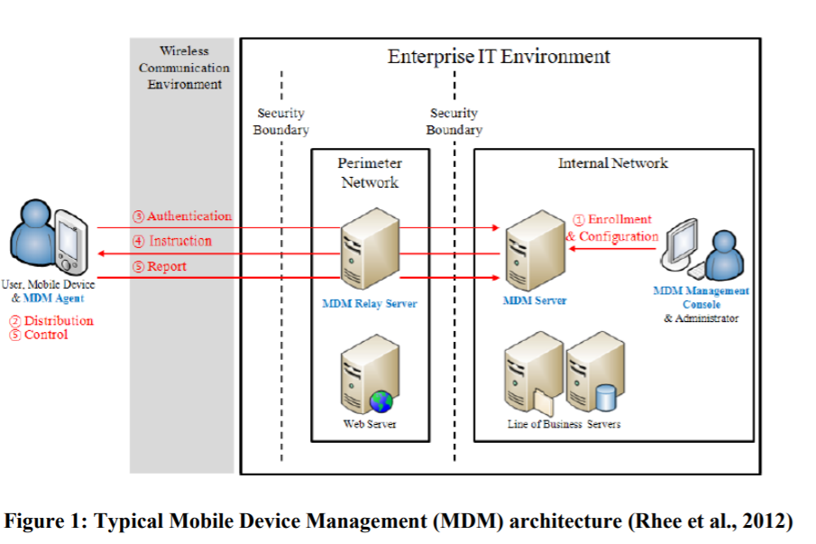[3]
Step 1. Enrollment/Configuration: In this step the user will register the data for their mobile device in the MDM system. Step 2. Distribution: In this step the MDM agent will be distributed and installed in mobile device. Step 3. Authentication: After the MDM agent is installed and run the data is sent to MDM server for authentication and matching if the data entered is correct. Step 4. Instruction: The MDM server redirect the instruction to MDM agent in accordance with the status of mobile device. Step 5. Control/Report: The MDM agent take care of the mobile device functionality as per the device control policy and sends the outcome back to the MDM server. Step 4 and 5 will be repeated regularly as per the requirement during MDM operations.[3]
The many benefits of MDM include backing up data, remote locking of stolen portable devices, logging and easy software updates.

There are numerous versions of MDM’s on the market with varying levels of pros and cons to each. It would be advisable to only discuss very briefly 4 of the top MDM services.

INTUNE
A Microsoft product combining Azure security which has a flexible means of applying the tools to the network. It can work with Android, macOS and Windows.

IBM MaaS360
This reads very similar to INTUNE with the added benefit of supporting IoT devices.

CISCO MERAKI
Once again this covers Android, macOS and Windows. For an office environment it has the ability to restrict access to the Google Play store as well as Itunes alone with gaming and other content.

SAP MOBILE SECURE
This appears to cover the most ground as not only does it cover everything the previous 3 pieces of software do, but contains MAM as well as EMM.

References

[1] A. M. French, C. J. Guo, and J. P. Shim, “Current status, issues, and future of bring your own device (BYOD),” Commun. Assoc. Inf. Syst., vol. 35, no. November, pp. 191–197, 2014.
[2] K. Downer and M. Bhattacharya, “BYOD security: A new business challenge,” Proc. - 2015 IEEE Int. Conf. Smart City, SmartCity 2015, Held Jointly with 8th IEEE Int. Conf. Soc. Comput. Networking, Soc. 2015, 5th IEEE Int. Conf. Sustain. Comput. Communic, pp. 1128–1133, 2015.
[3] D. Barthwal, “Mobile Device Management ( MDM ) in Organizations,” ResearchGate, no. July, 2016.

marking criteria and Student FEEDBACK

This section details the assessment criteria. The extent to which these are demonstrated by you determines your mark. The marks available for each criterion are shown. Lecturers will use the space provided to comment on the achievement of the task(s), including those areas in which you have performed well and areas that would benefit from development/improvement.

Common Assessment Criteria Applied (Assignment 1) | Marks available | Marks  awarded
1. Research-informed Literature
Extent of research and/or own reading, selection of credible sources, application of appropriate referencing conventions.
Only three sources have been cited in the work. The content is not sufficient for this assignment. (Grade mark: 26.67%) | 15 | 4
2. Knowledge and Understanding of Subject
Extent of knowledge and understanding of concepts and underlying principles associated with the discipline.
Some basic understanding of the subject is demonstrated. (Grade mark: 33.33%) | 15 | 5
3. Analysis
Analysis, evaluation and synthesis; logic, argument and judgement; analytical reflection; organisation of ideas and evidence
A few MDM solutions have been named and described very briefly. There is no comparison or critical evaluation between them and the discussion on practical application of the solution is not sufficient. (Grade mark: 25.00%) | 40 | 10
4. Practical Application and Deployment
Deployment of methods, materials, tools and techniques; application of concepts; formulation of innovative and creative solutions to solve problems.
PT submission contains a basic design. No hierarchy is observed. Very basic secrutiy implementations are demonstrated. Some redundancy is considered too. (Grade mark: 35.00%) | 20 | 7
5. Skills for Professional Practice
Attributes in professional practice: individual and collaborative working; deployment of appropriate media; presentation and organisation.
The assignment lacks in word count. The writing style could be improved and use of more references is required. (Grade mark: 40.00%) | 10 | 4

Assignment Mark (Assessment marks are subject to ratification at the Exam Board. These comments and marks are to give feedback on module work and are for guidance only until they are confirmed. ) | Late Submission Penalties (tick if appropriate) |  | 30%
 | Up to four weeks late |  | 30%
 | First Attempt? |  | 30%

