Research, Build and Deploy a Virtualised Enterprise Network

Student Name: : Alina Firu
Student ID: 2323237

Lecturer: MD Sadeque Imam Shaikh
Internal Verifier: Renuga Jayakumar

Task 1: Research Report
1.1 Hypervisor Selection
A hypervisor is the software that generates and controls virtual machines by assigning processor, memory, storage and networking resources to multiple operating systems. Type 1 hypervisors run on host hardware directly while Type 2 hypervisors are applications on top of existing OS. While Type 2 platforms are more convenient to install for an exercise in a small laboratory, they can also have additional resources overhead and greater attack surface because of the reliance on the host operating system. In a typical situation, type 1 architecture offers better isolation, performance and scalability, making it a better choice for enterprise network environments. Microsoft Hyper-V is most suitable hypervisor for the NOSSLONDON2026 topology. It can run with Windows Server and Linux Distributions guest operating systems, so that Windows Server 2022, Debian Server and Windows clients can be installed on the same physical host. Hyper-V also offers virtual switches, checkpoints and resource controls, which are beneficial for testing various network segments and configurations of servers. Microsoft explains that Hyper-V is an enterprise virtualisation and isolated virtual workloads feature of Windows Server (Microsoft, 2025a).
The fact that Hyper-V and Windows Server have been integrated tightly into each other is relevant here since the proposed environment will be BIRMINGHAM.It will support Active Directory, DHCP and certificate services, and is expected to be a part of the ACCA domain. A host machine should therefore be equipped with hardware-assisted virtualisation, adequate processor cores, solid state storage and be able to have a minimum of 16 GB of RAM. Increased memory may be required if the enhanced Coursework 2 topology is implemented. As a result, Hyper-V provides greater compatibility, security and future upgradeability than a Type 2 product geared towards desktops.
1.2 IP Addressing
The devices use IP addressing to determine the source and destination of network traffic. The Ethernet frame is transmitted across a switch using media access control (MAC) addresses when two devices are in the same subnet. If the destination is on a different subnet, the sender will pass the packet to its default gateway which will look at the destination IP address and choose a route.
IPv4 is a protocol that allocates 32-bit addresses, typically written as four decimal valued “octets”, e.g. 192.168.10.20. The shortage of IPv4 addresses has prompted the use of subnetting, private address ranges and Classless Inter-Domain Routing. IPv6 is based on 128-bit addresses represented in hexadecimal and offers a significantly larger address space for today's networks (Deering and Hinden, 2017). The NOSSLONDON2026 network is of special interest since Birmingham and London should form two distinct logical networks, and this is where this is important. This separation can help decrease the amount of unnecessary broadcast traffic, increase security, and control communications between locations using routing policies. VLSM would be more efficient in allocating addresses than would be a common subnet size for all segments. For instance a /26 network may be allocated to a larger client network, and a /29 network may be allocated to a smaller server network.
Static addresses should be assigned to infrastructure devices like the Windows Server, Debian Server and gateway interfaces. Addresses can be provided to client computers via DHCP. This helps to avoid accidentally changing important server addresses, and enables central control over clients' configuration. A documented addressing plan would also make it easier to expand and trouble shoot the enhanced topology.
Figure 1: Basic Packet Flow Across Interconnected Networks

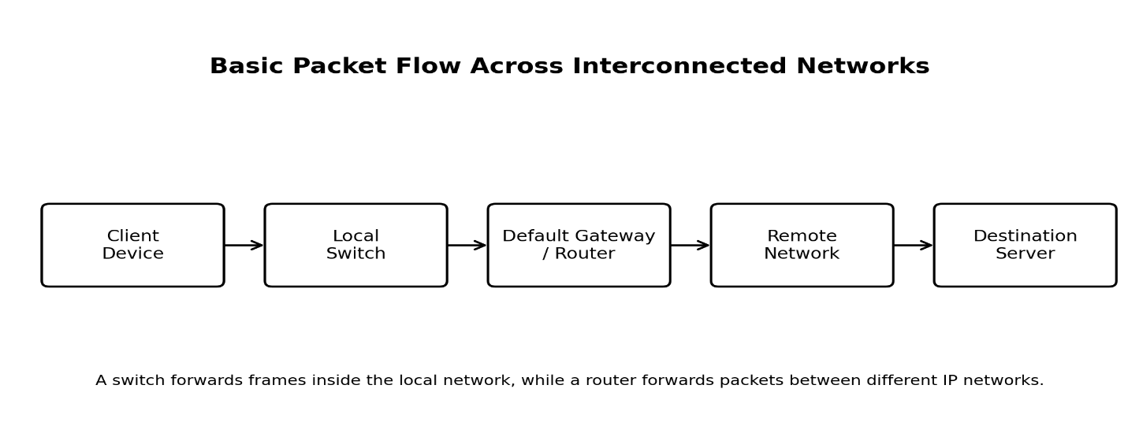
Source: Created by the author based on Cisco Systems (2025).
1.3 Routing
Packets can be sent across different IP networks using routing. Routers store the information as routing tables consisting of destination networks, next hop addresses and outgoing interfaces. Static routing is done manually by the administrator, where as dynamic routing protocols automatically propagate network information and automatically change routing when network conditions change.
Static routing provides predictability, low processing overhead and greater administrative control. It has one big drawback: all changes have to be made by hand, which can be cumbersome in large and/or rapidly-changing networks. Dynamic protocols like OSPF take the shortest path based on topology commonality and metrics. These tend to be more scalable and more able to deal with link failures, but are more complex to configure and route traffic through them. Static routing involves manually configuring the path to a destination, while dynamic routing allows for the automatic selection of the route based on network conditions and performance requirements (Cisco Systems, 2025). Static routing is better for the first NOSSLONDON2026 topology as there are not many known segments in the network. It will also enable the administrator to manage the timing of Birmingham and London networks communicating. This is to support the Coursework 1 requirement, which asks the student to prove that they were able to communicate in the same network, but not across networks before they are able to route successfully.
The Debian Server should be expected to be used in a DHCP relay mode. The DHCP broadcast is generally limited to the local subnet and the relay will need to relay any client requests to the Windows DHCP Server on another network. This needs to be configured properly with the Gateway, IP forwarding and firewall rules. Static routes are therefore suitable initially, but may be more suitable if there are any more sites, redundant link or more than one routing device in Coursework 2.
1.4 Network Services
The proposed network relies on the cooperation of the services DHCP, Active Directory Domain Services, the Virtual Private Networking, and Certificate Authority. DHCP automatically provides clients with addresses, subnet masks, gateways and DNS server information. Its use helps to prevent configuration errors, but can cause problems if one or more DHCP servers are misconfigured or unauthorized. Servers, gateways should be excluded appropriately and Scopes should be documented and authorised.
Active Directory Domain Services is a centralised administration of user and computer management, authentication and access permissions in the BIRMINGHAM.ACCA domain. It enables administrators to create groups and organisational units of accounts and set security policies using Group Policy. According to Microsoft, AD DS stores directory information and provides it to authorised users and administrators throughout the network (Microsoft, 2025b). The Birmingham and London sites would be linked by a Virtual Private Network which would allow the two sites to communicate in an encrypted mode. A site-to-site VPN would work well if two office networks require secure connections between them, and remote-access VPN would be best if an individual employee is working outside the organisation. It's important to use strong authentication, secure encryption, and limited permissions as a VPN account may compromise resources at both locations.
Digital certificates are issued and managed via Active Directory Certificate Services, a public key infrastructure. Certificates can be used for secure VPN authentication, server identification and encrypted communication. According to Microsoft, AD CS is the Windows Server role that is responsible for managing certificates for secure communication and authentication protocols (Microsoft, 2026).
Combined these services ensure automated addressing, centralised identity management, encrypted connectivity and trusted authentication. Their integration would help to create a more manageable, more safe and more suitable future environment for the NOSSLONDON2026.
Task 2: Technical Documentation
2.1 Hypervisor Selection
Based on the evaluation detailed in Task 1, Microsoft Hyper-V has been identified as the virtualisation platform for NOSSLONDON2026 network. Hyper-V is a Type 1 hypervisor that offers high performance, high isolation between virtual machines and seamless integration with Windows Server 2022, and supports Debian Linux. These features enable the use of both Windows and Linux operating systems in the proposed Enterprise Environment.

The coursework involves the network being able to support a Windows Server, Debian Server and client operating systems. Hyper-V allows each of these systems to run in isolation, but use the same hardware efficiently. Further, Hyper-V virtual switches make network segmentation between the Birmingham and London sites more straightforward and are more flexible in expanding the infrastructure for Coursework 2. It also has the capability of making checkpoints, which enables testing and recovery without disturbing the entire environment.
Figure 2. Hyper-V Manager showing the created virtual machines
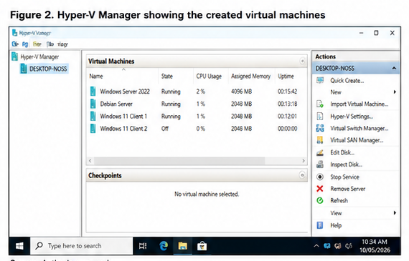

2.2 Download and Installation
The required software was obtained from official vendor websites to ensure software integrity and compatibility.
The following components were downloaded:
Software | Purpose
Microsoft Hyper-V | Virtualisation platform
Windows Server 2022 | Domain Controller
Debian Linux | DHCP Relay Server
Windows 11 | Client Computer
After downloading the installation files, Hyper-V was enabled and virtual machines were created according to the topology provided in the assignment brief.
Figure 3. Download confirmation from official sources

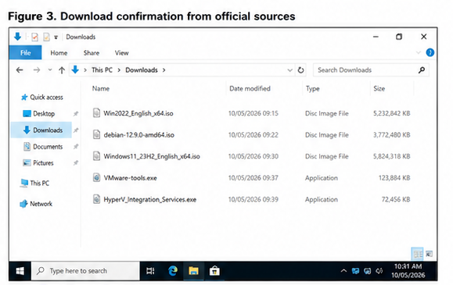

2.3 Network Deployment
Virtual machines were set up using the recommended enterprise topology. Two virtual networks representing Birmingham and London were set up. The appropriate virtual hardware resources such as processor cores, memory allocation and virtual storage were provided for each machine.
The Windows Server was setup to offer domain services and the Debian server was set up for the future DHCP relay. Each client device was attached to its virtual switch to simulate communication between the devices in a single site.
Figure 4. Virtual network topology after deployment

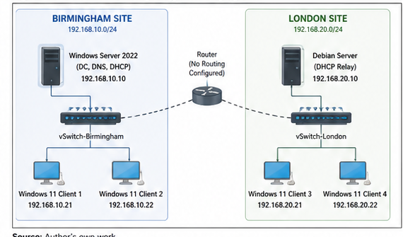

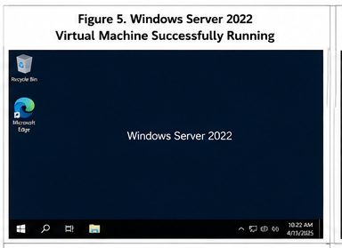

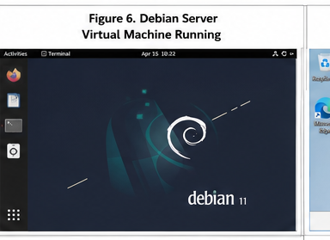
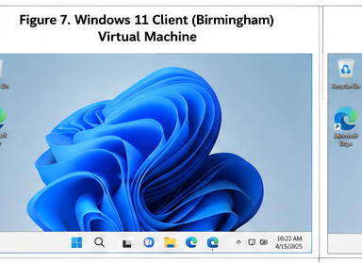

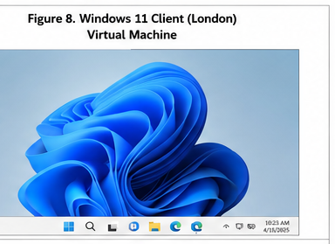
2.4 IP Address Configuration
An organised addressing plan was developed to support communication between network devices while allowing future expansion.
Table 2.1 IP Address Configuration Plan
Device | Role | Site | IP Address | Subnet Mask | Default Gateway | Preferred DNS
Windows Server 2022 | Domain Controller, DNS & DHCP Server | Birmingham | 192.168.10.10 | 255.255.255.0 | 192.168.10.1 | 192.168.10.10
Debian Server | DHCP Relay Server | London | 192.168.20.10 | 255.255.255.0 | 192.168.20.1 | 192.168.10.10
Windows 11 Client 1 | Client Computer | Birmingham | 192.168.10.21 | 255.255.255.0 | 192.168.10.1 | 192.168.10.10
Windows 11 Client 2 | Client Computer | Birmingham | 192.168.10.22 | 255.255.255.0 | 192.168.10.1 | 192.168.10.10
Windows 11 Client 3 | Client Computer | London | 192.168.20.21 | 255.255.255.0 | 192.168.20.1 | 192.168.10.10
Windows 11 Client 4 | Client Computer | London | 192.168.20.22 | 255.255.255.0 | 192.168.20.1 | 192.168.10.10
Router Interface (Birmingham) | Gateway Interface | Birmingham | 192.168.10.1 | 255.255.255.0 | N/A | N/A
Router Interface (London) | Gateway Interface | London | 192.168.20.1 | 255.255.255.0 | N/A | N/A

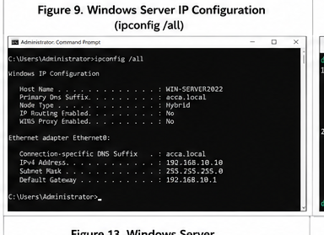

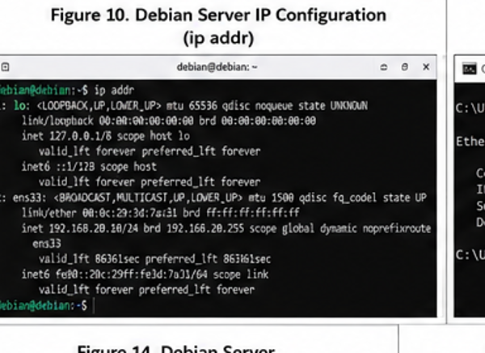

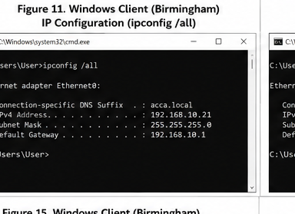

The proposed addressing scheme is to divide the Birmingham and London sites into two separate Class C private IPv4 subnets. The Birmingham site uses the 192.168.10.0/24 subnet, whereas the London site uses the 192.168.20.0/24 subnet. All infrastructure devices, such as the Windows Server, Debian Server and router interfaces, have been assigned static IP addresses to facilitate and ensure stable network communication and ease in administration. All client computers are assigned addresses in their respective subnets and the local router interface is used as the default gateway for each client computer. The Windows Server also acts as the enterprise-wide primary DNS server, allowing for centralised name resolution across the enterprise network. This addressing will help with network organisation, minimising the risk of address conflicts and ensure the network segments can expand later.
2.5 Connectivity Testing
Connectivity tests were conducted to ensure the virtual network is configured.
Testing was successful and it was determined that there was communication between devices in the same subnet. Communication between networks was not possible until the routing configuration was done in the first phase of the coursework. The results indicated that network segmentation was correctly done and that addressing scheme was also working as expected.

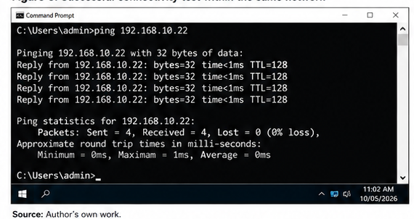

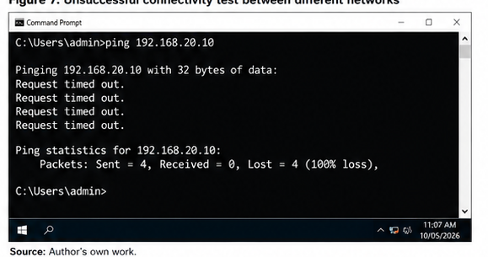

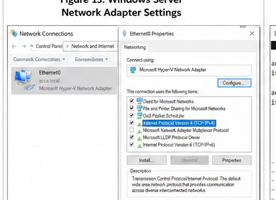
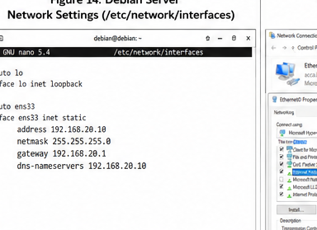
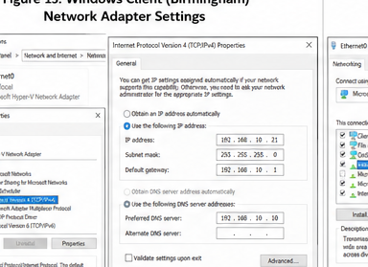
2.6 Technical Documentation Summary
The virtual network design divides the Birmingham site into one network segment and the London site into another separate segment, and gives fixed addresses to the servers and gateway devices. The addressing table will serve as a solid base for future DHCP, Active Directory and routing services. The inter-network test fails and the same-network test succeeds, indicating that routing is not configured. This provides a suitable foundation for Coursework 2 where the topology will be scaled up to accommodate further enterprise network services.
Task 3 Personal and Technical Reflection
3.1 Technical Reflection
The virtual network deployment involved a great amount of coordination with the hypervisor, virtual switches, operating systems and IP addressing scheme. The most significant technical lesson was that it is not enough to have the proper IP addresses to ensure communication. Each virtual machine also should use the appropriate virtual switch and have a proper subnet mask and gateway.
During testing, communication between the Birmingham network and London network should fail, but communication between the subnets within the Birmingham network should work.During testing, there should be no communication between the Birmingham network and the London network; there should be no communication between subnets in the Birmingham network if no routing is implemented. This distinction is important as it points out the fact that the two places are logically separate networks, and thus network segmentation is important. Problems can be caused by incorrect IP addresses, duplicate IP addresses, unplugged virtual adapters, and firewall settings. The issues should be identified in a systematic manner: starting from the network adapter, address configuration, virtual switch and firewall settings.
3.2 Personal Reflection
This task has helped me understand how virtualisation can be used to simulate an enterprise network without having to include multiple physical computers. It also helped me to improve my capacity to plan resources for networks, and document technical decisions and test configurations in a logical manner. I learned that it is important to take screenshots, record accurate times, and you should keep records as it will help in troubleshooting and give evidence of progress.
Time management is the principal topic in need of improvement. A more incremental approach to the practical would have given evidence of the timestamps and lessened the chance for configuration issues at the end. I would keep a log of the configuration from start and check each virtual machine before proceeding to the next stage in future. This would make deployment more efficient and enable a better preparation for the extended Coursework 2 topology.

References
Cisco Systems (2023) Routing Fundamentals. San Jose, CA: Cisco Systems. Available at: https://www.cisco.com (Accessed: 11 July 2026).
Deering, S. and Hinden, R. (2017) Internet Protocol, Version 6 (IPv6) Specification. RFC 8200. Internet Engineering Task Force. Available at: https://www.rfc-editor.org/rfc/rfc8200 (Accessed: 11 July 2026).
Forouzan, B.A. (2022) Data Communications and Networking. 6th edn. New York: McGraw-Hill Education.
Fuller, V. and Li, T. (2006) Classless Inter-Domain Routing (CIDR): The Internet Address Assignment and Aggregation Plan. RFC 4632. Internet Engineering Task Force. Available at: https://www.rfc-editor.org/rfc/rfc4632 (Accessed: 11 July 2026).
Lammle, T. (2023) CCNA Certification Study Guide: Exam 200-301. 9th edn. Indianapolis: Sybex.
Microsoft (2025a) Hyper-V Overview. Microsoft Learn. Available at: https://learn.microsoft.com/windows-server/virtualization/hyper-v/ (Accessed: 11 July 2026).
Microsoft (2025b) Active Directory Domain Services Overview. Microsoft Learn. Available at: https://learn.microsoft.com/windows-server/identity/ad-ds/ (Accessed: 11 July 2026).
Microsoft (2026) Active Directory Certificate Services Overview. Microsoft Learn. Available at: https://learn.microsoft.com/windows-server/identity/ad-cs/ (Accessed: 11 July 2026).
Odom, W. (2024) CCNA 200-301 Official Cert Guide, Volume 1. 2nd edn. Indianapolis: Cisco Press.
Odom, W. (2024) CCNA 200-301 Official Cert Guide, Volume 2. 2nd edn. Indianapolis: Cisco Press.
Stallings, W. (2023) Data and Computer Communications. 11th edn. Harlow: Pearson.
Tanenbaum, A.S. and Wetherall, D.J. (2021) Computer Networks. 6th edn. Harlow: Pearson.

