Introduction
St Illtyd’s Church in Ilston is a Grade II* listed medieval church located in the scenic Gower Peninsula, Wales. Renowned for its architectural, historical, and communal significance, the church has served as a religious and community hub for centuries. This report assesses its heritage value, addresses issues identified in recent inspections, proposes a conservation strategy to ensure its preservation for future generations and preserve its outstanding features while ensuring its continued relevance and utility for the community. This document evaluates the church’s history, its physical and cultural significance, and proposes a comprehensive strategy for mitigating risks and preserving its legacy.

The History of St Illtyd’s Church
According to a previous report carried out on the church, provided to myself be the churches caretaker, The origins of St Illtyd’s Church trace back to at least the early 12th century, with historical records referencing its existence in 1119. By 1221, the church was associated with the Knights Hospitallers, indicating its importance within the medieval ecclesiastical landscape. Following the dissolution of the monasteries, the Crown transferred its patronage to Thomas Penrice of Kilvrough in 1540, signifying a shift in its ownership and governance. (1)
Architecturally, the church evolved significantly over time. Originally a simple structure with a nave and chancel, its layout was augmented with a south porch, vestry, and a distinctive saddleback-roofed tower. The tower, likely constructed after the nave, is an unusual feature, positioned at an angle from the original building suggesting challenges finding suitable foundations on the sloping terrain.
In the 19th century, under the guidance of Rev. John Collins, the church underwent significant restoration. These works included re-roofing, installation of pews, construction of a gallery at the west end for additional seating, and decorative enhancements such as stained-glass windows and carved Gothic-style pulpit. A plaque above the porch arch records the year 1847, marking the culmination of these efforts. Despite these changes, much of the medieval fabric remains, preserving the church’s character while accommodating the needs of its evolving congregation. This information was also available on the previous report supplied by the church (1)

Architectural and Historical Significance
St Illtyd’s Church is a remarkable example of a medieval church adapted over centuries while retaining its core historic elements. The church’s limestone masonry, crenelated parapets, and Bath-stone-coped gables are testament to traditional craftsmanship. Notably, the saddleback roof of the tower, characteristic of Gower churches, adds a distinctive silhouette to the landscape. To support this point, See below Figure 1,2,3 which examples of other churches around the area with similar features.
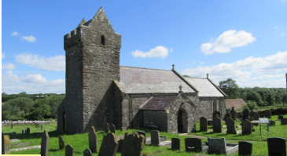
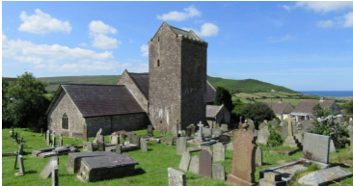
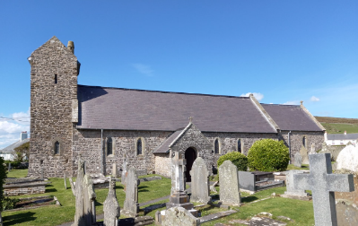
Figure 1 (2) Figure 2 (3) Figure 3 (4)

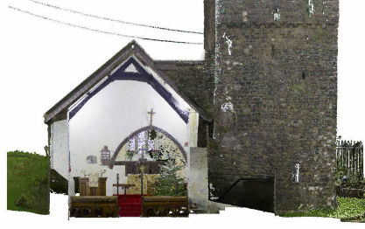
Internally, the church reflects a restrained aesthetic. The nave and chancel, separated by an arch decorated with timber. which was modified during major renovations, as you can see the differences between the painting and the photo taken during the inspection (figure 4 and 5) ceilings are adorned with a three-bay roof featuring chamfered beams (figure 6). The octagonal font, pine pews, and simple reredos maintain an understated charm. The presence of early memorials and stained-glass windows (Figure 7) further enriches its historical narrative, linking the site to its community across centuries.
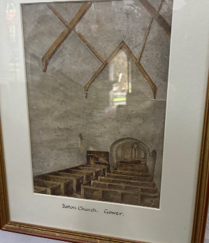
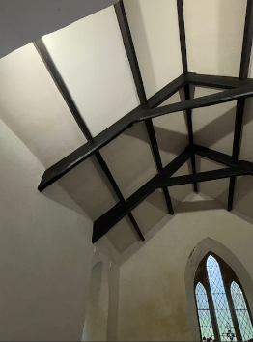
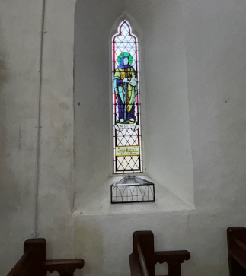

FIGURE 4 Figure 5 Figure 6 Figure 7

Current Issues and Challenges
The recent Quinquennial Inspection of 2024 highlighted several critical issues affecting the structural and aesthetic integrity of St Illtyd’s Church. These challenges, if unaddressed, risk undermining the church’s heritage value and functionality.
Structural Deterioration The church exhibits signs of structural stress, particularly in the chancel and nave walls, where an outward lean has been observed. While attributed to historical roof spread, the absence of recent movement is reassuring. However, cracks in the south porch and movement in the vestry walls signal vulnerabilities. Loose and damaged copings further exacerbate water ingress, potentially destabilizing the masonry.
Water Ingress and Damp Persistent damp remains a pervasive issue, affecting both external walls and internal finishes. Saturation of stonework, particularly near the NW corner and vestry, has been attributed to blocked gutters, damaged downpipes, and inadequate drainage. The use of cement-based mortars in past repairs traps moisture within the walls, worsening the situation.
Weathering and Vegetation Exposure to harsh weather and insufficient maintenance has led to significant erosion of masonry and roof elements. Ivy and weed growth, particularly on the tower walls, compound these issues by undermining the integrity of the stonework and flashings.
Windows and Doors The church’s windows, including stained-glass depictions of Christ’s ascension and St Illtyd, require urgent attention. Corroding saddle bars have caused cracking in the stone surrounds, while external protective coverings retain moisture against the stone, accelerating deterioration. Similarly, the vestry door’s design allows water ingress, and its non-compliance with fire safety regulations poses additional concerns.
Energy Efficiency and Accessibility The under-pew heating system, though functional, is outdated and insufficient for the building’s needs. Portable heaters in the vestry provide only temporary relief. Accessibility audits have highlighted challenges in accommodating disabled visitors, particularly due to the vestry’s configuration and steps leading to the chancel.

Conservation Policies and Recommendations
To preserve the historical, architectural, and communal significance of St Illtyd’s Church, a comprehensive conservation strategy must address its identified issues while promoting sustainable use and engagement. Points to include in said strategy are as follows:
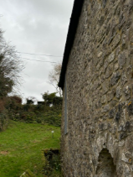
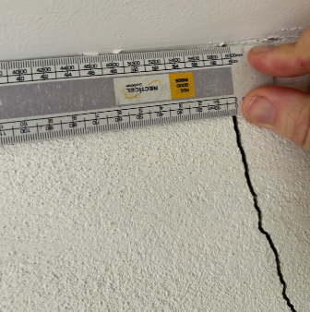
Structural Repairs A detailed structural assessment should prioritize stabilisation of the chancel and nave walls. Cracked masonry, particularly in the porch (Figure 8) see how crack is currently around 3mm wide, this must be monitored once every few months, to ensure it doesn’t get too big. If crack exceeds 8-10mm, a structural engineer should be called out, and potentially suggest stitching to be carried out on the crack. This should be under taken by an experienced stone mason who had worked on old listed buildings following advice from BS7913 or CADW guidance in repairing stonework. These cracks must be repaired using lime mortar to ensure compatibility with the historic fabric, as you can see in figure 9, the west elevation is slightly twisted likely causing cracks across the whole structure. Repointing and securing loose copings will mitigate water ingress and enhance structural resilience.

Figure 8 figure 9
Moisture Management. Improved drainage is crucial to combat damp. Regular maintenance of gutters, downpipes, and drainage channels must be undertaken (Figure 11), this would consist of removing all leaves mud and growth, and this would then give the opportunity to assess the state of the guttering and downpipes in greater depth. If in a poorly state, property manager could replace all guttering and downpipes throughout, with like for like cast iron drainage. These would also need maintenance on a regular basis. Alongside the introduction of effective roof flashings (figure 10) you can see a cement drip has been retrofitted, this is probably doing more harm than good, giving any water opportunity to track behind the drip at the seam and sit behind it causing damp inside. The replacement of cement mortars that have been put in by workers over the years as seen also in figure 10, to be replaced with soft lime-based alternatives, like the building would have been originally built with, will allow walls to breathe, promoting evaporation and reducing internal damage. Also damaged copings on the parapets encourages water to seep underneath, these also should be replaced with the same bath stone as on the best of the church. See figure 12
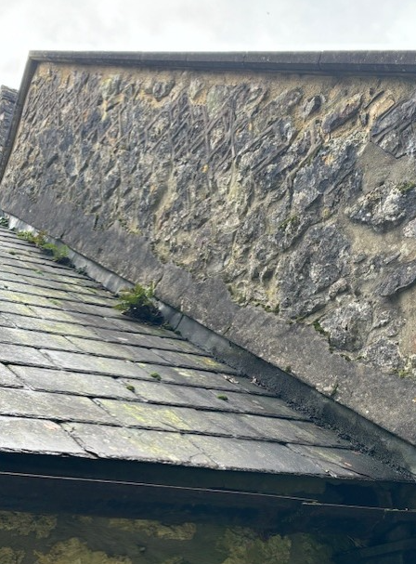 figure 10 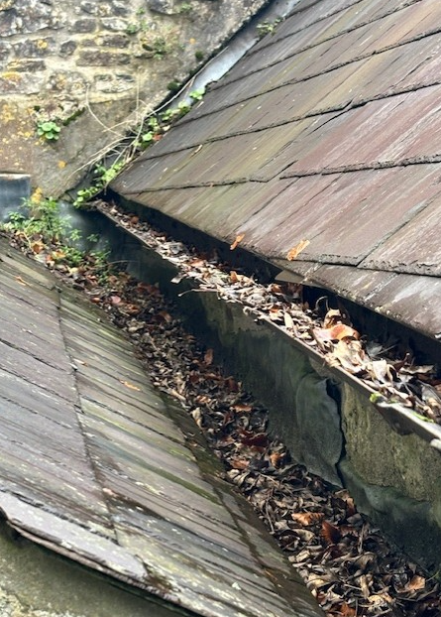 figure 11 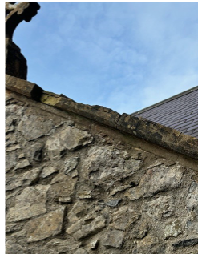figure 12
You can see inside where the water ingress stemming from the issues above is taking effect see figure 13 where you can see plaster on the internal walls blowing, also paint bubbling. Suggest investigation into the plaster whether it is appropriate for this type of construction, some areas look like may be gypsum (figure 14). Plaster inside the church needs to be lime plaster like what we can see in figure 13, to suit the time period and type of construction, this will allow the thick stone walls to breath, helping evaporate water from inside the wall.
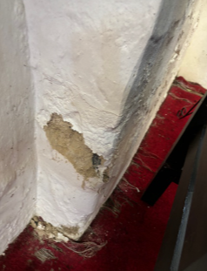 Figure 13 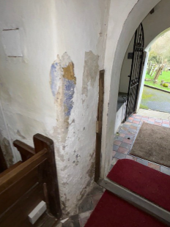 figure 14
Roof and Tower Maintenance High-level inspections should address loose flashings and vegetation on the saddleback roof. Ivy removal from the tower walls should be followed by repointing voids to prevent further damage (figure 15). The crenelated parapet’s also showed in figure 13 render must be repaired or replaced to reduce damp penetration. You can also see in the tower where vent holes have been put in to help get air circulated around the building, this should help some of the damp issues around this area internally. In terms of the roof itself, we understand that the roof was revamped on the 1970s so is relatively new is comparison to the rest of the church, however there are some issues where you can see the tiles are starting to slip in some areas (see figure 16) these are to be replaced with restored welsh slate from a similar time period, to ensure the slate matches the colour of the surrounding tiles.
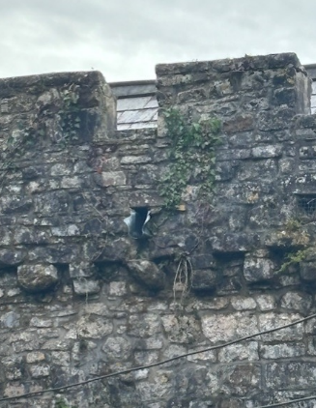
Figure 15 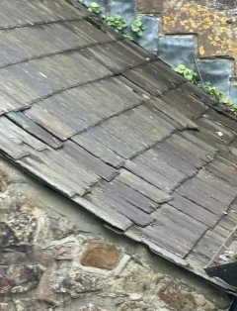 figure 16
Window and Door Restoration Stained-glass windows require conservation work, including replacing corroded saddle bars with bronze alternatives and repairing blown stone surrounds. Protective coverings should be spaced to allow ventilation or substituted with wire mesh screens (figure 17) as you can see in the image, moisture is getting trapped in the gap between the protection and the window, creating a perfect environment for moss and vegetation to grow, causing further damage to the window, and trapping moisture into the stone surrounds encouraging them to blow.
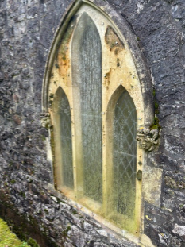 Figure 17
Energy and Accessibility Enhancements The heating system should be modernized to include efficient and sustainable solutions, like air-source heat pumps potentially, however, the church is only occupied a couple of weekends out of the month as informed by the property manager. So it is for the management to assess whether it is reasonable practical to fit state of the art, modern heating and ventilation. Also it is difficult to install these types of heating solutions without compromising the walls or floor of the original structure, therefore impacting the historical significance of the building itself. The Accessibility improvements, including ramps and handrails, will ensure inclusivity without compromising the church’s character.

Long-Term Sustainability and Engagement

Community Involvement The church’s preservation should involve the local community, fostering a sense of ownership and responsibility. Volunteers can assist with routine maintenance, while fundraising initiatives can support major works. Educational workshops and events will raise awareness of the church’s heritage value.
Monitoring and Review Annual inspections should monitor the condition of masonry, roofs, and drainage systems. A photographic record will track changes over time, enabling timely interventions. Conservation plans must be reviewed every five years to reflect emerging challenges and advancements in heritage management.
Funding and Partnerships Grants from Cadw, the Heritage Lottery Fund, and other heritage organizations can offset conservation costs. Partnerships with local authorities and conservation specialists will ensure adherence to best practices.

Conclusion
St Illtyd’s Church stands as a testament to the enduring legacy of medieval craftsmanship and community resilience. Its historical layers, from its Norman origins to 19th-century adaptations, tell a story of continual evolution and cultural significance. However, challenges posed by structural deterioration, damp, and accessibility must be addressed to secure its future.
Through careful conservation planning, St Illtyd’s Church can continue to serve as a place of worship, community gathering, and historical inspiration. By balancing heritage preservation with modern needs, this cherished landmark will remain a beacon of spiritual and cultural identity for generations to come.

References
(1)Hollocks, R. (2024). QUINQUENNIAL INSPECTION REPORT - 2024 ST ILLTYD’S CHURCH ILSTON. writen report.
(2) Gower Holidays. (2018). Gower Churches and Chapels | Gower Peninsula Holidays. [online] Available at: https://www.gowerholidays.com/attractions-activities-in-gower-swansea/gower-churches-and-chapels/ [Accessed 17 Jan. 2025].
(3) Gower Holidays. (2018). Gower Churches and Chapels | Gower Peninsula Holidays. [online] Available at: https://www.gowerholidays.com/attractions-activities-in-gower-swansea/gower-churches-and-chapels/ [Accessed 17 Jan. 2025].
(4) Gower Holidays. (2018). Gower Churches and Chapels | Gower Peninsula Holidays. [online] Available at: https://www.gowerholidays.com/attractions-activities-in-gower-swansea/gower-churches-and-chapels/ [Accessed 17 Jan. 2025].

