

LCMB7000: Human Resource Management
MBA – Masters of Business Administration
Table of Contents
Introduction 3
1. The current state of the labour market in the UK 3
2. New Developments in Human Resource Management in the Post-Covid and Post-Brexit Environment 6
2.1 Emerging changes in the Human resourcing strategies during post-covid Era 6
2.2 Emerging Changes in the Human resourcing strategies in the post-Brexit external management 8
Conclusion 10
Reference List 11

Introduction
The rate of unemployment increased during the time of Covid-19 as various workers lost their jobs and several workers were furloughed. This was one of the greatest prisons due to which the economy of the UK has declined. It was even one of the factors due to which inflation and recession increased in the UK. It is significant to note that this report is going to analyse the labour market of the UK and the people who were highly impacted due to the pandemic and the worldwide lockdown. Furthermore, it will also analyse the emerging changes in the UK due to post-covid and post-Brexit.

1. The current state of the labour market in the UK
Labour Market of the UK: The employment rate in the UK was approximately 75.6% as of October 2022. Nearly 0.2% or higher than the previous 3-month period and there is an increase in the number of employees over the latest quarter which was driven by part-time workers as well. Something important to mention is that 98,000 people have jobs until February 2023, which has helped the UK economy as well. Since employment rose by around 3.7% in the third quarter, the unemployment rate from November 2022 to January 2023 changed (Worth and Faulkner-Ellis, 2021). The number of jobless individuals in the UK was amended, and compared to the previous year. There has been a minor rise in the number of employees in the country, particularly during the past three months. From November 122 to January 2023, the rate of economic inactivity also dropped by 0.2% and 21.6%.
In the UK variety of people between the ages of 16 and 24 were often responsible for the decline in economic activity during the previous three months. Concerned about the state of the economy, many young people who are either students or retirees were often the ones that drove and created the falter lead decline. In the quarter, there were 1,124,000 vacancies, down around 51,000 from December 2019 to February 2020 (Bejakovi and Mrnjavac, 2020). Also, there was a 5.7% increase in the average total payroll as well as an improvement in the yearly pay and bonus because 6.5% of young workers obtained significant compensation in the private sector. However, it is significant to know that the advance of the pandemic during the time the world while down in March 2020 had a dramatic effect on the entire market for labourers in the UK. There was a large fallout in employment and the rate of unemployment has also increased due to economic inactivity. Economic inactivity can be referred to as a situation in which people do not work due to certain issues and challenges.
Impact on the labour market during a lockdown: It is obvious that the number of people who work in The UK fell by 825,000 between the tenure of January to March 2020 and especially from October to December 2020 (Costa Dias et al. 2020). Unemployment increased as almost 4 black people lost their jobs due to the pandemic and the economy of the UK became weak and activity rose by 327,000. However, it is also noted that the employment and unemployment levels began to enhance as the economic inactivity declined from December 2021 to February 202 by 8.89 million.
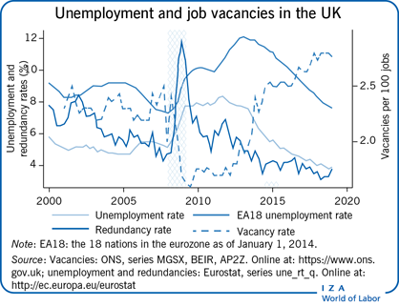
Figure: Labour market of the UK
(Source: wol.iza, 2023)
Schemes for supporting employment: over 11.7 million were furloughed and it was also observed that the number of jobs which were furloughed was approximately 8.9 million and hens several schemes initiated since 30th September 2021 through which various people who lost their jobs due to the advent of the pandemic can get jobs in the market (Costa Dias et al. 2020). It is also observed that due to these skins for supporting employment around 1.2 million jobs were provided by the UK Government to people. However, approximately 1.3 million claims were made for employment due to the Self-Employment Income Support Scheme (SEISS) which was also initiated on 30th September 2021.
Affected Groups: Following the negative impact of COVID-19, different workers will have experienced this proportionately and financially (Bell and Blanchflower, 2020). It is clear that between January and March 2020 and January to March 2022, the unemployment rate for minority ethnic associations—which was already significantly higher than the national norm before the pandemic increased. When the epidemic first started, those who belonged to minority ethnic organisations were often facing a loss of income.
It is also observed that while unemployment traits have given rice more for the minority groups due to the pandemic the rate of unemployment increased and decreased in the economic inactivity rates as well. It is also important to note that, throughout the epidemic, employment among males has decreased far more than that of women. The fact that women made up a record-high 48% of the workforce from January to March 2022 is often cited as evidence of a rise in economic inactivity among males. The beginning of COVID-19 was exacerbated by the fact that the youngest and oldest labourers were more likely to lose their employment and be furloughed (Ozgen, 2021). While many older workers chose to retire willingly, the employment of young people swiftly rebounded starting in the spring of 2021 and had almost reached pre-pandemic levels by January to March of 2022.
It is observed that post-pandemic, low-paid workers were likely to work in various sectors that have been affected due by the pandemic and which has particularly non-essential as well. It is significant to know that due to a fall in income at the initiation of the pandemic, people lost their jobs. However, after the initiation of the new normal, it saw drastic changes in the labour market of the UK as economic activity rises and people got employment in various sectors that helped them to reduce poverty. According to Lauder and Mayhew, (2020), it has also helped to enhance the economic condition of the UK comprehensively. It is also observed that the located workers were likely to work in various sectors due to the effect of the panda make and especially the hospitality and the non-essential retail people were furloughed. Even plumbers and other people also received less income due to the pandemic and the employment gap between disabled people and people without any physical challenges was widened. It is also observed that the UK government has published various schemes and statutory rules for administrating self-employment schemes post-pandemic. It is significant to note that on 29 May 2020, the UK Government announced a second round of various schemes that helps the citizens of the UK to get more jobs in the labour market. It is also evidence that initially it was proposed that the first of various plants would be covering 20% of the annual trading profits. This scheme has helped citizens of the UK to gain enhanced benefits in the competitive edge and to get jobs in the labour market as well.

2. New Developments in Human Resource Management in the Post-Covid and Post-Brexit Environment
Being a developing country, the UK has to face big difficulties and changes in its domestic and international business operations. According to Anjum et al. (2022), many multinational companies not only changed their organisational management but also had to adopt new HRM policies and practices due to massive external factors like Covid-19 and Brexit events. Although, over time new strategies, effective planning and active adoption of new developments helped the UK business to grow and get their possible sustainability in domestic and international business operations.

2.1 Emerging changes in the Human resourcing strategies during the post-covid era
Discussion on the topic: According to Sharma and Kumar, (2020), the pandemic covid-19, in the history of epidemics has been considered to be one of the effective diseases that affected the continuation of the normalcy of life. Hence created utter confusion in the entire process of running a smooth life in terms of both personal and professional aspects. Therefore, with time, it became necessary to deal with the situation to support life and hence the new normal practices were brought into existence (Affandi et al. 2020). Therefore, emerging changes have been observed to come in the process of Human resourcing strategies during the post covid era that was adopted to create space for building a paradigm. Hence shift the working style to deal with unaware challenges in a congruent manner.
Virtual set-up for teams: starting from supervising activity to making employees work from different corners of the earth but through a connected manner, through virtual team setup, the post-pandemic made the HR department of every industry think about this particular setup. Therefore, it can be justifyingly said by aligning with the words of (Yawson, 2020), the HR strategies began to get framed in alignment to the ensuring of HR managers create space for employees to navigate the turbulence and create space for comfort and benefit under the post covid situation.
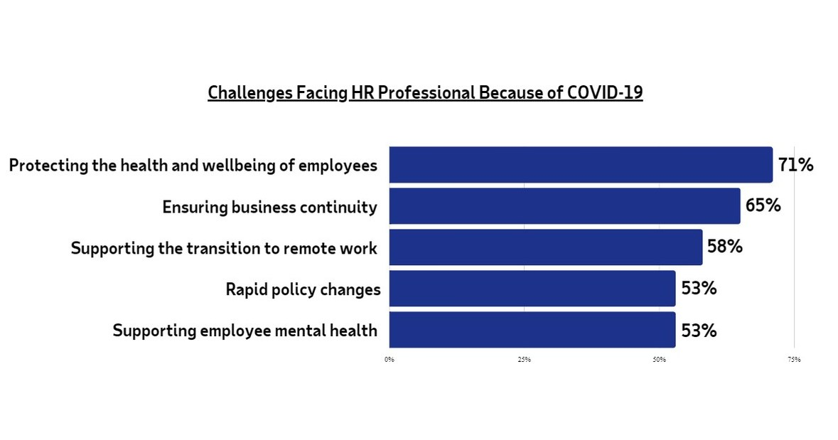
Figure 2: Challenges faced by HR professionals during covid-19
(Source: newswire, 2020)
The emergence of the post-covid workforce: The conditions under post covid terms were observed to create changes and alterations in the structure of the workforce and employees started to get allocated in terms of flexible working and teleworking. As per Slavić, (2021), the post covid era was also likely to advise the HR department to set up the new normal which demanded a virtual workplace setting. Therefore, to meet this need, the calls and approaches for deciding on setting the compensation and paying for the same were created to provide the needed approach to management. The companies were observed to follow the different aspects of training and people development that entirely created a new dimension (Anjum et al. 2022). For conducting different types of training through online platforms and hence providing equivalent data that made the HR team manage and perform out of the box.
Difficulties in setting up a new routine: Although all of the above-discussed points seemed exclusively effective and happening. There were utter confusion and tremendous difficulties while setting up a new routine that would make all the employees effective enough to go through the competitiveness of style of work and also maintain the needed benchmark to perform well. This is said so because, with the effective implementation of the virtual team and set-up, it became difficult for the companies to maintain the needed grasp on disciplinary actions. According to Buheji and Buheji, (2020), the entire process of adjusting the working of the terms is ineffective and inefficient to a great extent. Therefore, the operative term became incongruent. Hence the total set of dedicated staff along with the disciplinary set of actions was observed to become difficult in terms of the beneficial outcomes under the organisations. Even in terms of the payroll process, the HR strategies post-covid situation was observed to fail to get attached to the norms of lockdowns and hence this led to the fall in the setups of different organisational processes (Cooke et al. 2022). It was difficult for each of the managers to initiate a new routine during the time of covid-19 as during the lock down recruitment procedure also stalled. Each manager of various organisations is trying to recruit talented and skilful workers across the globe through virtual techniques. According to Lee et al., (2020), collaborative tools and other methods were utilised by them to recruit and onboard them. the HR managers are also trying to recruit top talented persons from various countries so that the companies can be getting enhanced benefits in the competitive edge as the new recruitment candidates will be giving enhanced customer services.
Probably adopted methods: Therefore, in congruence to the above-discussed methods, it can be seen that the HR managers, after the vivid situation of the pandemic, adopted methodologies that provide. According to Skeete et al. (2020) deciding new cultures which could be sufficient enough to decide new reporting structures and thus lead the remote workforce to adhere to a different set of agile methodologies and hence provide flexible terms and flat organisational to enhance the structures. Various virtual tools and methods were utilised source to bring efficiency to the nature and atmosphere of the business organisations. Tesco is one such business organisation and its HR department has utilised virtual and collaborative tools for recruiting and onboarding new employees. All the decision-making processes for the health and safety and welfare of employees are also taken virtually.

2.2 Emerging Changes in the Human resourcing strategies in the post-Brexit external Management
Discussion of the topic: The situation of Brexit is not an easy task and situation to handle. Therefore, standing on that note, it is worth mentioning that, it is of high anticipation that although it is understood that businesses across all borders and doing their best to adjust to the norms of Brexit. As per Bailey et al. (2023), the situation of Brexit is immensely creating hindrances in the process of creating efficient human resource strategies and hence creating space for better accommodation of resources. Therefore, post-Brexit it became an essential aspect for the industrial sectors of the UK to handle the condition by anticipating new norms of HR practices (Oseghale et al. 2022). Therefore, from the perspective of HR, handling the situation of Brexit and at the same time handling the staff of the companies has not been an easy task.
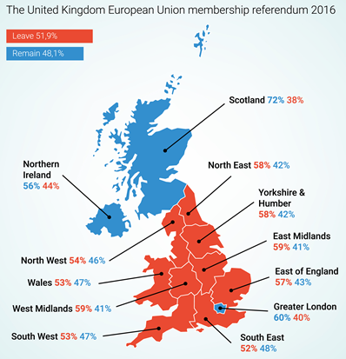
Figure 3: Impact of Brexit on the UK
(Source: shrm, 2019)
It is also observed that it is the role and responsibility of the HR department of the business organisations to provide proper grievance redressal schemes. However, it is observed that people working in those organisations if have any grievance related to their remuneration or with employers have to address this to the HRD department virtually and it was a long procedure. According to Lee et al. (2020), Brexit has even made the trading opportunity of the UK quite difficult and hence the economy of the entire nation declined drastically. However, it was evident that due to breaks the nation has also received several opportunities to trade with non-EU nations. It has helped the nation to bring more foreign direct investment and to enhance its economic condition as well.
Dealing with practical elements: According to Moradlou et al. (2022), HR strategies are essentially needed for practically considering the daunting effects of the Brexit era. Therefore, from this standing point, the cost of doing business and conducting the same under the EU norms due to the ongoing trade agreements has been observed to hamper the economic volatility. The new situation of Brexit had been observed to create hindrances by the avoided EU legislation, therefore, making changes in the surrounding legislation and adjusting to the San has been observed to be a new aspect of failure for the firm.

Conclusion
From the above discussion and analysis, it can be concluded that due to covid-19 and the bracket the economy of the UK became weak. It is also evident that Brexit has infected the trade activities of the UK due to which the economy of the country became weak. The condition of the labour market during the time of the pandemic and post-pandemic is compared and it is observed that various citizens of the UK received jobs. It is also evident from the report that around 8.9 million people lost their jobs during covid-19 and it had a severe impact on the economy of the nation.

Reference List
AM, E.N., Affandi, A., Udobong, A. and Sarwani, S., (2020). Implementation of human resource management in the adaptation period for new habits. International Journal of Educational Administration, Management, and Leadership, pp.19-26. Available at: http://harpressid.com/index.php/IJEAMaL/article/download/4/3
Anjum, N., Rahman, M.M. and Rahaman, M.S., (2022). Challenges for HR Professionals in the Post-COVID-19 Era. Journal of Business Strategy Finance and Management, 4(1), p.5. Available at: https://www.jbsfm.org/pdf/vol4no1/JBSFM_Vol4_No1_p_05-11.pdf
Bailey, D., De Propris, L., De Ruyter, A., Hearne, D. and Ortega-Argilés, R., (2023). Brexit, trade and the UK advanced manufacturing sectors: a Midlands' perspective. Contemporary Social Science, pp.1-16. Available at: https://www.open-access.bcu.ac.uk/13601/1/Bertha%20Kumodji%20PhD%20Thesis%20published_Final%20version_Submitted%20Nov%202021_Final%20Award%20Jul%202022.pdf
Bejaković, P. and Mrnjavac, Ž., (2020). The importance of digital literacy on the labour market. Employee Relations: The International Journal, 42(4), pp.921-932. Available at: https://repozitorij.ijf.hr/islandora/object/ijf%3A54/datastream/FILE0/view
Bell, D.N. and Blanchflower, D.G., (2020). US and UK labour markets before and during the Covid-19 crash. National Institute Economic Review, 252, pp.R52-R69. Available at: https://www.cambridge.org/core/journals/national-institute-economic-review/article/us-and-uk-labour-markets-before-and-during-the-covid19-crash/5A8D5A27F1854AF5E6906330B214AFF0
Buheji, M. and Buheji, A., (2020). Planning competency in the new Normal–employability competency in post-COVID-19 pandemic. International Journal of Human Resource Studies, 10(2), pp.237-251. Available at: https://pdfs.semanticscholar.org/572f/3d8e96a380648cbd464e21e7500a0d808681.pdf
Cooke, F.L., Dickmann, M. and Parry, E., (2022). Building sustainable societies through human-centred human resource management: Emerging issues and research opportunities. The InTernaTIonal Journal of human resource managemenT, 33(1), pp.1-15. Available at: https://www.tandfonline.com/doi/pdf/10.1080/09585192.2021.2021732
Costa Dias, M., Joyce, R., Postel‐Vinay, F. and Xu, X., (2020). The challenges for labour market policy during the Covid‐19 pandemic. Fiscal Studies, 41(2), pp.371-382. Available at: https://onlinelibrary.wiley.com/doi/pdf/10.1111/1475-5890.12233
Graham, M. and Anwar, M., (2019). The global gig economy: Towards a planetary labour market?. First Monday, 24(4). Available at: https://ora.ox.ac.uk/objects/uuid:f3bf8e6a-9f42-4b16-8f81-73f0ae8aad4f/files/md7cbec0c3cd81bdc3c3965a0881f33fe
Lauder, H. and Mayhew, K., (2020). Higher education and the labour market: an introduction. Oxford Review of Education, 46(1), pp.1-9. Available at: https://www.tandfonline.com/doi/full/10.1080/03054985.2019.1699714
Lee, S., Schmidt-Klau, D. and Verick, S., (2020). The labour market impacts of the COVID-19: A global perspective. The Indian Journal of Labour Economics, 63, pp.11-15. Available at: https://link.springer.com/article/10.1007/s41027-020-00249-y
Moradlou, H., Fratocchi, L., Skipworth, H. and Ghadge, A., (2022). Post-Brexit back-shoring strategies: what UK manufacturing companies could learn from the past?. Production Planning & Control, 33(14), pp.1319-1336. Available at: https://dspace.lib.cranfield.ac.uk/bitstream/handle/1826/16276/Post-Brexit_back-shoring_strategies-2021.pdf?sequence=6&isAllowed=y
newswire.ca, (2020). Impact of Covid-19 on the HR professional. [Available at: https://www.newswire.ca/news-releases/has-covid-19-redefined-the-role-of-hr--807847351.html], [Accessed on: 07-04-2023].
Oseghale, R., Ochie, C., Dang, M., Nyuur, R. and Debrah, Y., (2022). Human Resource Management Reconfiguration Post-COVID Crisis. In Organizational Management in Post Pandemic Crisis (pp. 139-159). Cham: Springer International Publishing. Available at: https://www.researchgate.net/profile/Vania-Carvalho-6/publication/359898612_Reinventing_the_Workplace_The_Adoption_of_Telework_in_Post-COVID_Times/links/629784d555273755ebc928b5/Reinventing-the-Workplace-The-Adoption-of-Telework-in-Post-COVID-Times.pdf#page=146
Ozgen, C., (2021). The economics of diversity: Innovation, productivity and the labour market. Journal of Economic Surveys, 35(4), pp.1168-1216. Available at: https://onlinelibrary.wiley.com/doi/abs/10.1111/joes.12433
Sharma, N.K. and Kumar, N., (2022). Post-Pandemic Human Resource Management: Challenges and Opportunities. Poonam Shodh Rachna. Available at: https://www.researchgate.net/profile/Neeraj-Sharma-108/publication/360835292_Post-Pandemic_Human_Resource_Management_Challenges_and_Opportunities/links/628dd47a6773462154d71246/Post-Pandemic-Human-Resource-Management-Challenges-and-Opportunities.pdf
shrm.org, (2019). Brexit fallout on the UK. [Available at: https://www.shrm.org/resourcesandtools/hr-topics/global-hr/pages/brexit-fallout.aspx], [Accessed on: 07-04-2023].
Skeete, J., Connell, K., Ordunez, P. and DiPette, D.J., (2020). Approaches to the management of hypertension in resource-limited settings: strategies to overcome the hypertension crisis in the post-COVID era. Integrated Blood Pressure Control, pp.125-133. Available at: https://www.tandfonline.com/doi/pdf/10.2147/IBPC.S261031?needAccess=true&role=button
Slavić, A., Poór, J., Berber, N. and Aleksić, M., (2021), July. Human Resource Management in the Time of Covid-19 Pandemic: Trends and Challenges. In International Scientific Conference Strategic Management and Decision Support Systems in Strategic Management (pp. 48-55). Available at: www.researchgate.net/profile/Nemanja-Berber/publication/353024112_Human_Resource_Management_in_the_Time_of_Covid-19_Pandemic_Trends_and_Challenges/links/61352d912b40ec7d8bea6fd7/Human-Resource-Management-in-the-Time-of-Covid-19-Pandemic-Trends-and-Challenges.pdf
Wol.iza.org, (2023). Labour market in the UK. [Available at: https://wol.iza.org/articles/the-labor-market-in-the-uk/long]
Worth, J. and Faulkner-Ellis, H., (2021). Teacher Labour Market in England: Annual Report 2021. National Foundation for Educational Research. Available at: https://eric.ed.gov/?id=ED615303.
Yawson, R., (2020). Strategic flexibility analysis of HRD research and practice post COVID-19 pandemic. Human Resource Development International, 23(4), pp.406-417. Available at: https://www.tandfonline.com/doi/abs/10.1080/13678868.2020.1779169?role=button&needAccess=true&journalCode=rhrd20

