
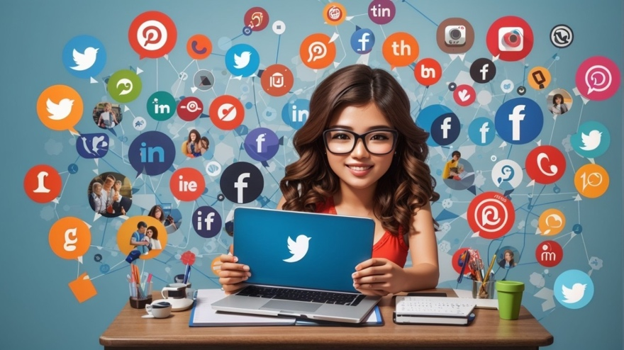
Social media and digital media can be used to reach a wider customer base

Student’s Name: Joanita Teixeira Fernandes Aparicio Guterres
Student’s ID: 2331039
Module Code: LCLM 4002
Module: Digital Skills
Group: 1 (Weekend)

Lecturer’s Name: Md Sadeque Imam Shaikh

August 27, 2024
University of wales trinity saint david
LONDON CAMPUS

Table of Contents
Introduction 2
Social media and Digital media for Marketing 3
Background of social media and Digital media 3
Traditional versus modern marketing of Sosial media 3
Using Sosial media or Digital media for marketing and reaching new customer 4
Advantages of Sosial marketing and customer acquisition 5
Disadvantages of social media marketing and gaining customer 5
Conclusion 7
References 8

Introduction
The rapid advancement of social media and digital media has completely transformed the marketing environment, equipping firms with potent tools to connect and captivate customers on a worldwide level. Since they began as online communities and bulletin boards, these platforms have evolved into complex networks that are now essential in modern marketing strategies (Kaplan and Haelein, 2010).
Social media sites such as Facebook, Instagram, and TikTok enable businesses to engage with specific audiences, establish brand recognition, and cultivate consumer loyalty through direct engagement. Furthermore, digital media, including websites, email, and online advertising, amplifies these endeavours by offering supplementary avenues for client interaction and conversion.
This paper examines the progress, advantages, and disadvantages of using social and digital media for marketing. It provides valuable insights into how organizations can efficiently exploit these tools to foster expansion.

Social media and Digital media for Marketing

Background of social media and Digital media
Since the 1980s, social media has extended beyond online groups and bulletin boards. According to Maryville University (2020), BBS and Usenet enabled modern social media by facilitating internet communication.
Six Degrees, Friendster, and Myspace pioneered user profiles and social networks in the late 1990s and early 2000s. Due to its popularity and features, Facebook, founded in 2004, has had an unmatched social media effect. In 2003, LinkedIn established itself as a platform for professional networking. Twitter became popular in 2006 by delivering real-time, succinct microblogging (Kaplan and Haenlein, 2010).
Instagram, Snapchat, and TikTok revolutionised video distribution and consumption in the 2010s. These platforms have transformed communication, business marketing, and sales, changing culture, communication, and business practices (Chaffey & Ellis-Chadwick, 2019). Video content, social commerce, influencer marketing, and privacy and regulation are transforming social media.
Developed in the late 20th century with the internet and personal computing, digital media includes text, audio, video, and graphics. World Wide Web adoption transformed media delivery and consumption in the 1990s. Online marketing and communication have relied on email, an early digital medium. Websites made e-commerce and digital advertising possible, solidifying digital media's role in marketing. Integration of social media with other digital media improves marketing (Chaffey & Ellis-Chadwick, 2019).

Traditional versus modern marketing of Sosial media
Traditional and modern social media marketing have different strategies, costs, and results.
Traditional marketing includes TV, radio, billboards, and print. It aims to reach large audiences with less precision and more costs. One-way communication in conventional marketing limits engagement and contribution. The lifespan of traditional marketing content is limited, and campaigns are longer to implement and adapt. However, modern social media marketing offers precision targeting at lower cost. It lets companies interact with their audiences, boosting immediate interaction and targeted content. Social media marketing’s versatility makes it easy to modify and share content, extending its lifespan. It also adapts quickly to current trends and audience feedback (Tuten and Solomon, 2017).
Traditional marketing creates a broad brand presence, while social media marketing is more personalised, adaptable, and cost-effective.

Using Sosial media or Digital media for marketing and reaching new customer
Sprout Social (2024) affirm that using social media for marketing requires multiple steps:
- Understand Your Audience: Develop thorough customer personas to reach your target market.
- Choose the Right Platforms: Use Instagram for visual material, LinkedIn for B2B, or TikTok for younger audiences.
- Develop a material Strategy: Create valuable, engaging material with high-quality visuals and storytelling. Posting consistently and keeping brand voice are essential.
- To establish community and loyalty, respond to comments, use user-generated content, and host live sessions.
- Use paid advertising: Targeted ads, retargeting, and A/B testing improve performance and reach specific audiences.
- Analyse and Optimise: Use data to improve strategy and track performance measures.
- Build Community: Use organisations, influencers, and loyalty programs to strengthen consumer relationships.
- Update: Follow trends, platform changes, and rival plans to compete.
- Compliance: Build confidence by being transparent, protecting data, and following rules.
- Measure Success: Track conversions and get customer feedback to evaluate your social media strategy.
- These strategies can help you reach and engage clients on social media and develop your business.

Advantages of Sosial marketing and customer acquisition
Social media has numerous significant benefits for marketing and acquiring new customers:
- Wide Reach: Ability to reach a worldwide audience.
- Targeted advertising refers to the capability of reaching specified populations.
- Cost-effective: Less expensive than conventional marketing.
- Enhanced Brand Awareness: Amplifies prominence and acknowledgement.
- Direct Interaction: Facilitates immediate and live communication with clients.
- Enhanced Engagement: Facilitates and encourages dynamic customer participation.
- Potential for Virality: Content could become viral, leading to a significant increase in exposure.
- Analytics and Insights: Offers information to facilitate well-informed decision-making.
- Competitor Analysis: Facilitates the monitoring and proactive response to industry trends.
- Fosters Trust: Establishes trustworthiness with the audience.
- Personalised marketing involves customising material to suit the specific tastes of everyone.
- Community building fosters the development of a devoted consumer base.
The advantages of social media make it a potent instrument for expanding businesses.

Disadvantages of social media marketing and gaining customer
The downsides of using social media for marketing and client acquisition include:
- It takes time and effort to manage accounts and content.
- Adverse criticism: Public scrutiny can destroy a brand.
- Regular algorithm updates may reduce content visibility.
- Intense Competition: Saturated markets make differentiation difficult.
- Ad Fatigue: Constant advertising may lose interest.
- Organic reach is limited: Reaching viewers without ads is harder.
- Privacy concerns can damage customer trust and lead to legal issues.
- Overreliance on social media may be risky.
- Disinformation: False information can spread quickly and damage brand reputation.
- Reputation management requires constant care.
- Possible costs: Paid ads and administration might be expensive.
- Short attention spans make explaining complex ideas difficult.
- These difficulties require careful planning to use social media for business.

Conclusion
In conclusion, social media and digital media have become crucial marketing tools, helping companies reach and engage more customers. From BBS and Usenet to Facebook, Instagram, and TikTok, these platforms have changed how businesses communicate with customers. These technologies improve brand loyalty and consumer relationships with real-time interactions and demographic targeting.
Digital media marketing and social media have cost-effectiveness, worldwide access, and virality, but they also have downsides. Due to regular algorithm upgrades and fierce competition, these platforms require enterprises to adapt and change methods. Balance is needed to address privacy, misinformation, and social media addiction.
In today's competitive market, businesses must use social and digital media for marketing. Businesses can utilise these tools to grow, create customer relationships, and stay competitive by understanding possibilities and challenges. To maximise social media and digital media marketing benefits and minimise risks, effective planning, ongoing optimisation, and trust and community are essential.

References
- NFI (2021) What Is Social Media? – Everything You Need to Know. Available at: https://www.nfi.edu/what-is-social-media/ (Accessed: 20 August 2024)
- Maryville University (2020) The Evolution of social media: How did it begin, and where could it go next. Available at: https://online.maryville.edu/blog/evolution-social-media/ (Accessed: 20 August 2024)
- Chaffey, D. and Ellis-Chadwick, F. (2019) Digital Marketing: Strategy, Implementation, and Practice. 7th edn. Harlow: Pearson Education.
- Smith, K. (2019). The importance of social media in Business. [Online] https://www.lyfemarketing.com/blog/importance-social-media-business/
- Kaplan, A.M. and Haenlein, M. (2010) ‘Users of the world, unite! The challenges and opportunities of social media’, Business Horizons, 53(1), pp. 59-68.
- Kaplan, A.M. and Haenlein, M. (2010) ‘Users of the world, unite! The challenges and opportunities of social media’, Business Horizons, 53(1), pp. 59-68.
- Tuten, T.L. and Solomon, M.R. (2017) Social Media Marketing. 3rd edn. London: Sage.
- Sprout Social (2024) ‘The Complete Guide to Social Media Marketing’, Sprout Social. Available at: https://sproutsocial.com/insights/social-media-marketing-strategy/ (Accessed: 23 August 2024).
- Mahoney, M. (2020). The Impact of Social Media on Business in 2020. [Online] https://www.singlegrain.com/blog-posts/impact-of-social-media-in-todays-business-world/ (Accessed: 22 August 2024 )

