

EXAMINATION PAPER
MARKS AND COMMENTS SHEET

PROGRAMME | OME Degree Apprenticeship
LEVEL | 4
MODULE | ACDB4011 Chemistry
STUDENT I.D. | 2416713
EXAMINER | Ewa Kazimierska | INTERNAL VERIFIER
Once completed marks only should be transferred onto the front of the examination paper (no comments other than ticks or crosses on the examination paper)

Question  Number | Comments | Marks available | Marks awarded | 2nd marker (sample) | 3rd marker (where necessary)
1 | 8/10 True/False answers correct. Strong performance overall, showing good grasp of reaction energetics, bonding, and orbital concepts. | 15 | 12
2 | Bohr model incomplete — missing particle counts and charges. Charge on N2 atom correct. Confusion in bonding and no link to OME. | 11 | 5
3 | Photon energy and configuration mostly correct. Unpaired electrons not stated; final part about absorption/emission was vague. | 10 | 8
4 | All parts answered correctly. However, ideal gas law was incorrectly used in part d when it was specifically asked not to do so. | 15 | 12
5 | No attempt on part a (oxygen balance), but strong performance in OB calculation and subsequent sections. | 16 | 12
6 | Reaction profile did not show enthalpy values. Reaction incorrectly labelled as exothermic. | 7 | 4
7 | Good understanding of phase diagram. No answer in part b (triple point), but the rest were well attempted. | 11 | 9
8 | Molarity calculated correctly. Net ionic equation not provided. | 5 | 3
9 | Fully correct calorimetry response. | 5 | 5
10 | Oxidation number error in part a. No clear agent identification in part b. | 5 | 3
 |  |  | 73

1st Marker Name | Ewa Kazimierska | 1st Marker Signature | 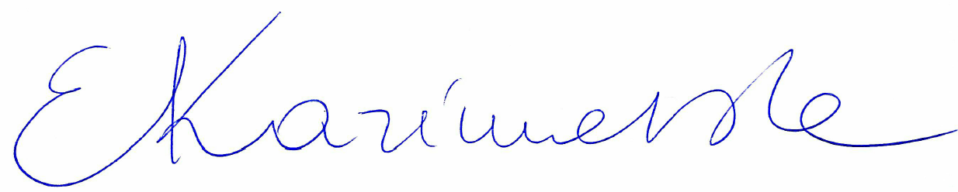
2nd Marker Name |  | 2nd Marker Signature
3rd Marker Name |  | 3rd Marker Signature
Reasons for awarding the final mark where there is more than one marker
Notes:
- The 3rd marker may be used where there is more than a 10 percentage point difference (in the TOTAL mark) between markers 1 and 2 OR when it is not possible to get agreement between markers 1 and 2. Reasons must be given where an agreed mark is given.
- This form is for internal use only and is NOT to be returned to the student. The final agreed marks must be transferred to the student feedback sheet in the assignment specification.
- The external examiner MUST be shown this form.

