Greig Western
ACHA6011
Advanced Motorsport Dynamics
Torque Vectoring
Tutor Mark Sandford

Contents
Introduction 1
Base vehicle specification 2
Generic torque vectoring systems 3
Longitudinal CofG position 5
Z-Z moment of inertia 6
Dynamic Index 7
Inertial Conjugate 8
Vehicle design specification 8
Mechanical torque path 9
Clutch pack torque capacity 10
Potential longitudinal acceleration improvements on a variety of surfaces 11
Control algorithms, sensors required and potential vehicle dynamic improvements 12
Conclusion 14
Bibliography 15

Introduction
The FF was Ferrari’s first foray into a four wheel drive vehicle for the road using the 4RM (4 Ruote Motrici, which translates to 4 wheel drive from Italian to English) four wheel drive system. It is unique amongst it’s contemporaries in the nature of its drivetrain, with the engine attached to 2 different gearboxes at either end of the crankshaft with the front gearbox, or PTU (Power Take-off Unit) capable of using 2 gears to enhance 4 of the gears in the rear mounted transaxle. Roberto Fedeli, Ferrari’s technical director tells that the PTU does not have a differential but rather uses wet carbon haldex type clutches to distribute the power to either or both wheels to varying amounts via continual slip up to 20% of total engine torque and weighs only 90 lbs (40.8 kg). (Forza, 2022) After this, the PTU is declutched to allow rear wheel drive only. The system intrudes less into the cabin space of the vehicle and improves the weight distribution. It was developed in conjunction with ex WRC champion Markku Alén to ensure the system worked correctly on all surfaces. Ferrari did not want to make a permanent 4 wheel drive system as they prefer rear wheel drive for dry conditions, “We don’t think it is the solution for dry conditions,” Fedeli explains. “It’s a compromise between the weight gain and the performance gain. For example, because we don’t think a supercar must deliver very high performance in the wet or on the snow, we don’t think we would use this kind of solution.”. Here, the system will be analysed with conclusions on the advantages or disadvantages compared to more conventional four wheel drive systems using 1 gearbox and multiple differentials to split the torque to all 4 wheels.

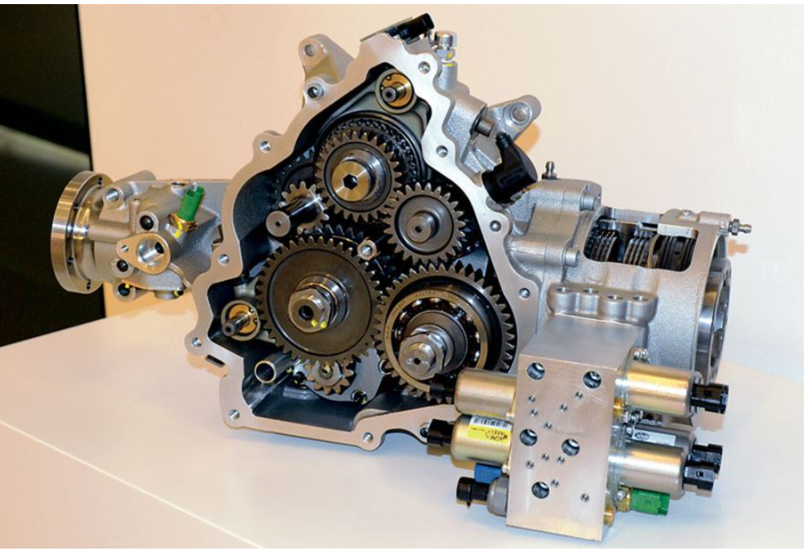
Fig 1. Ferrari FF PTU (Forza, 2022)

Base vehicle specification

Length 4907mm
Width 1953mm
Height 1379mm
Wheelbase 2990mm
Front track 1676mm
Rear track 1660mm
Kerb weight 1880kg
Fuel tank capacity 91 litres
Front tyres 245/35/20
Rear tyres 295/35/20
Power 660cv/486kw@8000rpm
Torque 683nm@6000rpm
0-100kph 3.7secs/ 35 metres

Mass distribution: 47% FRONT / 53% REAR
(Ferrari, 2022)

Generic torque vectoring systems

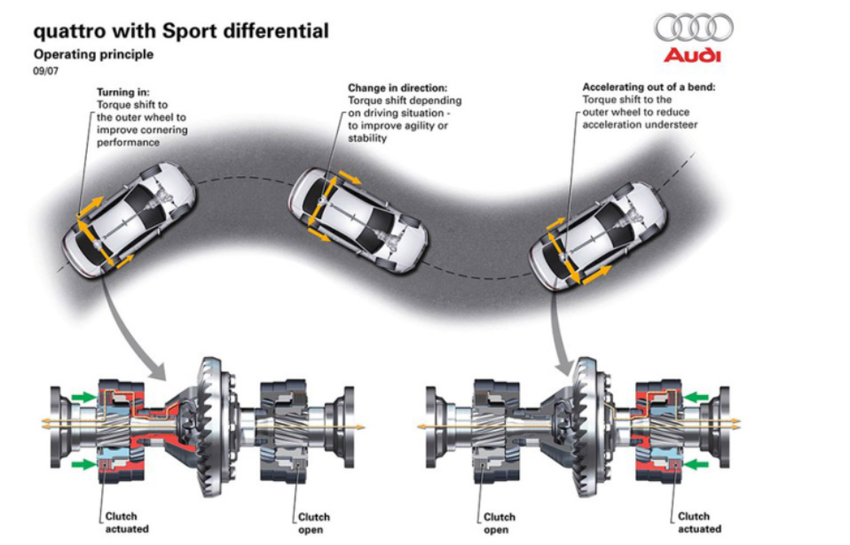
Fig 2. (Radu, 2022)
Torque vectoring, a term coined by Ricardo, in its simplest form, is directing the torque output of either output side of a differential to achieve the requested direction of travel for the vehicle by the driver. The increase of torque to an outside wheel will decrease the radius of the turn for a given input, whereas a reduction in torque will increase the radius of the turn, this is lateral torque vectoring. This can be seen in fig 3. A similar outcome can be achieved through longitudinal torque vectoring, with the dominant yaw authority given to the end of the vehicle with the most slip. In this manner a vehicle with predominantly rear biased power distribution could turn in quickly with rear yaw authority, allowing for oversteer, and then, as the requirement for increased yaw is reduced, the torque distribution can be managed to the front end, donating yaw authority, and understeer, to the front end, allowing the car to be more stable and controllable later in the corner. This can be seen in fig 4, on the left hand side, the car understeers naturally, but with longitudinal torque vectoring, the power distribution is varied to reduce the understeer moment by applying more power to the rear wheels. On the right hand side the oversteer prone vehicle is balanced by reducing power to the rear and increasing power to the front, allowing the vehicle to follow the requested path.

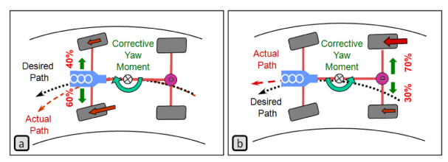
Fig 3. Lateral torque vectoring to correct under or oversteer in a vehicle (Jalali, Uchida, Lambert and McPhee, 2013)

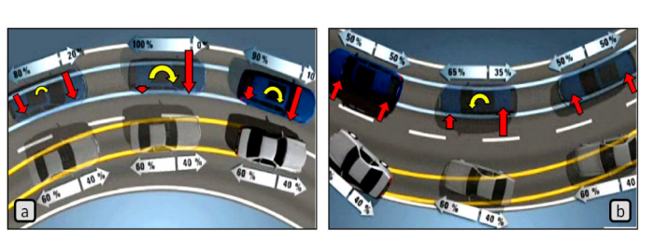
Fig 4. longitudinal torque vectoring in understeer and oversteer situations (Jalali, Uchida, Lambert and McPhee, 2013)

Lateral and longitudinal torque vectoring can be used in conjunction with each other to achieve increased results. This is seen in not only the Ferrari FF, but in more conventional vehicles such as the Ford Focus RS Mk3 and Range Rover Evoque. The benefit of these systems is also that it can keep each tyre within its traction ellipse, maximising the potential performance of the vehicle in any given situation.

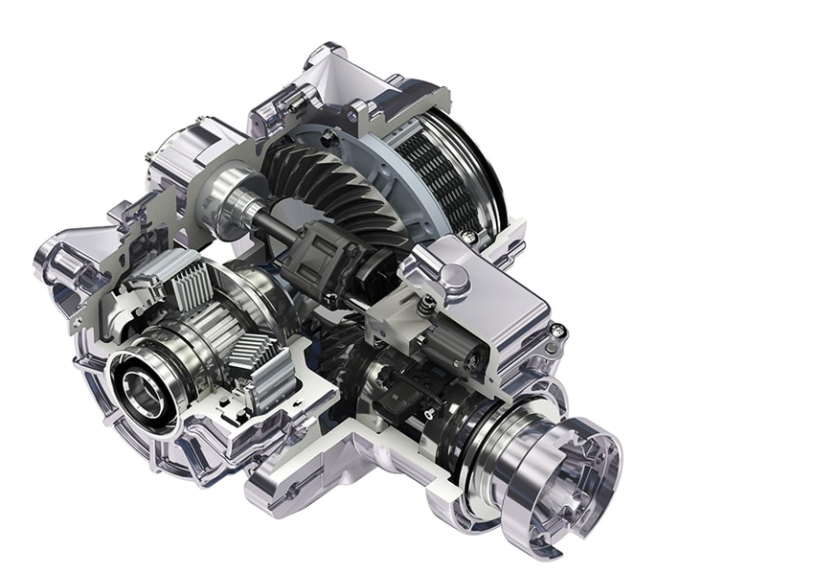
Fig 5. Ford Focus RS torque vectoring differential unit with spool drive and clutch packs for either side (GKNautomotive, 2022)

Longitudinal CofG position
Due to the known weight distribution of the car, 47% front and 53% rear, this can help deduce the centre of gravity longitudinally on the vehicle. If the front and rear masses are taken as the forces in opposing moments about the centre of gravity then the distances must be of the opposite percentage of length to each end as the percentages of mass. Therefore the front with 47% mass must have 53% of the wheel base to the front wheel to equal a moment at the other end with a mass of 53% of the overall, which must then act at 47%of the wheel base. As shown in fig 6.

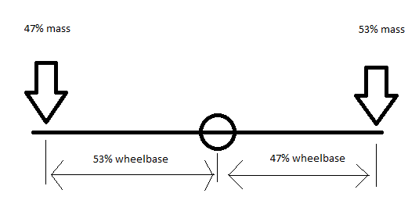
Fig 6.moments about CofG

Z-Z moment of inertia
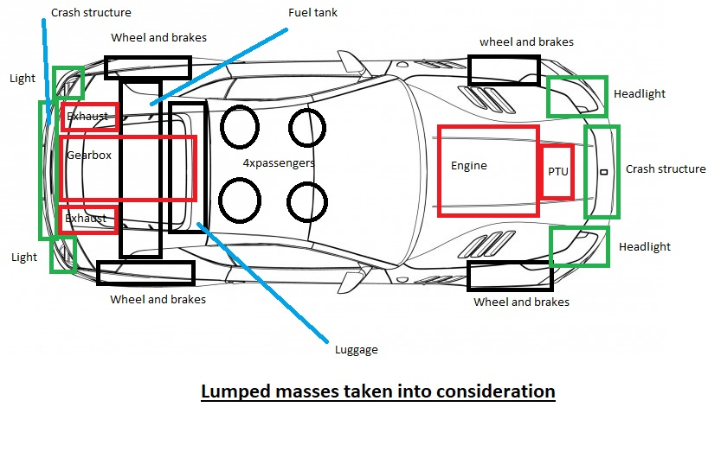
Fig 7. lumped masses
Generic values based on research were used for each of the lumped masses, and then these masses were compiled into an excel spreadsheet to calculate the mass moment of inertia of the vehicle. The remaining mass of the car was distributed between the front and rear of the car whilst keeping the front and rear moments equal based on their position and masses.

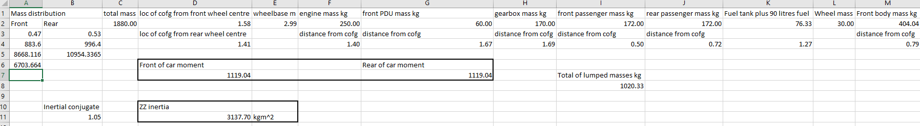
Fig 8. excel spreadsheet to calculate mass moment of inertia

The moment of Inertia is calculated using the sum of the masses multiplied by their respective radii squared from the CofG:
I_{zz}=Σmr² (1)
The masses were either taken as a longitudinal distance from the CofG if the mass is centrally located in the plan view, or in the case of passengers or wheels etc…the distance was calculated using Pythagoras theorem for the diagonal component of distance from the CofG for a more realistic value of Inertia.

Dynamic Index
Dynamic Index denotes the relationship between the rear axle and the centre of rotation of the car. A typical value of between 0.8 and 0.9 was found for regular road going vehicles, and a value of 0.52 being calculated for a Formula Student race car. From these values it is evident that the lower the figure, the easier it is to change direction quicky, but this figure also makes the car less stable in a straight line. It is therefore reasonable to expect a figure between these 2 values for a top of the range Ferrari, which will be expected to handle nimbly if required.
The equation to calculate the dynamic index is:
DI = $\frac{I_{zz}}{mab}$ (2)
Where I_{zz} is the inertia in the ZZ plane, m is mass, a is the front wheel to CofG position distance and b is the rear wheel to CofG position distance.
The final value based on The masses used for the Ferrari FF is 0.75.
Althought the dynamic index is low, the overall length of the car is quite long at 2990mm, and due to the parallel axis theorem, also known as Huygens or Steiner ((Rouelle, 2022), the vehicle will be stable in longer flowing corners rather than in tighter corners, which would be expected from a grand tourer type vehicle such as the FF. With the 47/53 balance of the car, the dynamic Index will be very close to its minimum for the given yaw inertia of the vehicle as seen in fig 9 (Sandford, 2022)
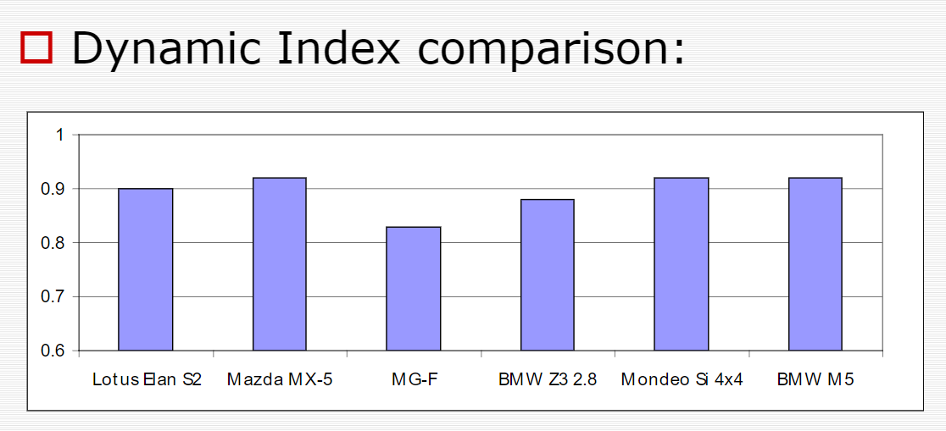
Fig 9. Dynamic Index comparison (Sandford, 2022)
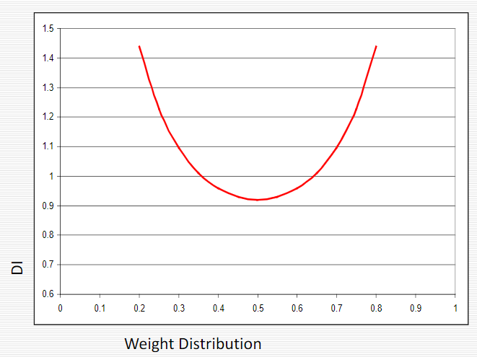
Fig 10. Dynamic index vs weight distribution split. (Sandford, 2022)

Inertial Conjugate
The Dynamic Index is a ratio of the centre of rotation from the CofG vs the rear axle position distance from the CofG.
DI = Inertial Conjugate distance/ rear axle distance (3)
As both the DI and the rear axle distance from CofG are known, the equation can be rearranged thus:
Inertial conjugate distance = DI*rear axle distance (4)
Giving a value of 0.75*1.41=1.05m

Vehicle design specification
The Ferrari FF is designed to be a grand tourer with its long wheelbase and large engine, however the low dynamic index of the vehicle due to the layout of the vehicle, such as the position of the engine inside the wheelbase, allows the naturally stable vehicle to also be used in a spirited fashion on smaller curves and corners. The front mounted gearbox with 6% additional slip vs the rear drive portion of the vehicle would suggest that this can be used to bring the vehicle back under control, reducing oversteer in tight bends when desired by increasing the yaw authority of the front end. This torque vectoring allows the car to be naturally agile, allowing greater turn in when required, with the ability to control excessive oversteer should the back end come around too aggressively for the driver.
With the long wheelbase, low dynamic index, and torque vectoring, this platform can potentially be used in any situation that is required by the driver, from straight line GT driving to tight cornering. The relationship between yaw authority, wheelbase and dynamic index can be seen in fig 11. The Ferrari FF seems to have been designed with the best of both worlds in mind with a low dynamic index and long wheel base.
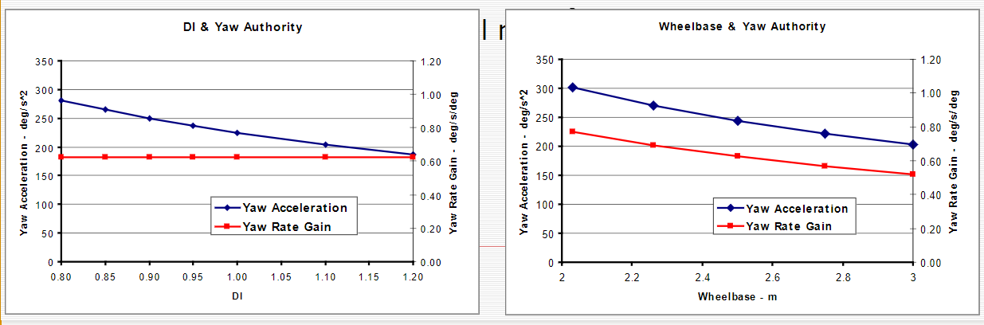
Fig 11. Yaw authority vs wheelbase and dynamic index. (Sandford, 2022)

Mechanical torque path

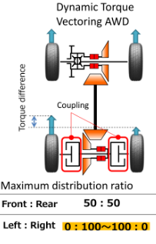
Fig 12. (Toyota introduces all-new RAV4 in Japan; new Dynamic Torque Vectoring AWD system, new hybrid, 2022)
Fig 12 shows a torque vectoring torque path as per the Ferrari FF, but with the system working at the rear end of the vehicle. The theory, however, is the same. The power is supplied to the axle through the gearbox, whereupon couplings, or clutch packs, are placed between the gearbox and the wheels to be driven. The amount of lock applied to each clutch pack determines the slip, and therefore the drive to each wheel, resulting in the shown torque difference. The Ferrari splits the power 20:80 front to rear instead of the shown 50:50, however, the left to right is the same as either side can have 100% of the power to the forward gearbox distributed to its respective driven wheel.

Clutch pack torque capacity

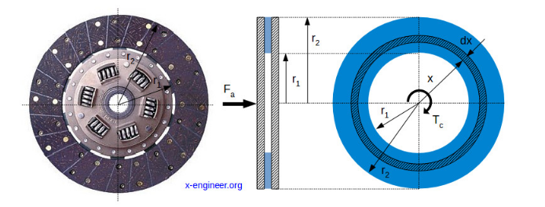
Fig 13.x-engineer.org

Using the uniform pressure equation:
T_{c} = n$\frac{2}{3}$µ $\frac{r_{2}^{3}{-r}_{1}^{3}}{r_{2}^{2}{-r}_{1}^{2}}$F_{a}
Where T_{c} is the clutch torque, n is the number of clutch faces, µ is the coefficient of friction, r₁ is the inner radius of the clutch face, r₂ is the outer radius of the clutch face, and F_{a} is the applied force axially to the clutch pack.
The maximum torque of the engine is rated by Ferrari at 683Nm at 6000 RPM. The PTU is designed to allow 20% of engine power through it, and as power is a function of torque and engine speed, the maximum torque rating for this clutch pack should be 20% of this figure, which is equal to 136.6Nm. This figure will be used for each side so that the torque vectoring system can send all of the power to one wheel in extreme conditions.
Assuming a carbon/steel combination (Forza, 2022) of clutch plates and pressure plates the coefficient of friction is 0.1 wet with a maximum axial pressure of 3MPa. (Friction Materials - Roy Mech, 2022)
An assumption of 4 clutches, based on fig 1. or 8 surfaces per side has been made leaving only the inner and outer radii to be determined.
Using an excel calculator, with the coefficient of friction and plates set, the clutch radii were set to 50mm and 75mm respectively, with an axial force of 2700N. Using the radii to calculate the area of the clutch surfaces and the axial force, the pressure achieved is 0.28MPa, which is far below the maximum pressure of 3MPa allowable in this case.

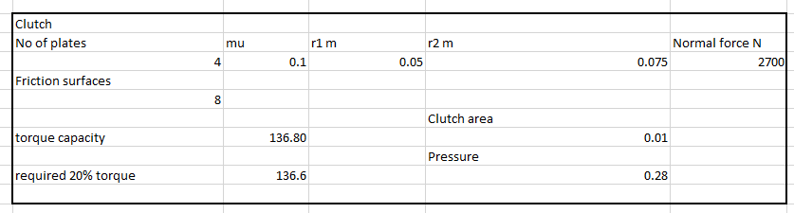
Fig 14. Excel calculator for clutch torque capacity

Potential longitudinal acceleration improvements on a variety of surfaces

MU: 0.1 ICE, 0.4 SNOW, 1.0 TARMAC
- RWD
- AWD
Using ∆W_{x} = $\frac{h}{l}$x W x A_{x}
Where ∆W_{x} is the increase in rear axle load, l is the wheelbase of the vehicle, h is the CofG height, W is the total car mass and A_{x} is the longitudinal acceleration one can calculate the longitudinal weight transfer. Due to a lack of ability t physically measure the centre of gravity height with a real Ferrari FF, and a lack of data available from Ferrari, a nominal CofG height of a Jaguar race car has been used due to the similarity in vehicle layout.

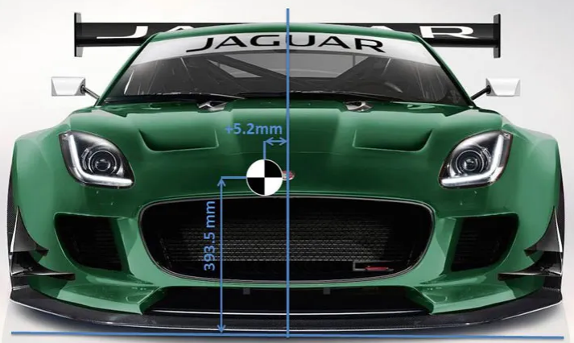
Fig 15. nominal CofG height. (Suspension Secrets, 2022)

This will be taken as 0.3935m, wheelbase is 2.99m, total mass is 1880kg and A_{x} can be calculated from the official acceleration figures of 0-100kph in 3.5 seconds, or 7.94 m/s², which can be divided by 9.81 for acceleration in g: 0.8
Therefore the equation becomes ∆W_{x} = $\frac{0.3935}{2.99}$x 1880 x 0.8 = 200.25 additional load on the rear axle from weight transfer. Added to the 53% rear weight distribution of 996.4kg = 1116.65kg or 10954.34N of load.
For a µ of 1.0, the equation F = ma can be rearranged for acceleration, giving a = $\frac{F}{m}$ or $\frac{10954.34}{1880}$ = 5.83m/s². Which is the best case scenario for rear wheel drive only. For snow with a $µ$ of 0.4 this becomes $\frac{10954.34*0.4}{1880}$ = 2.34m/s² and for ice, with a µ of 0.1 it is $\frac{10954.34*0.1}{1880}$ = 0.583m/s².
For 4wd we must account for the front drive wheels as well. Due to the weight transfer in acceleration the weight acting on the front wheels, and therefore useable load, reduces at the front end. However, the front wheels are now producing forward thrust in addition to the rear wheels.
The starting point is 47% of the 1880kg mass, being 883.6kg or 8668.12N. removed from this is the 200.25kg weight transfer calculated earlier, leaving 6703.66N. The acceleration at µ = 1 is therefore $\frac{10954.34+6703.66}{1880}$ = 9.39m/s², acceleration on snow is $\frac{\left(10954.34+6703.66\right)*0.4}{1880}$ = 3.76m/s² and ice is $\frac{\left(10954.34+6703.66\right)*0.1}{1880}$ = 0.94m/s². The official times differ from this, however, the CofG height can be adjusted from the assumption made against the Jaguar to give a closer acceleration value. The results given however, show a significant improvement in all acceleration values due to the additional force available at the front wheels.

Control algorithms, sensors required and potential vehicle dynamic improvements

For this system to work correctly, the ECU must read data from various sensors’ inputs to achieve the required outputs. Firstly, for longitudinal and lateral situations the ECU should know the wheel speed at each corner vs the speed of the vehicle, this can be achieved with hall effect sensors (Wheel speed sensors, 2022) at each wheel and a GPS system for speed (bridgewaterelectronics.co.uk, 2022). Torque can also be sensed via sensors on the driveshafts which measure the deflection of the shaft along its length, giving resultant torque (Dynamic Drive Shaft Torque Sensor | KASensors, 2022). Load sensors at each corner can then be used for the load placed on each tyre (AIM Motorsport Car/Bike Suspension Potentiometer, 2022). Using data for the tyres as for their specific adhesion ellipses, the ECU can monitor each corner of the vehicle vs the load, wheel speed and torque, and vehicle speed. Atop of this, the ECU should consider the steering input via a steering angle sensor and the yaw rate of the vehicle using a yaw sensor (Yaw rate sensor - Car Terms | SEAT, 2022) to monitor the rate of yaw vs input. At a set ratio of these 2 inputs the ecu should start to intervene by increasing slip to the corner, side, or end of the vehicle affected to correct the yaw rate to a pre selected level. Levels of steering rate between 100-1100 degrees per second (Sandford, 2022) would result in ever increasing intervention by the system as practicable response from a human dwindles.

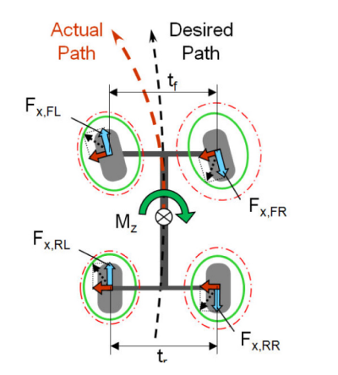
Fig 16. torque vectoring control showing adhesion ellipses of tyres (dashed lines potential adhesion, solid lines actual friction ellipse). (Jalali, Uchida, Lambert and McPhee, 2013)

Jalai et al showed that during the ISO double lane change maneuver, or moose test, the torque vectoring system, when correctly set up, allowed the vehicle to follow a near perfect desired path at 75 kph with far better lateral acceleration results with torque vectoring, and yaw control torque vectoring systems. Vehicle speed was also far better maintained over the maneuver with the systems active than without.

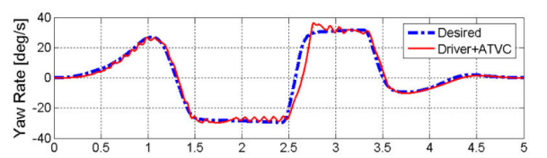
Fig 17. desired vs actual yaw rate in double lane change maneuver with torque vectoring) (Jalali, Uchida, Lambert and McPhee, 2013)

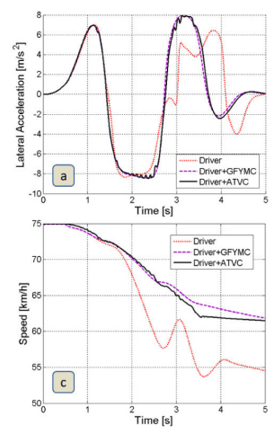
Fig 18. Lateral acceleration and vehicle speed vs time for driver, driver plus torque vectoring, and driver plus yaw sensing torque vectoring system (Jalali, Uchida, Lambert and McPhee, 2013)

Conclusion

The Ferrari FF platform has been designed to allow the car to be proficient at both GT car type situations and tight track day type driving. The long wheelbase and inertial conjugate gives stable performance on long corners, with the low dynamic index giving a comparatively lively chassis for its length. To overcome any excessive oversteer at lower speeds, such as those encountered on a twisty road or track, the 4RM system is able to provide a corrective yaw moment to afford the driver a much easier drive at speed. At higher speeds, where there is less likelihood of tight cornering, the FF becomes rear wheel drive, giving a ‘pure’ Ferrari feel. This system allows for better handling and response across a variety of surfaces and allows less competent drivers to extract performance from the car without injury to themselves or damage to the vehicle. This unique system seems to be the forebear to future EV systems where the forward and rear drive units can be separate from each other, allowing a larger space in the cabin, and more favourable weight distribution.

Bibliography
Rouelle, C., 2022. Optimal thinking. Racecar engineering, pp.60-62.
Green Car Congress. 2022. Toyota introduces all-new RAV4 in Japan; new Dynamic Torque Vectoring AWD system, new hybrid. [online] Available at: <https://www.greencarcongress.com/2019/04/20190411-rav4.html>
Radu, V., 2022. What Is Torque Vectoring and How it Works. [online] autoevolution.com. Available at: <https://www.autoevolution.com/news/what-is-torque-vectoring-and-how-it-works-152235.html>
Jalali, K., Uchida, T., Lambert, S. and McPhee, J., 2013. Development of an Advanced Torque Vectoring Control System for an Electric Vehicle with In-Wheel Motors using Soft Computing Techniques. SAE International Journal of Alternative Powertrains, 2(2), pp.261-278.
GKN. 2022. GKN Automotive | How the Ford Focus RS AWD system changed the game for drivelines. [online] Available at: <https://www.gknautomotive.com/en/Utilities/Focus-RS-torque-vectoring/>
Ankinovich, G., Verzhbitski, A. and Antonyan, A., 2020. Mathematical modelling of torque vectoring differentials. IOP Conference Series: Materials Science and Engineering, 820(1), p.012025.
Antunes, J., Antunes, A., Outeiro, P., Cardeira, C. and Oliveira, P., 2019. Testing of a torque vectoring controller for a Formula Student prototype. Robotics and Autonomous Systems, 113, pp.56-62.
Vignati, M., Sabbioni, E. and Cheli, F., 2018. A Torque Vectoring Control for Enhancing Vehicle Performance in Drifting. Electronics, 7(12), p.394.
L. De Novellis, A. Sorniotti and P. Gruber, "Wheel Torque Distribution Criteria for Electric Vehicles With Torque-Vectoring Differentials," in IEEE Transactions on Vehicular Technology, vol. 63, no. 4, pp. 1593-1602, May 2014, doi: 10.1109/TVT.2013.2289371.
G. De Filippis, B. Lenzo, A. Sorniotti, P. Gruber and W. De Nijs, "Energy-Efficient Torque-Vectoring Control of Electric Vehicles With Multiple Drivetrains," in IEEE Transactions on Vehicular Technology, vol. 67, no. 6, pp. 4702-4715, June 2018, doi: 10.1109/TVT.2018.2808186.
Kim, D. and Jang, S., 2020. DCTF Flow Distribution Design in Clutch Packs of wet DCTs. International Journal of Automotive Technology, 21(2), pp.527-533.
Agrawal, A., Jeet, C. and Jaiswal, S., 2014. Optimized Design of Friction Clutch for Maximum Torque Transmitting Capacity Using Uniform Pressure Theory. Applied Mechanics and Materials, 592-594, pp.1245-1251.
Forza. 2022. Fantastic Four | Issue 113 | Forza | The Magazine About Ferrari. [online] Available at: https://www.forza-mag.com/issues/113/articles/fantastic-four> [Accessed 5 April 2022].
Roymech.org. 2022. Friction Materials - Roy Mech. [online] Available at: <https://roymech.org/Useful_Tables/Drive/Brake_Clutch_mat.html> [Accessed 5 April 2022].
2022. [online] Available at: <https://www.ferrari.com/en-GB/auto/ff> [Accessed 5 April 2022].
ATE International. 2022. Wheel speed sensors. [online] Available at: <https://www.ate-brakes.com/products/wheel-speed-sensors/> [Accessed 5 April 2022].
2022. [online] Available at: <https://www.bridgwater-electronics.co.uk/gps-road-speed-signal-interface-p139> [Accessed 5 April 2022].
Kasensors.com. 2022. Dynamic Drive Shaft Torque Sensor | KASensors. [online] Available at: <https://www.kasensors.com/en/products/dynamic-drive-shaft-torque-sensor> [Accessed 5 April 2022].
Demon Tweeks. 2022. AIM Motorsport Car/Bike Suspension Potentiometer. [online] Available at: <https://www.demon-tweeks.com/uk/aim-motorsport-car-bike-suspension-potentiometer-609569/> [Accessed 5 April 2022].
Seat.co.uk. 2022. Yaw rate sensor - Car Terms | SEAT. [online] Available at: <https://www.seat.co.uk/car-terms/y/yaw-rate-sensor.html> [Accessed 5 April 2022].
Suspension Secrets. 2022. How To Calculate Centre of Gravity Position – How To Adjust And Tune – Suspension Secrets. [online] Available at: <https://suspensionsecrets.co.uk/how-to-calculate-centre-of-gravity-position/> [Accessed 5 April 2022].

