Evaluate the reasons for and against the return of the death penalty.

Student ID: 1900576
Tasnim Kadir
University of Wales Trinity Saint David

Contents
Executive summary 3
Introduction 3
Main body 5
References 10

Executive summary

In this report, I chose to explore the question title ‘evaluate the reasons for and against the return of the death penalty’. I have looked at three areas, for and against of the death penalty, the government and what the situation is currently with this subject matter. I focused on these areas specifically as I wanted to have a wide range of opinions are information to look at when making my conclusion. For the first part of my project I aimed to explore the for and against for bringing back the death penalty. My second aim was to assess what actions the government have put in place and what’s their opinions are on this matter. For my final aim I investigated what the current situation is. I found a

Introduction

In this assignment I will be looking at the two sided discussion on whether the death penalty should be brought back into act or not, and the pros and cons of the death sentence from members of the public at this point in the United Kingdom, I will also be looking into the views of different people’s opinions on if the death penalty should be brought back in and if not why wouldn’t it work in todays society. The death penalty was brought in act in the United Kingdom as early as the 17th century until it was abolished in 1965 but in Northern Ireland up until 1973. The death penalty was a government approved custom where a person is executed by state-owned as punishment for a crime they have committed, the act of carrying out the sentence is known as an execution. Crimes that are punishable by the death sentence is known as capital crimes which are essentially the more serious of crimes or capital offences, and they stand usually to include offences such as murder, crimes against humanity and genocide or war crimes.

Main body

The death penalty has been a subject matter of debate and discussion for a long time, there are many reasons for and against capital punishment. Capital punishments were common at one time or other in the evolving history of many countries and numerous of them have now abolished the death penalty from their criminal justice systems. There are 7 types of capital punishments well-known to people. These are: Death by Hanging, Execution by Firing Squad, Lethal Injection, Gas Chamber Executions, Death by Stoning, Death by Beheading and Electrocution. (Cornell Center on the death penalty worldwide, 2012). Arguments for the death penalty include; that if a person murders someone they have given up their human rights (BBC , 2011) most people believe in this and believe in a life for a life, and that the suspect does not deserve to live after taking another life. “Money is not an inexhaustible commodity and the government should very well better spend the limited resources on the old, the young and the sick” (Capital punishment UK, n.d.) several people believe that the taxpayers money should go to pay for more important issues for example the NHS and not for the imprisonment of murderers, rapists, and paedophiles. Another main argument people have for the death penalty is by executing criminals, the death penalty eliminates the problem of housing them inside the prison system. Prisons are overcrowded and due to the seriousness of inmates’ sentence, the expenses are a lot to house, feed and isolate these prisoners. If these dangerous criminals were discharged on bail there is always a likelihood they could re-offend, this is abolished with the death penalty. From the graph below, you can see there has been a major increase of the number of prisoners since the millennium. 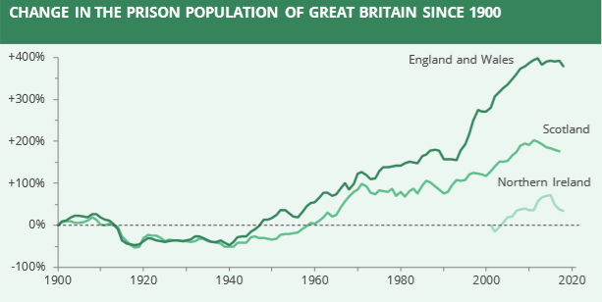
(UK Prison Population Statistics , 2019)
Arguments against the death penalty, include that the death penalty goes against human rights, the right to live (BBC , 2011) this argument is supported by a number of people who believe that penalising a person to death and killing them contravenes that right. The most popular reason against the death penalty is that innocent citizens will get executed because of mistakes and errors, for example from the case of Donald Marshall Jr, He was falsely sentenced of murder and he was put in prison for more than a decade for a crime he didn’t do (Crime Museum, 2017). Occasionally people turn out to be not guilty, the death penalty is irreversible as a result re-establishing the death penalty it can cause uprisings if mistakes happen. Another reason is that is the deaths aren’t always quick and painless especially with the lethal injection and electrocution (BBC , 2011).

A member of the Conservative Party, John Hayes, has asked the government to consider bringing back the death penalty. He believes that there should be punishments given to those who have committed horrendous crimes. The justice minister Edward Argar “opposes the use of the death penalty in all circumstances and has no plans to reintroduce it”. (Tory MP asks government to consider bringing back death penalty, 2018) “The Minister of State for the Home Office, Lord Williams of Mostyn QC, said that ratification made it impossible for Parliament to reintroduce the death penalty” (David Hoffman, 2010) Certain members of the government think that the death penalty would go against all legal matters. Overall the British government do not want to bring back the death penalty but instead want to encourage other countries to abolish it as well. (Is the UK government's stance on the death penalty shifting?, 2018). As they advocate in human rights especially those in minority groups such as people of colour, religious people and LGBT people. (HRC40: UK Statement on the use of the Death Penalty, 2019). The current situation regarding the death penalty is that there is improvement on abolition over the past 20 years and the international trend towards abolition is increasing. (HMG Strategy for Abolition of the Death Penalty 2010-2015, 2011) The government main aim is for global abolition of the death penalty.
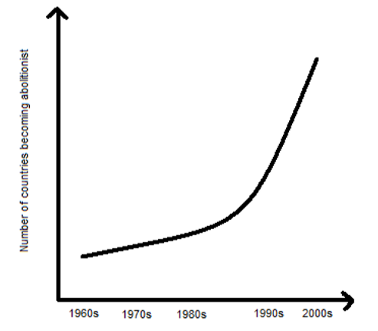
(HMG Strategy for Abolition of the Death Penalty 2010-2015, 2011)

Conclusions

References
(n.d.).
(2011, September 21). Retrieved from BBC : https://www.bbc.co.uk/newsround/15007511
Capital punishment UK. (n.d.). Retrieved from Capital punishment UK: http://www.capitalpunishmentuk.org/contents.html
Cornell Center on the death penalty worldwide. (2012, june 22). Retrieved from Death penalty worldwide : www.deathpenaltyworldwide.org/methods-of-execution.cfm
Crime Museum. (2017). Retrieved from Crime Museum: https://www.crimemuseum.org/crime-library/famous-prisons-incarceration/donald-marshall-jr/
David Hoffman, J. J. (2010). Human rights in the UK An introduction to the Human Rights Act 1998. In J. J. David Hoffman, Human rights in the UK An introduction to the Human Rights Act 1998 (p. 148). Essex: Pearsons Education limited .
HMG Strategy for Abolition of the Death Penalty 2010-2015. (2011, October). Retrieved from Gov uk: https://assets.publishing.service.gov.uk/government/uploads/system/uploads/attachment_data/file/35448/death-penalty-strategy-oct-11-15.pdf
HRC40: UK Statement on the use of the Death Penalty. (2019, February 26). Retrieved from GOV: https://www.gov.uk/government/news/hrc40-uk-statement-on-the-use-of-the-death-penalty
Is the UK government's stance on the death penalty shifting? (2018, July 23). Retrieved from The Guardian: https://www.theguardian.com/world/2018/jul/23/is-the-uk-governments-stance-on-the-death-penalty-shifting
Tory MP asks government to consider bringing back death penalty. (2018, November 3). Retrieved from The Independent : https://www.independent.co.uk/news/uk/politics/tory-mp-bring-back-death-penalty-john-hayes-lincolnshire-capital-punishment-a8615731.html
UK Prison Population Statistics . (2019, july 23). Retrieved from House of Commons Library : https://researchbriefings.files.parliament.uk/documents/SN04334/SN04334.pdf

