The module title: Sustainable Hospitality & Tourism
Management
Module code: BMIH5006

Student name: Mihaela Buzdugan Student number: 2121942

Lecturer’s name: Ruth Taylor Davies

Table of Contents
Introduction 3
Main Body 3
What is the future of hospitality, and is it profitable to be green? 3
Are businesses responsible for environmentally sound? 5
Models 7
Future recommendations 9
Conclusion 10
References 11

Introduction
Sustainable Hospitality is the key application of sustainable practices within hospitality and hotel operations and works towards creating compliance, environmental, social and governance (ESG) principles (Rossidis, Belias and Vasiliadis, 2021). The major principle of working in green hospitality is to offer a luxurious experience while focusing on the negative environmental impacts of hotel operations.
The present report focuses on justifying the statement that the concept of green hospitality needs to be emphasised. Along with this, the report with suitable industry examples also demonstrates the CSR of an organisation is not just to increase profits but also to make businesses responsible for being environmentally sound.

Main Body

What is the future of hospitality, and is it profitable to be green?
Hospitality will embrace AI and ML to better manage individuals and encounter operations.
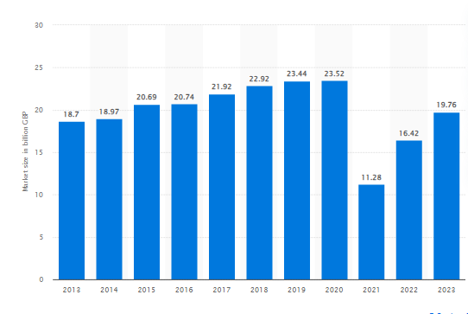
Figure 1: Hotel industry UK market size from 2013 to 2023
(Source: Statista, 2023)
The UK has renowned 5-star to major hotel brands. This shows in FY 2022, the size of the hotel industry was 16.42 billion British pounds approximately. This shows there is an increase from prior years of around 11.28 billion British pounds. As per 2023, the sizes of hospitality industry achieved 19.76 billion British pounds (Statista, 2023). Embracing AI and ML while looking after clients and guests within the hospitality sector announces the chance of addressing the challenges and the future of hospitality will be excellent due to the results showing in 2020, 23.52 billion British pounds was the market size, this shows the value of the hospitality sector is higher.
Therefore, looking at these outcomes and understanding the holistic approach to sustainability concerned with sustainability, it is noticed that working towards making eco-friendly goods will definitely translate into creating more profit and success (Uğurlu, 2020). Milton Friedman stated the social responsibility of an organisation is to leverage profits, which means the only responsibility is towards creating shareholders satisfied and has zero social responsibility to society and the public.
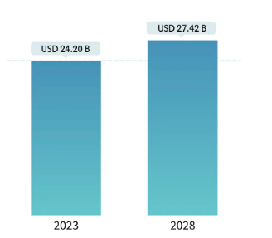
Figure 2: UK hospitality industry market size
(Source: Mordorintelligence, 2023)
The current hospitality market size of the UK is USD 24.20 B and is estimated to increase to about USD 27.42B in 2028 (Mordorintelligence, 2023). Looking at the figures, it can be said that UK hotels like Premier Inn, Travelodge, etc. use Milton Friedman's theory of corporate social responsibility, which means it helps in returning value to shareholders, and this must be the primary responsibility of the business. The current figure shows there is decent value in the hospitality sector of the UK, and in the upcoming year 2028, there will be USD 27.42B, and this is possible when shareholders will invest money in creating efforts to create value for the entire hotel.
If the hospitality sector works on developing Friedman’s business ethics and satisfying shareholders, there will be a possibility that the business will endeavour to maximise revenues to enhance returns (Lee, Man and Chan, 2022). Therefore, the concept of undertaking business ethics is still relevant today, and the statement “Does finance come first” is not entirely correct, but to make the business work on the desired goals, it is the duty of the shareholder to build emergency funds and encourage to invest in other long-term goals.

Are businesses responsible for environmentally sound?
The environment influences a company's legal responsibility, and to consider the fact that it is necessary to make businesses responsible towards the environment, it is crucial for the business to recycle waste, resulting in the business developing a positive reputation. Yes, businesses responsible are responsible for being environmentally sound along with being consumer-driven (Al-Hyari, Al-Smadi and Weshah, 2023). The justification for this is that working on environmental responsibility is truly crucial. When a business works on being more sustainable, it leads to creating a positive image, such as creating brand awareness and helping attract more customers who are favourably predisposed to brands actively engaged in sustainable practices.
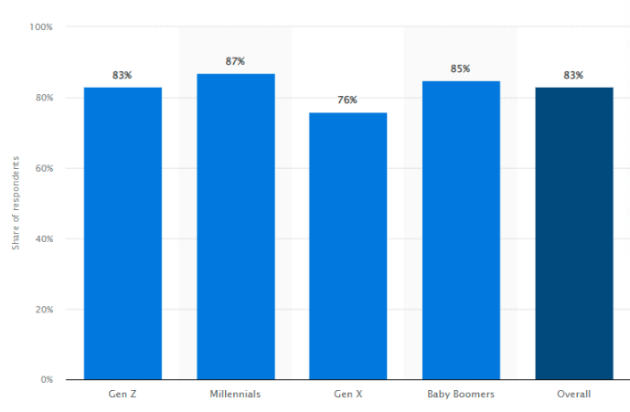
Figure 3: Customers willingness to splurge upon sustainable commodities within 2022
(Source: Tighe, D, 2022)
According to a survey conducted in FY 2022 in the UK, 80 per cent of consumers stated they would give at least ten per cent more for the commodities when the products were environmentally friendly (Tighe, D, 2022). This means that customers are more inclined towards making environmentally friendly items and keeping them all in the bathrooms or other areas. Sustainable items like organic fabrics, bamboo, and reclaimed materials. One of the well-known hotels, Whatley Manor Hotel and Spa, has taken steps to reduce its environmental impact while it works on long-term plans to stay eco-friendly.
As it is understood, businesses are responsible for being environmentally sound; likewise, Whatley Manor, UK, also aims towards working to reach Net Zero energy and supply chain emissions by 2028 (Whatley Manor, 2023). The justification for "Can the Hospitality Industry be truly green” is it is necessary for hotel chains to implement recycling initiatives as much as possible. For example, Marriott, UK’s green responsibility is one of the best-known practices in the hospitality industry because it includes the removal of single-use plastic in rooms. They also work with suppliers and share a common ethos (Marriott, 2023). Involving grey-water management systems helps in lowering water usage because they make use of recycled water, and it can significantly lessen entire water consumption.
Therefore, environmental management provides the hotel industry with eco-friendly establishments and offers them extraordinary outcomes; at present, almost half of the sectors in the world are focusing on working with green technology and creating a sustainable market. The hotel industry market amounted to around 13.76 billion U.S. dollars, and by 2030, it will gain a peak of about 62 billion U.S. dollars (Laricchia, 2023). These results show the hospitality industry can be truly green because of infinite positive results.
Yes, financial resiliency is the key to sustainability because creating resilience in any field of business creates the capability to strive towards presenting change for a better tomorrow. Financial resiliency is considered as the system's ability to prepare for threats, absorb bad influence, and come out with excellent results (Shiri and Jafari‐Sadeghi, 2023). Sustainability and financial resiliency are considered hand-in-hand because they help in recovering the bad impacts and adapting after disruptive events (Fatima and Elbanna, 2023). Establishing financial resiliency needs clear visibility and understanding that spans across the hospitality sector, and once the hospitality industry is able to have clear and precise knowledge of working with financial resiliency, it becomes effortless to effectively manage and measure efforts (Pan, et al. 2022).

Models
Doxey’s Irridex model
There are four-step timelines of Doxey’s Irridex model: Euphoria, Apathy, Annoyance and antagonism. In the Euphoria stage, the destination's population might feel euphoric, which is related to a positive emotion, and working in this stage, the hotel sector can be associated with the development of a hotel. As a result of this, it creates a sense of anticipation (Matala, 2022). The next stage is Apathy, which shows when employees' behaviour shows interest or energy and work towards being willing to take action. This creates the possibility of creating an understanding that employees need to create value among clients.
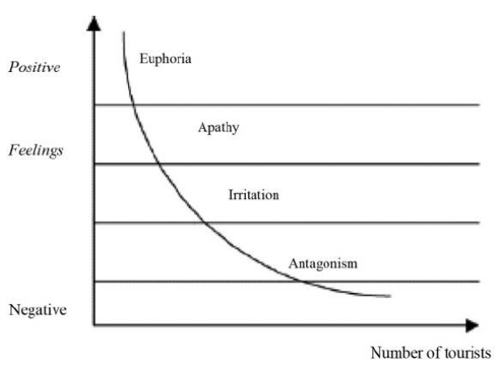
Figure 4: Doxey’s irridex irritation index
(Source: ResearchGate, 2023)
Part three of the Irridex is an annoyance, as this is a fairly negative emotion; therefore, it is necessary for the hotel industry to work on this stage and start developing factors or aspects which create a stronger feeling among the guests to make connections with the hotel. To consider this factor, all the hotel industry needs to focus on is staying on the eco-friendly concept as much as possible (ResearchGate, 2023). Work on supply chain emissions and provide them with something which they did not expect, resulting in creating a positive feeling. The final stage is antagonism, and this creates a worse situation for the hospitality sector; therefore, the report shows the root cause or issue faced by guests is not working on recycling initiatives or the overuse of fossil fuels. Therefore, overcoming them as soon as possible by making long-term plans to use renewable sources of energy creates environmental sustainability (Zaman, et al. 2022).
Butler’s life cycle model
Butler Model explains the evolution of tourism destination, and it suggests that tourism area evolves through exploration, development, consolidation, etc.
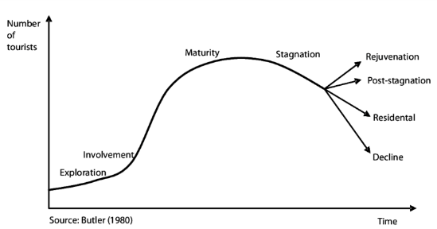
Figure 5: Butler Life Cycle Model
(Source: ResearchGate, 2023)
Exploration is the first stage where the administration of the UK thinks about the tourism sector, and it can provide maximum advantage when the hospitality sector is able to capitalise on tourism planning. The involvement stage marks the emergence of seasonality in tourism, where ensuring development, like enhancing marketing and promotion of location, ensures growth. Consolidation is the fourth stage (ResearchGate, 2023). When the government of the country works at this stage, there will be the possibility of having a close tie between gaining the economy of the destination.
Stagnation is the stage which represents the beginning of the decline in tourism because it is no longer desirable; thus, working on incorporating upcycled furniture and promoting the visiting of guests will create excellent outcomes for the hospitality sector. The decline will be the outcome when the sector is unable to work on the solution; thus, it is necessary to plan the actions and work on development projects for slow but continuous growth.

Future recommendations
- To measure the financial, environmental and social performance of hospitality, the Triple Bottom Line (TBL) theory is used (Achmad and Yulianah, 2022). It is suggested that TBL theory helps companies to work on profit, people, and the planet simultaneously and using this ensures businesses are able to earn income in an ethical and fair manner. This theory allows business to solicit partner’s shareholders with which it aligns philanthropically, and it becomes easier for the business to develop its strategy as well as financial operating plans. Profit is also tied with the responsibility of the company to pay their shareholder and make them satisfied. Also, when business works towards ensuring customers have access to products and employees receive a fair wage, this eventually encourages professional development. Additionally, working on lessening the harmful impact on the planet and working with eco-friendly transit reports saves the planet from greenhouse gas emissions and creates brand awareness.
- It is also suggested that the UK hospitality sector needs to educate employees who can make a meaningful influence and create a truly sustainable future. Employees will be educated about recycling programs to reduce the waste the business creates by ensuring toiletries or spoons are biodegradable (Al-Shammari, Banerjee and Rasheed, 2022). When the hotel industry will be green, it will surely help to make profitable gains. As the report already shows, the number of customers who want the business to utilise green products to lessen the environmental impact and prioritise the R&D department for green packaging. The hospitality sector of the UK will choose environmentally friendly options such as renewable energy and grey-water management systems for lessening water utilisation. Grey-water management systems make use of recycled water, and it can significantly lessen entire water consumption.
- Also, when the hospitality sector works towards creating a transition to renewable energy by reducing carbon footprint and moving to renewable energy (Khan, et al. 2023). Investing in solar energy power is yet another best way to maximise renewable energy, which leads the way through reducing harmful carbon emissions into the atmosphere. Small initiatives like locally made body wash and a small bag which is to keep leftover organic soap and this initiative can make a huge difference. Especially when it comes to making the future of hospitality, working on the removal of single-use plastic in rooms creates profitability and creates brand awareness, enhances the reputation of the firm, ensures compliance and creates positive impacts upon local as well as other communities.

Conclusion
Sustainable Hospitality has a unique opportunity to help create a lead on sustainability across all dimensions, such as social, governance or environmental concerns. The report shows the concept of sustainable hospitality, which is the key application of sustainable practices related to hotel operations and hospitality management. Milton Friedman's theory works towards creating compliance, environmental, social and governance (ESG) principles and provides justification that the greatest responsibility of the business lies when the business endeavours to leverage returns for stakeholders. Establishing financial resiliency creates visibility that spans across the hospitality industry, and once the hotel industry is able to have a precise understanding of the importance of working towards financial resiliency, it provides effortlessly measured values.

References
Achmad, W., and Yulianah, Y. (2022). Corporate social responsibility of the hospitality industry in realizing sustainable tourism development. Enrichment: Journal of Management, 12(2), 1610-1616.
Al-Hyari, H. S. A., Al-Smadi, H. M., and Weshah, S. R. (2023). THE IMPACT OF ARTIFICIAL INTELLIGENCE (AI) ON GUEST SATISFACTION IN HOTEL MANAGEMENT: AN EMPIRICAL STUDY OF LUXURY HOTELS. Geo Journal of Tourism and Geosites, 48, 810-819.
Al-Shammari, M. A., Banerjee, S. N., and Rasheed, A. A. (2022). Corporate social responsibility and firm performance: A theory of dual responsibility. Management Decision, 60(6), 1513-1540.
Fatima, T., and Elbanna, S. (2023). Corporate social responsibility (CSR) implementation: A review and a research agenda towards an integrative framework. Journal of Business Ethics, 183(1), 105-121.
Khan, I., Jia, M., Lei, X., Niu, R., Khan, J., and Tong, Z. (2023). Corporate social responsibility and firm performance. Total Quality Management and Business Excellence, 34(5-6), 672-691.
Laricchia, F., (2023). Global green technology and sustainability market size 2022-2030. [Online]. Available through: < https://www.statista.com/statistics/1319996/green-technology-and-sustainability-market-size-worldwide/>. [Accessed on: 5th November 2023].
Lee, W. K. H., Man, S. S., and Chan, A. H. S. (2022). Cogeneration system acceptance in the hotel industry: A qualitative study. Journal of Hospitality and Tourism Management, 51, 339-345.
Marriott, (2023). Sustain responsible operations. [Online]. Available through: < https://serve360.marriott.com/sustain/>. [Accessed on: 7th November 2023].
Matala, A. (2022). Reviewing the Performance Of Local Governments In Managing Corporate Social Responsibility Program. AKADEMIK: Jurnal Mahasiswa Humanis, 2(2), 55-63.
Mordorintelligence, (2023). UK hospitality industry market size. [Online]. Available through: < https://www.mordorintelligence.com/industry-reports/hospitality-industry-in-the-united-kingdom/market-size>. [Accessed on: 9th October 2023].
Pan, C., Abbas, J., Álvarez-Otero, S., Khan, H., and Cai, C. (2022). Interplay between corporate social responsibility and organizational green culture and their role in employees’ responsible behavior towards the environment and society. Journal of Cleaner Production, 366, 132878.
Rossidis, I., Belias, D. and Vasiliadis, L., (2021), June. Strategic hotel management in the “Hostile” international environment. In Culture and Tourism in a Smart, Globalized, and Sustainable World: 7th International Conference of IACuDiT, Hydra, Greece, 2020 (pp. 325-336). Cham: Springer International Publishing.
RsearchGate, (2023). BUTLERS-LIFE-CYCLE-MODEL. [Online]. Available through: < https://www.researchgate.net/figure/BUTLERS-LIFE-CYCLE-MODEL_fig1_265456483>. [Accessed on: 5th November 2023].
RsearchGate, (2023). Doxeys irridex irritation index. [Online]. Available through: < https://www.researchgate.net/figure/Doxeys-irridex-irritation-index_fig2_282199161>. [Accessed on: 9th November 2023].
Shiri, N., and Jafari‐Sadeghi, V. (2023). Corporate social responsibility and green behaviour: Towards sustainable food‐business development. Corporate Social Responsibility and Environmental Management, 30(2), 605-620.
Statista, (2023). UK hotel industry market size 2013-2023. [Online]. Available through: < https://www.statista.com/statistics/1364712/hotel-industry-market-size-uk/>. [Accessed on: 9th October 2023].
Tighe, D., (2023). Willingness to spend more on sustainability in the UK in 2022, by generation. [Online]. Available through: < https://www.statista.com/statistics/1318317/willingness-to-spend-more-on-sustainability-by-generation/>. [Accessed on: 7th November 2023].
Uğurlu, K. (2020). Integrated Marketing Approach in Hotel Management. In The Emerald Handbook of ICT in Tourism and Hospitality (pp. 67-84). Emerald Publishing Limited.
Whatley Manor, (2023). Willingness to work on sustainability. [Online]. Available through: < https://www.whatleymanor.com/sustainable-hotel/>. [Accessed on: 27th October 2023].
Zaman, R., Jain, T., Samara, G., and Jamali, D. (2022). Corporate governance meets corporate social responsibility: Mapping the interface. Business and Society, 61(3), 690-752.

