University of Wales Trinity Saint David

Module – ACCA4019
Analysing and Solving Problems
Assessment Component 2 – Written Assessment:
Problem Analysis and Solution Development
Prepared by:
Student Name: Nabeel Zafar
Student ID: 2523172

Table of Contents
1. Problem Deconstruction 3
2. Proposed Solution and Explanation 3
3. Reflection and Justification 5
References 6

List of Figures
Figure 1. Flowchart of the group meeting scheduling process 4

1. Problem Deconstruction
The college computing course does not allow students to meet on a regular basis to work on a project in a group. Three factors are responsible for this situation: different personal timetables, part-time work, and other factors outside the course. In some groups, these things happen together, making it difficult for some group members to finish their work on time and causing some work to be done by a few members while others are not. The situation is broken up into smaller, more manageable parts, conforming to the computational thinking principle that a complex problem is best tamed through breaking it into smaller pieces and abstraction [2].
In the overall problem, the problem is subdivided into five sub-problems. Data collection is the first: All class timetables and hours of part-time work for each member will need to be collected for the next week. The latter is the distinction between constraints which are not allowed to be broken (such as class clash) and constraints which are preferred but not absolutely required (such as a convenient length of meeting). The third sub-problem is matching: the person schedules are matched and time windows are identified that are similar across all individuals. The fourth is conflict resolution, when there is not a common window. The fifth is confirmation—making sure that the agreed upon time actually arrives at all of its members before the weekly deadline.
These requirements are prioritised using the technique called MoSCoW. The MoSCoW technique is used to prioritise these requirements [1]. All members participate in "Must have", the selected meeting time is within the defined meeting time per week, and none is double booked on a lecture, seminar or paid shift. When the meeting is under the “Should have” the meeting is at least half an hour long so that the discussion is meaningful, and the members are notified at least 24 hours ahead of the agreed meeting time. When the group receives an email reminder of their obligations, under "Could have", it is because they had one. When there are multiple slots common to the group, then the slots are ordered by the ease of access for the group, such as by the date they fall in the week. Integration with external calendar applications like Outlook or Google Calendar is not included in "Won't have" for this iteration and neither are automated room bookings, because they are not important to solving the immediate scheduling problem, and they would complicate a small group of students.
Various factors are seen as to be the key to the solution. There are n members in a group. The set of free time slots in the next week for each member i is represented by Ai, which is based on the timetable and declared working hours. The week's project deadline is represented by the constant D, and is set once for the week by the module tutor. The minimum acceptable meeting duration, Tmin, is another constant, that relates to the above "Should have" requirement. The set of candidate slots that satisfy the Must-have constraint is the intersection of all the members' availability sets is S. If there are more than one slot in S, a ranked list P is generated. A boolean fallback flag F, to tell if S is empty and relaxation of a Should-have constraint is needed. The distinction between constants (D and Tmin) and variables that may vary each week (Ai and S) maintains a uniform and easily understood design of the algorithm.
Table 1 Key Variables Used in the Solution
Variable | Type | Description
N | Variable | Total number of students in the project group.
Ai | Variable | Availability set of each group member based on their timetable and part-time work schedule.
S | Variable | Common available meeting slots obtained from the intersection of all members' availability.
P | Variable | Ranked list of suitable meeting slots based on priority and convenience.
F | Boolean Variable | Indicates whether no common slot exists and the fallback procedure should be applied.
D | Constant | Weekly project deadline that all meetings must occur before.
Tmin | Constant | Minimum acceptable meeting duration (e.g., 30 minutes).
Table 2 The variables and constants used in the proposed scheduling solution are identified in Table 2. Some variables such as Ai, S and P will vary as per the weekly availability of each group, and some constants such as project deadline (D) and minimum meeting duration (Tmin) are fixed throughout the scheduling process. By stating these values before the algorithm is designed, the algorithm becomes more readable and it is easy to connect each step of the flowchart with the data needed for decision making.

2. Proposed Solution and Explanation
The solution is defined as a flow chart as indicated in Figure 1, which is a repeatable process that is ordered and represents the requirements and the variables from Section 1. The logic in the flowchart is tied to each decision point directly to a MoSCoW category, ensuring that the logic is traceable back to the original requirements.
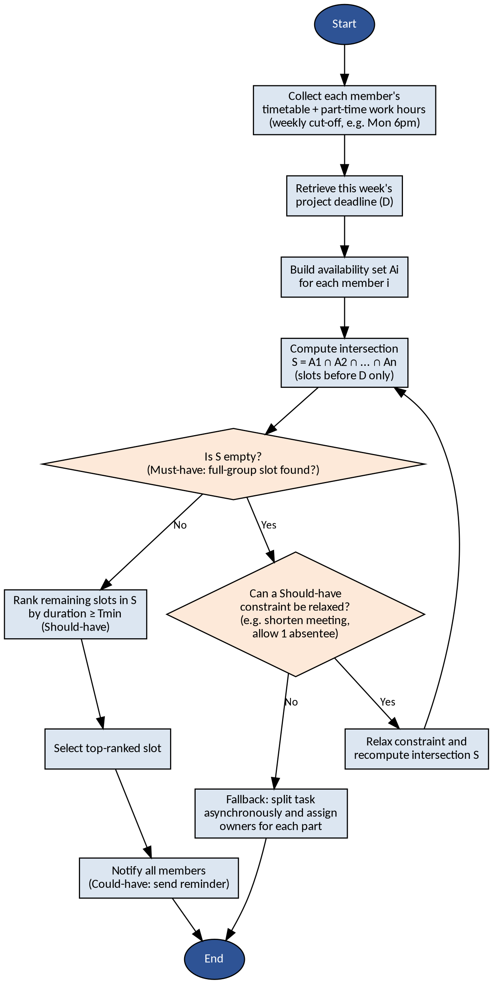
Figure 1: Flowchart of the group meeting scheduling process

There are two collection steps, followed by processing. Each member provides the agency with a submitted time schedule and the number of hours they will be working part-time by a specific time on Monday (which is set here to be 6pm), so that a scheduling process can start once the input data are complete. Secondly, the current step's deadline D is retrieved as it is the upper bound for all subsequent steps. These two inputs are then used to construct an availability set Ai for each member i, which is a set of all time windows where member i has no lectures, seminars or paid work.
The basic idea of the algorithm is the intersection step, which is given a set of n sets, A1, ..., An, and returns the set of elements that are common to all, S, and restricts the output to elements that are present in each set before the deadline D. This single step meets the first and third aims mentioned in the brief of the assignment: it ensures that any slot that the group selects is appropriate for all members and it ensures that the slot is available in time to satisfy the deadline requirement (since slots following D are not included in S).
Now comes a Decision Point: Is S empty? This is checking to see if the Must-have requirement (full group slot) is met. The flowchart proceeds to a ranking step if S is not empty; it allocates the remaining candidate slots to the available time based on the Should-have constraint that a meeting must be at least Tmin minutes long; and if there are multiple candidates that meet that requirement, the candidates are ranked by the week in which their slots fall. The highest ranking slot is then chosen and the group informed (optionally automatically, which would be the Could-have requirement). This part of the flowchart directly tackles the second objective of the brief because each slot of S is constructed without any timetable conflicts, therefore any timetable conflict is only a side effect of the construction of S.
If S is empty, a second decision point occurs: Is there a Should-have constraint that can be modified? The two relaxations are deemed to be realistically achievable with a small student group. The first one is to reduce the length of the meeting, thus increasing the number of slots that qualify for a meeting once the Tmin is lowered. The latter is to do with accepting one missing member, and to perform the intersection computation over n – 1 members instead of n. For each relaxation one of the two steps is taken and the intersection step is repeated; the flowchart is repeated until a slot is found or no more relaxation is possible. In case of no relaxation or no slot found after relaxation, the process reverts to an asynchronous arrangement which involves dividing the outstanding task into smaller sub-tasks, assigning owners to each of them, and coordinating the progress without meeting. Having this alternative makes the algorithm always return to an actionable result, otherwise the group will be without a plan when a real time comes around.
There are a number of assumptions underlying this design. It is assumed that members submit accurate and up to date availability by the date of the cutoff, if the member's situation changed since submission, then the process would have to be re-run, which is known limitation and is discussed in more detail below in Section 3. The other assumption is that a typical project group is small; typically, 3 to 6 members, so that a simple set intersection is computable, with a simple formula in a spreadsheet or by hand. This assumption is vital because it forms the basis for why, in this solution, one eschews using the more weighty optimisation machinery for institution-wide problems. Many problems in university course timetabling, such as solving the full university course timetabling problem, are often formulated as constraint satisfaction or mixed-integer programming problems, and are therefore solved by custom-tailored solvers, which have to simultaneously satisfy thousands of students, rooms and staff [4]. This level of complexity does not apply to a small number of students in a student group, so the decomposition and intersection approach is not too heavy to be proportionate; it is also easy for a student to understand and check by hand, and not a significant amount of computation if a student had to implement a full constraint programming model.
The design also captures the "Should have" and "Could have" categories without altering the "Must have" guarantee: Relaxation can only ever apply to the softer constraints, such as length or full attendance; never to the actual deadline, or to the need for the proposed deadline to be truly clash-free. Separate the negotiable from the non-negotiable requirements and allow the flowchart to degrade gracefully; it does not fail outright if it's not possible to find the perfect slot available. In this manner, the MoSCoW work prioritisation of Section 1 can be mapped to a specific sequence of decisions within the flowchart; for every one of the three actions outlined in the assignment brief (which could be categorised under the MoSCoW priorities), there is a specific decision or set of decisions within the flowchart.
A worked example follows, to illustrate the process. Assume that you have a deadline Friday at noon, and your team consists of four people. The intersection step does not include Wednesday, however, the fourth member has a part-time shift on Wednesday afternoon, so Wednesday is added to S. Tuesday evening (which includes before the deadline) is free for all four members. The flowchart then skips the relaxation step to the next one, which is to rank and notify, as S is not empty and Tuesday evening is thus confirmed as meeting time. In the absence of a common slot in the beginning, however, the group would otherwise be given a fifteen-minute check-in, and if that didn't work out, the group would be given the alternative of having the tasks run asynchronously. This example demonstrates how the same flowchart is used for both the simple case and the more challenging case, in the same process.

3. Reflection and Justification
The above solution was obtained using two problem solving techniques: decomposition and abstraction which are crucial components of computational thinking [2] and MoSCoW prioritisation, a requirements-engineering technique that is commonly employed to distinguish between essential and negotiable requirements [1]. Then, decomposition was used first, transforming the vague statement "students struggle to meet" into five concrete sub-problems that were all able to be reasoned about and designed separately, before being put back together in the single flowchart in Section 2. Only the resulting free or busy state of each time slot was represented, and that was enough, for what determines the state of the time slot is irrelevant to the scheduling logic; why a member is not available, for example, was left out; this is called abstraction and was used to determine what to model and what to ignore.
This mix of techniques is deemed to be suitable for the size of the problem for various reasons. First, a small number of members in the small group yields a small number of variables, and the benefit of applying a heavier optimisation method, like constraint satisfaction or mixed-integer methods used for whole-university timetabling [4] is lost, for students who are not likely to have the specialist scheduling software required for such techniques. Second, MoSCoW provides a clear rationale for each of the decisions that the flowchart can make: If a constraint is not a Must-have, but rather a Should-have, the reasoning is shown on the surface of the flowchart, and is defensible, rather than being buried in a black-box algorithm.
The method does have its drawbacks, however. It assumes submitted availability is correct and is in effect until meeting day, and this will not always be the case if a member's shift pattern is suddenly changed at the last minute. Additionally, although the literature generally on student group work suggests the problem is often social, rather than logical, as student contribution is uneven, standards are different, and communication is lacking, this is reported to be at least as disruptive to group work as conflicting timetables [5], [6]. Considered from the point of view of soft systems thinking [3] that separates hard problems (well defined) from soft problems (people-centred and open-ended), the timetable-matching part of this scenario is a hard problem that is well suited to a flowchart, but the rest of the scenario is a soft problem, one that a scheduling algorithm alone cannot solve. The reason for the fall-back of asynchronous task allocation is also partially explained with this: if it is not possible to find a common time, the group will have a place to go. But it does not solve other problems such as free-riding that the literature talks about as a persistent problem for group assessment even if the scheduling of the tasks is solved [6].
Overall, the decomposition and MoSCoW approach is considered suitable: it explicitly addresses the three objectives of the scenario, is simple enough that students who have never been taught programming or operations-research can apply it on their own, and requires students to think about the requirements that must remain fixed and the ones that can be flexed under pressure. It has its main weakness in that it assumes a partially social problem is completely technical and thus must be viewed as a component of a larger array of group-work practices and not in isolation as a solution to why groups don't meet.

References
[1] T. Kravchenko, T. Bogdanova, and T. Shevgunov, "Ranking requirements using MoSCoW methodology in practice," in Cybernetics Perspectives in Systems (CSOC 2022), Lecture Notes in Networks and Systems, vol. 503, R. Silhavy, Ed. Cham: Springer, 2022, pp. 188–199. [Online]. Available: https://doi.org/10.1007/978-3-031-09073-8_18
[2] J. M. Wing, "Computational thinking," Communications of the ACM, vol. 49, no. 3, pp. 33–35, Mar. 2006. [Online]. Available: https://doi.org/10.1145/1118178.1118215
[3] Toolshero, "Soft Systems Methodology (SSM) by Peter Checkland," Toolshero, 2024. [Online]. Available: https://www.toolshero.com/problem-solving/soft-systems-methodology-ssm/ [Accessed: 10-Jul-2026].
[4] M. Davison, A. Kheiri, and K. G. Zografos, "Modelling and solving the university course timetabling problem with hybrid teaching considerations," Journal of Scheduling, vol. 28, no. 2, pp. 195–215, 2025. [Online]. Available: https://doi.org/10.1007/s10951-024-00817-w
[5] University of Waterloo Student Success Office, "Four common group project challenges (and what to do)," 2025. [Online]. Available: https://uwaterloo.ca/student-success/blog/four-common-group-project-challenges-and-what-do [Accessed: 10-Jul-2026].
[6] "Group project practices and guidance in higher education contexts," Frontiers in Education, 2025. [Online]. Available: https://www.frontiersin.org/journals/education/articles/10.3389/feduc.2025.1614627/full [Accessed: 10-Jul-2026].

