Appendix

Contents

Page
Appendix 1 – Ethics form 2
Appendix 2 – School consent form and information 14 letter
Appendix 3 – Staff consent form 17
Appendix 4 – Pupil interview questions 18
Appendix 5 – Pupil interview transcripts 19
Appendix 6 – Staff interview questions 28
Appendix 7 – Staff interview transcripts 29
Appendix 8 – Staff questionnaire 32
Appendix 9 – Response to question 1 of the questionnaire 35
Appendix 10 – Response to question 4 of the questionnaire 36
Appendix 11 – Response to question 10 of the questionnaire 37
Appendix 12 – Response to question 5 of the questionnaire 38
Appendix 13 – Response to question 7 of the questionnaire 39

Appendix 1 – Ethics form

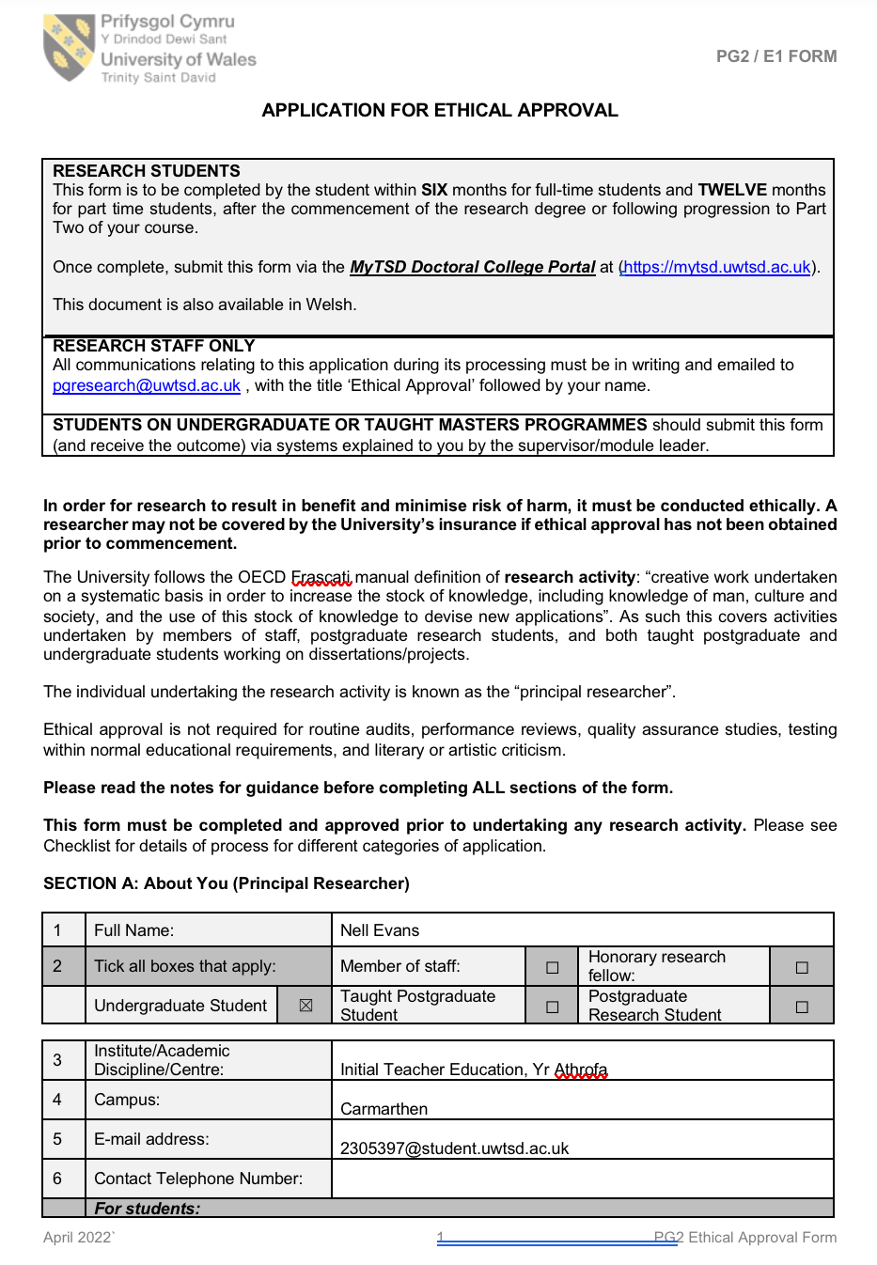

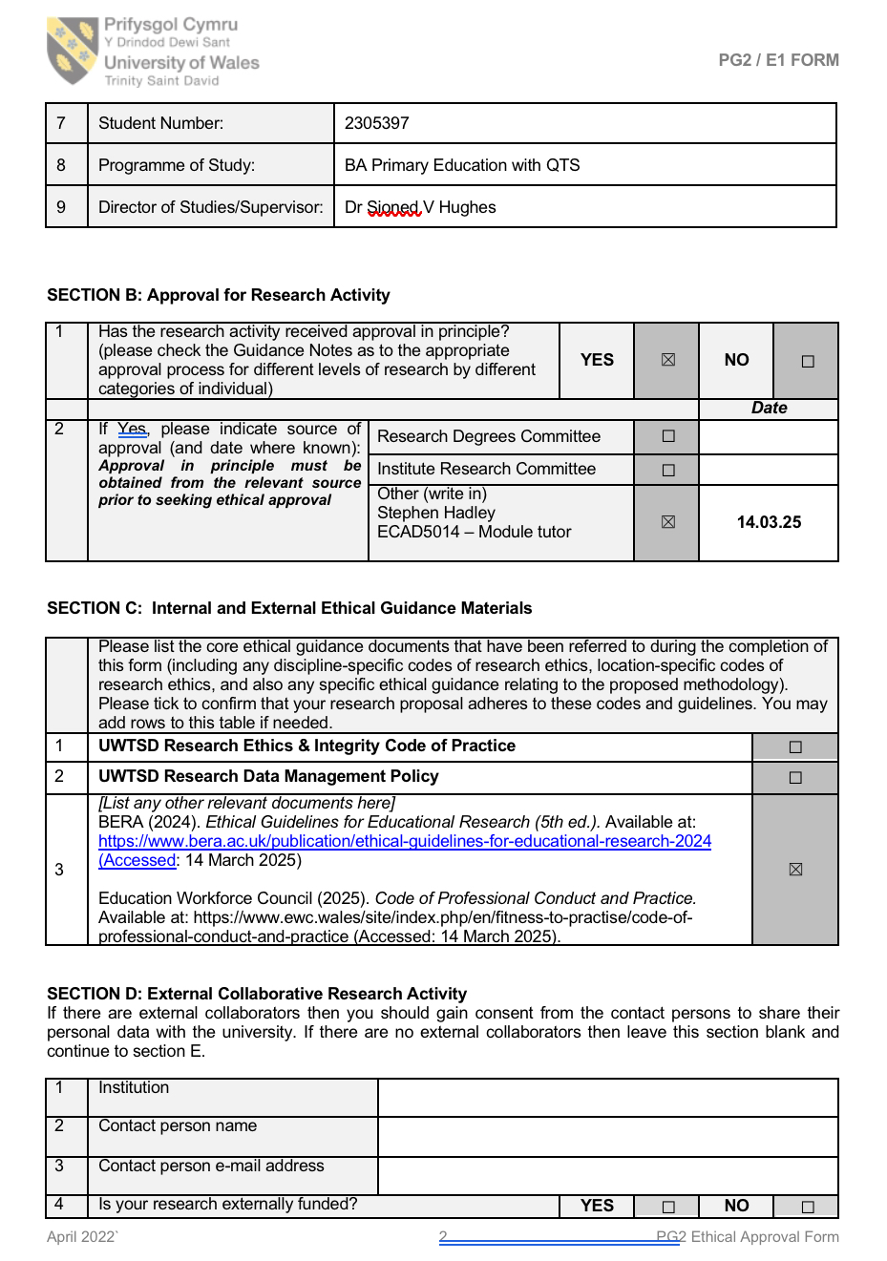

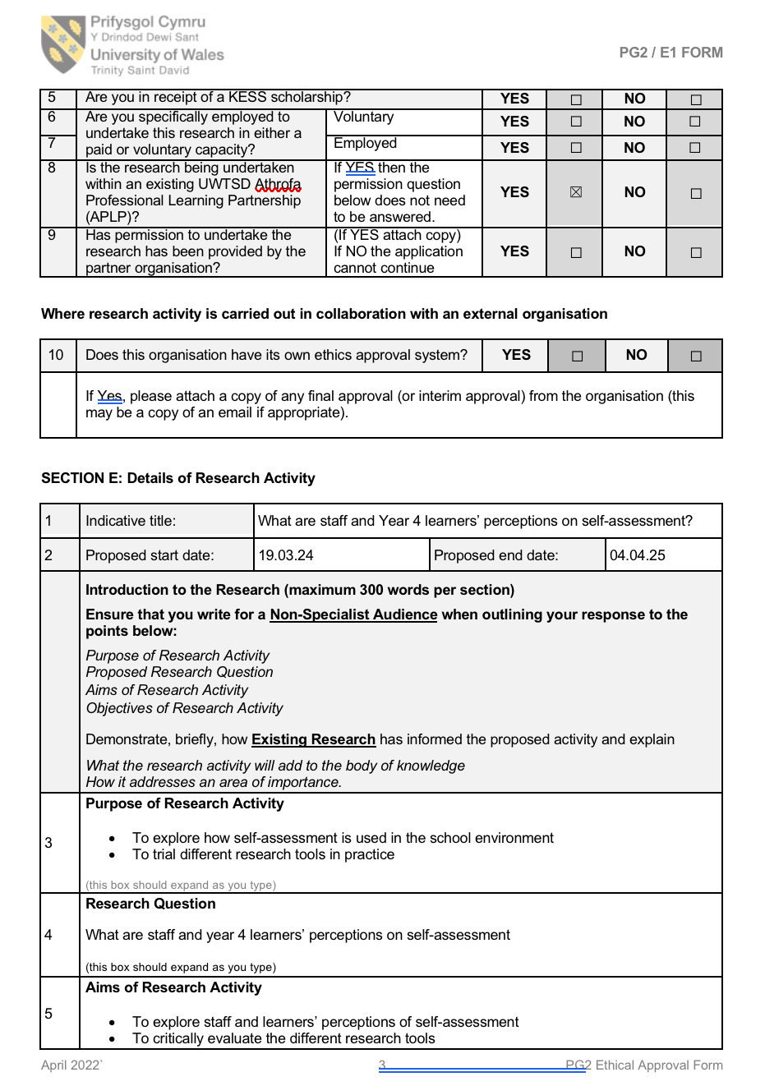
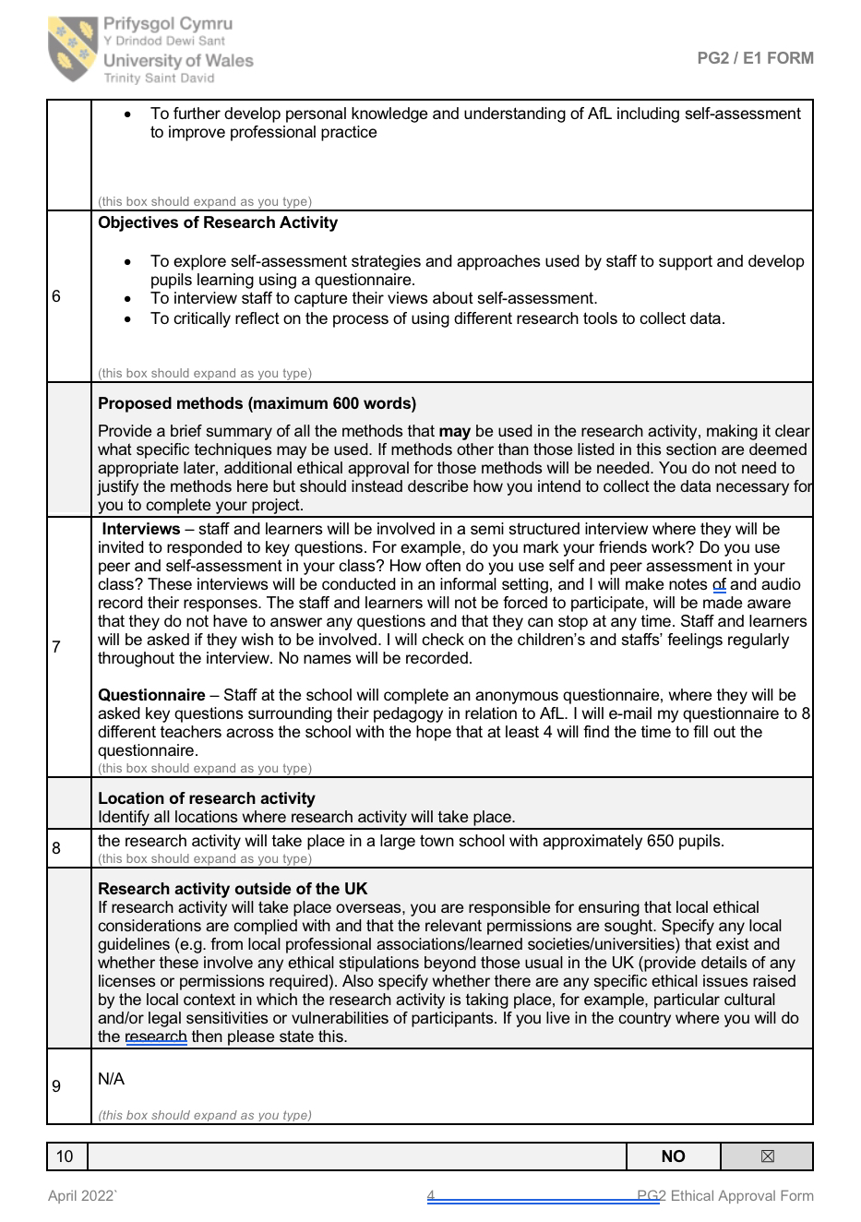

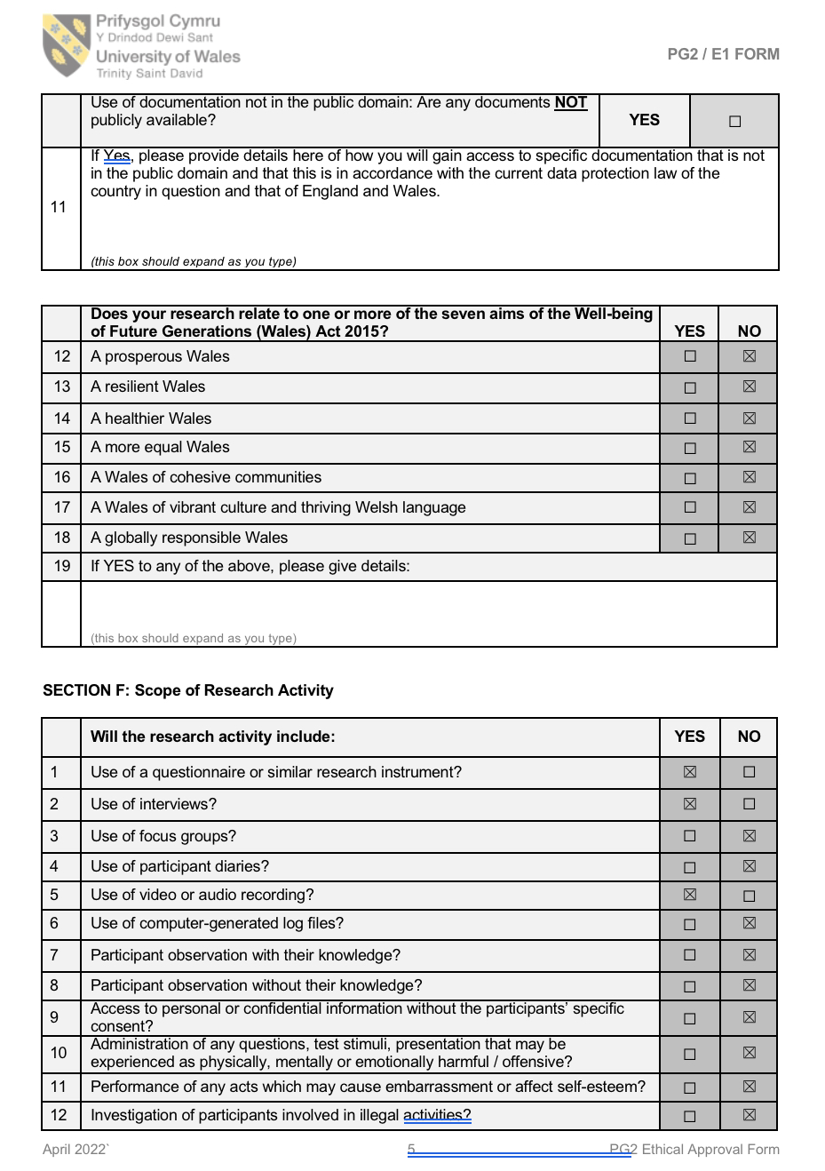

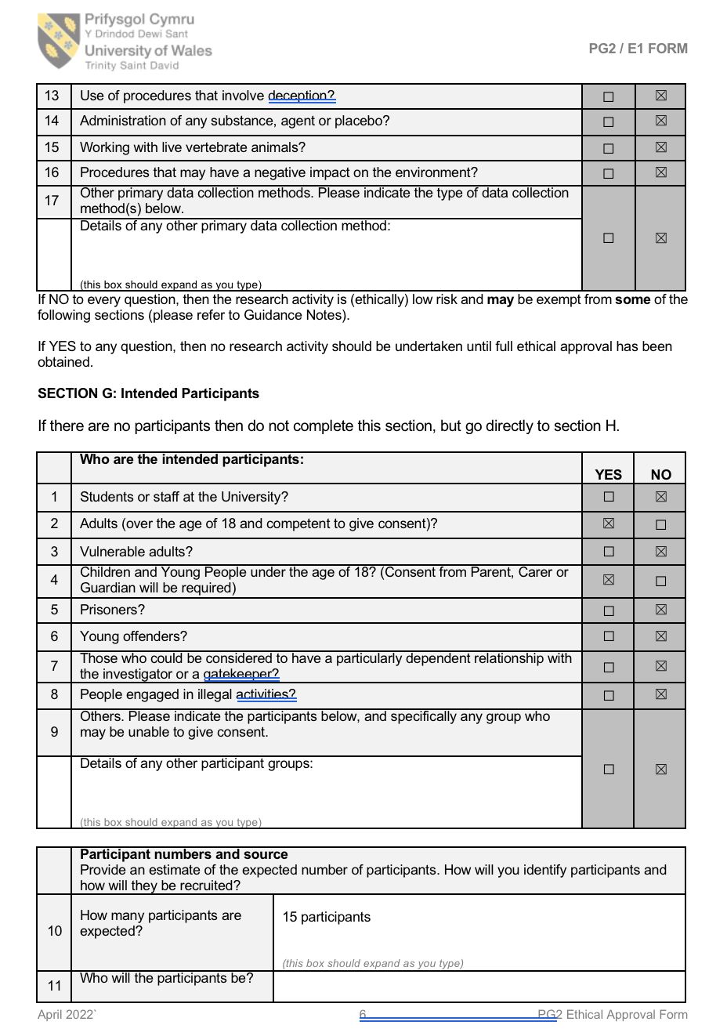

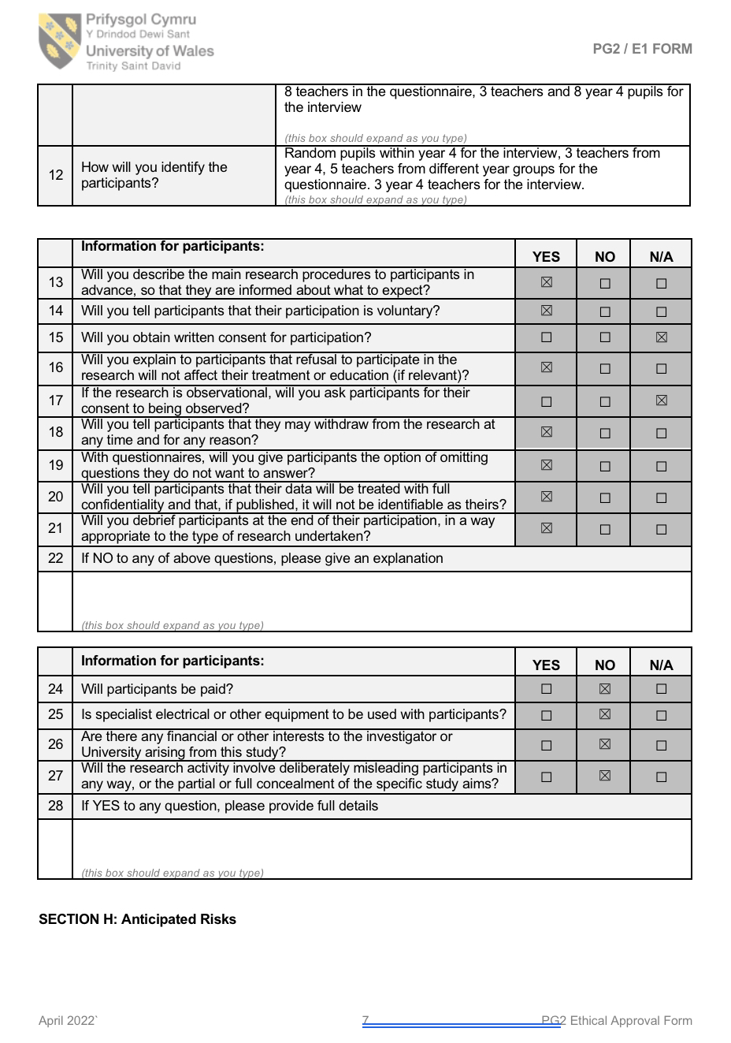

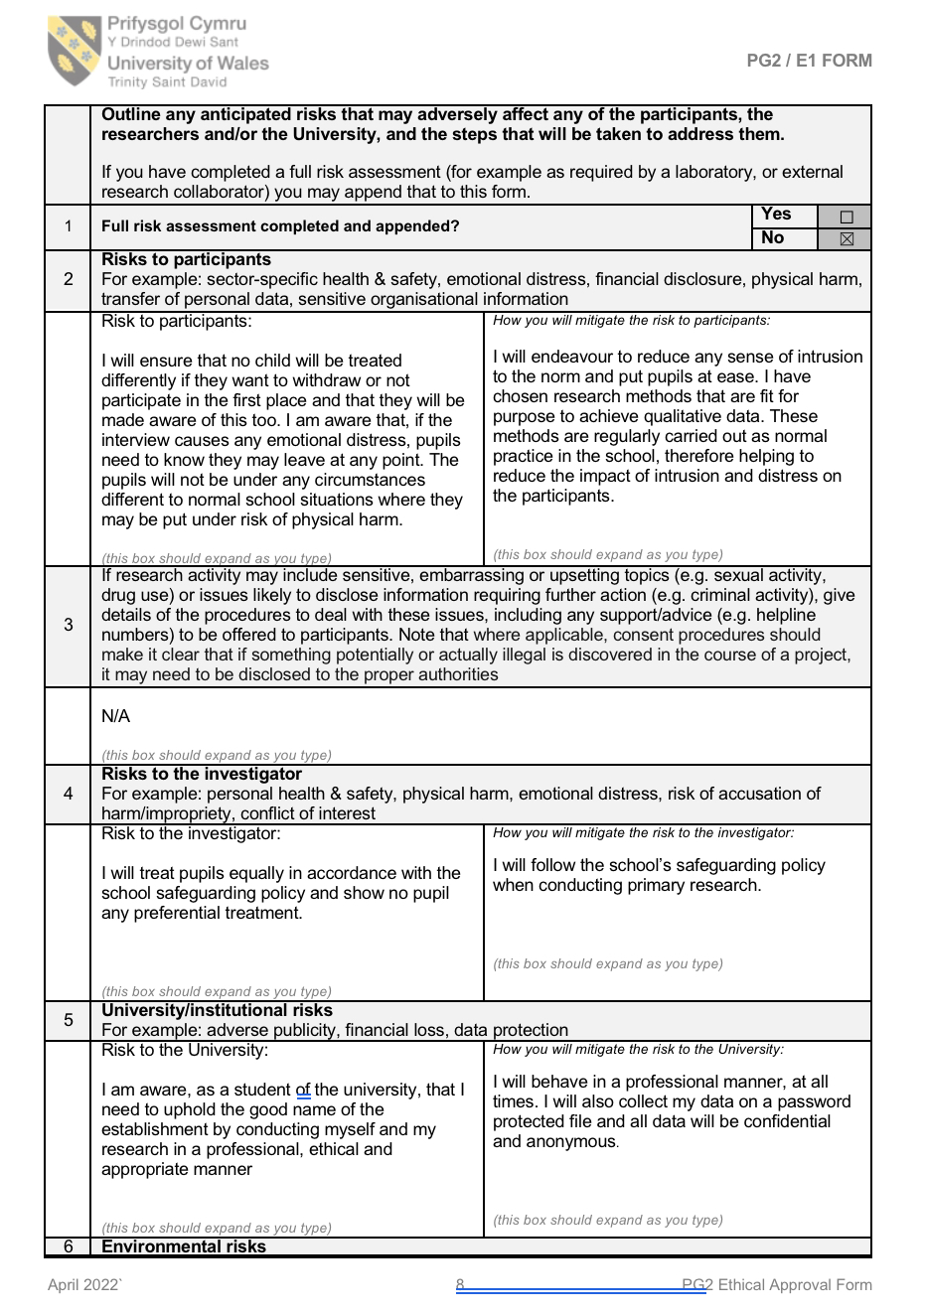

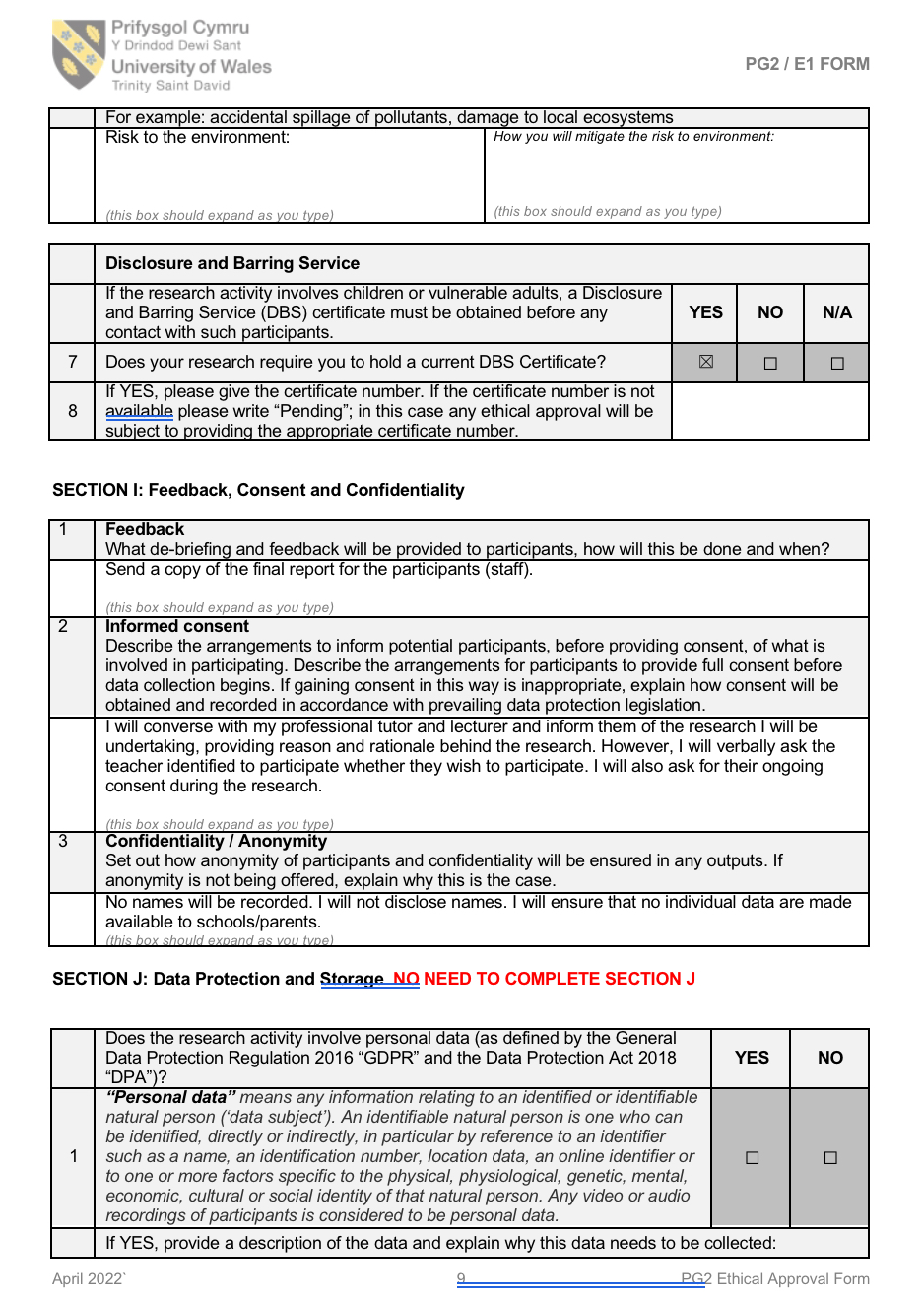

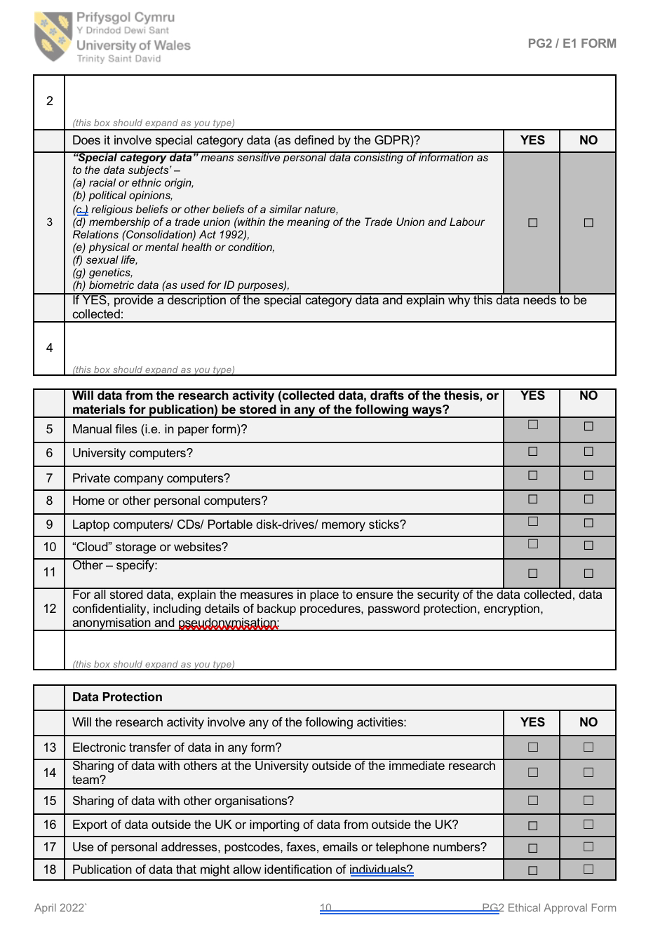

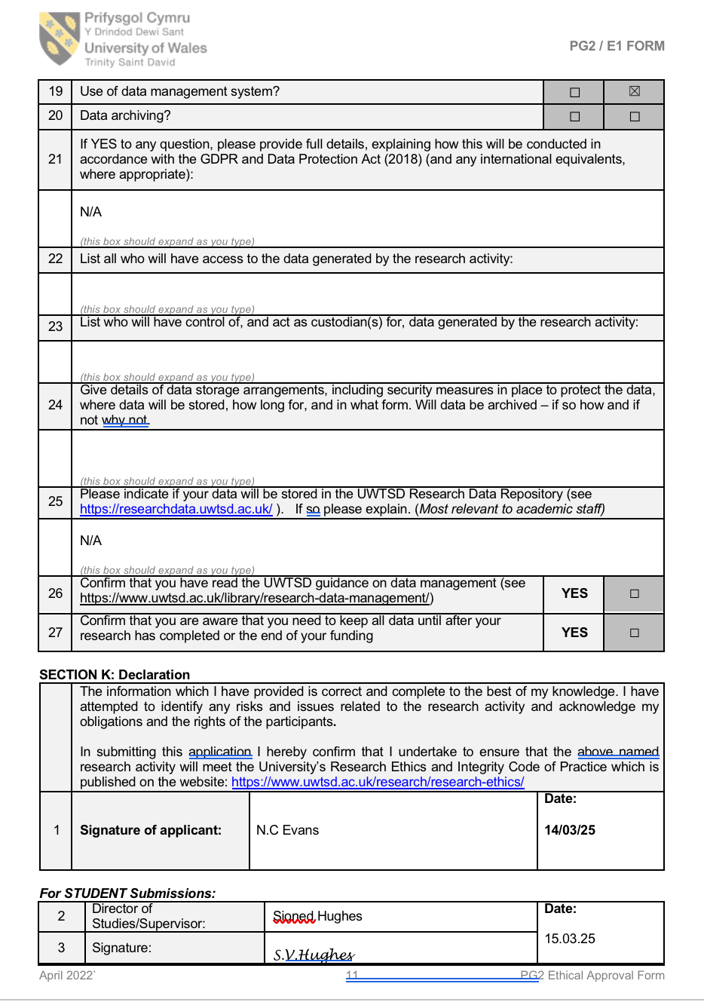

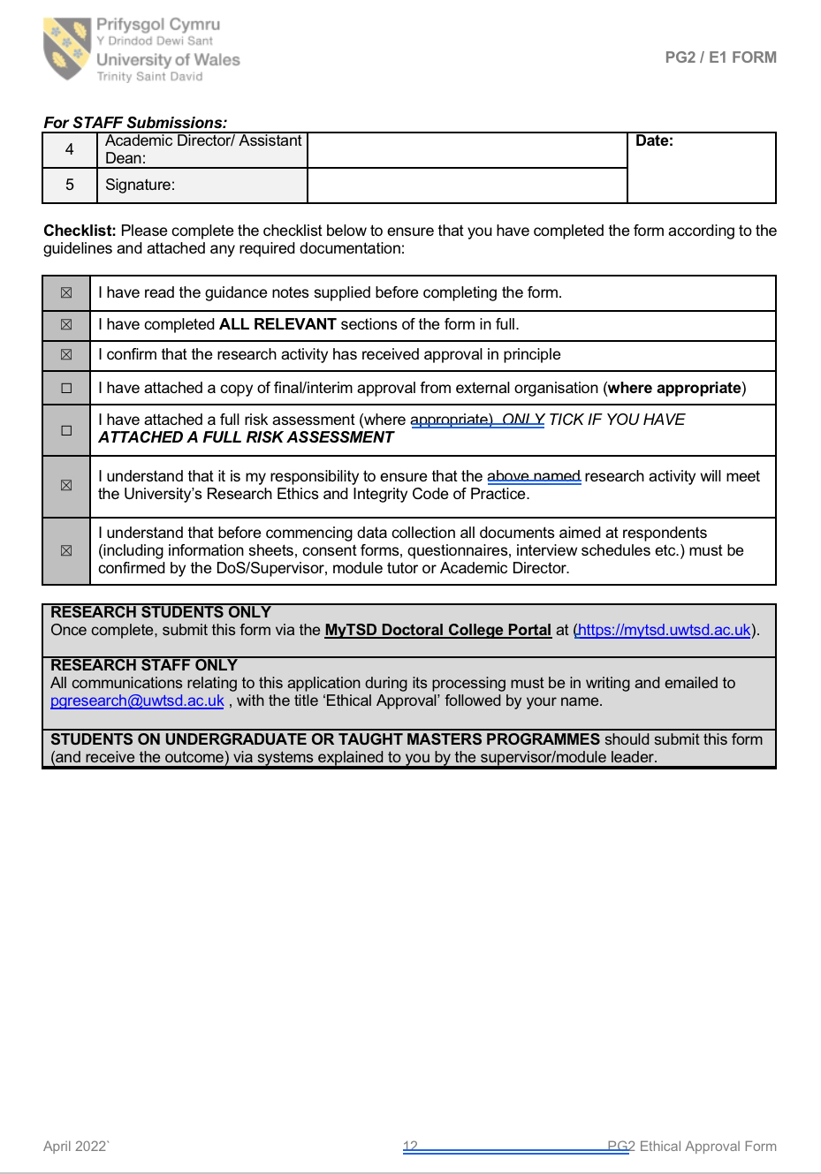
Appendix 2 – School consent form and information letter

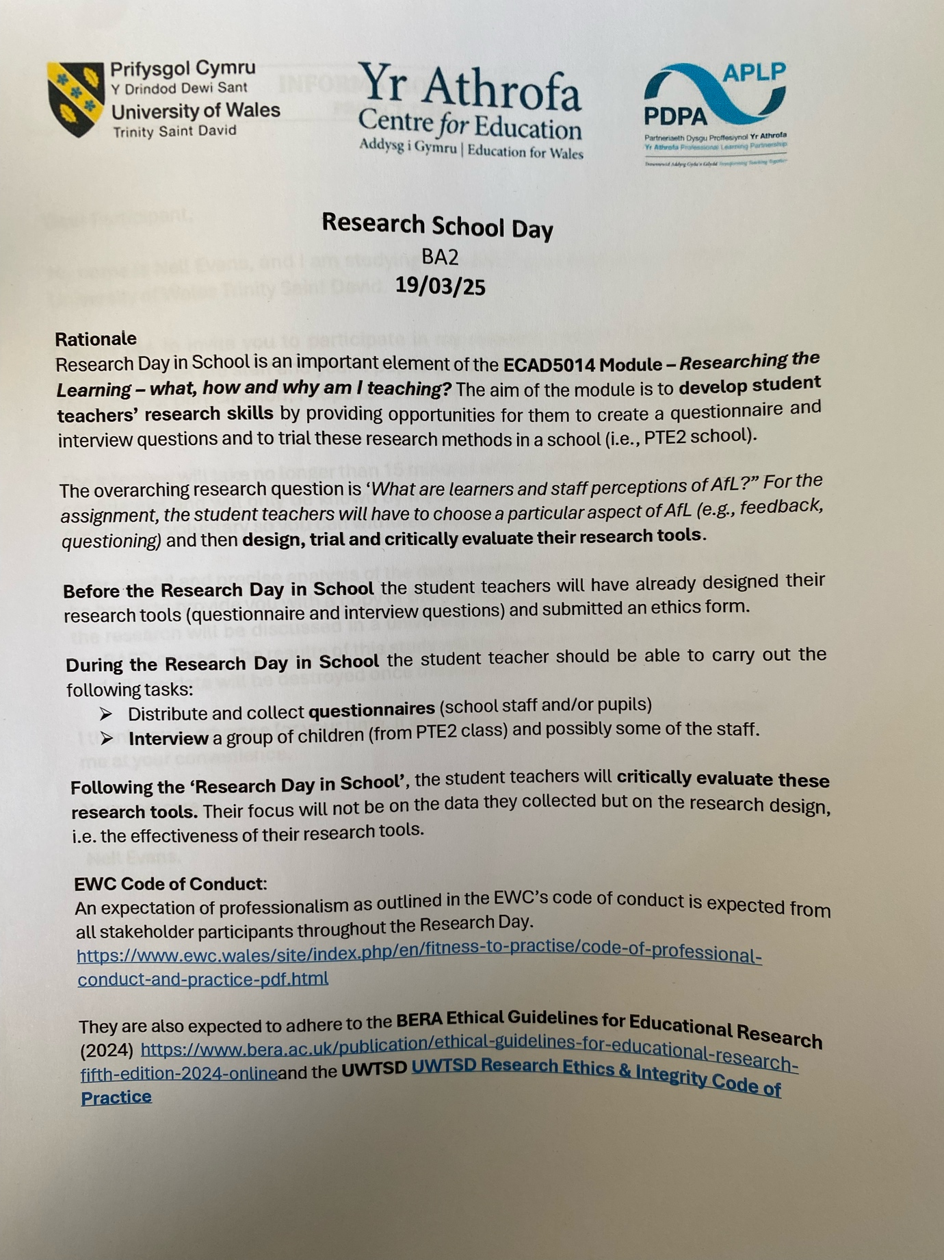

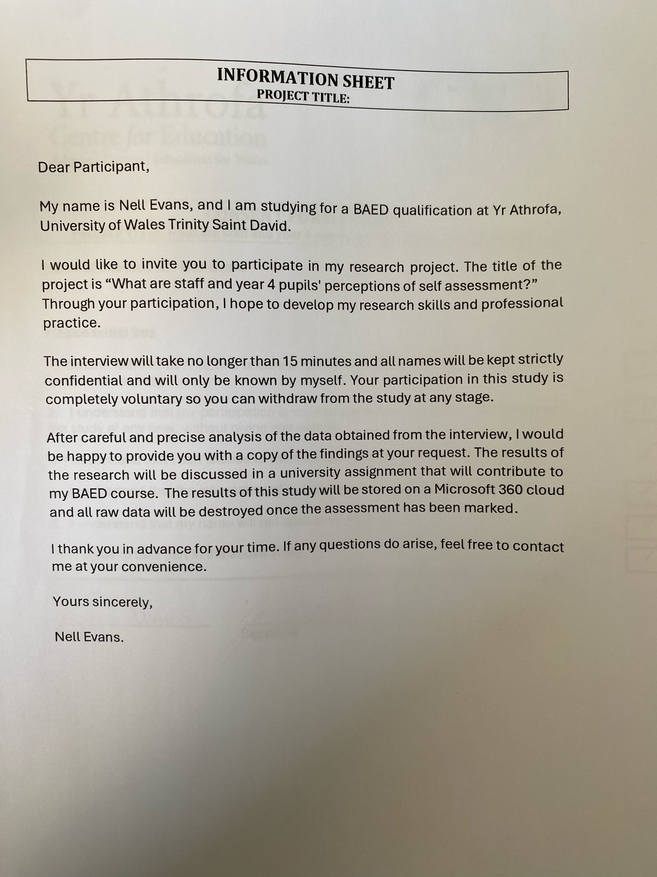

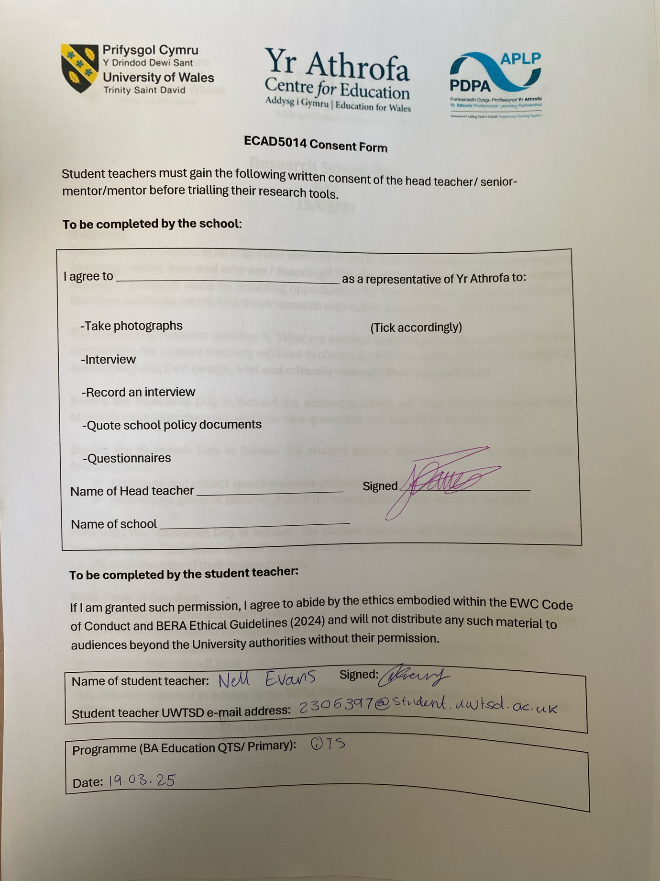

Appendix 3 – Staff consent form
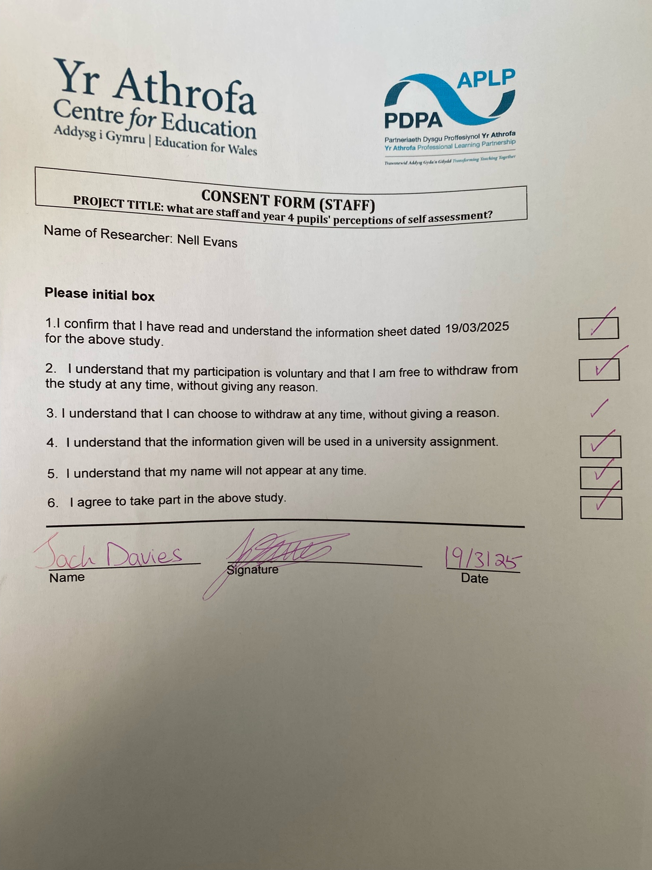

Appendix 4 – pupil interview questions

RQ: What are staff and Year 4 pupils’ perspectives of self-assessment?
Interview questions for pupils.
Notes: Explain to pupils the purpose of the interview and inform the pupils that they can end their participation at any point during the interview. Check throughout the interview that the pupils are happy/willing to continue. Ensure all pupils have a chance to answer every question.
Key questions:
Q.1a - Do you ever mark your own work in class?
If yes, Q.1b – How do you do this? Can you give examples?
Q2. Do you think marking your own work helps you learn?
Q.3. Do you prefer marking your own work or when your teacher marks your work? Prompt: Can you extend? Is there a reason you feel this way?
Q4. Do you know what it means to peer assess/peer mark work?
Prompt: Ask pupils to expand their answers (reword the question if needed) e.g. do you ever mark your classmates work?
Q5. Do you like marking your classmates work? Prompt: Are there any reasons for this?
Q6. How do you feel when classmates mark your work?
Prompt – Why do you feel this way?
Questions to ask if there is extra time:
Q. Would you like to mark your own work more? Prompt: Are there any reasons for this?
Q. How often would you say you mark your own work? Prompt: every day? Every week? Etc

Appendix 5 – Pupil interview transcripts

Data has been colour coded into different themes for ease of analysis
Provides opportunities for independence and responsibility.
Self-assessment provides opportunities to move learning forward, identifying next steps.
Prefer marking their own work over teachers
Prefer teachers to mark their work
Examples of self-assessment
Scared of mistakes
Negative feelings towards self-assessment

Interview 1
Sample: Pupil A
Time taken to interview: 5 minutes and 24 seconds
Interviewer: Okay, so I have asked you to do this interview with me today because i am doing some work for university, and i would like to hear some of your thoughts on some of the work you do in class. I will ask you a few questions which shouldn't take long. If you get stuck on any questions just let me know so I can reword them. Try to be as honest as you can, remember I'm not trying to test you and everything you say won't be shared with any teachers. You can decide if you want to still take part in this interview throughout, so if you don't want to answer a question or not answer anymore, please let me know so we can stop it, I won't be upset if you do and there won't be any consequences. Okay so with that being said would you like to take part in the interview?
Pupil A: Yes
Interviewer: Ok, so the first question I would like to ask you is do you mark your own work in class?
Pupil A: Yes, we use a green pen, oh, and we use a red pen to make things right in our books.
Interviewer: Thank you, can you give me any examples of when you use the pens?
Pupil A: Umm. When we do retrieval, we use a calculator to find the answer then mark on our skills slips how well we think we did in our work.
Interviewer: Lovely, do you think marking your own work helps you learn?
Pupil A: Yeah, I think it makes me more independent.
Interviewer: Do you prefer it when the teacher marks your work or when you mark your own work?
Pupil A: Myself.
Interviewer: Is there a reason for this?
Pupil A: I just like marking my own work because I can see like straight away if i got anything wrong and I can mark it straight away.
Interviewer: Ok, do you know what it means to peer asses/ peer mark work?
Pupil A: Yes, when you swap books.
Interviewer: Do you like it, marking your classmates work?
Pupil A: Yes, sometimes because I can see their work, but it depends what mood I'm in.
Interviewer: Ok, how do you feel when classmates mark your work?
Pupil A: A bit scared because I don't know if they are going to mark something wrong when its actually right.
Interviewer: Would you like to mark your work more in class?
Pupil A: No, I don't think we need to, we do it literally for every lesson for the skills slips.
Interviewer: Ok, thank you so much for your time in answering those questions

Interview 2
Sample: Pupil B
Time taken to interview: 5 minutes and 15 seconds
Interviewer: I have asked you to do this interview with me today because I am doing some work for university, and I would like to hear some of your thoughts on some of the work you do in class. I will ask you a few questions which shouldn't take long. If you get stuck on any questions just let me know so I can try and reword them for you. Try to be as honest as you can, I'm not trying to test you and everything you say won't be shared with the teachers. You can decide if you want to still take part in this interview throughout, so if you don't want to answer a question or not answer anymore, let me know and we can stop it, there won't be any consequences if you want to stop. Okay so would you like to take part in the interview?
Pupil B: Yes.
Interviewer: The first question I would like to ask you is do you mark your own work in class?
Pupil B: Sometimes.
Interviewer: Can you give me an example?
Pupil B: When we do retrieval and skills slips.
Interviewer: Do you think marking your work helps your learning?
Pupil B: Not really, rather the teacher because I might make a mistake.
Interviewer: Do you know what it means to peer assess your work?
Pupil B: No.
Interviewer: do you ever mark your classmates work?
Pupil B: Yes.
Interviewer: Do you like marking their work?
Pupil B: Wouldn't recommend, because I'm scared of making mistakes.
Interviewer: How do you feel when they mark your work?
Pupil B: Scared, because making mistakes
Interviewer: Would you like to mark your work more in class?
Pupil B: No, because I don't want to make mistakes
Interviewer: Ok that's all, thank you for your time.

Interview 3
Sample: Pupil C
Time taken to interview: 5 minutes and 25 seconds
Interviewer: I have asked you to do this interview with me today because i am doing some work for university, and I would like to hear some of your thoughts on some of the work you do in class. I will ask you a few questions which shouldn't take long. If you get stuck on any questions just let me know so I can reword them. Try to be as honest as you can, I'm not trying to test you and everything you say won't be shared with the teachers. You can decide if you want to still take part in this interview throughout, so if you don't want to answer a question or not answer anymore, let me know and we can stop it, there won't be any consequences if you want to stop. Would you like to take part in the interview?
Pupil C: Yes
Interviewer: Ok great, so my first question is do you mark your work in class?
Pupil C: Yes, we do our skills slips.
Interviewer: Do you think marking your own work helps you learn?
Pupil C: Yes, I feel more independent when I do it cause I don't have to ask the teacher, and I can see what I need to do to do better next time.
Interviewer: What do you mean by do better next time?
Pupil C: So, I can see my mistakes and make sure I don't do them again.
Interviewer: do you prefer it when the teacher marks your work or when you do it?
Pupil C: When I do it because I like it.
Interviewer: Thank you, do you know what it means to peer assess work?
Pupil C: When you mark your friends work.
Interviewer: Do you like it when you mark your classmates work?
Pupil C: Yes, it's fun to see their work and I can congratulate them.
Interviewer: How do you feel when your classmates mark your work?
Pupil C: I don't really like it because I'm scared of them making mistakes.
Interviewer: Ok that's great, thank you for your time.

Interview four
Sample: Pupil D
Time taken to interview: 5 minutes and 12 seconds
Interviewer: I have asked you to do this interview with me today because I am doing some work for university, and I would like to hear some of your thoughts on some of the work you do in class. I will ask you a few questions which shouldn't take long. If you get stuck on any questions just let me know so I can reword them. Try to be as honest as you can, I'm not trying to test you and everything you say won't be shared with the teachers. You can decide if you want to still take part in this interview throughout, so if you don't want to answer a question or not answer anymore, let me know and we can stop it, there won't be any consequences if you want to stop. Would you like to take part in the interview?
Pupil D: Yes, I want to.
Interviewer: Ok amazing, the first question I have for you is do you mark your own work in class?
Pupil D: 100% yes, all the time.
Interviewer: Can you give me any examples of when you do this?
Pupil D: we do our skills slip, when we colour in how well we think we have done in the lesson.
Interviewer: Do you think marking your work helps you learn?
Pupil D: Not really, it feels like extra work like homework.
Interviewer: do you prefer marking your own work or when the teacher marks your work?
Pupil D: When the teacher does because I'm clumsy and I sometimes mark things right when it could be wrong.
Interviewer: Do you know what it means to peer assess work?
Pupil D: Yes, when my friends mark my work.
Interviewer: Do you like it when you mark your classmates work?
Pupil D: Not really, they could get things wrong.
Interviewer: how do you feel when your classmates mark your work?
Pupil D: Nervous because they could cheat, like mark my work wrong when it could be right.
Interviewer: Ok, that was the last question thank you for answering.

Interview 5
Sample: Pupil E
Time taken to interview: 4 minutes and 54 seconds
Interviewer: I have asked you to do this interview with me today because I am doing some work for university, and I would like to hear some of your thoughts on some of the work you do in class. I will ask you a few questions which shouldn't take long. If you get stuck on any questions just let me know so I can reword them. Try to be as honest as you can, I'm not trying to test you and everything you say won't be shared with the teachers. You can decide if you want to still take part in this interview throughout, so if you don't want to answer a question or not answer anymore, let me know and we can stop it, there won't be any consequences if you want to stop. Would you like to take part in the interview?
Pupil E: Yes.
Interviewer: Ok, do you mark your own work in class?
Pupil E: Yes.
Interviewer: Can you give me an example?
Pupil E: when we do skills slips.
Interviewer: Do you think marking your own work helps you learn?
Pupil E: Yes, because I have to work things out in my head.
Interviewer: Do you prefer it when the teacher marks your work or when you mark your work yourself?
Pupil E: Teacher because they are always right.
Interviewer: Do you know what it means to peer assess your work?
Pupil E: Yes, when friends do it for you.
Interviewer: Do you like marking your friends work?
Pupil E: Yes, because sometimes they get tired.
Interviewer: How do you feel when friends mark your work?
Pupil E: Scared in case they mark it wrong
Interviewer: Thats great, you can go back to class now.

Interview 6
Sample: Pupil F
Time taken to interview: 4 minutes and 20 seconds

Interviewer: I have asked you to do this interview with me today because I am doing some work for university, and I would like to hear some of your thoughts on some of the work you do in class. I will ask you a few questions which shouldn't take long. If you get stuck on any questions just let me know so I can reword them. Try to be as honest as you can, I'm not trying to test you and everything you say won't be shared with the teachers. You can decide if you want to still take part in this interview throughout, so if you don't want to answer a question or not answer anymore, let me know and we can stop it, there won't be any consequences if you want to stop. Would you like to take part in the interview?
Pupil F: Yes
Interviewer: Ok, do you ever mark your own work in class?
Pupil F: Yes
Interviewer: Can you give me an example?
Pupil F: If we do an independent task.
Interviewer: Do you think marking your own work helps you learn?
Pupil F: Yes, i feel more responsible like I have to do it myself which is good because it makes me work harder.
Interviewer: Do you prefer marking your own work or when the teacher does it?
Pupil F: Me, because I can see my own work and what I need to do to be better.
Interviewer: Do you know what it means to peer assess work?
Pupil F: Yes, when my peers do it.
Interviewer: Do you like marking your peers work?
Pupil F: Yes, because I can see their work.
Interviewer: How do you feel when they mark your work?
Pupil F: Good, because they can tell me what i need to improve on.
Interviewer: Thank you for your time.

Interview 7
Sample: Pupil G
Time taken to interview: 4 minutes and 30 seconds

Interviewer: I have asked you to do this interview with me today because I am doing some work for university, and I would like to hear some of your thoughts on some of the work you do in class. I will ask you a few questions which shouldn't take long. If you get stuck on any questions just let me know so I can reword them. Try to be as honest as you can, I'm not trying to test you and everything you say won't be shared with the teachers. You can decide if you want to still take part in this interview throughout, so if you don't want to answer a question or not answer anymore, let me know and we can stop it, there won't be any consequences if you want to stop. Would you like to take part in the interview?
Pupil G: Yes
Interviewer: Do you ever mark your own work in class?
Pupil G: Yes.
Interviewer: Can you give me an example?
Pupil G: When we mark your skills slips.
Interviewer: Do you think marking your own work helps you learn?
Pupil G: Yes, because I know what to do to make improvements.
Interviewer: Do you prefer it when the teacher marks your work or when you do it yourself?
Pupil G: Myself because I can be more independent.
Interviewer: Do you know what it means to peer assess?
Pupil G: Yes, when your friends mark your work.
Interviewer: Do you like marking your friends work?
Pupil G: Yes, it's fun.
Interviewer: How do you feel when your friends mark your work?
Pupil G: Nervous incase they do something silly
Interviewer: Thats amazing, we are all finished now thank you for your time.

Interview 8
Sample: Pupil H
Time taken to interview: 5 minutes and 8 seconds

Interviewer: I have asked you to do this interview with me today because I am doing some work for university, and I would like to hear some of your thoughts on some of the work you do in class. I will ask you a few questions which shouldn't take long. If you get stuck on any questions just let me know so I can reword them. Try to be as honest as you can, I'm not trying to test you and everything you say won't be shared with the teachers. You can decide if you want to still take part in this interview throughout, so if you don't want to answer a question or not answer anymore, let me know and we can stop it, there won't be any consequences if you want to stop. Would you like to take part in the interview?
Pupil H: Yes.
Interviewer: Ok, so do you mark your own work in class?
Pupil H: Most of the time
Interviewer: Can you give me an example?
Pupil H: When I mark my maths work, do retrieval and skills slips.
Interviewer: Do you think marking your own work helps you learn?
Pupil H: I guess, because it lets you see mistakes.
Interviewer: Do you prefer it when the teacher marks your work or when you do it yourself?
Pupil H: Me, because it makes me feel better maybe more independent.
Interviewer: Do you know what it means to peer assess?
Pupil H: Sort of, when someone does it for you.
Interviewer: Do you like marking your classmates work?
Pupil H: Yes, because they are happy when I say good things they've done.
Interviewer: How do you feel when classmates mark your work?
Pupil H: Ok I guess, I get a bit disappointed when they spot out mistakes.

Appendix 6 – Staff interview questions

What are staff and year four pupils' perceptions on self and peer assessment?
Q1. Do you use self-assessment in the classroom?
Q2. What are your views on using self-assessment as a strategy for AFL in the classroom?
Q3. Which do you use more in the classroom: self-assessment or peer assessment and why?
Q4. Do you find self or peer assessment more effective for year 4 pupils? Why?
Q5. Can you give me examples of self-assessment you use in the classroom?
Q6. Do you think that self-assessment allows learners to recognise their next steps in progression?
Q7. Are there any challenges you face when implementing self-assessment in the classroom? How do you address them?
Q8. Is there anything else you would like to add?

Appendix 7 – Staff interview transcripts
The same code is used from Appendix 5
Sample: Teacher A
Time taken to interview: 6 minutes and 3 seconds

Interviewer: Good morning, so I would like to interview you today as I am doing a research project in university about staff and pupils' perceptions on self-assessment. I would like to ask you a few questions on the topic. Feel free to add anything you feel would benefit the subject. Also, if you don't want to continue or answer any questions let me know and the interview can stop. Would you like to be interviewed?
Teacher A: Yes, thank you.
Interviewer: Do you use self-assessment in the classroom?
Teacher A: Yes, we use self-assessment regularly in the classroom, especially through our Skill Slips. In these, students either self-assess their own work or peer-assess their classmates' work. This practice encourages students to reflect on their learning and make adjustments where necessary. The process helps them become more aware of their strengths and areas that need improvement, fostering greater ownership of their learning journey.
Interviewer: What are your views on using self-assessment as a strategy for AFL in the classroom?
Teacher A: I like to use self-assessment as an Assessment for Learning (AFL) strategy, as it allows students to gauge their own progress and identify areas for development. However, I also prefer to incorporate peer assessment, as I believe that peer learners play a crucial role in influencing and enhancing each other’s learning. Peer feedback often brings fresh perspectives that students may not consider when reflecting on their own work, and it encourages collaborative learning.
Interviewer: Which do you use more in the classroom: self-assessment or peer assessment and why?
Teacher A: I believe in a mixture of both self-assessment and peer assessment, and we vary this daily depending on the needs of the lesson and the task. Some days, self-assessment is more beneficial, as it gives students a chance to evaluate their individual progress. Other days, peer assessment is more useful, as it promotes collaboration and allows students to learn from each other’s approaches. This dynamic approach keeps students engaged and supports their growth in different ways.
Interviewer: Do you find self or peer assessment more effective for year 4 pupils and why?
Teacher A: I believe in a mixture of both self-assessment and peer assessment, and we vary this daily depending on the needs of the lesson and the task. Some days, self-assessment is more beneficial, as it gives students a chance to evaluate their individual progress. Other days, peer assessment is more useful, as it promotes collaboration and allows students to learn from each other’s approaches. This dynamic approach keeps students engaged and supports their growth in different ways.
Interviewer: Can you give me examples of self-assessment you use in the classroom?
Teacher A: In my classroom, I use several methods for self-assessment, including Skill Slips, lesson summaries, and group feedback sessions. Skill Slips allow students to reflect on the skills they've mastered, while the lesson summaries give them a chance to revisit the key points from the lesson. Group feedback provides an opportunity for collaborative reflection, allowing students to discuss their work together and identify areas for improvement as a group.

Interviewer: Do you think that self-assessment allows learners to recognise their next steps in progression?
Teacher A: To some extent, students should be involved in assessing their own learning, but the level of involvement depends on how well they can self-evaluate. Younger students or those who are still developing metacognitive skills may need more support in this area, while older students can take more responsibility for their own assessments. The goal is for students to progressively develop the ability to evaluate their own work accurately and to use that reflection to make improvements.

Interviewer: Are there any challenges you face when implementing self-assessment in the classroom and how do you address them?
Teacher A: No, I don’t face any significant challenges when implementing self-assessment, but I do recognize that it can be difficult for some students to be completely honest and objective when reflecting on their own work. At times, students may be overly lenient with themselves, marking work as successful when it doesn't fully meet the criteria. However, with regular practice and guidance, I’ve noticed that students become more adept at self-evaluating in an honest and constructive way.

Interviewer: Is there anything else you would like to add?
Teacher A: There is nothing else I’d like to add at this time. I believe self-assessment is a valuable tool in the classroom, but it’s important to use it alongside other strategies, like peer assessment, to create a more well-rounded approach to learning and feedback.
Interviewer: Thank you for your time.

Appendix 8 – Staff questionnaire
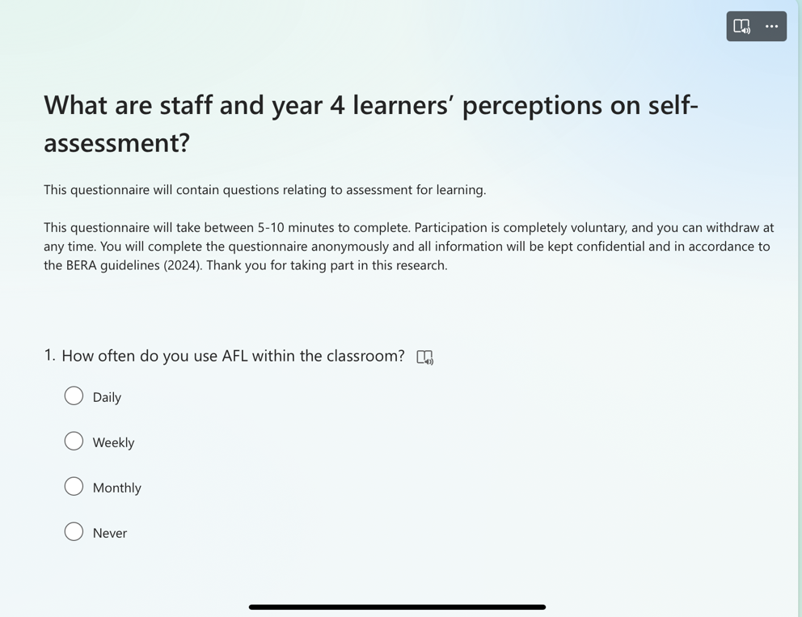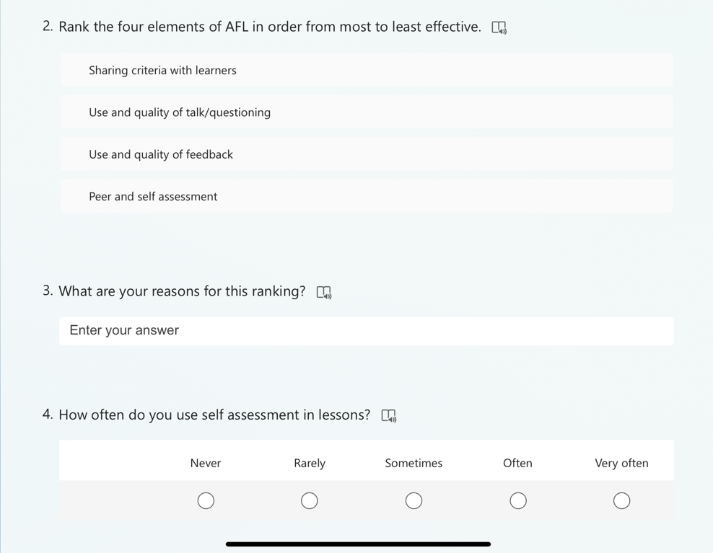

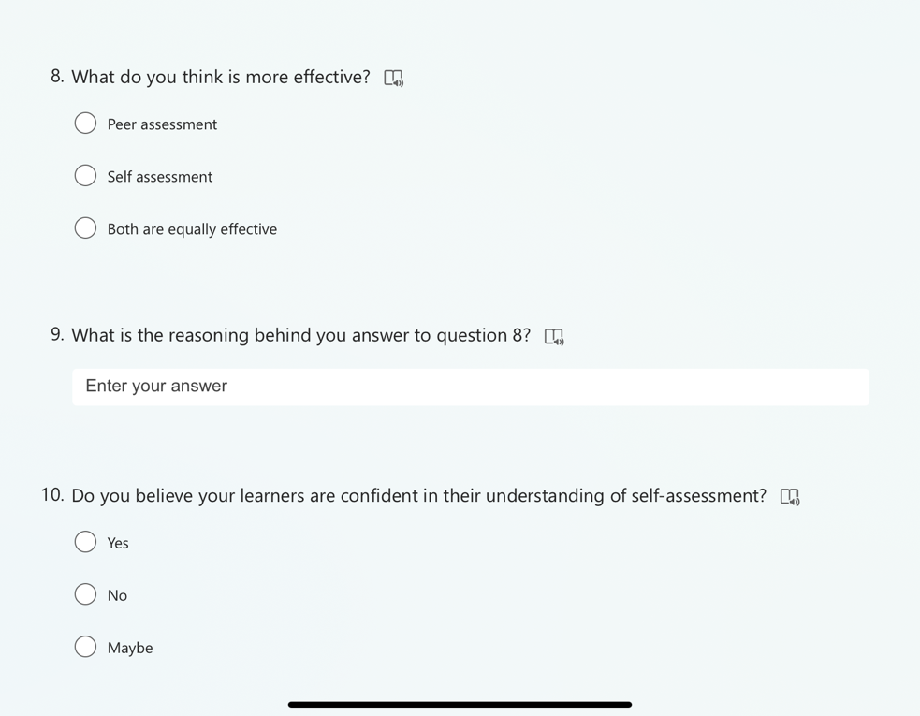
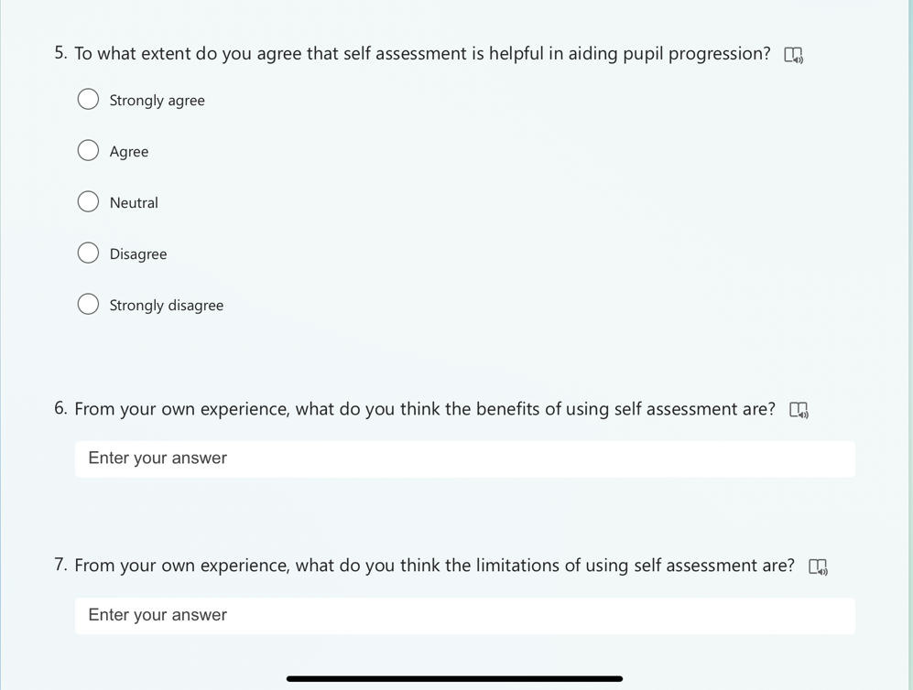

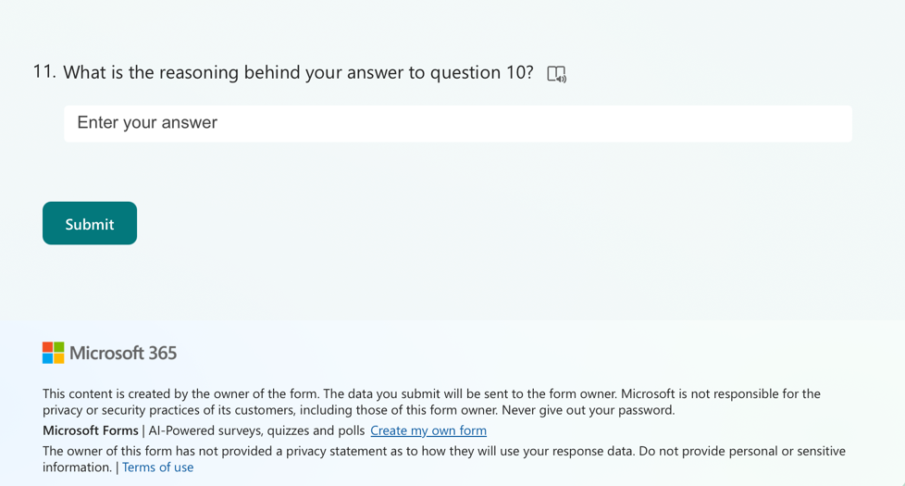

Appendix 9 – Response to question 1 of the questionnaire
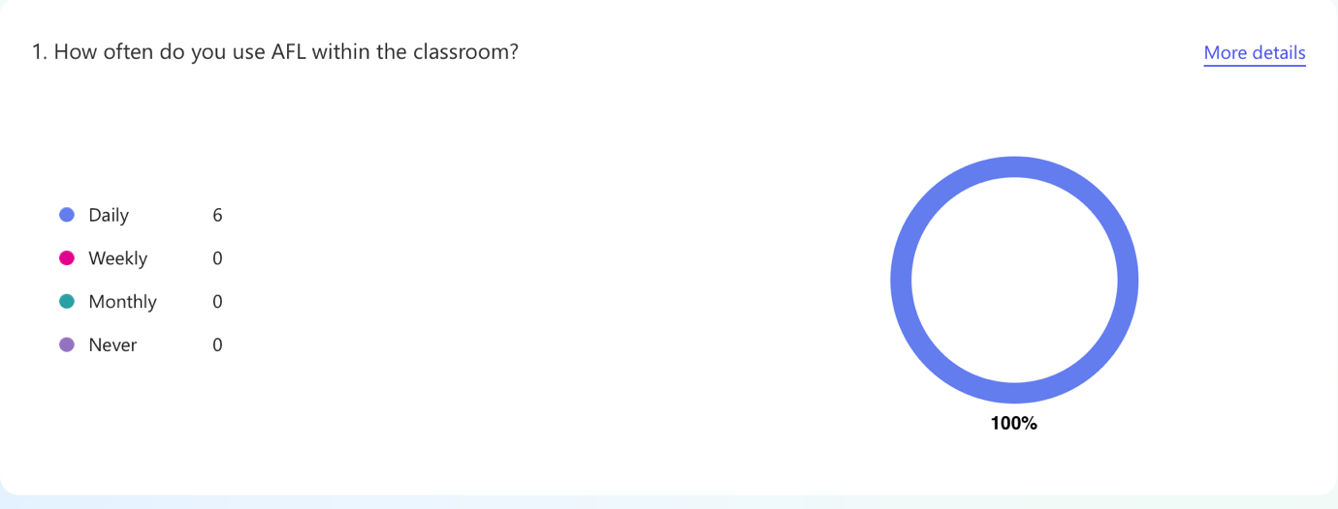

Appendix 10 – Response to question 4 of the questionnaire
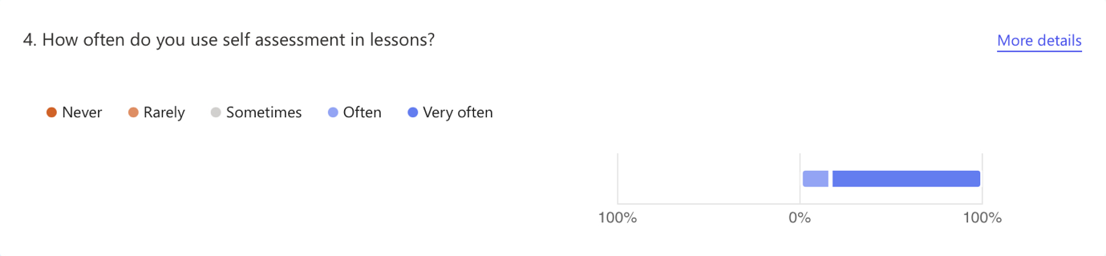

Appendix 11 – Response to question 10 of the questionnaire
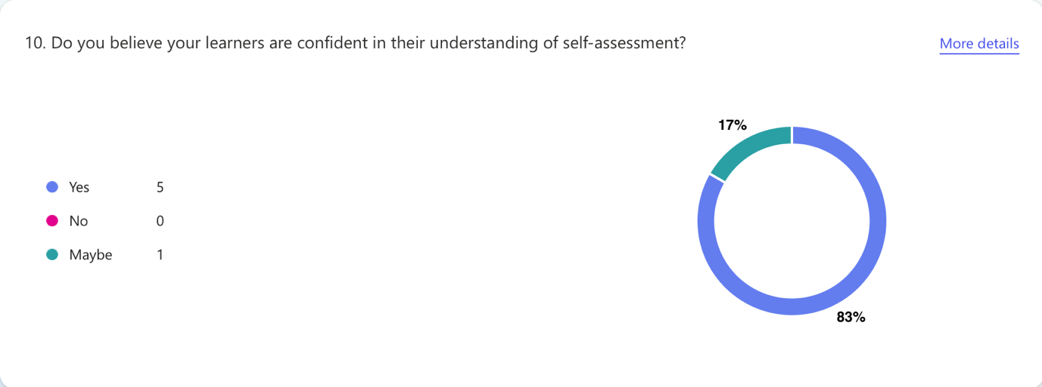

Appendix 12 – Response to question 5 of the questionnaire
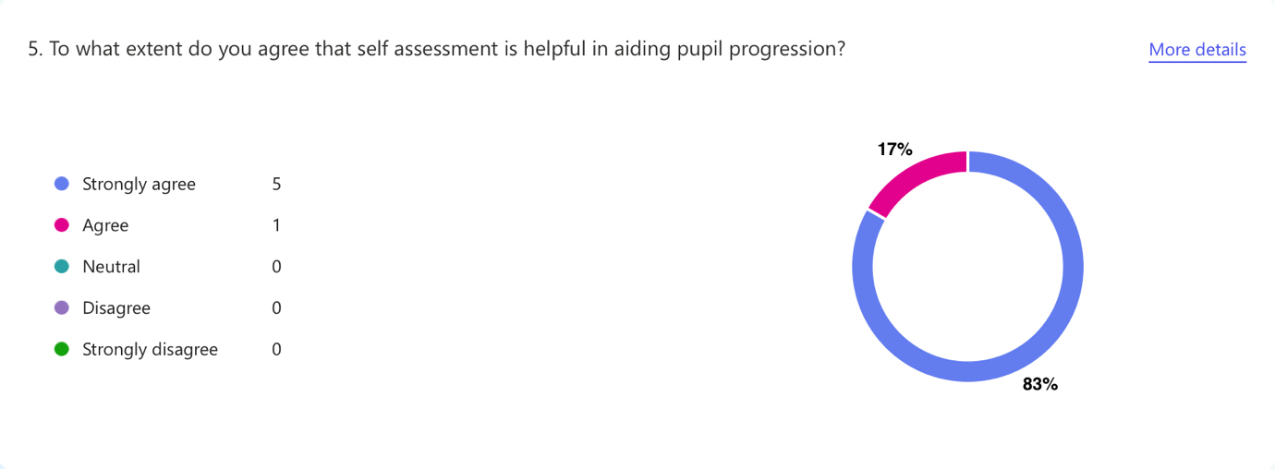

Appendix 13 – Response to question 7 of the questionnaire



