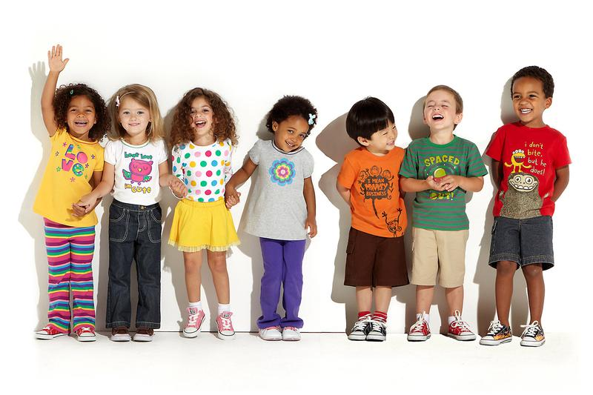
(Grace Church Childcare, No Year)
Supporting Early Year’s During Transitions
Contents Page
Introduction
- Who is the handbook appropriate for?
- Aims of the handbook
- The importance of supporting children through transitions

Transitions
- What is a transition?
- Transition preparation from nursery to reception
- The importance of transitions and why
Role of the Adult
- The importance of the adult
The Needs of the Child
- Urie Bronfenbrenner
- What children need to develop
- Maslows hierarchy of needs theory
Interventions
- What is an intervention
- Activities that support learning across the transition
- Easing the process of transition throughout a childs early years
Outcomes
- Key factors in making a transition smooth
Reference List

Aims of the handbook
This handbook is aimed for children who are in nursery and are soon to start reception in primary school. It will provide necessary information to support children of different needs and requirements and ways to over come barriers that may affect a child’s transition.
It is aimed for key workers in the nursery setting who are supporting children during their first years of learning and development. It is a useful source to use as a guide when preparing the children for transitioning to reception.
It will also provide information to support key workers to work in partnership with parents or guardians of the children. As a key worker it is important to have a sufficient understanding of the support that can be provided for both children, and adults when dealing with potential issues based on transition. (Allingham, 2011)
The importance of supporting children during transitions
Transitions are important as children have to go through this stage in order to develop. Although the process of transitioning can be very challenging for children, this is why as a key worker, this process should be done as smoothly as possible. (Brooker, 2008)
Many barriers can occur when transitioning therefore as a key worker it is important to try and reduce these as much as possible by having the adequate knowledge to be able to support a transition. (Dunlop and Fabian, 2002)
If children are supported from an early stage before the transition by key workers, parents and guardians working together in partnership this is going to have a greater impact on the child and improve the quality of the outcome by ensuring a seamless experience.

Who is this handbook appropriate for?
This handbook is appropriate for key workers working with early years children aged two to four years old supporting with transitioning from nursery to reception. The handbook will contain useful information which can be used as a guideline to support key workers. It will explain the purpose of transitions, the importance and how these can be done smoothly to benefit children and their families during this time.

Introduction

Transitions

What is a transition?

A transition is referred to as a change in routine of what a child is use too. According to Allingham (2011) this change can include a new teaching practitioner, ‘unexpected visitor, or someone new collecting a child from the setting.’ (Allingham, 2011)
Transition is a progression from one setting to another. It is an intense phase of a child’s developmental demands. (Dunlop and Fabian 2007)
It is a requirement for key workers to prepare children for a transition as the way this is controlled could have a large impact on a child’s ability to cope with change, and this could affect them both short-term and long-term. As a key worker, it is a responsibility to vary from each child depending on their individual needs. (Walker, 2017)

Transition preparation from nursery to reception
Preparing children to move into reception is a big step as it is the beginning stages of primary school. It is important during this process that the key workers, teachers and parents communicate effectively to allow the best preparation. It will also inform everyone involved with the child to work together and aim for the smoothest outcome for a child going through this stage. As a key worker, it is a responsibility to share information and communicate effectively between the staff within the setting and the parents before the transition begins. (Walker, 2017.)

Examples of good practice

Children should be made aware of the transition at an early stage to give time for them to get use to the situation. Organising open days to reception to meet other children and teachers and allowing the child to express their feelings are ways to support the child.

The importance of transitions and why

Depending on how a child reacts to a new experience through transitioning, it will have an impact on them both short term and long term which is likely to affect the future of how they are going to deal with these new experiences. (Fabian and Dunlop 2006)

Smooth transitions

Freud believed that children who experience transitions smoothly become well centred adults, however those who do not complete this stage, the child becomes fixated on that particular phase and could either over or under-indulge throughout adulthood. Therefore the help of a key worker through these transitions, children can successful achieve these phases. (Grace, 2015)

ROLE OF THE ADULT
The importance of the adult
The role of the adult is crucial in assisting children with transitions, they are the core of development a child experiences. It is important that parents and practitioners work together as a team. In assistance of one another, they need to plan in order to explore specific strengths, needs and characteristics of each child. ‘This theme includes recognition and consideration of familes’ and professionals’ social supports as part of the transition planning process. (Hanline, 1993).

Childrens wellbeing relies on the everyday interaction they have with their parents and how supportive their parents are during these transitions. This is why parents and practitioners should work together as ‘parents are an important source of continuity for children’s self-esteem and identity at transition (Gniewosz et al 2011), which helps children make sense of the changes they experience.’ (Jenifer, 2015)

Lev Vygotsky theory

Lev Vygotsky’s theory is based on the development of children through their culture and interpersonal experiences. He developed the ‘zone of proximal development (ZPD)’ (Good Therapy, 2017) which shows the process of how a child learns. This is based on children needing peers, teachers support and parents to achieve the things they cannot do. (Good Therapy 2017).

According to Vygotsky, during education the role of the teacher is vital. Teachers can assist children to reach beyond their current ability. The zone of proximal development is the linking point of when the adult and child meets. Teachers can provide support for children to reach beyond their ability, within limits. ‘Vygotsky (cited in Doyla, 2010: 9) defined these limits as the Zone of Proximal Development, which he described as the “difference between the level of solved tasks that can be performed with adult guidance and help, and the level of independently solved tasks”. (Doyla 2010:9)

The role of the adult plays a very important part using the ZPD method during transitions. Children need the support of peers, teachers and parents to be able to progress their development and over come the things they are unable to do. They require the support of the adult for successful development. During the transition, they may have developed certain social and developmental skills whilst in nursery, however require the support of the adult to progress to reception and overcome boundaries they have not explored. Children require a more knowledgeable other (MKO), such as key workers, parents or peers. The ZPD and MKO link together, a child requires someone with more knowledge in order to develop and learn new things. (Anastasia 2016).
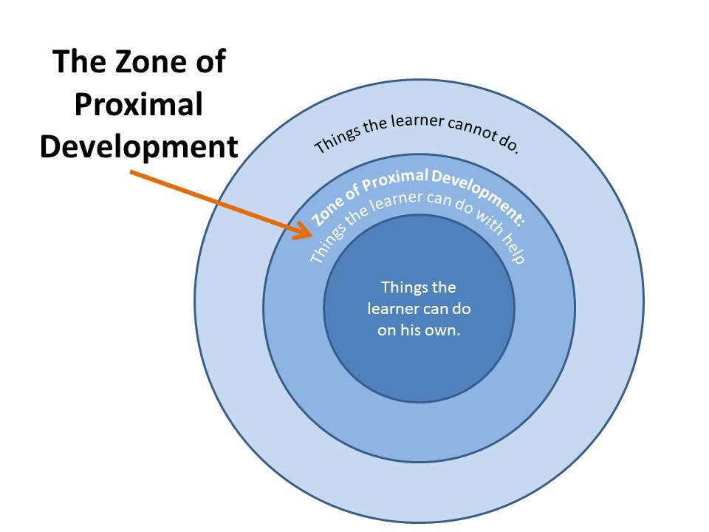
(Source: Cuppacocoa 2014)

The needs of a child
Children will react differently to transitions, their way of coping during change and a new experience will vary. Listening to the child, allows adults to support their needs by hearing what the child has to say. Using visual aids for children to express their thoughts and help their understanding is an effective way for adults to gain knowledge of what they are thinking, or what they already know. (Fabian and Dunlop 2006).

Urie Bronfenbrenner

Urie Bronfenbrenner used an ecological approach to human development during the 1970s. This theory concerned the position of an individual in wider ecological systems and how external influences the ability key workers can help the development of children. There were four parts of the ecology of how children grow up, these are: ‘microsystems, mesosystems, exosytems, and macrosystems. (Vogler et al. 2003:23).
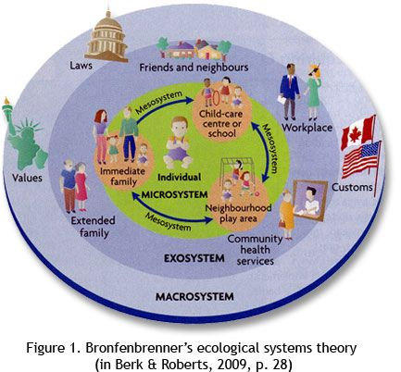
Microsystems are the every day interactions a child has with their peers, key workers, practitioners at home, school or nursery. Mesosystems are the relationships and communications between the microsystem factors which impact the child. These are the ‘complementary and/or con icting practices and belief systems at home and at school and the informal/formal communications between parents and teachers.’ (Vogler et al. 2003:24).
Pinterest, No Year
If the parent has conflicting beliefs of their child’s development with the teacher, this is going to affect the child’s development negatively as it will give the child conflicting emotions, affecting how they react to what their teacher tells them and what their parent tells them. This highlights the importance of relationships and communications between key workers and parents as both have a large impact on a child’s development and in order for this to be successful, they should work in partnership. (Psychology Notes, 2013)
Exosystems is the phase which does not involve the participation of the child, although it still impacts on their development. This includes their parents workplace, and the stresses that could impact on the family, the availability a parent has to care for the child at home, other family members or the neighborhood environment. (Vogler et al. 2003:24).
The Macrosystem is the outer layer which relates to the culture of the chld. This involves the socioeconomic status of the childs family, their ethnicity or race. The background of a childs parent will reflect on the ability and time it takes for the child to develop. (Sincero 2012)

What children need to develop
Stable living environment

Children need the support of adults and key workers, practitioners to provide a secure base where they feel able to grow and develop their confidence and over come challenges. It is important that from a young age children feel secure in a stable environment so they can meet their full potential when they are an adult. If they experience their early years as positive, this will continue to flourish across transitions, helping to ease challenges. Children who have an unstable environment may struggle to develop relationships with peers and people around them and suffer in areas academically causing issues later on. If children have a secure living environment with the people they live with at home this is likely to have a positive impact and make transitions to new environments easier.

Routines and structured life

Another important feeling of security to children is having a routine, knowing what is going to happen next will ease pressure.

Individual difference

Moving from nursery to reception is a very unique experience for each individual. As a key worker, it should be recognised that each child will experience this transition differently, therefore each child should be supported individually. Some may struggle with developmental and experience difficulties. Although others may have developed their social competence and find the process easier. (Dunlop and Fabian 2007)

Maslow’s Hierarchy of Needs theory

Maslows Hierarchy of Needs pyramid describes what children need in order to develop and grow, and that everyone has the ability to meet these needs but however, progress can be affected by not being able to meet lower level needs. Everyone begins at the bottom of the pyramid, and few will reach the top. Each step prevents the challenges of development, and the ability to progress to the next step is dependent on the present level.
A developing child requires the correct nutrition, clean clothes and a comfortable environment in order to develop to the next level.

At this stage, children should still feel they are being looked after and taken care of. They require protection and stability and need structure and limitations.
The third stage, a child wants to feel love and be provided with a sense of belonging from others. If the child has a secure relationship with their parents. guardians then they are able to show love to that person.

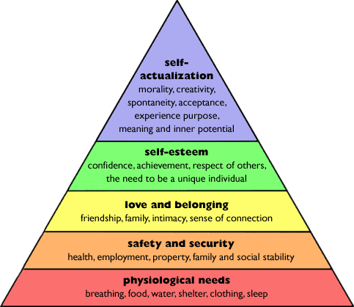

(Research History, 2012)

Although if the child loses a parent or guardian in that relationship, they may struggle to be emotionally stable and know how to love or love themself, if this bond hasn’t formed. If this is the case, they will struggle to move on to the next level of the pyramid. Not being able to share emotions with close ones may affect confidence and develop loneliness and anxiety. For the child to progress on the next stage, they should feel loved and show love by being surrounded in a stable environment. During the next level, the child develops their self worth and respect for others.
Maslow’s Hierarchy of needs show how a child may fail to develop due to different aspects of growth and surroundings. If the child has nutritious food, a house with sufficient heating, hot water and feeling safe, they are able to continue to develop, if these aspects are hindered, how can a child develop self-esteem if these are not met. (Minton, B 2008)

Interventions

What is an intervention?
An intervention is a way to prepare children for transitions by carrying out activities related to the transition. By doing these activities, both the key worker and parent can pick up on any emotional and social difficulties the child may be experiencing during this transition. The role of the adult is then to address these issues by supporting to reduce anxieties the child may experience before the transition happens, showing them the new school and let the child to familarise themselves with the setting, teaching coping strategies with arising challenges and making sure the parents are involved. (Symonds 2015).

Activities that support learning across the transition

A key workers most important aim is to enable the best outcome for a child so that they begin reception, the start of primary school successfully. Planning and communicating are two key words that are deemed very important to successful transitioning. Planning transition days is a great way for children to adjust slowly to change in the least dramatic way. The more the child does and sees something, the more they are going to become familiar with this. Transitional activities include visits to the school, teaching children boundaries of the difference between play and formal learning, using play based activities and using a breakdown of the day, going to the school for an hour a day to ease them into the environment. (Fabian and Dunlop 2006).

Children also need social and emotional support during a transition to be able to build relationships with teachers and peers. The transition needs to be supported smoothly to provide the best start to learning. Children need to be emotionally stable, have a upbeat attitude and have effective communication as a foundation to start learning. (Fabian and Dunlop 2006).

Burell and Bubb, 2000 (Fabian and Dunlop 2006) believe that if children are happy and stable, they are able to engage with challenges that may occur through their education.

Easing the process of transition throughout a childs early years
During the early years of a child’s life it is important that they feel stable and secure within their environment. However transitions are unavoidable for the majority of young children, therefore as key workers, it is important to understand how making these transitions for children smoothly, is beneficial to them long term. (Patel, No Year)

Relationship and Partnership
Key workers and parents or guardians need to work together to provide the best outcome for the child by communicating effectively to track the progress and an issues which may occur. For reception aged children they are likely to have attachment issues, therefore the guidance of a responsible adult will provide reassurance and help make transitions positive. (Patel, No Year)

Enabling Environments
Children need to feel comfortable in their environment. Families should visit the child’s new school they are going to start reception in and interact with the new surroundings, so they have the opportunity to talk about it with their child and be a positive influence by being aware of what the child is going through. (Patel, No Year)
Maria Montessori believes that having a prepared environment is an important aspect of her theory. The environment needs to be safe and inviting for children to work, it should be set up with activities for success and to allow movement and choice. She relates play and work together, they can still enjoy their work but recognise it as play. It shows the importance of a key worker, teacher or parent in enabling the environment accessible to the child in order for them to develop. (Daily Montessori, No Year)

Transition in practice
As key workers, to help the child during the transition, providing them with experiences to help ease the pressure will help a smooth transition. Key workers need to: plan ahead, carry out open days for the children to visit their new setting in reception, communicate with the new school and inform them with the child’s progress, role play activities and to be encouraging and allow the children to express themselves during the transition. (Patel, No Year)

Outcomes
Interventions can be successful if they are properly planned out to make the transition smooth for children. It depends on the child, family and the school how well a child can adjust to the new setting. Moving from nursery into reception is a large step for children and they may experience difficulties such as; adjusting to new surroundings, getting to know their peers and practitioners, adjusting their behavior and learning the correct manor. If they experience these difficulties it is likely to have an effect on their development. Therefore, if key workers can make the new setting more familiar and welcoming for the child, the easier the transition is going to be. To support the interventions in being successful, it depends largely on the communication and team work between the people who are involved during the transitions. Those who are involved include; the parent, teacher, key worker, practitioner should develop clear goals to reach before the transition happens. An import aspect to remember when children are transition from nursery to reception is to identify any challenges that may affect a smooth transition, and how these can be addressed. A child may have had an issue with their transition from being with their parents to spending a day in their nursery, therefore as a key worker this should be communicated to minimilse any problems during the next transition.

If children feel secure and content in their environment, it gives them the stability to function and to grow and develop. Children also need the support of adults and peers to further develop their confidence, ability and personality. They require key workers, teachers and parents or guardians to work together and communicate effectively in order to aid a smooth transition making the process an easier challenge, minimalizing barriers.

To conclude, a childs transition from reception to nursery is largely dependant on the support of their parents, key workers, teachers working together and communicating effectively during the process. When the transition is planned effectively and the adults all colaberate together, children have the best chance in a smooth transnition if they are provided with many experiences prior transitioning. (Dunlop, Fabian 2002).

The main key focus on interventions is to prepare the child for the next stage they will experience. Visiting the school with the child and parent is important as it provides the child security while with their parent but also to get use to the new settings and the teachers they are going to be with. Buddy systems can be used to support children with the new experience.

Reference list

Allingham, S., 2011. Transitions in the early years : a practical guide to supporting transitions between early years settings and into key stage one, London: Practical Pre-School Books.
Anastasia (2016) ‘Understanding Vygotsky’s Social Development Theory’ https://www.cleverism.com/vygotskys-social-development-theory/ [Date Accessed 13th November 2017]
Brooker, L., 2008. Supporting Transitions in the Early Years, Maidenhead: McGraw-Hill Education.
Burrell, A. and Bubb, S. (2000) ‘Teacher Feedback in the reception Class: Associations with Children’s Positive Adjustment to School’, Education 3-13 28(3), 58 – 69.
Croner-i. (2012) ‘The Emotional Environment’ https://app.croneri.co.uk/feature-articles/emotional-environment [Date Accessed: 27th November 2017].
Cuppacocoa. (2014) ‘The Zone of Proximal Development’ http://www.cuppacocoa.com/the-zone-of-proximal-development/ [Accessed 14th Novemeber 2017]
Daily Montessori. (No Year). ‘Montessori Theory’. http://www.dailymontessori.com/montessori-theory/ [Date Accessed 20th November 2017]
Dunlop, A.-W. & Fabian, H., 2002. Transitions in the Early Years Debating Continuity and Progression for Children in Early Education, Hoboken: Taylor and Francis.
Dunlop, A.-W. & Fabian, H., 2007. Informing transitions in the early years : research, policy and practice, Maidenhead: McGraw-Hill/Open University Press.
Fabian, H., Dunlop A-W. (2006) ‘Outcomes of good practice in transition processes for children entering primary school.’ United Nations Educational, Scientifc and Cultural Organisation, pp. 8. [On-line]. http://unesdoc.unesco.org/images/0014/001474/147463e.pdf [Accessed: 18.11]
Good Therapy (2017) ‘Lev Vygotsky (1896-1934)’ https://www.goodtherapy.org/famous-psychologists/lev-vygotsky.html [Date Accessed 14th November 2017]
Grace Church Childcare. (No Year) ‘3-Year-Old Programme’ http://www.gracechurchchildcare.org/3-Year-Old-Program.html [Date Accessed 28th November 2017].
Grace E. (2015) ‘Freud’s Theory of Developmental Phases’ http://www.kidsdevelopment.co.uk/freudsdevelopmentaltheory.html [Date Accessed: 19th November 2017]
Hanline, M.F. (1993). Facilitating integrated preschool service delivery transitions for children, families, and professionals. In C. A. Peck & S. L. Odom (Eds.), Integrating young children with disabilities into community programs: Ecological perspectives on research and implementation (pp. 133-146). Baltimore: Brookes.
Minton, B., (2008) ‘Maslow’s Hierarchy of Needs Explains Why Some Children Fail’ https://www.naturalnews.com/024190_child_children_WHO.html# [Date Accessed: 27th November 2017].
Patel A. (No Year) ‘Supporting Transitions in the Early Years’ https://www.teachearlyyears.com/a-unique-child/view/supporting-transitions-in-the-early-years [Date Accessed: 18th November 2017]
Pinterest, (No Year) ‘Ecological systems theory’ https://www.pinterest.com/explore/ecological-systems-theory/?lp=true [Date Accessed 29th November 2017]
Psychology Notes. (2013) ‘What is Bronfenbrenner’s Ecological Systems Theory?’ https://www.psychologynoteshq.com/bronfenbrenner-ecological-theory/ [Date Accessed: 19th November 2017]
Research History. (2012) ‘Maslow’s Hierarchy of Needs’ http://www.researchhistory.org/2012/06/16/maslows-hierarchy-of-needs/ [Date Accessed: 27th Novemeber 2017].
Rous, Beth, Christine Teeters Myers, and Sarintha Buras Stricklin. "Strategies for Supporting Transitions of Young Children with Special Needs and Their Families." Journal of Early Intervention 30, no. 1 (2007): 1-18.
Suncero S. (2012). ‘Ecological Systems Theory.’ https://explorable.com/ecological-systems-theory [Date Accessed: 19th November 2017]
Symonds, J., 2015. Understanding School Transition What happens to children and how to help them, Taylor and Francis.
Vogler, P., Crivello, G. and Woodhead, M. (2008) Early childhood transitions research: A review of concepts, theory, and practice. Working Paper No. 48. The Hague, The Netherlands: Bernard van Leer Foundation.
Vygotskiĭ Dolya & Vygotskiĭ, L. S., 2010. Vygotsky in action in the early years : the 'key to learning' curriculum New ed.]., London ; New York: Routledge.
Walker, E. (2017) ‘Managing transitions in early years provisions’ https://app.croneri.co.uk/feature-articles/managing-transitions-early-years-provisions [Date Accessed 12th November 2017].

