HTML & CSS Web Development Assignment

Introduction to Web and Database Concepts - ACCA4023 – Due Date: 26/4/2021
  - Daniel Carlson (2001079)

Table of Contents
Introduction 2
Requirements 2
Implementation 2
Screenshots of Website 2
Page 1 – Home 2
Page 2 – Movies 3
Page 3 – Games 3
Page 4 – Books 4
Page 5 – Art 4
Validation 5
HTML Validation 5
CSS Validation 6
Evaluation 7
Part A – Website Development Research 7
Website Usability 7
Accessibility 8
Search Engine Optimization (SEO) 9
Part B – Personal Website Evaluation 10
Usefulness (usability and utility) 10
Search Engine Optimization (SEO) 10
Accessibility 12
Is the website in line with the 4 principles? 13
References 14
Appendices 15
Appendix 1 – HTML Code Full 15
Index.html 15
movies.html 17
Books.html 19
Games.html 21
Art.html 23
Appendix 2 – CSS Code 25

Introduction
This report is all going to be based on my creation of a simple website. I used both HTML and CSS code to create a simple 5-page website all based on the genre of Science Fiction. This report will explain and demonstrate the different areas of the website and show the code for each separate section of the website. I chose to use Notepad ++ to code this website, the internal validation within the software helped me to create an error free website. In this report I will demonstrate all the validation I did to ensure the code was correct and show my full evaluation of the website.

Requirements
The website I created is all about the Science Fiction genre. The website contains useful information and links on the newest films, books, games, and art available now that all correspond to the Science Fiction genre. The purpose of this website is to show what my favourite genre of interest is. On the website I aimed to give a brief definition of Science Fiction but also show the relevant modern-day information that would be useful to users in the modern age. I aimed my website towards students ranging in the ages of 18-25 and of different courses e.g., literature, art, and games design. This website would show my perspective on the science fiction genre while also referring to modern day devices and creations such as gaming consoles.

Implementation
Here I will demonstrate the brief outlook and validation of the website. I will provide a brief overview of the content in each page and then providing adequate screenshots of the content.

Screenshots of Website

Page 1 – Home
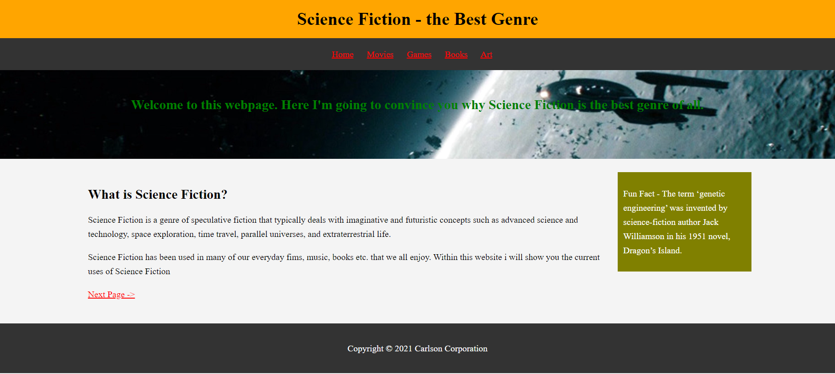
This is the main home page of the website. This gives a brief definition on what science fiction is and gives the user a brief message on the website’s content. I have also included some brief fun facts on each webpage for the user to see- all facts found from [1]. I used an online definition created by Wikipedia:
Science Fiction is a genre of speculative fiction that typically deals with imaginative and futuristic concepts such as advanced science and technology, space exploration, time travel, parallel universes, and extra-terrestrial life. [2]
I also included a next page link at the bottom of the page to allow the user to continue within the website – To the Movies Section.

Page 2 – Movies
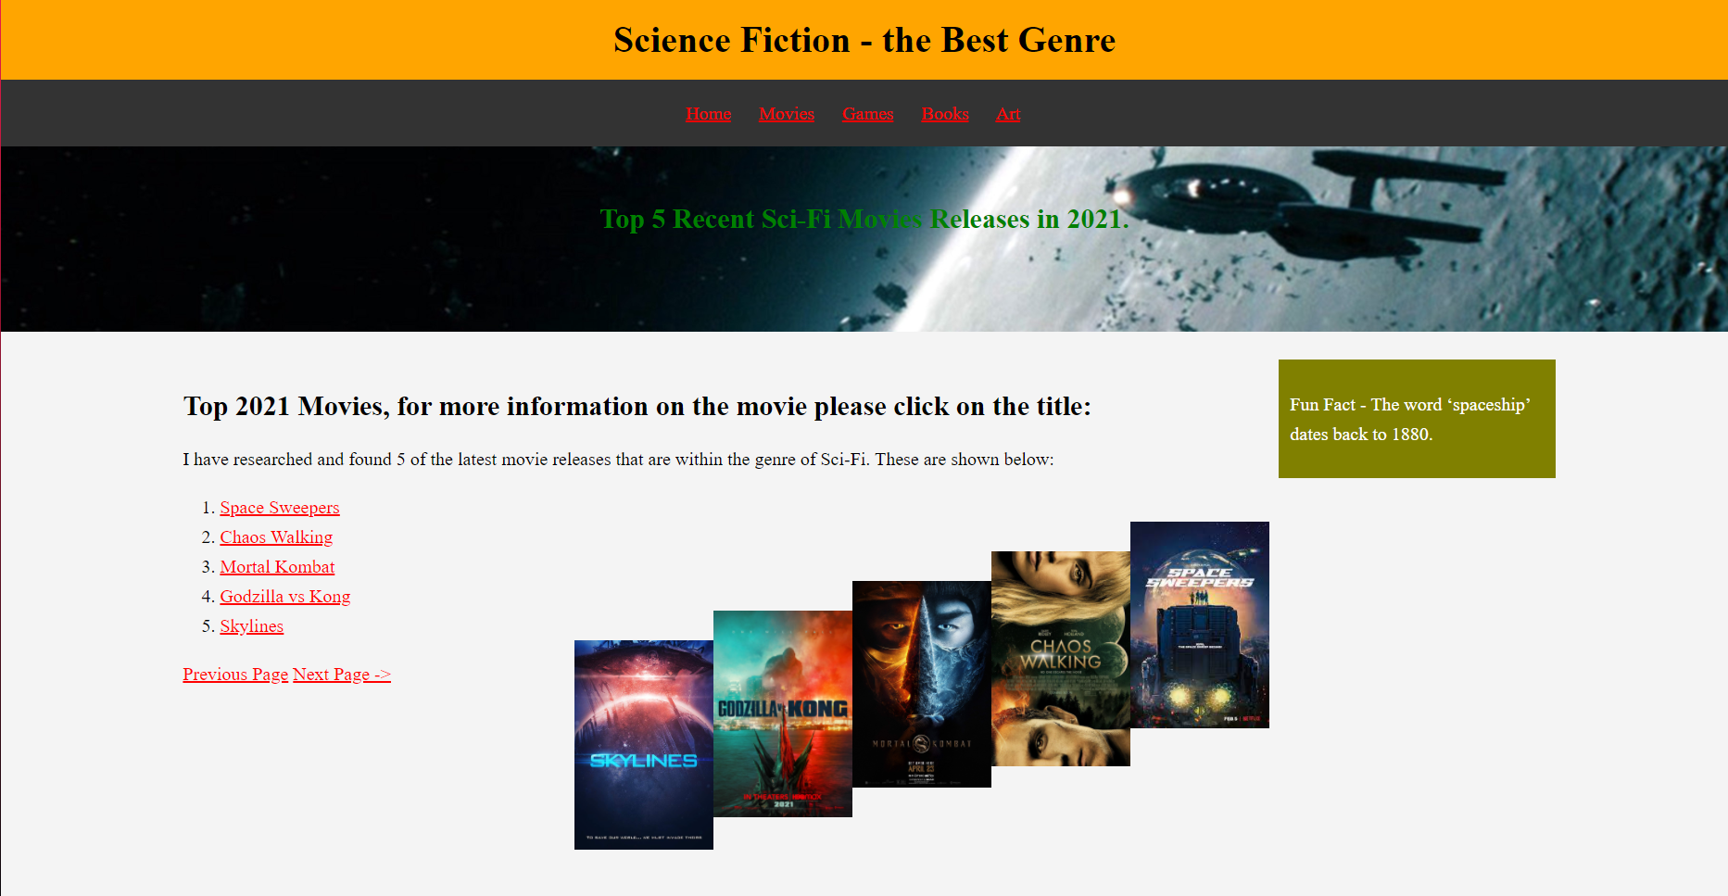
In this page I did some research into the current trending Sci-Fi films available to watch. I found the 5 most trending and added both photos and links of all the relevant movies I inserted. This allowed me to show what the movie titles were but also allowed the user to choose a movie and click on the link to find out more information.
Figure 1-5 – Website Page 2 – Movie Covers – Adapted from [3]

Page 3 – Games
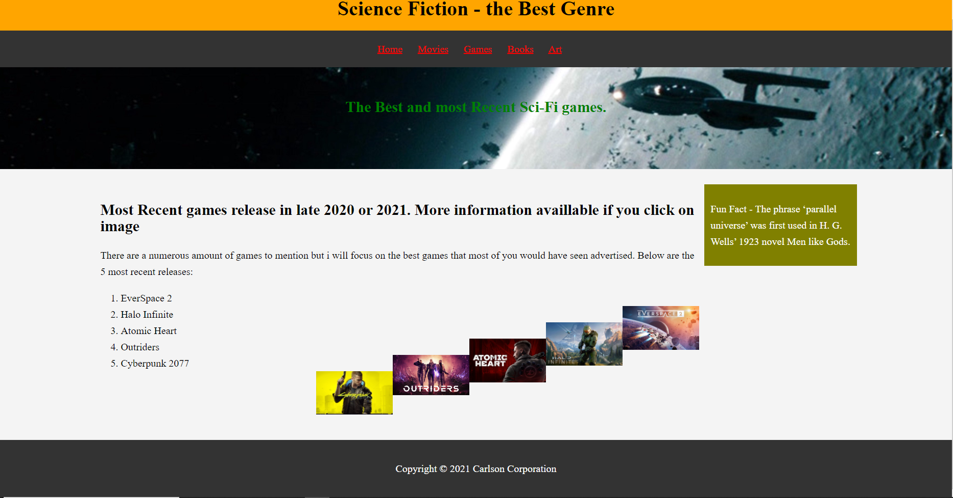
Figure 6-10 – Website Page 3 – Game Covers – Adapted from [4]

The Games section page above was my favourite as I am an avid gamer. I found the 5 most recent sci-fi oriented games and put a relevant link joined with the image, so all the users must do is click the image for more information about the game. I used a picture link on this to show another aspect of the html possibilities.

Page 4 – Books
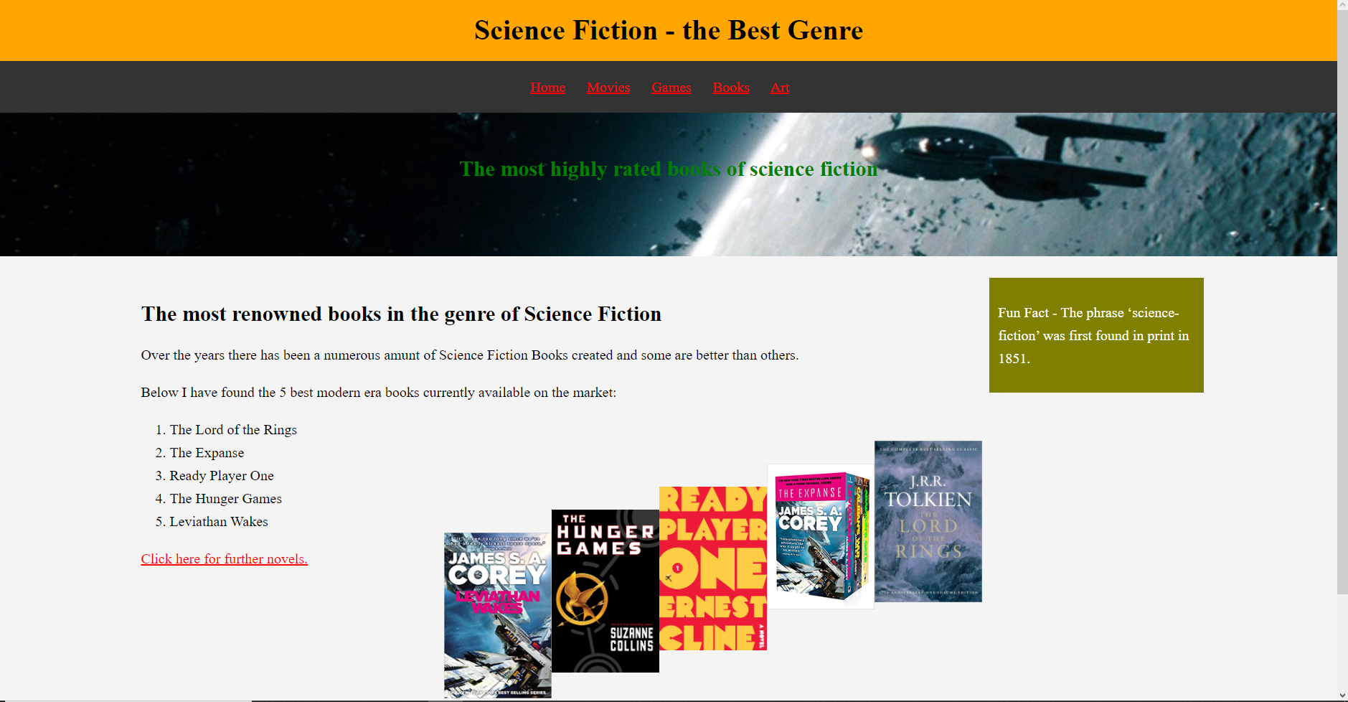
The next page I created was about Science Fiction Books. This section I looked for the most modern books available that we would recognize based on the films or from the appearance. There was a numerous number of Sci-fi books, but I believe I found 5 well recognised books that the user could enjoy. I also added a link where the user could click on it if they wish to view more books.
Figure 11-15 – Website Page 4 – Book Covers – Adapted from [5]

Page 5 – Art
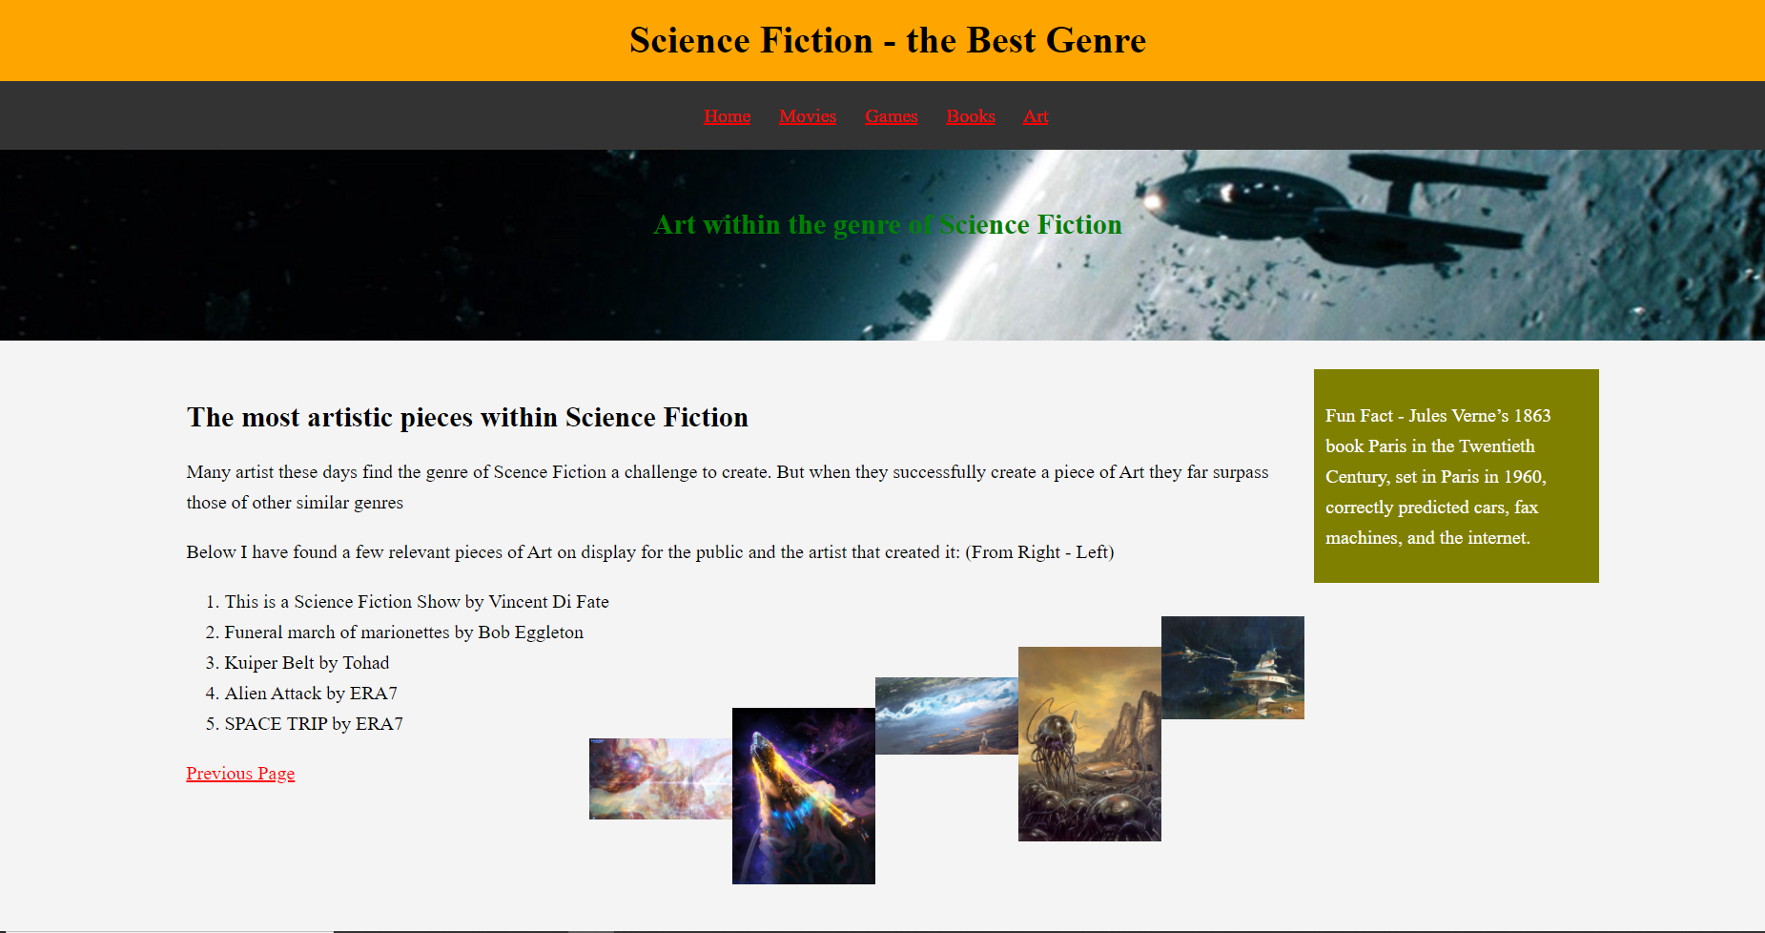
Figure 16-20 – Website Page 5 – Art Pieces – Adapted from [6]
The final page above was dedicated to Science Fiction related art. I have researched and included 5 pieces of exceptional Science Fiction art and the artist who created the piece. I have included a guide to view the pieces from right to left based on their order to view their name and artist. This was the final page on the website and therefore I though that these pieces of art would be able to show the broadness of the genre as it can be interpreted in so many ways.

Validation
The next part I underwent was after the full creation of the website I used 2 different tools to validate my code in full to identify any significant errors within the program. I have shown the results below:

HTML Validation
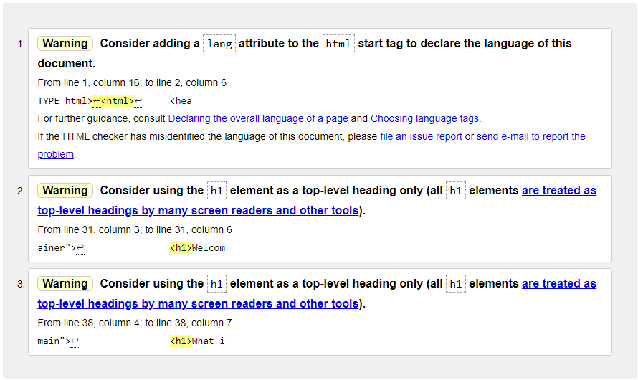
The validation of my home page returned these 3 warnings/possible changes, these changes were all based on aesthetics and the function would not change. Overall, there was no significant errors detected by the validator but during my time coding the home page I discovered that there was an error in allowing the widow to scale to the user’s device. After some research I discovered a tutorial on how to fix the viewport error. The website I used was w3schools where according to the creator all I needed to do was add the following line of code:
<meta name="viewport" content="width=device-width, initial-scale=1.0"> [7]
This line code then allowed my website to scale based on the user’s device and window size. This ensured that no website content would be lost if the user were on a mobile device instead of a desktop. Apart from that one error there were no other significant errors within coding the home page of the website.

CSS Validation

As we can see above, when I inputted my CSS code for validation there were no errors to be found. This was a good sign as that meant that all the style code was correct but at the initial stages of the CSS coding, I discovered that there were a few quite significant errors. The first was that the backgrounds of the different sections would not appear and as I kept redoing everything there was still no avail to problem. I discovered that as I was coding, I forgot to add some simple symbols which were a “#” for the sections but also “;” at the end of the style variable and therefore without these symbols the program would not recognize these style changes.
The final error was the scaling and position of all the text, images, and boxes. Over the main page there was a lot of overlapping between the background image and the txt beneath. I discovered that to resolve this issue I needed to create a dedicated section that would be only for the top title which would ensure that any style changes would only affect that background. But also, for the images beneath I discovered that to align them in the page I had to set a max width of 90%, the max width command would ensure that the photos would not get cut off by the browser, and I had to set them to float(appear) on the right by using “float: right”. This command allowed the images to display without affecting the text in any way.

Evaluation

Part A – Website Development Research

Website Usability
When talking about creating an effective website, we must remember that there are many aspects that if not done correctly can lead to a failed website. Website usability is one of them, this aspect of website creation is important as it allows the website to look and feel easy to use. The full definition of usability is stated by J. Nelson with “Usability is a quality attribute that assesses how easy user interfaces are to use. The word "usability" also refers to methods for improving ease-of-use during the design process.” [8]. Usability mainly focuses on general user interaction. There are many aspects associated with website usability which all refer to different parts of a website section, they all contribute toward a successful website and I will list 3 of the most important roles below:
- Visual Complexity – How Eye-Catching is the layout and design of the website?
- Efficiency – How would the design affect the user’s interaction. Would the design cause confusion in navigating the website?
- Quality – What overall quality is the website. Quality of information used, images found, design and user interface?
There are many credible resources available that help to support these aspects above. The report I am going to mention is about information overload within a website which occasionally mentions aspects of usability within the report. According to M. Chen:
Previous studies find that website usability depends greatly upon its visual complexity which has significant effects on users' psychological perception and cognitive load. It is well known that website success is highly dependent on its usability. Poor usability is a key element in many high-profile site failures and can turn away users even if its information is of high quality. [9]
This created research study is a perfect study on what effect usability has on a successful website but also on how too much information within a website can cause an information overload. The research study I am using is “Improving website structure through reducing information overload” [9], In essence this report shows all aspects of reducing information overload within a website without compromising any aspect of website usability and information. M. Chen clearly created an exceptional research study focused on the successful creation of a website using effective methods but also by using a math programming model to reduce information overload. He does a numerous number of experiments to support all his findings. His key findings were that website usability is important in a successful website and that the success is all based on its usability but his main finding was that by using a mathematical formula he could reduce the cognitive load of the website.
We see that the roles mentioned above all contribute towards having a successful website through website usability. These roles supported by the research paper help me to understand that without website usability then most websites would fail.

Accessibility
The next aspect was accessibility, when talking about accessibility it can refer to a few things such as user interface layout, image links, page browsing etc. For a successful website design the accessibility factor must be to a high standard. According to M. Wallwood:
Web accessibility focuses on designing and developing websites that are more accessible to people with disabilities. It means that websites that have applied the accessibility principles can provide more accessible content. [10]
We see that accessibility id focused on the website use for people with disabilities. To have a successful website it must adhere to all aspects for it to be suitable for all types of users. There are many examples of modes accessibility within a website and how they created this, for example, some users with colour blindness would be unable to differentiate normal text from links and therefore might miss them, the way to mitigate this was to underling the links only. There are numerous accessibility guidelines available for every website creator to adhere to. The Research article I will refer to now explains to what effect implementing the web accessibility guidelines would have on non-disabled users.
Within this article the authors S. Schmutz, A, Sonderegger and J, Sauer clearly give a good definition of web accessibility of “Web accessibility (hereafter “accessibility”) aims to ensure that “people with disabilities can perceive, understand, navigate, and interact with the web” [11] This article is focused on the implementation of accessibility guidelines and their effect on everyday users without any disability. The objective of the research article was to examine the consequences of implementing the Accessibility guidelines on the experience for nondisabled users. Their key findings were that:
- A high level of Web accessibility led to better performance (i.e., task completion time and task completion rate) than low or very low accessibility.
- High Web accessibility improved user ratings (i.e., perceived usability, aesthetics, workload, and trustworthiness) compared to low or very low Web accessibility.
- There was no difference between the very low and low Web accessibility conditions for any of the outcome measures. [11]
This article refers to several accessibility implementation techniques such as text alternatives. They state that to create a successful website, “Improving our knowledge of their effects on nondisabled users is important because nondisabled users also use accessible-designed Web sites and even represent the vast majority of users.” [11]
This research article helped me to understand why accessibility is important within creating a successful website. It made me realize that accessibility has a massive effect on the performance and user ratings that the website would receive. I understood that the higher the accessibility the better the performance would be and would have no negative effect on any specific user categories.

Search Engine Optimization (SEO)
The final aspect was Search Engine Optimization (now referred as SEO). SEO is basically visibility of your webpage in the search engines. The official definition is stated by L. Baker with “At its core, SEO is the process of making your site rank as high as possible in Google when someone types in “burrito blanket” (or whatever it is you sell, promote, or talk about.)” [12] In essence, SEO is your website rank regarding similar websites with the same content/information. SEO regards site rank as it is relevance in displaying when a user searched for that subject on a search engine such as Google. The higher the site rank the higher relevance it would have on the web browser search.
There are many aspects of a website that the SEO uses to determine your ranking. I have shown a few below:
- Keywords – The web browsers now analyse all the text and context of your websites and split them into keywords that if they match with the user’s search your website would be more relevant.
- URL’s, Headers and Titles – To increase your rank we must ensure that all the titles and headers are clear and easy to identify and if possible, also add keywords within that text.
- Content – The amount of content in the website also matters. Each Search engine will pick you website based on the topic and the purpose of each page on the website, if they align with the user’s input then the rank of the website would increase.
This is also reinforced by the research article PR Students’ Perceptions and Readiness for Using Search Engine Optimization by M. Moody and E, Bates when they say that “Search engines consider article length, writer’s expertise, title, topic, keywords, and quality of linking sites, or inbound links” [13]. This research article shows why SEO is used within the creation of websites and by search browsers. To summarise this research article, It’s purpose was to first “we briefly outline the definitions and uses of SEO” [13] and then “Second, we survey junior and senior public relations majors to assess the importance that they attach to SEO and how they might apply the tactic to the PR industry.” [13]. They aimed to find out what major students thought about the use of SEO and were they ready to implement it into their own work. Their Key Findings were that students do possess the relevant SEO skills, but the PR professionals are not aware of their skill, but also they found that a majority of student understood the basic definition of SEO but did not understand how to apply the tactic to their work.
By using all these relevant resources I was able to fully grasp that SEO is an important aspect to get users to view the page but also SEO is ranked on the overall content and design of the website, without enough content and a decent design then the SEO would not give a high ranking to the created website.

Part B – Personal Website Evaluation
For my completed website I will now evaluate the Usefulness, SEO and Accessibility within the website.

Usefulness (usability and utility)
When looking over my website I was considering all the design aspects but also how easy to use it was. My website design is simple but the same across all pages, each set of images is formatted in the same way and the content is all in a similar format, with regards to its usability I found that the overall easy of use was decent as each page had a next page link as well as a previous page link (where applicable) which helped to increase the easy of use. When reviewing the content, I realized that I only put the basic amount of information that was needed, and I used a numerous number of links in replacement of information. Finally, the utility of the website worked as intended, I wanted the navigation bar to direct to the relevant pages in which it did but also, I wanted every link to work as intended. Overall, the functionality of the website was good.

Improvements
Possible improvements I could make are as follows:
- Use more information based on the content already provided such as explain the brief plots of the movies stated in the movies tab.
- Create a dedicated page to facts and the history of science fiction and give more than just the definition of the genre.
- I could have alternated background images on every page to make the design more eye-catching, also the background colours based on the content on the page.

Search Engine Optimization (SEO)
Next, I evaluated on what SEO techniques I applied to my website:
- Easy to read pages
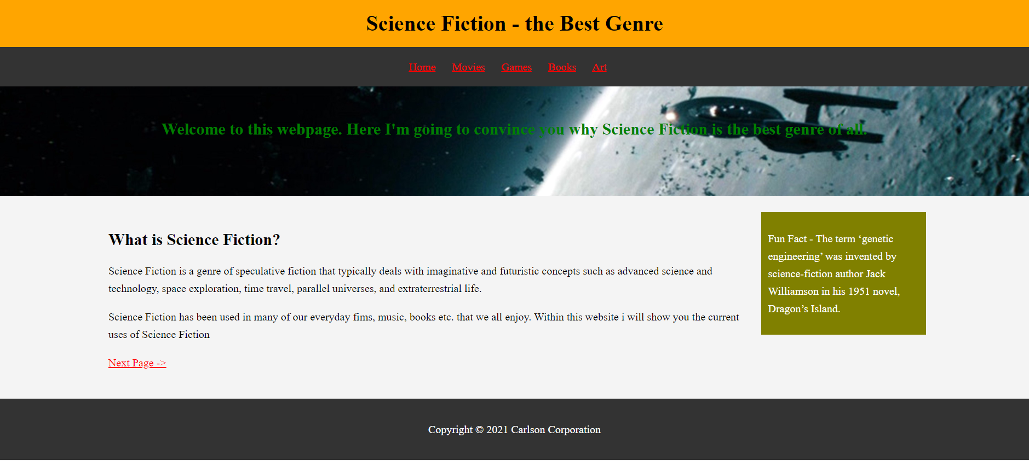
I used a simple background for the title but also, I used several paragraphs to show my information content in an easily readable fashion. Also used clear and bold headers to show what was included in each section.

- Using relevant links
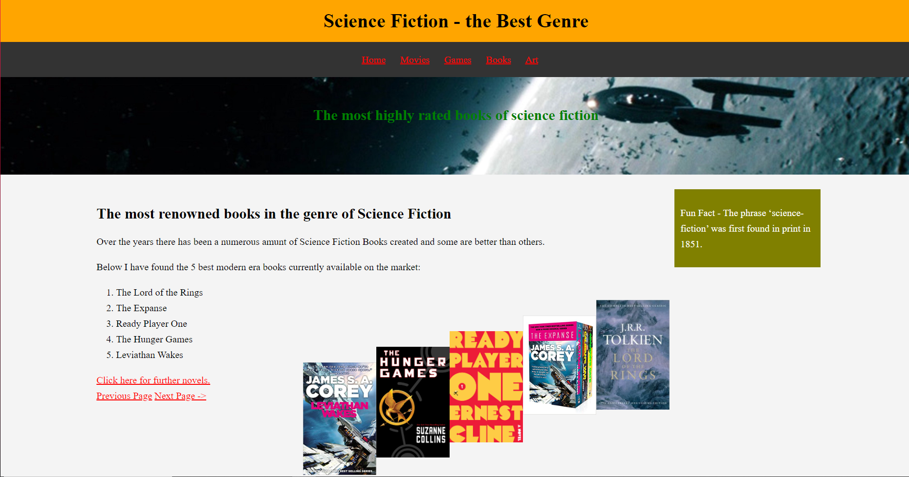
I created this webpage about Science Fiction Books for the users to see, but I also included the relevant external link for the user find out further information about the explained books in the website. The link leads them to an external website which explains the plots of the books but also where they could purchase the selected books.
- Images on Webpages
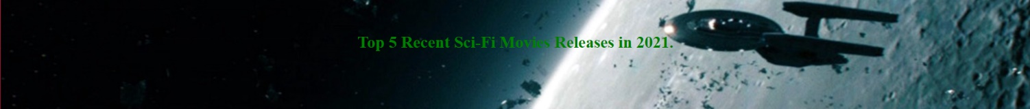
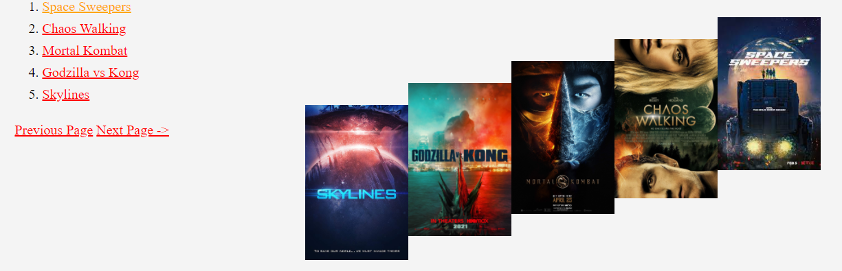
One technique of SEO that was important was the use of images within the webpage. I used several different images based on the content selected on the specific page. As shown above I used an image to show every cover for the movies stated but also, I used one universal photo that I used as a background across all the webpages. I optimized each image based on the size of the webpage and I used descriptive file

- Internal Links
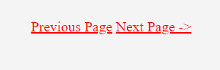
Next was the use of internal links within the web page. Above I have shown both my navigation bar and the next and previous page keys. I used the internal links to link each web page together as the user clicks the links. This gives the search engines availability to see my other web pages but also it’s a way to get users to spend more time on the site. I implemented these internal links by using the following line of code and adapting based on the webpage title, this code is the way to link internal coded files to the webpage for them to display:
<a href="index.html">Home</a>

Accessibility
The Final evaluation aspect was Accessibility. I evaluated my website based on the 4 base principles of accessibility.
- Contrast Tool
For this aspect I used the provided contrast checker tool to identify if my colour scheme would adhere t the base principles. The results are Below:
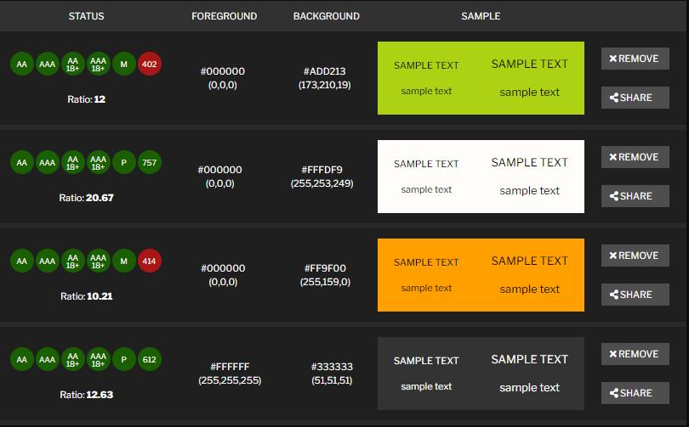
The majority of the colours used were all ok and in line with the guidelines there were 2 colours where the colour difference was slightly low but this would have no major effect on the guidelines for the website as all other values were correct.

- WAVE Tool
Next, I use the WAVE accessibility tool to review my webpage in full to identify any errors and ant contrast errors etc. The result is below:
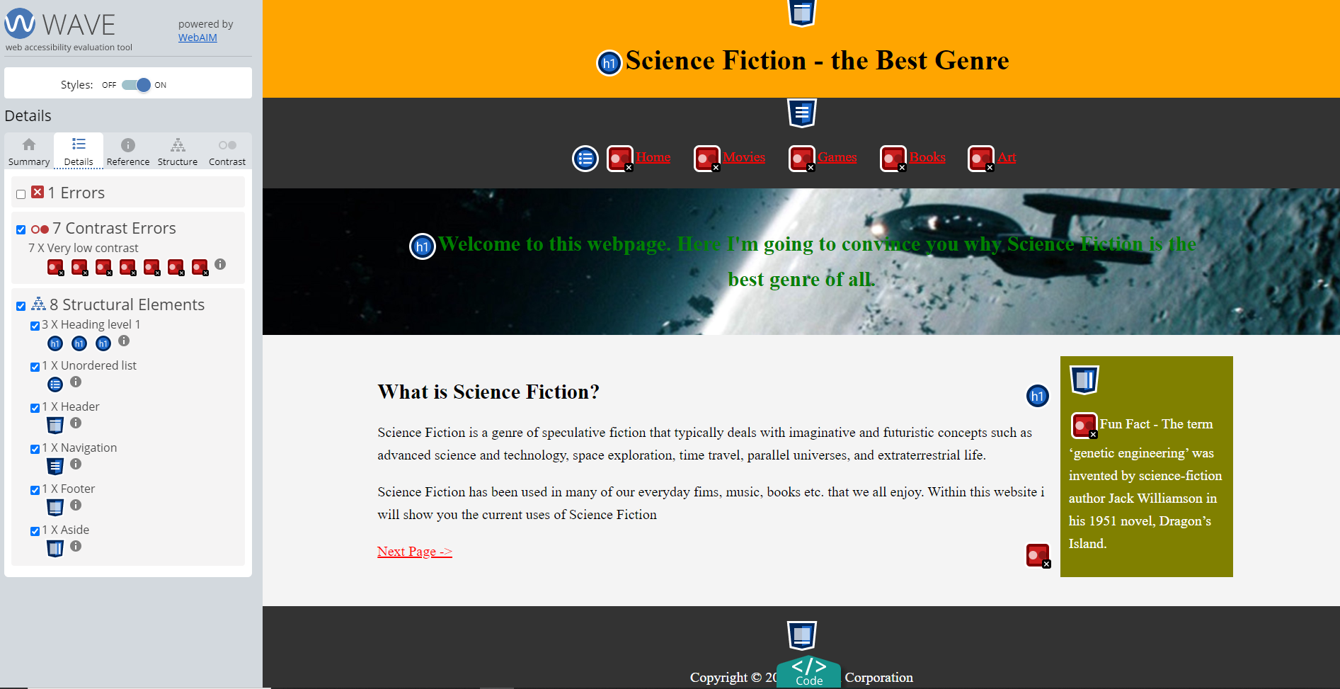
We see that this tool shows that there are a few contrast errors within the colour scheme. But there was 1 error reported but this was miscalculated as the language is clear and the error was wrong. The error stated that the language was unregistered and unidentified. I researched into this problem and identified that this is an internal problem with the WAVE tool.

Is the website in line with the 4 principles?
After using the tools above, I can now clearly say that my website does adhere to the 4 principles. My website is Perceivable as the information and content is short and easy to see and understand. Next, Operable – my website included numerous links to relevant content and is a simple interface to use for all users, simple mouse clicks to move between pages. The third is Understandable – my website has simple and straightforward content which is easy to read and has every definition and word explained to the user. Each webpage is set out in a clear and understandable fashion by using numbered lists and short paragraphs. Finally, the fourth is Robust – My website is configured to be robust as whatever device the user is on, the website would scale to accommodate the screen Sze of the device. The website is accessible on every modern browser on every device.

References

[1] | Interestingliterature.com, “20 Interesting Facts about Science Fiction,” [Online]. Available: https://interestingliterature.com/2016/04/20-interesting-facts-about-science-fiction/#:~:text=(More%20great%20word%20facts%20here,didn't%20coin%20the%20word.. [Accessed 25 April 2021].
[2] | Wikipedia, “Science Fiction,” [Online]. Available: https://en.wikipedia.org/wiki/Science_fiction. [Accessed 25 April 2021].
[3] | Nedowski, “Sci-Fi/Fantasy Movies 2021,” IMDB, 02 April 2020. [Online]. Available: https://www.imdb.com/list/ls094718474/. [Accessed 25 April 2021].
[4] | Steam.co.uk, “Sci-fi Games,” [Online]. Available: https://store.steampowered.com/tags/en/Sci-fi/. [Accessed 25 April 2021].
[5] | theworks.co.uk, “Sci-Fi Books,” [Online]. Available: https://www.theworks.co.uk/c/books/fiction-books/sci-fi-books. [Accessed 25 April 2021].
[6] | this-is-cool.co.uk, “SCI-FI, FANTASY & HORROR,” [Online]. Available: https://www.this-is-cool.co.uk. [Accessed 25 April 2021].
[7] | w3schools.com, “Responsive Web Design - The Viewport,” [Online]. Available: https://www.w3schools.com/css/css_rwd_viewport.asp. [Accessed 25 April 2021].
[8] | J. Nelson, “Usability 101: Introduction to Usability,” 3 January 2012. [Online]. Available: https://www.nngroup.com/articles/usability-101-introduction-to-usability/. [Accessed 25 April 2021].
[9] | M. Chen, “Improving website structure through reducing information overload,” June 2018. [Online]. Available: https://www-sciencedirect-com.ezproxy.uwtsd.ac.uk/science/article/pii/S0167923618300575#bb0015. [Accessed 25 April 2021].
[10] | M. Wallwood, “What is web accessibility?,” 26 December 2019. [Online]. Available: https://uxdesign.cc/what-is-web-accessibility-they-asked-80a39a7ebe59. [Accessed 25 April 2021].
[11] | S. Schmutz, A. Sonderegger and J. Sauer, “Implementing Recommendations From Web Accessibility Guidelines: Would They Also Provide Benefits to Nondisabled Users,” Human Factors: The Journal of the Human Factors and Ergonomics Society, vol. 58, no. 4, pp. 611-629, 2016.
[12] | L. Baker, “What is SEO & How It Works,” 27 February 2021. [Online]. Available: https://www.searchenginejournal.com/seo-101/what-is-seo/#close. [Accessed 25 April 2021].
[13] | M. Moody and E. Bates, “PR Students’ Perceptions and Readiness for Using Search Engine Optimization,” Journalism & Mass Communication Educator, vol. 68, no. 2, pp. 166-180, 2013.

Appendices

Appendix 1 – HTML Code Full

Index.html
<html>
<head>
<meta charset="utf-8" />
<title>My Favourite Genre - Science Fiction</title>
<meta name="viewport" content="width=device-width, initial-scale=1">
<link rel="stylesheet" href="css/style.css">
</head>
<body>
<header id="main-header">
<div class="container">
<h1>Science Fiction - the Best Genre</h1>
</div>
</header>
<nav id="navigation-bar">
<div class="container">
<ul>
<li><a href="index.html">Home</a></li>
<li><a href="movies.html">Movies</a></li>
<li><a href="games.html">Games</a></li>
<li><a href="books.html">Books</a></li>
<li><a href="art.html">Art</a></li>
</ul>
</div>
</nav>
<section id="welcome">
<div class="container">
<h1>Welcome to this webpage. Here I'm going to convince you why
Science Fiction is the best genre of all.</h1>
</div>
</section>
<div class="container">
<section id="main">
<h1>What is Science Fiction? </h1>
<p>Science Fiction is a genre of speculative fiction that typically deals with Imaginative and futuristic concepts such as advanced science and technology, space exploration, time travel, parallel universes, and extraterrestrial life.</p>
<p>Science Fiction has been used in many of our everyday films, music, books etc. that we all enjoy.
Within this website I will show you the current uses of Science Fiction</p>
<a href="movies.html">Next Page -></a>
</section>
<aside id="fun fact-sidebar">
<p>Fun Fact - The term ‘genetic engineering’ was invented by science-fiction author Jack Williamson in his 1951 novel, Dragon’s Island.</p>
</aside>
</div>
<footer id="bottom-page">
<p> Copyright &copy; 2021 Carlson Corporation</p>
</footer>
</body>
</html>

movies.html
<html>
<head>
<meta charset="utf-8" />
<title>Science Fiction - Most Popular Movies</title>
<meta name="viewport" content="width=device-width, initial-scale=1">
<link rel="stylesheet" href="css/style.css">
</head>
<body>
<header id="main-header">
<div class="container">
<h1>Science Fiction - the Best Genre</h1>
</div>
</header>
<nav id="navigation-bar">
<div class="container">
<ul>
<li><a href="index.html">Home</a></li>
<li><a href="movies.html">Movies</a></li>
<li><a href="games.html">Games</a></li>
<li><a href="books.html">Books</a></li>
<li><a href="art.html">Art</a></li>
</ul>
</div>
</nav>
<section id="welcome">
<div class="container">
<h1>Top 5 Recent Sci-Fi Movies Releases in 2021.</h1>
</div>
</section>
<div class="container">
<section id="main-movies">
<h1>Top 2021 Movies, for more information on the movie please click on the title:</h1>
<p>I have researched and found 5 of the latest movie releases that are within the genre of Sci-Fi. These are shown below:</p>
<ol>
<li><a href="https://imdb.to/3dLMkFW">Space Sweepers</a></li> <img src="images/Movies/Space Sweepers.jpg">
<li><a href="https://imdb.to/3gBT0ID">Chaos Walking</a></li> <img src="images/Movies/Chaos Walking.jpg">
<li><a href="https://imdb.to/3dJQb6u">Mortal Kombat</a></li> <img src="images/Movies/Mortal Kombat.jpg">
<li><a href="https://imdb.to/2RSor76">Godzilla vs Kong</a></li> <img src="images/Movies/Godzilla vs Kong.jpg">
<li><a href="https://imdb.to/2PiCQbN">Skylines</a></li> <img src="images/Movies/Skylines.jpg">
</ol>
<a href="index.html">Previous Page</a>
<a href="games.html">Next Page -></a>
</section>
<aside id="funfact-sidebar">
<p>Fun Fact - The word ‘spaceship’ dates back to 1880.</p>
</aside>
</div>
<footer id="bottom-page">
<p> Copyright &copy; 2021 Carlson Corporation</p>
</footer>
</body>
</html>

Books.html
<html>
<head>
<meta charset="utf-8" />
<title>Science Fiction - Books</title>
<meta name="viewport" content="width=device-width, initial-scale=1">
<link rel="stylesheet" href="css/style.css">
</head>
<body>
<header id="main-header">
<div class="container">
<h1>Science Fiction - the Best Genre</h1>
</div>
</header>
<nav id="navigation-bar">
<div class="container">
<ul>
<li><a href="index.html">Home</a></li>
<li><a href="movies.html">Movies</a></li>
<li><a href="games.html">Games</a></li>
<li><a href="books.html">Books</a></li>
<li><a href="art.html">Art</a></li>
</ul>
</div>
</nav>
<section id="welcome">
<div class="container">
<h1>The most highly rated books of science fiction</h1>
</div>
</section>
<div class="container">
<section id="main-book">
<h1>The most renowned books in the genre of Science Fiction</h1>
<p>Over the years there has been a numerous amunt of Science Fiction Books created and some are better than others.</p>
<p>Below I have found the 5 best modern era books currently available on the market:</p>
<ol>
<li>The Lord of the Rings</li> <img src="images/Books/The Lord of the Rings.jpg">
<li>The Expanse</li> <img src="images/Books/The Expanse.jpg">
<li>Ready Player One</li> <img src="images/Books/Ready Player One.jpg">
<li>The Hunger Games</li> <img src="images/Books/The Hunger Games.jpg">
<li>Leviathan Wakes</li> <img src="images/Books/Leviathan Wakes.jpg">
</ol>
<a href="https://www.theworks.co.uk/c/books/fiction-books/sci-fi-books">Click here for further novels.</a>
<br><a href="games.html">Previous Page</a>
<a href="art.html">Next Page -></a>
</section>
<aside id="funfact-sidebar">
<p>Fun Fact - The phrase ‘science-fiction’ was first found in print in 1851.</p>
</aside>
</div>
<footer id="bottom-page">
<p> Copyright &copy; 2021 Carlson Corporation</p>
</footer>
</body>
</html>

Games.html
<html>
<head>
<meta charset="utf-8" />
<title>Science Fiction - Games</title>
<meta name="viewport" content="width=device-width, initial-scale=1">
<link rel="stylesheet" href="css/style.css">
</head>
<body>
<header id="main-header">
<div class="container">
<h1>Science Fiction - the Best Genre</h1>
</div>
</header>
<nav id="navigation-bar">
<div class="container">
<ul>
<li><a href="index.html">Home</a></li>
<li><a href="movies.html">Movies</a></li>
<li><a href="games.html">Games</a></li>
<li><a href="books.html">Books</a></li>
<li><a href="art.html">Art</a></li>
</ul>
</div>
</nav>
<section id="welcome">
<div class="container">
<h1>The Best and most Recent Sci-Fi games.</h1>
</div>
</section>

<div class="container">
<section id="main">
<h1>Most Recent games release in late 2020 or 2021. More information availlable if you click on image</h1>
<p>There are a numerous amount of games to mention but i will focus on the best games that most of you would have seen advertised. Below are the 5 most recent releases:</p>

<ol>
<li>EverSpace 2</li> <a href="https://www.everspace.game/"><img src="images/Games/Everspace 2.jpg"></a>
<li>Halo Infinite</li> <a href="https://bit.ly/3aDpC0I"><img src="images/Games/Halo Infinite.jpg"></a>
<li>Atomic Heart</li> <a href="https://mundfish.com/"><img src="images/Games/atomic heart.jpg"></a>
<li>Outriders</li> <a href="https://bit.ly/3sUtq3T"><img src="images/Games/outriders.jpg"></a>
<li>Cyberpunk 2077</li> <a href="https://www.cyberpunk.net/gb/en/"><img src="images/Games/Cyberpunk-2077.jpg"></a>
</ol>
<a href="movies.html">Previous Page</a>
<a href="books.html">Next Page -></a>
</section>
<aside id="funfact-sidebar">
<p>Fun Fact - The phrase ‘parallel universe’ was first used in H. G. Wells’ 1923 novel Men like Gods.</p>
</aside>
</div>
<footer id="bottom-page">
<p> Copyright &copy; 2021 Carlson Corporation</p>
</footer>
</body>
</html>

Art.html
<html>
<head>
<meta charset="utf-8" />
<title>Science Fiction - Art</title>
<meta name="viewport" content="width=device-width, initial-scale=1">
<link rel="stylesheet" href="css/style.css">
</head>
<body>
<header id="main-header">
<div class="container">
<h1>Science Fiction - the Best Genre</h1>
</div>
</header>
<nav id="navigation-bar">
<div class="container">
<ul>
<li><a href="index.html">Home</a></li>
<li><a href="movies.html">Movies</a></li>
<li><a href="games.html">Games</a></li>
<li><a href="books.html">Books</a></li>
<li><a href="art.html">Art</a></li>
</ul>
</div>
</nav>
<section id="welcome">
<div class="container">
<h1>Art within the genre of Science Fiction</h1>
</div>
</section>
<div class="container">
<section id="main-book">
<h1>The most artistic pieces within Science Fiction</h1>
<p>Many artist these days find the genre of Scence Fiction a challenge to create. But when they successfully create a piece of Art they far surpass those of other similar genres</p>
<p>Below I have found a few relevant pieces of Art on display for the public and the artist that created it: (From Right - Left)</p>
<ol>
<li>This is a Science Fiction Show by Vincent Di Fate </li> <img src="images/Art/This is a Science Fiction Show.jpg">
<li>Funeral march of marionettes by Bob Eggleton</li> <img src="images/Art/Funeral march of marionettes.jpg">
<li>Kuiper Belt by Tohad</li> <img src="images/Art/Kuiper Belt.jpg">
<li>Alien Attack by ERA7</li> <img src="images/Art/Alien Attack.jpg">
<li>SPACE TRIP by ERA7</li> <img src="images/Art/SPACE TRIP.jpg">
</ol>
<a href="books.html">Previous Page</a>
</section>
<aside id="funfact-sidebar">
<p>Fun Fact - Jules Verne’s 1863 book Paris in the Twentieth Century, set in Paris in 1960, correctly predicted cars, fax machines, and the internet.</p>
</aside>
</div>
<footer id="bottom-page">
<p> Copyright &copy; 2021 Carlson Corporation</p>
</footer>
</body>
</html>

Appendix 2 – CSS Code
body{
background-color: #f4f4f4;
color: #555;
font: normal 20px Calbri;
line-height:1.6em;
margin: 0;
}
.container{
width:80%;
margin:auto;
overflow:hidden;
}
#main-header{
background-color: orange;
color: black;
text-align: center;
}
#navigation-bar{
background-color: #333;
color: white;
text-align: center;
}
#navigation-bar ul{
padding: 0;
list-style: none;
}
#navigation-bar li{
display: inline;
color: white;
}
#navigation-bar a{
font-size: 20px;
padding-right: 25px
}
a{
color: red;
}
a:hover{
color:orange;
}
#main{
float: left;
color: black;
width: 80%;
padding: 10px;
box-sizing: border-box;

}
#main img{
max-width: 90%;
width: 150px;
float: right;
}
#main-movies{
float: left;
color: black;
width: 80%;
padding: 10px;
box-sizing: border-box;

}
#main-movies img{
max-width:90%;
width: 150px;
float: right;
}
#main-book{
float: left;
color: black;
width: 80%;
padding: 10px;
box-sizing: border-box;

}
#main-book img{
max-width: 90%;
width: 150px;
float: right;
}
#funfact-sidebar{
float: right;
width: 20%;
color: #fff;
padding: 12px;
box-sizing: border-box;
background-color: olive;
}
#welcome{
background-image:url("images/sci-fi.jpg");
background-size: 2000px;
color: red;
opacity:1.0;
background-position:center right;
min-height:200px;
margin-bottom:30px;
text-align:center;
}
#welcome h1{
color:green;
font-size:30px;
line-height:1.6em;
padding:30px;
}
#bottom-page{
background:#333;
color:#fff;
text-align:center;
padding:20px;
margin-top:40px;
}
@media(max-width:600px){
#main{
width:100%;
float:none;
}
#sidebar{
width:100%;
float:none;
}
#navbar li{
display:block;
}

