
Software solution for business
Assessment 1
Program: certificate of higher education in computing

Task 1. e-Commerce Website builders or software solutions

Shopify

Shopify can be considered one of the most popular tools to build an online store, as it's pretty easy to use and works for almost any business size. Whether you are selling a few handmade items or running a growing company, Shopify gives you the basics you need to open a store without having to learn how to code or deal with technical work.

One of the major reasons people are moving to Shopify is probably how fast you can set everything up. You just pick a theme, add your products, choose your payments, and basically your store is ready. The system leads you through most steps, so it never feels overwhelming. Shopify also has a big app store, where you can add extra features when you need them: things like reviews, email marketing, subscriptions, etc.

In recent years, Shopify added more and more AI tools that help with the writing of product descriptions, suggest marketing ideas, and basically take away some of the boring daily tasks. It also has a very smooth checkout process that helps customers finish their purchase quickly, especially on phones.

The major drawback is that most of the advanced functionalities require paid apps, and if not monetized, your overall cost may go up every month. However, the experience as a whole is fairly reliable, and support is available 24/7.

All in all, Shopify is a great choice for anyone who wants a simple, clean way to get started selling online without getting bogged down on tech headaches.

1.2 Wix

Wix is one of the most popular website makers out there, and even allows you to create an online store, all while being extremely easy to use. It's perfect for beginners, small businesses, artists, or anyone who needs a nice-looking website without needing to learn how to code. With Wix, you can create almost any type of site just by dragging and dropping things where you want them, which makes the whole process simple and even fun.

By far, one of the greatest things about Wix is the sheer number of templates. From within, designs exist for clothing shops, cafes, beauty stores, digital products, and about a thousand more. You can change anything on the page: colors, pictures, text, buttons-and make the site feel truly your own. The Wix template also has inbuilt functions for product galleries, online payments, shipping options, and even digital downloads.

With Wix, other useful marketing tools are also available: sending email campaigns, automatic reminders to customers who have left items in their cart, and basic SEO features to help people find your store on Google. It also has an AI-powered website generator that will do the heavy lifting of building a full starter website for you, based on a few questions it asks.

The major negative is that Wix just isn't as powerful when it comes to really large stores or particularly complex product setups. It's ideal for small and medium-sized shops, but very large e-commerce shops (scaling into the thousands of products) might be better off with another platform. However, for most small businesses, creators, and new sellers, Wix represents a straightforward and reasonably priced option for getting a professional store online quickly.

Task 2. Mind-map of contemporary software applications
Mind mapping and explain the advantages of using mind mapping in business activities During the time I prepared my mind map, I wanted to organize the various types of software businesses use every day, in such a way that would, at least, make sense. This includes everything from trying to remember lists to having messy notes, so I put "contemporary software applications" at the center and then did branches for each major area a business relies on. Such things are HR, CRM, Project Management, Analytics, Marketing, Accounting, Communication Tools, etc. Immediately, having everything spread out on either side of the center made it exponentially easier for me to see the big picture.
Under each branch, I included the software examples that fell under that category. For example, under HR, I included things like BambooHR, Zenefits, and Workday. For CRM, I added Salesforce, HubSpot, and Zoho. Under project management, I included Trello, Asana, Monday.com, and Jira. I did this for every category, including Tableau and Qlik Sense for analytics, Freshdesk and Zendesk for customer support, and tools such as Xero and QuickBooks for accounting. The process helped me to see everything grouped together like this; I started to grasp what each tool was used for, and how each of them worked in relation to different business activities.
One of the main reasons I like using mind maps is that they make things easier to understand. Sometimes when information is in straight lines or long paragraphs, I lose my place or forget how things link together. But with a mind map, I can see everything at once. Tony Buzan, who developed mind mapping, writes about how our brains are wired to naturally connect ideas visually—and honestly, I get that. To me, a mind map is so much clearer than regular notes.
It also helps me to make decisions a lot quicker. If I needed to decide on some software to handle inventory, for instance, I would look into that branch and instantly know the options listed, such as TradeGecko, Zoho Inventory, and Inflow Inventory. It saves a lot of time as opposed to searching through a number of websites or documents.
Another thing I like is how helpful mind maps are in team work settings. If I show this map to someone, they can grasp what I'm talking about without needing an explanation of all the minute details. It keeps the discussions relevant because we can look at the same visual layout and talk through each branch. In fact, there were studies that proved visuals help people stay on track and remember more things, and from my point of view, that absolutely checks out.
Generally speaking, making this mind map helped me to truly understand the varied types of software that businesses use today. It also showed how each tool supports a different part of a company. Mind mapping makes things more straightforward, clear, and way easier to organize; for this reason, I see it as very helpful in learning and planning.

Create a mind map of contemporary software applications
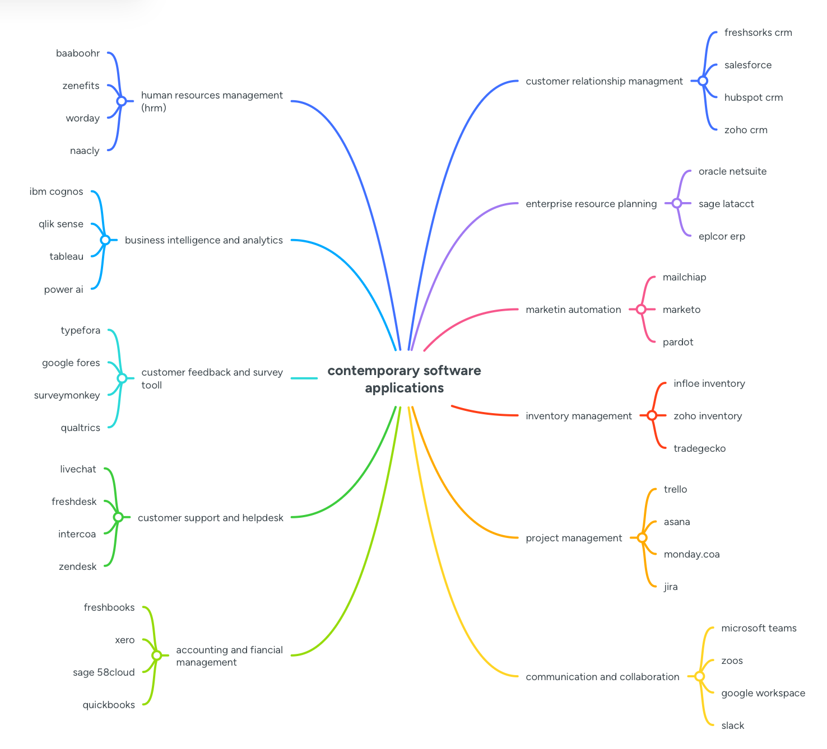

Task 3. Office Applications

Four office software solutions for business operations

MS Word

One of the most widely used programs for making documents is Microsoft Word. Primarily used for word processing, such as text manipulation, editing, and formatting, this application offers many other functions as well. With Word, you can employ a variety of fonts, font sizes, and colors. In addition, you can insert headings, tables, and pictures into your documents. Word also gives you access to a variety of tools and functions to make a lengthy document, such as an automatic page numbers function, header/footers, footnotes, and a Table of Contents. Microsoft Word further enables you to do a ‘mail-merge’ if you want to create a large number of letters or a form with a standard set of information. Such a facility is very common with most businesses, which require sending common documents to a large number of people.

One major pro of Word is that it is an excellent tool for collaboration. Several people can work on a document simultaneously if it is saved in OneDrive or Sharepoint. Users can make comments, suggest changes, and follow updates so they are all up to speed on what is happening. Word also contains safeguards such as passwords and read-only options to shield sensitive information such as contracts, HR documents, or financial statements. The other pro of Word is that it is a widely used tool, and pretty much all individuals have access to read Word documents without worrying about them not being able to read them because of compatibility issues.

However, Word is not perfect either. The full version will cost money if you install it in a copy of Microsoft Office or a Microsoft 365 subscription, which can be a problem for smaller companies. Additionally, Word can be overwhelming if you are simply using it to jot down simple notes because it contains so many functions that people don't really need. At other times, different versions of Word aren't entirely compatible with each other, which can affect formatting and sometimes removes functions altogether. Word can insert images into your documents and charts but is not really meant for analysis, which can easily be accomplished using Excel.

Despite these shortcomings, Word remains a critical application in any organization. Documenting professional and polished documents quickly is facilitated by Word. The application can be used for all matters, including drafting simple memos to complicated reports or proposals. Word is flexible, reliable, and easy to work with once you become accustomed to using it.

Microsoft PowerPoint

This is a presentation-building tool that is in essence a slide show where you can insert texts, images, charts, videos, among other things. The tool is widely used in offices because it enables you to present your ideas in an effective manner. With this tool, you can have all the designs you need for your slide show without necessarily being a designer. With this tool, you can insert designs such as animations and transitions to make your slide show more interesting, and you can insert charts from your Excel or tables from your Word documents, which makes it simple to illustrate numbers in your slide show. Other designs you can include in your slide show are pictures, shapes, or even videos.

PowerPoint is very useful in different environments in a business setup. For instance, you can present a project during a company meeting, teach employees during a training session, or show your idea to a potential client. Additionally, you can spend less time working on your document using pre-made templates or simply reuse some of your old PowerPoint work. Collaboration can also be achieved when you store your presentation online using OneDrive or SharePoint. Meanwhile, you can edit, comment, or simply view other people’s work on different slides, making teamwork a simpler task. Moreover, you can easily connect to other Office programs when using PowerPoint. For example, you can access information from Excel or Word right in your presentation without repeating your work.

However, PowerPoint has a few cons. When you overuse slides, your presentation can sometimes become boring or too simplistic, a phenomenon sometimes referred to as "death by PowerPoint." Additionally, PowerPoint is not an analysis tool since you will need Excel or other separate programs to make calculations. Although the full version of PowerPoint will cost you money, and variants have different functions with a very slight difference, PowerPoint remains a very important tool in illustrating your ideas, your stories, or keeping your audience engaged.

MS Excel
Excel is a spreadsheet application used in businesses to organize, calculate, and analyze information. Excel employs a row and column structure to record information, and you can employ formulas to make calculations automatically, such as calculating totals, averages, or math calculations. Additionally, Excel incorporates graphing tools such as charts, graphs, and Pivot Tables to help you easily summarize information and spot trends. Numerous firms employ Excel for budgeting, expense tracking, forecasting, sales and inventory tracking, or performance analysis. Additionally, you can employ other functions such as conditional formats to point out vital information or trends in your data, making it simpler to analyze just by glancing at your information.
One of the good things about Excel is that it is very flexible and can be used for quick analysis of information without requiring a separate database. Additionally, you can repeat a series of actions with macros, which is time-saving when you consider tasks such as compiling monthly reports. Additionally, you can connect your Excel information to Word or Power Point in order to make compiling your reports or creating your Power Point presentation faster and more accurate.
However, Excel also has some flaws. Mistakes can easily be made when incorrect information is put in, or when calculations are not right, and when dealing with very large and complicated spreadsheets, they can become confusing and slow to operate. Excel is not intended for working with large relational databases, such as where customer orders relate to items and inventory for this purpose, Access or a full database is a better option. Viewing and managing where multiple people may be working on the same document can be problematic, and a very large spreadsheet with a lot of calculations might not operate well. Yet despite all these flaws, Excel remains a very vital application in a business setting. Excel is ideal for both information management and making decisions based on numbers.

MS Access
Microsoft Access is a database tool which enables a user to store, manage, and organize a large amount of information. Microsoft Access is an Excel tool but unlike Excel, which is primarily used for working with spreadsheet information, Microsoft Access is used for working with other information, which contains relationships such as customer intake or product stock. Additionally, with Microsoft Access, a database can be established in a table format, a form to record information, a query to find information within a database, and a report for viewing information in a database format.
One of the main advantages of using Access is that it ensures all your information is well organized and eliminates errors. For instance, you can establish guidelines for accurate entry of information, and you can connect your tables in a way that all your information is accurate. Additionally, Access gives you a chance to develop small applications such as using forms, queries, and macros, which can be an effective way of handling issues such as customer data, sales, inventory, and employee information. Access is also preferable to Excel when working with a team. With Access, you can work with a team without creating a mess with your information.
But Access also has some shortcomings. Access operates in a file environment, so it can never go beyond a total storage capacity of approximately 2GB, which makes it not ideal for very large databases. Additionally, it lacks flexibility in scaling compared to other server-oriented solutions such as SQL Server. Access is primarily available for Windows operating systems; hence, using it with a Mac and other smartphones can be a challenge. Furthermore, it requires prudent organization of your database because improper organization can sometimes lead to occurrences of inaccuracies or slow performance. Nevertheless, Access is an indispensable tool to small to medium-sized companies wishing to establish a good means of storage and organization of well-structured information.

Practical demonstration of Two Office Features

Mail Merge

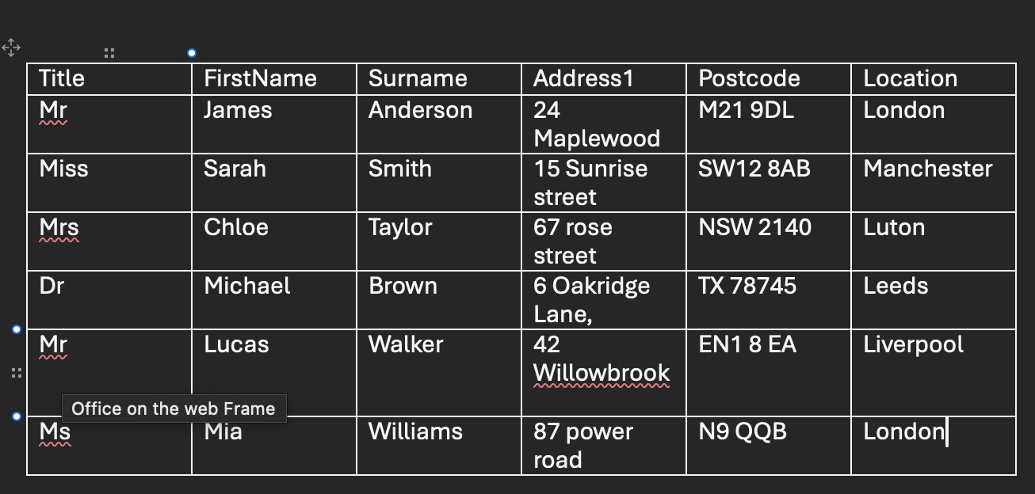

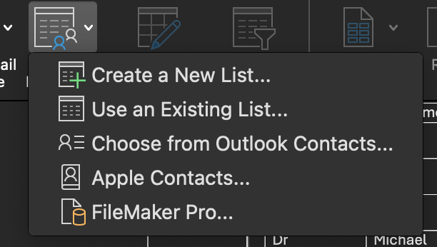

Task 4. Communication and Collaboration applications

One contemporary Communication and one Online Collaboration applications/tools

MS Outlook

Microsoft Outlook is one of the most common applications in communication in the modern business world and part of the Microsoft 365 suite. This is primarily designed to support professional communication through email, calendar management, and personal information organization. It has been selected by many organizations as their official platform for formal internal and external communication.

The ability to send and receive emails is the primary function of Microsoft Outlook. One can easily compose, send, and receive emails in Outlook, as well as manage them. Features like folders, categories, flags, and advanced search capabilities make it much easier to organize a large number of emails. The Focused Inbox further enhances this with its functionality of prioritizing important messages and filtering less relevant emails. With Outlook, attachments are supported, as well as sharing via OneDrive, which facilitates secure document exchanges.

Another major feature of Outlook is the integrated calendar and scheduling system. In its business usage, one can schedule meetings, send out invitations to others via calendar invites, and view colleagues' availability. Outlook directly integrates with Microsoft Teams, where online meetings can be scheduled and will automatically include video conferencing links in them. Shared calendars enable teams to coordinate schedules and effectively manage their time.

Contacts management and task manager are also part of Microsoft Outlook. It helps users to store and manage professional contact information, attach related contacts to email conversations, and create a task list with a reminder for due dates. These features support personal productivity by ensuring effective follow-up on communication.

Security is one of the strong points of Microsoft Outlook. As it is oriented towards corporate application, it includes all types of enterprise-grade security related to spam filtering, phishing protection, encryption, and secure authentication. The features listed above enhance the protection of sensitive business communications and ensure compliance with the organizational security policies.

Microsoft Outlook supports professional e-mail communication, as well as scheduling and information management. Its integration with Microsoft 365, reliability, and extensive security advantages make it a core application in modern environments.

MS Teams
Microsoft Teams is a modem online platform meant for teamwork and communication among various people online. Its other name is Microsoft 365. One of the main reasons for using this platform is that it acts as a common workspace where people can work from different sites. Its application will continue to grow with increased adoption of working from different sites.
One of the major elements of Microsoft Teams is its chat and channel conversations system. With Teams, different people can communicate with each other using personal conversations, group conversations, and channels in teams. Channels are usually organized based on department, project, or topic, making it easy to have a conversation or search for a piece of information in a team.
Microsoft Teams provides powerful online meeting and video conferencing capabilities. Users are enabled to conduct online meetings, webinars, and conferences using screen sharing, captions, recording capabilities, and breakout rooms. Such capabilities make teamwork and decision-making possible without requiring face-to-face meetings. Integration with Outlook makes team meetings easy to schedule and conduct.
Another prominent function offered by Teams is file sharing and co-authoring. Teams allow sharing files and working on them collaboratively in real time. Users can share files through a chat service in Teams or share through channels in a team. Files can be edited simultaneously by different people using different Microsoft apps such as Word and Excel.
Microsoft Teams can also be integrated with other application programs in Microsoft 365, such as Planner, OneNote, and SharePoint. Integrations support team collaboration in handling tasks, documents, and work processes in a centralized platform. Additionally, other advanced security measures such as encryptions are offered in Microsoft Teams for organizational information.
Conclusion
Based on the above analysis, it is evident that Microsoft Teams is a very effective online tool for collaboration purposes. With all these features incorporated into one tool, Microsoft Teams is a very important tool in today's business world.

One feature of a freely available Communication (1) and one feature of a Collaboration (1) application

MS Outlook
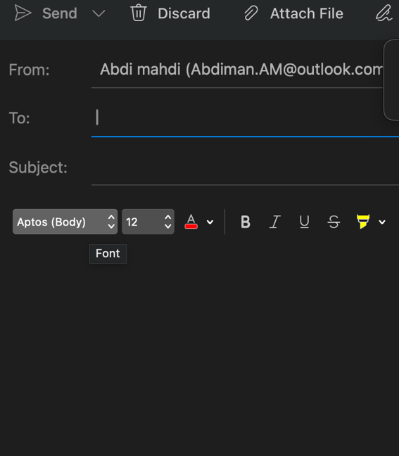

Ms Teams


Conclusion
In the contemporary business setting, Microsoft Outlook and Microsoft Teams have become critical tools in the realm of communication and collaboration. Outlook offers systematic and secure communication, scheduling meetings using calendars, and management of tasks in a professional way. The role of Microsoft Teams is to provide a collaborative platform with chat functions, video meetings, sharing files, and real-time co-authoring capabilities to collaborate in a team manner in a remote or hybrid model work environment.

References
https://en.wikipedia.org/wiki/Microsoft_Teams
https://support.microsoft.com/en-gb/office/stay-organized-communicate-and-collaborate-with-teams-4d116240-cecc-43b4-b41e-a88bafcf1e85?

