Community Engagement

Table of Contents
Introduction 3
Discussion 3
The sector in which it the company operates, its size and structure of the organisation 3
Goals, missions and values of the organisation 3
Identifying the customers and the expectations from the goods and services of the organisation 4
Analysis 6
Micro and Macro analysis of the organisation 6
Training and development and its importance in the organisations 8
Role in the chosen organisation 9
Skills and knowledge needed to carry out the role of an HR 9
Requirements of training and development which needs to be considered 9
Conclusion 10
Reference 11

Introduction
J Sainsbury’s Plc, is the one of the most renowned super market chains in London. It founded in 1869 and from then it became one of the largest retailer in groceries in 1922. The organisation holds a market share of 16%. The marketing and the human resource department of the organisation plays a big role in taking care of the needs and wants of the customers which helps them to achieve the goals and objectives of the organisation. In this study the goals, missions and values of the organization will be discussed. With the help of the primary and secondary data, the expectations of the customers from the organization will be analyzed. A micro and macro analysis will be done with the help of the frameworks Swot analysis, Pestle analysis (Mara, 2019). Also, the role of Human resources towards the success of the organisation will be discussed in this study.

Discussion

The sector in which it the company operates, its size and structure of the organization
J Sainsbury's is a Public Limited Company (PLC). It is one of the largest supermarket sectors in the U.K. It is a major food retailing chain. Sainsbury’s has a total market share of 16.6% in U.K. The company has originated into a multi-million pound organization. It is in charge of 547 supermarkets and 347 convenience stores which makes it a total of 890 stores. The Sainsbury's is one of the big 4 supermarkets in U.K. The supermarket operates in an oligopoly market. Sainsbury's fits the characteristics of the oligopoly market where interdependent organizations compete with each other. The structure of the organisation, Sainsbury's hierarchical. This is so because there is series of levels of people and the level above controls the other levels. For example, the senior managers are responsible for the functioning of the line managers and the line managers look after the sales assistants.

Goals, missions and values of the organization
The main mission of Sainsbury's is to provide their customers with high-quality service and to provide the stakeholders with good financial returns. It also aims to exceed the expectations of the customers by offering them safe, healthy, tasty food which would make their day-to-day life easy (RASHID, 2020). The main objective of Sainsbury's is to fulfil the obligations of the communities and the environment by providing the customers with high-quality products at fair prices. They aim to meet the needs of varieties of customers.
The value of the organization is to offer a healthy lifestyle to the customers that is sourcing with integrity. They also target at making a positive difference in the community and making the organization a great place to work.

Identifying the customers and the expectations from the goods and services of the organisation
The Sainsbury’s retailer grocery store’s target customers are the family and especially the mother. They design their goods and services to meet the household needs of a family and also of a mother. The Sainsbury’s organisation designs a variety of products which comprises the grocery items like fresh vegetables, fruits, meat, fish, dairy products, flowers and home appliances and so on (Bentham, 2018). They offer high-quality products at pocket-friendly prices which help them to retain their customers. Sainsbury's uses the market segmentation strategy which helps them to meet the needs of a varieties customers.
Primary data has been collected from the customers of Sainsbury's to identify their expectations from the organisation and what improvements they want to see in the services of Sainsbury’s. Few close-ended questions had been designed and 25 responses had been collected from customers who are the regular visitors at the store to identify their expectations.
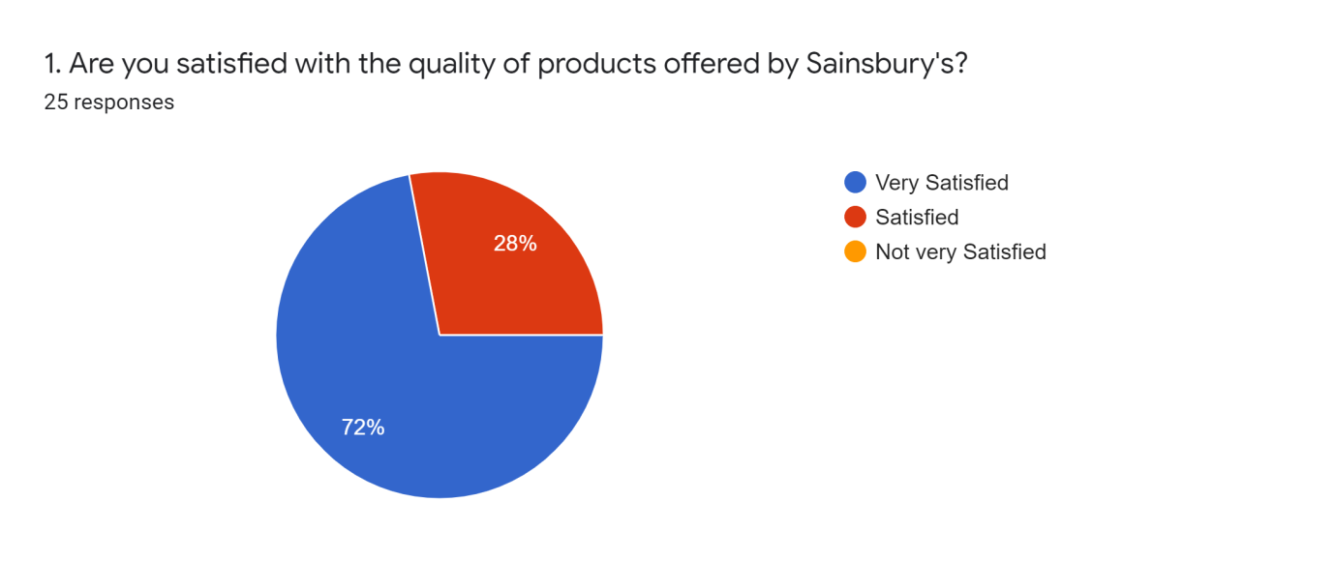
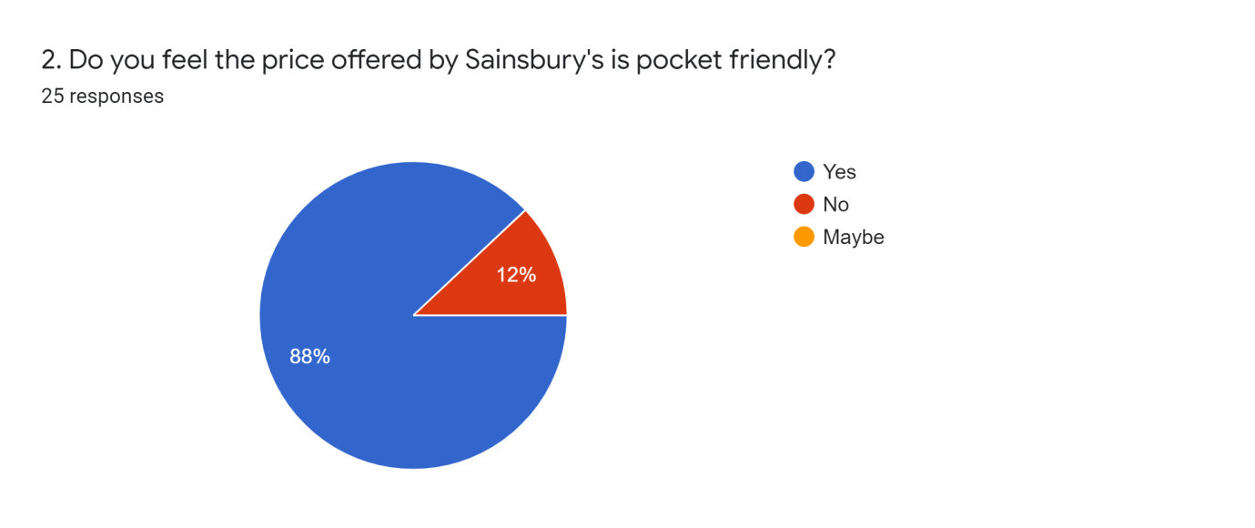
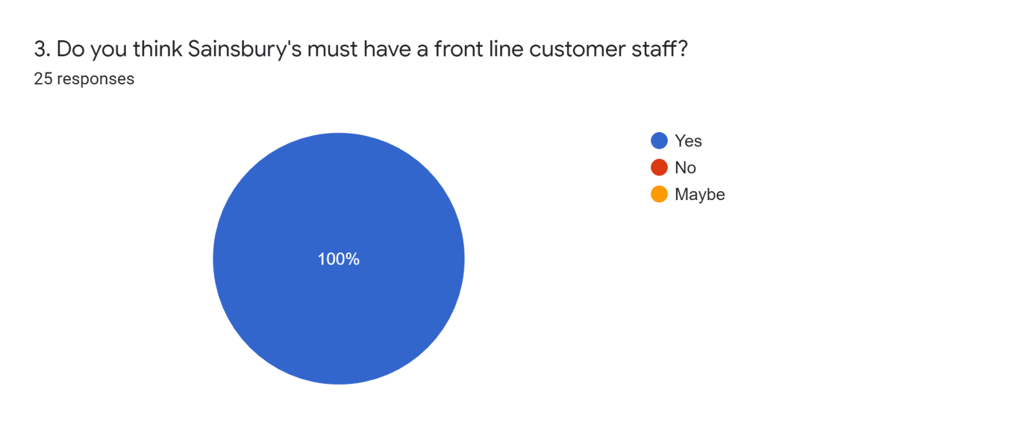
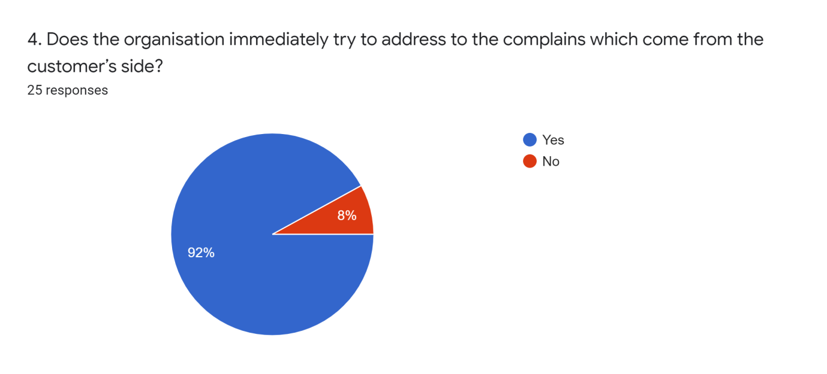
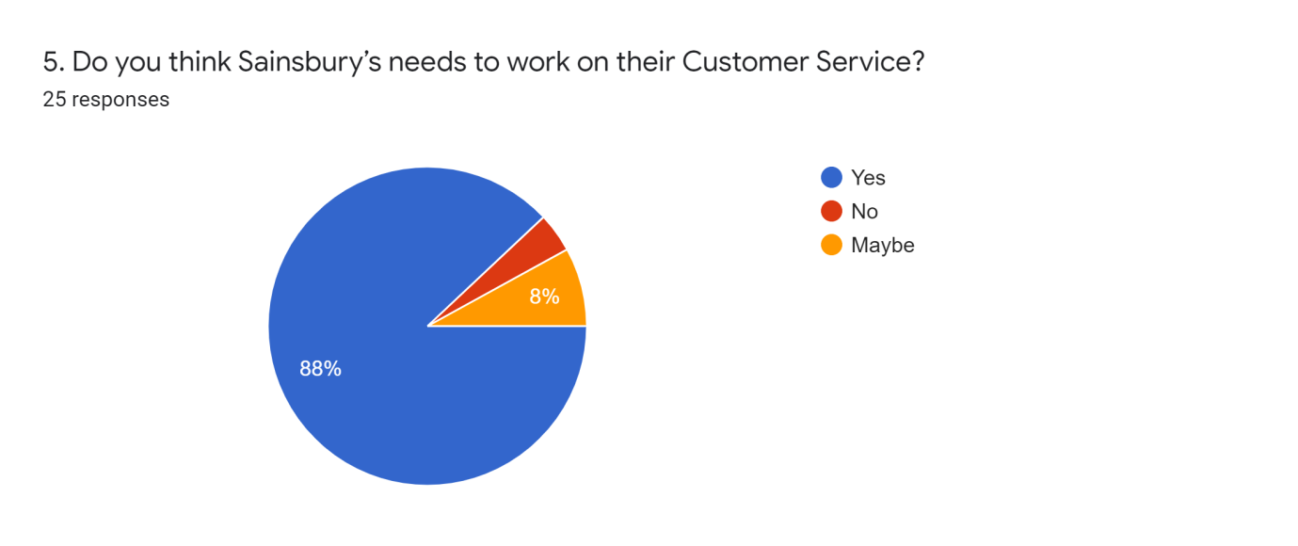

The responses which were recorded from the customers determined that 72% of the customers are very satisfied with the quality of products which is offered at Sainsbury's and 88% of the customers feel that the products of Sainsbury's is very pocket-friendly but almost all the customers have expressed their need for a front line customer service at Sainsbury's, who will help to assist the customers when they go to the shop at the store. 100% of customers feel the need for front-line customer staff. Since the main objective of the organization is to address to the needs and wants of the customers the survey aimed to find out if the complains of the customers are addressed or not. Therefore, on a positive note 92% of the customers agreed that the organization immediately tries to address to the complains of the customers, buts still it can be seen that 88% of the customers feel that Sainsbury's needs to work on their customer services. They need to more attentive towards the customers as by addressing to the needs and wants of the customers the organization can achieve its goals and objectives.

Analysis

Micro and Macro analysis of the organization
Micro analysis of Sainsbury’s
The microanalysis of the firm refers to the Swot analysis of the firm which would help in identifying the strengths, weaknesses, opportunities and threats of the organization.
The Strengths of Sainsbury’s
Sainsbury's is one of the largest retail grocery stores with more than 15000 workers working in it (Misbah, 2017). The highly experienced leadership team of Sainsbury’s act as the strength of the company. Their excellent way of advertising their products through online campaigns and print ads helps in promoting their products to the customers so that they get attracted to the store. Sainsbury's has proven to be the largest retailer chain with more than 800 stores in the U.K. The organization is also listed in the London Stock Exchange.
Weaknesses
Sainsbury's faces very high competition in the retail market and at they are compelled to sell their products at a high price when due to the rise in the food process all over the world. These factors act as the weakness of the organization as they are in constant fear of losing their customers.
Opportunities
Sainsbury’s have the provision of entering the market of the companies which are emerging through partnership and joint ventures with the motif of exploring the new markets. The machines which enables self checkout help in Sainsbury’s opening store for 24 hours (Haleem, 2017). This helps in boosting sales. There are opportunities for the organisation to grow itself into the markets of Asia, Africa, etc.
Threats
The increase in globalisation has brought many challenges to the organisation this acts as a threat to the organisation but it also acts as an opportunity. The organization is always compelled to buy the best quality products from the world.
Macro Analysis of Sainsbury’s
The macro analysis of the organisation refers to the Pestle analysis of the organisation. this framework is used by organizations to analyze the political, economical, sociological, technological, legal and environmental factors which affect the organisation.
Political Factors- The Brexit movement had a serious effect on Sainsbury’s supermarket chain. Leaving of the European Union made it difficult for the supermarkets to import their products from abroad and this had led to the increase in the import taxes. This will lead to an increase in the price of the products and thus there is a probable threat of losing out on the customers.
Economical factors: As Sainsbury's is dependent on the road based transport for shipping its product across U.K so increase in the price of petrol and diesel will lead to an increase in the price of the products this will mean a loss to the customers with lower income range.
Sociological factors- Sainsbury's as a brand derives its main profit from the fast food items but as people are gradually becoming health conscious they are getting inclined towards organic food products and they are shifting their focus from the fast food items. Sainsbury's should also cater to the fair trade movement which leads to the increase in the prices of grains, vegetables and farm-related products.
Technological factors: The eCommerce store of Sainsbury's has proven to helpful for the tech-friendly generation. The brand can improve itself on this aspect for giving a better experience to the customers.
Legal Factors- With the changing needs of the customers the company needs to strive each day for meeting the needs of the customers. Delay in regulatory approval can lead to losses in the market.
Environmental Factor- Sainsbury's produces a high level of carbon footprint which harms the environment. Currently with the adverse change in the climate the brand must take measures to curb the environmental impact.

Training and development and its importance in the organisations
Training and development is referred to the various educational activities offered by the organizations to enhance the skills and knowledge of the employees and also provide information that will help the employees to work in a much better way. Many workers lack many skills at work in that case training and development allows the employee to enhance those skills which every employee need to take (Rodriguez, 2017). This program aims to bring the employees to a higher level to those who have higher skills. Proper training can help in reducing the weak links of the employees who struggle to complete a basic task. Providing the employees with the proper training and development helps in increasing the overall knowledge of the employees which help the employees to work independently or work on behalf of someone or work in a team. Robustness in the training and development will ensure that the employees have a consistent experience and it increases the background knowledge of the employees. The employees are made aware of the policies, procedures and expectations of the organisations so that they can work appropriately. An increase in efficiently of the employees leads to gain company gain.

Role in the chosen organization
Human resources play an important role in Sainsbury's. The human resources management of Sainsbury's helps on developing the financial position of the company. The human resources management of the organisation uses new tactics for giving job opportunities to a large number of people. It helps them to select the best candidate for the appropriate job with the help of the selection process. The process of recruitment and selection process plays a major role in this case.

Skills and knowledge needed to carry out the role of an HR
The human resources management must have various skills like the communication skill, organisational skills, management skills, decision making skill and also the training and development skill which is required to train to the employees and enhance their skills (SRILATHA, 2019). At the chosen organization, Sainsbury's the human resource management possesses the raining and developmental skill which helps them to enhance the skills of their employees and their knowledge which helped them to carry on with their task more effectively. If the human resource manager has the required skills then he plays a big role in enhancing the performance of the employees.

Requirements of training and development which needs to be considered
The human resources department of every organisation plays the most important role in enhancing the performance of the employees. The human resource manager needs to learn new techniques to keep the employees motivated and find out techniques which can help in improving their performance (Charlesworth, 2018). The human resource manager at Sainsbury’s should learn the tricks to find out information of the rival companies this will give them an idea about their movement. The human resources management of Sainsbury’s is the most important department. They look after the performances of the employees.

Conclusion
The Sainsbury's organization is one of the largest retailer stores in U.K. From this study, the expectations of the customers from the organization has been found out with the help of primary data which is collected by surveying the customers. The survey helped in understanding the grievances of the customers. The micro and macro environment of the organization was also analysed which helped in identifying the strengths and weaknesses of the organization. Training and development plays a very important role in every organisation, and it is very necessary for the human resources manager to have the skill of training and department as that will help in enhancing the performance of the employees.

Reference
Mara, D. and Campbell, S., 2019. Sainsbury's: The Queen has been introduced to self-service supermarket shopping during a trip to mark British supermarket giant Sainsbury's 150th anniversary.
Misbah, S. and Mahboob, U., 2017. Strengths, weaknesses, opportunities, and threats analysis of integrating the World Health Organization patient safety curriculum into undergraduate medical education in Pakistan: a qualitative case study. Journal of educational evaluation for health professions, 14.
RASHID, C.A., 2020. Balanced Score Card and Benchmarking as an Accounting Tool to Evaluate Morrison’s Performance. Journal of Global Economics and Business, 1(3), pp.59-72.
Haleem, F. and Jehangir, M., 2017. Strategic Management Practices by Morrison PLC, UK. Analysis, Lessons and Implications. Middle East Journal of Business, 55(4182), pp.1-7.
Bentham, J., 2018. Business and Economics in the News–Sainsbury's and Asda-the decade's mega-merger. Teaching Business & Economics, 22(3), pp.11-12.
Rodriguez, J. and Walters, K., 2017. The importance of training and development in employee performance and evaluation. World Wide Journal of Multidisciplinary Research and Development, 3(10), pp.206-212.
SRILATHA, T. and LAKSHMI, P.V., 2019. IMPORTANCE AND EFFECTIVENESS OF TRAINING AND DEVELOPMENT. Complexity International, 23(2).
Tamzid, M. and Parves, M.T., 2017. Human Resource Management Policies and Diversity Management (A Case Study on Sainsbury’s). Human Resource Management, 8(4).
Charlesworth, K., Stewart, G. and Sainsbury, P., 2018. Addressing the carbon footprint of health organisations: eight lessons for implementation. Public Health Res Pract, 28(4), p.e2841829.

