2.F Aesthetics

Elements of Building
The design is meant to provide a colourful, but modern looking building. The upper floor walls are made up of blockwork and high quality rainscreen cladding to protect the building from the environment and allow for easy access for cleaning. The steel frame used throughout both buildings allow for an open plan design to be used, which improves the flexibility of use of the building. The ground floor will have retail units varying in size which will be leased out to produce revenue for the client. Flooring will be a mixture of vinyl and carpet tiles depending on the usage of the space. Acoustic suspended ceilings will be used to improve sound properties and provide easy access to the M&E for maintenance on the ground floor. The upper floors will use plasterboard, as they are more suitable for accommodation.

External Walls
They will be made up of a blue facing brick for the external walls, and engineering brick for the inside of the cavity. Paired together they will provide a modern quirky building, that provides high insulating properties.
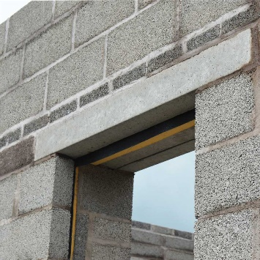

Internal Walls
Stud wall partitions will be used throughout to divide up the rooms. This option has been selected, as it provides flexibility where necessary to change the layout at some point if required. Four stairwells will be reinforced concrete for fire safety purposes and will be located around the two buildings.
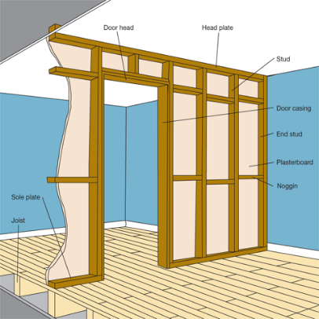

Floor Finishes
Vinyl will be used throughout on the ground floor, in hallways and bathrooms around the building. Carpet tiles will be used in bedrooms, as they can be replaced easily if required, and provide a cosier feel in comparison to vinyl or other alternatives.
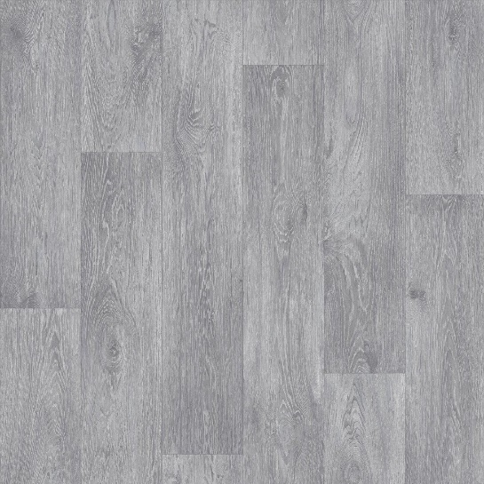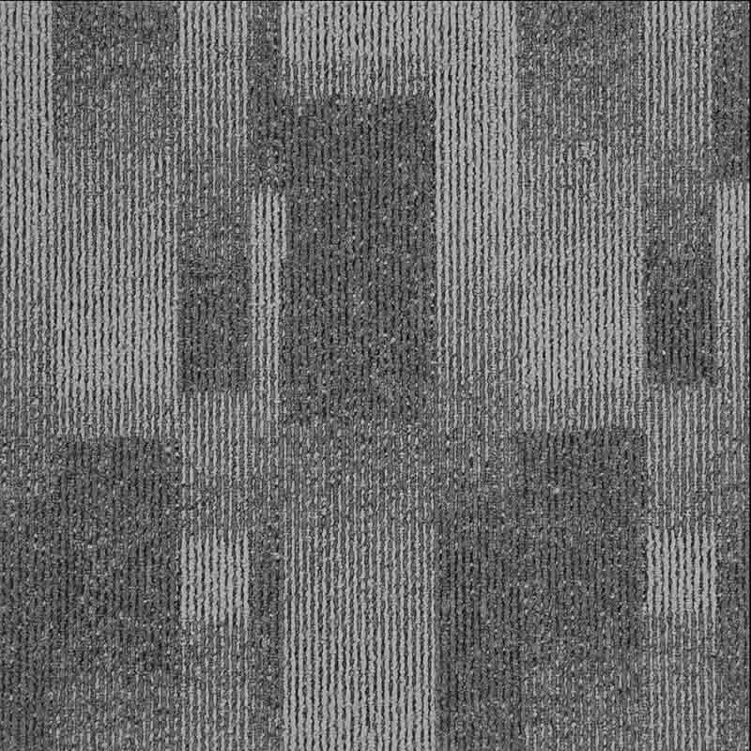

Ceilings Finishes
Acoustic suspended ceilings will be used on the ground floor to easily access M&E whilst ensuring that sound is absorbed to mitigate echoing. Plasterboard ceilings will be used on the first and second floors, as this works better for residential units.
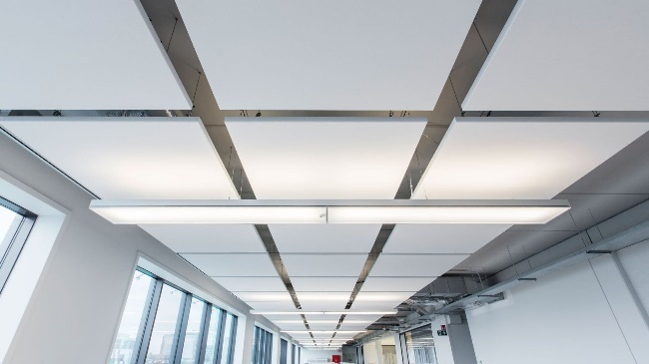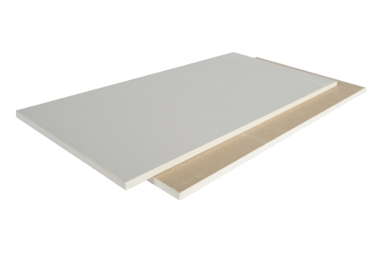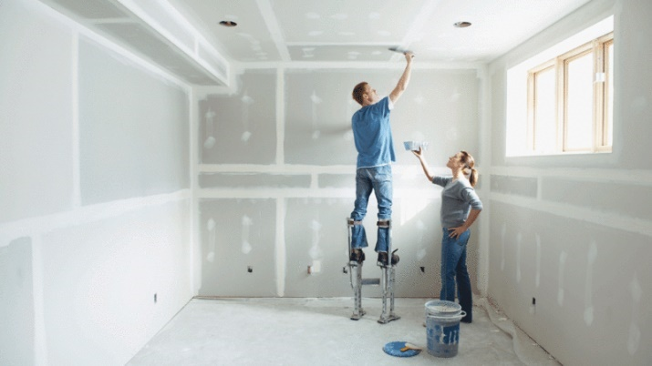

Internal Wall Finishes
A variety of emulsion paints similar to the grey shown below will be used throughout to ensure that the building is sleek and modern; however, provides a sophisticated environment where students can study.


Roof
A flat roof has been chosen for this building, as the ventilation units can be installed on the roof, along with rainwater management, and solar panels.
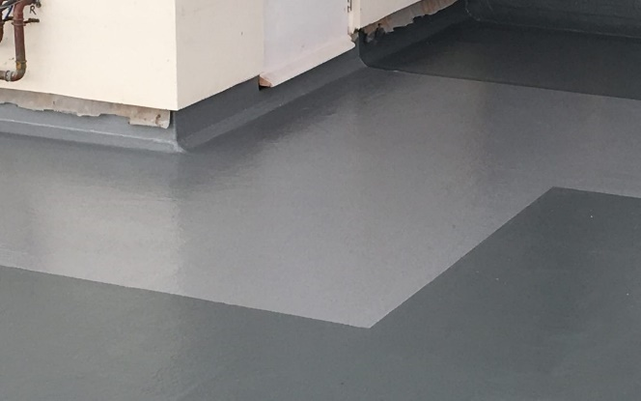

Windows/Curtain Walling
A mixture of aluminium windows and curtain walling will be used throughout to provide plenty of solar light into the building. This is most suitable for a larger building.
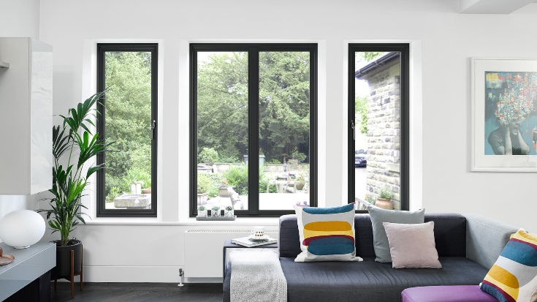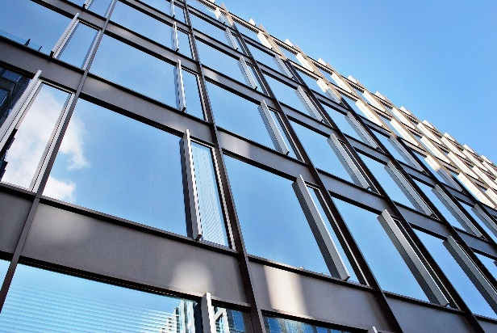

Cladding
Sustainable rainscreen cladding will be used to protect the blockwork on the upper floors and provide slightly different aesthetics compared to the ground floor.
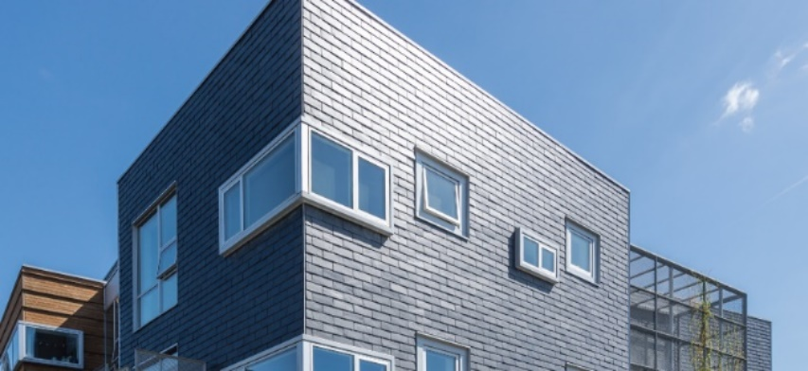

Doors
Entrances will use glass automatic doors, whilst fire doors will be used where necessary for fire escapes.
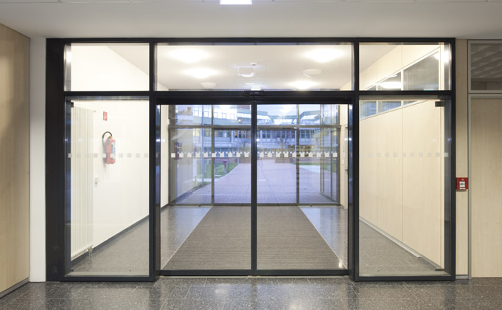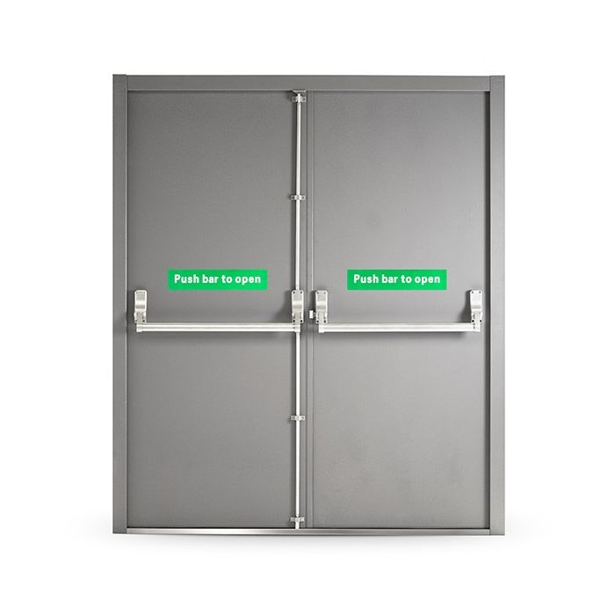
Internal doors will be a mixture of single fire doors with key card unlocking for ease of access for residents. This is vital for security purposes, as the ground floor will be open to the public.
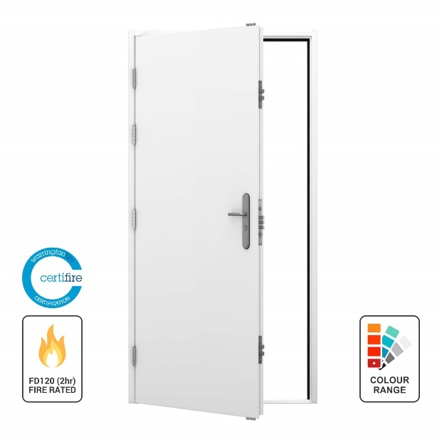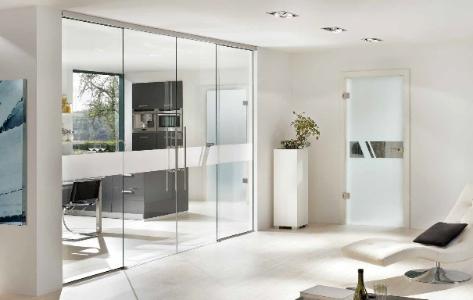

Internal/External Design
The aim for the space requirements of this building is to provide an open social space for all residents to use. This is to encourage residents to socialise with each other and take their mind away from their studies. This is crucial for university students, as with anything there must be a good work, life balance.
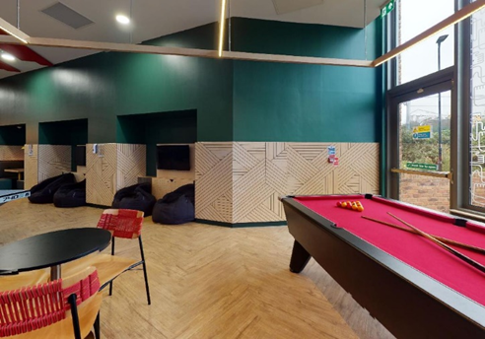
Additionally, there will be a bar located on the bottom floor of the main building which will serve drinks for students in the evenings. Furthermore, a small convenience shop will be located on the bottom floor as well, where students can stock up on the essentials rather than travelling into town to get groceries.

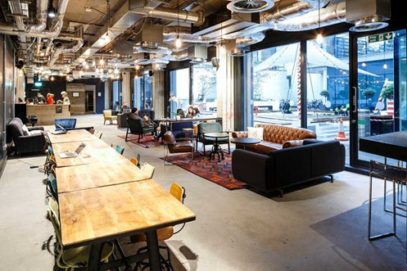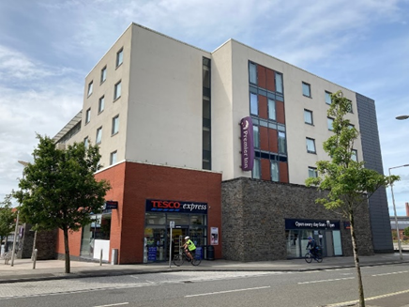
There will be a small mail room by the main entrance of the building where parcels will be stored, so that students can come and collect them when they order something. Storage rooms will be located around the building for general storage. Additionally, there will be cleaning storage rooms, which will have sufficient cleaning facilities for cleaners. Each group of dorms will have a communal kitchen where they can cook and eat food whilst socialising with other students.

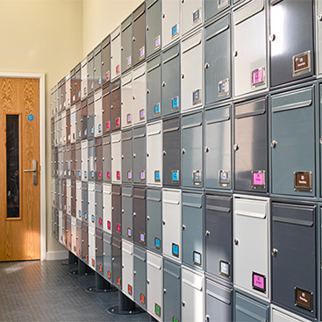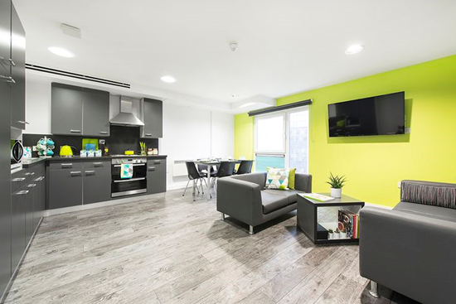
There will be many footpaths located around the building to allow residents to move freely. To reduce carbon emissions and pollution, the aim is to limit the amount of parking just to staff, families that are renting rooms, and disabled students. If necessary, students can park their cars free in the university carpark about 10 minutes away from the site. This should reduce the amount of carbon emissions and encourage students to take alternative methods of transport with the implementation of a cycle path and easily accessible bus routes.
Modern, easy to access M&E fittings will be located all around the building to provide students with high level living conditions. By ensuring that the M&E fittings are easy to work on and maintain, it ensures a minimal level of disruption for residents of the accommodation. These will include, many power sockets, USBs by the beds so that students can charge their phones at night and light switches, so that the light can be turned off without getting out of bed. Furthermore, the lights will be adjustable in brightness level, so that lighting levels can be changed depending on the tasks students are completing. There will thermostats fitted to every dorm, so that students can adjust the temperature to their preference. Individual high quality, modern bathrooms will allow an extra level of privacy and comfort in comparison to shared bathrooms that exist in older dorms. These will include lighting mirrors, heated towel racks, a large shower, and modern sinks.

Due to the extra space with the family units, there will be a small bath included. Fast Wi-Fi will allow students to complete downloads and uploads quickly, which will improve their quality of life whilst living there. This is crucial for the younger generation with almost everything being internet based. Additionally, there will be a few computers located around the building for students to use if they need a change of scenery from their room. This can make a massive difference to student’s mental health and wellbeing. Finally, student cards will be programmed to open students’ dorms and key cards will be created for the families. This will add another layer of security for students. Finally, solar panels will be installed on the roof to provide electricity for the building.
Cycle paths will be located around the site to encourage students to use bicycles as an alternative to cars. Planning permission has been approved to construct a cycle path from the place of residence to the university. This will provide a quick method of transport to and from university, which could be quicker than taking a car.
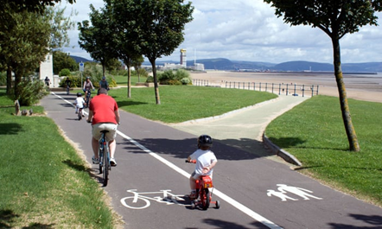
Paths will be constructed around the site to allow for easy access between facilities. Furthermore, benches will be provided around the site to encourage students to spend time outdoors when the weather is nice instead of procrastinating in their dorms. Additionally, there will be alternative seating with tables for similar reasons.
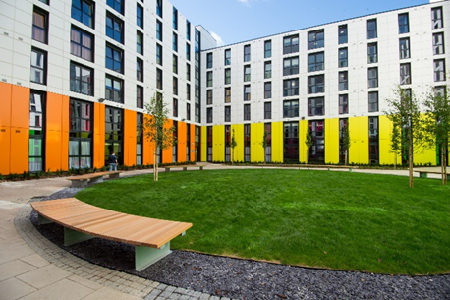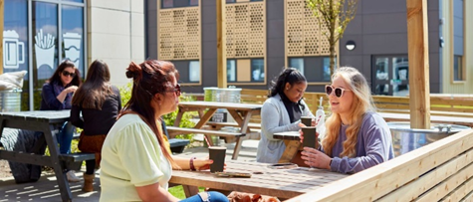

Outdoor lights will be fitted around the site, so that paths are always lit up, which is helpful when students come back late from nights out. Bins will be fitted near seating to mitigate waste.
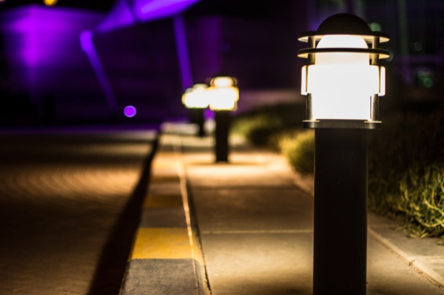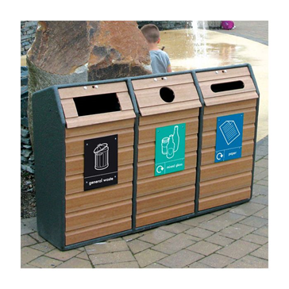
Greenery such as grass and shrubs will be planted to make the outdoor environment a pleasant place to be all year round. Multiple types of smaller trees will be planted in these areas to encourage natural habitats, as well as birdboxes which will be fitted to these trees once fully grown.
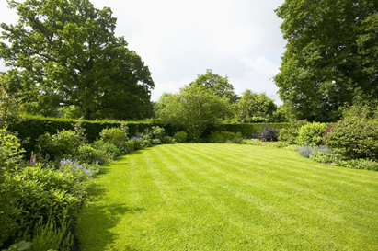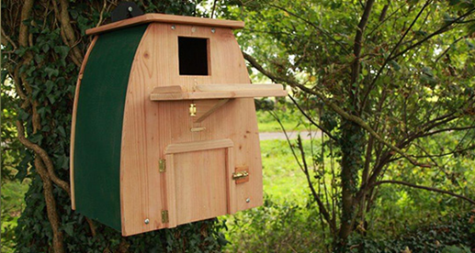
Additionally, bushes and hedges will be located around the edges of the property for the same reasons. Finally, fences and electronically operate gates will be installed where required to improve the safety of residents or workers.
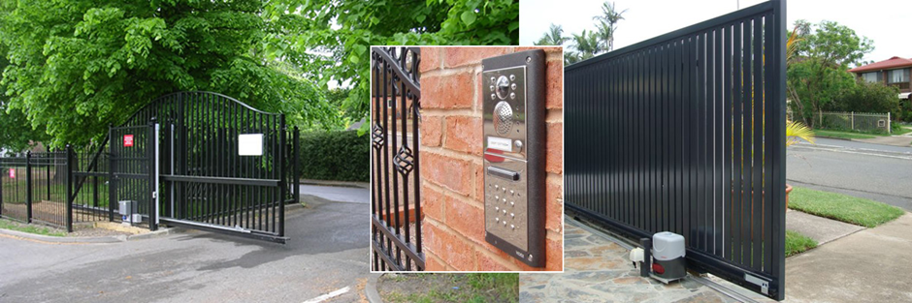
Each dorm will be fitted with high quality divan single or double beds depending on room. This is important, as better rest allows students to perform better academically. Additionally, a divan bed provides extra draws of storage, which is vital in student accommodation where space is limited.
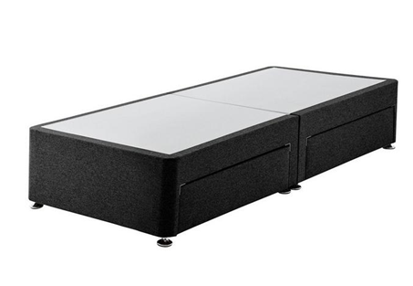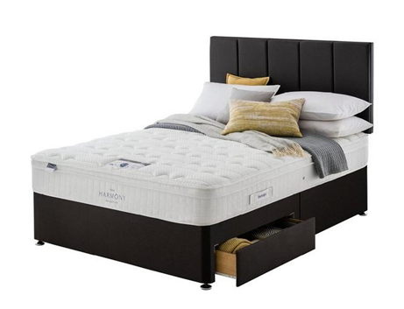

Office chairs will be included in every room, along with a small (100*60cm) height adjustable standing desk with cable management tray, so that students have a practical space to work. These will be fitted with USBs, sockets, and a cable management tray. This will provide students with a clear, open space to study.
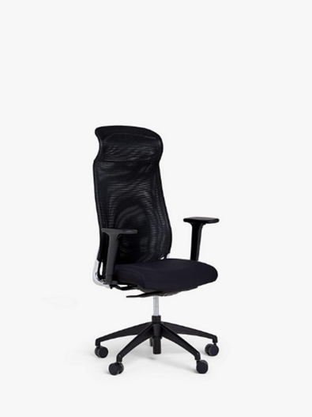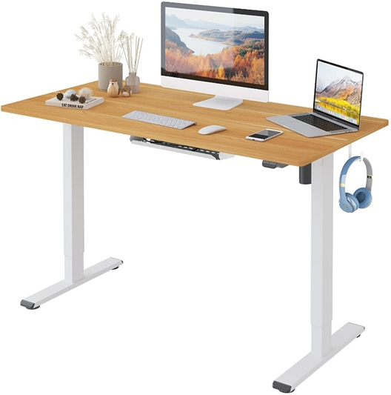

A large double wardrobe will be included in each room for clothes and shoe storage. Additionally, there will be extra storage space in the two cupboards below the wardrobe for general storage. Two shelves (76cm) will be installed on the wall next to the bed for students to personalise the room or store items.

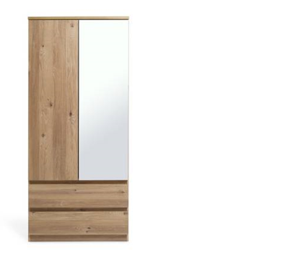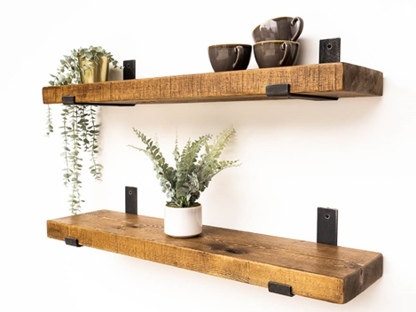

A Small bathroom vanity unit will be installed in the bathroom to store cleaning products, toiletries, along with a backlit LED bathroom mirror to provide good lighting.
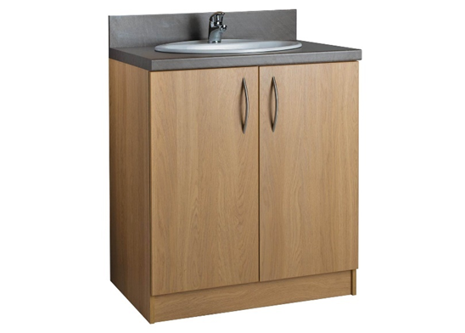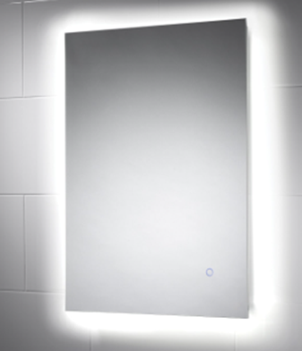

Outside the dorms, there will be high-quality sofas with USBs and wireless charging in the social areas.
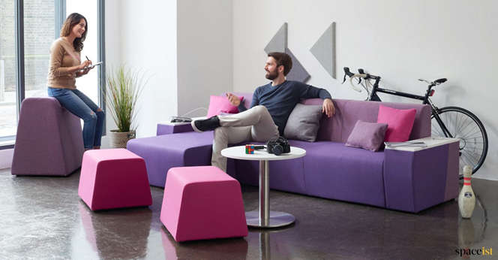
Finally, there will be café tables and chairs which residents will use to eat and drink throughout the day.
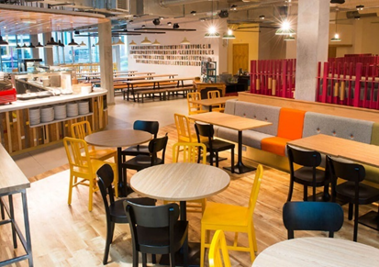
Careful consideration has gone into the design of each dorm to maximise space and effectiveness for students to fulfil their needs. High quality carpets have been installed to provide a warm, cosy feel to the room. Meanwhile, LVT Vinyl flooring has been selected for the bathrooms, as it dries quickly, can be easily cleaned, and can be easily replaced if damaged.

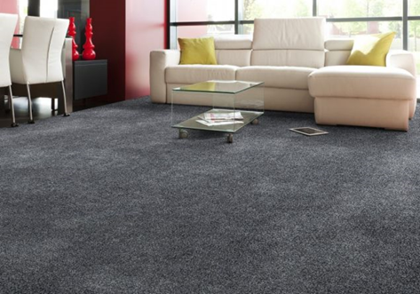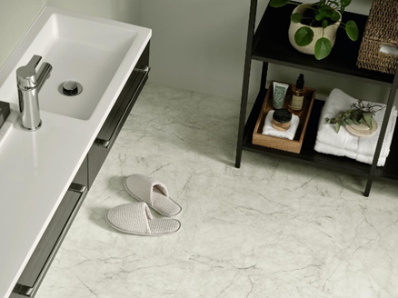

There will be a corner walk in shower with which can be operated by controls attached to the wall.
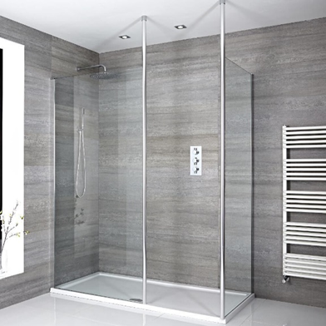

There will be a small wall-mounted smart TV which can be adjusted to different angles depending on students’ preference in each dorm which they can use when they’re relaxing and having time away from work. Unfortunately, there are very few high EPC rated TVs; however, the 32-inch LG Smart TV has one of the better ratings of E.


Three displates will be fitted around the room which can be changed depending on student preference. Displate are a company that provide posters that attach magnetically to an adhesive magnetic pad that is stuck to the wall. This is a good way of personalising a student’s room without drilling holes in the wall. Additionally, they can be switched easily by pulling them away from the magnetic pad.
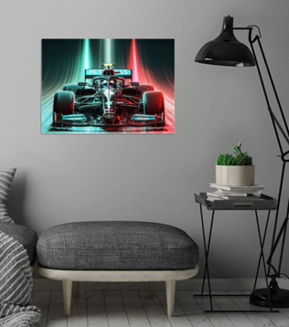

Blackout curtains will ensure that residents can sleep no matter the time of day and small bedroom bins will be fitted for convenience. This will be located under the desk to maximise space.
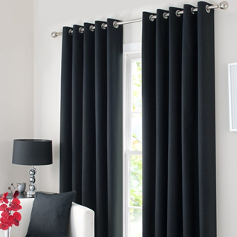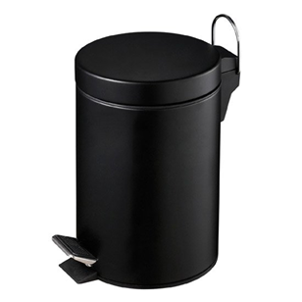
There will be designated studios which will be made suitable for disabled people. These will include ramps to enter the building, wet rooms instead of bathrooms and sufficient rails that are always easily accessible. Additionally, there will be lifting beds to assist them where necessary. There are four main lifts in total which will provide disabled to access all areas of the building.
There will be security cameras installed around the site to ensure the safety of the residents of the building. Additionally, students can access the camera when someone buzzes their dorm. A security guard will be present 24 hours a day as well. Student cards/key cards will be used to enter dorms or rooms.
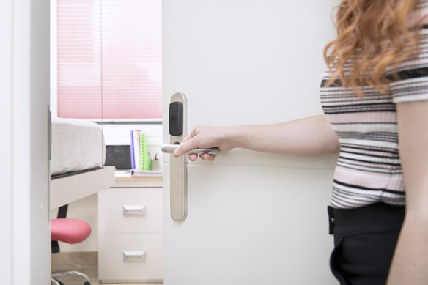
Due to the use of the building, it has been designed to house students; however, it can accommodate different types of residents all year around. Predominantly the building will be student accommodation for 9 months of the year; however, in the summer the rooms could be used like a hotel/hostel or rented units for the summer. Additionally, family units can be rented out during the holidays if vacant to produce revenue for the client. Therefore, the design is very multifunctional due to the high level of funding being provided to construct the project.

Option 1 (preferred) – this proposal is much more aesthetically appealing. There has been a lot of time and detail put into the design of this proposal by the Project team and Architect. It is a building that has a high-end specification and has been deigned to ensure all occupants are fully satisfied that their needs have been met. It also maximises the use of sustainable approaches.
Option 2 – this proposal is much more simplistic. It is time driven in the sense that it can be designed and constructed much quicker than option 1, and budget driven in the sense that there is a lot less detail when compared to option 1.
These options have been formulated so that the different elements and uses can be interchanged to make a several different alternatives.

