Computer Networks and Security
Network Security
Laurance Cutforth
P146632
UWTSD Swansea
Dr Carlene Campbell
Abstract: - This report has been commissioned by Tevel Cyber Corps Private Limited, to provide a comprehensive document recording a Pen test the author has operated against the company’s website. This document contains information about the tools used during the Pen test, such as Kali Linux and shows any potential vulnerabilities found by the author.

Contents
Table of Figures 1
Introduction 2
Penetration Test Framework 2
Contingency Policy 2
Rules of Engagement 2
Rules and Test Exclusions 2
Attacks 3
Tools 3
Running test 4
Nmap 4
WebScarab 8
SPARTA 14
Skipfish 20
Results of the Scans 23
Recommendation 24
Conclusion 25
References 26
Appendices 27

Table of Figures
Figure 1: Nmap port Scan Part 1 6
Figure 2: Nmap port Scan Part 2 7
Figure 3: Nmap DDOS Vulnerability Scan. 8
Figure 4: WebScarab Proxy setup. 9
Figure 5: Tevel Cyber unsecure connection. 10
Figure 6: Tevel Cyber invalid security certificate 11
Figure 7: WebScarab host packets. 12
Figure 8: WebScarab HTTP Packets capture Parsed. 13
Figure 9: WebScarab HTTP Packets capture RAW. 14
Figure 10: SPARTA Scan. 15
Figure 11: Tevel Cyber, Scan results. 16
Figure 12: Nikto scan port 80 TCP vulnerability scan results part 1. 17
Figure 13: Nikto scan port 80 TCP vulnerability scan results part 2. 18
Figure 14: Nikto scan port 8080 TCP vulnerability scan results 18
Figure 15: Nikto scan port 2078 TCP vulnerability scan results 19
Figure 16: SPARTA Services HTTP. 20
Figure 17: Skipfish, scan results. 21
Figure 18: Tevel Cyber interactive sitemap. 22
Figure 19: Captured HTTP traffic between Tevelcyber and nginx server. 23

Introduction

The Author of this Report has been commissioned by Tevel Cyber Corps Private Limited, to run a series of pen tests on their company network. Tevel Cyber is a technology-based organization that focus on Information Security services, this includes Knowledge management and Cybersecurity Services & Consulting.
As a trainee security consultant employed by Tevel Cyber, the author has been tasked with conducting a real-life penetration test on the https://tevelcyber.com/ website. To conduct these tests the author must follow the rules stated by the Tevel Cyber organization and provide a comprehensive technical report on the pen test findings.[1]

Penetration Test Framework

Contingency Policy

The contingency policy is a list of rules and guidelines that are put in place to protect the company and the tester during pen testing. This includes the parameters of the tests done e.g. external or internal, and the rules about what it is that can and cannot be tested.

Rules of Engagement

- External – testing the ability of a remote attacker gaining access to a network.
- Not Covert – The tests are done with the knowledge and consent of the IT staff and upper management.
- Black Box – No information has been shared with the testers, to simulate an external attack with extended reconnaissance phase.
- Non-destructive – the methods and tools selected for the test are chosen to reduce the amount of have they could cause the company.[2]

Rules and Test Exclusions
- Do not modify any contents in the website.
- Provide details of the vulnerability and exploit methodology.
- Make a good faith effort to avoid privacy violations, destruction of data, and interruption or degradation of our services.
- Do not modify or access data that does not belong to you.
- Do not use vulnerabilities to discover further vulnerabilities.
- In no event penetration testers are permitted to access, download or modify data residing in any other Account, or one that is not registered to them.
- Executing or attempting to execute any Denial of Service attack.
- Knowingly posting, transmitting, uploading, linking to, sending or storing any Malicious Software.
- Testing in a manner that would result in the sending of unsolicited or unauthorized junk mail, spam, pyramid schemes or other forms of duplicative or unsolicited messages.
- Testing in a manner that would degrade the operation of the Service.
- Testing third party applications or websites or services that integrate with or link to the Service.[1]

Attacks
The author has run tree attacks against the company in an attempt to pen test: -
- The first test is a simple reconnaissance test to discover vulnerabilities on the network, this involves a port scan of the website to discover open and vulnerable ports.
- The second test was a fake DDOS designed to test the networks susceptibility to denial of service attacks.
- The third test was a website attack that tested to see if the site was vulnerably to traffic tracking and monitoring.
- The forth test was a vulnerability scan using a different software, the reason for this is that it allows the discoverer of different problems and to provide redundancy during testing.
- The fifth test was designed to scan and copy http links, this would provide information to seeing how susceptible the website is to link tampering.

Tools

The tools at the authors disposal greatly affected their ability to run testing, that Tevel Cyber require. Although limited by their hardware, the software that was used is freely available online and can be accessed by securely for future testing. The tools used are as follows: -
- PE70 2QE MSI Laptop i5-4210h CPU 8.00 GB ram – this is the authors personal work laptop; all the software was functioned on this device.
- Kali Linux – this is an Open source Operating system, designed for pen testing and security testing of networks. This was installed on a bootable USB that was used to run the OS in the authors Laptop. The Kali Linux OS comes preinstalled with many different security testing software and applications such as Sparta and Nmap.[3]
- Nmap – Network Mapper (Nmap) is a open source utility for network security auditing and discovery, to do this Nmap uses IP packets to determine what hosts are available on the network and the OS and applications they are using.[4]
- WebScarab – is a framework used for the analysis of application that communicate using the HTTP and HTTPS protocols. WebScarab is an intercepting proxy that allows the operator to modify and review responses form a browser before they are sent to the server and before they are received by the browser.[5]
- SPARTA – is a GUI application made in the python programming language, that was designed to streamline Network pen testing by the tester in the scanning and enumeration phase. The speed of the application is thanks to the software having point and click access to a toolkit and by displaying all the outputs in a convenient way.[6], [7]
- Skipfish – is a web application security reconnaissance tool, this software prepares an interactive sitemap for the targeted website. This map is annotated with the output form a number of security checks, the repot generated by this tool serves as the groundwork for security assessments. [8]

Running test

Nmap

Nmap is a network discovery and auditing tool, it is used to discover what hosts are available on a network. In figure 1 it is shown that the variables used to run the Nmap test, are -v (that increases the verbosity level of the scan) which collects debugging information on OpenVPN connections, -A enables the scan to detect operating systems, the version, script scanning and traceroute, the Tevel Cyber website has been used as the destination host. It is shown in figure 1 and 2 discovered all the open tcp ports such as ports 80, 8080 and 3306, these ports could be open on the Tevel Cyber network or the web server hosting the Tevel Cyber website. List of open ports and what they are used for: -
- Port 21 – File Transfer Protocol (FTP) data transfer
- Port 25 – Simple Mail Transfer Protocol (SMTP), used for email routing between mail servers.
- Port 26 – RSFTP protocol, similar to FTP. This port is sometimes used as an alternative to port 25 for SMTP.
- Port 53 – Domain Name System (DNS)
- Port 80 – used mostly for Hypertext Transfer Protocol (HTTP), but this port can also be used for Quick UDP internet Connections (QUIC) using stream multiplexing.
- Port 110 – Post Office Protocol version 3 (POP3)
- Port 143 – Internet Message Access Protocol (IMAP), used to manage electronic mail messages on a server.
- Port 443 – HTTP over TLS/SSL, Hypertext Transfer Protocol Secure (HTTPS)
- Port 465 – this port is used for URL Rendezvous Directory for SSM and Authentication for SMTPS
- Port 587 – Email Message Submission for SMTP
- Port 993 – Internet Message Access Protocol over TLS/SSL
- Port 995 – Post Office Protocol 3 over TLS/SSL
- Port 2222 – this port is used for TCP and UDP, it is known to be vulnerable to Trojans such as, BackDoor.Botex, SweetHeart and Rootshell.
- Port 3306 – This is used for MySQL Server connection; a known vulnerability of this port is the Backdoo.Nemog that is enables infected systems to be used as email relays and HTTP proxies.
- Port 8443 – this port is used as an alternative for HTTPS.
- Port 8080 – this port is used as an alternative to the port 80 and is used for offering web services.

Also shown in figure 2 is the trace route the packets took to get to the tevelcyber.com website, it shows the path taken by test data through the internet to reach the Tevel Cyber network. To see the full transcripts of the Nmap results check Appendices.
Figure 3 shows the DDOS test and results, this vulnerability scan tests a network for weakness to denial of service attacks, it does this by attempting to discover hosts in the local network using the DNS service discovery protocol and sends NULL UDP packets to each host. This test for the vulnerability of Avahi NULL UDP, that allows unauthenticated remote attackers to cause DDOS conditions on a targeted system.
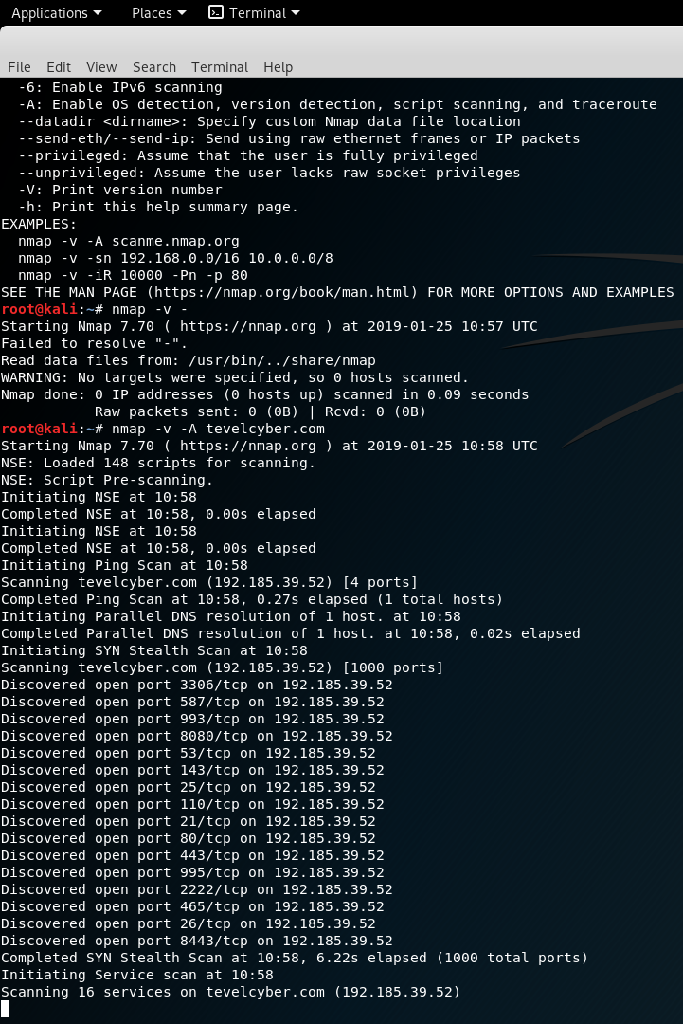
Figure 1: Nmap port Scan Part 1
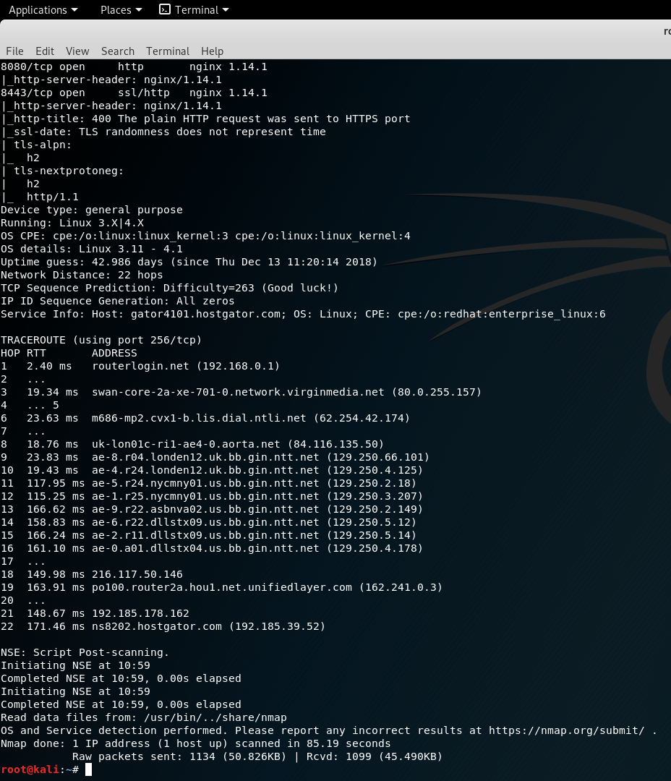
Figure 2: Nmap port Scan Part 2

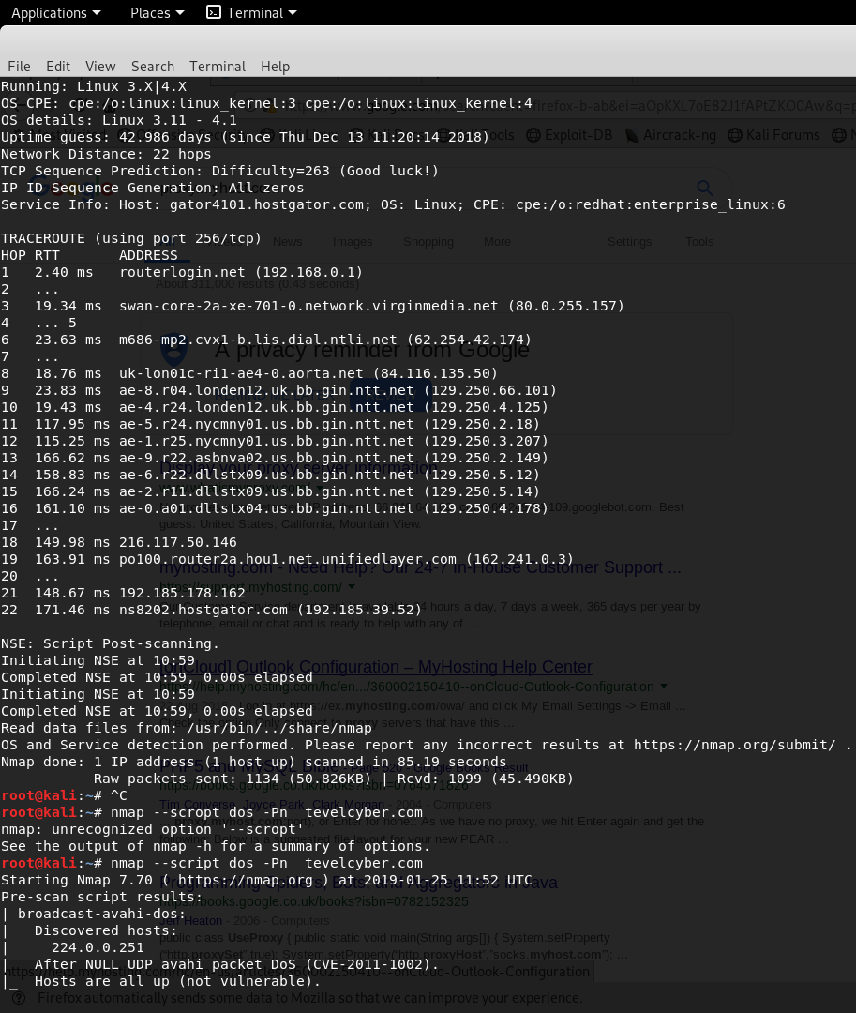
Figure 3: Nmap DDOS Vulnerability Scan.

WebScarab

WebScatab is used to intercept and modify requests and responses between browsers and HTTPS servers. Figure 4 shows the setting up of Webscarab, it can be seen that to run this application effectively the author had to set their browser settings to use the HTTP Proxy 127.0.0.1 port 8008, this is done to allow WebScatab to act as a proxy for the browser enabling the application to intercept requests, the browser the author used is Firefox. Figure 5 is of Firefox blocking the Tevel Cyber website, it does this because the author changed the proxy settings of the browser to allow WebScarab to function causing it to believe that it is an unsecure connection. Figure 6 shows the reason that Firefox blocked the connection because Tevelcyber.com has invalid security certificates, it also shows the reason the certificates are considered invalid because the browser did not recognise the certificate issuer.
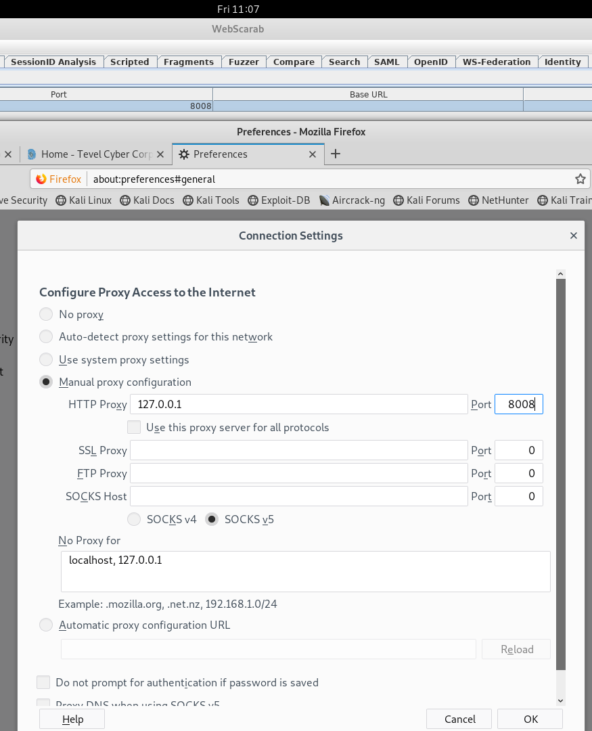
Figure 4: WebScarab Proxy setup.
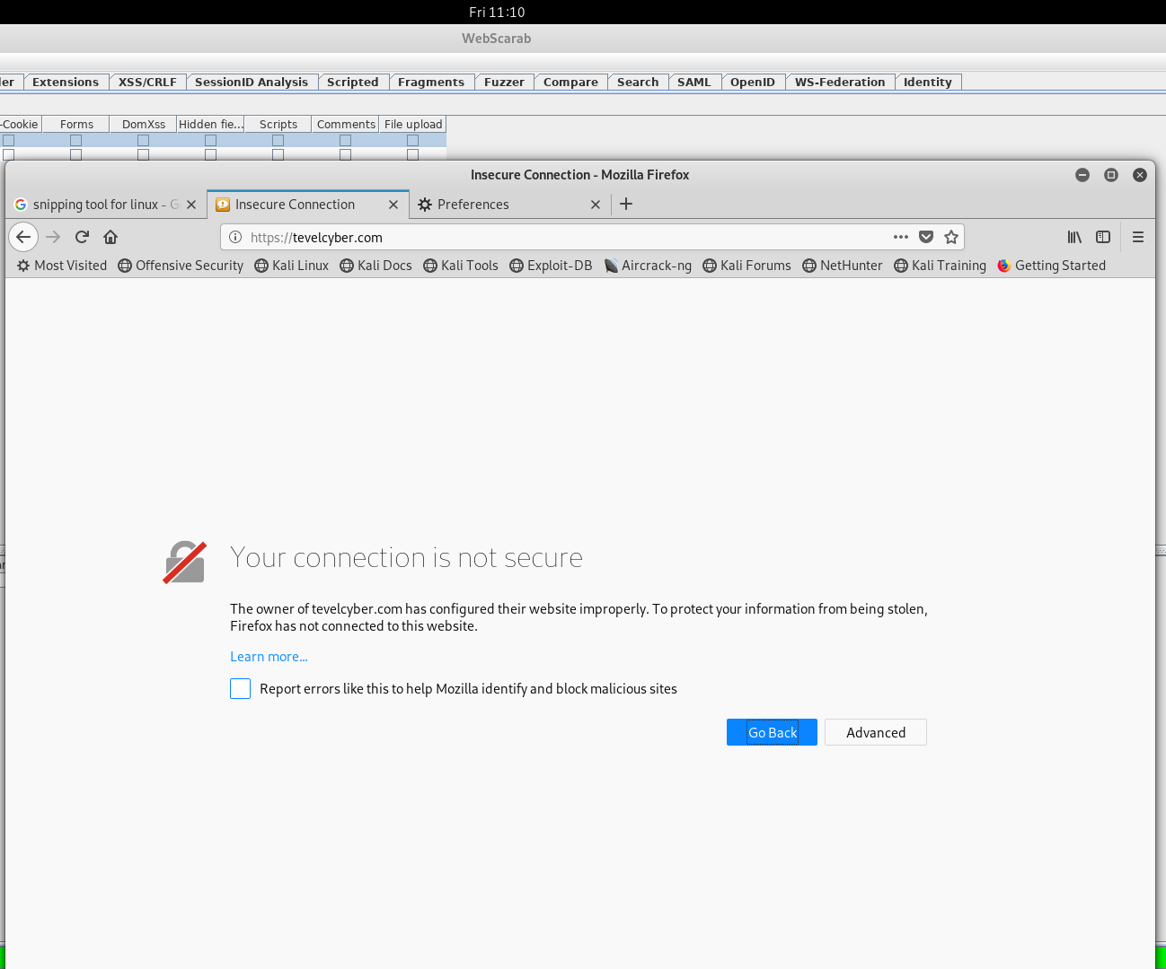
Figure 5: Tevel Cyber unsecure connection.
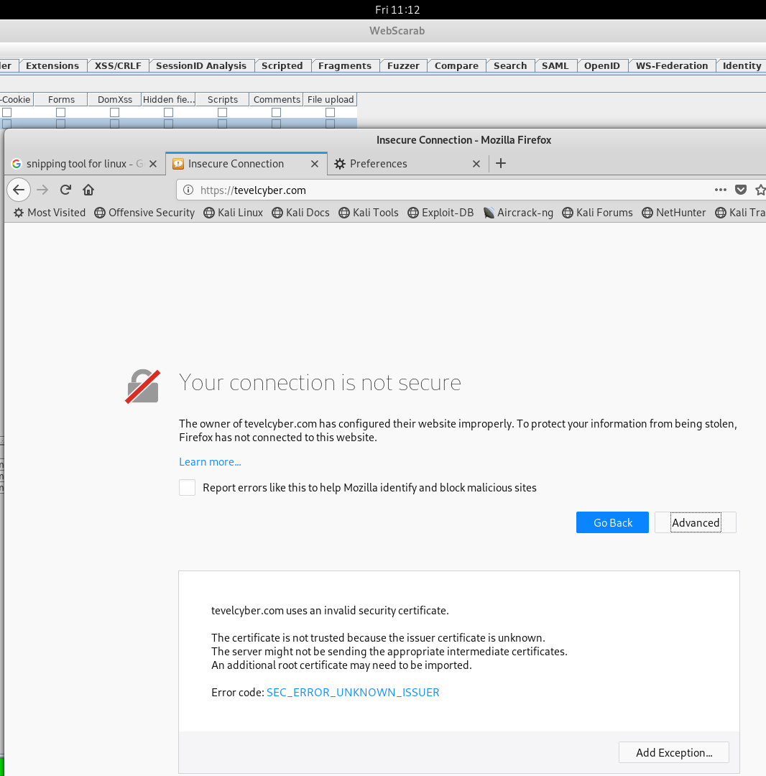
Figure 6: Tevel Cyber invalid security certificate

When running WebScarab the application tracks and captures request traffic to a website, Figure 7 shows the capturing of GET packets from the Firefox host using port 80, Figures 8 and 9 shows the header information broken into a table and the request/response content is shown according to the content-Type header (Parsed) in Figure 8 and in the Raw format where the request/response content is shown as it would be seen on the wire in Figure 9.

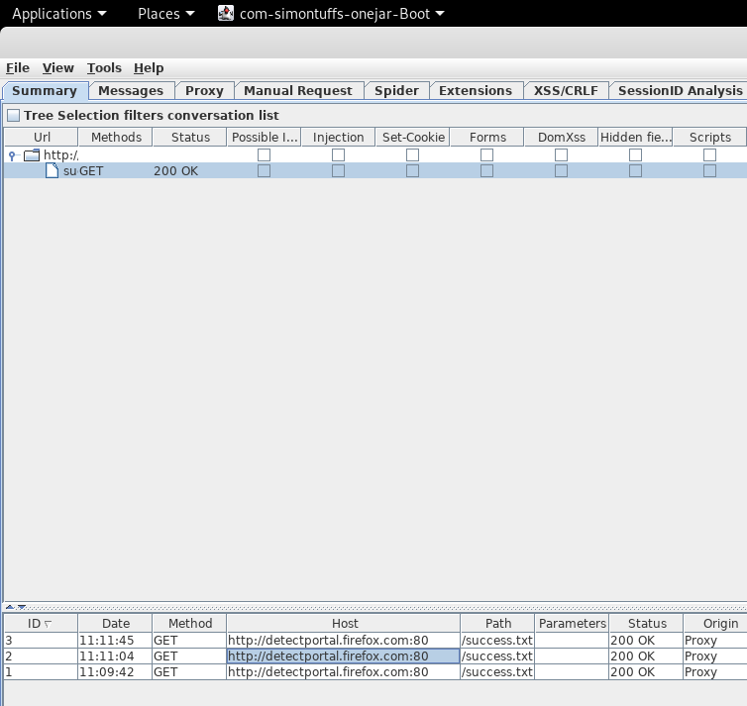
Figure 7: WebScarab host packets.
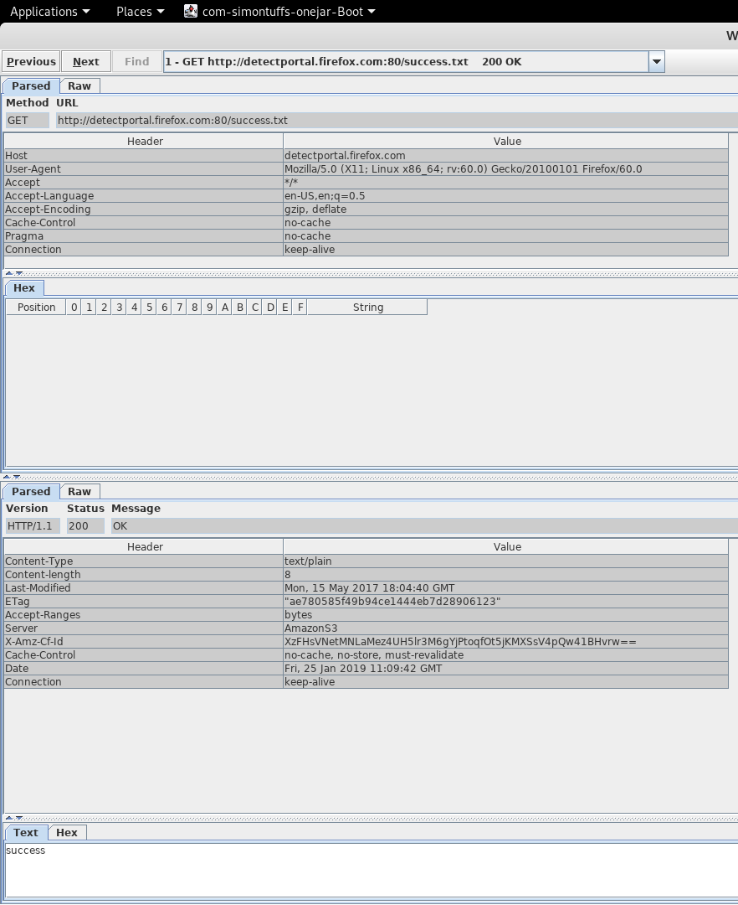
Figure 8: WebScarab HTTP Packets capture Parsed.
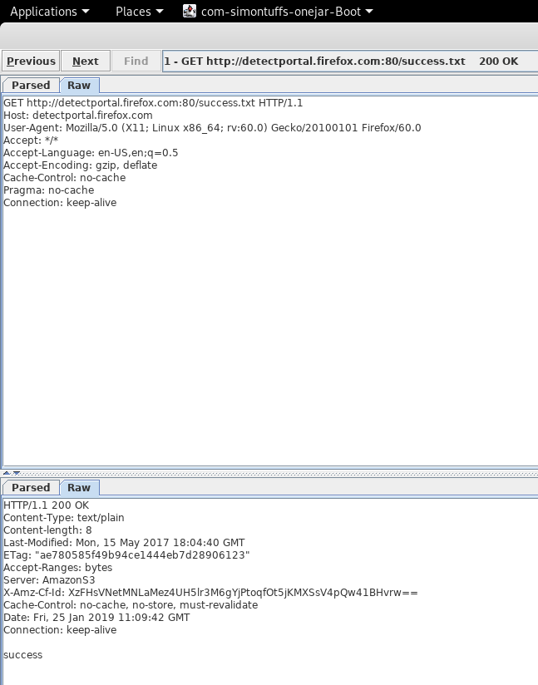
Figure 9: WebScarab HTTP Packets capture RAW.

SPARTA

The SPARTA tool is used to run penetration tests on a network with the intent to identify vulnerabilities such as user passwords. Figure 10 shows the active SPARTA scan of the Tevel Cyber website IP address and shown in Figure 1; it can be seen in the scan that there are seven open ports all using the TCP protocol, also the names of each server connected to the ports are shown. On the information tab of the SPARTA application Figure 11 it can be seen that the severs are connected to a Motorola RFD6000 Wireless LAN Switch/Controller [9]. During the scan SPARTA is able to identify and verify any and all vulnerabilities on the network, Figures 12-15 show the vulnerabilities listed by the application such as not having protection against Cross site scripting (XSS), also shown is the port these vulnerabilities are located, ports 80,8080 and 2078. This is a significant amount of information that allows an attacker to refine the types of attack they use such as exploiting the weaknesses of FormMail to gain access to users Emails and privet data. The following is a list of vulnerabilities found by the SPARTA application: -
- No XSS protection
- No protection from Clickjacking
- Formmail CGI vulnerability where version number is reviled
- Mailman
- Count.cgi this can allow attackers to execute commands on a server

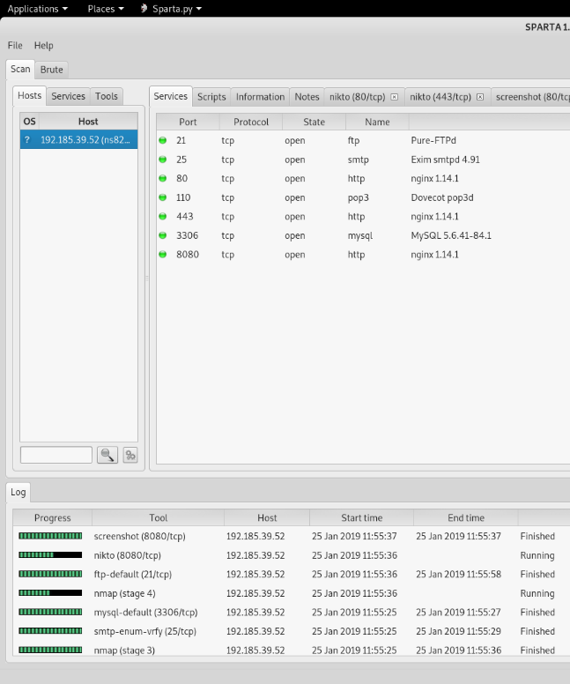
Figure 10: SPARTA Scan.
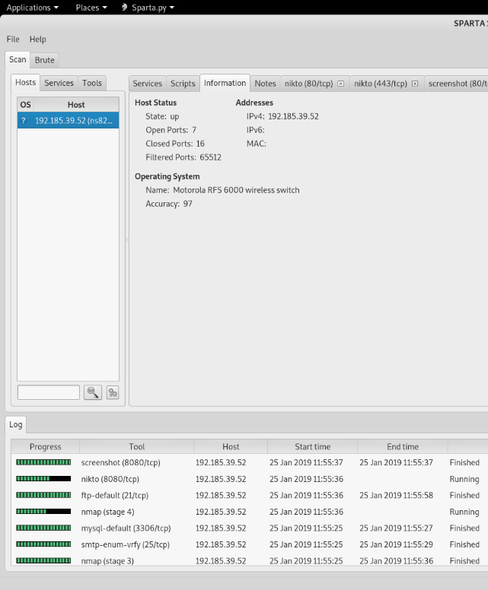
Figure 11: Tevel Cyber, Scan results.
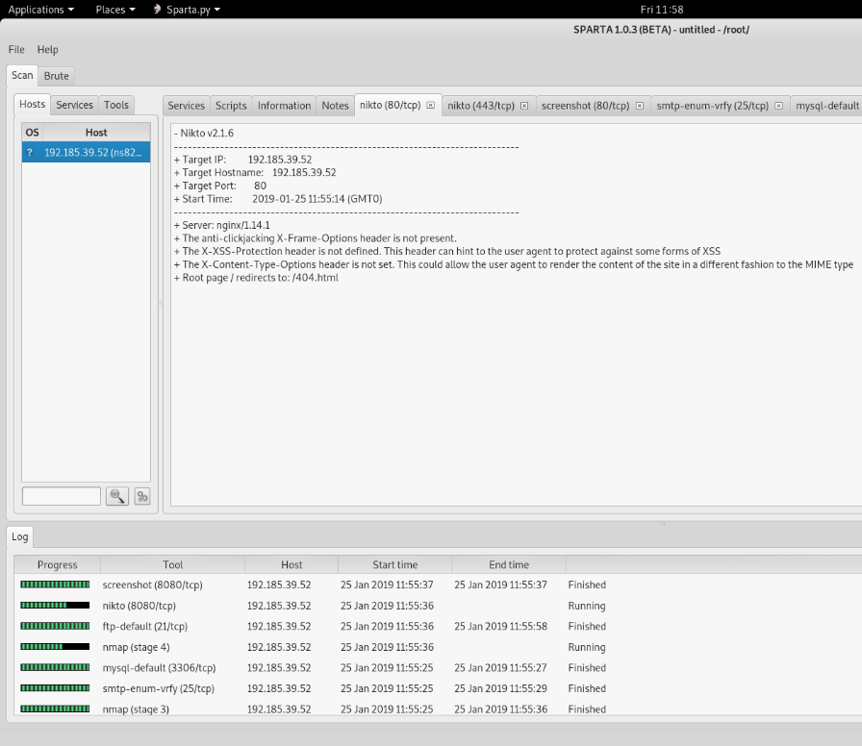
Figure 12: Nikto scan port 80 TCP vulnerability scan results part 1.

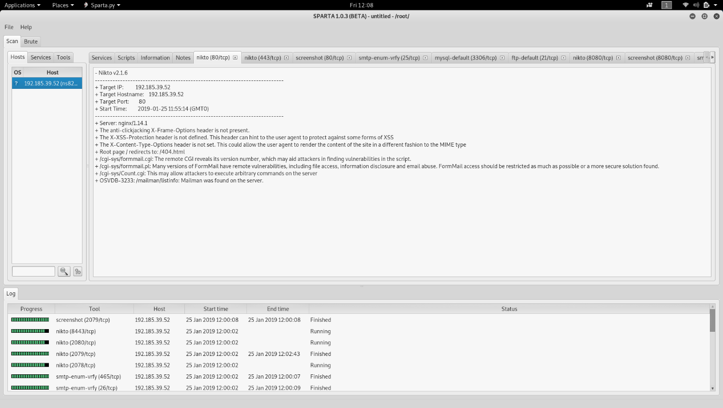
Figure 13: Nikto scan port 80 TCP vulnerability scan results part 2.

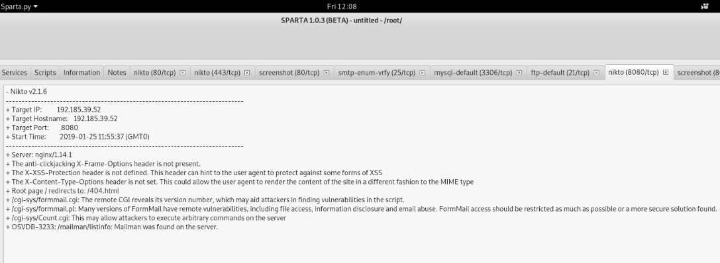
Figure 14: Nikto scan port 8080 TCP vulnerability scan results

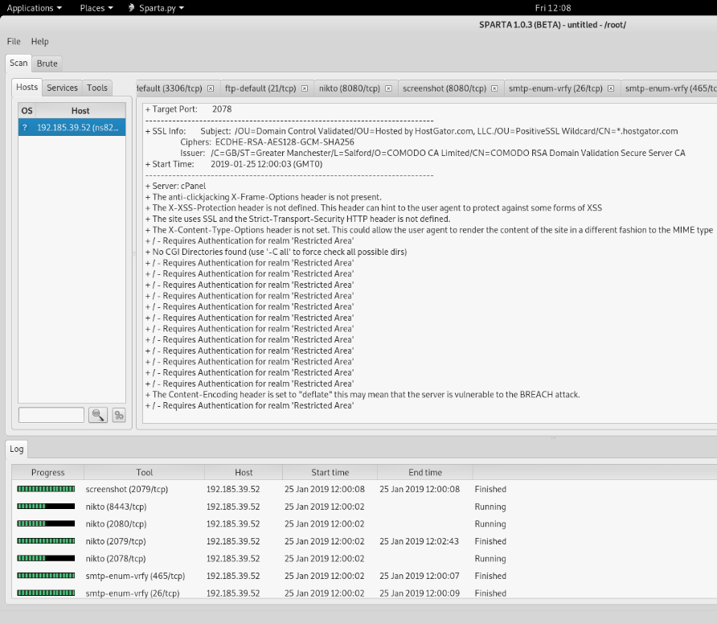
Figure 15: Nikto scan port 2078 TCP vulnerability scan results

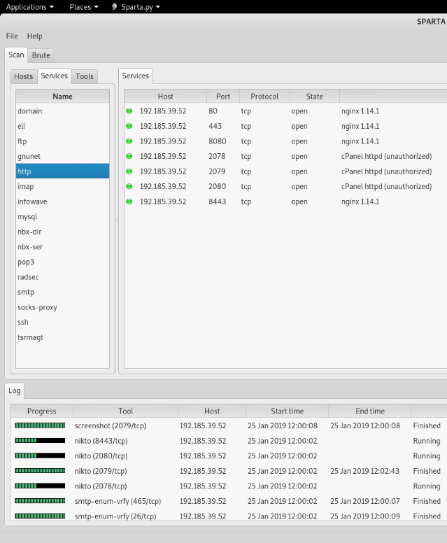
Figure 16: SPARTA Services HTTP.

Skipfish

Skipfish web reconnaissance tool used to make interactive sitemaps of targeted websites, Figure 17 shows the results of running the Skipfish dictionary probes, as shown the scan ran 387 HTTP requests to prob the website and whent through 17 TCP security handshakes. Figure 18 shows the interactive sitemap of the Tevel Cyber, it shows the sever that is hosting the site has some problems such as numerical filenames that allow for vulnerability with attackers uploading files and incorrect or missing charsets that allow for XSS attacks. The text/html file shown in Figure 19 reveals the request and replay form the authors laptop and the Tevel Cyber website, the type of encoding used can be seen in figure 19, the Gzip encoding is vulnerable to Breach attacks that extract login tokens for email addresses.

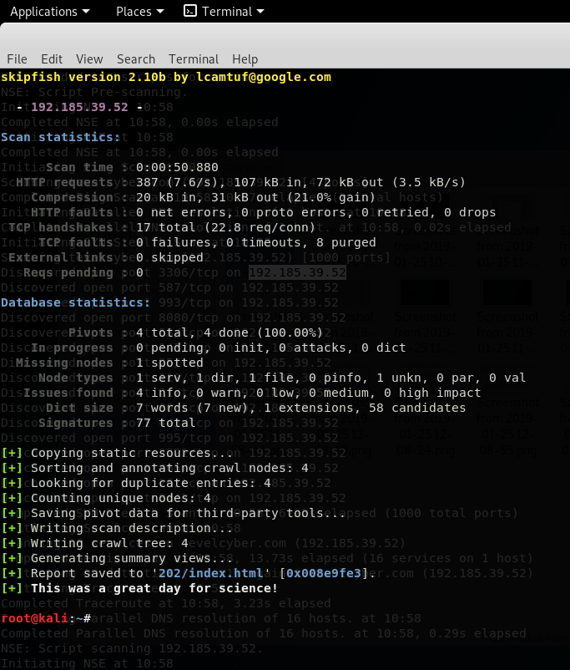
Figure 17: Skipfish, scan results.

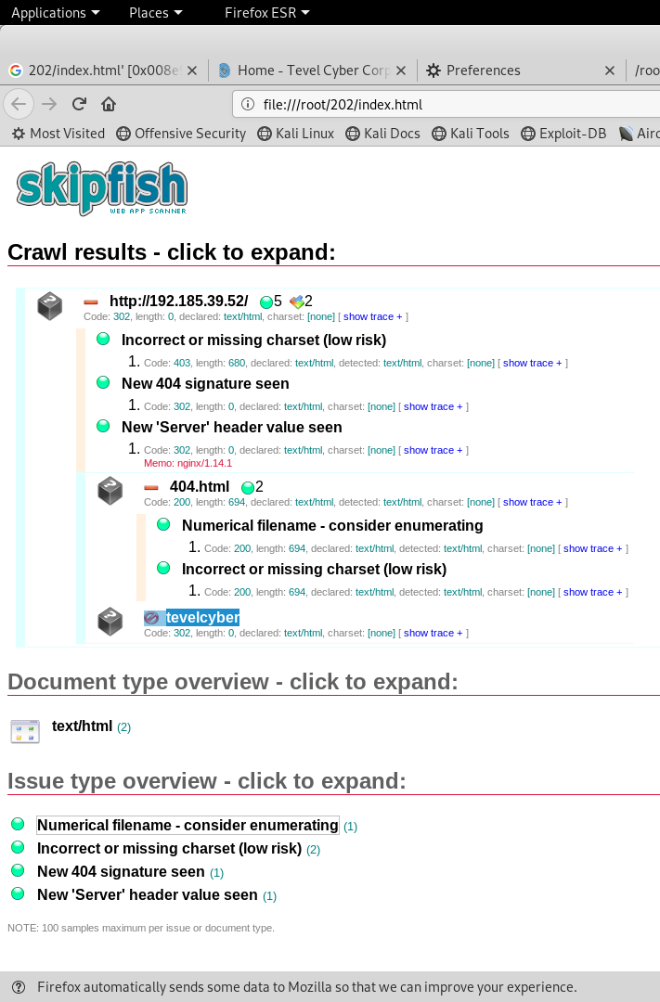
Figure 18: Tevel Cyber interactive sitemap.
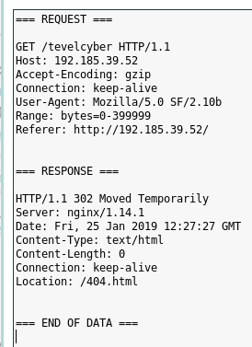
Figure 19: Captured HTTP traffic between Tevelcyber and nginx server.

Results of the Scans

As a result of pen testing Tevel Cybers website the author discovered a few possible vulnerabilities with their security or with the security of the internet hosting service they are using. The vulnerabilities are: -
- A lack of XSS protection, this allows attackers to inject client-side scripts onto the web pages viewed by other users; this enables the attacker to bypass access controls like the same-origin policy that allows the script to access data from the website such as user login information.
- No Clickjacking protection, this is the method employed by attackers to trick users into accessing resources through fake links; this is done to course the user to reveal their private details (banking information) or for the attacker to hijack the user’s device without their knowledge.
- Lack of data encryption, the scans showed that some of the data (filenames) on the servers where being displayed in plain text; this is a problem as it means that an attacker has a simpler time of navigating and accessing data after breaching the network.
- Server not properly setup, this is evident from the Skipfish interactive sitemap in Figure 18; it can be seen that although the server is functioning as intended because of issues with Charset, sever header and 404 signature the server is not as secure as it should be, and this allows for attackers gaining access to the server quicker and with less effort.

Although these are serious problems with the security of Tevel Cyber, the scans also revealed that they are protected against DDOS attacks, this means that the company will suffer a minimal amount of downtime if this type of attack is used.

Recommendation

There is a myriad of different approaches for Tevel Cyber to protect their network and customers online, they author is going to suggest that Tevel Cyber runs their own web server to allow for more control over the security of the website Tevelcyber.com.
One of the vulnerabilities that was discovered XSS can be prevented by using three different methods, these methods may not work well by themselves and should be used together: -
- Escaping – this method of protection is about taking the data an application has received and scanning, said data to ensure the validity of the data before rendering it to an end user. This can be described as censoring the data a website receives in the hopes of preventing the data being interpreted in a malicious way; protecting the users and website. [10]
- Validating input – this means that any untrusted data (Data from outside the system), is suspected of being malicious and needs to be scanned before it is rendered on the site. Input validation protects against XSS by preventing users from adding special characters (<$%£>) in to data fields, this method while good at protecting against XSS it is also used to protect against SQL injections. [11]
- Sanitizing – this method of protection is used to remove all unnecessary information from data input, it does this by modifying the data such as removing tags, line breaks and extra white space to ensure the validity of the data and prevent any security loophole from being exploited.[12]

To protect against Clickjacking Tevel Cyber can use the Content Security Policy of frame ancestor directive, this method can be used in a HTTP response header to specify if a Brower is allowed to render a page in a <frame> or <iframe>. This is used to prevent Clickjacking on a website by ensuring content is not embedded onto other sites[13]; the following examples are of Content-Security-Policy frame ancestors:-
- Content-Security-Policy: frame ancestors’ “self” – this allows the current site to frame the content of the website.
- Content-Security-Policy: frame ancestors “self”” *.website.com” ”https://Tevelcyber.com” – this allows multiple sites to frame the content, from the website itself to the two websites listed.
- Content-Security-Policy: frame ancestors “none” - this prevents the content being framed by any domain, this example is the recommended setting to protect the website.
The limitations of CSP frame ancestors is that it is not supported by all browsers, this could make the site unaccusable to users of specific browsers such as Microsoft Edge; another limitation is that the browsers Chrome and Firefox ignore frame ancestors directive and follow the X-Frame-Option header instead when it is available. X-Frame-Options header functions I the same way as CSP frame ancestors but with the key difference of being supported by every major browser, although this is useful for users accessing the site; the limitations of X-Frame-Options header are as follows: -
- Per-page Policy specifications.
- ALLOW-FROM browser support.
- Multiple options not supported.
- Problems with Multi-domain Sites.
- Nested Frames do not operate with the SAMEORIGIN and ALLOW-FROME functions.
To quickly improve the security of the company website all Tevel Cyber needs to do is to setup their own server, this will allow for greater control and management of the website and will make it easier for the IT staff of the company to monitor any problems that occur. It is possible to get a cheap server for a small business the HPE ProLiant Gen10 AMD Opteron X3216 Tower server for £304.14 [14], and coupled with Windows Server 2019 OS priced at around £102 [15]; it would be easy and cheap for Tevel cyber to set up their own web server. Windows Server 2019 is a operating system designed for the operating and management of servers, it comes preinstalled with a bunch of packages for running different types of services such as email servers and DNS servers. While the author does not have extensive experience with this OS they have used Windows Server 2016, 2017 and 2018for setting up and managing servers such as a Web server.

Conclusion
In conclusion, the author of this report has discovered a surprisingly large amount of security vulnerabilities; for a cyber security company such as Tevel Cyber to have. It was not clear from the scans if the problem lay with the company or with the website hosting company Tevel Cyber is using to mange their website, to that end the author has recommended possible solutions to protect against the vulnerabilities such as using input validation to protect against XSS and hosting their own webserver so the company can exert more control over their website security and management.

References

[1] ‘M7X01701_sem1_CW1_2018_19_NetworkSecurity (1)’. .
[2] Isaca, ‘Planning for Information Security Testing—A Practical Approach’.
[3] ‘19 Powerful Penetration Testing Tools (BEST Security Testing Tools Ranks)’. [Online]. Available: https://www.softwaretestinghelp.com/penetration-testing-tools/. [Accessed: 29-Jan-2019].
[4] ‘Nmap: the Network Mapper - Free Security Scanner’. [Online]. Available: https://nmap.org/. [Accessed: 29-Jan-2019].
[5] ‘Category:OWASP WebScarab Project - OWASP’. [Online]. Available: https://www.owasp.org/index.php/Category:OWASP_WebScarab_Project. [Accessed: 29-Jan-2019].
[6] ‘SPARTA | Penetration Testing Tools’. [Online]. Available: https://tools.kali.org/information-gathering/sparta. [Accessed: 02-May-2018].
[7] ‘SPARTA – Network Infrastructure Penetration Testing Tool’. [Online]. Available: https://sparta.secforce.com/. [Accessed: 29-Jan-2019].
[8] ‘Skipfish | Penetration Testing Tools’. [Online]. Available: https://tools.kali.org/web-applications/skipfish. [Accessed: 29-Jan-2019].
[9] Motorola, ‘RFS6000 Wireless LAN Switch/Controller’.
[10] ‘XSS (Cross Site Scripting) Prevention Cheat Sheet - OWASP’. [Online]. Available: https://www.owasp.org/index.php/XSS_(Cross_Site_Scripting)_Prevention_Cheat_Sheet#XSS_Prevention_Rules_Summary. [Accessed: 31-Jan-2019].
[11] ‘3 Ways to Prevent XSS’. [Online]. Available: https://www.checkmarx.com/2017/10/09/3-ways-prevent-xss/. [Accessed: 31-Jan-2019].
[12] ‘Validating Sanitizing and Escaping User Data « WordPress Codex’. [Online]. Available: https://codex.wordpress.org/Validating_Sanitizing_and_Escaping_User_Data. [Accessed: 31-Jan-2019].
[13] ‘Clickjacking Defense Cheat Sheet - OWASP’. [Online]. Available: https://www.owasp.org/index.php/Clickjacking_Defense_Cheat_Sheet. [Accessed: 31-Jan-2019].
[14] ‘HPE ProLiant Gen10 AMD Opteron X3216 1.6 GHz 8GB No HDD Tower Server on Servers Direct’. [Online]. Available: https://www.serversdirect.co.uk/p/1213893/hpe-proliant-microserver-gen10-amd-opteron-x3216-dual-core-3.4-ghz-8gb-4-x-non-hotplug. [Accessed: 31-Jan-2019].
[15] ‘Windows Server 2019 Standard Core Licenses | SoftwareKeep UK’. [Online]. Available: https://softwarekeep.co.uk/windows-server-2019-standard-core-licenses.html?utm_source=google_shopping&gclid=Cj0KCQiA1sriBRD-ARIsABYdwwH_JpqRBVHFgg9Uf-XzhGHI-dS_uzPnr-dkecKzVa9we3lJI9EhUxMaArJDEALw_wcB. [Accessed: 31-Jan-2019].

Appendices

root@kali:~# nmap -v -A tevelcyber.com
Starting Nmap 7.70 ( https://nmap.org ) at 2019-01-25 10:58 UTC
NSE: Loaded 148 scripts for scanning.
NSE: Script Pre-scanning.
Initiating NSE at 10:58
Completed NSE at 10:58, 0.00s elapsed
Initiating NSE at 10:58
Completed NSE at 10:58, 0.00s elapsed
Initiating Ping Scan at 10:58
Scanning tevelcyber.com (192.185.39.52) [4 ports]
Completed Ping Scan at 10:58, 0.27s elapsed (1 total hosts)
Initiating Parallel DNS resolution of 1 host. at 10:58
Completed Parallel DNS resolution of 1 host. at 10:58, 0.02s elapsed
Initiating SYN Stealth Scan at 10:58
Scanning tevelcyber.com (192.185.39.52) [1000 ports]
Discovered open port 3306/tcp on 192.185.39.52
Discovered open port 587/tcp on 192.185.39.52
Discovered open port 993/tcp on 192.185.39.52
Discovered open port 8080/tcp on 192.185.39.52
Discovered open port 53/tcp on 192.185.39.52
Discovered open port 143/tcp on 192.185.39.52
Discovered open port 25/tcp on 192.185.39.52
Discovered open port 110/tcp on 192.185.39.52
Discovered open port 21/tcp on 192.185.39.52
Discovered open port 80/tcp on 192.185.39.52
Discovered open port 443/tcp on 192.185.39.52
Discovered open port 995/tcp on 192.185.39.52
Discovered open port 2222/tcp on 192.185.39.52
Discovered open port 465/tcp on 192.185.39.52
Discovered open port 26/tcp on 192.185.39.52
Discovered open port 8443/tcp on 192.185.39.52
Completed SYN Stealth Scan at 10:58, 6.22s elapsed (1000 total ports)
Initiating Service scan at 10:58
Scanning 16 services on tevelcyber.com (192.185.39.52)
Completed Service scan at 10:58, 13.73s elapsed (16 services on 1 host)
Initiating OS detection (try #1) against tevelcyber.com (192.185.39.52)
Initiating Traceroute at 10:58
Completed Traceroute at 10:58, 3.23s elapsed
Initiating Parallel DNS resolution of 16 hosts. at 10:58
Completed Parallel DNS resolution of 16 hosts. at 10:58, 0.29s elapsed
NSE: Script scanning 192.185.39.52.
Initiating NSE at 10:58
Completed NSE at 10:59, 58.23s elapsed
Initiating NSE at 10:59
Completed NSE at 10:59, 0.01s elapsed
Nmap scan report for tevelcyber.com (192.185.39.52)
Host is up (0.14s latency).
rDNS record for 192.185.39.52: ns8202.hostgator.com
Not shown: 982 closed ports
PORT STATE SERVICE VERSION
21/tcp open ftp Pure-FTPd
| ssl-cert: Subject: commonName=*.hostgator.com
| Subject Alternative Name: DNS:*.hostgator.com, DNS:hostgator.com
| Issuer: commonName=COMODO RSA Domain Validation Secure Server CA/organizationName=COMODO CA Limited/stateOrProvinceName=Greater Manchester/countryName=GB
| Public Key type: rsa
| Public Key bits: 2048
| Signature Algorithm: sha256WithRSAEncryption
| Not valid before: 2018-10-02T00:00:00
| Not valid after: 2020-10-01T23:59:59
| MD5: 9007 c122 c844 32ba 08a1 9bcb 9c49 304f
|_SHA-1: 6bc5 779a 982b 7464 0cf2 211a 5bdd 923c 71d4 80f7
|_ssl-date: 2019-01-25T10:59:10+00:00; -1s from scanner time.
22/tcp filtered ssh
25/tcp open tcpwrapped
|_smtp-commands: Couldn't establish connection on port 25
| ssl-cert: Subject: commonName=tevelcyber.com
| Subject Alternative Name: DNS:autodiscover.tevelcyber.com, DNS:cpanel.tevelcyber.com, DNS:mail.tevelcyber.com, DNS:tevelcyber.com, DNS:webdisk.tevelcyber.com, DNS:webmail.tevelcyber.com, DNS:www.tevelcyber.com
| Issuer: commonName=Let's Encrypt Authority X3/organizationName=Let's Encrypt/countryName=US
| Public Key type: rsa
| Public Key bits: 2048
| Signature Algorithm: sha256WithRSAEncryption
| Not valid before: 2018-11-28T11:29:10
| Not valid after: 2019-02-26T11:29:10
| MD5: 1a15 55aa b46b aae0 d2bf 7e87 97f7 be40
|_SHA-1: acbc 9231 0041 eb6f 83d4 4ac8 476b 534a 2b17 ffbc
26/tcp open smtp Exim smtpd 4.91
| smtp-commands: gator4101.hostgator.com Hello cpc1-gors3-2-0-cust884.know.cable.virginm.net [82.3.179.117], SIZE 52428800, 8BITMIME, PIPELINING, AUTH PLAIN LOGIN, STARTTLS, HELP,
|_ Commands supported: AUTH STARTTLS HELO EHLO MAIL RCPT DATA BDAT NOOP QUIT RSET HELP
53/tcp open domain ISC BIND 9.8.2rc1 (RedHat Enterprise Linux 6)
| dns-nsid:
|_ bind.version: 9.8.2rc1-RedHat-9.8.2-0.68.rc1.el6
80/tcp open http nginx 1.14.1
|_http-favicon: Unknown favicon MD5: D41D8CD98F00B204E9800998ECF8427E
|_http-server-header: nginx/1.14.1
|_http-title: 500 Error
110/tcp open pop3 Dovecot pop3d
|_pop3-capabilities: TOP RESP-CODES STLS CAPA USER UIDL PIPELINING AUTH-RESP-CODE SASL(PLAIN LOGIN)
| ssl-cert: Subject: commonName=*.hostgator.com
| Subject Alternative Name: DNS:*.hostgator.com, DNS:hostgator.com
| Issuer: commonName=COMODO RSA Domain Validation Secure Server CA/organizationName=COMODO CA Limited/stateOrProvinceName=Greater Manchester/countryName=GB
| Public Key type: rsa
| Public Key bits: 2048
| Signature Algorithm: sha256WithRSAEncryption
| Not valid before: 2018-10-02T00:00:00
| Not valid after: 2020-10-01T23:59:59
| MD5: 9007 c122 c844 32ba 08a1 9bcb 9c49 304f
|_SHA-1: 6bc5 779a 982b 7464 0cf2 211a 5bdd 923c 71d4 80f7
|_ssl-date: 2019-01-25T10:59:13+00:00; -1s from scanner time.
143/tcp open imap Dovecot imapd
|_imap-capabilities: more have IMAP4rev1 post-login listed Pre-login SASL-IR NAMESPACE AUTH=PLAIN OK ENABLE IDLE capabilities AUTH=LOGINA0001 STARTTLS LITERAL+ ID LOGIN-REFERRALS
| ssl-cert: Subject: commonName=*.hostgator.com
| Subject Alternative Name: DNS:*.hostgator.com, DNS:hostgator.com
| Issuer: commonName=COMODO RSA Domain Validation Secure Server CA/organizationName=COMODO CA Limited/stateOrProvinceName=Greater Manchester/countryName=GB
| Public Key type: rsa
| Public Key bits: 2048
| Signature Algorithm: sha256WithRSAEncryption
| Not valid before: 2018-10-02T00:00:00
| Not valid after: 2020-10-01T23:59:59
| MD5: 9007 c122 c844 32ba 08a1 9bcb 9c49 304f
|_SHA-1: 6bc5 779a 982b 7464 0cf2 211a 5bdd 923c 71d4 80f7
|_ssl-date: 2019-01-25T10:59:12+00:00; 0s from scanner time.
443/tcp open ssl/http nginx 1.14.1
|_http-favicon: Unknown favicon MD5: D41D8CD98F00B204E9800998ECF8427E
| http-methods:
|_ Supported Methods: HEAD POST
|_http-server-header: nginx/1.14.1
|_http-title: 500 Error
| ssl-cert: Subject: commonName=tevelcyber.com
| Subject Alternative Name: DNS:autodiscover.tevelcyber.com, DNS:cpanel.tevelcyber.com, DNS:mail.tevelcyber.com, DNS:tevelcyber.com, DNS:webdisk.tevelcyber.com, DNS:webmail.tevelcyber.com, DNS:www.tevelcyber.com
| Issuer: commonName=Let's Encrypt Authority X3/organizationName=Let's Encrypt/countryName=US
| Public Key type: rsa
| Public Key bits: 2048
| Signature Algorithm: sha256WithRSAEncryption
| Not valid before: 2018-11-28T11:29:10
| Not valid after: 2019-02-26T11:29:10
| MD5: 1a15 55aa b46b aae0 d2bf 7e87 97f7 be40
|_SHA-1: acbc 9231 0041 eb6f 83d4 4ac8 476b 534a 2b17 ffbc
|_ssl-date: TLS randomness does not represent time
| tls-alpn:
| h2
|_ http/1.1
| tls-nextprotoneg:
| h2
|_ http/1.1
465/tcp open tcpwrapped
|_smtp-commands: Couldn't establish connection on port 465
| ssl-cert: Subject: commonName=tevelcyber.com
| Subject Alternative Name: DNS:autodiscover.tevelcyber.com, DNS:cpanel.tevelcyber.com, DNS:mail.tevelcyber.com, DNS:tevelcyber.com, DNS:webdisk.tevelcyber.com, DNS:webmail.tevelcyber.com, DNS:www.tevelcyber.com
| Issuer: commonName=Let's Encrypt Authority X3/organizationName=Let's Encrypt/countryName=US
| Public Key type: rsa
| Public Key bits: 2048
| Signature Algorithm: sha256WithRSAEncryption
| Not valid before: 2018-11-28T11:29:10
| Not valid after: 2019-02-26T11:29:10
| MD5: 1a15 55aa b46b aae0 d2bf 7e87 97f7 be40
|_SHA-1: acbc 9231 0041 eb6f 83d4 4ac8 476b 534a 2b17 ffbc
587/tcp open smtp Exim smtpd 4.91
| smtp-commands: gator4101.hostgator.com Hello cpc1-gors3-2-0-cust884.know.cable.virginm.net [82.3.179.117], SIZE 52428800, 8BITMIME, PIPELINING, AUTH PLAIN LOGIN, STARTTLS, HELP,
|_ Commands supported: AUTH STARTTLS HELO EHLO MAIL RCPT DATA BDAT NOOP QUIT RSET HELP
| ssl-cert: Subject: commonName=tevelcyber.com
| Subject Alternative Name: DNS:autodiscover.tevelcyber.com, DNS:cpanel.tevelcyber.com, DNS:mail.tevelcyber.com, DNS:tevelcyber.com, DNS:webdisk.tevelcyber.com, DNS:webmail.tevelcyber.com, DNS:www.tevelcyber.com
| Issuer: commonName=Let's Encrypt Authority X3/organizationName=Let's Encrypt/countryName=US
| Public Key type: rsa
| Public Key bits: 2048
| Signature Algorithm: sha256WithRSAEncryption
| Not valid before: 2018-11-28T11:29:10
| Not valid after: 2019-02-26T11:29:10
| MD5: 1a15 55aa b46b aae0 d2bf 7e87 97f7 be40
|_SHA-1: acbc 9231 0041 eb6f 83d4 4ac8 476b 534a 2b17 ffbc
993/tcp open ssl/imap Dovecot imapd
| ssl-cert: Subject: commonName=*.hostgator.com
| Subject Alternative Name: DNS:*.hostgator.com, DNS:hostgator.com
| Issuer: commonName=COMODO RSA Domain Validation Secure Server CA/organizationName=COMODO CA Limited/stateOrProvinceName=Greater Manchester/countryName=GB
| Public Key type: rsa
| Public Key bits: 2048
| Signature Algorithm: sha256WithRSAEncryption
| Not valid before: 2018-10-02T00:00:00
| Not valid after: 2020-10-01T23:59:59
| MD5: 9007 c122 c844 32ba 08a1 9bcb 9c49 304f
|_SHA-1: 6bc5 779a 982b 7464 0cf2 211a 5bdd 923c 71d4 80f7
|_ssl-date: 2019-01-25T10:59:10+00:00; -1s from scanner time.
995/tcp open ssl/pop3 Dovecot pop3d
|_pop3-capabilities: USER UIDL RESP-CODES SASL(PLAIN LOGIN) AUTH-RESP-CODE PIPELINING CAPA TOP
| ssl-cert: Subject: commonName=*.hostgator.com
| Subject Alternative Name: DNS:*.hostgator.com, DNS:hostgator.com
| Issuer: commonName=COMODO RSA Domain Validation Secure Server CA/organizationName=COMODO CA Limited/stateOrProvinceName=Greater Manchester/countryName=GB
| Public Key type: rsa
| Public Key bits: 2048
| Signature Algorithm: sha256WithRSAEncryption
| Not valid before: 2018-10-02T00:00:00
| Not valid after: 2020-10-01T23:59:59
| MD5: 9007 c122 c844 32ba 08a1 9bcb 9c49 304f
|_SHA-1: 6bc5 779a 982b 7464 0cf2 211a 5bdd 923c 71d4 80f7
|_ssl-date: 2019-01-25T10:58:56+00:00; 0s from scanner time.
1723/tcp filtered pptp
2222/tcp open ssh OpenSSH 5.3 (protocol 2.0)
| ssh-hostkey:
| 1024 8e:ac:98:46:3c:a5:36:a4:b5:ca:19:84:2b:06:c0:a0 (DSA)
|_ 2048 e9:da:4c:f3:56:f6:0d:58:5e:75:0d:58:eb:44:5d:b3 (RSA)
3306/tcp open mysql MySQL 5.6.41-84.1
| mysql-info:
| Protocol: 10
| Version: 5.6.41-84.1
| Thread ID: 43452321
| Capabilities flags: 65535
| Some Capabilities: IgnoreSigpipes, DontAllowDatabaseTableColumn, InteractiveClient, Support41Auth, SupportsCompression, Speaks41ProtocolNew, IgnoreSpaceBeforeParenthesis, LongColumnFlag, ConnectWithDatabase, SwitchToSSLAfterHandshake, Speaks41ProtocolOld, SupportsTransactions, FoundRows, SupportsLoadDataLocal, LongPassword, ODBCClient, SupportsMultipleStatments, SupportsAuthPlugins, SupportsMultipleResults
| Status: Autocommit
| Salt: o'nx2+!cPHUS#OEO;vdr
|_ Auth Plugin Name: 84
8080/tcp open http nginx 1.14.1
|_http-server-header: nginx/1.14.1
8443/tcp open ssl/http nginx 1.14.1
|_http-server-header: nginx/1.14.1
|_http-title: 400 The plain HTTP request was sent to HTTPS port
|_ssl-date: TLS randomness does not represent time
| tls-alpn:
|_ h2
| tls-nextprotoneg:
| h2
|_ http/1.1
Device type: general purpose
Running: Linux 3.X|4.X
OS CPE: cpe:/o:linux:linux_kernel:3 cpe:/o:linux:linux_kernel:4
OS details: Linux 3.11 - 4.1
Uptime guess: 42.986 days (since Thu Dec 13 11:20:14 2018)
Network Distance: 22 hops
TCP Sequence Prediction: Difficulty=263 (Good luck!)
IP ID Sequence Generation: All zeros
Service Info: Host: gator4101.hostgator.com; OS: Linux; CPE: cpe:/o:redhat:enterprise_linux:6

TRACEROUTE (using port 256/tcp)
HOP RTT ADDRESS
1 2.40 ms routerlogin.net (192.168.0.1)
2 ...
3 19.34 ms swan-core-2a-xe-701-0.network.virginmedia.net (80.0.255.157)
4 ... 5
6 23.63 ms m686-mp2.cvx1-b.lis.dial.ntli.net (62.254.42.174)
7 ...
8 18.76 ms uk-lon01c-ri1-ae4-0.aorta.net (84.116.135.50)
9 23.83 ms ae-8.r04.londen12.uk.bb.gin.ntt.net (129.250.66.101)
10 19.43 ms ae-4.r24.londen12.uk.bb.gin.ntt.net (129.250.4.125)
11 117.95 ms ae-5.r24.nycmny01.us.bb.gin.ntt.net (129.250.2.18)
12 115.25 ms ae-1.r25.nycmny01.us.bb.gin.ntt.net (129.250.3.207)
13 166.62 ms ae-9.r22.asbnva02.us.bb.gin.ntt.net (129.250.2.149)
14 158.83 ms ae-6.r22.dllstx09.us.bb.gin.ntt.net (129.250.5.12)
15 166.24 ms ae-2.r11.dllstx09.us.bb.gin.ntt.net (129.250.5.14)
16 161.10 ms ae-0.a01.dllstx04.us.bb.gin.ntt.net (129.250.4.178)
17 ...
18 149.98 ms 216.117.50.146
19 163.91 ms po100.router2a.hou1.net.unifiedlayer.com (162.241.0.3)
20 ...
21 148.67 ms 192.185.178.162
22 171.46 ms ns8202.hostgator.com (192.185.39.52)

NSE: Script Post-scanning.
Initiating NSE at 10:59
Completed NSE at 10:59, 0.00s elapsed
Initiating NSE at 10:59
Completed NSE at 10:59, 0.00s elapsed
Read data files from: /usr/bin/../share/nmap
OS and Service detection performed. Please report any incorrect results at https://nmap.org/submit/ .
Nmap done: 1 IP address (1 host up) scanned in 85.19 seconds
Raw packets sent: 1134 (50.826KB) | Rcvd: 1099 (45.490KB)

marking criteria and Student FEEDBACK

This section details the assessment criteria. The extent to which these are demonstrated by you determines your mark. The marks available for each criterion are shown. Lecturers will use the space provided to comment on the achievement of the task(s), including those areas in which you have performed well and areas that would benefit from development/improvement.

Common Assessment Criteria Applied (Assignment 1) | Marks available | Marks  awarded
1. Research-informed Literature
Extent of research and/or own reading, selection of credible sources, application of appropriate referencing conventions.
Your referencing not consistently applied (lack of in-text citations). Reference to a limited range of peer reviewed sources. (Grade mark: 50.00%) | 10 | 5
2. Knowledge and Understanding of Subject
Extent of knowledge and understanding of concepts and underlying principles associated with the discipline.
Evidence of knowledge & understanding of the main theories and concept but required more depth of the research. (Grade mark: 50.00%) | 10 | 5
3. Analysis
Analysis, evaluation and synthesis; logic, argument and judgement; analytical reflection; organisation of ideas and evidence
Your analysis require more in-depth discussions of your research and finding. Your report mainly explain the tests done. Cost could be done on consultancy time. Timetable plan i.e. time plan taken to carry out planning and testing etc. an put in appendix. Some other areas could do with some improvement: The introduction could end with the most specific information: a guide to the scope and structure of your report (What coming next in each section). Your conclusion and abstract also need improvement. (Grade mark: 57.14%) | 35 | 20
4. Practical Application and Deployment
Deployment of methods, materials, tools and techniques; application of concepts; formulation of innovative and creative solutions to solve problems.
A range of tools used to gather information and launched attack to tests for vulnerabilities on Tevel Corp Private Limited site. This was explained but could critically analysed. (Grade mark: 77.14%) | 35 | 27
5. Skills for Professional Practice
Attributes in professional practice: individual and collaborative working; deployment of appropriate media; presentation and organisation.
Can communicate effectively in a suitable format with room for improvement. Avoid 1st person writing such as we, you, I, etc. Write all abbreviations out in full on first use. Report could do with some formatting (justifying alignment in some areas.) (Grade mark: 55.00%) | 10 | 5.5

Assignment Mark (Assessment marks are subject to ratification at the Exam Board. These comments and marks are to give feedback on module work and are for guidance only until they are confirmed. ) | Late Submission Penalties (tick if appropriate) |  | 62.5%
 | Up to four weeks late |  | 62.5%
 | First Attempt? |  | 62.5%

