Marcos Gonzalez norris (1802722), Hannah White (1702206), Steffan Robinson (1801468) and Tom Unwin (1703582)
Uwtsd Engineering
Concept designs and final designs

Contents
Introduction 2
Concepts 2
Evaluation 3
Concept 1 3
Concept 2 3
Concept 3 3
Final design 4
Team leadership and Integrated systems 6
Power generation and storage 7
Mechanical drive and propulsion 8
Control, Robustness and Reliability and payload 9
Conclusion 10
References 11

Introduction
The aim of this report is to show our concept designs and evaluation of them as well as our final design. The final design is a culmination of aspects of the group’s previous concepts, using the parts which we felt gave us the best chance of success. This included a pivot and self-adjustment mechanism to deal with the various deformations on the surface of the pipe, and thick rubber wheels to reduce the risk of wheel-spin – these aspects will be discussed in more depth later into the report.

Concepts

Concept 1)
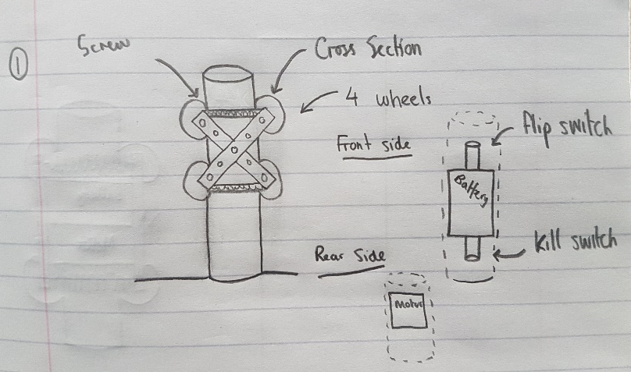
This pipe climber consists of 4 wheels mounted on a cross section formed from steel. The wheels are clamped onto the pipe via screws at the top and bottom of the cross section on both sides. The battery and motor are connected on the side of the pipe climber. There is a flip switch at the top to put the motor in reverse and a kill switch at the bottom to turn the motor off.

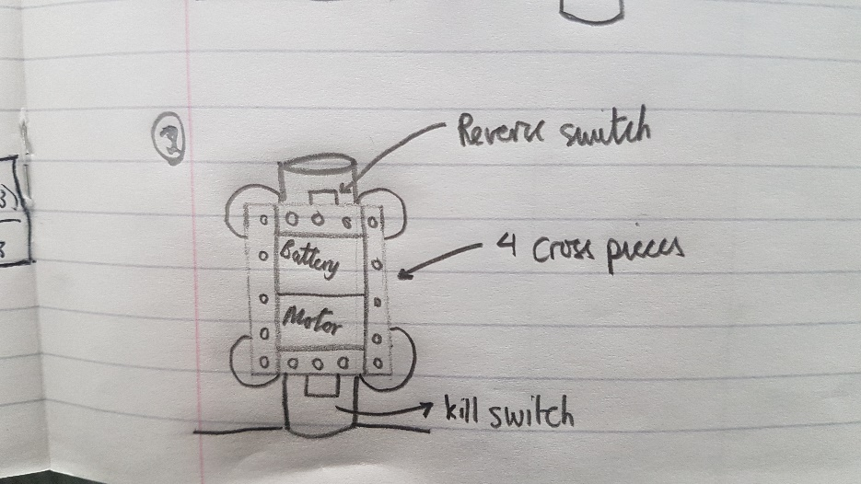
Concept 2)

This pipe climber has a fixed frame with the wheels attached at each corner. The battery and motor are placed in the centre within the frame. There is a flip switch at the top to change the direction and a kill at the bottom.

Concept 3)
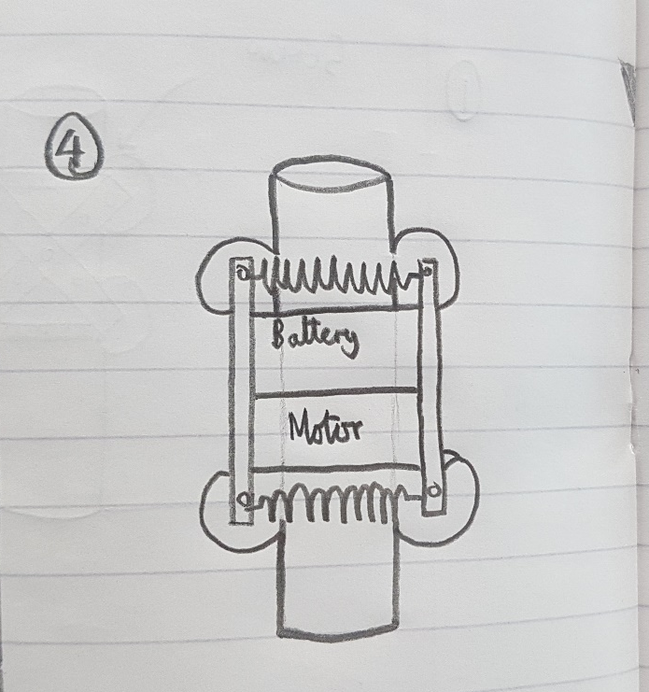
This pipe climber has a frame connecting the left wheels together and another connecting the right wheels together. There is a spring at the top and the bottom to provide tension against the pipe. The battery and motor are placed inside the framework.

Evaluation

Concept 1
The first concept idea was to have a cross section of material and have screws connected to either side to make the device strong. The purpose of the cross section is to get most of the weight as central as possible because we do not want more weight on one side than the other. There are many pros to this device one of which is; that the device would be very solid due to the screws that kept everything in its place and would give it a sturdy feel. The main downfall to this however is that the device is not adjustable and would need tightening and loosening every time we needed to put it on or off a pole. Even though that this is a one-off event, if it were to be made it would be very time consuming and very frustrating to keep pulling it off and putting it back on. The battery would have been connected at the front and the motor connected at the back for better weight distribution. On the front side there would be a reverse switch connected at the top and a kill switch at the bottom. The reverse switch would essentially reverse the movement of the motor and drive the wheels down the pipe instead of up. And when it got to the bottom the kill switch would trigger and kill the motor so that it doesn’t brake while trying to dig itself into the ground.

Concept 2
The second concept idea was to create a frame with the battery and motor inside and have the 4 wheels on the outer corners of the framework. This would also give us a strong barrier to protect the inner components of the device. Again, the main issue is adjustability of the device because the framework would be held together by screws most likely and this would not be very practical. Again, we would have a kill and reverse switch on the battery to help of the control of the device so that it doesn’t drop from the top of the pipe and brake. The main downfall of this device however is the weight distribution, because the battery and motor are both on one side of the device it could have a significant impact on the performance of the device. It could also affect the grip of the tyres onto the pipe surface because it could be leaning to one side.

Concept 3
The final concept idea is to have, similar to concept 2 the battery and motor in-between two pipes. There would then be small extension springs to connect either side together. The purpose of the spring is to compress the whole thing together and give more grip for the wheels. This would then give us tension against the pipe and help it give more friction to the wheels. We would use hooks to connect the spring and the pipes together giving us good adjustability and being able to take it on and off pipes with ease. It also allows us because of the springs to connect it to a variety of different width of pipe just not one fixed diameter. Again, our main problem is having most of the weight on one side of the device this could cause a problem with the performance with the tyres not getting the right amount of grip when its ascending up the pipe which could even cause something to brake.

Final design
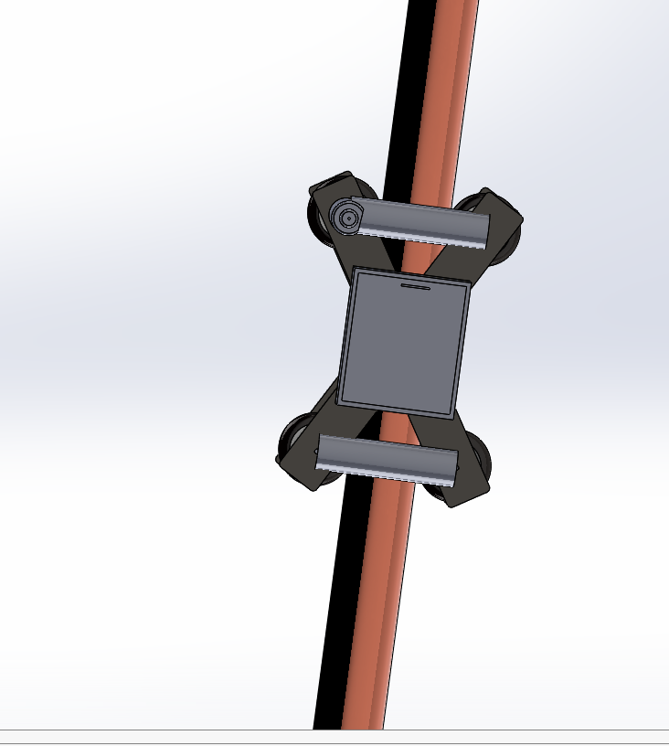

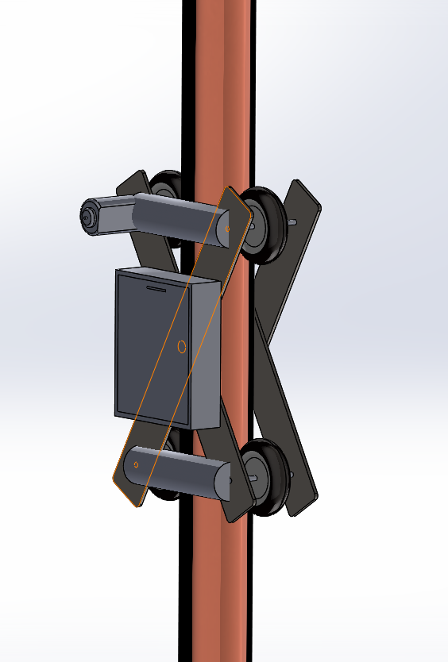

Team leadership and Integrated systems
Aim
This section of the report will discuss the final design of the chassis, any relevant calculations to support the design will also be added. This section will also include a breakdown of the costing for each section and the weight and discuss why the budget was split in the way that it was. A Gannt chart will be added to this section to show the dead line given to each task.
Planning and targets
In figure 1 a Gannt chart of the targets set by the group for the pipe crawler can be seen. Each target was set to make sure that the group stayed on track and made sure that deadlines were met.
It can be seen from the gannt chart the group is on target and meeting the set deadline. Most of the parts have been purchased, such as wiring, washers and batteries, also gears have not been purchased yet as the group is looking into whether it’s a possibility to have them 3d printed. Money from the budget has already be allocated for those parts so the overall cost does not go above £25.
Costing and weights
 | Integrated systems | Power generation and storage | Mechanical drive and propulsion | Control, Robustness and Reliability and  payload
Parts | Steel sheet  Screws | Motor  Batteries  Battery holder  wiring | Wheels  springs | Switches  Sponge base  Gears
Cost | £4.76 | £8.79 | £5.47 | £4.30
Weight | 355g | 200g | 28g | 255g
Table 1
Total cost £22.38
Total weight 838g
The total weight of the device is 338g heavier than first stated in the initial specification, the group decided that having a more stable reliable structure and more power would outweigh the benefits of the device being a lighter weight.
As can be seen from the table a larger amount of the budget was dedicated to power generation and storage is was because the group felt that having a more powerful motor and a larger battery capacity would be more beneficial for the device because it will allow the device to overcome the added weight and be easier to achieve the goal of the device being able to complete the set task of travelling up and down the pole in 30 seconds , this is due to the device needing to have a better power to weight ratio (Griffin, 2019). For example when looking at vehicles if you had two cars with a similar amount of BHP but one was heavier than the other the lighter car would have a better power to weight ratio which would mean the car would be able to accelerate quicker , for example a Bentley continental GT has 602 bhp power and a curb weight of 2414kg and a Nissan GTR Nismo has 592bhp and has a curb weight of 1736kg, the Bentley produces 248.96BHP/tonne and has an acceleration from 0-60 in 4.3 seconds and the Nissan produces 341.01BHP/tonne and has an acceleration from 0-60 in 2.5 seconds. (SKIPWORTH, 2016).

Chassis
As stated in the initial report the main material of the chassis was going to be stainless steel, but due to costing it was more beneficial to get a 200mm by 200mm sheet of mild steel with a thickness of 1.5mm. Originally steel mending plates were going to be used or Meccano , but it was decided that steel plate would be cheaper and more practical to use , as it can be cut into the exact sizes that are needed for device ,and the holes that are needed to attach the various parts to the chassis can be measured and drilled precise and accurate.
The group decided that it would be better to use steel of 1.5mm thickness rather than 0.75mm which was originally looked at when using stainless was an option but due to the strength to weight ratio of mild steel being considerably lower(Lewis, 2018) (figures can be seen in table 2 below).

Material | Tensile strength (MPa) | Density (g/cm^3) | Specific strength (kg/Nm)
Mild steel | 365 | 7.87 | 46.4
Stainless steel | 505 | 8.00 | 63.1
Table 2
Keeping the thickness at 0.75mm would of saved weight but having a stronger structure is more important so it can with stand higher power out puts if a second motor is needed, support a heavier payload and less likely to break during the testing period also the chassis will be under a lot of stress due to the device having a high co efficient of friction.
As can be seen from the CAD model of the device the steel plates will have drilled holes at the top of the device so the motor can slot in an directly drive the wheels so minimum power will be lost , on the CAD model it shows one motor , but if one motor isn’t powerful enough to drive the device the chassis will be able to accommodate a second motor which has already been purchased and deducted from the budget.

Power generation and storage

Great difficulties were had when it came to the selection of an appropriate motor for use in the pipe crawler. Of course, the cost was prohibitive - only having £25 for the whole build significantly restricted the pool of motors to choose from. After expenses for the other parts came out of the budget, it left little to deal with the motor and batteries. Given this situation, the collective opinion throughout the group was that two smaller, cheaper motors powering both of the top wheels (1 motor per wheel) of the proposed design would be a good way to overcome the potentially low-power of the very cheap solution. The motors running together in tandem at their maximum RPM (16500) will need a minimum of 12v (eBay, 2019). Since a single alkaline AA battery produces, on average, 1.5v (Lewis, 2017) – a minimum of 8 of these batteries would need to be used to keep the motors running at full power. Lithium batteries, while more dangerous than alkaline batteries due to their volatile nature (ThoughtCo., 2018), provide double the voltage of the alkaline alternative. Using these batteries, while increasing the risk of significant failure would also reduce the amount of batteries required to run the crawler at maximum RPM or would allow the machine to run for much longer by using a higher number of batteries. The use of nickel-based batteries in conjunction with alkaline ones is a viable alternative, since the nickel-based batteries can produce between 1.2 and 3.6 volts each depending on which model is chosen (Lewis, 2017). The use of them in conjunction with normal alkaline batteries will allow for higher voltages, meaning longer life for the machine running at max RPM, and lower cost since the nickel batteries are cheaper and less dangerous than Lithium ones and provide higher voltages than the alkaline ones they are being supplemented with.

Selection of a motor based on power output was difficult, since nowhere online provided any power figures at all for any of the motors that were short-listed. While no distinct power figures have been given for the chosen motor, it’s possible to use the RPM and voltage to calculate the voltage constant (Kv) and torque constant (Kt) (Stanford University, 2010). The Kv of a motor is calculated by dividing the given RPM by the voltage. In the case of the selected motor, 16500/6 giving a Kv of 2,750RPM per volt. Using this value, it’s possible to calculate the Kt, being 1355/(Kt). In this case, that gives the value 0.49 Newton Metres per amp. These figures serve only as estimates, since the internal resistances of the motors are not actually known values.

Mechanical drive and propulsion
The main points that had to be considered when looking into the mechanical drive and propulsion for the final design were: The tension of the springs, delivery of power to the wheels, Material of the wheels, overall weight and price. Having done various concept designs and plenty of research we came up with the final design. The following shows the thinking behind the decisions that were made for the mechanical drive and propulsion of the final design.
In the final design we have decided to go with an x frame coupled with four springs which will pull the frame towards the pipe. Therefore, these springs will be applying the normal force from the wheels to the pipe. The springs that we have purchased for this are extension springs from (Ashfield Springs Ltd, 2019) and will cost £0.54 each. They have an initial tension of 23.34N which mean that between the four of them there should be an initial tension of 93.36N. When we put these numbers into the formula F = N*u we end up with a frictional force of 74.69N. If we divide this number by the acceleration of gravity, we should get our theoretical value for the maximum mass that the device will be able to resist until gravity overcomes the frictional force. Therefore, the theoretical max load of the device is 7.61Kg. This meets our specification in which we stated that the device must lift a payload of at least 1Kg. The spring itself has an initial length of 25.4mm which means that it is shorter than the diameter of the pipe. This is important because the springs need to be constantly providing tension against the pipe and this can only happen if the springs themselves are shorter than the pipe diameter and therefore being stretched out across it.
The wheels that have been chosen are from (www.banggood.com, 2019). These wheels are originally designed for RC airplanes and are therefore very light weight which helps also meet our specification. The wheels are made of rubber which is the ideal material to apply the most friction against the pipe while still being cost affective. They have a diameter of 31mm and a width of 9mm. The wheels themselves weigh at around 2g each which means they will have a minimal effect on the overall weight of the device. They have an inner hole of 2.1mm and so therefore require an axel of the same diameter. However, if one cannot be bought or manufactured then we can always machine a larger hole into the wheel as it made from plastic. In total the wheels should cost £2.93 for a set of five wheels.
The wheels will be driven directly by the electric motor. This has been done to ensure that as little energy is lost through mechanical devices as possible. If we were to use cogs or belts, then there would be mechanical loss of energy and therefore the powertrain would not be as efficient as possible. By doing this we also make the design more cost effective as there is no need to buy extra parts for the power train, it also makes the design much simpler. A simpler design usually means that there are less things to go wrong and that it is easier to fix and maintain when required. We have decided to power one of the top wheels so that the device pulls itself up the pipe instead of pushing it up. This is as a result of the way the frame is mounted together. By pulling the device up we can use the force of the devices weight to stretch the frame out and therefore provide an additional normal force to the pipe. If the device were to push itself up, then the force of its weight would do the opposite effect.
One of the main advantages of this design is that most of the parts are pre-made by third party companies. This means that they can mass produce parts and are therefore able to sell them for less than it would cost to machine them ourselves. As a result of this not only have we reduced the overall cost but we have also been able to reduce the overall manufacturing time for the device.
Overall the mechanical drive and propulsion of the final design has accounted for £4.09 and less than 20g of the overall weight. Considering the importance of the components the fact that it has cost less than 20% of the overall budget shows that economically the device has been well designed. The final design also surpasses all the specifications defined by the product specification by a significant margin.

Control, Robustness and Reliability and payload

Payload
There were various ways a payload could be attached to the device it could be put on top, dead in the centre, either side or at the bottom of the device. The best way for our device is at the bottom. This is because at that point it would benefit the device. Because the device is a sort of “x” shape if we put the weight at the bottom of the device it would act as a sort of clamp and both the top and bottom wheel would have better grip because there is more of a force acting on the wheels. Whereas if the payload were on the sides it would do the opposite and increase the gap of the vertical distance between the two sides giving less grip for the wheel. If the device were put dead in the centre it wouldn’t benefit the device at all only adding more weight which is a bad thing therefore it would be a bit of a rash decision to put it there. Therefore, the most logical place to put the payload is at the bottom of the device where it would benefit the most. The next question is how it’s going to be attached. The device needs to be able to carry a chain up the 2000mm pipe. There are a few ways of being able to attach the chain to the device, one of which is to hook it. This would ensure that the chain would fall off at any point. The hook would be attached to the bottom of the device and then the chain attached to the hook, the hook would need to be attached in the dead centre to give equal sides more grip due to the weight of the chain.

Control
The control of the device is a very important aspect of the device, you need to have good control in order to keep the device moving in a controlled manor and also to look after the device, there are two measures of control on the device one of which is that there will be a sponge connected at the bottom of the pipe. The purpose of the sponge is to absorb any impact on the device should the device stop working and it fell down the pipe. It would protect it from any harm against the battery or motor or any of the connecting components. The main reasoning behind using sponge rather than anything else is because of its lightness and its ability to absorb impact. Sponge is also very cheap and very popular therefore meaning it would be easy to obtain and would barely impact our budget which is key. Another method of control is by using reverse and kill switches on the motors. A reverse switch will be put at the top of the device attached to the motor and when the device gets to the top it will essentially reverse the motor and drive the wheels down the pipe in a controlled manor. The cost of the reverse switches varies from around £1-£20 (eBay) but the more expensive ones being for bigger motors and bigger devices. There would then be a kill switch fitted to the bottom of the device to kill the motor to stop it driving the wheels downwards possibly braking the device if not fitted. The prices of a kill switch vary from around £1-£15 (cpc) similar to the reverse switches.

Robustness & Reliability
The device should be robust enough for this project it has a steel cross section area to which the wheel and other components are fixed. This should make the device strong and robust. With the sponge at the bottom protecting the device and its components it does help give the device vital protection and ultimately a more robust feel. The sponge also gives the device the best reliability because it’s almost impossible for a sponge not to work because it’s a sponge. The reliability is also a very important aspect of the device, there are rubber wheels going to be fitted to give the best grip possible and are highly unlikely to slip when in contact with the pipe which makes it very reliably. The best way to make the device as reliable as possible is to keep it simple and that was the main objective. The materials and components chosen were just what was needed nothing more would be added because this would mean more could go wrong on the device. Another reliability aspect is the reverse and kill switches because they make sure that the device doesn’t drive the wheels into the ground/roof which could possibly brake the device. These switches guarantee that this won’t happen at all.

Conclusion
This report has highlighted the progress the group has made towards a successful final design and indicates the group’s readiness to build and test a prototype.

References
Griffin, K. (2019, 02). Here's what a power-to-weight ratio means for car buyers. Retrieved from Motor 1: https://www.motor1.com/news/76305/heres-what-a-power-to-weight-ratio-means-for-car-buyers/
SKIPWORTH, H. (2016, august). Bentley Continental GT review - performance and luxury from grand tourer. Retrieved from Evo: ttps://www.evo.co.uk
Lewis, P. (2018, march). How to Calculate a Weight-to-Strength Ratio. Retrieved from sciencing.com: https://sciencing.com/calculate-weight-strength-ratio-8114466.htm
Ashfield Springs Ltd. (2019). The UK's leading extension spring manufacturers and suppliers of extension springs.[online] Available at: https://www.ashfield-springs.com/extension-springs
www.banggood.com. (2019). Rubber Wheel For RC Airplane And DIY Robot Tires. [online] Available at: https://uk.banggood.com/Rubber-Wheel-For-RC-Airplane-And-DIY-Robot-Tires-p-80649.html?gmcCountry=GB&currency=GBP&createTmp=1&utm_source=googleshopping&utm_medium=cpc_bgcs&utm_content=garman&utm_campaign=pla-gbg-toy-brand-pc&ID=48236&cur_warehouse=CN [Accessed 7 Feb. 2019].
eBay. (2019). [online] Available at: https://www.ebay.co.uk/bhp/motor-reversing-switch [Accessed 10 Feb. 2019]. https://www.ebay.co.uk/bhp/motor-reversing-switch
Combined precision components. (2019). Miniature Push Button Switch, Red, Momentary, SPST, Off-(On), 125V, 1A - PPW01082. [online] Available at: https://cpc.farnell.com/pro-power/ppw01082/switch-pb-mini-no-mom-red/dp/SW03239?mckv=5FD3JtCC_dc|pcrid|75110407246036|kword||match||plid||slid||pid|SW03239|&CMP=KNC-MUK-CPC-SHOPPING-M-450-Shopping-Electronic+and+Electrical+Components-Switches%2C+Relays+%26+Solenoids&msclkid=b88af020b6db1fa40128ac40c361cc1b&utm_source=bing&utm_medium=cpc&utm_campaign=M-450-Shopping-Electronic%20and%20Electrical%20Components&utm_term=4578710019920212&utm_content=Switches,%20Relays%20%26%20Solenoids [Accessed 10 Feb. 2019].
https://cpc.farnell.com/pro-power/ppw01082/switch-pb-mini-no-mom-red/dp/SW03239?mckv=5FD3JtCC_dc|pcrid|75110407246036|kword||match||plid||slid||pid|SW03239|&CMP=KNC-MUK-CPC-SHOPPING-M-450-Shopping-Electronic+and+Electrical+Components-Switches%2C+Relays+%26+Solenoids&msclkid=b88af020b6db1fa40128ac40c361cc1b&utm_source=bing&utm_medium=cpc&utm_campaign=M-450-Shopping-Electronic%20and%20Electrical%20Components&utm_term=4578710019920212&utm_content=Switches,%20Relays%20%26%20Solenoids

