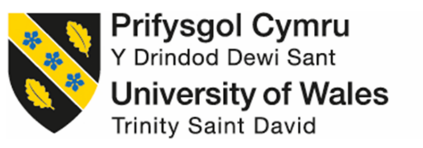

‘How has the approach of architects developed or changed to climate change over the last 25 years?’

School of Architecture, Built and Natural Environment

Course: BSc Architecture

Name: Iestyn Bentley

Student Number: 1900945

Module Code: ACAA6003

Word Count:

Author’s declaration

I declare that the work in this dissertation was carried out in accordance with the regulations of the University of Wales, Trinity Saint David. The work is original except where indicated by special references in the text and no part of the dissertation has been submitted for any other degree.

Any views expressed in the dissertation are those of the author and in no way represent those of the University of Wales, Trinity Saint David.

The dissertation has not been presented to any other University for examination either in the United Kingdom or overseas.

I hereby give permission for my work, if accepted, to be available for photocopying and inter-library loan, and for the title and summary to be made available to outside organisations.

Signed: Iestyn Rhys Bentley

Date: 11/04/2023

Copyright statement

The copyright of this dissertation rest with the University of Wales, Trinity Saint David. No information derived from this dissertation shall be published without the prior written consent of the University.

Signed: Iestyn Rhys Bentley

Date: 11/04/2023

Abstract

When the Royal Institute of British Architects (RIBA) declared on 27 June 2019 that there was a “environment and climate emergency”, qualified architects have approached the issue in differing ways. This thesis addresses the response to the environment and climate emergency through an in-depth study of architectural developments that are deemed as sustainable, and examines how treaties have developed legislative steps for future architects to design sustainable buildings. The planet’s average surface temperature has risen by approximately 1°C since the late 19th century, a change driven primarily by the increased carbon dioxide emissions into the atmosphere and a number of other human activities, including the architecture industry and the built environment, which are responsible for 40% of global carbon emissions. It is clear that architects have a role to play in limiting the further exacerbation of the climate change.

Four methods of research were employed: academic books, online articles, journals, newspapers and magazines research, official statistical analysis, in depth case study analysis and interviews with key individuals. The first chapter of this dissertation explored the climate crisis and how legislation such as the Paris Agreement were written to combat this issue, and also considers how architects were already combatting the emergency through certification such as BREEAM. The next four chapters explore a range of differing sustainable architectural developments: the second chapter explores the approach to sustainable residential architecture, the third chapter explores an industrial sustainable development, the fourth chapter looks at a commercially sustainable building, and the fifth chapter explores a modern sustainable building that has been designed with a lifespan of 400 years.

Architectural developments such as the innovative Beddington Zero Energy Development (BedZED) and the Enterprise Centre in Norwich will be discussed in this work. Both of these exemplar projects both exemplar in sustainable architecture have a more orthodox approach to sustainable design, through sustainable construction, materiality, technologies and overall principles. BedZED being one of the first sustainable housing developments in the UK, and the Enterprise Centre dubbed by the press as the “greenest building in the UK”. The other case studies discussed in this work: CopenHill and The New Library take a more unorthodox approach to sustainable design. Copenhill is a waste-to-energy plant that doubles as public infrastructure, the plant produces enough electricity to power 30,000 homes and heating for 72,000 homes across Copenhagen. The New Library takes advantage of natural lighting and ventilation while minimising the dependence on energy-consuming appliances and systems.
Acknowledgements

Firstly, I would like to thank my dissertation tutors, Ian Standen and Dr Elizabeth Walder, for their knowledge, guidance, and overall support through this process.

I would also like to personally thank Pooran Desai, who was kind enough to have a thirty-minute meeting with me to discuss the sustainable principles of the Beddington Zero Energy Development, which he, being co-founder of BioRegional, had a massive role in.

I would also like to thank Christian Dimbleby of Architype, and Bryony Jones of Níall McLaughlin Architects. Even though I couldn’t converse with the relevant people from both practices, they were kind enough to send me the necessary information on both case studies, The Enterprise Centre by Architype and The New Library by Níall McLaughlin Architects.

Finally, I would like to thank my parents, for being extremely supportive throughout this process, without them bringing me endless cups of tea, I don’t think I would have had the energy to complete the body of work.

Table of Contents
PAGE NO.

2.

3.

4.

5.

6.

7.

12.

17.

25.

32.

39.

46.

0.

0.

0.

Author’s Declaration……………………………………………………………………………….

Copyright statement……………………………………………………………………………….

Abstract……………………………………………………………………………………………..

Acknowledgements………………………………………………………………………………..

List of Illustrations………………………………………………………………………………….

Introduction……………………………………………………………………………………….

Chapter 1: The Climate Crisis………………………………………………………………..

Chapter 2: The Residential Approach………………………………………………………

Chapter 3: The Industrial Approach…………………………………………………………

Chapter 4: The Commercial Approach…………………………………………………….

Chapter 5: The Modern Approach…………………………………………………………..

Conclusion………………………………………………………………………………………

Bibliography: Published Works

Bibliography: Unpublished Works

Appendix A: Questionnaire for Pooran Desai, BioRegional Development Group

List of illustrations

PAGE NO.

13.

16.

18.

19.

19.

20.

21.

21.

21.

22.

23.

24.

25.

26.

27.

28.

28.

30.

31.

32.

Chapter 1: The Climate Crisis

Figure 1: A city showing the effect of Climate Change………………………………………

Figure 2: Ostro Passivhaus by Paper Igloo…………………………………………………..

Chapter 2: The Residential Approach

Figure 3: Aerial view of BedZED……………………………………………………………….

Figure 4: South facing conservatories at BedZED…………………………………………...

Figure 5: BedZED’s iconic wind cowls…………………………………………………………

Figure 6: BedZED's reclaimed structural steel………………………………………………..

Figure 7: Access bridge at BedZED……………………………………………………………

Figure 8: Roof garden on one of the BedZED units………………………………………….

Figure 9: Side street at BedZED……………………………………………………………….

Figure 10: Section through a BedZED unit showing the CHP………………………………

Figure 11: The external wall makeup of a unit at BedZED………………………………….

Figure 12: BedZED, a thriving sustainable housing community……………………………

Figure 13: The village square at BedZED…………………………………………………….

Chapter 3: The Industrial Approach

Figure 14: Aerial view of Copenhill…………………………………………………………….

Figure 15: A waste-to-energy plant that doubles as a ski slope……………………………

Figure 16: CopenHill’s façade and climbing wall…………………………………………….

Figure 17: Steam from the plant is emitted from the tall chimney………………………….

Figure 18: Inside the garbage burning Amager Bakke……………………………………

Figure 19: Machinery that is positioned in height order……………………………………..

Figure 20: Aerial view, showing the rooftop biodiverse garden…………………………….

Chapter 4: The Commercial Approach
PAGE NO.

33.

34.

35.

35.

36.

38.

40.

41.

42.

43.

44.

45.

Figure 21: Aerial view of The Enterprise Centre……………………………………………...

Figure 22: Plan of The Enterprise Centre……………………………………………………..

Figure 23: The surrounding landscape of The Enterprise Centre………………………….

Figure 24: A thatch and reed façade………………………………………………………….

Figure 25: A glulam frame sitting on top of a sustainable concrete deck………………….

Figure 26: Roof mounted photovoltaics panels………………………………………………

Chapter 5: The Modern Approach

Figure 27: The New Library settled in the historic setting…………………………………...

Figure 28: A network of interconnecting rooms………………………………………………

Figure 29: The Pepys Library sits just to the south of The New Library…………………..

Figure 30: Bespoke bricks, matching the aesthetic of neighbouring buildings……………

Figure 31: Façade elevation, showing the timber tracery and brick chimneys……………

Figure 32: Load-bearing brick vertical structures and spanning CLT………………………

Introduction

The defining concern in 2023 is climate change, the present global warming trend is important as the majority of the warming is the result of human activities since the mid-19th century (Shaftel, 2023a). The planets temperature is consistently rising, according to a continuing temperature investigation operated by scientists at NASA’s GISS. The average global temperature since 1880 has increased by roughly 1°C. Since 1975 two-thirds of the earth’s global warming has occurred, this a rate of approximately 0.15-0.20°C per decade (Shaftel, 2023b).

The architecture industry and the built environment are responsible for 40% of global carbon emissions, through processes like the production of cement, greenfield development and the burning of fossil fuels such as coal, oil and gas (Cramer, 2017).

The Royal Institute of British Architects (RIBA) declared on 27 June 2019 that there is a “environment and climate emergency”. It was agreed that architects could “play a part in saving society from collapse”. The RIBA has developed voluntary performance targets for operative energy use, water use and the embodied carbon of architecture. The RIBA 2030 Climate Challenge provides a stepped approach for RIBA Chartered Practices to aim towards achieving net zero (RIBA, 2019). Other ambitious actions have been set out to combat climate change and the constant rise of temperature, such as The Paris Agreement, the main aim of the agreement is to limit the global temperature rise to 1.5°C (United Nations, 2023).

Sustainable architecture developments are already being developed in accordance with certifications such as BREEAM, which is a third-party certified standard that is used by designers to measure the sustainability performance of a building (BRE Group, 2023a). BREEAM inspires architects to constantly improve their approach towards sustainable design, to constantly innovate and make effective use of resources (BRE Group, 2023b). Othe certifications include the Passivhaus Trust, this provides a range of approaches to architects when delivering net zero buildings, designed for a decarbonised grid and the prioritisation of occupant health and wellbeing (Passivhaus Trust, 2021).

Methodology

In researching material for this dissertation, I engaged in four different approaches:

- Academic books, online articles, journals, newspapers and magazines
- Official statistical analysis
- In depth case study analysis
- Interview with key individuals

- Academic books, online articles, journals, newspapers and magazines

Through the literature research, the researcher used academic books, online articles, journals and magazines. These forms of research were used to gain further knowledge on the topic. Books, articles and journals were also used to deepen the researchers’ knowledge on sustainability in architecture and the current climate crisis.

- Official statistical analysis

Official scientific and governmental statistics were used when discussing the current climate crisis and the ever-growing issue of global warming. Statistics and measurements were also used when the researcher discussed the performance of selected case studies, further discussing the approach of architects to climate change.

- In depth case study analysis

In depth case study analysis has enabled the author to compare four very differing case studies, all recognised as examples of good sustainable schemes from different sectors of architecture.

- Interviews with key individuals

Key people were interviewed as part of the research, including Co-founder of award-winning environmental organisation BioRegional Development Group Pooran Desai. Desai was extremely helpful because of his direct involvement in the design and development of the Beddington Zero Energy Development (BedZED), including first-hand experience of living in a sustainable development and observing on site wellbeing strategies, as he was a resident at BedZED for approximately 18 years.

The complete list of questions is included in Appendix A of this dissertation.

Aims and Objectives

The main aim of this dissertation is to:
- Identify the climate crisis and find out how the approach of architects and how sustainable architecture has developed in response to climate change.

The dissertation will address the following objectives, to:

- Identify the current climate crisis, discussing the on-going rise of the planet’s temperature.
- Assess how buildings can impact the climate, and how treaties like ‘The Paris Agreement’ plan on combatting this issue.
- Compare, review, and analyse differing exemplar sustainable architectural developments.
- Interview key individuals about how they are incorporating sustainable energy, construction, materiality, and design into their work.

Introduction of case studies

In this dissertation the author will be analysing and comparing four differing case studies, with each building selected due to their sustainable credentials in their architectural sector. The first building is the Beddington Zero Energy Development (BedZED), Hackbridge, South London. The housing development consists of 82 mixed tenure residential homes, all of them incorporating innovative approaches to energy conservation and sustainable architecture. Secondly is CopenHill, a sustainable waste-to-energy plant located on the industrial waterfront of Amager, Copenhagen. Thirdly, the Enterprise Centre, Norwich. A university building that aims to encourage new sustainable businesses that emerge from The University of East Anglia’s (UEA) while demonstrating exemplary low-carbon architecture and sustainable principles (Passivhaus Trust, 2016). Finally, the author will analyse The New Library at Magdalene College, Cambridge. A building provides students at the 700-year-old University of Cambridge campus with a purpose-built library that will last at least 400 years (Jennings, 2022).

Literature Review

Within the literature review, the author has used a number of press statements announcing awards won by the selected case studies, also including interviews from the project directors responsible for each project. In addition to this discussion, thorough analysis of articles in online architectural journals, highlighting the sustainable approach and principles of the chosen case studies will be undertaken. Several official scientific statistics were also used, to investigate and discuss the climate crisis and the continuing issue of global warming. The author has also spoken with key individuals involved with sustainable design. These have given the author the ability to construct this thesis, addressing the issue at hand, and comparing existing approaches that seek to reduce said issue.

Significant publications to which the author referred from within the literature review include those which refer to the chosen case studies for comparative study, such as Schoon’s publication about The BedZED Story (2017), this document was supplemented by the interview with which furthered knowledge of the development. Another informative source was Jacob Littman’s unpublished Masters Theses from the University of Massachusetts Amherst, which discussed Regenerative Architecture and how it could be a path beyond sustainability.

Chapter 1: The Climate Crisis

Climate change is one of the most convoluted issues facing us as a society today. It involves many differing dimensions, including; economic, science, politics, society, and moral and ethical questions. The issues that climate change presents are worldwide, which are also felt on local scales affecting the way we live for many years. The basic premise of climate change and global warming is carbon dioxide, a heat-trapping greenhouse gas that is the primary driver of the recent issues (Shaftel, 2023a). Continuing investigation lead by scientists at NASA’s GISS shows that the planet’s current warming trend is clearly a result of human activity since the mid-1800s and is continuing to rise at a rate unforeseen over recent millennia (Shaftel, 2023b). The planet’s average surface temperature has risen by approximately 1°C since the late 19th century, a change driven primarily by the increased carbon dioxide emissions into the atmosphere and a number of other human activities (Earth Observatory, 2022). According to the Intergovernmental Panel on Climate Change "Since systematic scientific assessments began in the 1970s, the influence of human activity on the warming of the climate system has evolved from theory to established fact" (Somerville, 2007). Most of this rise in temperature has occurred over the past 40 years, with the Earth’s warmest global average surface temperature being in both 2020 and 2016, when the temperature was 1.02°C. Since 1975 two-thirds of the earth’s global warming has occurred, at a rate of approximately 0.15-0.20°C per decade (Shaftel, 2023c).

Figure 1: A city showing the effect of Climate Change (Photo credit: B. Goode)

It is commonly recognised in the architecture industry that the built environment is responsible for 40% of global carbon emissions (The Climate Group, 2023). Buildings are responsible for emitting nearly 50% of the carbon dioxide, through greenfield development, the production of concrete/cement, and the constant consumption of fossil fuels (Cramer, 2017). Building emissions are typically measured as a combination of two factors:
- Day-to-day energy usage, known as the ‘operational carbon emissions’, which come from powering, lighting and heating a building.
- The ‘embodied carbon of a building’, this is the carbon generated through the manufacturing of building materials, the transportation of said materials to sites, and the erection and construction of the actual buildings (Budds, 2019). The embodied carbon of a building, accounts for approximately 25% of a building’s total lifecycle carbon emissions. Globally, the embodied carbon of a building accounts for about 11% of emissions (World GBC, 2019).

How can architects limit the further exacerbation of climate change?

Responding to climate change involves two different approaches, reducing emissions of and stabilising greenhouse gases, is commonly referred to as ‘mitigation’. The second approach is adapting to the recent change in climate, known as ‘adaptation’ (Shaftel, 2023a). The climate crisis demands crucial actions and leadership by both the architecture sector and the wider construction industry. In 2019 the UK Government passed a law that requires the end of its contribution to global warming by 2050, thereby reducing all greenhouse gas emissions to a net zero. The Royal Institute of British Architects (RIBA) declared on the 27th June 2019 that there is a “environment and climate emergency”. The RIBA are committed to developing a five-year plan to back the establishment of zero carbon buildings, it was agreed that architects could “play a part in saving society from collapse” (RIBA, 2019). The challenge that faces architects is to extend good sustainable practice to all future schemes. The RIBA has developed voluntary performance targets for operative energy use, water use and the embodied carbon of architecture. The RIBA 2030 Climate Challenge provides a stepped approach for RIBA Chartered Practices to aim towards achieving net zero. The RIBA has set architects the challenge of achieving the following reductions urgently; reduce the operational energy demand by at least 60%, reduce the embodied carbon of building by at least 40%, reduce potable water use by 40% and achieve all core health and wellbeing metrics (RIBA, 2021).

Health and wellbeing metric
Overheading | 25-28°C maximum for 1% of occupied hours.
Daylighting | > 2% average daylight factor, 0.4 uniformity
CO₂ levels | < 900ppm
Total VOCs | < 0.3mg/m³
Formaldehyde | < 0.1mg/m³

Other actions include The Paris Agreement, a legally binding international treaty on climate change. Adopted by 196 parties at the UN Climate Change Conference (COP21) in Paris, France, the main goal of the treaty was to limit the temperature increase to 1.5°C above pre-industrial levels (United Nations, 2023). The Paris Agreement is a landmark in the climate change process because the legally binding agreements collaborated all nations together to approach climate change and adapt. “Over the next 40 years, the world is expected to build 230 billion square metres in new construction – adding the equivalent of Paris to the planet every single week,” said Fatih Birol, Executive Director of the International Energy Agency (United Nations, 2017). The energy intensity of the built environment is improving by approximately 1.5% annually, however, the amount of buildings being constructed is exponentially increasing – the global floor area grows by roughly 2.3% per year. It is clear that architects must act now, designing schemes that limit the further exacerbation of the climate change (Architecture 2030, 2018).

How are architects already reducing carbon emissions?

Leaders in sustainable architecture are already developing ways to reduce carbon emissions and limit the impact of the climate crisis. Schemes are being developed in accordance with programs and certifications such as BREEAM, a third-party certified standard that is used to specify and measure the sustainability performance of buildings (BRE Group, 2023a) and was first published in 1990. BREAAM ensures that architectural schemes meet sustainable goals and continue to perform optimally for years to come. BREEAM assessments are set against well-established benchmarks, which measure a building’s specification, construction, use and design. These measurements use a range of differing criteria, from energy to ecology, each of which focuses on influential factors. These include reduced carbon emissions, low impact design, ecological merit, biodiversity and most importantly the adaptation towards climate change (McPartland, 2016). Introducing sustainable measures at the conceptual level of a project using the BREEAM framework facilitates reduced life cycle costs. The framework also allows a client to compare a building’s sustainable performance with other BREEAM rated buildings. The specific focus on sustainable values makes BREEAM rated schemes attractive property investments and it generates sustainable communities that promote the wellbeing of the occupants that live and work in them. BREEAM is part of The Code for Sustainable Environment (The Code), which consists of a set of strategic principles that define a coherent approach to the construction, evaluation, certification and design of the environmental, economic, and social aspects of the built environment. BREEAM inspires architects to constantly improve in terms of sustainable design, innovate and make effective use of resources (BRE Group, 2023b).

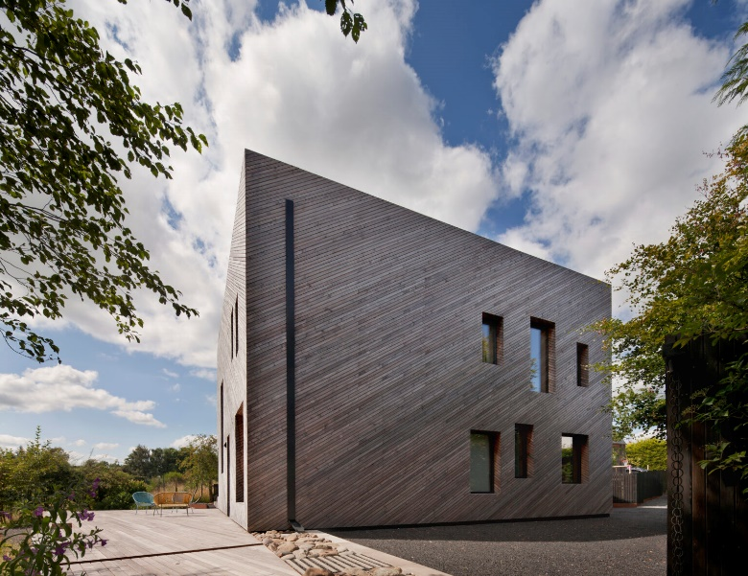
Figure 2: Ostro Passivhaus by Paper Igloo (Photo Credit: D. Barbour)
Other solutions are being adopted by architects, such as the Passivhaus approach. Passivhaus provides a range of solutions to delivering net zero buildings, designed for a decarbonised grid and the prioritisation of occupant health and wellbeing. Passivhaus buildings deliver a high level of comfort using low energy principles for heating and cooling of spaces (Green Building Store, 2023). They adopt a holistic approach with clear targets, focusing on high-quality construction, through a quality assurance process. Passivhaus certified buildings differ from other carbon neutral buildings that use a combination of energy efficient and clean energy generation, a Passivhaus buildings utilise lower amounts of energy due to their highly sealed nature. Construction includes; far greater levels of insulation than typical UK developments, triple glazed windows with insulated frames, impressive airtightness levels (20 times more than a typical build) and mechanical ventilation. To achieve the Passivhaus standard of building involves rigorous designing using the Passive House Planning Package, which is a design tool produced by Passivhaus to aid architects when designing this style of housing (Energy Saving Trust, 2022).

Chapter 2: The Residential Approach

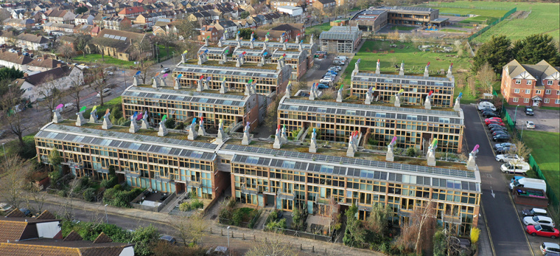
Figure 3: Aerial shot of BedZED (Photo credit: D. Fu)
Beddington Zero Energy Development, more commonly known as BedZED, is a mixed-use sustainable community in the heart of Hackbridge, south London. A blueprint for architects wanting to build eco-friendly dwellings, the housing development consists of 82 mixed tenure residential homes, all of them incorporating innovative approaches to energy conservation and sustainable architecture.

Apart from providing residential units, the BedZED provides live-work, commercial and most importantly, communal facilities. A child-care facility unit, a doctor’s surgery, living centre and café are also included on site, all of these elements further reinforcing the development’s community (Salat, 2021).

The idea for the zero-carbon housing community was first conceptualized in 1997, when the sustainability charity BioRegional and sustainable architect Bill Dunster learnt that the London Borough of Sutton were selling a brownfield site previously used for the spreading of sewage for a housing development near Beddington Farmlands. Completed in 2002, the project was led by the housing association Peabody Trust, in partnership with architectural practice Bill Dunster Architects and sustainability consultants, BioRegional (Schoon, 2016).

The buildings at BedZED allow occupants to live a sustainable life, within their share of the planet’s renewable resources, without surrendering a modern, urban, and flexible way of life. BedZED enables an easier sustainable lifestyle, which is engaging and most importantly, affordable (Lazarus, 2009).

The importance of sustainable materiality and construction
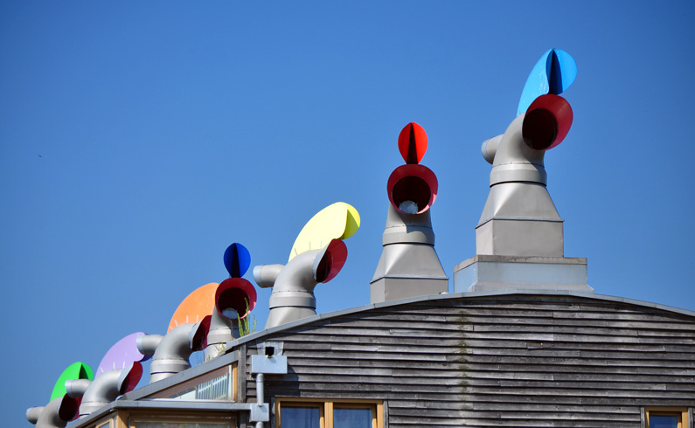
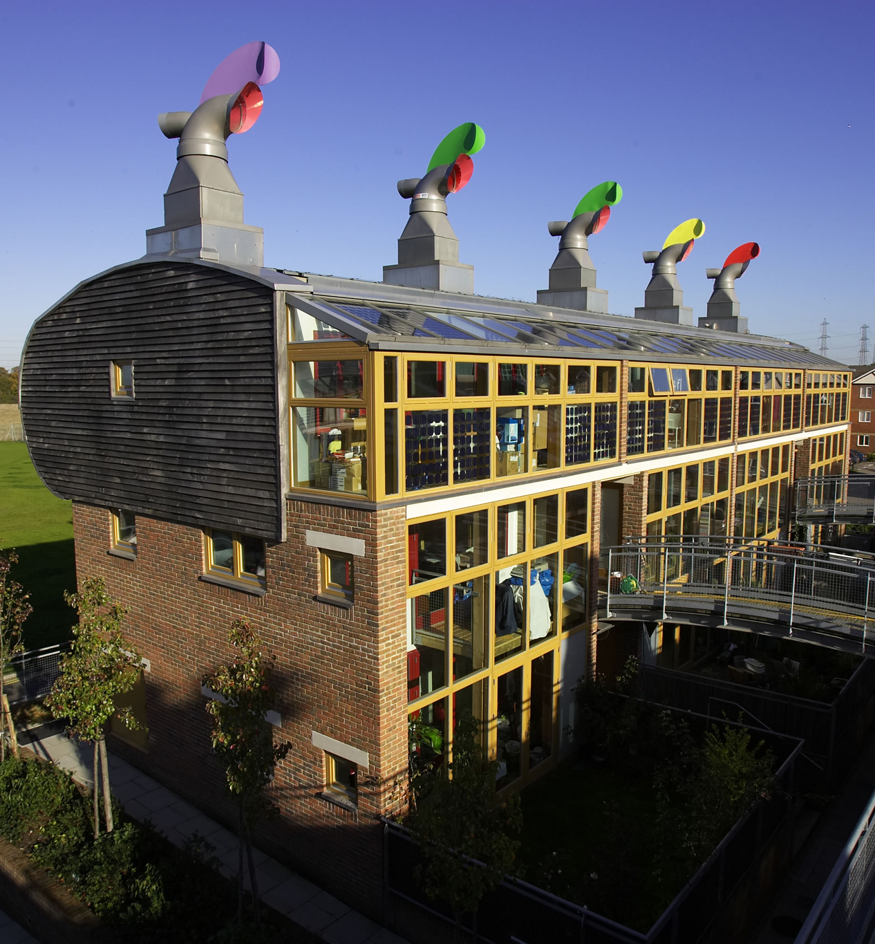
Figure 4: South facing conservatories at BedZED (Photo Credit: M. Lyon)
Figure 5: BedZED’s iconic wind cowls
(Photo credit: G. Rex)

All aspects of the material and construction of BedZED were considered during the design phase, in terms of the environmental impact and carbon footprint. Materials used in the development were specifically selected for their low environmental impact, being sourced locally when possible, and using reclaimed and recycled materials where possible. In an interview, the founder of BioRegional Pooran Desai, said “the culture of place is very import and we’ve lost that as we use and bring in materials from all over the place” (Desai, 2023). The external envelope of the dwelling is defined by the locally sourced green oak weatherboard. Although these boards are more expensive than commonly used softwoods, the maintenance savings to the Peabody Trust over the lifetime of the buildings has justified the extra cost. The familiar warm red bricks of BedZED were also sourced locally, from a brickworks just 20 miles away, maintaining the local vernacular. The development is finally defined by its iconic wind cowls which deliver preheated fresh air to each home and extract its vitiated air, these differing, yet innovative design elements are a demonstration and testament of Bill Dunster’s eye for detail (Schoon, 2016).

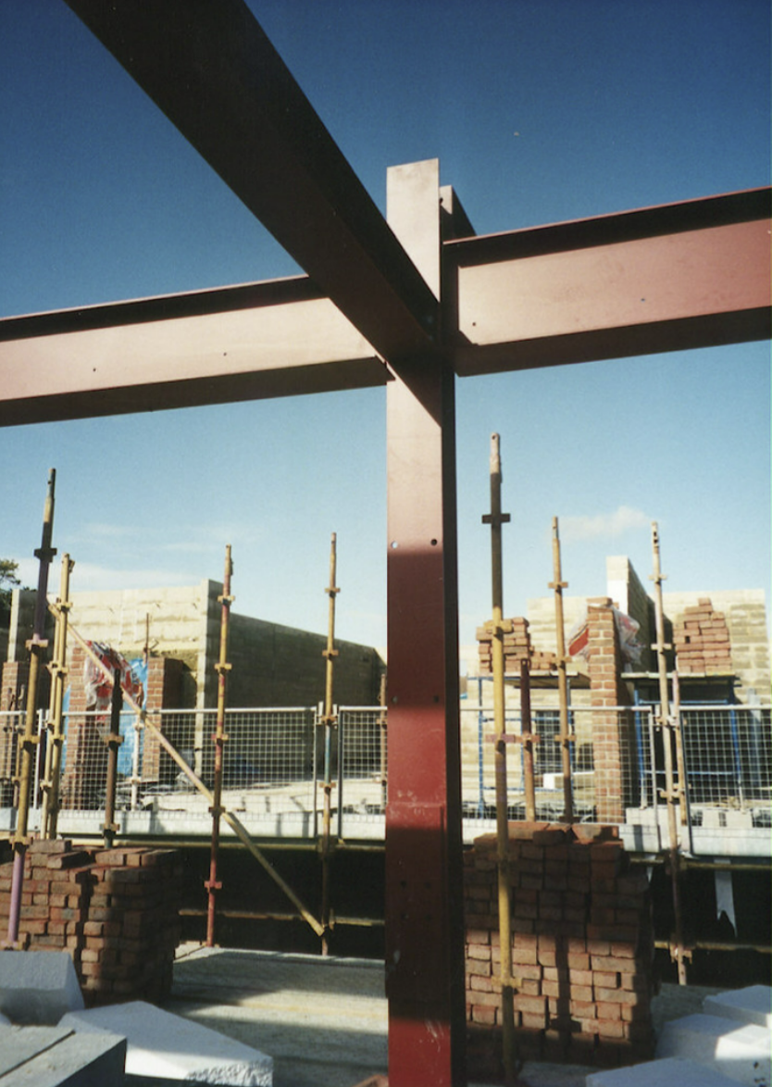
Figure 6: BedZED's reclaimed structural steel (Photo credit: BioRegional)
In 2016, construction and demolition were responsible for approximately 60 million tonnes of waste in the UK (Adams, 2020). As previously stated, reclamation of materials was important when constructing the housing development, 15% of all the materials used were either reclaimed or recycled. The vast majority of the steel used in the building frames is reused, much of it coming from refurbishment work at the Brighton Railway Station completed by BioRegional (Lazarus, 2009).

The 82-home development was expected to cost £14.168m, but the overall cost of the scheme ended up costing £24.821m. Visionary urbanist Dickon Robinson, Peabody Trust’s group development director, said that "The final [£24m] figure is an estimate of our maximum total liabilities. This includes land, staff time and the cost of the money borrowed to pay for the scheme" (Macdonald, 2004).

Sustainable approach and principles

It is commonly known throughout the architecture industry that the built environment is responsible for 40% of global carbon emissions (The Climate Group, 2023). The concept of sustainable architecture transpired as a means to combat climate change, the numerous ways of creating sustainable architecture aim no higher than making buildings and environments that produce less carbon. However, the issue with this statement is that some examples of “sustainable architecture” just ‘sustain’ (Littman, 2009).

BedZED embodies the notion of ‘regenerative design’. In the natural environment, regeneration refers to the ability to renew, restore or grow tissues in organisms and ecosystems in accordance with natural fluctuations (NIGMS, 2020). However, regenerative architecture is the practice of engaging the natural environment as the initiator and premise of the architecture. Regenerative architecture responds to the living and natural systems that exist on a site, which then become the ‘building blocks’ of said architecture (Littman, 2009). Desai believes that there are three things regenerative design must do; it must promote the health of people, it must promote the health of communities, and it must promote the health of the planet. Desai also believes that “it’s not enough now to just be sustainable because we have destroyed half of all life on planet earth” and went on to comment that “if we want a habitable planet in 30 years, we are going to have to change everything we do including how we approach architecture” (Desai, 2023). Regenerative architecture demands a forward-thinking approach, and it is obvious that BedZED certainly accomplished this aim.

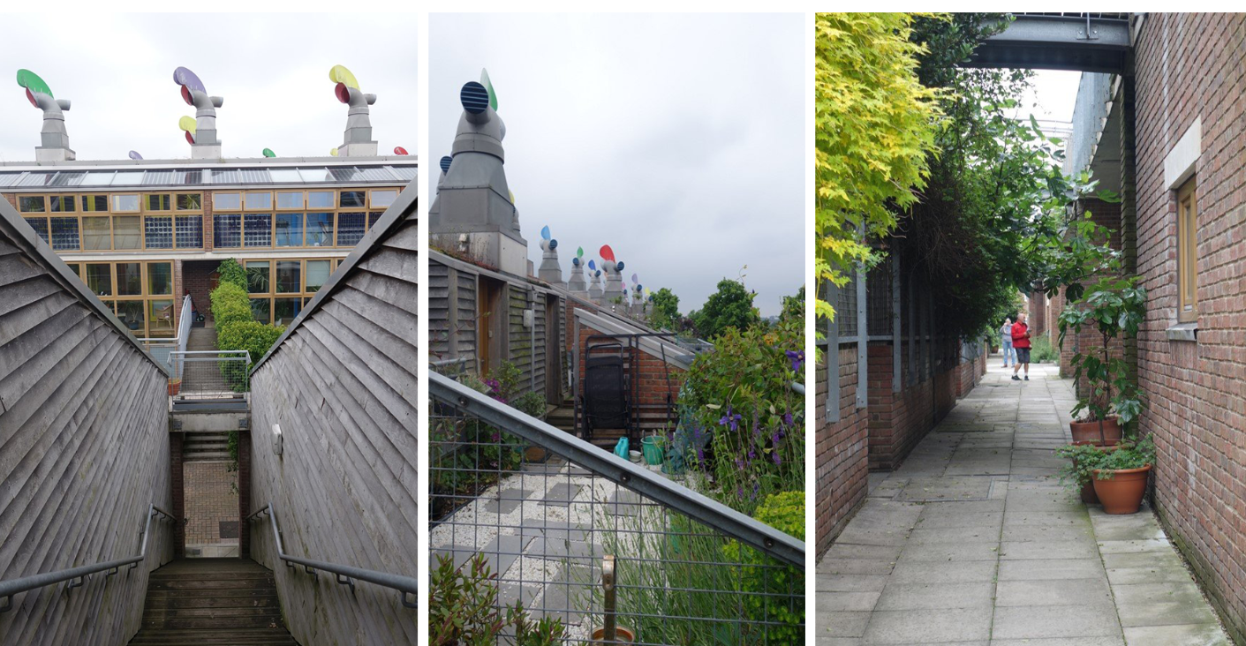
Figure 7: Access bridge at BedZED (Photo credit: F. Labbé) | Figure 8: Roof garden on one of the BedZED units (Photo credit: F. Labbé) | Figure 9: Side street at BedZED (Photo credit: F. Labbé)

Residential household energy usage is responsible for 29% of the UK carbon dioxide emissions. BedZED challenges the traditional approach to residential architecture by accomplishing sustainability in every aspect. BedZED employs innovative energy efficiency and was designed to be free of fossil-fuel consumption upon completion, entirely reducing its occupants’ emissions of climate-changing carbon dioxide and providing them with energy security. The plan to achieve this was by developing a Passive house approach (Hodge, 2009). BedZED utilises water efficient appliances, such as dual flush toilets, which at the time of design was extremely innovative and forward thinking.
The development’s main source of electricity and heat was generated by using a wood-burning Combined Heat and Power Plant (CHP), waste heat from electricity gained was used to provide hot water to the occupants. However, the CHP was removed due to the frequent need for service and maintenance and has been replaced by a biomass boiler, which burned wood pellets, an almost zero-carbon fuel. Electricity purchased for BedZED is on a green tariff, which means that all power consumption is matched to generation by zero-carbon wind turbines and hydro power projects by Renewable Energy Guarantee of Origin certificates (Schoon, 2016). Energy generation is also reinforced with a further 777m² of high-efficiency Photovoltaic (PV) panels, these are integrated into the sunspace roofs.
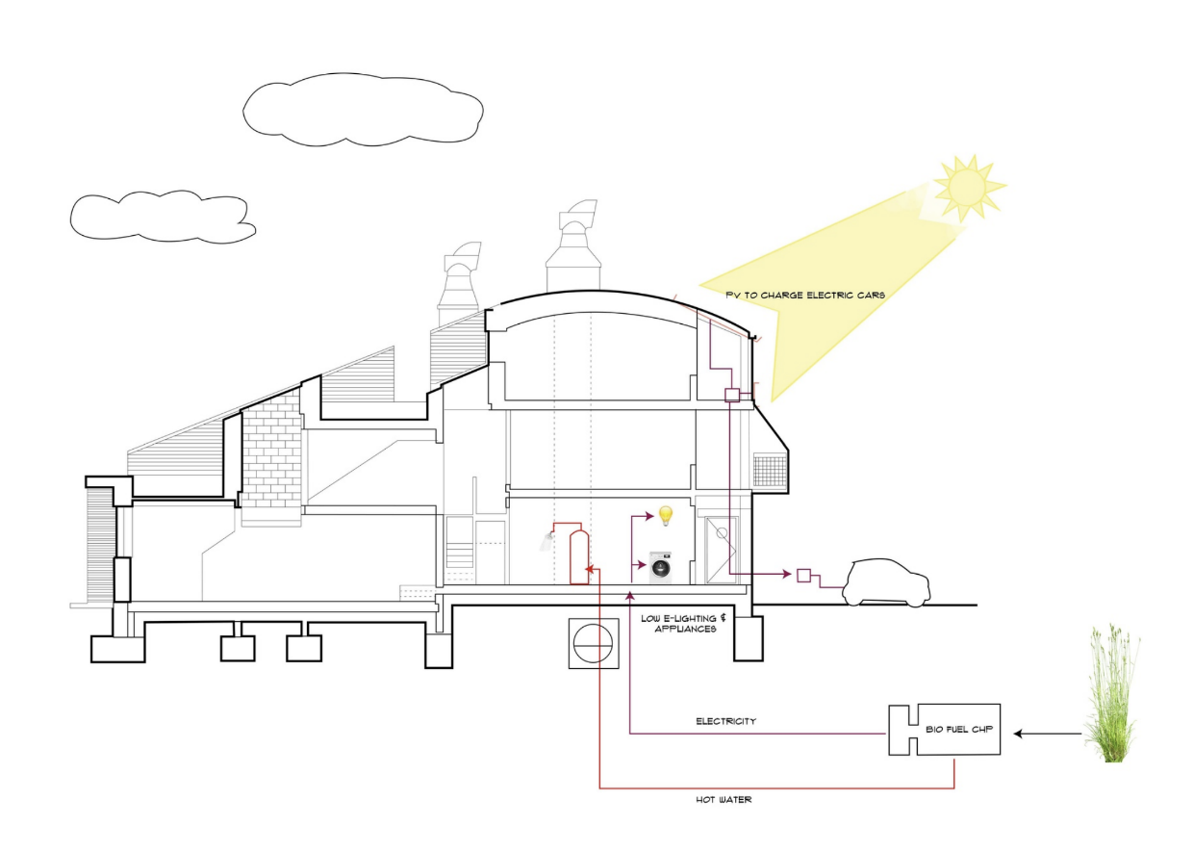
Figure 10: Section through a BedZED unit showing the CHP (Photo credit: R. Riddle)

Insulation levels at BedZED are greater than those required by mandatory building standards at the time of construction (Hodge, 2009). External walls were provided with a 300mm layer of rockwool insulation, and the same amount was installed beneath the concrete floors and the roofs. Most of BedZED’s thermal mass was made up by the concrete floor and ceiling slabs, concrete blocks in the external walls, along with the reclaimed structural steel frame. This high level of thermal mass helps sustain temperatures at a comfortable level throughout the year. Glazing on the south-facing facades are double glazed, while the development’s smaller windows that were north, east, and west fronting windows are triple glazed, krypton filled windows with timber frames to further improve the thermal massing of the dwellings (Schoon, 2016). BedZED utilises solar passive techniques, with southern oriented terraces that maximise solar gain from the sun. However, each of these terraces is backed by north-facing offices, reducing solar gain, meaning that the dwelling’s temperature is regulated negating the need for air conditioning (Salat, 2021).

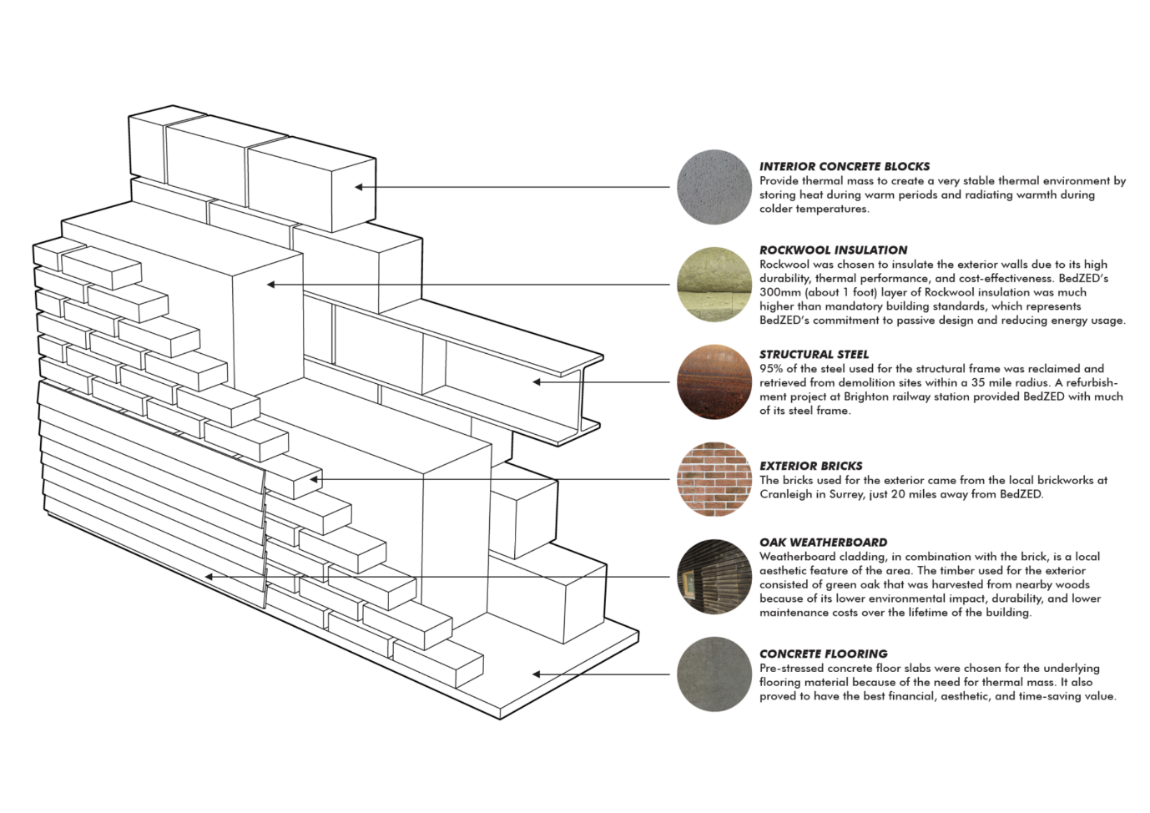
Figure 11: The external wall makeup of a unit at BedZED (Photo Credit: R. Riddle)

Sustainable communities

BedZED is recognised for its innovative sustainable technologies and strategies; all of these were implemented with the aim of achieving net zero and being free of fossil-fuel consumption. Shortlisted for the RIBA Stirling Prize 2003, BedZED won the RIBA Journal Sustainability Award in 2023 with the jury commenting: "We were looking for buildings that pushed the sustainable agenda through a step change and took a more radical approach. For this reason, we were unanimous in our decision to award the prize to BedZED solar urban village” (Chapman, 2003).

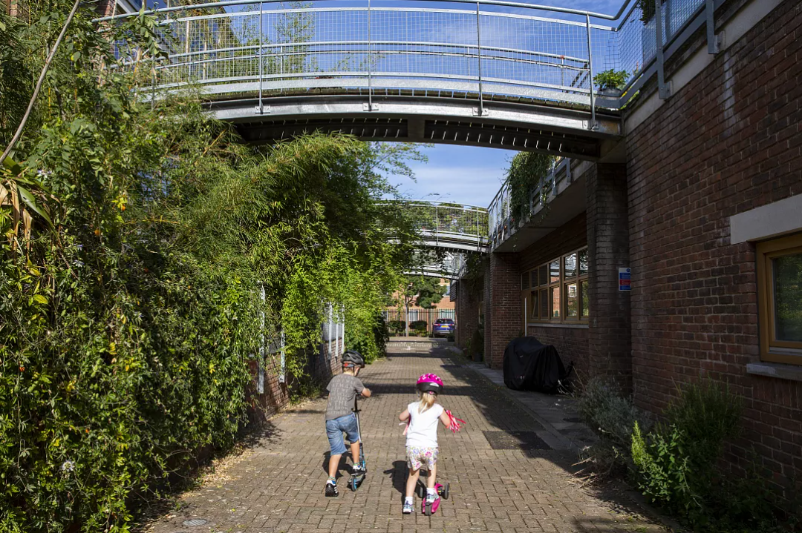
Figure 12: BedZED, a thriving sustainable housing community (Photo credit: A. Aitchison)

Other awards include the RIBA Housing Design Award for sustainability (2001), the Evening Standard New Homes Awards (also in 2001), winning a 'Completed Scheme' award.in the Housing Design Awards (2003), and a Sustainability Award from the Civic Trust (2005).

Central to BedZED is a village square, contoured with native trees and seating, forming part of the pedestrian route that meanders through the site (Salat, 2021). The eco-village provides 81 car parking spaces for residents, visitors and employees who work on site. This provision works out to be less than one car parking space per home, which encourages and incentivises using a more sustainable means of travel, such as walking or cycling. BioRegional founded England’s first car club, sited on a new development and operated by Enterprise Car Club, the club offers a low emission yet fuel-efficient hybrid car to any member of the car club. This scheme gives members the opportunity of to use a sustainable vehicle without all the cost implications of car ownership, and members can book a car online, using a cashless and efficient pay-as-you-go system.
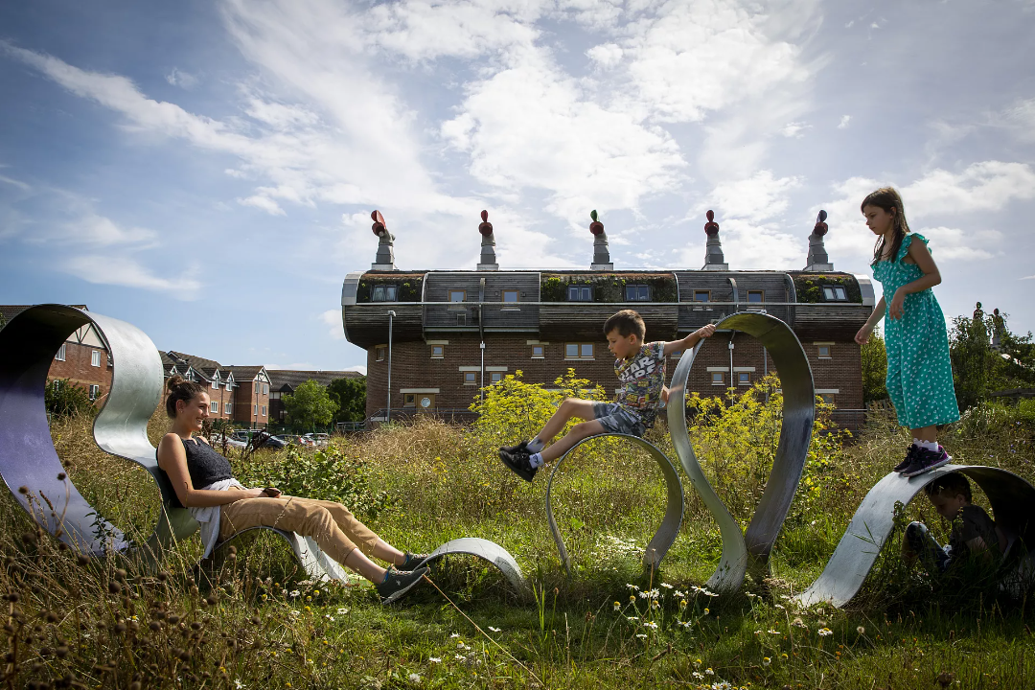
Figure 13: The village square at BedZed (Photo credit: A. Aitchison)

From the beginning, BedZED was designed to be an attractive yet functional place to live, promoting people to live, work, and play in a healthier, happier way (Hodge, 2009), and it is clear that the collaborative partnership of BioRegional and Bill Dunster Architects has achieved this aim.

Chapter 3: The Industrial Approach

Amager Bakke, more commonly known as CopenHill, is a sustainable waste-to-energy plant located on the industrial waterfront of Amager, Copenhagen. The plant is an exemplary display of waste management and energy production, whilst also doubling as public infrastructure in the industrial landscape of Copenhagen, Denmark (Crook, 2019). The power plant was designed by Danish architecture firm Bjarke Ingels Group (BIG), with the concept launched in 2011, and then built in conjunction with landscape architecture firm, SLA. CopenHill provides visitors with tree-lined hiking trails, an artificial ski-slope that runs down the roof of the building, and the tallest artificial climbing wall in the world (Bjerke, 2019). Due to the location of CopenHill on the Copenhagen industrial waterfront, where raw industrial facilities have become the home for extreme sports like wakeboarding to go-karting, this state-of-the-art power plant accommodates thrill seekers the ski-slope and rock-climbing wall (Pintos, 2019).
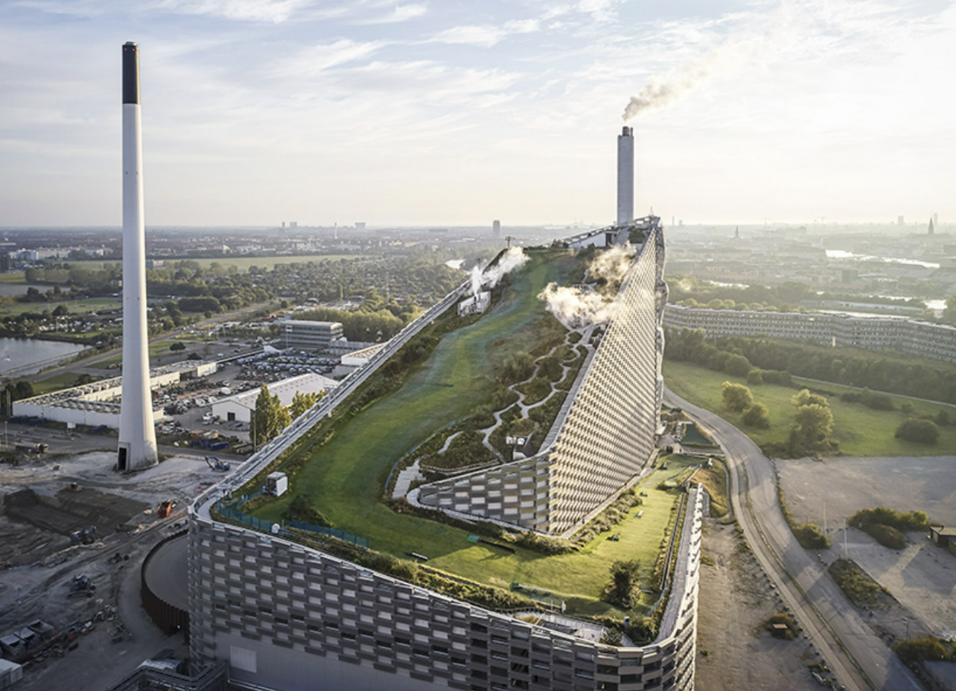
Figure 14: Aerial view of Copenhill (Photo credit: Hufton + Crow)

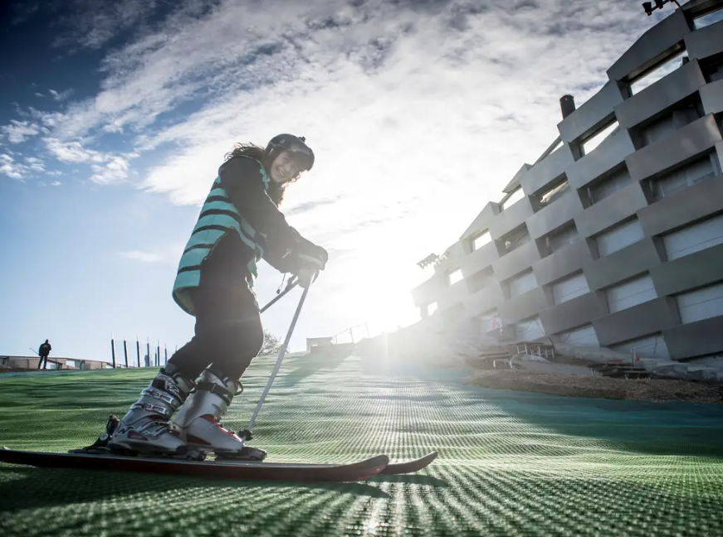
Figure 15: A waste-to-energy plant that doubles as a ski slope (Photo credit: M. Rasmussen)
Completed in 2019, the £490m power plant replaces the 50-year-old Amagerforbraendig plant that resided on the site. The 41,0000m² “ski plant” is distinguishable by its wedge-like shape, this geometry adequately accommodates the skiing facility, which provides skiers from a broad range of experience with 500-metres of ski runs (Ijeh, 2019). The very summit of the ski slope is a designated black run intended for expert skiers, the middle section of the artificial slope is for intermediate level skiers, while beginners and children can ski on the lower green slopes. Skiers and members of the public can ascend to the summit of the power plant using four different lifts, with glass lifts providing visitors views and glimpses of the waste incineration process inside the building. The top of the ski slope is capped with a viewing-point and a rooftop cafeteria, giving visitors additional panoramic views over Amager and Copenhagen city-centre. At the bottom of the artificial ski slope, there is an après-ski bar that welcomes visitors and locals alike. Amager Bakke is also equipped with ten floors of administrative space and a 600m² centre, used for academic tours, workshops and (more importantly) sustainability conferences. Whilst CopenHill is formally an example of industrial architecture, the building is a destination for all citizens and visitors of Copenhagen (Matthews, 2019).

CopenHill’s architectural detail

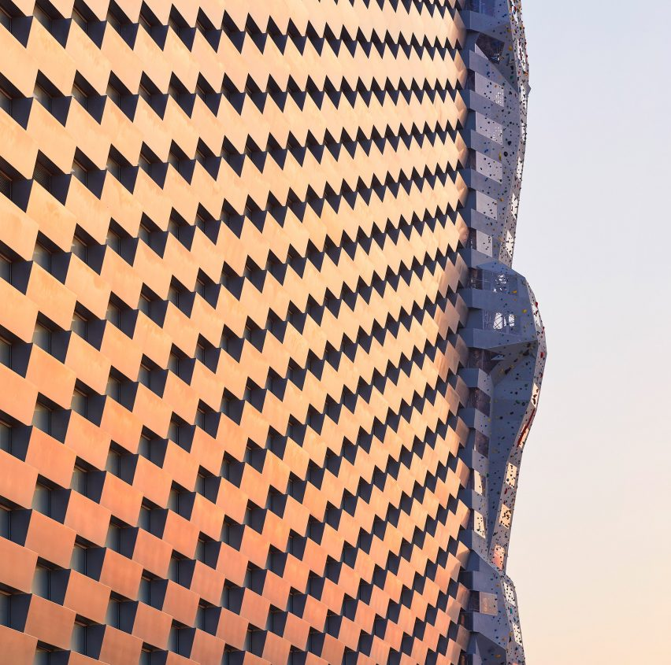
Figure 16: CopenHill’s façade and climbing wall (Photo credit: Hufton + Crow)
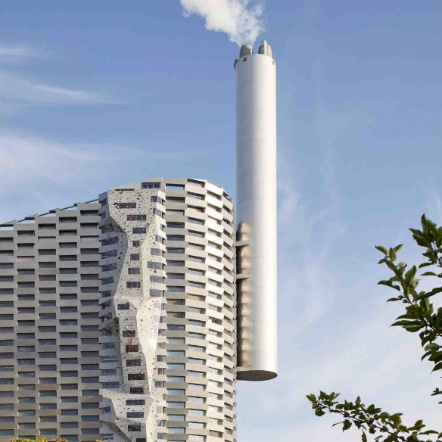
The building’s wrapping shimmering façade responds to changing light, showing that BIG’s architectural details are effective from close up and far away. The building’s envelope is made up of ‘alu-bricks’: 1.2m tall and 3.3m-wide blocks of rolled aluminium that are stacked like hypothetical bricks overlapping with each other. In between these boxes, glazed windows allow sunlight to penetrate the facility, while the larger openings on the southwest façade light up workstations on the administrative floors of the power plant (Baldwin, 2019). At the beginning of the project, BIG founder, Bjarke Ingels complained that the majority of waste-to-energy plants were simply “big, ugly rectangular boxes” and the hill-like form of CopenHill is a clear departure from this (Ijeh, 2019). The building’s materiality may be somewhat of a contradiction to the building’s sustainable principles, however, the building needed to be robust so as to combat the natural elements that affect the power plant due to the location on the industrial waterfront. The 85m high climbing wall on the tallest vertical façade makes this the tallest artificial climbing wall in the world for new world records to be broken with views inside the factory (Hartman, 2019). Steam from the plant is emitted from the tall chimney of 125m high. Initially, BIG proposed that this chimney released a ring of vapour every time 250 kilograms of carbon dioxide was released into the atmosphere, as an art demonstration to remind local residents of their carbon footprint. Unfortunately, this concept could not materialise as doing so would negatively impact the environmental performance of the plant (Bjerke, 2019).
Figure 17: Steam from the plant is emitted from the tall chimney (Photo credit: Hufton + Crow)
(Photo credit: G. Rex)
ARC, the public utility company that handles almost all of the aspects of waste management in Copenhagen, had issues with unprecedented safety challenges due to the proximity of industrial, recreational, and administrative activities to the building. At a traditional waste-to-energy plant, if there is an unexpected internal explosion, usually the roof would lift off, however at CopenHill with the ski-slope on the roof, this was clearly impossible. However, the windows on one façade are designed to break in the event of an explosion if an extreme heat situation occurs (ARC, 2023a).

In September 2017, CopenHill was awarded the Award of Merit at the European Convention for Constructional Steelworks. “The plant exhibits an exceptional use of steel - both as a visible material and as structural steel - united in a building construction of international class", stated the committee of judges in their explanation (State of Green, 2017). The building also won the World Building of the Year 2021 at the 14th annual World Architecture Festival (WAF). On behalf of the judges, Paul Finch OBE, Programme Director praised the way that CopenHill "addresses the role of architecture in the new world of recycling and zero carbon. It treats infrastructure projects in a way which makes people say ‘Yes in my back yard’ rather than ’no’" (World Architecture, 2021).

A sustainable contradiction – how does CopenHill provide energy for hundreds-of-thousands of homes?

CopenHill embodies the notion of ‘hedonistic sustainability’, a term coined by Ingels, which demonstrates that architecture and design can and should be commercially successful and environmentally beneficial (Basulto, 2011). This term also aligns with the CPH 2025 Climate Plan, a plan that aims to make Copenhagen the world’s first carbon-neutral city by 2025. Copenhagen has a dual responsibility to mitigate the effects of climate change and to prove that it is possible to combine, growth development, and an enhanced way of life with smaller levels of carbon dioxide (Urban Development, 2023).

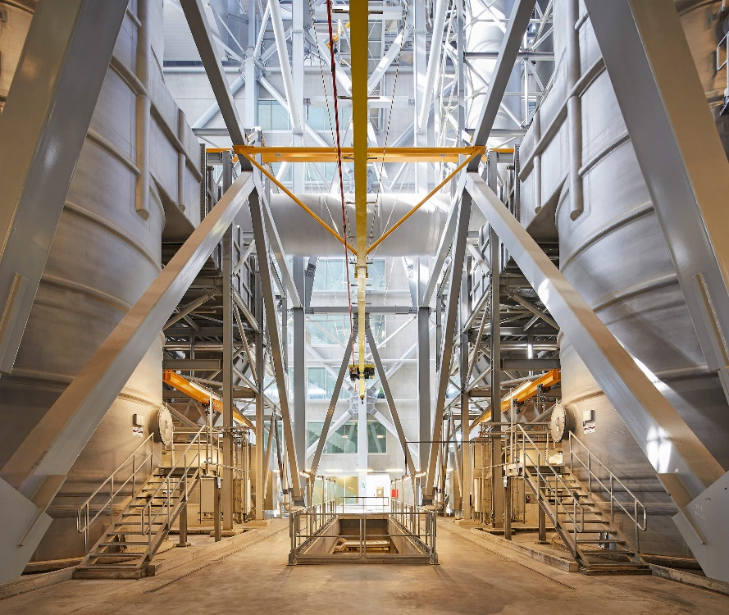
Figure 18: Inside the garbage burning Amager Bakke (Photo credit: Hufton + Crow)
As previously stated, CopenHill was conceived as a landmark that mixes public infrastructure with state-of-the-art waste-to-power energy production. Below the shimmering silver power plant, humming furnaces, steam, and turbines convert roughly 440,000 tons of waste annually into clean energy, this waste produces enough electricity to power 30,000 homes and heating for 72,000 homes across Copenhagen, recycling 3kg of household waste to provide up to five hours of domestic heating. Amager Bakke is responsible for treating the surplus waste of 645,000 inhabitants and 68,000 companies over five municipalities including Copenhagen (Ijeh, 2019). In 2020, CopenHill converted 599,000 tonnes of waste (159,000 tonnes more than average) into heat and electricity. The power plant is oversized, in order to accommodate the multiple municipalities it serves. Approximately 23% of the waste fuels incinerated at CopenHill are residual waste produced by homes from these five municipalities, the rest of the incinerated matter is from commercial and industrial waste (Edo, 2020). This decision was justified as a climate win by ARC Director Jacob Hartvig Simonsen, because the gains of importing waste outweigh the losses, even when the travel of residual waste is considered. CopenHill was primarily built to serve these municipality owners, however, due to the capacity being higher than the demand, the power plant also receives waste from other countries during winter months if these countries experience difficulty with their own waste-to-energy plants (Hartman, 2019). Today, Europe sends roughly 44M tonnes of waste to the power plant: with 30,000 tonnes of this matter coming from the UK and Ireland in 2018 (Hartman, 2019). The waste is sourced and sorted before collection, and since July 2020, all 98 municipalities of Denmark are obliged to sort and collect the different waste properties; food waste, glass, paper, metal, plastics, food and drink packaging, cardboard, textiles, hazardous waste and residual waste (Edo, 2020). Less than 4% of waste in Denmark goes to landfill, recycling accounts for 42% of waste and 54% is transformed into district heating and electricity. CopenHill receives between 250-300 trucks daily containing residual waste. These trucks are weighed and approximately 5% of the trucks undergo random inspections to make sure that the waste is adequate for incineration, with any waste that is not in line with the environmental permit rejected (ARC, 2023b). The waste is then incinerated in giant combustion boilers where temperatures reach up to 1000°C. The large amount of heat generated in these boilers provides power via a district heating system, to thousands of homes across Denmark. Ash from these boilers is spray dried and cleaned to remove any hazardous chemicals in giant tanks, before being recycled and used as aggregate (Ijeh, 2019). Steam produced by the scrubbers is emitted from the 125m tall chimney. The waste-to-power sequence running through the plant is handled by machinery that is positioned precisely in height order, this then creates the efficient slope that gives the power plant the iconic silhouette shape (Pintos, 2019).

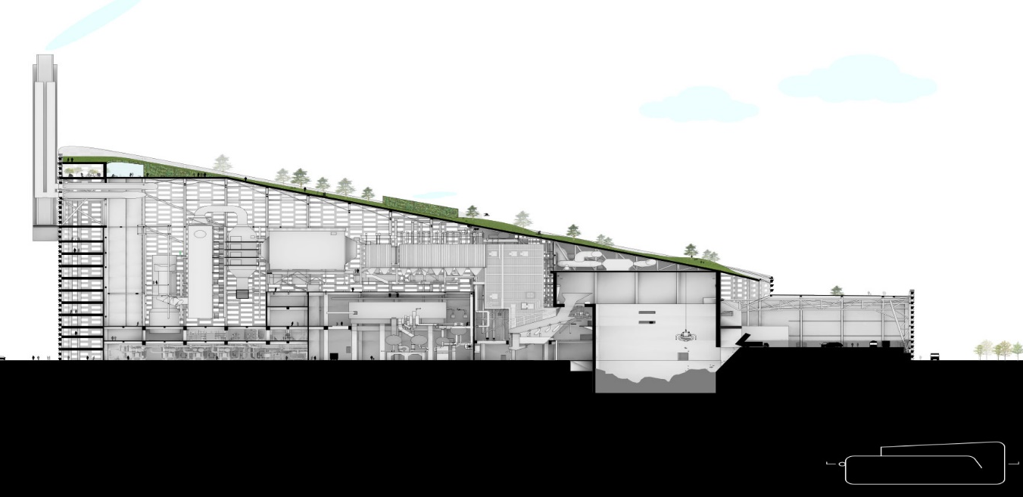
Figure 19: Machinery that is positioned in height order (Photo credit: Bjarke Ingels Group)

SLA designed the green rooftop park, combining hiking trails, playgrounds, viewpoints, climbing walls and street fitness, along with the infamous ski slope. The park was designed with the concept of incorporating a wild and sensuous mountain nature with plants, approximately 7000 bushes and 300 trees, and rockscapes. The result of this approach is a biodiverse and vigorous natural design that provides visitors with the opportunity to use CopenHill all year round and to enjoy the sensory environment at all of the varying activities provided (SLA, 2021).

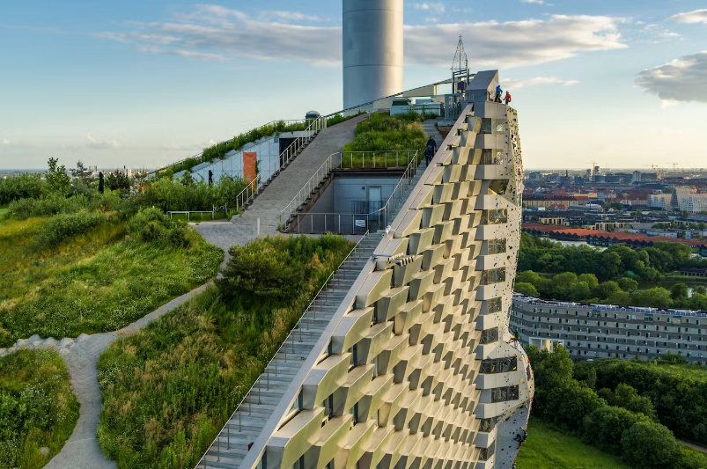
Figure 20: Aerial view, showing the rooftop biodiverse garden (Photo credit: SLA)

Ingels commented “CopenHill is a blatant architectural expression of something that would otherwise have remained invisible: that it is the cleanest waste-to-energy power plant in the world,” (Matthews, 2019). CopenHill aimed to challenge common misconceptions of industrial architecture, by incorporating a waste-to-energy plant with public infrastructure that promotes health and wellbeing, biodiversity, and the social aspects of sustainability. It is clear that the collaboration between Bjarke Ingels Group and SLA achieved this aim.

Chapter 4: The Commercial Approach

This chapter will discuss the Enterprise Centre, a university building that aims to encourage new sustainable businesses that emerge from The University of East Anglia’s (UEA) academic research programme and those attending other activities within the Norwich Research Park. The centre is located in Norwich, England, neighbouring the historical Earlham Hall and Park and demonstrates exemplary low-carbon architecture and sustainable principles (Passivhaus Trust, 2016).
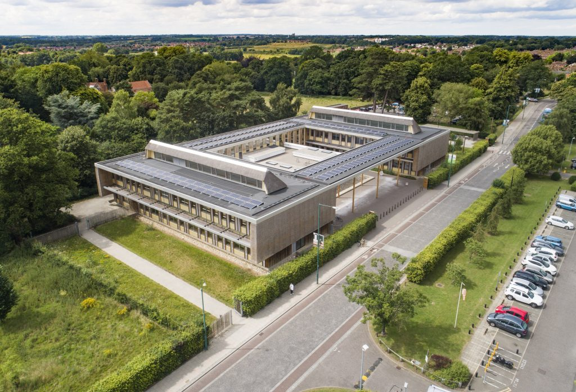
Figure 21: Aerial view of The Enterprise Centre (Photo credit: UEA)

The Enterprise Centre provides space for business support workshops, networking activities, open plan offices, incubation, and hatchery space for new graduate startup companies and other businesses in the Knowledge Economy. The building also provides a base for business support through the University’s low carbon MBA and associated graduate development and entrepreneurship programmes operated by the Norwich Business School (Architype, 2018).

The building is E-shaped in plan, facing east and perpendicular to the main entrance road to the UEA campus. The ground floor entrance is recessed from the open portico, behind which is a 300-seat lecture theatre. An open, double-height foyer space extends down the west part of the building, including a reception area, seating, and exhibition spaces, above these are four ‘meeting pods’ strung along the open gallery. The north part of the building accommodates the small business hatcheries, with the student workrooms and seminar rooms located in the southern part of the building (Schoof, 2016). This creates a total of 3,400m² gross internal floor area, costing £11,600,000 to build (Architype, 2018).

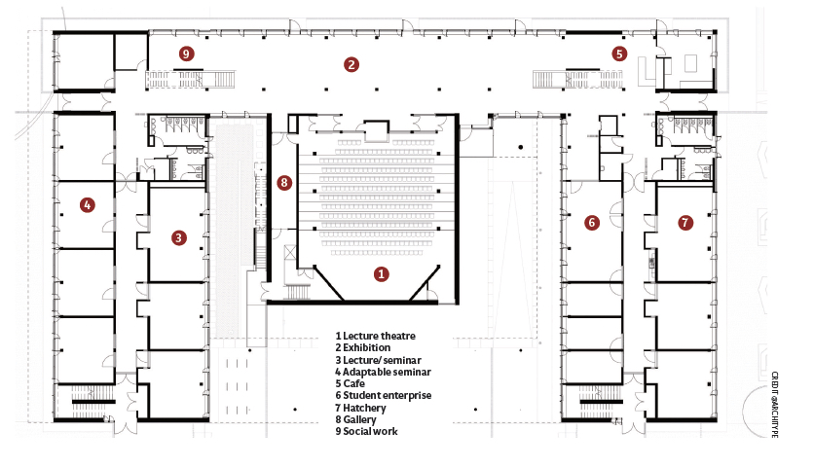
Figure 22: Plan of The Enterprise Centre (Photo credit: Architype)

The Enterprise Centre was constructed in 2015 and was delivered using a forward thinking ‘single point delivery’ (SPD) form of contract for all work stages. This promoted collaborative working between sustainable architecture practice Architype and was led by main contractors Morgan Sindall Group as the Single Point Deliverer (UK Green Building Council, 2021). The masterplan for The Enterprise Centre was created in concurrence with a wider strategic plan to expand and develop the university’s eastern approach. The centre opens up the far side of the campus, improving access for the public and reinforcing the link to the previously mentioned historic Earlham Hall and Park, this promotes links with local community and commerce, restoring a formerly low-footfall area of the UEA estate (Passivhaus Trust, 2016).

The importance of sustainable materiality and construction
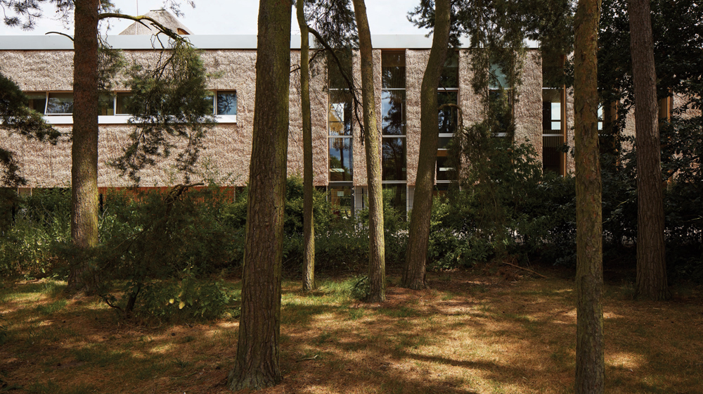
Figure 23: The surrounding landscape of The Enterprise Centre (Photo credit: Architype)

The Enterprise Centre was dubbed by the press as the UK's greenest building (McDonald, 2015). The centre has been designed and delivered to achieve the Passivhaus standard and a BREEAM outstanding rating (Architype, 2018). The centre and surrounding landscape are an exemplar of low embodied energy and carbon construction technologies, with every material used to construct the building chosen due to its minimal environmental impact (Adam-Smith, 2015).

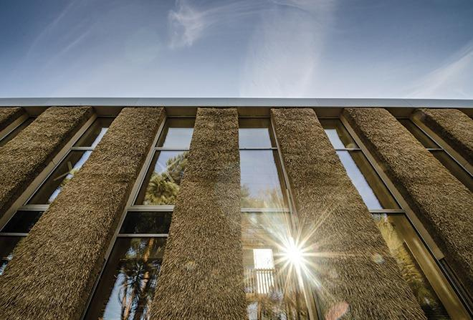
Figure 24: A thatch and reed façade (Photo credit: Morgan Sindall Group)
The building is most distinctively clad in Norfolk thatch and reed, a nod to local heritage and sustaining the local vernacular. However, this ancient craft of hatching is extremely time-intensive, so a more modern approach was adopted for the centre. Morgan Sindall Group proposed that prefabricated thatch panels were created, so that these could simply be put into place on the building (Hanson UK, 2015). In collaboration with master thatcher Stephen Letch and local joiners, 297 panels were fabricated, and were applied as a rain screen cladding on the north, west and east facades, creating the iconic aesthetic that the Enterprise Centre encompasses. These prefabricated panels are made from regionally grown, long straws that are harvested from wheat species cultivated by the neighbouring John Innes Centre, only 1.3km away from the Enterprise Centre (Schoof, 2016). These demountable façade panels have a 40-year design life, they can be lifted off, re-thatched, and re-installed again. Reed thatch is also used on the inclined parts of the roof, whole reed board panels cover one of the upper-floor meeting pods. The other three pods have been lined with nettle and hemp fabrics or finished with a lime plaster (Colley, 2015).

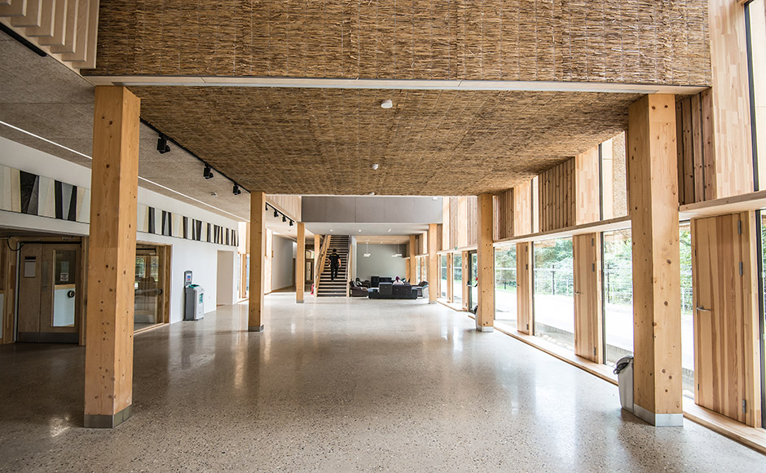
Figure 25: A glulam frame sitting on top of a sustainable concrete deck (Photo credit: Kingston Joinery)
The building sits on a foundation that is made from a concrete that makes substantial embodied carbon reductions, 70% of the standard Portland cement is replaced with ground granulated furnace slag (GGBS). The manufacturing process of GGBS requires much less energy and produces around one tenth of the CO2 emissions of Portland cement. The cement also requires no mineral extraction and prevents large amounts of waste being disposed in landfill. As a result, the concrete used provided a 62% saving of the embodied carbon of a comparable CEM I Portland cement mix. A fine ash is created as a by-product of the steel smelting process, along with recycled sand and aggregates. The cement is also polished, saving on additional material for floor surfaces as completing this produces a finish for the interior of the building. The building is supported by a glulam timber frame, steel beams were used when needed, such as spanning the roof that separates the courtyard from the street (Hanson UK, 2015).
The majority of materials used in the construction of the Enterprise Centre were sourced within 30 miles of the site, including the Corsican Pine, which was responsible for up to 70% of the stud work in the external walls and was sourced from Thetford Forest. Corsican Pine is usually used for minor purposes like fencing and pallet work, however the design team decided it was adequate for the structure (Architype, 2018).

James Knox, senior engineer for Morgan Sindall Group, explains how some elements were differed to most projects: “There are many different materials that we are not used to using and completely innovative materials on the project which have never been used before. The low-carbon concrete, for example, was designed specifically for this project and the thatching method, which our team conceived, is a world first” (Colley, 2015).

Sustainable approach and principles

The Enterprise Centre’s inclusion in the COP26 ‘Built Environment Virtual Pavilion’ demonstrates the significance of the building to international architecture and sustainable schemes (Markovitz, 2021). The construction of the building is part of the UEA’s commitment to sustainability (including the university’s pledge to become 100% net zero by 2045 or earlier), leadership in addressing environmental issues and commitment to the latest in sustainable construction (Richardson, 2021). The Enterprise Centre is recognised globally for its innovative construction methods, winning over 26 awards; including the 'Best of the Best' and ‘Best Corporate Workplace' at the 2016 BCO National Awards, Best Education Project at the 2016 BREEAM Awards, the 2017 RIBA Sustainable Project of the Year, and winning the non-domestic category of the 2018 UK Passivhaus Awards (Architype, 2018).
Future climate data was applied to the Enterprise Centre model, simulating the effect of climate change over the next 87 years, this was completed by the UEA Climate Team. Using this information a number of design scenarios were simulated in the Passive House Planning Package to identify the most vigorous solution over the 87-year period. A lifecycle carbon study was also carried out, including embodied carbon, which allowed optimisation of the building mass, glazing ratio, shading, and natural ventilation design. Sensitivity analysis was also carried out, for both a warming and cooling scenario (Passivhaus Trust, 2016).

The building utilises a Mechanical Ventilation with Heat Recovery (MVHR) system to provide fresh air to all spaces, increasing the well-being of occupants of The Enterprise Centre. Night cooling strategies are also utilised, combined with the thermal mass of the concrete ground foundation, and fermacell partitions, these ensure compliance with CIBSE, summertime overheating spaces will not exceed 28°C for more than 1% of the occupied hours. Additional summer ventilation is provided by the use of open windows and louvres, stack effect and high-level exhaust. The Enterprise Centre’s receptionist is responsible for managing the night cooling, this ensures that the building is cooled by the opening of vents. Analysis concluded that high material mass would be effective for controlled heat gains, however, was not at the expense of the Life Cycle Assessment. In response to this analysis, a low carbon, high mass solution was chosen (UK Green Building Council, 2021).

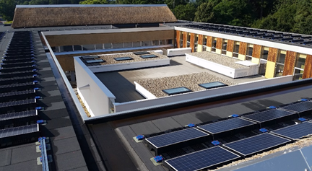
Figure 26: Roof mounted photovoltaics panels (Photo credit: UKGBC)
Similarly, to BedZED, the Enterprise Centre is heated by being connected to the university’s local heat network, which is a combined heat and power system, fuelled by burning non-toxic waste material (Colley, 2015). A 200mm layer of insulation is wrapped around the building in a ‘duvet’ layer, and 58 tonnes of newspaper was recycled to produce cellulose fibre insulation (Hanson UK, 2015). The Enterprise Centre is also equipped with 50kW roof mounted photovoltaics panels, these exceed the local planning requirement for 10% of the building’s energy to be from renewable sources, for example 31.9% of the Enterprise Centre’s electricity is generated from renewable sources (UK Green Building Council, 2021).

To achieve the Passivhaus certification, ongoing monitoring of energy use was required in the first year of being constructed. The full Soft Landings approach was utilised with three-year post-occupancy evaluations to ensure that the building performed at its maximum from the outset. Further approaches were utilised, including triple glazed windows which allowed beneficial solar gain and good daylighting as well as better levels of insulation. The Enterprise Centre achieved BREEAM Outstanding, combining best practice across a range of sustainability measures, including biodiversity features such as insect hotels, bat and bird boxes and display bed terraces, which enhance the ecological value of the building. As at BedZED, the Enterprise Centre also uses site waste management and building recycling nodes, water-saving appliances and also reuses rainwater for flushing toilets helps with the water credits of the building (Architype, 2018). The Enterprise Centre achieved an embodied carbon of 443kgco2/m2, this is a 65% reduction in embodied carbon compared to a conventional higher education building at the time (UK Green Building Council, 2021).

Ben Humphries, Director at Architype, said: “Visionary in its brief, we have responded with a design that has pushed at the boundaries of traditional approaches, and with the commitment and dedication of the site team, believe we have achieved a building that sets new benchmarks not only for the university but also the wider construction industry” (Mark, 2015). From the offset, The Enterprise Centre was designed to be a building with outstanding sustainability credentials, whilst promoting the welfare of occupants and reinforcing links to local heritage. It is clear that the collaboration between Architype and Morgan Sindall Group accomplished this aim.

Chapter 5: The Modern Approach

The New Library at Magdalene College, the elegantly detailed building provides students at the 700-year-old University of Cambridge campus with a purpose-built library with 50% more capacity for books and much needed study space for students. The library is located in the Fellows’ Garden in a ‘semblance of alignment’ to the 350-year-old Grade I-listed Pepys Building, home to the Samuel Pepys library collection, and which previously contained all of the college library and undergraduate study space. Magdalene College provides the student body of approximately 350 undergraduates with a state-of-the-art library and workspace, a climate-controlled archive and an art gallery (Jennings, 2022).
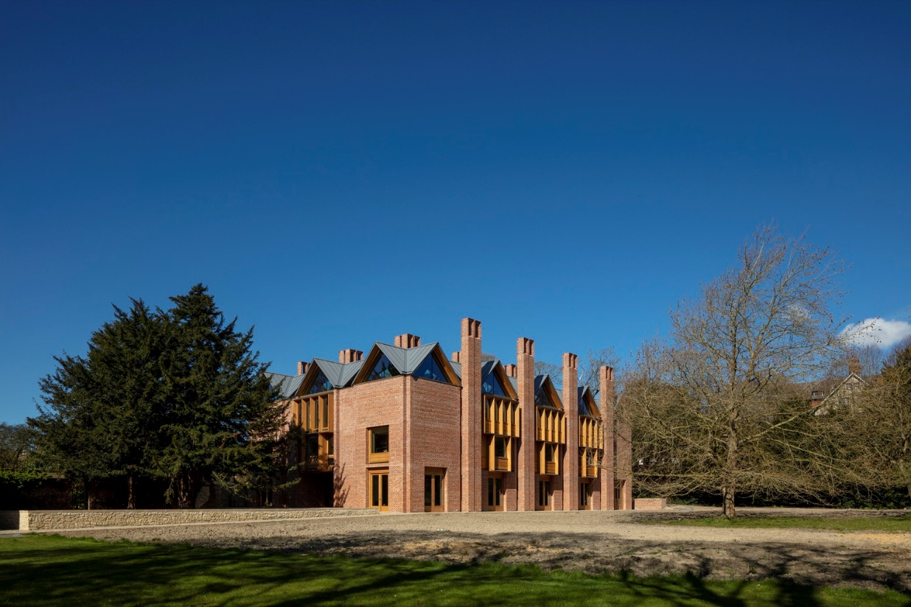
Figure 27: The New Library settled in the historic setting (Photo credit: N. Kane)

The New Library was designed by architecture practice Níall McLaughlin Architects with the aim of lasting 400 years, a practice that are among the most experienced when it comes to producing postsecondary developments. The design studio was tasked with planning the building in 2014 after they had won a design competition for the library (Pintos, 2021). Completed in 2021, the function of the library is intended to be a domestic place of study rather than being a cold institutional “cathedral” of learning, and Níall McLaughlin Architects prided themselves on creating a plethora of unique workspaces to suit the Magdalene College students’ needs (Jennings, 2022).

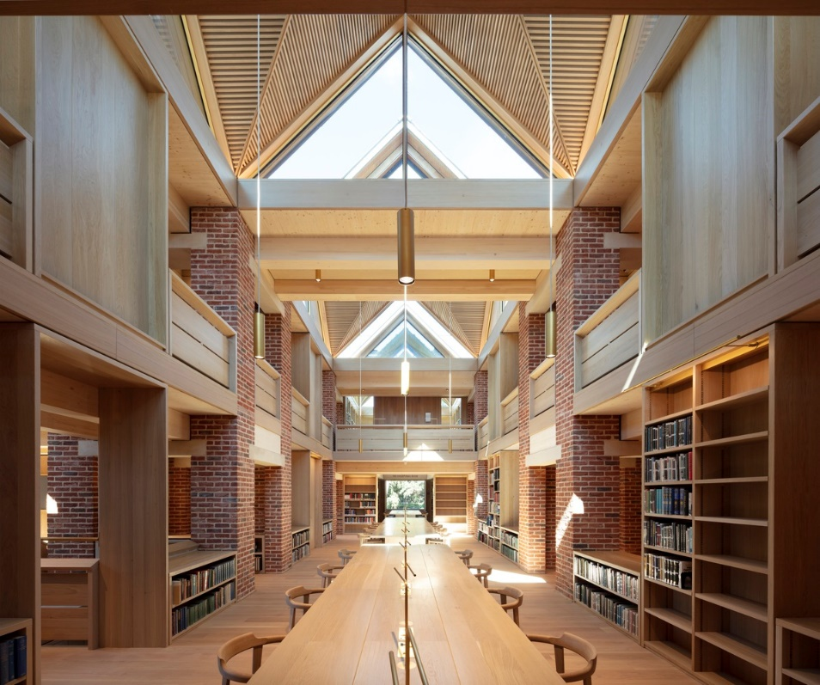
Figure 28: A network of interconnecting rooms (Photo credit: N. Kane)
The main part of the library is a collection of interconnecting rooms, equipped with bookcases that contour the walls, reading desks in several nooks for more secluded students, there are also large communal tables (referred to as the ‘Medieval Mead Hall’ by deputy college librarian Tom Sykes), benches that look out over the river, and the ‘prima donna’ desks with their own balcony suspended out over the void of the atrium space (Wainright, 2022). "The main library is a suite of interconnecting rooms lined with bookcases, reading desks and galleries, arranged on a tartan grid between interconnecting passageways" explained Niall McLaughlin Architects. Three main reading rooms organise the main circulation route through the building, from the three-story entrance hall to the double-height central reading area, up to a long single-height room with views overlooking the gardens (Astbury, 2022).

The importance of sustainable materiality whilst reinforcing the historic vernacular

It was import for Magdalene College when commissioning a new building to maintain a delicate traversing of its traditional identity as an ancient community with a conservative character, yet to pair this with contemporary aspirations as a progressive place of learning. The desire, articulated by Rowan Williams was that the building needed to feel ‘settled’ (Jennings, 2022). The library is approached through a small doorway and out under an old yew tree, “We wanted to make the building a journey that gradually rose up towards the light,” explains Níall McLaughlin Architects (Schoof, 2022).

The New Library is located in a highly sensitive historic setting, along the boundary wall between the Master’s Garden and the Fellows’ Garden. The placement of the library extends the quadrangular arrangement of the surrounding buildings, including the Pepys Library, and courts that developed from the monastic origins of the college site (Pintos, 2021). The materiality and form of the building are inspired by both the rich historic site and Magdelene College’s desire to have a highly durable and sustainable building. The neighbouring college buildings’ architectural details include load bearing brick construction, with timber floors and gabled pitched roofs. Brick chimneys contour the skyline and stone tracery frame the windows. Níall McLaughlin Architects designed the library to inherit these architectural elements (Martin, 2023).
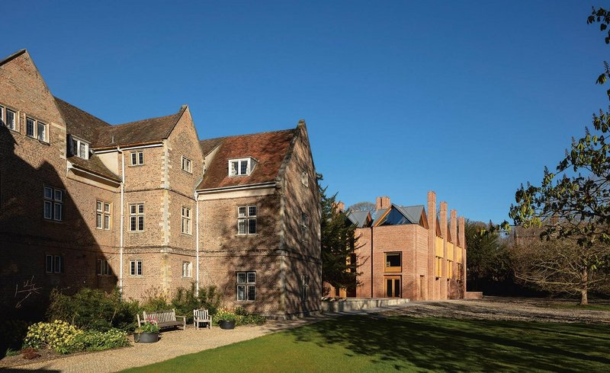
Figure 29: The Pepys Library sits just to the south of The New Library (Photo credit: N. Kane)

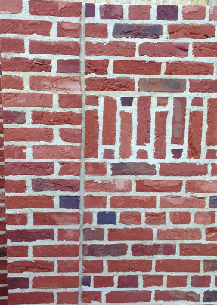
Figure 30: Bespoke bricks, matching the aesthetic of neighbouring buildings (Photo credit: Níall McLaughlin Architects)
Simplicity and longevity were crucial objectives for the building’s architecture. The New Library’s iconic hand-moulded bricks are conceived as naturally weathered; however these were uniquely textured by York Handmade, the building was constructed using over 300,000 of these bespoke bricks (York Handmade, 2023). The neighbouring Pepys Library, of 1703, displays rich brickwork with a range of differing colour and character, the front elevation of this historic building is formed of bricks varying in colour; deep reds, browns and purples. The Pepys Library also displays unusual mortar joints, which played a significant role in the overall colour and texture of the wall makeup. The joints on the existing building are larger than that of a standard brick joint, and the bricks are smaller in height than a standard brick. The architects responded to this by implementing bespoke bricks of varying colours to further reinforce the philosophy of the New Library needing to feel ‘settled’ – from bright terracotta to the deeper purples and browns, along with the matching larger mortar joints (Jennings, 2022). Lime mortar was used instead of the typical cement mix, this was to facilitate the eventual reuse of the bricks, it is also more environmentally friendly, achieving a higher BREEAM rating than cement. The wall pattern and makeup were achieved by a close collaboration between the architects and craftsmen, careful diagrammatic drawings were produced, setting out each individual brick’s placement. According to Níall McLaughlin Architects: “We named each brick with a letter. In the end, we had one brick for every letter of the alphabet” (Níall McLaughlin Architects, 2020a).

Other methods were used to further reinforce the conservation of character, instead of the stone tracery found on neighbouring buildings, the New Library adopts a more modern approach with timber window tracery. However, when this timber weathers with age, it will develop a silvery grey aesthetic, mimicking the stone used in the neighbouring historic buildings (Jennings, 2022).

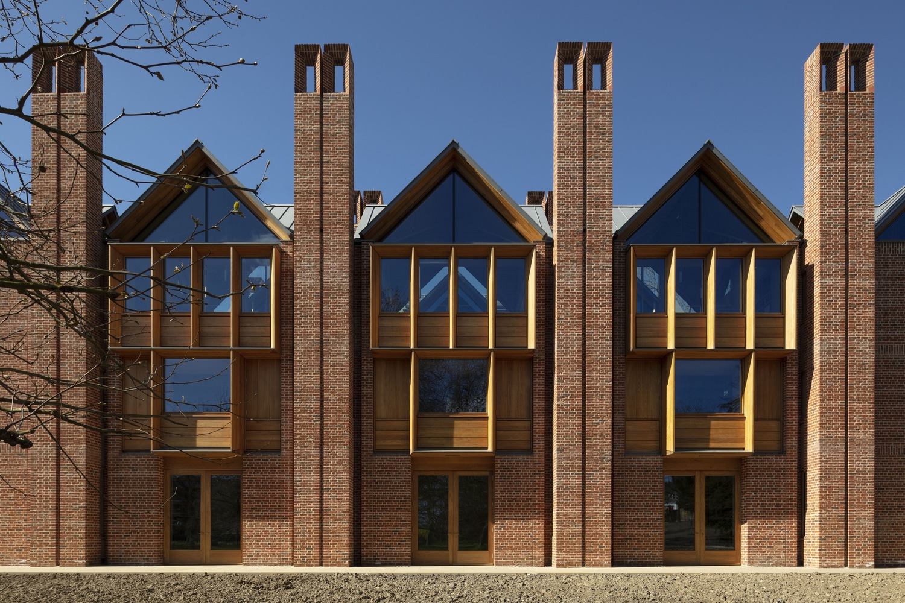
Figure 31: Façade elevation, showing the timber tracery and brick chimneys (Photo credit: N. Kane)

The New Library is built upon a latticework of interlinked modular architectural elements, with alternate spacings of approximately 5.4m and 2m, commonly described as a ‘tartan grid’. Load-bearing brick cores are located where the 2m grid lines intersect, these brick cores also act as chimneys, mimicking the characteristic of the roofscape of surrounding buildings (Eurban, 2023). These chimneys also provide support for the book stacks and carry warm air upwards to be ventilated. Between every four chimneys there is a roof lantern skylight incorporated into the gabled roof forms, providing light for spaces below, air rises whilst light falls (RIBA, 2023). The geometry of these skylights help to illuminate the intimate reading spaces with soft light, they are also lined with grooved timber panels which minimises direct sunlight and glare. The regular grid produces a natural echelon with zones for circulation and zones for reading areas. In plan, the 5.4m squares form interior spaces, and create a
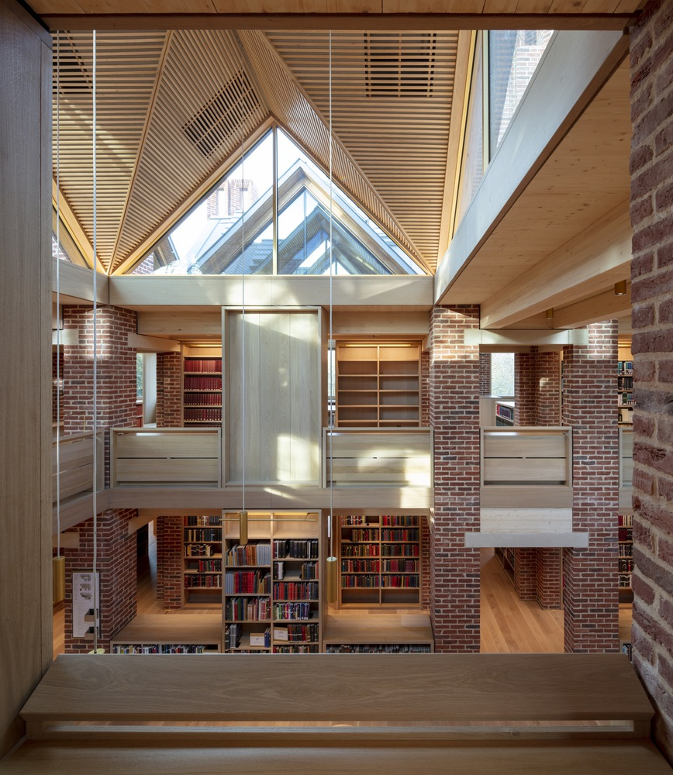
Figure 32: Load-bearing brick vertical structures and spanning CLT (Photo credit: N. Kane)
number of intimate reading rooms, while the intersecting grids become passageways and stairs connecting these rooms together (Pintos, 2021). The definition of the load-bearing brick vertical structures for the chimneys, supporting the spanning CLT and glulam horizontal structure is used to reinforce the highly detailed organisational emphasis of the scheme (Jennings, 2022).

Sustainable approach and principles

The project brief required the building to have an enlightened approach to sustainable design, taking advantage of natural lighting and ventilation while minimising the dependence on energy-consuming appliances and systems (Jennings, 2022).

The building is naturally ventilated, fresh air is provided through openings in the façade. Vitiated, stale air is extracted through ventilation in the red-brick chimney stacks and openings in the roof, the air is extracted through the stack effect (Astbury, 2022). The modular-plan nature of the library and interconnection of floors through open atrium voids ensure that all spaces are ventilated. Dynamic modelling of the building physics simulated the large, glazed areas and natural ventilation system to ensure the building would not overheat in warm weather. The openings in the roof and chimneys are automatically controlled by heat and CO2 sensors to avoid excessive ventilation when the library is being heated (Max Fordham, 2020).

The archive room provides a secure and environmentally stable space for safe storage, and have been designed as a passive archive. The surrounding walls and ceiling have an extremely low U-value (0.09 W/m²K), an airtight envelope and a slab that is in direct contact with the earth regulate the conditions in the room, these features minimise the need for a mechanical air conditioning system. The New Library’s fabric has a high degree of thermal performance and airtightness, this is to minimise the building’s overall energy demand. Minimising the use of materials like steel and concrete reduced the overall embodied carbon. As stated previously, the main vertical structure is brick and the horizontal structure is CLT and glulam, these materials were chosen due to their relatively low embodied carbon and their durability (Jennings, 2022).

Creating a building that will last at least 400 years was a monumental challenge, but one that Níall McLaughlin Architects rose to with the utmost skill, care and responsibility. Níall McLaughlin Architects was recognised for this innovative scheme, winning the RIBA Stirling Prize in 2022. Speaking as the Chair of the 2022 RIBA Stirling Prize jury, RIBA President Simon Allford described the building's design as the “epitome” of sustainable architecture (Crook, 2022). He said: “A unique setting with a clear purpose - The New Library at Magdalene College is sophisticated, generous, architecture that has been built to last” (World Architecture Community, 2022). Magdalene College’s New Library fulfils a challenging brief: to create a building on the edge of one of Cambridge’s most sensitive and historic sites, neighboured by the Grade-I listed Pepys Building, and it was challenged to do this whilst feeling ‘settled’ (Jennings, 2022). It is clear that Níall McLaughlin Architects’ approach accomplished this.

Conclusion

The architecture industry and built environment can have a clear negative impact on our planet, buildings are responsible for emitting nearly 50% of the carbon dioxide, through greenfield development, the production of concrete/cement, and the constant consumption of fossil fuels. The climate crisis demands crucial actions and leadership by both the architecture sector and the wider construction industry. Through legislation such as The Paris Agreement, a legally binding international treaty on climate change, and the RIBA 2023 Challenge, which provides a stepped approach for RIBA Chartered Practices to aim towards achieving net zero. Architects now have frameworks that promote and celebrate the construction of sustainable developments. Other certification such as BREAAM and the Passivhaus trust are inspiring architects to constantly improve in terms of sustainable design, innovate and make effective use of resources.

Architects have approached climate change in a number of differing ways, through mitigation and adaptation; materiality, construction, energy consumption, technologies used and the embodied carbon of a building. The concept of sustainable architecture transpired as a means to combat climate change, the numerous ways of creating sustainable architecture aim to make buildings and environments that produce less carbon. The team at Bill Dunster architects were revolutionary in terms of their sustainable approach, BedZED was designed over two decades ago, meaning sustainability wasn’t as mainstream or as urgent as of today. All aspects of the material and construction of BedZED were considered during the design phase, in terms of the environmental impact and carbon footprint. Residential household energy usage is responsible for 29% of the UK carbon dioxide emissions, BedZED challenges the traditional approach to residential architecture by accomplishing sustainability in every aspect. BedZED employs innovative energy efficiency and was designed to be free of fossil-fuel consumption upon completion, entirely reducing its occupants’ emissions of climate-changing carbon dioxide and providing them with energy security. Other architects like BIG had a more unorthodox approach to sustainability and the climate change, CopenHill is a waste-to-energy plant that converts roughly 440,000 tons of waste annually into clean energy, this waste produces enough electricity to power 30,000 homes and heating for 72,000 homes across Copenhagen. CopenHill embodies the notion of ‘hedonistic sustainability’, a term coined by Ingels, which demonstrates that architecture and design can and should be commercially successful and environmentally beneficial. BIG aimed to challenge common misconceptions of industrial architecture.
More rigorous and heavily sustainable approaches are adopted by architects like Architype, with the Enterprise Centre, a university building that demonstrates exemplary low-carbon architecture and sustainable principles. The Enterprise Centre achieved BREEAM Outstanding, combining best practice across a range of sustainability measures, including locally sourcing materials, heat-recovery ventilations systems, biodiverse landscaping and high thermal massing. A more sensitive and durability driven approach was adopted by architects Níall McLaughlin Architects, who were challenged with creating a The New Library, a building with a lifespan of up to 400 years. The design team took advantage of natural lighting and ventilation while minimising the dependence on energy-consuming appliances and systems. The library’s envelope has a high degree of thermal performance and airtightness, this intern minimises the building’s overall energy demand. The minimisation of materials like steel and concrete, while using cross-laminated and glulam timber reduced the overall embodied carbon of The New Library.

It is becoming increasingly more crucial that architects respond to climate change. Sustainable architecture is not just about energy efficiency and producing healthier environments for its occupants, by reducing the reliance on non-renewable technologies and the use of fuels such as fossil fuels, sustainable architecture can promote and maintain healthy lives, environments and communities. As Pooran Desai said, “it’s not enough now to just be sustainable because we have destroyed half of all life on planet earth”, if we want a habitable planet in 30 years, we are going to have to change everything we do including how we approach architecture”.

Bibliography – Published Works

Adam-Smith, B. (2015). Is this the UK's greenest building? Available at: https://passivehouseplus.ie/magazine/new-build/is-this-the-uk-s-greenest-building (Accessed: 19 April 2023)

Adams, K. (2020). Zero Avoidable Waste in Construction. Available at: https://www.constructionleadershipcouncil.co.uk/wp-content/uploads/2016/05/ZAW-Report-Final-Draft-25-February-2020.pdf (Accessed: 4 April 2023)

ARC (2023a) Visit ARC. Available at: https://a-r-c.dk/english/visit-arc/ (Accessed: 15 April 2023)

ARC (2023b) Technique. Available at: https://a-r-c.dk/amager-bakke/teknik/ (Accessed: 15 April 2023)

Architecture 2030. (2018). Why the built environment? Available at: https://architecture2030.org/why-the-building-sector/ (Accessed: 26 April 2023)

Architype. (2018). The Enterprise Centre - University of East Anglia and The Adapt Low Carbon Group. Available at: https://www.architype.co.uk/project/the-enterprise-centre-uea/ (Accessed: 19 April 2023)

Astbury, J. (2022). Gables and chimneys inform Magdalene College library by Niall McLaughlin Architects. Available at: https://www.dezeen.com/2022/10/03/magdalene-college-library-niall-mclaughlin-architects/ (Accessed: 25 April 2023)

Baldwin, E. (2019). Exploring BIG’s CopenHill, the Clean Energy Plant With Its Own Ski Slope. Available at: https://architizer.com/blog/practice/details/bjarke-ingels-group-copenhill/ (Accessed: 15 April 2023)

Basulto, D. (2011) Designing a Hedonistic and Sustainable Future. Available at: https://bigthink.com/guest-thinkers/designing-a-hedonistic-and-sustainable-future/ (Accessed: 15 April 2023)
Bjerke, C. (2019). BIG’s skiable Copenhill power plant is a contradictory landmark. Available at: https://www.archpaper.com/2019/10/big-skiable-copenhill-powerplant-crit/ (Accessed: 15 April 2023)

Chapman, T. (2003) ‘RIBA Journal Sustainability Award - BedZed, London’, The Architects’ Journal, vol. 218, no. 20, 2003 Nov. 27, p. 76. Available at: https://www.architectsjournal.co.uk/archive/riba-journal-sustainability-award-bedzed-wallington-surrey (Accessed: 14 April 2023)

BRE Group. (2023a). BREEAM. Available at: https://bregroup.com/products/breeam/#:~:text=BREEAM%20is%20the%20world's%20leading,construction%2C%20to%20use%20and%20refurbishment. (Accessed: 26 April 2023)

BRE Group. (2023b). How BREEAM works. Available at: https://bregroup.com/products/breeam/how-breeam-works/ (Accessed: 26 April 2023)

Budds, D. (2019). How do buildings contribute to climate change? Available at: https://archive.curbed.com/2019/9/19/20874234/buildings-carbon-emissions-climate-change (Accessed: 26 April 2023)

Colley, J. (2015) ‘Is this the UK’s greenest building?’, Passive House Plus, vol. 12, 2015 Nov. 6, p. 34-35. Available at: https://issuu.com/passivehouseplus/docs/passive_house_plus_issue_12__uk_edi (Accessed 19 April 2023)

Cramer, N. (2017). The Climate Is Changing. So Must Architecture. Available at: https://www.architectmagazine.com/design/editorial/the-climate-is-changing-so-must-architecture_o#:~:text=Architecture%20must%20change%20with%20the,to%20survive%2C%20and%20hopefully%20thrive. (Accessed: 26 April 2023)

Crook, L. (2019). BIG opens Copenhill power plant topped with rooftop ski slope in Copenhagen. Available at: https://www.dezeen.com/2019/10/08/big-copenhill-power-plant-ski-slope-copenhagen/ (Accessed: 15 April 2023)

Crook, L. (2022). The New Library at Magdalene College by Niall McLaughlin Architects wins 2022 Stirling Prize. Available at: https://www.dezeen.com/2022/10/13/new-library-magdalene-college-stirling-prize-2022/ (Accessed: 25 April 2023)
Earth Observatory. (2022). World of Change: Global Temperatures. Available at: https://earthobservatory.nasa.gov/world-of-change/global-temperatures (Accessed: 26 April 2023)

Edo, M. (2021) Waste-to-Energy and Social Acceptance: Copenhill WtE plant in Copenhagen. Available at: https://www.ieabioenergy.com/wp-content/uploads/2021/03/T36_WtE-and-Social-Acceptance_Copnehhill-WtE-plant-in-Copenhagen.pdf (Accessed: 15 April 2023)

Energy Saving Trust. (2022). What is Passivhaus? The gold standard in energy efficiency. Available at: https://energysavingtrust.org.uk/passivhaus-what-you-need-know/#:~:text=Passivhaus%2C%20literally%20passive%20house%20in,maintain%20an%20almost%20constant%20temperature. (Accessed: 26 April 2023)

Eurban. (2023). Magdalene College Library Cambridge – Part 1. Available at: https://www.eurban.co.uk/industry-insights/magdalene-college-library-cambridge/ (Accessed: 25 April 2023)

Green Building Store. (2023). What is Passivhaus? Available at: https://www.greenbuildingstore.co.uk/information-hub/what-is-passivhaus/ (Accessed: 26 April 2023)

Hanson UK. (2015). The Enterprise Centre. Available at: https://www.hanson.co.uk/en/case-study/the-enterprise-centre (Accessed: 19 April 2023)

Hartman, H. (2019). BIG’s CopenHill waste-to-energy plant-cum-ski slope opens in Copenhagen. Available at: https://www.architectsjournal.co.uk/buildings/bigs-copenhill-waste-to-energy-plant-cum-ski-slope-opens-in-copenhagen (Accessed: 15 April 2023)

Hickman, M. (2022). Níall McLaughlin Architects wins the 2022 RIBA Stirling Prize for Magdalene College Library in Cambridge. Available at: https://www.archpaper.com/2022/10/niall-mclaughlin-architects-2022-riba-stirling-prize-magdalene-college-library-cambridge/ (Accessed: 25 April 2023)

Hill, J. (2022). 2022 RIBA Stirling Prize to The New Library, Magdalene Collage. Available at: https://www.world-architects.com/en/architecture-news/headlines/2022-riba-stirling-prize-to-the-new-library-magdalene-collage (Accessed: 25 April 2023)
Hodge, J (2009). BedZED seven years on. Available at https://www.bioregional.com/resources/bedzed-7-years-on (Accessed: 04 April 2023)

Ijeh, I. (2019). Projects: Copenhill ski slope and energy-from-waste plant, Copenhagen. Available at: https://www.building.co.uk/buildings/projects-copenhill-ski-slope-and-energy-from-waste-plant-copenhagen/5102285.article (Accessed: 15 April 2023)

Jennings, H. (2022). From modern to timeless: Níall McLaughlin’s Magdalene College Library. Available at: https://www.architectsjournal.co.uk/buildings/from-modern-to-timeless-niall-mclaughlins-magdalene-college-library (Accessed: 25 April 2023)

Kucharek, J. (2022a). Níall McLaughlin wins 2022 Stirling Prize for Magdalene College library. Available at: https://www.ribaj.com/buildings/2022-stirling-prize-winner-niall-mclaughlin-magdalene-college-library-cambridge (Accessed: 25 April 2023)

Kucharek, J. (2022b). Modesty is the hallmark of Níall McLaughlin’s Magdalene College library, Cambridge. Available at: https://www.ribaj.com/buildings/magdalene-college-cambridge-university-library-niall-mclaughlin (Accessed: 25 April 2023)

Lazarus, N. (2009). BedZED: A guide to construction materials for carbon neutral developments. Available at: https://www.bioregional.com/resources/using-sustainable-building-materials-lessons-from-bedzed (Accessed: 24 March 2023)

Littman, J (2009). Regenerative Architecture: A Pathway Beyond Sustainability. Available at:
https://scholarworks.umass.edu/cgi/viewcontent.cgi?article=1389&context=theses#:~:text=Regenerative%20architecture%20is%20the%20practice,building%20blocks%E2%80%9D%20of%20the%20architecture (Accessed: 4 April 2023)

Macdonald, S. (2004). Peabody’s BedZED soars £10m over budget. Available at: https://www.building.co.uk/peabodys-bedzed-soars-10m-over-budget/3031053.article (Accessed: 04 April 2023)

McDonald, F. (2015). Britain’s ‘greenest’ building - reed all about it. Available at: https://www.irishtimes.com/business/britain-s-greenest-building-reed-all-about-it-1.2111110 (Accessed: 19 April 2023)

McDonald, H. (2022). Cambridge University library described as the ‘epitome’ of sustainability wins the UK's most prestigious architecture award. Available at: https://www.dailymail.co.uk/news/article-11314127/Cambridge-University-library-described-epitome-sustainability-wins-UK-architecture-award.html (Accessed: 25 April 2023)

McPartland, R. (2016). What is BREEAM? Available at: https://www.thenbs.com/knowledge/what-is-breeam (Accessed: 26 April 2023)

Mark, L. (2015). Architype completes thatch-clad enterprise centre. Available at: https://www.architectsjournal.co.uk/news/architype-completes-thatch-clad-enterprise-centre (Accessed: 19 April 2023)

Markovitz, G. (2021). Here are 7 of the world's greenest buildings at COP26 - and how they can help tackle climate change. Available at: https://www.weforum.org/agenda/2021/11/cop26-buildings-green-architecture-build-better-now-climate-change/ (Accessed: 19 April 2023)

Martin, E. (2023). Magdalene College’s New Library shows how architects can engage in thoughtful design intended to last centuries. Available at: https://www.designcurial.com/news/nall-mclaughlin-architects-the-new-library-magdalene-college-cambridge-university-10731149 (Accessed: 25 April 2023)

Matthews, L. (2019). Bjarke Ingels Group’s Power Plant Topped With a Ski Slope Is Now Open. Available at: https://www.afar.com/magazine/bjarke-ingels-groups-copenhill-power-plant-topped-with-a-ski-slope-is-now-open (Accessed: 15 April 2023)

Max Fordham. (2020). Magdalene College New Library, Cambridge. Available at: https://www.maxfordham.com/projects/magdalene-college-new-library-building (Accessed: 25 April 2023)

Níall McLaughlin Architects. (2020a). Brickwork at Magdalene College Cambridge. Available at: https://www.niallmclaughlin.com/news/brickwork-at-magdalene-college-cambridge/ (Accessed: 25 April 2023)

Níall McLaughlin Architects. (2020b). The New Library Magdalene College. Available at: https://www.niallmclaughlin.com/projects/the-new-library-magdalene-college/ (Accessed: 25 April 2023)
NIGMS (2020). Regeneration. Available at: https://nigms.nih.gov/education/fact-sheets/Documents/fact-sheet-regeneration.pdf (Accessed: 4 April 2023

Passivhaus Trust. (2016). The Enterprise Centre. Available at: https://www.passivhaustrust.org.uk/projects/detail/?cId=87 (Accessed: 19 April 2023)

Passivhaus Trust. (2021). What is Passivhaus? Available at: https://www.passivhaustrust.org.uk/what_is_passivhaus.php (Accessed: 26 April 2023)

Pintos, P. (2019). CopenHill Energy Plant and Urban Recreation Center / BIG. Available at: https://www.archdaily.com/925970/copenhill-energy-plant-and-urban-recreation-center-big
(Accessed: 15 April 2023)

Pintos, P. (2021). Magdalene College Library / Niall McLaughlin Architects. Available at: https://www.archdaily.com/986471/new-library-magdalene-college-niall-mclaughlin-architects (Accessed: 25 April 2023)

RIBA. (2019). RIBA declares environment and climate emergency and commits to action plan. Available at: https://www.architecture.com/knowledge-and-resources/knowledge-landing-page/riba-declares-environment-and-climate-emergency-and-commits-to-action-plan (Accessed: 26 April 2023)

RIBA. (2021). RIBA 2030 Climate Challenge – Version 2 (2021). Available at: https://www.architecture.com/about/policy/climate-action/2030-climate-challenge (Accessed: 26 April 2023)

RIBA. (2023). The New Library, Magdalene College. Available at: https://www.architecture.com/awards-and-competitions-landing-page/awards/riba-regional-awards/riba-east-award-winners/2022/magdalene-college-library (Accessed: 25 April 2023)

Richardson, D. (2021). University of East Anglia – Sustainable Development Goals. Available at: https://www.uea.ac.uk/about/university-information/sustainability/sustainable-campus/net-zero-uea (Accessed: 19 April 2023)

Salat, S (2021). Integrated Neighbourhood Systems – Integrated Guidelines for Sustainable Neighbourhood Design. Available at https://static1.squarespace.com/static/5e81ba08f524e90512e30541/t/63fce5be05371e2ead5044d6/ (Accessed: 04 April 2023)

Schoof, J. (2016). ‘Is this the UK’s greenest building?’, DETAIL Green, 2016 Jan., p. 34-35. Available at: https://issuu.com/detail-magazine/docs/bk_green-2016-1-det-dee (Accessed: 19 April 2023)

Schoof, J. (2022). Magdalene College Library in Cambridge. Available at: https://www.detail.de/en/de_en/magdalene-college-library-in-cambridge (Accessed: 25 April 2023)

Schoon, N. (2016). The BedZED Story - The UK’s first large-scale, mixed-use eco-village. Available at: https://www.bioregional.com/resources/bedzed-the-story-of-a-pioneering-eco-village (Accessed: 24 March 2023)

Shaftel, H. (2023a). Responding to Climate Change. Available at: https://climate.nasa.gov/solutions/adaptation-mitigation/#:~:text=Mitigation%20%E2%80%93%20reducing%20climate%20change%20%E2%80%93%20involves,these%20gases%20(such%20as%20the (Accessed: 26 April 2023)

Shaftel, H. (2023b). How Do We Know Climate Change Is Real? Available at: https://climate.nasa.gov/evidence/#:~:text=Scientific%20information%20taken%20from%20natural,of%20a%20warming%20planet%20abounds. (Accessed: 26 April 2023)

Shaftel, H. (2023c). 2020 Tied for Warmest Year on Record, NASA Analysis Shows. Available at: https://climate.nasa.gov/news/3061/2020-tied-for-warmest-year-on-record-nasa-analysis-shows/ (Accessed: 26 April 2023)

SLA. (2021). Amager Bakke Copenhill Rooftop Park. Available at: https://www.sla.dk/cases/amager-bakke/ (Accessed: 15 April 2023)

Somerville, R. (2007). Historical Overview of Climate Change Science. Available at: https://www.ipcc.ch/site/assets/uploads/2018/03/ar4-wg1-chapter1.pdf (Accessed: 26 April 2023)

State of Green. (2017). Copenhill Wins European Prize. Available at: https://stateofgreen.com/en/news/copenhill-wins-european-prize/ (Accessed: 15 April 2023)
Sumner, Y. (2022). “Something Like Love”: A Conversation With Níall Mclaughlin. Available at: https://www.azuremagazine.com/article/niall-mclaughlin-interview-magadalene-college-stirling-prize/ (Accessed: 25 April 2023)

The Climate Group. (2023). Built environment - Smarter energy use in towns and cities. Available at: https://www.theclimategroup.org/built-environment#:~:text=40%25%20of%20global%20greenhouse%20gas,driving%20the%20clean%20energy%20transition. (Accessed: 4 April 2023)

UK Green Building Council. (2021). A University building that achieved Passivhaus and BREEAM Outstanding certification, and continues to demonstrate high performance in-use through its DEC A rating. Available at: https://ukgbc.org/resources/the-enterprise-centre/ (Accessed: 19 April 2023)

United Nations. (2017). Time running out for construction sector to cut energy use, meet climate goals – UN. Available at: https://news.un.org/en/story/2017/12/639212-time-running-out-construction-sector-cut-energy-use-meet-climate-goals-un#:~:text=%E2%80%9COver%20the%20next%2040%20years,One%20Planet%20Summit%20in%20Paris. (Accessed: 26 April 2023)

United Nations. (2023). The Paris Agreement. Available at: https://www.un.org/en/climatechange/paris-agreement (Accessed: 26 April 2023).

University of East Anglia. (2021). UEA’S Enterprise Centre showcased at COP26 as one of the world’s most sustainable buildings. Available at: https://www.uea.ac.uk/news/-/article/uea-s-enterprise-centre-showcased-at-cop26-as-one-of-the-world-s-most-sustainable-buildings (Accessed: 19 April 2023)

Urban Development (2023) The CPH 2025 Climate Plan. Available at: https://urbandevelopmentcph.kk.dk/climate (Accessed: 15 April 2023)
Wainright, O. (2022). Cosy nooks in a thicket of books: time-straddling library is Britain’s best new building. Available at: https://www.theguardian.com/artanddesign/2022/oct/13/magdalene-college-cambridge-library-riba-stirling-prize (Accessed: 25 April 2023)

World GBC. (2019). Bringing embodied carbon upfront. Available at: https://worldgbc.org/advancing-net-zero/embodied-carbon/ (Accessed: 26 April 2023)

World Architecture Community. (2021). BIG-Designed Copenhill / Amager Bakke Wins World Building Of The Year Award For 2021. Available at: https://worldarchitecture.org/article-links/emcpe/big-designed-copenhill-amager-bakke-wins-world-building-of-the-year-award-for-2021.html (Accessed: 15 April 2023)

World Architecture Community. (2022). Níall McLaughlin Architects' The New Library At Magdalene College Wins 2022 RIBA Stirling Prize. Available at: https://worldarchitecture.org/article-links/enemg/n%C3%ADall-mclaughlin-architects-the-new-library-at-magdalene-college-wins-2022-riba-stirling-prize.html (Accessed: 26 April 2023)

York Handmade. (2023). Handmade bricks for Magdalene College Library. Available at: https://www.yorkhandmade.co.uk/handmade-bricks-for-magdelene-college-library (Accessed: 25 April 2023)

Bibliography – Unpublished Works

Littman, J (2009). Regenerative Architecture: A Pathway Beyond Sustainability. Unpublished Masters Theses from the University of Massachusetts Amherst. Available at
https://scholarworks.umass.edu/cgi/viewcontent.cgi?article=1389&context=theses (Accessed: 04 April 2023)

Interview with Pooran Desai OBE, co-founder of BioRegional Development Group, 22 February 2023.

Appendix A: Questionnaire for Pooran Desai, BioRegional Development Group

The following questions were asked, during a Google Meet interview, with Pooran Desai OBE, co-founder of award-winning environmental organisation BioRegional Development Group (1994-present), and CEO of oneplanet.com (2018-present).

The questions were devised by the author of this dissertation.

- You have worked on sustainable architecture for over three decades, what inspires you to continue creating sustainable developments?
- How would you define sustainable architecture, and do you feel all architecture should embrace these principles?
- Did the design of BedZed contribute to the wellbeing of the occupants?
- BedZed is considered the UK’s first major zero-carbon community and is deemed as innovative, what do you think was innovative for the time, what innovative technology could be used today?
- Was there any environmental assessment used on the project, such as BREEAM or ‘Code for sustainable homes’ if applicable?
- Energy conservation is deemed as an important topic due to cost-of-living crisis, how important was this when designing BedZed? What approach was used?
- Planning policy in the UK has moved to restricting car usage due to congestion and pollution, what strategy was utilized on your project?
- How important is durability in your design, is the lifespan of a building important in the overall design approach?
- How important are sustainable materials when designing a project, in terms of the functionality and the aesthetic?
- What measures were adopted into the design to conserve water consumption and use, as water is seen as a rare commodity?
- How was recycling and waste managed per BedZed housing unit?

Responses were received during the interview with Pooran Desai which was held on 22 February 2023.

Sustainability charity involved with designing BedZED, one of the case studies analysed.
Schoon, N. The BedZED Story - The UK’s first large-scale, mixed-use eco-village. Article by BioRegional, 2017.
The NASA Goddard Institute for Space Studies (GISS) is a laboratory in the Earth Sciences Division.
The Intergovernmental Panel on Climate Change (IPCC) is the United Nations body for assessing the science related to climate change.
Established in 1834, the Royal Institute of British Architects is a global professional membership body driving excellence in architecture in the UK, and the world.
The Code for Sustainable Environment is a strategic international framework for sustainability assessment of the built environment.
The Passivhaus Trust (PHT) is an independent industry organisation that promotes the adoption of Passivhaus in the UK, and is part of the global Passivhaus movement and the International Passive House Association (iPHA).
Currently serving as a Commissioner for the Cathedrals Fabric Commission for England, Robinson was previously Assistant Director of Housing for the London Borough of Camden 1976-1988, and Director of Development for the Peabody Trust 1988-2004. At the Peabody Trust, Robinson was responsible for promoting contemporary architecture within the housing industry, pioneering key worker housing and mixed-use developments.
Established in 1996, the RIBA Stirling Prize is judged against a range of criteria including design vision; innovation and originality; capacity to stimulate, engage and delight occupants and visitors; accessibility and sustainability; how fit the building is for its purpose and the level of client satisfaction. The RIBA Stirling Prize is presented to RIBA Chartered Architects and International Fellows for buildings in the UK which have made the greatest contribution to the evolution of architecture over the past year. The prize is named after RIBA Royal Gold Medallist architect James Stirling (1926-1992).
which was won by the Laban Dance Centre in London, by Herzog & de Meuron.
The European Convention for Constructional Steelwork is the federation of the national associations of steelwork industries, a worldwide network of industrial companies, universities and research institutes.
WAF is the largest global live awards event for architects and designers.
Journalist Paul Finch (b. 1949) is deputy chair of the Design Council and editorial director of the Architectural Review and Architects’ Journal. Previously, he was a commissioner and deputy chair at the Commission for Architecture and the Built Environment (Cabe), 1999-2005, and chair, 2009-2011. He chaired Cabe’s Olympic Design Review panel from 2006-2012. He has been joint editor of Planning in London since 1992, and received an honorary FRIBA in 1994.
These municipalities are Dragør, Frederiksberg, Hvidovre, Tårnby and Copenhagen.
research and development activities.
Based on NEC3, a diverse range of definitive end-to-end project management contracts that empower users to deliver projects on time, on budget and to the highest standards.
A research institute engaged in plant science and microbiology.
The PHPP is an easy-to-use planning tool for energy efficiency for the use of architects and planning experts.
Fermacell is used as load-bearing and stiffening planking for walls, as fire protection cladding for wooden components and as stiffening components for ceiling and roof panels.
CIBSE is the standard setter and authority on building services engineering. It publishes Guidance and Codes which are internationally recognised as authoritative and sets the criteria for best practice in the profession.
LCA is a process of evaluating the effects that a product has on the environment over the entire period of its life thereby increasing resource-use efficiency and decreasing liabilities.
Soft Landings is a mindset - delivering better buildings by setting requirements at the start of the project, and then maintaining the focus on those throughout the project from inception to completion and beyond.
English diarist Samuel Pepys (1633-1703) was a lifelong bibliophile and carefully nurtured his large collection of books, manuscripts, and prints. At his death, Pepys bequeathed his personal library to Magdalene College, Cambridge at which point there were more than 3,000 volumes, including the diary, all carefully catalogued and indexed. These works form one of the most important surviving 17th century private libraries.
The Right Reverend and Right Honourable Rowan Williams PC FBA FRSL FLSW (b. 1950) was the 104th Archbishop of Canterbury (2002-2012), 35th Master of Magdalene College (2013-2020), and is an Honorary Professor of Contemporary Christian Thought in the University of Cambridge.
Award-winning independent brickmakers, based in York, England.
The raw material (limestone) is burnt at a much lower temperature in the production process than cement – 900°C as opposed to cement at 1300°C. Carbon absorbing is achieved in the production of lime mortar. Some of the CO2 emitted during the firing process is re-absorbed by the lime as it hardens, and this continues throughout the life of the material.
The stack effect describes the passive movement of air through a building resulting from differences in vertical pressure developed by thermal buoyancy. When air inside a building is warmer than the outside air, the warmer, less dense air will rise.
Each year the Royal Institute of British Architects (RIBA) awards its Stirling Prize to one of the UK’s best new buildings, a prestigious award, which is the most significant in UK architecture.

