
wales car sales and repaIRs
BUSINESS PLAN

REQUESTED BY MELANIE SQUIRE
Compiled by vALENTIN GOTSEV Student number :1912864
University of Wales Trinity Saint David

Contents
1 Company concept 2
2 Company name 3
3 Mission statement 4
4 Business aim 5
5 Busines objective 6
6. Legal Identity 7
7. Marketing and PR plan – 8
8 Pricing strategy 10
9 Marketing Sample – Flyer 11
10 The 7 P's 12
10.1 Product 12
10.2 Pricing 12
10.3 Promotion 12
10.4 Place 13
10.5 People 13
10.7 Physical evidence 13
11. Physical Location – 14
12. Human resource strategy 15
13. Sources of finance - 16
14. Cash flow forecast – 17
14.1 Starting costs. 17
14.2 Expected sales and monthly costs. 19
14.3 Cashflow Forecast – 20
15 SWOT ANALYSIS – 21
15.1 Weaknesses – 21
15.2 Strengths – 21
15.3 Threats – 22
15.4 Opportunities – 22
16 Reference list – 23
17 Appendices 25

1 Company concept – The concept of my business idea is to sell used cars from the best brands. It will offer a 0£ deposit to customers who choose to pay monthly. What will make the business stand out in front of others is to provide car repair services. The service will be very low or cost-free for customers that that have bought a car from us.

2 Company name – The company name will be" Wales Car Sales and Repairs". I choose this name because it contains my business's location and the market I am aiming at. The second part of the name shows the potential customers the concept of our business.

3 Mission statement – The company's mission statement will be "Helping you afford a car for life". The statement shows that the company focuses on helping working-class families afford a car with no deposit and low APR if they choose to pay monthly. It also points to my business's aim to help the families maintain the vehicle with minimum costs.

4 Business aim - To create car sales and repairs and reach as many families in Wales and the UK as possible. To sell the most reliable brands and offer the best repair service. Offer 0£ deposit if you choose to pay monthly.Two months of free insurance for new drivers. Offer the best customer service and experience.

5 Busines objective – Lusk and Marshal (n/d) defines business objectives as tasks that must be complete to achieve the business aims. To achieve my business aims, I will:
- Create a business plan.
- Make a partnership with a friend who has good knowledge of car mechanics.
- My business partner and I will apply for bank finance with the business plan. Development bank of Wales offers loans to small or micro business (Development bank of Wales n/d)
- Rent industrial unit where we can store our tools and cars.
- Pay to Facebook and other social network platforms to promote our business.
- Establish a contract with a money lending company that will supply the loans for the customers.

6. Legal Identity - According to the Department for Business Innovation & Skills (gov. UK 2011), the Partnership is a simple way to start a business and requires fewer documents and formalities. Korchak (2017) explains that the process of registering a partnership with HRMC is straightforward. Gov. UK (2011) writes that the two parties usually create a legally binding partnership agreement. Lawdepot.co.uk offers free partnership agreements. According to Lawdepot (n/d), the partnership agreement sets up the terms of our future Partnership. The negatives of partnerships are that there might be disagreement, according to Thecompanywarehouse.co.uk (n/d). The website suggests that during Partnership some disagreements can occur, which can harm the business. Thecomanywarehouse.co.uk (n/d) indicates that all the variances must be cleared during the formation of the company. My business partner and I are friends for many years and our families too. However, some disputes that may occur will be cleared, and we will make the partnership agreement. We will start our business by buying just a few cars and an industrial unit, so we will rely on credit and our savings. We will have to be responsible for hiring new staff and manage the business. Therefore, we choose Partnership as a legal identity for our business.
Korchak (2017) writes that the Partnership can also help share experience, knowledge, and contacts. In this case, my partner has experience as a car mechanic, but his English speaking is low level. On the other hand, my English is better, which will help set up all documents and negotiate with banks for the loan. I, however, do not have that good understanding of car mechanics. Having a partner can also benefit the decision making for the company (Kochak 2017).

7. Marketing and PR plan – According to Iowa State University Hofstrand (2018), advertising the publicity and the sales promotion is essential in promoting your business. Advertising is a paid communication that gives us information about a product through symbols or language (Hofstrand 2018). This message about the product is transmitting through the mass media (Hofstrand 2018). According to Hofstrand (2018), publicity shows your product in newspapers or advertises it on radio or TV. According to the author, sales promotion is a type of advertising that involves personal selling (Hofstrand 2018). The sales promotion can be flyers, coupons, samples, exhibits, etc. (Hofstrand 2018).
For my business, I will do advertising through social networks such as Facebook, Twitter, Instagram, etc. According to Statista (2020), the price per click on social media is changing. It is approximately 1.5 US dollars per click. My business partner and I will invest in making a website that we will promote through Facebook, Twitter, and Instagram for my business's needs. Another part of the PR investment will be creating a Facebook group with the car dealership name, which we will promote by paying to Facebook. To target the local customers, I will send the flyer I made through the post.
According to a questionnaire conducted regarding my business, the most significant part of people who responded to it is 25-38 years old. These are young/middle-aged groups of people who are now making families and establishing their lives. All people at this age range use social networks where I am going to invest the most in advertising my business.
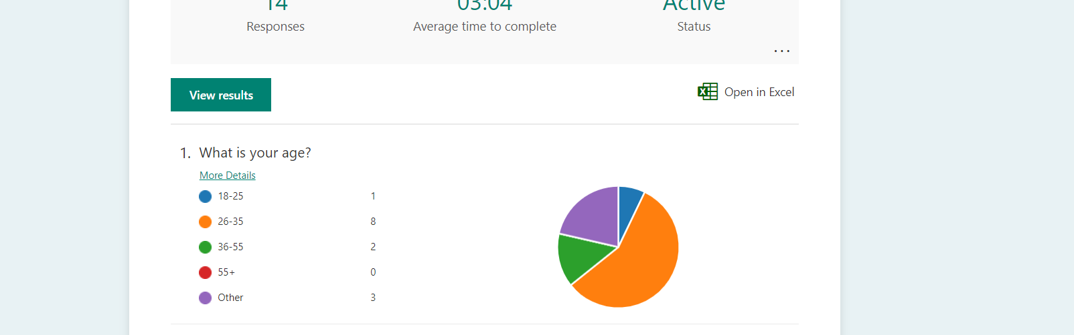
A significant percentage of people who answered the questionnaire choose to travel if the price is better than the other competitors. I will target potential customers from Bristol and London, where the car prices are higher than in Bristol. I will do that through social media advertising.
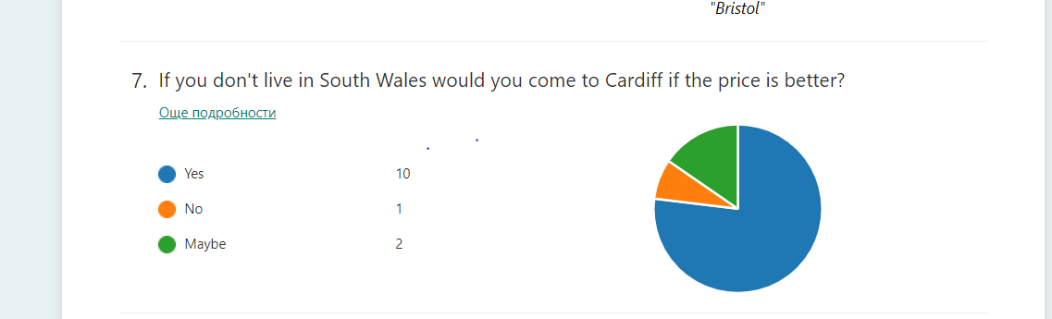

8 Pricing strategy – According to Dolgui & Proth (2010), one of the best pricing strategies is Adjustable strategies. The authors point the market segmentation, also called marked discrimination strategy, as the best car sales strategy. This strategy segments the market and puts a price for each segment, depending on how much the customer wants to pay (Dolgui & Proth 2010). For example, cars can be the same make and model but with different petrol types or the number of doors. If the vehicle is diesel, the price will be lower than if it is petrol and if the car has three doors it will be cheaper than the one with five.
The authors break down the strategy into four parts:
- Identify the customer needs through a questionnaire, for example. (Dolgui & Proth 2010)
- Identify the characteristics of parameters that are in the interest of our customers (Dolgui & Proth 2010)
- Define the characteristics (Dolgui & Proth 2010)
- Identify the parameters that characterize the customer cluster. For example, habits, geographic location, etc. (Doulgu & Proth 2010)
Sammut-Bonnici & Channon (2015) suggests a target return on investment pricing. The author explains this pricing is being used by big companies that have invested a lot of money and want a safe return on investment. Calculating the price with a target return on investment means the cost varies depending on returned investment (Sammut-Bonnici & Channon 2015). For my business, I can use that pricing depending on whether my investment in buying new cars has returned for the month or not. If not, I will have to increase the prices slightly to cover the monthly costs or have a profit that can be in usage for future investments. My car dealership will offer the possibility of buying our customer cars or part exchange them. The other option that my dealership will offer will be upgrading to a newer car when the customers pay off their previous one.

9 Marketing Sample – Flyer
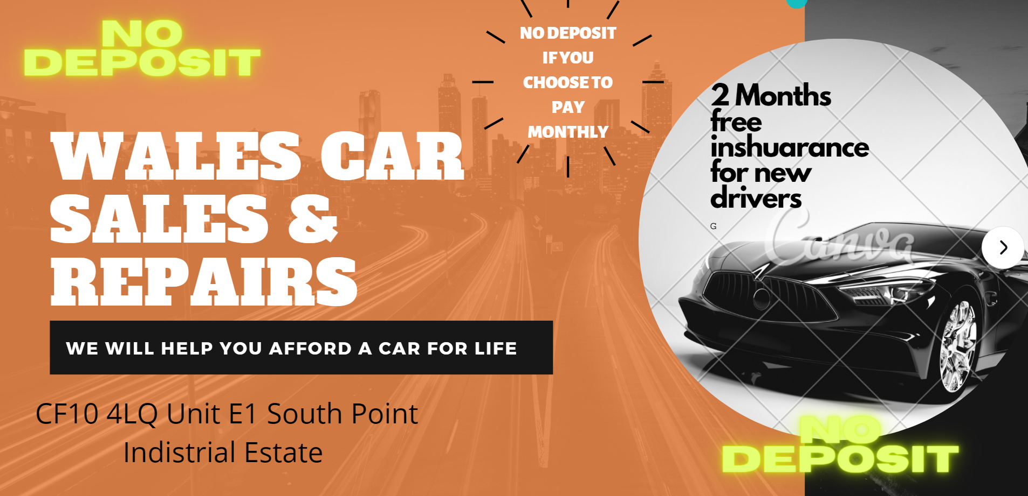
This is the flyer that I have made and will send through the post to promote my business. It shows the address and the mission statement of the car dealership. It also promotes the 0£ deposit payment option and the two-month free insurance option for new drivers.

10 The 7 P's

10.1 Product – According to the Chartered Institute of Marketing (2009), the product must provide the customer's best value. The institute also suggests that going too far with the product can be unsuccessful, for example selling Rolls Royce to a customer who wants Nissan Micra will not be possible (The Chartered Institute of Marketing 2009). One of the questions in the questionnaire regarding my business was what car makes future customers prefer.
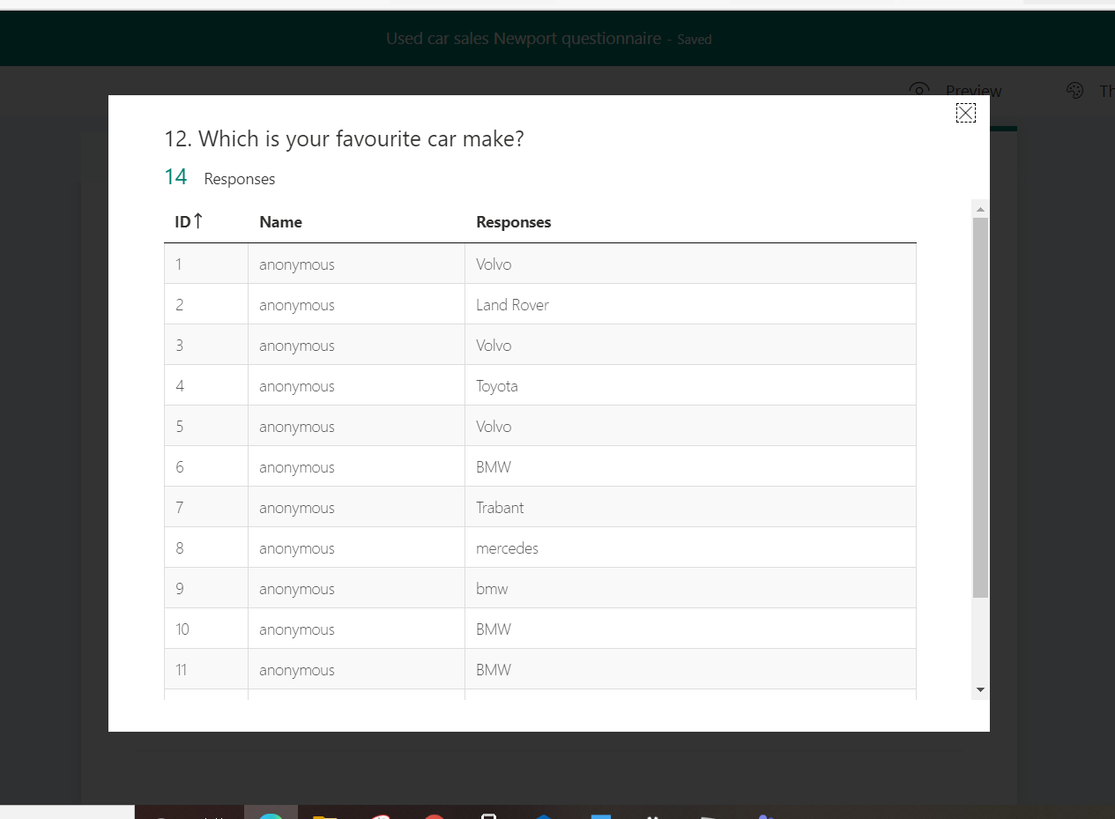
The most favorite cars, according to the questionnaire, are BMW and Volvo. However, profitable brands like Landrover Mercedes and Toyota are also good brands on their favorite lists. My first investment will be in buying BMW, and Volvo makes then. After returning my investment, I will invest in buying Mercedes, Toyota, and Land Rover.
10.2 Pricing - According to The chartered institute of marketing (2009), the pricing is where the profit comes, and it is what can keep the customer using your services ( The chartered institute of marketing 2009). To identify the price of my vehicles, I will use the pricing strategies in point 8.0.
10.3 Promotion – Tracy (2004) explains that promotion is all the ways you can tell the customer about your product. The author suggests that even smaller changes in the promotion can lead the business to success. In my future business, I will continuously update and adapt the advertisements with the trends.
10.4 Place – Tracy (2004) states that the place is where the products are selling, and it is regularly reviewing is essential. Tracy (2004) means that sometimes the change of position can skyrocket the sales. For my business, I will use an industrial unit where I can fit all the cars. The benefits of industrial units are that many people will work or pass through while going to work, which can make my business more popular.
10.5 People – Cim (2015) explains that the first impression of the people working inside your business is essential. My partner in my business and I will create a happy and enthusiastic working environment.
10.6 Process - Cim (2015) writes that buying something new for a customer now is a whole experience. Cim (2015) explains that the process and the behavior of the service or product are crucial for customer satisfaction. Therefore, for my business, the procedure of buying a car will be stress-free. The process for applying for a loan will be as simple as possible. The customers will be able to drive away with their vehicle as soon as they are approved.
10.7 Physical evidence - Cim (2015) explains that the state of where your business location is must be cleaned and beautifully decorated. Cim (2015) also suggests that physical evidence can earn the trust of the customer. We will pay a cleaning company that will clean the car park and the office inside every week for my business. My business partner has ten years of experience in car mechanics. He has several qualifications and diplomas. We will put these on the wall to build trust towards the customers and prove that we provide the best car repair service. We will also offer full car repair history for every car showing when and what repairs were made.

11. Physical Location –
https://propertylink.estatesgazette.com/ offers a wide range of industrial units. The one that I chose is ideal for the beginning of the car dealership business. It has an office and a place where the cars will go in. It is in an industrial area in Cardiff. A small benefit is that many people go to work in this area and notice the car dealership. My business partner and I are choosing this unit mainly because of the affordable rent, which is 30 000£ per year.
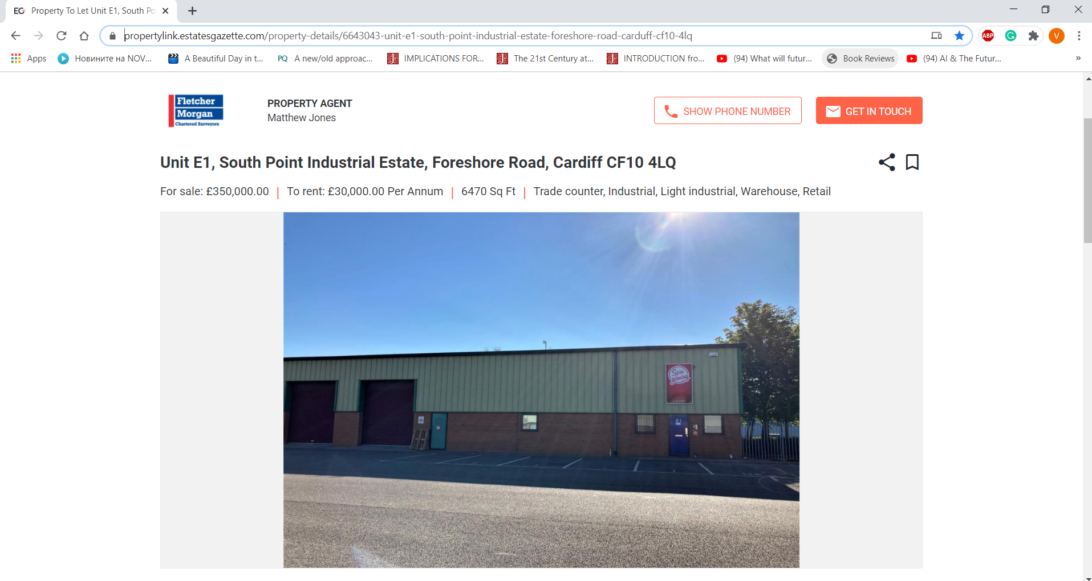

12. Human resource strategy

The legal Identity of the car dealership is Partnership. My business partner and I have agreed that it will not be necessary to hire new staff from a mechanical and decision-making point of view in the first year. We will dedicate all our time to that business and try to minimalize any costs. However, a place for experienced people in car dealerships, experienced car mechanics or accountants will always be welcome. According to the businessfirstonlone (2020), there are several benefits to hiring an accountant while setting up a small business. According to the author, the accountants can support the small business with Bookkeeping, minimizing the costs, saving time, reducing tax liability, managing business assets. There are several online accountant services that can be used for the first months of my business.

13. Sources of finance -
According to the develiopmentbank. wales (n/d), business grants can be offered to a clear business idea. The bank also offers large business loans from 50 000 £ to 5mln £. My business partner and I have 15 000 savings each, which we are going to deposit for the loan and try to apply for a business loan of 100 000 through the Development Bank of Wales.
If we cannot obtain funding from the Development Bank, several banks offer loans by showing our business plan.
Our families can also support us with 20 000 pounds. And each of us will have 5000 after applying for the loan.
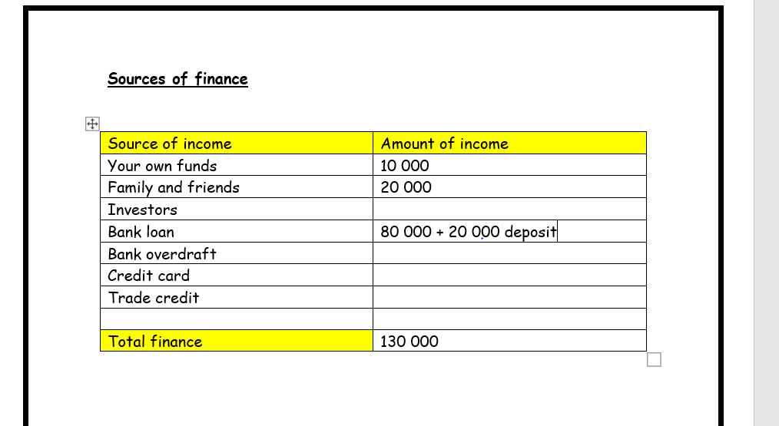

14. Cash flow forecast –

14.1 Starting costs.

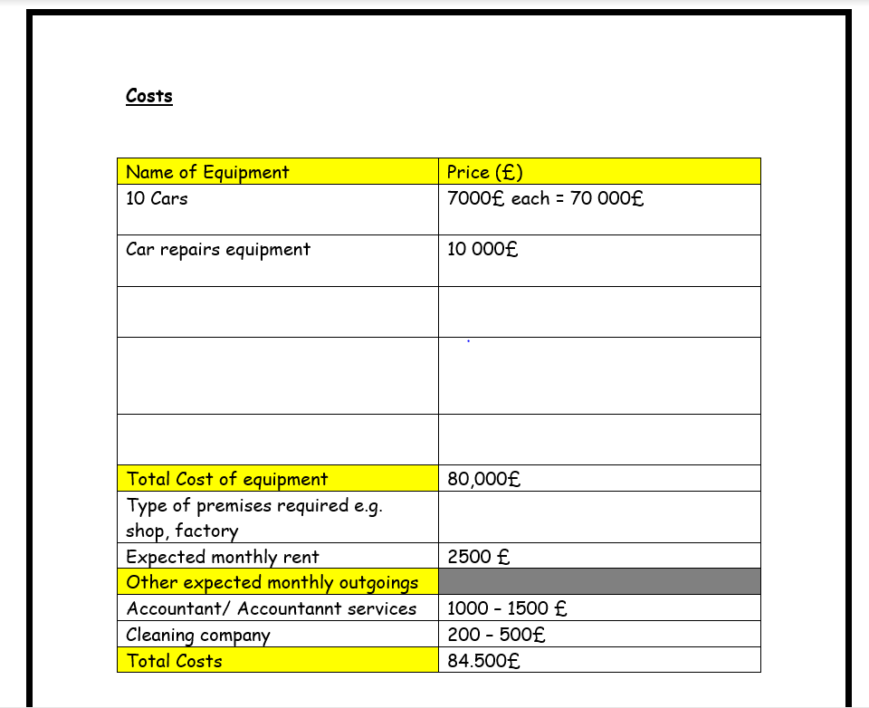
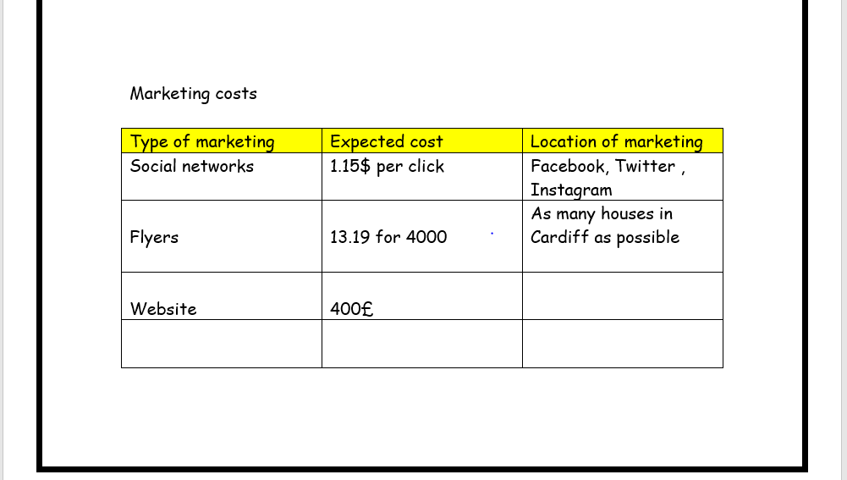

14.2 Expected sales and monthly costs.

This table shows the expected sales and utility costs.
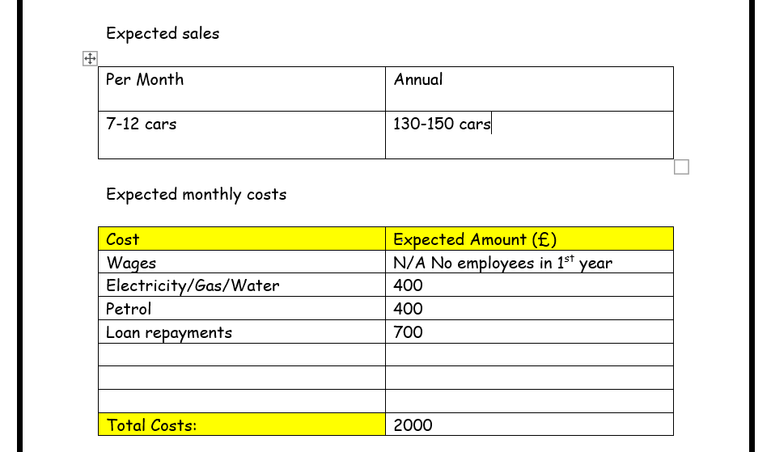

14.3 Cashflow Forecast –
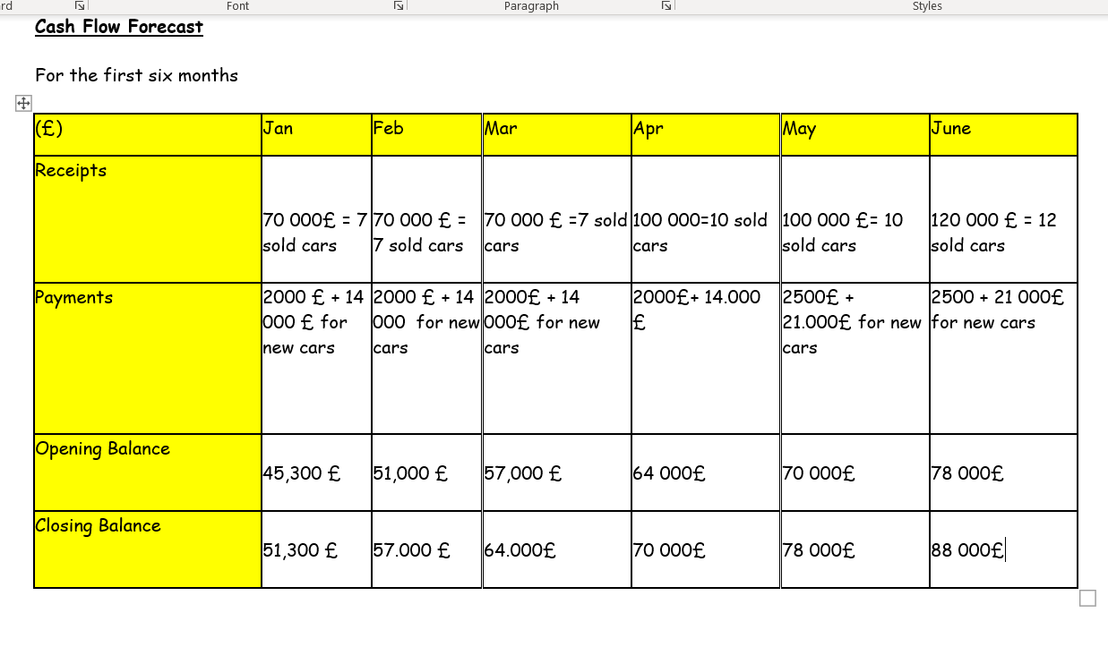
Because my business's pricing is based on the return on investment, the cash flow forecast can change every month. In this forecast, I have entered the expected monthly costs and the costs of buying new cars. In the part receipts, I entered the amount of money that Is forecasted to come into the business for the first month (in this amount is included the money I have invested for buying those cars). The estimated profit is around 3000£ per sold car. In the later months, I will increase my investment in advertising and buying new cars if there is an increase in customers.

15 SWOT ANALYSIS –

15.1 Weaknesses –

- It is risky for my business partner and me to start a business in a foreign country where you do not know that many people and u do not know the market well.
- There are a lot of used car dealerships, and I must look for alternative services.
- Lypen (n/d) concludes that today's economic times require us to step back and consider the fundamentals of the business before investing, especially in the car sales business.
It will be challenging to select which makes and how many cars to buy as a beginning.
- Investing in a car sales business is expensive and risky.

15.2 Strengths –
- People will always need cars
- Having a repair service in my car sales is unique that other car sales don't have. The unique service will help my business turn the weaknesses into strengths.
- Offering a 0£ deposit if you choose to pay monthly with the easy application process is another way to turn weaknesses into strengths.
- My business partner and I have enough savings to apply for 100 000 £ or a bigger loan.
- Friendly and helpful environment.
- There is no need to hire anyone in the first couple of months.

15.3 Threats –

- Many competitors.
- Opening new business during the pandemic
- Many people have a lower income due to the COVID-19 pandemic.
- Declined loan.
- Conflicts in the Partnership.
- In an article in The Guardian, Ambrose (2020) writes that UK has targeted to remove fossil fuel cars by 2030/ 2040. By 2030/2040 the sales of petrol and diesel cars will be banned by the UK government.

15.4 Opportunities –

- Having a repair service can be unique for the area.
- Buying electric cars can help turn competition threats into opportunities.
- Making business in the Cardiff area can be beneficial because Cardiff is the capital of Wales, and it is close to Bristol and London, which can help me reach out to customers from those areas.
- According to Jolly (2020), after easing the COVID 19 pandemic lockdown, there was a strong car trade start that increased car dealerships' sales.
Jolly (2020) states that some dealerships furlough their workers during the pandemic, allowing my business to hire some of the workers.
A colleague from UWTSD suggested I give two months of free car insurance for customers who have just passed their drive test, and this is their 1st car. This solution will help me target young people's market and make customers for life.

16 Reference list –

- Ambrose, J. (2020). UK Plans to bring forward a ban on fossil fuel vehicles to 2030. Available: https://www.theguardian.com/environment/2020/sep/21/uk-plans-to-bring-forward-ban-on-fossil-fuel-vehicles-to-2030. Last accessed 27/11/2020.
- BUSINESSFIRST. (2020). Benefits Of Hiring An Accountant For Your Business. Available: https://www.businessfirstonline.co.uk/advice/benefits-of-hiring-an-accountant-for-your-business/. Last accessed 19/11/2020.
- CIM. (2015). Marketing and the 7P. A brief summary of marketing and how it works. p1-11. https://www.cim.co.uk/media/4772/7ps.pdf
- Department for Business Innovation and Skills., (2011). A Guide to Legal Forms For Business. Available: https://www.gov.uk/government/publications/legal-forms-for-business-a-guide. Last accessed 19/11/2020.
- Development Bank of Wales. (N/D). Large business loans in Wales. Available: https://developmentbank.wales/large-business-loans-wales. Last accessed 27/11/2020.
- Hofstrand D. (2018). Promoting your business. AG Decision Maker. File C5-43, p1-3.
- Johnathan Korchak. (2017). Advantages and disadvantages of a partnership business. Available: https://www.informdirect.co.uk/business-management/partnership-business-advantages-and-disadvantages/. Last accessed 19/11/2020.
Jolly, J. (2020). Car dealers in England report strong trade as lockdown eases. Available: https://www.theguardian.com/business/2020/jun/03/car-dealers-in-england-report-strong-trade-as-lockdown-eases. Last accessed 27/11/2020.
- Lawdepot. (n/d). Free partnership agreement. Available: https://www.lawdepot.co.uk/contracts/partnership-agreement/?loc=GB&pid=googleppc-gprtnr_gb-PartnershipT1_sx1-ggkey_set%20up%20partnership&gclid=Cj0KCQiAwMP9BRCzARIsAPWTJ_HfYAzsNJ30oiXIfws-NfA4rnOh0e2e. Last accessed 19/11/2020.
- Lusk C. and Marshall I. M. (n/d) 'How to Use Goals to Achieve Business Success: First Steps for New Entrepreneurs' (EC-726)
- Lypen, J. (N/D). EDITOR'S REPORT. Available: https://www.motor.com/magazine-summary/editors-report-2-september-2001/#:~:text=The%20primary%20strengths%20of%20dealerships,and%20that%20they%20are%20impersonal.. Last accessed 21/02/2020.
- Proth J-M. and Dolgui A.. (2010). Pricing Strategies and Models. Annual Reviews Control. 34 (1), p101 - 110
- Sammut-Bonnici,T., and Channon D. F. (2015). Pricing Strategy. In: Professor Sir Cary L Cooper Wiley Encyclopedia of Management. University of Malta: John Wiley & Sons, Ltd. p1-3.
- Statista. (2020). Facebook and Instagram CPM (cost-per-mille) in the UK 2020 Published by Joseph Johnson, Nov 24, 2020 Cost-per-mille (CPM) on Facebook and Instagram in the United Kingdom (UK) dropped below 1.5 U.S. d. Available: https://www.statista.com/statistics/1114986/facebook-cost-per-mille-uk/. Last accessed 19/11/2020.
- The Chartered Institute of Marketing. (N/D). Marketing and the 7Ps . Available: https://www.thensmc.com/sites/default/files/CIM%207Ps%20Resource.PDF. Last accessed 19/11/2020.
- The Company Warehouse. (N/D). Advantages and Disadvantages of Partnership. Available: https://www.thecompanywarehouse.co.uk/blog/advantages-and-disadvantages-of-partnership#:~:text=The%20two%20main%20disadvantages%20are,body%20only%20available%20since%202000). Last accessed 19/11/2020.
- Tracy, B. (2004). The 7 Ps of Marketing. Available: https://www.entrepreneur.com/article/70824. Last accessed 19/11/2020.

17 Appendices -
Questionnaire Link :
https://forms.office.com/Pages/ShareFormPage.aspx?id=DQSIkWdsW0yxEjajBLZtrQAAAAAAAAAAAAN__hLDDeVUN09FODhNNFFSMlYxVlI4VlhaWlZPOERTRy4u&sharetoken=aIG7n09pkeraqU3hi2bO
Location link :
https://propertylink.estatesgazette.com/property-details/6643043-unit-e1-south-point-industrial-estate-foreshore-road-carduff-cf10-4lq
Partnership agreement link :
https://www.lawdepot.co.uk/contracts/partnership-agreement/?loc=GB&pid=googleppc-gprtnr_gb-PartnershipT1_sx1-ggkey_set%20up%20partnership&gclid=Cj0KCQiAwMP9BRCzARIsAPWTJ_HfYAzsNJ30oiXIfws-NfA4rnOh0e2eF-1XkY26BXXCLU-44A5RiEYaAsLcEALw_wcB#.X84YHWj7RPb

18 Presentation Slides –



