Student name: Laura Jayne Williams
Student number: 1802657
Course: BA music technology, year 1

Word count: 1,474

Bury A Friend

A). Billie
What do you want from me? Why don't you run from me?
What are you wondering? What do you know?
Why aren't you scared of me? Why do you care for me?
When we all fall asleep, where do we go?
B). Come here
Say it, spit it out, what is it exactly
You're payin'? Is the amount cleanin' you out, am I satisfactory?
C). Today, I'm thinkin' about the things that are deadly
The way I'm drinkin' you down
Like I wanna drown, like I wanna end me
Step on the glass, staple your tongue (ahh)
Bury a friend, try to wake up (ah ahh)
Cannibal class, killing the son (ahh)
Bury a friend, I wanna end me
I wanna end me
I wanna, I wanna, I wanna end me
I wanna, I wanna, I wanna
D). What do you want from me? Why don't you run from me?
What are you wondering? What do you know?
Why aren't you scared of me? Why do you care for me?
When we all fall asleep, where do we go?
Listen
E). Keep you in the dark, what had you expected?
Me to make you my art and make you a star
And get you connected?
I'll meet you in the park, I'll be calm and collected
But we knew right from the start that you'd fall apart
'Cause I'm too expensive
Your talk'll be somethin' that shouldn't be said out loud
Honestly, I thought that I would be dead by now (Wow)
Calling security, keepin' my head held down
Bury the hatchet or bury your friend right now
F). For the debt I owe, gotta sell my soul
'Cause I can't say no, no, I can't say no
G). Then my limbs all froze and my eyes won't close
And I can't say no, I can't say no
Careful
Step on the glass, staple your tongue (ahh)
Bury a friend, try to wake up (ah ahh)
Cannibal class, killing the son (ahh)
Bury a friend, I wanna end me
I wanna end me
I wanna, I wanna, I wanna end me
I wanna, I wanna, I wanna
H). What do you want from me? Why don't you run from me?
What are you wondering? What do you know?
Why aren't you scared of me? Why do you care for me?
When we all fall asleep, where do we go?
Throughout this essay I am going to discuss my ideas and plans for an art exhibition in the Glynn Vivian Museum Swansea. I want the exhibition to be in the Glynn Vivian Museum as I believe the venue is of a larger holding capacity and with my plan for the event being at night, I believe the venue would enable me to achieve a dark sublime looking walk-through experience which would enhance the themes displayed as discussed below.

Below is the list of artist’s whose work I hope to present at the exhibition:
- Agnes Cecile
- Louis Jover
- American McGee

The exhibition will be accompanied and introduced by singer-songwriter Billie Eilish’s hit ‘Bury a Friend’. The idea is to have multiple speakers placed in different locations near the art features with different levels of volumes and effects placed on the music in order to highlight and accompany the pieces so that it is not the sole attraction.

I have chosen Eilish’s song because it portrays both literal and metaphorical images which can be perceived to fit multiple different themes and ideas, presenting fluidity in haunting gothic themes. I was drawn to this piece of music as a result of this, but, also the fact that the song plays with the ideas of typical beauty and arguably portrays the opposite.

I believe that the art that I have chosen and the music accompanying it will create a dark theme which can be explored and perceived in numerous ways by the audience. I want to play with the fear of the unknown and the uncertainty of life which are two themes present in Eilish’s song. In order to coherently portray this, each piece of art will be displayed with spotlights of different colours in order to create different themes and moods to accompany the piece in order to present a cohesive theme.

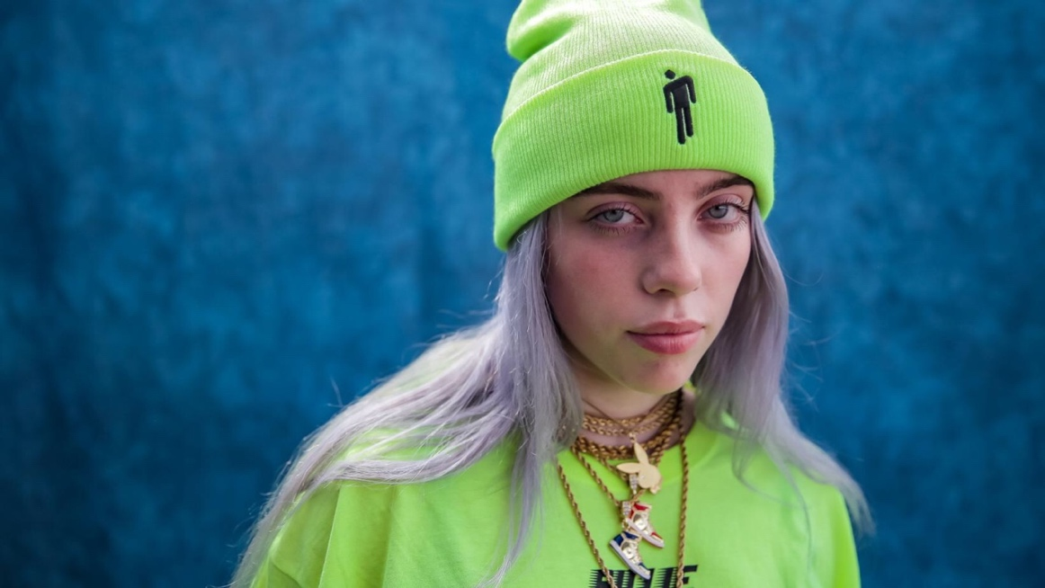
Billie Eilish

(Image from google)

Billie Eilish’s album from which the song derives from is titled “When we all fall asleep, where do we go?”. Playing with the core theme of sleep paralysis and the emotions caused as a result. Naturally, this song and album inspired my ideas for my exhibition as she plays with the ideas of moods and feelings as a result of something negative like sleep paralysis whilst creating different songs which portray her different moods.

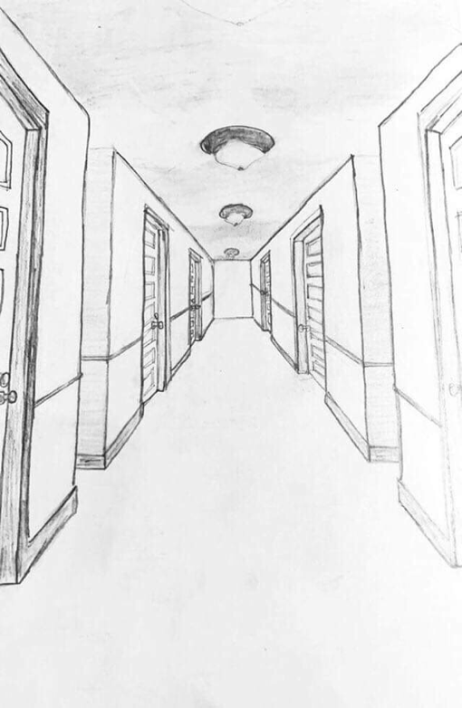
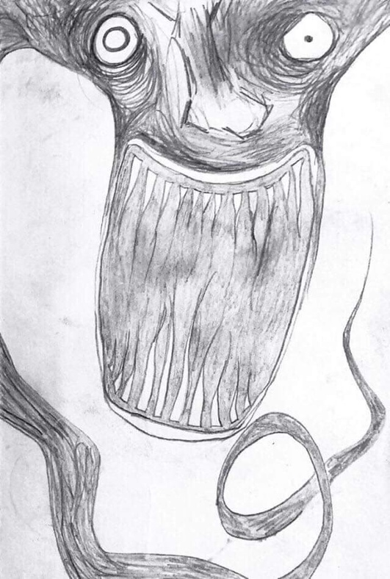
Another reason why I chose Eilish is due to the fact that she creates a lot of art coordinating with each song. She uses a notebook in which she writes all of her lyrics and then sketches designs which she feels links to each song. Below, I have included some images which I also will be displaying at the exhibition as I feel having art from Eilish herself is a unique opportunity which could help to bond the art and music together.
(Image from Eilish’s instagram)

I have gained this knowledge through watching multiple interviews from Eilish, however, felt incredibly inspired by the one linked below. In this interview she drew an image which she linked to ‘Bury a Friend’, explaining how the character in which she designed draws likeness to the concept of the ‘monster under the bed’ and the darkness within herself. She later explains that the drawings she created to each song not only help inspire her to write more, but also help her express how each song makes her feel.
("Billie Eilish Attempts The Blank Canvas Challenge | MTV PUSH", 2019).

Agnes Cecile

Agnes Cecile is an Italian, self taught artist that creates watercolour paintings to express human emotion. I believe that this artist will suit my exhibition as I feel her artwork is very expressive and could help portray the message of uncertainty regarding life which Billie uses as a core theme. The media used is watercolour which in itself is a very expressive and almost careless medium as the way she uses it is in a rapid and messy manner. Creating an almost sketch like finish which depicts the messiness and unclarity revolving around the central themes.
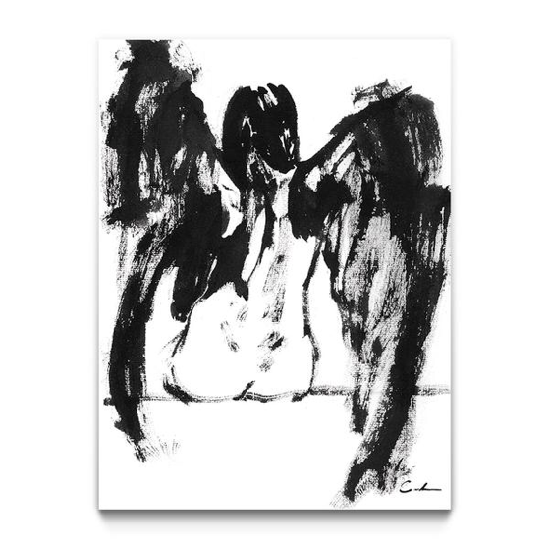
(Walls, 2019).
This is the first image I have chosen by this artist as I feel it presents the feeling of someone watching over you as you sleep, and as a result, will link with Eilish’s concept of sleep paralysis. For this piece I will have a dull white/grey light shining onto it to highlight the darkness of the piece. The fact that it is a black and white painting and the roughness of the outlines gives the piece a haunting look as if it’s something from a nightmare and I feel it suits the song very well a a result.

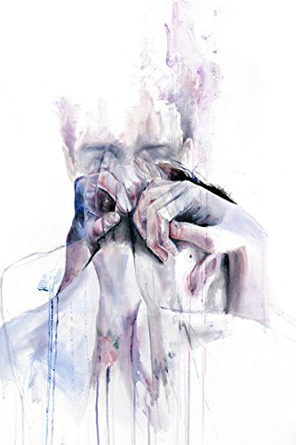
( image from google )

This piece I feels shows a person leaving their body almost like astral projection also known as an outer body experience. Like I have said previously I believe that is what Billie Eilish means when she asks “when we all fall asleep, where do we go?”. It’s almost as if it is a cry fro help, during an outer body experience you cant really move or talk so I feel it links into section G of the song “my limbs are froze” and “my eyes wont close”.
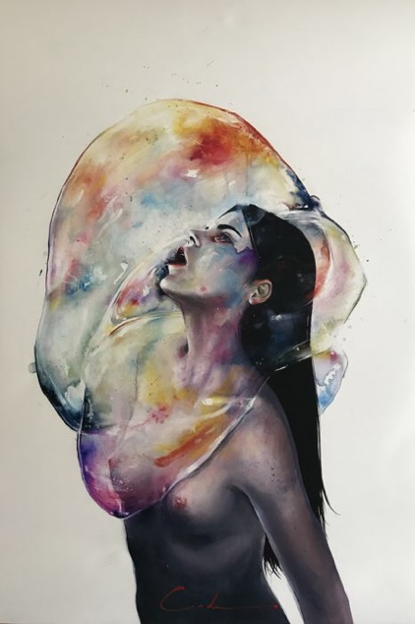
(image from google)

With this piece I feel that the artist is trying to express the feeling of metaphorically drowning within yourself. I believe this could link into sleep paralysis as when it happens you wake up suddenly unable to move or speak, almost as if you are being held down by an energy. I believe it fits in with section C of the song “Today, I'm thinkin' about the things that are deadly” almost as if the stress, anxiety or depression is a deadly thing in her brain. She then sings
“Like I wanna drown, like I wanna end me” showing that there is a feeling of wanting to drown and pushing her to feel the pain she is experiencing in such a negative manner that suicide is mentioned.

Louis Jover

Jover is an Australian artist and is known for his art style with canvases which he has covered with pages from vintage books. The reason his art work feels relevant to the exhibition is because he not only plays with colour in a manner that portrays complex emotions and feelings of sadness, but also, because he depicts a lot of women crying. This image not only portrays the overall feeling of Eilish’s song, but, is also reminiscent of her music video from the song “when the party’s over” because in the music video she has black tears streaming down her face.
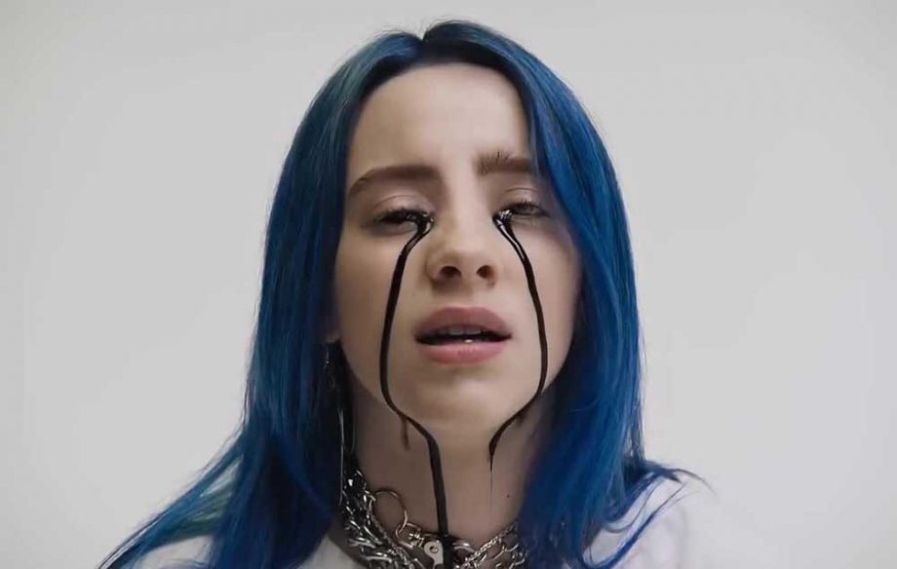
("Billie Eilish - when the party's over", 2019)

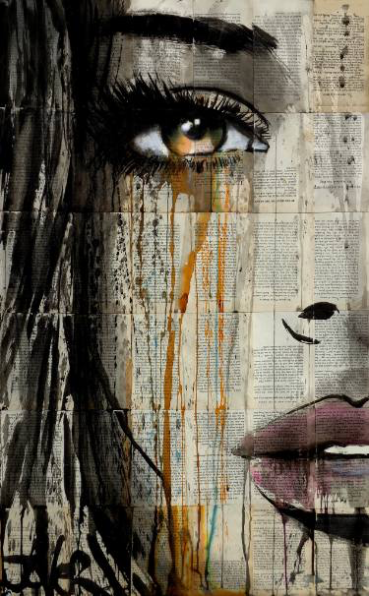
A lot of his artwork that I have seen is a lot like this, for example:
( image from google )
Through finding this image I looked into more of Jover’s work and found some interesting images that I feel would also fit into my exhibition efficiently.

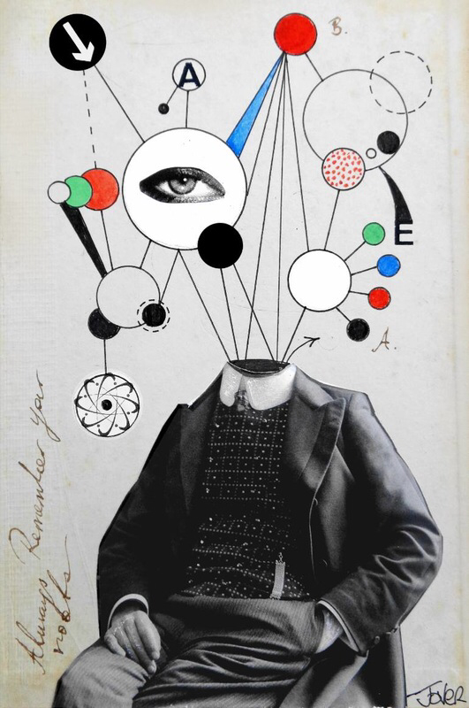
( image from google )
I feel that this image represents dissociation. Dissociation is “a mental process of one’s thoughts, feelings, memories or sense of identity” ("Dissociation and dissociative disorders", 2019) . Looking into this I have found out that dissociation is as if the person is detached from themselves and reality. I believe that this piece of art work and my believed meaning behind it fits in with the song because the common theme of mental illness, stress and trauma are a common link in many of these images and Eilish’s track.

( image from google )
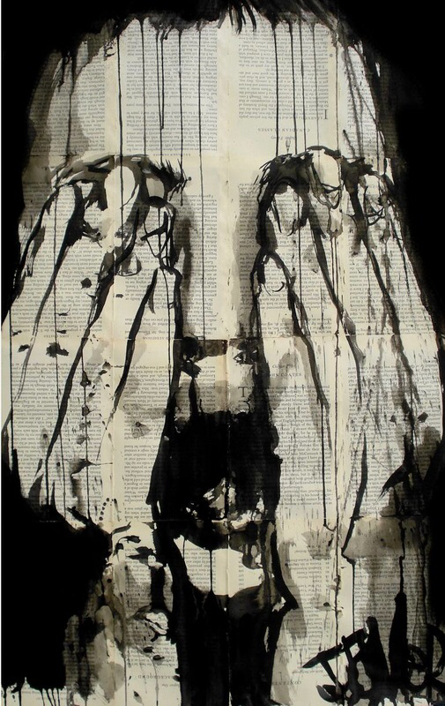
This image I think represents the fear of the “unknown” which something I’m strongly believing this song is about. This piece captures the darkness of what Eilish is putting out there with the song and I feel it would be a strong piece to have at the exhibition with a red spotlight on it to highlight the sense of fear and desperation that is strong in the image.

American McGee

Game designer, American McGee created multiple games depicting the twisted and dark themes occurring in Alice in Wonderland. Not only does he play with the concept of the monster under the bed, but also depicts macabre looking characters which I believe would fit with section F of the song in which she claims she has to ‘sell her soul’. I feel this is a coherent link as Eilish plays on the idea of the good and bad within us in this section of her song, in the same manner that McGee does in his art. He has taken Lewis Carrolls’ concept of the fairy tale ‘Alice in Wonderland’ and twisted it into a dark macabre story of hardship, pain and misery. I plan for these images to be at the final section of the exhibition to symbolise the idea of falling down the rabbit hole or ‘selling your soul’ in a sense of finality.

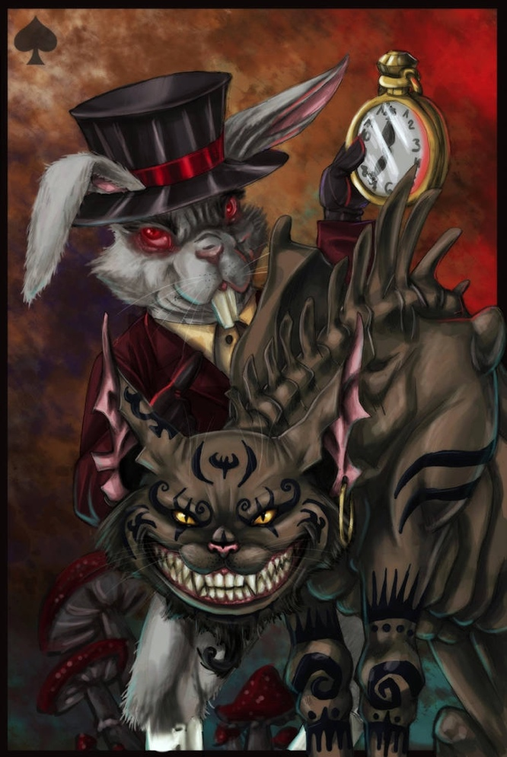
( image from google )

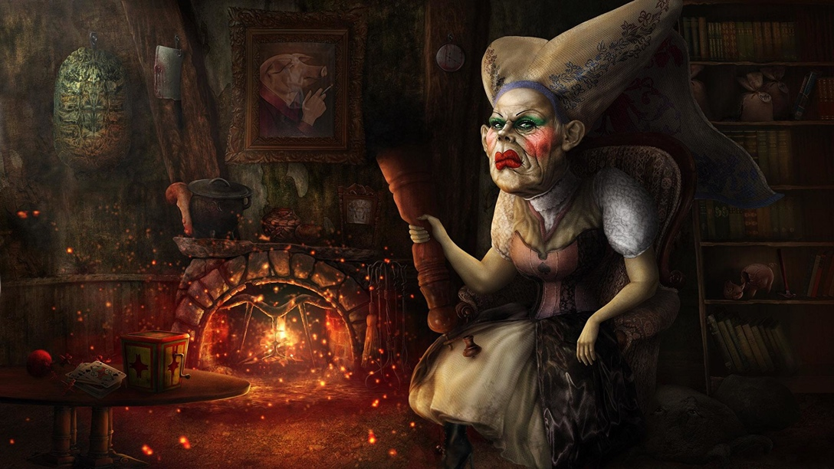
( image from google )

Bibliography

Billie Eilish Attempts The Blank Canvas Challenge | MTV PUSH. (2019). Retrieved from https://youtu.be/3xwh3tR_e88

Walls, E. (2019). Wings I. Retrieved from https://www.eyesonwalls.com/collections/agnes-cecile/products/wings-i

Billie Eilish - when the party's over. (2019). Retrieved from https://youtu.be/pbMwTqkKSps

Dissociation and dissociative disorders. (2019). Retrieved from https://www.betterhealth.vic.gov.au/health/conditionsandtreatments/dissociation-and-dissociative-disorders

