
Assignment 2:
Operating Systems
CertHE Computing Skills for Workplace

Computer Architecture and Operating Systems. ACCA4022_LON
DR. Redhwan Al-Amri (Lecturer)
University of Wales Trinity Saint David
(London Campus)
Student Name: Pedro Claudio Martinez Almanzar
Student Number: 2510674
Lecturer: Kwame Assa Agyei
Group: 04
Date: 29/04/2026

Table of Contents
Introduction 1
1. Key functions of general Operating Systems 1
Systems 1
1.1 Process and Processor Management 1
1.2 Memory Management 3
1.3 File System Management 4
1.4 Security and Protection 5
2. Use of Windows OS CLI commands. 7
3. Use of Linux OS CLI commands. 15
4. Use of Windows OS scripts. 20
5. Use of Linux OS scripts. 23
Conclusion 26
References 27
Appendices 29

Introduction

An Operating System is often described as the “brain” of a computer, but a more interesting way to see it is as an invisible coordinator working behind the scenes. Every time you open an app, save a file, or connect to the internet, the OS is quietly making thousands of decisions per second—deciding which program gets priority, how memory is used, and how hardware components communicate without conflict.
Rather than being just another piece of software, the Operating System acts as a bridge between human intention and machine execution. It translates simple user actions into complex instructions that the hardware can understand, ensuring everything runs smoothly and efficiently. Without it, even the most advanced computer would be unable to perform basic tasks or respond to user input.
In this way, the Operating System is not just a tool, but the foundation that makes all digital interaction possible.

Key functions of general Operating Systems
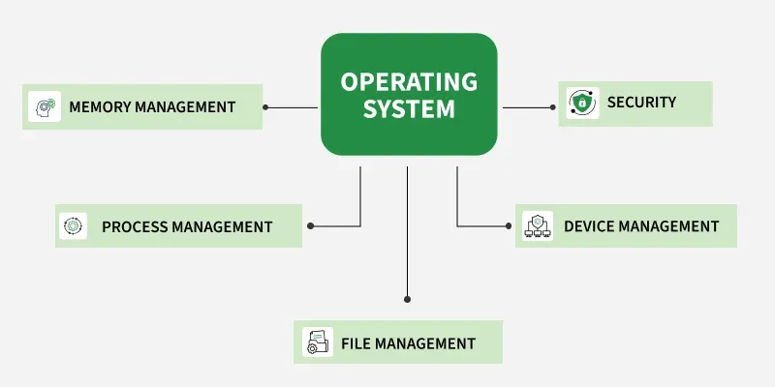
An operating system is a collection (or suite) of programs that manages and controls the computer. Operating systems have many functions:
- controlling hardware components
- providing a platform for software to run on
- providing a user interface
- multitasking facilities
- managing the computer's memory
- managing peripherals
- managing files
- managing users

- Example operating systems include:
- Microsoft Windows
- MacOS
- Linux
- Android
- IOS

Process and Processor Management
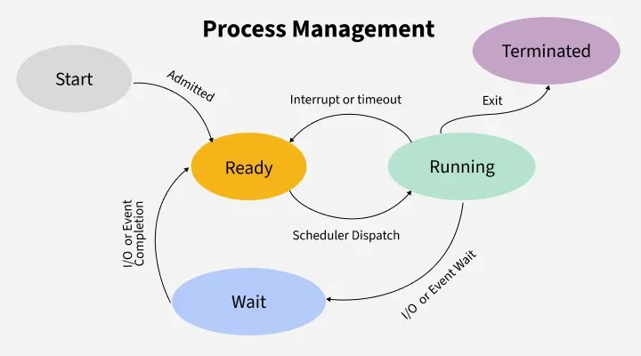

- Process Creation:
- Processes are created by other processes using system calls. This parent-child relationship leads to the formation of a process hierarchy. In Unix-like systems, the fork system call is used to create a new process by duplicating the current process.
- The child process created by fork is an exact copy of the parent process, except for a few distinctions such as the unique process identifier (PID).
- After a fork, the exec family of system calls (execl, execv, etc.) is often used to replace the child’s memory space with a new program, allowing the execution of different code.
2. Process Scheduling:
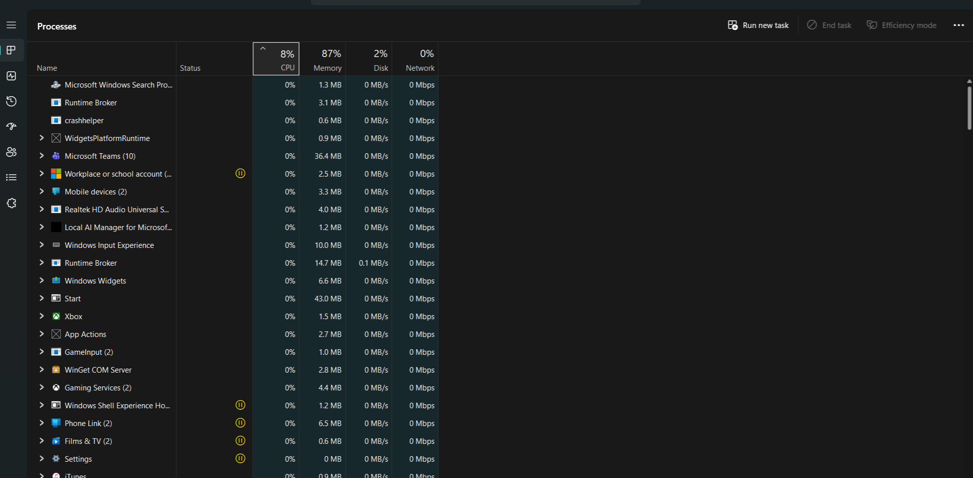

- The OS must manage which process runs at any given time to ensure efficient CPU utilization. This is the responsibility of the scheduler, which uses various algorithms to manage process execution.
- Preemptive Scheduling: The OS can interrupt and switch the running process to ensure all processes get CPU time.
- Non-preemptive Scheduling: The process runs to completion once started.
- Common scheduling algorithms include:
- First-Come, First-Served (FCFS): Executes processes in the order they arrive.
- Shortest Job Next (SJN): Selects the shortest job available to minimize waiting time.
- Round Robin (RR): Each process is assigned a fixed time slot in rotation, providing a balanced allocation of CPU time.
- Priority Scheduling: Processes are executed based on priority levels, which can be dynamic or static.
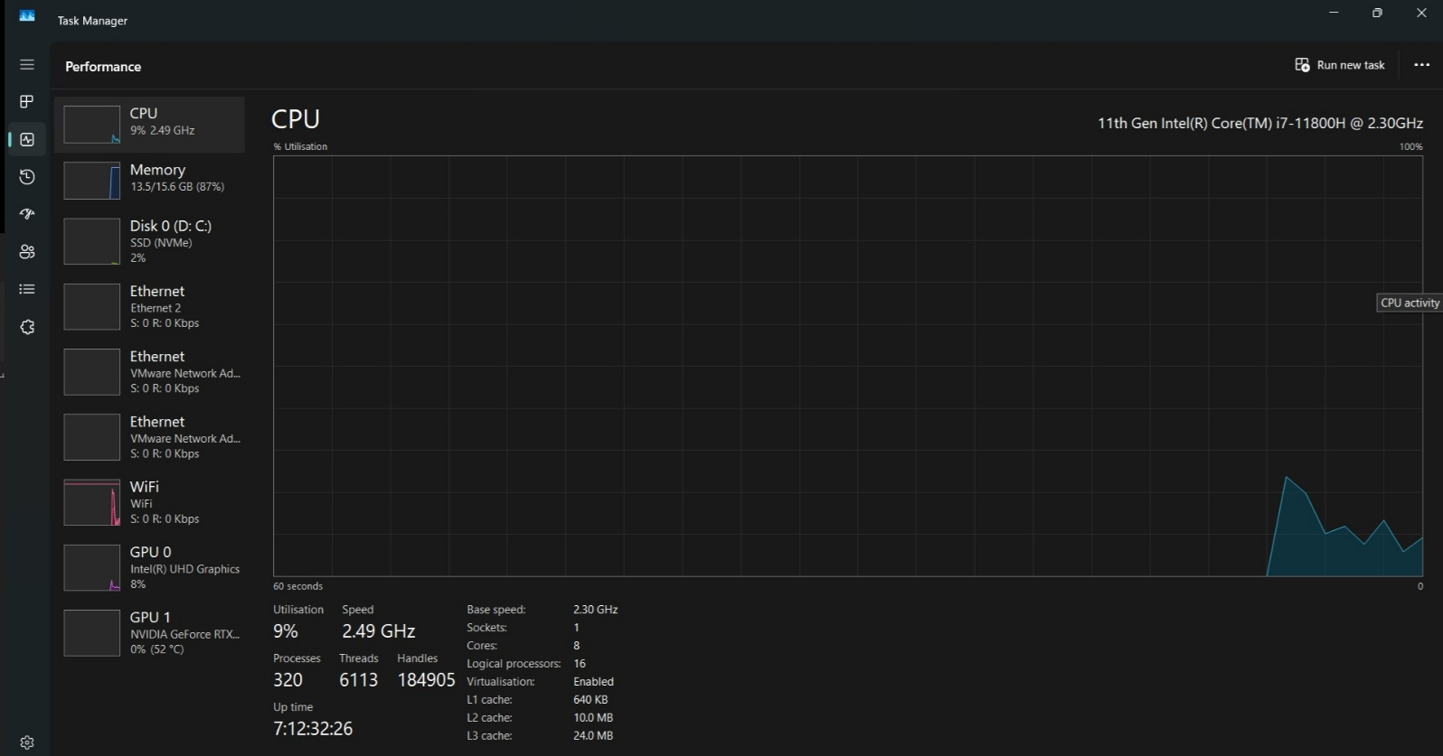
3. Core Functions in Process Management:
- Scheduling: Decides which process uses the CPU next (using algorithms like Round Robin or Priority Scheduling).
- Synchronization: Ensures orderly execution using locks, semaphores, or monitors to prevent race conditions.
- Deadlock Handling: Detects and prevents situations where processes wait forever for resources.
- Inter-Process Communication (IPC): Allows processes to exchange data via shared memory or message passing.

1.2 Memory Management
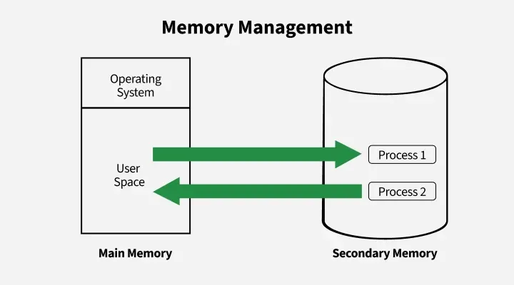
- Memory management in an operating system controls how data is stored and organized in main (primary) memory and secondary storage, ensuring programs get the memory they need and freeing it when no longer used.
Key Activities in Memory Management:
- Allocation & Deallocation: Assigns and frees memory as needed.
- Protection: Prevents processes from interfering with each other’s memory..
- Virtual Memory: Uses disk space as extra memory to run large programs.
- Fragmentation Handling: Reduces wasted space through compaction.
- Disk Management: Handles file storage, free space, disk scheduling, and backups.

1.3 File System Management
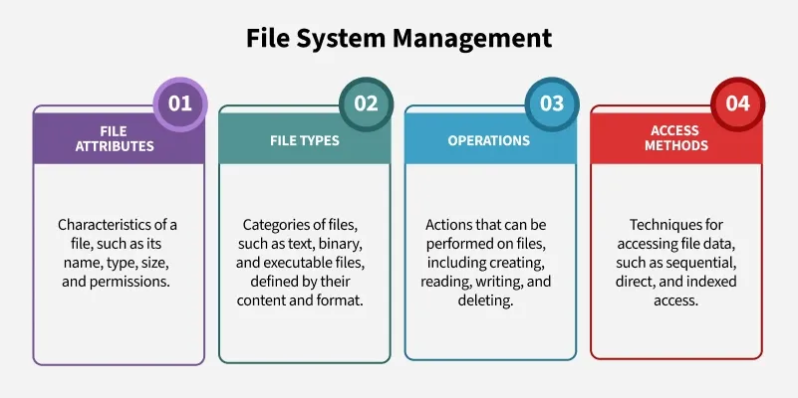
- File management in an operating system organizes and controls how data is stored, named, and accessed on storage devices, making it easy for users to find and use their files.
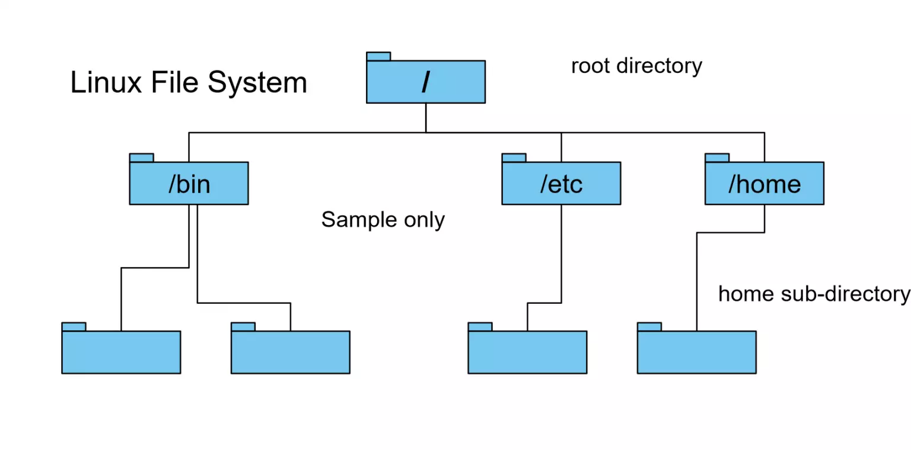

1.4 Security and Protection
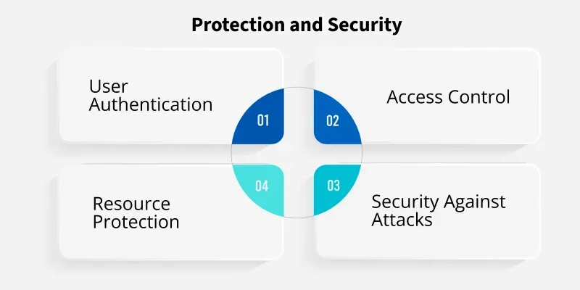
The OS protects system resources and user data from unauthorized access and attacks.
- Access Control: Limits user and process permissions.
- Authentication: Verifies users through credentials (UIDs/SIDs).
- Resource Protection: Prevents misuse of files, memory, or devices.
- Security: Guards against malware, denial-of-service attacks, and data theft.

2. Use of Windows OS CLI commands.
- Systeminfo
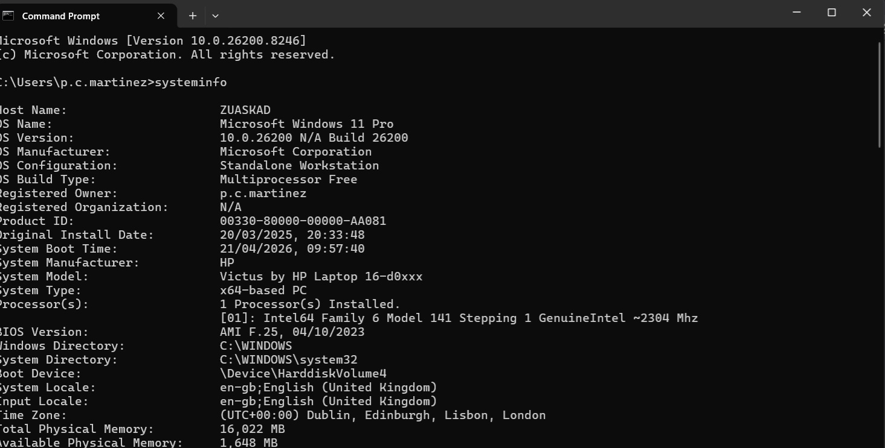
- Dir - Displays a list of the files and subdirectories in a directory. If used without parameters, this command displays the disk's volume label and serial number, followed by a list of directories and files on the disk (including their names and the date and time they were last modified). For files, this command displays the file extension and size in bytes. This command also displays the total number of listed files and directories, their cumulative size, and the remaining free space (in bytes) on the disk.
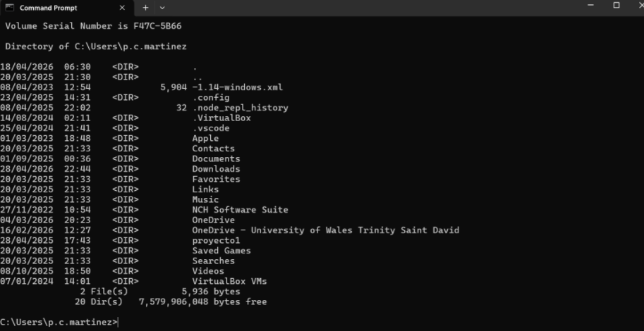
- Color 2 - Changes the Text Color of the Command Prompt

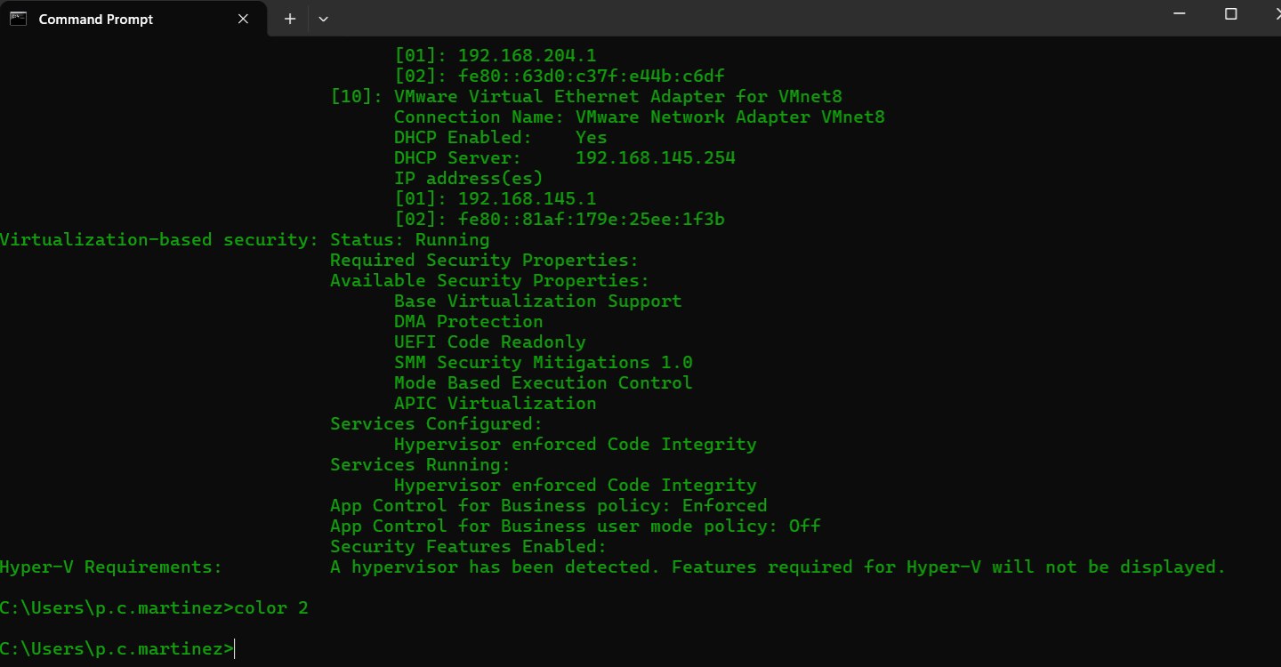

3. Use of Linux OS CLI commands.
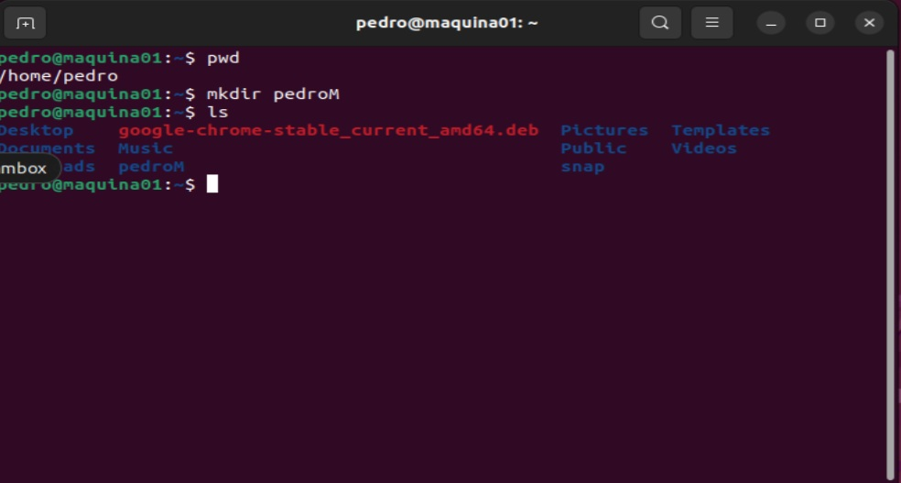
- The mkdir command allows you to create directories from within the terminal.
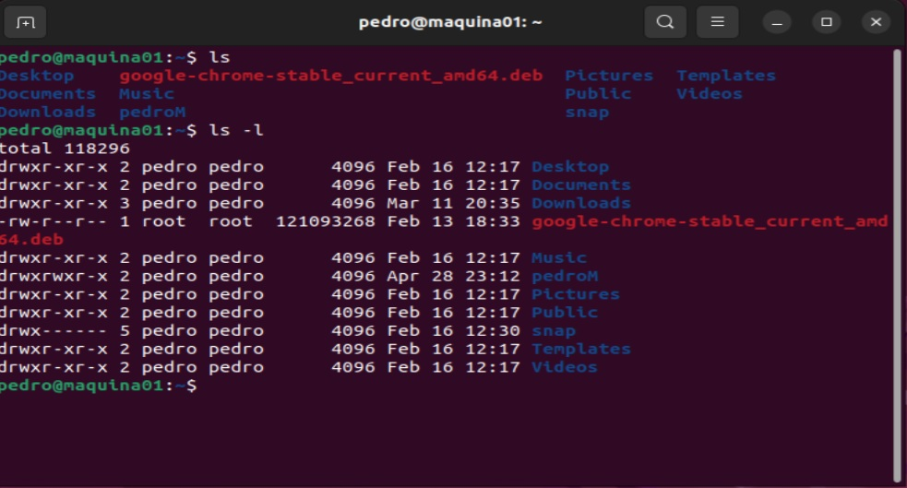

- The ls command is used to list files and directories in the current working directory. This is going to be one of the most frequently used Linux commands you must know of.

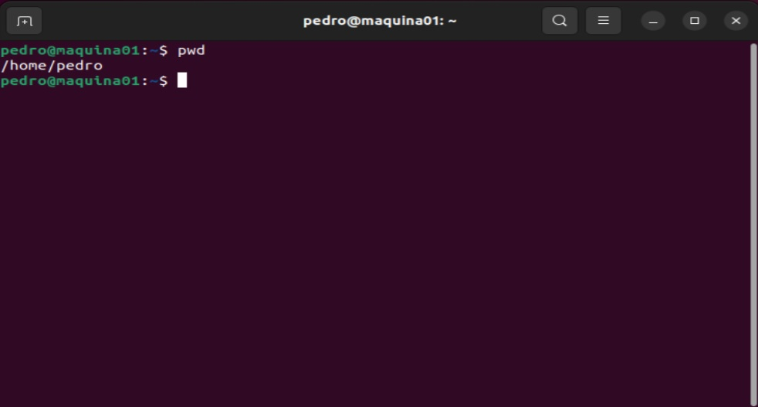

- The pwd command allows you to print the current working directory on your terminal. It’s a very basic command and solves its purpose very well.

4. Use of Windows OS scripts.

Let's create a simple batch file. First, open Notepad. Type the following lines into it:
ECHO OFF
ECHO Hola Pedro Martinez
PAUSE
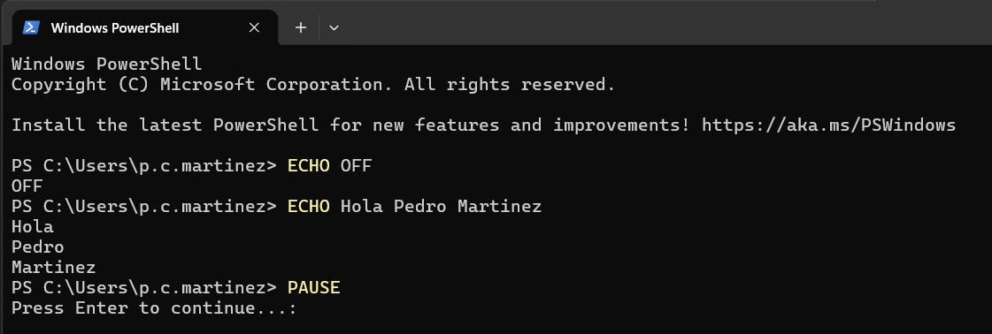
- A batch file is simply a text file saved with the .bat extension. You can write one using Notepad or a more advanced text editor like Notepad++, but don't use a word processor like Microsoft Word.

5. Use of Linux OS scripts.
#!/bin/bash
# Adding two numbers
num1=2
num2=7
sum=$((num1 + num2))
echo "the Sum Of $num1 and $num2 is $sum"
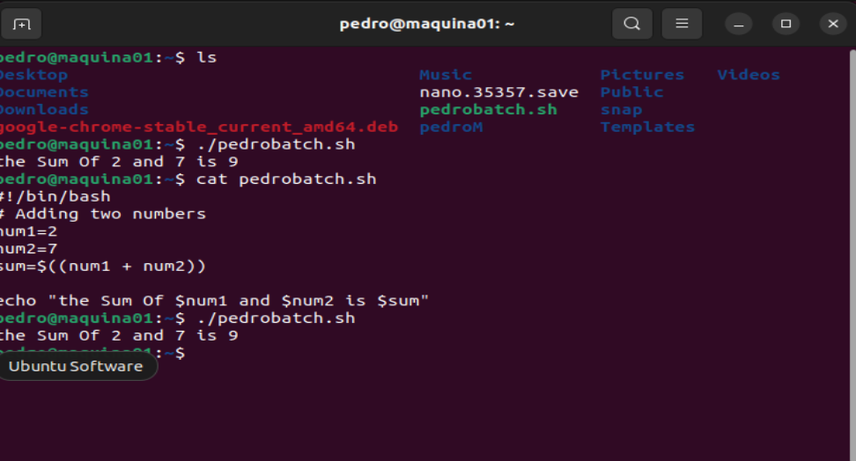
- I developed a batch file that performs the addition of two numbers. This is achieved by defining two variables, num1 and num2, and applying an arithmetic operation to compute their sum. The result is displayed on the screen using the echo command.

Conclusion
- In conclusion, this work highlights the fundamental role that Operating Systems play in the functioning of modern computing environments. By exploring key areas such as process and processor management, memory management, file system organization, and security and protection, it becomes clear that the OS is responsible for ensuring efficiency, stability, and safe interaction between hardware and software.
- Furthermore, the practical use of command-line interfaces in both Windows and Linux demonstrates the importance of understanding system-level operations beyond graphical environments. CLI commands provide greater control, precision, and flexibility when managing tasks, troubleshooting issues, and automating processes.
- In addition, the use of scripting in both operating systems shows how repetitive tasks can be optimized, saving time and reducing human error. Scripts not only improve productivity but also allow for more advanced system administration and customization.
- Overall, mastering these concepts and tools is essential for anyone working in IT or computing, as they provide a deeper understanding of how systems operate and how to manage them effectively in real-world scenarios.

References

[1] | AITS-TPT, "UNIT-I Operating Systems Functions," 26 August 2025. [Online]. Available: https://aits-tpt.edu.in/wp-content/uploads/2022/06/Operating_System-min.pdf.
[2] | Britannica, "Operating system (OS) | Definition, Examples, & Concepts," 26 August 2025. [Online]. Available: https://www.britannica.com/technology/operating-system.
[3] | UTC, "Chapter 8: Memory Management," [Online]. Available: https://www.utc.edu/sites/default/files/2021-04/2800-lecture8-memeory-management.pdf. [Accessed 26 August 2025].
[4] | University of Bologna (cs.unibo.it), "File Systems," [Online]. Available: http://www.cs.unibo.it/~sangio/SO_currentAA/Luc_SO/FileSystem/File_Systems1.pdf. [Accessed 26 August 2025].
[5] | MBIT, "Operating System Concepts, 8th Edition," [Online]. Available: https://www.mbit.edu.in/wp-content/uploads/2020/05/Operating_System_Concepts_8th_EditionA4.pdf. [Accessed 26 August 2025].
[6] | GeeksforGeeks, "How to Monitor System Activity in Linux | top Command," [Online]. Available: https://www.geeksforgeeks.org/linux-unix/top-command-in-linux-with-examples/. [Accessed 26 August 2025].
[7] | OpenStax, "6.4 Memory Management - Introduction to Computer Science," [Online]. Available: https://openstax.org/books/introduction-computer-science/pages/6-4-memory-management. [Accessed 27 August 2025].
[8] | TechRepublic, "How to use Windows 10's Resource Monitor to track memory usage," [Online]. Available: https://www.techrepublic.com/article/how-to-use-windows-10s-resource-monitor-to-track-memory-usage/. [Accessed 27 August 2025].
[9] | Testbook, "Process Management in Operating System - Learn Details Here!," [Online]. Available: https://testbook.com/operating-system/process-management-in-operating-system. [Accessed 27 August 2025].
[10] | Turing, "How to Use the Linux Free Command," [Online]. Available: https://www.turing.com/kb/how-to-use-the-linux-free-command. [Accessed 27 August 2025].
[11] | OpenStax, "6.5 File Systems - Introduction to Computer Science," [Online]. Available: https://openstax.org/books/introduction-computer-science/pages/6-5-file-systems. [Accessed 27 August 2025].
[12] | GeeksforGeeks, "df command in Linux with Examples," [Online]. Available: https://www.geeksforgeeks.org/linux-unix/df-command-linux-examples/. [Accessed 27 August 2025].
[13] | man7.org, "top(1) - Linux manual page," [Online]. Available: https://man7.org/linux/man-pages/man1/top.1.html. [Accessed 27 August 2025].
[14] | GeeksforGeeks, "System Protection in Operating System," [Online]. Available: https://www.geeksforgeeks.org/operating-systems/system-protection-in-operating-system/. [Accessed 27 August 2025].
[15] | Fiveable, "OS Security and Access Control | Cybersecurity and Cryptography Class Notes," [Online]. Available: https://library.fiveable.me/cybersecurity-and-cryptography/unit-5. [Accessed 28 August 2025].
[16] | PDQ, "10 PowerShell commands every sysadmin should know," [Online]. Available: https://www.pdq.com/blog/top-powershell-commands-to-know/. [Accessed 28 August 2025].
[17] | Active Directory Pro, "50 Basic Windows Commands with Examples," [Online]. Available: https://activedirectorypro.com/windows-cmd-commands/. [Accessed 28 August 2025].
[18] | Varonis, "Windows PowerShell Scripting Tutorial For Beginners," [Online]. Available: https://www.varonis.com/blog/windows-powershell-tutorials. [Accessed 28 August 2025].
[19] | NinjaOne, " How to Automate Repetitive Tasks with PowerShell," [Online]. Available: https://www.ninjaone.com/blog/how-to-automate-tasks-with-powershell/. [Accessed 28 August 2025].
[20] | Tom, " Essential PowerShell Commands for Beginners," [Online]. Available: https://medium.com/tomtalkspowershell/essential-powershell-commands-for-beginners-613bfa9cef82. [Accessed 29 August 2025].
[21] | Hostinger, " Bash Scripting for Beginners + Downloadable Free Cheat Sheet," [Online]. Available: https://www.hostinger.com/tutorials/bash-scripting-tutorial. [Accessed 29 August 2025].
[22] | It's FOSS, "Bash Scripting Tutorial for Beginners," [Online]. Available: https://itsfoss.com/bash-scripting-tutorial/. [Accessed 29 August 2025].
[23] | DataCamp, "How to Write a Bash Script: A Simple Bash Scripting Tutorial," [Online]. Available: https://www.datacamp.com/tutorial/how-to-write-bash-script-tutorial. [Accessed 29 August 2025].
[24] | geeksforgeeks, "File Systems in Operating System," geeksforgeeks, 2026. [Online]. Available: https://www.geeksforgeeks.org/operating-systems/file-systems-in-operating-system/.

Appendices
- This section provides supplementary material that supports the content presented in this work. It includes additional examples, command references, and scripts used throughout the report for both Windows and Linux Operating Systems.

