Understanding and Engaging in the Customer Experience

Student Name: Iulian-Alexandru Dinu

Student Id: 1909113

Lecturer Name: Mary March

Module Name: Understanding and Engaging
in the Customers Experience

Module Code: BMSW5103_LON

Contents
2 Introduction 2
2.1 Company Introduction 2
2.2 Report Introduction 3
3 Main Body 4
3.1 Platforms used by Prezzo 5
3.1.1 TripAdvisor. 6
3.1.2 Google reviews. 6
3.1.3 Prezzo voice. 7
4 How covid-19 affected relationship between customers and company. 7
4.1 How Prezzo pass the Covid-19 pandemic and how they keep good relationship with their customers. 8
5 Customer service and Customer Relationship 10
6 Customer Relationship Management (CRM). 13
7 Porter’s five forces 17
8 Conclusion 17
9 References 18

Introduction

Company Introduction

The company we are going to analyse today is called PREZZO which it’s an Italian restaurant which was founded in year 2000 on New Oxford Street London, back then the restaurant was called Jonathan’s. (prezzorestaurants.co.uk, 2022)
Since then, till present the restaurant become very well-known and loved Italian restaurant which has around 150 restaurants across UK with more than 2.500 employees that are creating memorable moments for the customers spreading the passion and love for Italian food.
In 2014 the company was bought by TPG Capital for over 300 million pounds, which become a partner TPG it’s also in partnership Ask Italian, and other restaurants.
In 2019 Cain International which is a private investment firm bought the company which are working together with the executive chair to restore the popularity and the prestige of PREZZO again, making the people to live the Italian food that the restaurant provides using authentic Italian recipes.
Using Authentic Italian product to create the perfect dishes such as pizza, pasta, seafood, fish, and many others for the customers giving them a taste of Italy in their home.

Report Introduction

This report will analyse how the company was engaged in Customer Experience and how they keep a track on what the customers wants and what are their expectation from the company.
Using different methods and platforms to collect information from the people and improve the way the company works, such tools, platforms, and methods they will be identify and analysed in the report underneath.
During COVID-19 many businesses were affected and the physical engagement with the customer disappear which affected the Customer relationship with the business, very important factor on profitability and effectiveness of the company.
After the Covid-19 when everything started slowly to improve and come back to normal all the people started to feel insecure to return to their normal life such as before the virus, many of them lose the trust in different company.
It’s the company duty to analyse all the information gather for the people and create the perfect plan using different methods on winning their trust back.
This will give a clear idea to the reader how important it’s the Customer Relationship for a business and how this information will help a company to advance in their working sector and keep ahead of the competition, by creating a plan to improve the Customer satisfaction and relation.

Main Body
What is Customer experience and relationship, customer experience?
- Customer Experience.
For a successful business customer experience, it’s crucial to attract people, provided an amazing experience and making the customers happy it’s a high probability for those to become loyal to the business.
Having loyal customers can help with the promotion of the products and brand making word of mouth marketing making the company more known across the country.
- Customer Relationship.
It’s similar just like a relationship the company needs to keep the trust and keep the customers happy on the way, with customers happy they will keep preferring the company rather than other companies.
The company needs to make sure that the standards are not dropped and keeps all the loyal customers happy, which can refer the company to others by increasing the reputation.
Both are a part of the Customer relationship management (CRM), managing all of them will give the company a boost in the relation with the existing customers or future customers.

Prezzo it’s a company that’s using few platforms to gather feedbacks and information from the customers about the products which are sold by the business, with the help of those feedback the company can act, rectify, or improve those products or dishes.
The huge amount of information and feedback gather by Prezzo company it’s more precise when more than one platform it’s used, all the information from all the platforms is processed, separated, and analysed by the company.

Platforms used by Prezzo

What are these platforms, they are application or websites which allows customers to leave feedback from all the places they are visiting and what were their experience during the visits?
These feedbacks will allow them to describe, compliment, or disagree with the service receive, and the feelings they had during the visit, which allows the company to gather information about the restaurant they have and how they treat the existing customers.
The platforms used by Prezzo company are common and very popular within Hospitality sector such as TripAdvisor, Google reviews, Prezzo voice which it’s the most used by the company.
Each platform has their own strengths and weaknesses, which will be explained and analysed after, using more than one platform gives better data and information on what the customers think and what are their dissatisfaction or satisfaction about the company.
Taking in consideration the feedbacks a plan can be created which will improve the standards and quality of the products sold to satisfy the customers and improve the productivity, and service provided by the company, which will make the company name and reputation to grow more.

TripAdvisor.

This platform it’s know Globally used by most of the hospitality sector companies. This application allows the customers to write and rate their satisfactions or dissatisfactions of the places they visit with a rate system they can chose to rate how they felt and what was their experience.

Google reviews.

World-wide website and application which allow people to navigate and check all the restaurants, hotels, pubs, and many other businesses around them, by clicking and navigating through the app they can gather information about those places and check other people’s opinion and feedbacks which visited in the past.
Providing access to previews reviews from different people, having an impact on their decision if they will visit in the future or not.

Prezzo voice.

Prezzo voice it’s the company Review system which give access for the customers to leave feedbacks with specific details by giving them the opportunity to choose exactly where was wrong or good which affected their experience, they can rate and write their satisfaction or dissatisfaction.
On this application they can rate from the following:
- Tase of drink and food.
- Presentation of the drinks and food.
- If they’ve had any issues during the visit.
- If there were solved fast and accordingly with their demands.
- If the Server was polite and dress accordingly with the venue.
- How they will rate the service.
And many other questions which allows the company to gather the necessary information and get involved on how they can solve the problem if it’s one.

How covid-19 affected relationship between customers and company.

In 2019 when the corona virus pandemic has spread many countries around the world chose to stop the spread by closing all the borders and enter in a full national lockdown which affected the economy and the people more than we realised, everyone was locked in their houses, the government close all the public venues or business which worked with customers to prevent the further spread of the virus.
Hospitality sector was the most affected from them all when smaller or family business forced to shut the doors and stop function, most of them didn’t have the financial power to pass through the lockdown being forced to keep the doors shut permanently or sell.
The lockdown forced the people (customers) to stay indoors without socializing or having their normal routine which, which had a strong emotional affect on their behaviour and thrust for the outside world.
Loosing the trust and confidence for many businesses they started to fell into depression losing the relationship they had before wit many businesses and peoples.
Chain restaurant businesses with financial power manage to adapt to the situation by converting their business from face-to-face service to online service which allowed them to keep the relationship with some of the customers, by selling the products which customers loved at their doorstep.

How Prezzo pass the Covid-19 pandemic and how they keep good relationship with their customers.

During the lockdown Prezzo kept the restaurants open delivering their food to the customers, implementing a safe environment for the driver which were waiting to deliver the food to the customers.
Adaptation of a business after the external condition its crucial and doing it right can have a positive effect on the customers and business as well.
Each business suffers in their own way with the business close all the employees working in hospitality sector loss their job going in Furlough or made redundant, the government trying to support and help all the employees and business their offer financial support, which allowed business to keep some of their employees.
But many of them retreated to their origin countries with the thought not to come back because of the actual situation and instability that business offers during the pandemic.
Another factor which affected many businesses was Brexit with the United Kingdom leaving Europe Union they close the gates for many European people which are possible future employees for many businesses.
When the Brexit occurred so many European people, got scared and decide to go back to their origin country leaving a massive gap in the hospitality sector which affected all the business in the sector.
Even after the Brexit settled in the law and rules change for all the people entering the United Kingdom make it very hard for the people to obtain documents and visa to work in the UK which left many businesses understaffed.
Each understaffed businesses suffers in loss of profit close a part of the branches making them vulnerable for closure, many companies reduce their menu trying to save money and increase their profit, the remaining staff it’s overworked to compensate with the loss of the others working extra hours.

Marketing strategy during Covid-19 Lockdown

Prezzo come up with a plan to promote their products online and attract new customers, and keep the existing customers happy and satisfied, increasing the trust in the company.
The steps of the promotional plan can include promotions, product deals such as 2 for 1 or x percent off the total amount, family packages, partners, and association discounts.
Prezzo works with few delivery platforms such as Uber Eats, Deliveroo, and Just Eats which are the most popular across the UK, providing a large variety of dishes for the customers to choose from.
Using the social media platforms to promote the products and promotions, such as Instagram, Facebook, and the Prezzo website.
Prezzo in association with the platform used for delivery creates different promotions for each of them.
- Uber Eats most of the customer which choose to use this platform can benefit from discounts such as family pack for a fixed price of free drink with a minimum amount of x Pounds, used to attract new customers and keeping the existing one to order more often increasing the relation with the business.

- Just eat users benefits most of the discounts such as x percent of from the total amount if x pounds amount its reach, or bonuses for the drivers working extra hours to deliver food for our customers.
Increasing their productivity and volume of the products sold which will increase the profit of the company.

- Deliveroo users of this platform can benefit for different discount such as two products purchased third it’s for free which can include a soft drink of choice, or a free dessert.

All the drivers are rewarded for their hard job with discounts and specific promotion for each purchase they make from the company products.

Customer service and Customer Relationship

To provide the best customer service Prezzo company released special training from steps of service, wine pairing with the dishes, spirits, and the perfect pairing, going over and beyond for the customer satisfaction. All the staff members including management, need to have every six months retraining and accept the new terms and conditions of the company.
Before the start of the shift, duty manager briefs the staff, give them the information about the day, remind them service steps, ask them questions about allergens, dishes ingredients, recommendations and give them small tasks that they need to achieve, and they will be rewarded on the end of the shift or week. Duty managers need to sure that the waiters are providing excellent hospitality and service together. Service will impress the customers, hospitality will bring them back and if all is excellent, they will recommend the restaurant.
Customer service is a key factor to satisfy customer needs, and feedback is one of the most important tasks that the line manager needs to provide every week to the OPT management. Prezzo work with platform called SMG, that create a survey and every customer is asked to give us feedback in the end of his experience in the restaurant. Based on the information that we have from the customer we know where our strengths are and were the service needs to be improved. In times after Covid-19 were large number of restaurants closed because they couldn’t sustain on the market, to survive and provide great hospitality, Prezzo worked to improve every single complain, customer needs, to pay attention on every detail and to become favourite Italian restaurant.
During the pandemic Prezzo used different take away platforms and even now some of the restaurants are depending on them to continue to work and keep their staff. That’s the reason every takeaway to be treated like the customer is in the, to pay attention on details like special requests, allergens, extras, to reward the customer if its regular and to do small extras that will make him happy – children’s stickers when it’s a kid’s menu, add promotion leaflet with the new dishes, offer 20% discount for a Click and Collect. Line manager is checking every single complain that come from the platforms and is approving refund only if the error comes from the restaurant. That’s save over £1,500 per week that will go out from the sales.
In March, Prezzo board of directors decided to increase the prices on the menu, to add new dishes and to invest in the refurbishment in a part of their restaurants. Due to these changes, employees needed to start their trainings to increase their knowledge and to provide hospitality that will be special. Demand is high and lots needs to be improved especially with the lack of the experienced staff members that hospitality in general have after 2020. Most of front of house staff members are young, sixteen years old part-time students, this is first job for them and management needs to be careful how there are treated, if they are safe, if there are overwhelmed, need extra support. On the same time, management is also responsible for the customers to received maximum of service that Prezzo promise, great experience, to add always extra doesn’t matter if it’s a casual dinner or special occasion. Balance between unexperienced staff, lack of the chefs, meantime customers are willing to come in the restaurant especially after two years of pandemic, increase the stress and professionalism is more than important than before. Prezzo make a campaign and send to all their restaurants that are experiencing difficulties with finding the right candidates for their positions special 30% cards and written apology to their customers, if the duty manager can’t provide them a table, because of the lack of the staff members. They aren’t many waiters for example that will be able to provide excellent service on a shift if they are alone with only one manager and more than 50 people. That will cause delays, stress, complaints, and the consequences will stay longer than the good experience. In general people are willing to leave a complain than the great revue, and one customer can use social platforms to share their bad experience in the restaurant.

Customer Relationship Management (CRM).

Customer Relationship Management help a business to create a strategic plan to provide a better service to attract new customers and keep the standards for the existing customers.
With the implementation of a CRM plan will help a business to reach the desire revenue and even increase the revenue, to keep providing the best service for the customers company standards need to be keeps without fail, a decrease on standards means losing customers which will affect the revenue and trust build with the customers.
CRM it’s a strategic process which will help the company to understand better what the customers want and what they need, and what the company can do to meets those needs which will enhance the relationship with the customers.

For a successful CRM plan implementation there are few key steps to follow which will lead to a successful implementation of the plan.
Bringing together all the possible information about customers and trends will help you underpin all the essential information which will provide us key points about the customers and there are expectations and experience.
As we mention before Prezzo use SMG platform to collect feedback from the customers and to understand how the business is run daily. For example, on the bill they can see who served them, name of the person, unique code that they need to apply when they are making the feedback. The questions are related to the service, food, if they experienced any issues during, they stay and if this issue were properly resolved. In situation if something goes wrong is important how the waiter communicate with the customer if they listen to them and correctly provide information to the duty manger so the problem will be resolved painless. Service recovery is one of the key points in costumer relation and communication with the restaurant. On a busy shift everything can happened and with the proper tools and provided information and training, the recovery can be successful and in the end the feedback can be positive.
To avoid misunderstanding or to provide for example on busy special holidays service and tables to all the customers, line manager needs to collect the maximum information about the customer when booking is done – over the phone or online. For example, Prezzo is extremely busy on Mother’s Day, more than 300 bookings are received for the day, the general manager or assistant manager need to call all the bookings before the day to re-confirm them, to read properly the notes that customers are leaving when they are doing the reservation and to answer customers questions during the phone call. During Christmas period, Valentine’s Day, Mother’s Day, etc the company are not doing any discounts (Tesco Vouchers, Taste cards, Meerkat, NHS discounts etc.), to avoid any issues on the day, when the line manager call to confirm the booking, he needs to explain that Prezzo’s discounts aren’t available on the day, needs to provide proper timing , how long the customers can have the table due to the demand of the bookings and if the customer needs some extra help. Communication is a key for a great hospitality. Providing all this information line manager is sure that during the busy shift everything will be smoothly managed, waiters will be focused on their sections, and he can provide excellent hospitality to his guests.
When all the information is collected and the plan implemented all the key points now its to focus on keep the high standards regarding service provide the best experience for the customers, after all the team should be focus on the following key points.
- Providing the products and services exactly how the customer wants.
- Offering the best service for them.
- Selling products more effectively.
- Retaining the existing customers and discover new ones.
There are 3 types of CRM each company choose the best suited one for them, those types are.
- Collaborative.
- Analytical.
- Operational.
Prezzo CRM contain all 3 types which will help the company keep a track on what’s happens with all the branches being a chain with 150 restaurants everything needs to be organise all the information store and sorted for each brunch individual.
The company it’s using collaborative were communication between suppliers, team, customers, and Company are essential for a successful business and increase in productivity and revenue.

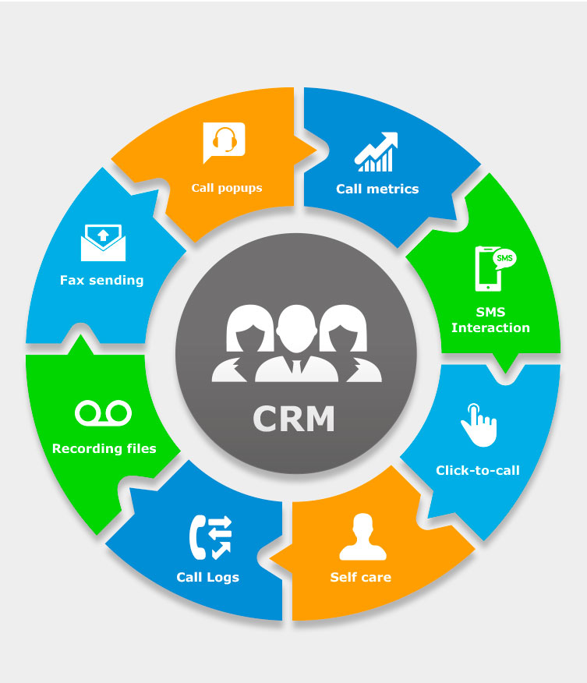
This Photo by Unknown Author is licensed under CC BY-NC-ND
By the data provided during the customer experience in the restaurant, Prezzo keep a connection with them, sending them emails with discounts on special occasions like birthdays – bottle of Prosecco free of charge, two desserts or discount from the bill. Regular customers always received the offers first and information about what is going on, new Set menus, lunch menus or Holidays menus (Christmas set menu – 2 courses for £19.00: 3 courses for £22.00).
Analytical CRM is used to pass the information to the head office and to create a pattern between the customer and the company and to keep the customer information safely for marketing purposes.
Based on the information collected from the customers Prezzo adjust the menu based on the customers feedbacks, analysing the menu and the sales of the dishes, adding or remove dishes from the menu based on those sales, this process it’s analyse carefully, and all the customers’ demands, and reviews are sorted and separate.
That information are transmitted from the HO to the branches, any change made to the menu it’s carefully planned and implemented, to ensure that the customers will not be disappointed on the change and lose the desire to buy the company products.

Porter’s five forces
Porters five it’s a business analysis model that explain why various industries manage to keep a level of profitability.
What is Porter’s five forces.
- Competition in the industry.
- Potential of new entrant in the industry.
- Power of supplier.
- Power of customers.
- Threats of substitute products.

Conclusion
After finalising the report will give a better understanding how a company creates strategically a plan step by step to achieve and provide the best customer service, what are the steps they take, how they collect the information from the customers and how they analyse the information to for efficient in the specific purpose.
What type of marketing they use and what promotion they provide for the customers to win new one and keep the existing ones loyal and keep their trust, and to stay on top of the competitors by wining more customers and reach the desired goals and targets?
How they can maximize they revenue and how to improve their standards to achieve the customers needs and what they want from the company in term of service and experience.
Which are the steps the company takes and how they provide training for the team to reach the company standards, by providing access to the company training platform all team member they will know how to provide the excellent service the business wants them to improve the productivity, efficiency, and revenue.
Understanding better what it’s CRM and how this helps a company stay on top and increase the communication between suppliers, customers, and team, increasing the relation with the customers and wining regular customers which will choose the company over others.

References
1928, M. A., 2015. Armstrong's handbook of performance management : an evidence-based guide to delivering high performance. 5th ed. s.l.:Kogan Page.
Anon., 2022. https://www.bighospitality.co.uk. [Online]
Available at: https://www.bighospitality.co.uk/Article/2020/12/02/Italian-casual-dining-restaurant-group-Prezzo-bought-by-real-estate-investment-firm-Cain-International
[Accessed 10 4 2022].
Images, G., 2022. Google Images. [Online]
Available at: https://www.google.com/search?q=tutto+application&tbm=isch&ved=2ahUKEwioy5LBwZ_1AhUaKxoKHXeYAQMQ2-cCegQIABAA&oq=tutto+application&gs_lcp=CgNpbWcQAzIHCCMQ7wMQJzoECAAQGDoLCAAQgAQQsQMQgwE6CAgAEIAEELEDOgUIABCABDoICAAQsQMQgwE6BAgAEEM6BAgAEB5QkwlY9ipg3i1oAHAAeA
[Accessed 02 01 2022].
investopedia, 2022. [Online]
Available at: https://www.investopedia.com/terms/p/porter.asp
[Accessed 26 04 2022].
prezzorestaurants.co.uk, 2022. https://jobs.prezzorestaurants.co.uk/our-story. [Online]
Available at: https://jobs.prezzorestaurants.co.uk/our-story
[Accessed 2022 03 15].
Wailgum, T., 2017. CRM definition and solutions, Framingham: CXO Media, Inc..

