

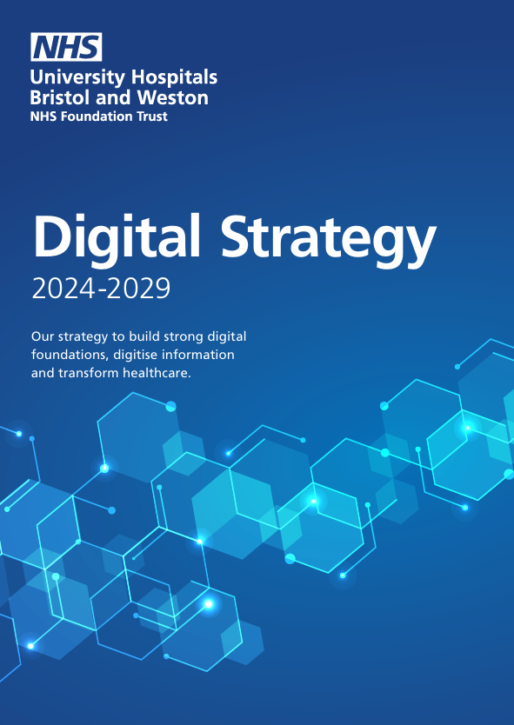
Critically reflection on Multi- and Inter-disciplinary working in digital transformation
Abstract

Grant Healey (2517190)

Contents
Introduction 2
context 2
Stakeholder identification and categorisation 2
Core clinical stakeholders 2
Digital, informatics, and data professionals 2
Managerial and organisational leadership 3
External stakeholders 3
Patients and users 3
Engagement across disciplines 4
Tailored vs Collective engagement 4
Multi-disciplinary working 4
Engaging patients and users 4
Reflection on communication and engagement methods 5
Formal meetings and governance structures 5
Informal engagement 5
Written communication 5
Co-design and interactive engagement 6
Consensus building, power dynamics, and groupthink 6
Consensus in digital change 6
Groupthink 6
Professional hierarchies 7
Inclusion strategies 7
Conclusion 7
References 8

Introduction

Context
- Brief restatement of digital transformation strategy analysed in coursework 1 (without repeating detail)
- Rationale for focusing on multi- and inter-disciplinary working as critical to success
- Brief acknowledgement of complexity of health and care systems, need for collaboration across, professional, organisational, and sectoral boundaries.
- Statement of reflective approach
In the first coursework component, a large-scale NHS digital strategy was critically analysed In relation to organisational context, digital maturity, and national policy alignment. This reflective essay builds upon that analysis by examining the methods of Multi and Inter-disciplinary working required to support successful implementation of the strategy in practice. Digital transformation in health and care is widely recognised as a socio-technical challenge, requiring coordinated action across clinical, technical, managerial, regulatory, and public domains rather than reliance on technology alone (Greenhalgh et al., 2017).
This essay adopts a critical reflective approach, drawing on established reflective practice literature that emphasises learning through examination of experience, assumptions, and professional judgement (Schön, 2017). While reflective writing necessitates the use of first person, analytical distance is maintained where appropriate to ensure clarity, professionalism, and alignment with academic standards.

Stakeholder identification and categorisation

Core clinical stakeholders
- Different clinical professions
- Variations in clinical priorities, digital confidence and literacy, perceived risk to professional autonomy
- Reflection on how critical credibility and trust influence engagement
The implementation of a complex digital transformation strategy involves a wide and interdependent range of stakeholders operating across professional, organisational, and system boundaries. Clinical stakeholders constitute a central group, including medical staff, nursing teams, allied health professionals, and clinical administrative staff. These groups are typically the primary adopters of digital systems and are directly affected by changes to workflows, documentation practices, and decision-making processes. Variations in clinical role, seniority, and digital confidence mean that engagement cannot be assumed to be uniform across the group (Greenhalgh et al., 2017).

Digital, informatics, and data professionals
- Digital and IT teams
- Tensions between, technical risk management, operational and clinical urgency
- Reflection on differences in language, timescales, and success measures
Digital and informatics professionals represent another key stakeholder category. This includes IT infrastructure teams, clinical informaticians, data analysts, and cyber security personnel. Their contribution is critical to ensuring system safety, reliability, interoperability, and compliance with national standards. However, their priorities around risk management and long-term sustainability may differ from those of operational and clinical teams, creating potential areas of tension that must be navigated carefully.

Managerial and organisational leadership
- Programme and operational managers
- Senior responsible officers
- Influence of organisational priorities such as finance, performance, and assurance
- Reflection on decision making authority and accountability
Managerial and organisational leaders also play a significant role, providing strategic direction, governance oversight, and access to resources. Their influence over prioritisation, investment decisions, and delivery timelines positions them as a powerful stakeholder within digital programmes.

External stakeholders
- System partners
- Vendors and suppliers
- Regulators and national bodies
- Reflection on contractual, regulatory, and power dynamics
External stakeholders further extend the stakeholder landscape, including system partners within integrated care systems, regulators, and commercial vendors, each bringing contractual, regulatory, and political considerations that shape implementation choices.

Patients and users
- Patients and service users as stakeholders in digital change
- Citizens as recipients of indirect system level benefits
- Reflection on representation, voice, and legitimacy in decision making
Finally, patients, service users, and the public are stakeholders in digital transformation, both as beneficiaries and as participants in digitally mediated care. While often referenced as central to digital ambition, their direct involvement in implementation decision making is frequently constrained by representation structures, time pressures, and competing priorities (NHS England, 2021).
Figure of stakeholder matrix (power matrix)

Engagement across disciplines

Tailored vs Collective engagement
- Reflection on when separate engagement was necessary, profession-specific concerns, psychological safety, technical or regulatory complexity
- Reflection on when collective engagement was valuable
Reflecting on practice, effective engagement across such a diverse landscape requires purposeful differentiation between separate and collective engagement mechanisms. In my experience, assuming that collective engagement alone will foster alignment risks overlooking professional power dynamics and differences in knowledge, confidence, and priorities.

Multi-disciplinary working
- Challenges of aligning; clinical, technical, managerial, and regulatory perspectives
- Reflection on managing competing priorities without privileging one discipline
- Tensions between pace of change and inclusivity
Separate engagement with specific professional groups can be particularly valuable during early stages of digital change. For example, profession-specific engagement allows clinical concerns around patient safety, workload, and professional practice to be articulated without inhibition. This supports more psychologically safe dialogue and enables issues to surface before being addressed collectively. Once these concerns have been explored, collective engagement becomes more effective in supporting shared understanding of interdependencies and system-level trade-offs (Reeves et al., 2017).

Engaging patients and users
- Reflection on; methods used to involve patients/users, limitations of representation
- critical consideration of digital inclusion, accessibility, and power imbalance
- acknowledgement of where engagement was constrained by time or resources
Engagement with system partners and regulators tends to be more formal, shaped by assurance, compliance, and accountability requirements. While necessary, such engagement can limit opportunities for collaborative problem-solving. In contrast, engagement with patients, users and the public requires careful consideration of accessibility, representation, and digital inclusion. Reflecting on this, I recognise that meaningful involvement often demands earlier, more sustained engagement than is typically afforded within programme timelines (NHS England, 2021).
Overall, effective communication is not a single activity but a deliberate and adaptive process, shaped by stakeholder role, context, and stage of implementation.

Reflection on communication and engagement methods

Formal meetings and governance structures
- MDT meetings, programme boards, steering groups
- Effectiveness in; decision making, assurance, accountability
- Limitations; hierarchical dynamics, risk of performative consensus
Formal meetings such as programme boards, steering groups, and MDT-style forums have been central in the digital transformation work I have been involved in. These structures supported accountability, escalation, and decision-making, and align with established NHS governance principles. MDT-based forums were particularly useful in aligning clinical and operational perspectives (NHS England, 2021).
However, reflecting critically, such settings often reproduced professional hierarchies. Dominant voices, particularly from senior clinical or managerial staff, could shape discussion, while others contributed less openly. While formal meetings created the appearance of consensus, they did not always provide sufficient space for challenge or uncertainty to be expressed.

Informal engagement
- Corridor conversations, ad hoc calls, relationship based problem solving
- Reflection on; speed and trust building, risk of inequity or exclusion
- Tension between transparency and pragmatism
Informal communication played a significant role in progressing digital work. Ad hoc discussions, follow-up conversations, and problem-solving interactions enabled trust-building and allowed sensitive issues to be explored. I found these approaches particularly effective for clarifying misunderstandings between clinical and digital teams.
At the same time, reliance on informal engagement risks inequity and reduced transparency. Reflecting on this tension, I became more conscious of the need to ensure that insights gained informally were appropriately captured and reflected within formal governance processes.

Written communication
- Emails, briefing papers, reports
- Usefulness for; clarity, auditability
- Reflection on; information overload, assumptions about digital literacy
Written communication, including briefs and reports, provided clarity, continuity, and auditability. Well structured documents supported shared understanding across diverse audiences. However, I observed that written communication alone was often insufficient to influence engagement or behaviour, particularly in clinically pressured environments. Its effectiveness depended on being reinforced through dialogue and discussion.

Co-design and interactive engagement
- Workshops or co-design sessions involving mixed stakeholders
- Reflection on; power-flattening potential, practical constraints
- Consideration of digital tools for engagement
Workshops and co-design sessions, where feasible, prove highly effective. Facilitated environments helped reduce hierarchical barriers and encouraged contributions from quieter participants. These sessions were particularly valuable for surfacing assumptions and aligning understanding across professional groups (Greenhalgh et al., 2017). However, they required time, facilitation skill, and organisational commitment, which were not always available in fast-paced delivery contexts.
Figure 2 example of communication including stakeholders

Consensus building, power dynamics, and groupthink

Consensus in digital change
- Reflection on why consensus is often sought after in NHS context
- Benefits for legitimacy, adoption, and sustainability
Consensus-building is often viewed positively within NHS culture, associated with collaboration, inclusion, and shared ownership. In digital transformation, consensus can support adoption and sustainability. However, the pursuit of consensus also carries a risk of groupthink, particularly in hierarchical, time-pressured environments.

Groupthink
- Pressure to conform in hierarchical settings
- Tendency for dominant disciplines or individuals to shape outcomes
- Personal reflection on moments where challenge was muted or avoided
Where senior clinicians or organisational leaders articulated views early, there was often implicit pressure to conform, allowing dominant individuals or disciplines to shape problem framing and limit alternative perspectives. Reflecting critically, I can identify occasions where challenge was muted or not actively encouraged, as apparent agreement appeared to support momentum and harmony. However, this sometimes masked unresolved concerns, which later resurfaced during implementation (Edmondson, 2019). This experience reinforced that consensus should not be assumed to reflect conviction, and that without deliberate attention to power dynamics and psychological safety, conformity can undermine decision quality in multi-disciplinary digital programmes.

Professional hierarchies
- Medical dominance and managerial authority
- Impact on; junior staff, non-clinical professionals, patients
Professional hierarchy, disciplined dominance, and organisational authority can shape whose perspectives are heard and valued. Where agreement is prioritised over challenge, dissenting or uncertain views may be supressed, potentially undermining decision quality. The literature on psychological safety highlights the importance of creating environments in which individuals feel able to question assumptions and raise concerns without fear of negative consequences.

Inclusion strategies
- Practical approaches I have used or would strengthen;
- Clear facilitation and ground rules
- Structured turn taking or smaller break out groups
- Explicit invitation of dissenting views
- Reflection on my own responsibilities
To mitigate these risks, a range of strategies can be employed, including structured facilitation, explicit encouragement of alternative viewpoints, smaller group discussions, and anonymised feedback mechanisms. These approaches help ensure that quitter or less assertive participants are not marginalised and that decisions are informed by diversity of perspectives rather than the influence of dominant individuals.

Conclusion
- Reiteration that effective digital transformation is findumentally relational
- Reflection on centralirty of multi and inter disciplinary working to access
- Acknowledgement of ongoing complexity and learning
This reflective essay has examined the multi and inter-disciplinary working involved in implementing the digital transformation strategy analysed in the first coursework component. It highlights that successful digital transformation depends on effective stakeholder identification, tailored engagement, thoughtful communication, and active management of group dynamics. By critically reflecting on these factors, the essay demonstrates that sustainable digital change in healthcare is achieved through inclusive, reflective, and well-governed collaboration rather than technology alone.

I confirm this essay is my own original work and does not include text created by a generative artificial intelligence tool

References
Edmondson, A.C.. (2019) The fearless organization : creating psychological safety in the workplace for learning, innovation, and growth. John Wiley & Sons, Inc.
Greenhalgh, T. et al. (2017) ‘Beyond Adoption: A New Framework for Theorizing and Evaluating Nonadoption, Abandonment, and Challenges to the Scale-Up, Spread, and Sustainability of Health and Care Technologies’, Journal of Medical Internet Research, 19(11), p. e367. Available at: https://doi.org/10.2196/jmir.8775.
NHS England (2021) Multidisciplinary team (MDT) toolkit. Available at: https://www.hee.nhs.uk/our-work/workforce-transformation/multidisciplinary-team-mdt-toolkit (Accessed: 21 April 2026).
Reeves, S. et al. (2017) ‘Interprofessional collaboration to improve professional practice and healthcare outcomes’, Cochrane Database of Systematic Reviews, 2018(8). Available at: https://doi.org/10.1002/14651858.CD000072.pub3.
Schön, D.A. (2017) The Reflective Practitioner. Routledge. Available at: https://doi.org/10.4324/9781315237473.

