

Master of Business Administration
Module Name: Human Capital Management
Module Code: LCMB7023

Assignment Title: Assessment component 1: Individual report – HR strategy

Student Name: Maheshwari Mehta
Student ID: 2531264

Words: 2651

Table of Contents
Part 1: Option 2 – Building a Culture of Innovation &amp; Future Work Practices. 3
1.1 Introduction 3
1.2 Examine the current practices in culture and work among the tech companies 3
1.3 recommend cultural and structural initiatives that embed innovation 5
1.4 Propose a future work model 6
1.5 Demonstrate how the new approach would motivate and enable staff to perform optimally. 7
Part 2: Reflection 8
2.1 Learning journey reflection using Gibbs' reflective cycle 8
2.2 Planning to deal with AI in the workplace 11
Reference List 12

Part 1: Option 2 – Building a Culture of Innovation &amp; Future Work Practices.

1.1 Introduction
Operating a business in the Tech industry is highly challenging in the digital edge. The preference of stakeholders is rapidly changing, which creates immense pressure among the managing committees to adopt the new trend (Omar et al., 2023). This report provides a broad understanding of the current culture of innovation and future work practices of Aether company. It is a fast-growing tech company. Operating a business with 300 people. The main issue with this organisation is that it is struggling with flat growth. There is no advanced system followed by the organisation which increase the staff turnover rates. Limited innovative approaches reduce the customer satisfaction rate, which creates a threat to long-term operation. This report proposes a future work model which can be further followed by the organisation for the betterment of work practices.

1.2 Examine the current practices in culture and work among the tech companies
Tech companies today are re-shaping the working environment, culture and working process by emphasising inclusivity, diversity, flexibility and innovation-driven practices. The most successful firms in the tech industry emphasise these factors (Al-Busaidi, Alias and Alam, 2021). Integrating these factors creates strong value in the market and empowers the employees to utilise the opportunities in the market to satisfy the customer.
The HR manager of the organisation takes the decision to follow innovation centric culture in the workplace. The HR managers share the organisational values and visions during the recruitment procedure. The HR manager follows the Harvard model, which support to use open communication with the employees. Through open communication, the HR managers share the important information which helps to complete the action on time (Opatha, 2021). Mainly, the HR manager experience issue due to the lack of integration of digital technologies. Harvard HRM approach does not allow the organisation to emphasise the technological factors. There is no improvement noticed under this HRM approach. The same technological infrastructure is followed by the organisation, which increases the turnover rates because employees are now expecting a digitally integrated working environment, which is specifically offered by tech companies like Google, IBM, Microsoft, etc (Attah et al., 2024). The current infrastructure of aether innovations does not support building an agile system to improve the performance of the employees.
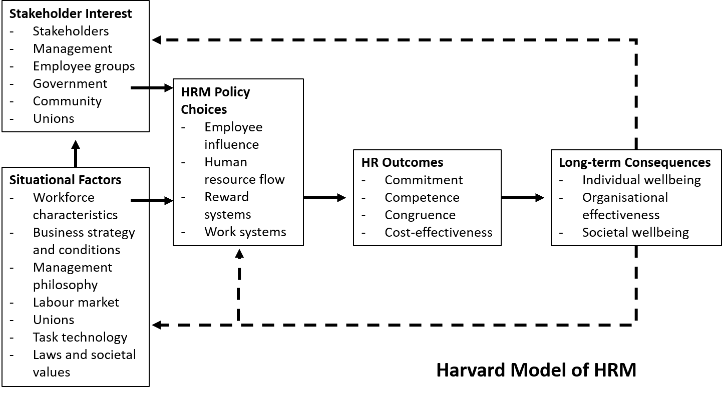
Figure 1: HRM approach
(Source: Personio, 2026)
The managing committee of the organisation take the decision to follow clan culture in the workplace. There is no inclusivity noticed in strategic decisions. Harvard HRM approach does not allow the organisation to adopt the new trend to improve the capability of employees. The HR manager does not organise any employment empowerment program to uplift their capability (Manduva, 2022). To boost the motivation, it is essential for a hr manager to organise training and skill development programmes, which are common in tech giants' companies like Amazon, Microsoft, google.
Clan culture is a collaborative approach which fosters mental engagement among the employees. In this competitive business environment, it is essential to emphasise innovation and creativity instead of cohesion. The Harvard HRM model is currently irrelevant in tech companies. This theory is broadly focused on the situational factors such as the labour market, union laws, workforce characteristics and management philosophies. As per, Santillan et al. (2023), Emphasising these points misses the technological factor, which is mainly important to a tech company. For cultural improvement, there is no advanced strategy taken by the company. The Harvard HRM model is time consuming approach to implement in organisational practices. It requires balancing the multiple decisions of stakeholders. Harvard HRM approach does not allow the organisation to make quick decisions to improve organisational performance.

1.3 Recommend cultural and structural initiatives that embed innovation
Cross-functional teams
The hr manager of the company can make the decision to develop a cross-functional team for the betterment of the strategic decisions. Cross functional team helps the organisation to develop a diverse perspective. A cross-functional team comes with different mindsets and ideas, which help the organisation to improve its decisions over time (Kokot, 2023). As per, Attah et al. (2024), The main benefits of this team are that all the team members are focused on one unified goal and align their efforts to improve the organisational performance. In this competitive business s market, it is essential for a tech company to improve its capabilities. Cross functional team helps to improve the dynamic nature to explore the current market opportunities. To be successful in the competitive business market, now an emphasis on the cross-functional team. So, it is a highly recommended model to improve the cultural and structural system of the organisation. The employee's strength in the company is less than that of Microsoft (Manduva, 2022). So, it can be said that there is a high opportunity to design the entire system to improve the performance. At a global scale, the tech companies are following this model. So, for a fast-growing company, it is the most effective and relevant option.
Developing crosss s functional team help the organisation to make decisions faster compared to the current team. By involving stakeholders in the decision-making procedure, the HR manager can ensure that their decisions are available to the organisation. The managing committee value the opinion shared by them (Santillan et al., 2023). Different areas are considered by the cross-functional team to tackle the current challenges in the market and utilise the opportunities which ensure the growth potential of the company. As per, Kokot (2023), By enabling a cross-functional team, the HR manager can ensure that the slow growth-related issue can be addressed successfully. Cross functional team allows the organisation to maintain consistency by using digital tools. The digital dashboard will be used by the company to maintain strong integrated communication with each other (Santillan et al., 2023). A cross-functional system will be developed to offer a seamless service to the customer.

1.4 Propose a future work model
Hybrid work model
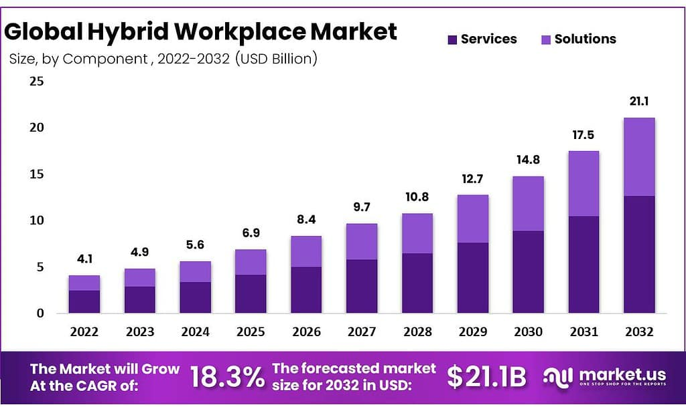
Figure 2: Global trend of Hybrid work model
(Source: Market.US, 2024)
Hybrid work models offer a flexible working schedule to employees. Currently, 56 % of tech companies are following a hybrid model. This concept has gained popularity since 2020. The managing committee can consider this model to improve the mental health and well-being of employees. A hybrid work model embedded with remote and office-based work. As per the choice and feasibility, employees get the option to select the working mode (Manduva, 2022). The convenient option is to offer to the employees to improve their mental health conditions.

Figure 3: Proposed model
(Source: self-developed, idea taken from Kokot, 2023)
The main reason is to propose this model to address the employee management issue. There is a scope to improve the working system by using a new model. The hybrid work model increases the employee productivity rate. As per, Attah et al. (2024), Employees can work at their preferable time, which increases productivity and quality. Better work-life balance reduces stress. Currently, the tech giant companies are following this model to improve the relation with employees. As per believe, this model saves time for transportation, which can be utilised by the employees for working purposes (Kokot, 2023). Now, the tech giant companies hire people from different locations to build cross-functional teams, where offering a hybrid model of work is highly feasible. The same strategic option is proposed to this company for better management of the system (Santillan et al., 2023). As it is a new approach to the organisation, the HR can plan that for the first few days, employees can work from the office for collaboration and team meetings, then can continue working from home. The hybrid work model is a cost-effective option for organisations as well (Manduva, 2022). To track the progress of the employee in the hybrid work model, the hr can use performance metrics like productivity rate through a daily tracker.

1.5 Demonstrate how the new approach would motivate and enable staff to perform optimally.
Enhancing employee motivation
Through the proposed hybrid model application, the company can enhance the work-life balance by letting employees split some of their working time between work and at home to achieve more work-life balance, which is closely associated with increased job satisfaction and a decrease in attrition (Vehosalmi, 2022). A flexible schedule enables employees to gain autonomy, which is a significant source of intrinsic motivation, whereas a structured collaboration in the office helps the staff to work together, be creative, and innovative. For example, Google, Amazon different tech-giants provide the hybrid working facility to ter workers so that the bonding among the employees is maintained and also, they can manage work-life balance, which motivate them.
Enhancing staff performance
The strategy incorporates the use of effective performance management systems that are performance-based to facilitate the best performance. Jindain and Gilitwala (2024) said that the tools can be used to assist the employees with the help of digital collaboration tools, frequent virtual check-ins, and open channels of communication, which can keep them aligned with the organisational goals. Furthermore, personalised skill development programmes can be implemented to reskill employees in digital skills, flexibility, and innovation processes to develop a culture of continuous learning (Mabaso and Manuel, 2024). Training can equip managers on hybrid leadership as a means of building trust, giving feedback, and nurturing the well-being of the employees. In addition, an inclusive culture, in which remote and in-office workers are equally regarded and appreciated, will serve to increase engagement and overall performance.

Part 2: Reflection

2.1 Learning journey reflection using Gibbs' reflective cycle

2.1 Learning journey reflection using Gibb’s reflective cycle
Using Gibb's reflective cycle, the six stages can help me to express my experiences and my journey in this module (Nurlatifah et al., 2023). The module is about human capital management. The stages are used for reflection below:
Description
The module name is Human capital management module, and I have gained some key concepts from this module such as HRM, international HR, talent management and organisational development. Along with the HRM practices, the different aspects of workplace culture and innovation are also included in this module. The module mainly provides the understanding and critical evaluation of contemporary HRM challenges in the different global organizations as well as the challenges in the SMEs. the diverse organisational context for the challenges is taken into account. The diverse concepts of working mode in the current context are also the key aspects of the module. Different HRM theories and models have been learned from this module and through the different activities, I have learned how these models can be applied in the real-world contexts. Through the different lecture materials, case studies and discussion in the class, I have gained a strong insight into the HR practices aligning with organisational strategy and culture which impacts the organisational performances. The overall learning from the module is about the diverse theories, models, concepts and literature, the workplace culture, innovation and HRM practices.
Feelings
Initially I felt nervous because I faced issues in understanding the theoretical frameworks as I understood the theories and models taught in the module but faced issues while applying in the real-world scenario In this module, I had to take part in diverse activities and due to the confusion, I faced quite difficulties initially. However, the tutor and the peer groups were very supportive so with their support, I overcame the issues and I became very confident while analysing the HRM theories into practice. I was very happy while I could effectively explore the real-world HR challenges and I successfully can apply the theories and concepts to address the issues. The overall growth and progress over the time have improved my motivation. The overall experiences of the module have strengthened my analytical skills and I felt motivated
Evaluation
Through the module I have identified my strengths as well as my weaknesses from the module or skills. I have gained the ability to balance between theory and its application, though I need to enhance the synthesis skills more for the future. I have enhanced my critical thinking skills because while synthesizing the real-world case scenario and the HRM theories and concepts, I applied the analytical and critical thinking abilities. The learning on the global HRM models and HR practices improve my knowledge and the confidence I have shown good communication skills while group discussion took place, and I have developed a good relationship with peers (Ansari et al., 2022). However, I have to improve my time management ability, and I have to adopt more AI tools and HRM software skills to enhance my ability on HRM practices. I also have to improve my leadership ability which I demonstrated poorly during group activities.
Analysis
I have gained the understanding that a growth mindset is essential for the HR professionals for meeting the workforce demand. To develop a good workplace culture and align innovation within it, the proper application of modern HRM theories and the humanistic approach towards the workforce is required. From the module, I have gained the insight that designing an effective and fair policy in the HRM requires a strong analytical and innovative skills and along with that the strong emotional intelligence skills are required.
Conclusion
The entire module significantly contributes to my academic progress as well in my professional growth. It has provided some important knowledge and insights which will help me in my next modules and the skills helps me to better performance in the other modules. It also provided me with practical application ability and real case scenarios and enhanced my employable skills, which will help me to grow in my career.
Action plan
Goal | Action taken | Measuring success | Timeline
To enhance time management ability | I have to use Pomodoro or black box technique and prioritize tasks by dividing them into small segments. | Through daily feedback and self-observation. | 3 months
To improve my synthesizing skill | I have to work on three real case HRM issues of organisations and apply theory for practice (Lenker, 2025). | Self-evaluation and feedback from tutor. | 3months
To improve my leadership ability | I have to work more in group projects as team leader and enhance my EQ ability. | Team performance, team feedback and self-evaluation. | 6 months

2.2 Planning to deal with AI in the workplace
Since AI is automating the process of performing simple HR functions, I intend to remain relevant by concentrating on purely human strengths like critical thinking, emotional intelligence, ethical judgments, and strategic decision-making. Employee engagement, conflict management, leadership growth, and organisational culture are the fields in Human Resource Management where empathy and contextual sensitivity cannot be completely replaced by AI (Celestin and Vanitha, 2023). I have to balance between the AI application in HRM and the humanistic approach in this field because this field deals with the employees, who are humans, so AI machines can't make the most effective decisions as per the needs or requirements of the employees. To ensure the ability to combine technology and strategic acumen, I will constantly engage in professional development and remain knowledgeable on the new trends in HR, including people analytics and digital HR transformation, and the like.
I will adopt AI as a supporting tool and not a substitute. As an example, artificial intelligence may assist in my professional activity through data analysis of extensive datasets, job recruitment, and HR reports and the recognition of trends related to the workforce (Nawaz et al., 2024). This will make it more efficient and enable me to concentrate on better value activities like the design of employee development programmes and creating an innovative work culture. As an HR, I have to make sure that the decisions made for the employees and their well-being should be fair, ethical and humanistic. I want to present myself as an HR professional who has the ability to use advanced tools and technologies such as AI to enhance productivity but making decisions on my own and not neglect the human-centric HRM.

Reference List
Al-Busaidi, Z.A.H., Alias, R.B. and Alam, M.N., (2021). The influence of human resource management practices on employee performance at private companies in Oman: Moderating role of organizational politics. Rigeo, 11(12).
Ansari, S., Kumar, P., Jain, V. and Singh, G., (2022). Communication skills among university students. World Journal of English Language, 12(3), pp.103-109.
Attah, R.U., Garba, B.M.P., Gil-Ozoudeh, I. and Iwuanyanwu, O., (2024). Cross-functional team dynamics in technology management: a comprehensive review of efficiency and innovation enhancement. Eng Sci Technol J, 5(12), pp.3248-65.
Celestin, M. and Vanitha, N., (2023), May. AI vs HR: Will artificial intelligence replace human resource professionals. In 10th International Conference on Multidisciplinary Research and Modern Education (Vol. 90).
Jindain, C. and Gilitwala, B., (2024). The factors impacting the intermediating variable of employee engagement toward employee performance in a hybrid working model. Rajagiri Management Journal, 18(2), pp.167-179.
Kokot, T., (2023). Hybrid remote work models in Project-Organized small and Medium-Sized IT companies. International Journal of Computers and their Applications, 30, pp.259-66.
Lenker, M., (2025). Thoughts on Synthesizing Information: A Research Skill for Our Time?. portal: Libraries and the Academy, 25(3), pp.441-452.
Mabaso, C.M. and Manuel, N., (2024). Performance management practices in remote and hybrid work environments: An exploratory study. SA Journal of Industrial Psychology, 50(1), pp.1-13.
Manduva, V.C., (2022). The Role of Agile Methodologies in Enhancing Product Development Efficiency. International Journal of Acta Informatica, 1(1), pp.138-158.
Market.us., (2024). Hybrid Workplace Market. Available at: https://market.us/report/hybrid-workplace-market/ [Accessed on: 18.3.2026]
Nawaz, N., Arunachalam, H., Pathi, B.K. and Gajenderan, V., (2024). The adoption of artificial intelligence in human resources management practices. International journal of information management data insights, 4(1), p.100208.
Nurlatifah, L., Purnawarman, P. and Sukyadi, D., (2023), December. The implementation of reflective assessment using Gibbs’ reflective cycle in assessing students’ writing skill. In AIP Conference Proceedings (Vol. 2621, No. 1, p. 070006). AIP Publishing LLC.
Omar, S.S., Aris, N.F.M., Alias, S., Mu'min, R. and Arokiasamy, L., (2023). Assessing the disparities between strategic human resource management and conventional human resource management: a theory-based review. KnE Social Sciences, pp.588-613.
Opatha, H.H.D.N.P., (2021). Towards a generic model of human resource management. International Business Research, 14(7), pp.58-68.
Personio, (2026). What is the Harvard Model of HRM?. Available at: https://www.personio.com/hr-lexicon/harvard-hrm-model/ [Accessed on: 18.3.2026]
Santillan, E.G., Santillan, E.T., Doringo, J.B., Pigao, K.J.F. and Mesina, V.F.C., (2023). Assessing the impact of a hybrid work model on job execution, work-life balance, and employee satisfaction in a technology company. Journal of Business and Management Studies, 5(6), pp.13-38.
Vehosalmi, N. (2022). Employee motivation in hybrid work: how motivational needs have changed after Covid-19.

