MODULE CODE: BMIH6001
PROGRAMME: BA INTERNATIONAL HOTEL MANAGEMENT
OPTION 1: ARTIFICIAL INTELLIGENCE AND HUMAN COLLABORATION IN THE HOTEL AND HOSPITALITY SECTOR

Student Name: Andrei Maria
Student ID: 2243878
Course Name: BMIH6001

Abstract
Technology has acted as the driving force for business in the hospitality sector. This has been obtained through the development of guest enhancement and operational efficiency. However, the demand for human engagement is growing among guests and demand for synergy in technology such as AI and humans has evolved in the hospitality industry.
The study aims to analyse the contribution of AI and human synergies for meeting the demand of consumers in the hotel industry.
The study has been developed based on secondary data obtained from various authentic journal articles and company profiles of hotels in the UK. Secondary data collection has been developed to fetch secondary qualitative data from the hotel industries of the UK. Besides, an analysis has been done using thematic analysis to identify the impact of human and AI collaboration in the hospitality units.
The research has identified that the demand for collaboration between humans and AI has provided positive results in reducing employee stress and effective operational growth. The study has also identified the variable approaches and coordination of values that have integrated a reliable balance within the industry.

Table of Contents
Introduction 4
Outline of the theme 4
Importance and relevance to the hotel and hospitality sector 4
Objective 4
Background of study 4
Literature Review 5
Artificial intelligence in the hotel and hospitality sector 5
Humans in the hotel and hospitality sector 5
Collaboration of artificial intelligence and humans in the hospitality sector 6
Theoretical underpinnings 7
Technology Acceptance Model (TAM) 7
Situated Artificial Intelligence theory 7
Method 8
Data collection procedure 8
Analytical techniques 8
Tools and frameworks 8
Theme impact analysis 9
Theme 1: Collaborative approach of human and AI increases guest experience and builds operational efficiency with cost reduction 9
Theme 2: Improvement in employee productivity and satisfaction can be observed due to the collaboration of AI and humans within the hospitality sector 10
Conclusion 10
Recommendation 11
Recommendation 1: Automating routine and empowering humans 11
Recommendation 2: Actionable Data Insight 11
Recommendation 3: Phased implementation 11
Recommendation 4: Operational growth points 11
Reference List 13

Introduction

Outline of the theme
The advancement of technology in the hospitality industry is done to enhance guest experience, efficiency and streamlining of operations. However, the study forecast maintenance of balance between human touch and technology to be obligated towards customer experiences.

Importance and relevance to the hotel and hospitality sector
The coordination of human touch or collaboration and technology within the hospitality sector is known as the high-tech and high-touch hybrid model (Davari et al., 2022). This model is effective in meeting the growing customer expectations.
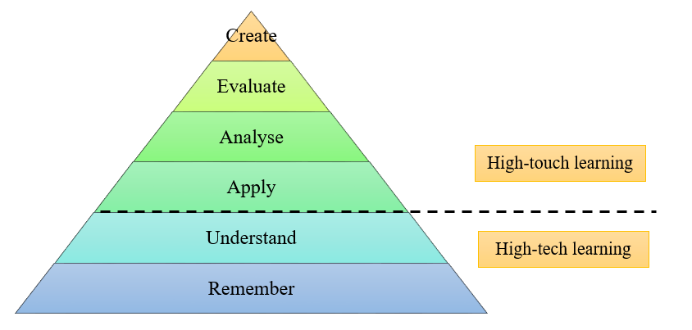
Figure 1: High-tech and high-touch hybrid model
This demands both empathetic and personalised care. This signifies that the hotel and hospitality sector is deemed to drive a strategic point to incorporate technology and humans to meet the demand of the visitors.

Objective
To analyse the contribution of artificial intelligence and human collaboration to meet the demand of consumers in the hospitality sector

Background of the study
Artificial intelligence (AI) in the hotel industry is creating a landscape for the hospitality business. About 70% of the hotel executives are prioritising AI investment (GLION, 2025). However, a review of Guest Experience management found that 70% of the guests reported an elevated level of satisfaction with both automated services and staff interaction (Karagiannis, 2024). This can leave a positive review online, making a vast demand in the market for building a positive guest experience. The study has directly focused on identifying areas where collaboration of AI and human touch can facilitate exceptional service in the hospitality sector.

Literature Review

Artificial intelligence in the hotel and hospitality sector
The AI in the hotel and hospitality sector drives efficiency as well as personalisation by leveraging data analytics and operations. As per Fernandes, Wani and Shah (2024), key operations of AI in the hospitality sector include AI-powered chatbots, predictive analytics and demand-based pricing. For instance, this streamlines operations such as check-ins and maintenance while experiencing guest loyalty through the tailored experience.
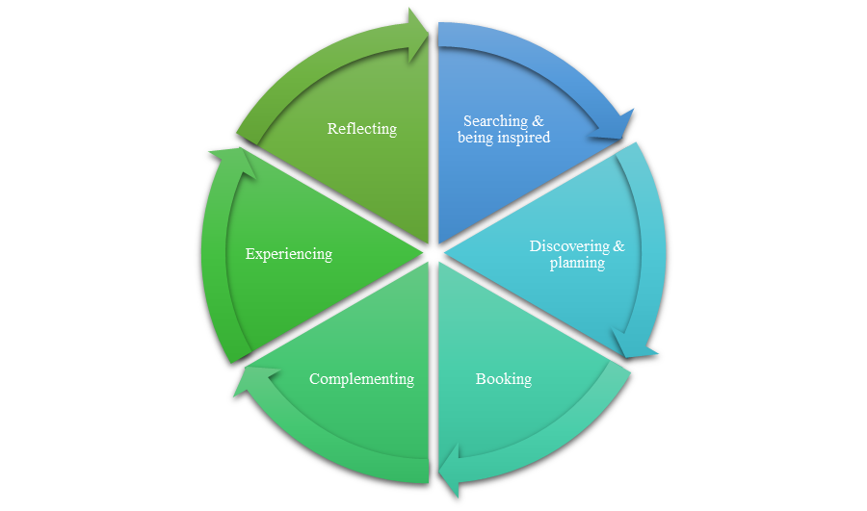
Figure 2: Use of AI in the hospitality sector
This has enhanced the success rate of various hotel chains in the world. For instance, the incorporation of AI in Premiere Inn has observed a production growth of 153% year over year and 177% in the last quarter (Shiji Group, 2026). However, in certain cases, the implementation of AI has created a series of issues, such as data security, high implementation costs, and loss of human touch. In order to overcome such perspectives, synergies in technology and humans are highly provisional to drive change.

Humans in the hotel and hospitality sector
The human touch is the core differentiator within the hotel and hospitality sector. It has been identified by Bardukova (2023) that human touch in the hotel chain is essential for developing emotional connections that ensure guest loyalty and foster a welcoming and personalised environment. This approach is directly invincible for the technology to drive strategic growth options. This can be evident from the fact that about 47% of leisure travellers demand integration of humans to serve them besides technology (Rageev, 2024). This has significantly laid a diversified dimension in the hospitality industry to drive a strategic change as demanded. However, in certain segments, human intervention is majorly preferred over chatbots and voice-activated assistance. For instance, BWH Hotel GB of the UK revealed that customers are demanding technology in check-ins, internet connectivity and a few other services, but also preferred human interaction for customer services for assistance (Rumney, 2024). Thus, human interaction also lays a major agenda in this fast-moving world that contemplates driving change in business in hotels.

Collaboration of artificial intelligence and humans in the hospitality sector
AI and humans have both significantly impacted the business performance by leading it to sustainable growth in the hotel sector. As opined by Didea and Ilie (2025), the fact of technology replacing humans is a non-viable agenda in this evolving world. Targeting the growth of the hotel business can easily be achieved through building constructive collaboration between humans and AI implementation. For instance, synergy can be less effective if the resistance to implementing AI is high due to evolving challenges of incorporating AI in the hotel business. These challenges are staff resistance, lack of technical expertise, and high costs (Swiss Hotel Management School, 2026).
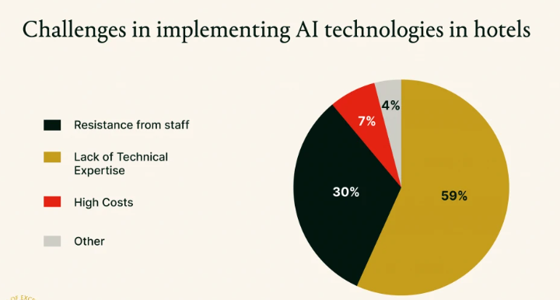
Figure 3: Challenges in implementing AI technologies in hotels
(Source: Swiss Hotel Management School, 2026)
The rising challenges have been replaced by a constructive interaction between the human touch and AI within various hospitality organisations. For instance, HiJiffy, used by renowned hotel Kabannas of the UK, provides high-value, empathetic and satisfactory guest experience leading to reduction of staff burnout due to repetitive enquiries of the guests (Hijiffy, 2026Shiji). This amalgamation of values and orientation of AI and human indulgence has led to a positive response, leading to the sustainable growth of business. Thus, operational efficiency, enhancement of personalised services and dynamic revenue management can be generated through this constructive collaboration.

Theoretical underpinnings

Technology Acceptance Model (TAM)
The Technology Acceptance Model (TAM) is stated to be defined as an information system theory. This theory explains the way users are getting encouragement for accepting and utilising the modern technology based on two prime determinants, such as perceived usefulness and perceived ease of use (Mogaji et al., 2024). The case of accepting AI technology has initiated a strategic change perception among the guests of the hotels.
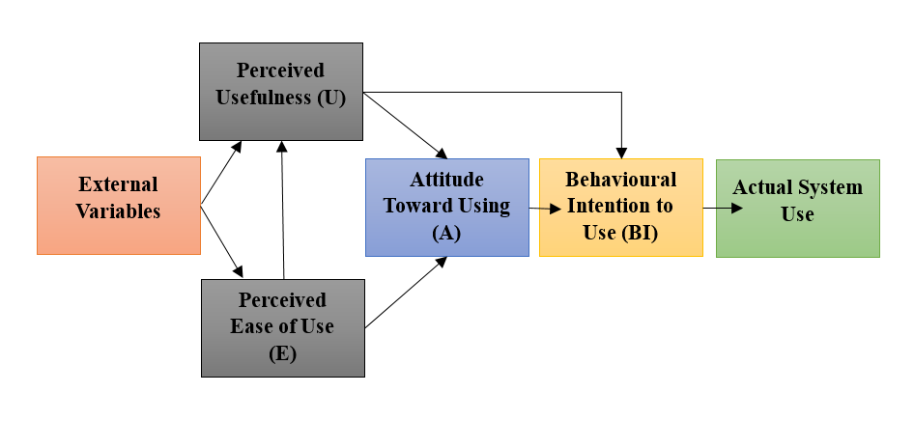
Figure 4: Technology Acceptance Model
However, Abuhassna et al., (2023) stated that the lack of human touch or empathy has lowered the conviction of AI implementation among hotel industry consumers. Using the TAM model, the hotel business can easily analyse the perceived usefulness of AI in areas of requirements and synergies between human touch and AI to drive the demand of the guests (Musa et al., 2024). For instance, guests demanding support or assistance from the human perception through daily support on skills and attributes of the business.

Situated Artificial Intelligence theory
The Situated Artificial Intelligence theory highlights intelligent behaviour that evolves from the direct and active interaction with the environment rather than through internal symbolic and abstract representation (Zhang et al., 2022). This prospectus has illustrated a strategic drive in understanding values through the integration of AI with a human approach to drive alteration in the hotel industry.
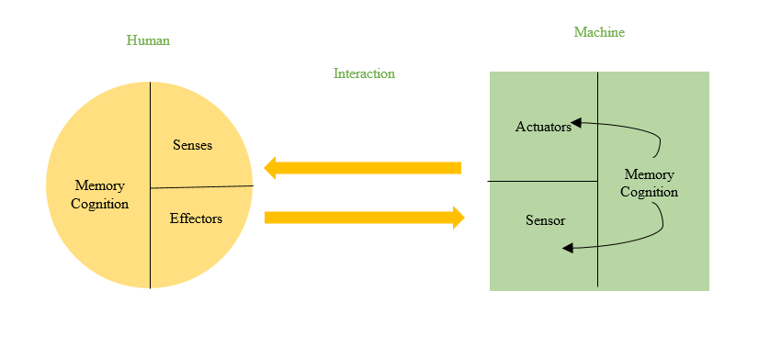
Figure 5: Situated Artificial Intelligence Theory
Based on that, the reliability of the human approach and the AI has been a core fundamental proposition for business (Yim, 2024). It has been identified as direct coordination of values and perception towards the growth of a model that coordinates a significant collaboration between humans and AI in the hospitality industry.

Method

Data collection procedure
The data collection process for the identification of the impact of human and AI collaboration in the hospitality sector has incorporated a secondary data collection process. The data are being obtained from various authentic journals, news articles and company reports. Besides that, the collection process has included credible and reliable secondary sources obtained from Google Scholar, PubMed, PubMed Central, and hotel websites. The secondary data collection is responsible for understanding the human emotions associated with driving change in business.

Analytical techniques
The analysis process for identifying the impact of human and AI collaboration within the hospitality industry has been done using the thematic analysis technique. This technique is feasible for understanding the values and orientation of significance laid by AI and human collaboration within the industry. Thematic analysis provides a detailed analysis of each variable, making a suitable connectivity between the hotel brand and the collaborative approach (Braun and Clarke, 2023). Thus, thematic analysis is an effective process to find out the study objectives.

Tools and frameworks
The study has been developed using literature-based thematic analysis. This tool has facilitated the study to enlist a strategic growth proposition leading to sustainable delivery of results through analysing the values built on the collaboration of human and AI impact on the hotel industry.

Theme impact analysis

Theme 1: Collaborative approach of human and AI increases guest experience and builds operational efficiency with cost reduction
The AI-driven, smart room technology and voice-activated services are a feasible service point that provides enhanced experiences for the guests. As observed by Dixit (2020), the collaborative approach of humans and AI has tangentially built strategic guest experiences with 24/7 assistance and personalised service with empathy. This has enhanced the operational efficiency of the hospitality sector, which reduces costs by automating routine tasks and optimising resources. On the other hand, Batabyal and Das (2019) AI can efficiently manage data and simple inquiries that allow the staff to focus on the high-touch and complex guest interactions, leading to increasing loyalty and reducing errors. This has led to a strategic growth in value through optimising the efficiency level and driving the feasible growth of the business. For instance, Park Hotel Resort and Spa of the UK have implemented the AI concierge to improve the guest operation rate and operational gains (Marketinglancashire, 2025). This allows the staff to directly focus on the guest-centric activities rather than the administrative tasks.
In addition to guest experience, the cost of operation can be reduced through the collaborative approach of AI and humans by increasing operational efficiency. As mentioned by Cooper and Hall (2023), predictive and AI-driven maintenance has raised a strong management approach to downtime, allowing the staff to focus more on guest preferences to drive strategic growth in the hotel business. This signifies the constructive collaboration between humans and AI, as the AI handles the data and routine tasks. On the other hand, Chkoniya (2021) stated that human employees focus on empathy-driven, complex and high-value service interaction. This ensures a warm and welcoming environment, irrespective of high technology adoption. For example, the Hilton Hotel of the UK has incorporated AI to provide personalised guest experiences by evaluating the data to customise room settings before the arrival of the guests (Kitishian, 2025). This enables the human staff of Hilton to provide a more tailored and welcoming experience upon check-ins. Accordingly, it prioritises the values and orientation of human touch, besides seamless operation of AI, which has increased the value of the hotel brand. Thus, the approach of human and AI has generatively laid a wider dimensional change to the business, leading to sustainable growth and valuation.

Theme 2: Improvement in employee productivity and satisfaction can be observed due to the collaboration of AI and humans within the hospitality sector
The value and coordination can be observed as AI can legitimately handle the repetitive tasks that enable the employees to effectively manage higher workloads or directly focus on the personalised services. It has been noticed by Costa and Costa (2022) that by reducing repetitive tasks, AL reduces the burnout of the employees and engages them more in meaningful and creative customer-oriented tasks. This increases the speed and drive motivation of both the employees and the customers, leading to sustainable coordination of values and beliefs. Apart from that, AI can provide easy support to the employees in building coordination with the guests and provide oriented training of empathy for delivering operational decision-making. For example, Yotel, the renowned hotel in the UK, has observed productivity-based AI robots that create human AI collaboration by incorporating application-based check-ins, robot luggage storage and AI-powered service requests (Qubein, 2025). This not only reduces tasks for the staff but also maintains constructive interaction between guest experience and building strategic action to drive growth for the hotel business.
Varied intelligence can be observed to be the driving force behind strong business perseverance. The usage of varied types of intelligence has a positive impact on employment, leading to the creation of various jobs across different hotel industries. The results demonstrate the coexistence of three types of intelligence within the hotel industry (Socaci, 2020). This has a high managerial impact on employment in roles which require emotional intelligence. From this, it can be derived that these traditional variables can be considered as the determinants of employment in the hotels. In that context, the usage of Metis by Dorchester Collection of London has shared significant values where the human and AI have maintained synergy and gained support from each other to drive a strategic change in business (Bayley, 2025). Associated with that, these perspectives have laid a significant orientation leading to sustainable change in the system. Thus, reliability and diversification have been maintained to drive a reliable change that increases the productivity and satisfaction of the employees.

Conclusion
Artificial intelligence and human collaboration have driven a transformative and symbiotic relationship that optimises efficiency through AI-driven automation. This increases the guest experiences through building personalised human interactions. Besides, this hybrid model of human coordination and AI integration enhances operational productivity, redeems the costs and enables the staff to focus on emotional connection and high touch. The study has identified various hotels and restaurants in the UK, such as Park Hotel, Dorchester London, and NWH Hotel GB, which have incorporated AI with human coordination. Thus, this proposition has provided them with wider integrity to drive change and build resilience within the hospitality sector.

Recommendation

Recommendation 1: Automating routine and empowering humans
The hotel industry is keener towards building rapport with guests to retain loyal customers for sustained growth. The hotel and hospitality sectors can easily utilise AI for 24/7 guest enquiries, optimisation of operations and booking (Gündüz, 2023). This eventually keeps the staff engaged to handle the complex situations and meet the personalised demands of the guests. This entails the perspective of lowering staff burnout and increasing staff retention in this volatile market environment.

Recommendation 2: Actionable Data Insight
The basic attributes of the business are driven by data associated with the hospitality sector. In this fast-moving world, data has acted as a strategic growth point. Accordingly, AI-powered analytics for predictive maintenance has been cited as a beneficial action that needs to be included by the hospitality sector. However, certain data, such as customer moods and values, cannot be accessed with AI or automation, where integration of humans is necessary (Štilić, Nicić and Puška, 2023). This form of data regarding mood and values can be obtained for analysing effective action based on data obtained from AI and humans.

Recommendation 3: Phased implementation
The boutique hotels or the small hospitality firms can use the phased concept of integrating the collaboration of humans and AI. In this proposition, the hospitality industry and hotels are recommended to start with small propositions. These small propositions can be specified for projects such as chatbots, revenue management tools for scaling and analysing the values. This form of approach by the hotel and hospitality industries can solve the real and immediate pain point of the visitors. Thus, these need to be integrated with human concern for better integration of results and values in business.

Recommendation 4: Operational growth points
Technology has built a surge in the hospitality industry, but also created a series of challenges, starting with a lack of human touch and less productive emotional considerations. In order to overcome such issues, the hospitality sector can implement a concierge. This concierge is the prospect where AI can provide recommendations based on obtained data, while humans can easily deliver personalised and insider advice. Besides, the sector can easily implement AI to ensure it can empower and not eliminate human interaction in the luxury and service-intensive roles. Thus, these operational growth points will engage in more strategic and reliable business points for the hospitality sector.

Reference List
Abuhassna, H., Yahaya, N., Zakaria, M.A.Z.M., Zaid, N.M., Samah, N.A., Awae, F., Nee, C.K. and Alsharif, A.H., (2023). Trends on using the technology acceptance model (TAM) for online learning: a bibliometric and content analysis. International Journal of Information and Education Technology, 13(1), pp.131-142. DOI: 10.18178/ijiet.2023.13.1.1788
Bardukova, L., (2023). Navigating the hospitality horizon: Current trends and strategies for customer attraction and retention in the hotel industry. Economics and computer science, 2, pp.88-103. https://eknigibg.net/Volume9/Issue2/spisanie-br2-2023_pp.88-103.pdf
Batabyal, D. and Das, D.K., (eds) (2019) Global trends, practices, and challenges in contemporary tourism and hospitality management. Hershey, Pennsylvania: Business Science Reference, an imprint of IGI Global.
Bayley., J. (2025). 10 ways hospitality businesses can benefit from AI in 2025. Available at: https://www.thedrinksbusiness.com/2025/03/10-ways-hospitality-businesses-can-benefit-from-ai-in-2025/ [Accessed 8 February 2026].
Braun, V. and Clarke, V., (2023). Toward good practice in thematic analysis: Avoiding common problems and be (com) ing a knowing researcher. International journal of transgender health, 24(1), pp.1-6. DOI: https://doi.org/10.1080/26895269.2022.2129597
Chkoniya, V. (2021) Handbook of research on applied data science and artificial intelligence in business and industry. Hershey, Pennsylvania: IGI Global.
Cooper, C. and Hall, C.M., (2023) Contemporary tourism: an international approach. 5th ed. Oxford: Goodfellow Publishers Limited.
Costa, V. and Costa, C. (2022) Sustainability and competitiveness in the hospitality industry. Hershey, Pennsylvania: Business Science Reference.
Davari, D., Vayghan, S., Jang, S. and Erdem, M., (2022). Hotel experiences during the COVID-19 pandemic: high-touch versus high-tech. International Journal of Contemporary Hospitality Management, 34(4), pp.1312-1330. DOI: https://doi.org/10.1108/IJCHM-07-2021-0919
Didea, I. and Ilie, D.M., (2025). At the Intersection of Technological Innovations and Geopolitical and Economic Turmoil. Echoes of Insolvency Law and Practice. Persp. L. Pub. Admin., 14, p.6. https://www.adjuris.ro/revista/articole/An14nr1/1.pdf
Dixit, S.K., (2020) ‘Managing hospitality organizations: achieving excellence in the guest experience (second edition): by Robert C. Ford and Michael C. Sturman, Sage Publications Inc., 2019, 544.
Fernandes, M.D., Wani, P.S. and Shah, G.D., (2024). The Integration of Artificial Intelligence in the Hospitality Industry. In Hotel and Travel Management in the AI Era (pp. 525-550). IGI Global. DOI: 10.4018/979-8-3693-7898-4.ch025
GLION (2025). AI in the hospitality industry: how technology is shaping the guest experience. Available at: https://www.glion.edu/magazine/ai-hospitality-guest-experience/ [Accessed 7 February 2026].
Gündüz, C., (2023). Customised holiday experiences through artificial intelligence: Case studies from the aviation and hospitality sectors. Journal of Aviation, 7(3), pp.337-345. DOI: https://doi.org/10.30518/jav.1351472
Hijiffy (2026). Kabannas surpasses industry average conversion rates 90x with HiJiffy automation. Available at: https://www.hijiffy.com/success-stories/kabannas#:~:text=Introduction,Kabannas%2C%20who%20is%20quoted%20throughout [Accessed 11 February 2026].
Karagiannis., M. (2024). Balancing Automation and Human Touch in Guest Relations. Available at: https://medium.com/hotel-tech/balancing-automation-and-human-touch-in-guest-relations-76941ef005cc [Accessed 7 February 2026].
Kitishian., D. (2025). Hilton’s AI Strategy: Analysis of Dominance in Hospitality, Hotel AI. Available at: https://www.klover.ai/hilton-ai-strategy-analysis-of-dominance-in-hospitality-hotel-ai/ [Accessed 7 February 2026].
Marketinglancashire (2025). Lancashire’s Park Hall Hotel deploys AI Concierge by Inntelo AI in UK first. Available at: https://www.marketinglancashire.com/news/lancashires-park-hall-hotel-deploys-ai-concierge-by-inntelo-ai-in-uk-first/ [Accessed 7 February 2026].
Mogaji, E., Viglia, G., Srivastava, P. and Dwivedi, Y.K., (2024). Is it the end of the technology acceptance model in the era of generative artificial intelligence? International Journal of Contemporary Hospitality Management, 36(10), pp.3324-3339. DOI: https://doi.org/10.1108/IJCHM-08-2023-1271
Musa, H.G., Fatmawati, I., Nuryakin, N. and Suyanto, M., (2024). Marketing research trends using technology acceptance model (TAM): A comprehensive review of researches (2002–2022). Cogent business & management, 11(1), p.2329375. DOI: https://doi.org/10.1080/23311975.2024.2329375
Qubein., R. (2025). Yotelpad Goes Global With First Hotel In Europe And Sets Sights On Asia. Available at: https://www.forbes.com/sites/ramseyqubein/2025/02/17/yotelpad-goes-global-with-1st-hotel-in-europe-sets-sights-on-asia/ [Accessed 7 February 2026].
Rageev., R. (2024). Survey: 'Technology is important, but so is the human touch’. Available at: https://www.asianhospitality.com/survey-technology-is-important-but-so-is-the-human-touch/ [Accessed 8 February 2026].
Rumney., T. (2024). "Tech vs. the human touch: The Battle for Guest Satisfaction in Hotels". Available at: https://www.joinbwhhotels.co.uk/bwh-blog/tech-vs-the-human-touch-the-battle-for-guest-satisfaction-in-hotels/ [Accessed 9 February 2026].
Shiji Group (2026). How Premier Inn Significantly Increased Search Success Rates and Overall Bookings Through Collaboration with Shiji. Available at: https://www.shijigroup.com/customers/how-premier-inn-significantly-increased-search-success-rates-and-overall-bookings-through-collaboration-with-shiji#:~:text=The%20Search%20Success%20Rate%20increased,with%20such%20an%20outstanding%20organization [Accessed 6 February 2026].
Socaci, S.A. (ed.) (2020) Food preservation and waste exploitation. London, England: IntechOpen.
Štilić, A., Nicić, M. and Puška, A., (2023). Check-in to the future: Exploring the impact of contemporary information technologies and artificial intelligence on the hotel industry. Turističko poslovanje, (31). https://aseestant.ceon.rs/index.php/turpos/article/download/43739/23061/
Swiss Hotel Management School (2026). The Role of AI in Hospitality: Trends & Benefits. Available at: https://www.shms.com/en/news/ai-in-hospitality-industry/ [Accessed 10 February 2026].
Yim, I.H.Y., (2024). A critical review of teaching and learning artificial intelligence (AI) literacy: Developing an intelligence-based AI literacy framework for primary school education. Computers and Education: Artificial Intelligence, 7, p.100319. DOI: https://doi.org/10.1016/j.caeai.2024.100319
Zhang, Y., Yao, F., Liu, T., Wang, X. and Zhang, Q., (2022). How does artificial intelligence create competitive advantages for enterprises?--Discussion based on situated artificial intelligence theory. Discussion based on situated artificial intelligence theory. https://papers.ssrn.com/sol3/Delivery.cfm?abstractid=5482423

