Name – Mr Zia Uddin
Student ID – 1814354
Module Code & Title – BMSW 4005 in Professional & Career Development
Lecturer – Dr. Buddhi Pathak

Discursive & Reflective Portfolio

Table of Contents
Introduction……………………………………………………..Page 2
Discursive Report………………………………………………Page 2
Self-Awareness & Johari Windows Model………………Page 2,3
The Johari Windows Classroom Activity…………………Page 4,5,6
16Personalities Test…………………………………………….Page 7
Career Motivation Test………………………………………….Page 8
Reflective Report…………………………………………………Page 8
123Test……………………………………………………Pages 9
Job Description & Application…………………………………..Page 10
CV Building & Cover Letter…………………………….Page 11
Preparing for the Job Interview………………………...Page 12,13,14,15
Conclusion, References & Appendix………………………… Page 15-28

Introduction
This report is produced firstly in a discursive manner based on self-awareness test techniques taught and practiced in class. Self-awareness is very important because it gives people the ability to understand and see yourself from the outside yourself.
Recognizing the emotions and feelings is crucial to make a person aware of themselves too, and how to adapt with it in the real world. The Johari window is utilized and will be explained what it is and how this technique works in this report. The discursive report will discuss other relevant topics such as building CVs and cover letters to develop a career in a professional way.
The second part of the report deals with the reflective bit that concentrates on the recruitment activities learnt in class too. Basically, the reflective report will reflect on how my job application was processed and how to be successful in getting a job by using good interview techniques and providing quality CV’s and cover letters to the employer. I will also reflect on how my self-awareness test using the Johari Window went in class with fellow students. The reflective report will reflect on my experiences and how I have dealt with it, what I have learnt from it and how to improve from it. This report in general, will also highlight some of the online tests such as personality and career tests I have conducted during this module.
Discursive Report
Self-Awareness
We will briefly elaborate further on what exactly self-awareness means and when to make yourself recognized towards other people. Making oneself aware of themselves involves looking at your inner self which includes the thoughts, feelings and beliefs. Self-awareness is vital in personal development influence in life (Davis, 2019). Having a self-examination makes us aware of our strengths and weaknesses as long as we are honest with ourselves, otherwise we will fail. Recognizing our good and bad parts of our character also plays a huge role to understand ourselves better. This enables us to adapt and correct ourselves in order to be successful.

The Johari Window Model
The Johari Window is a fine perspective for exploring self-awareness and this method is the preferable one to reflect on my experience in career development at university. Of course, there are other methods to explore self-awareness such as yoga, meditation, personality tests or maybe even asking thoughtful and reflective questions about one’s self for example (Woods, 2017). Such techniques are discussed and used in different ways by different people in different surroundings. However, the Johari Window is the ideal tool to prepare oneself in finding employment such as preparing for that crucial job interview.
Before I reflect on my use of the Johari Window, the communication tool was created by two psychologists Joseph Luft and Harrington Ingham from the US around the mid 1950’s. The origin of the word ‘Johari’ was derived from the first half of their first names and then combined to create that word (Harris, 2017). This clever tool consists of four sections which are:
- Open Self – This means that any information and behaviour you know about yourself, others will know about this information and behaviour about you too. Basically, the general character and personality is open with you and others.
- Blind Self – This means any information or behavioural pattern about you is only known by other people, but you are not aware of it yourself. Such examples can include other people talking behind your back about your bad habits such as picking your nose in public, bad odours from your clothes or maybe using slang words which you may think is normal but not to others for example.
- Hidden Self – This is referring to information you know about yourself, but other people will not know. This may mean keeping certain secrets about yourself and do not wish to share it with people for example.
- Unknown Self – This means any information or behaviour about you are not known by you or others. This unknown area is hardly talked about because you and the others are not aware of it, so it becomes a non-discussion. (Mulder, 2017)
As we can see, the Johari Window Model is useful to make a person self-aware of his or her actions and gives you the ability to improve your behaviour, demeaner and character in the internal and external reality. By knowing yourself about your strengths and weaknesses, it is possible to motivate and control other people in life respectfully and you will receive the respect back in return.
In the classroom activity, we asked each other (the students) personal questions such as name, age, hobbies, lifestyle and other stuff etc. During this activity, I have been interviewed by four students about myself and what I do. I also in turn interviewed those same four students so I can get to know about them too, even though I may know certain things that they do not know and vice versa.
Johari Window Classroom Activity
The Johari windows below is an example on two students named Alina Bratu (Student ID: 1814422) and Abidur Rahman (Student ID: 1815081), and I will also include myself.
Alina’s Johari Window
OPEN SELF  This is what Alina and I knew about her:  - Person is female  - Absent-minded  - Quiet  - Her name is Alina  - She is Romanian | BLIND SELF  This is what Alina does not know about herself:  - No sense of humour  - Poor handwriting  - Does not like contributing her ideas to others in their work  - Impolite  - Does not smile
HIDDEN SELF  This is what I did not know about Alina (but she knew) before the Johari Window activity:  - 31 years of age  - Likes to watch movies and dine out  - Getting a driving licence  - Opening her own beauty clinic  - Speaks Spanish fluently  - Afraid of isolation  - No brothers or sisters | UNKNOWN SELF  Non-discussion for both of us

Abid’s Johari Window
OPEN SELF  This is what Abid and I knew about him:  - He wants to be called Abid  - He works as a taxi driver  - Likes to speak in public  - Very friendly and helpful  - He is Bengali | BLIND SELF  This is what Abid does not know about himself:  - He speaks unclear English  - Dresses too casual which can offend  - Never has a tidy appearance  - Talks too much
HIDDEN SELF  This is what I have learnt about Abid’s hidden self (but he knew) after this activity:  - He likes eating out  - Married with 2 children  - Used to work as a waiter  - Never afraid of conflicts  - Had a Facebook account  - Wants to open his own business | UNKNOWN SELF  Non-discussion

My Johari Window
Open Self  This is what others know about me (including myself):  - I am Bengali  - My name is Zia  - Quiet  - Shy  - Helpful towards others | Blind Self  This is what I did not know about me but found out later:  - Wearing bad clothes  - Not shaving because it makes me look scruffy  - Bad breath  - Never socialize much
Hidden Self  This is what I knew about me, but others did not before this activity (except friends):  - I am 42 years of age  - Literate and fluent in English  - Skills with computers  - Fluent in Spanish and French  - Dislikes uncivilized people  - Married for 12 years  - Worked as a waiter for 11 years  - Worked as a taxi driver for 4 years  - I am ambidextrous  - Sometimes stammer which I tend to hide if possible | Unknown Self  Non-discussion

As mentioned above, this exercise on the Johari Window by asking each other questions about our personal details and lifestyle is quite intriguing. The Johari Window enabled us to understand ourselves and what we know about our open, blind, hidden and unknown self and what we do not know. I have learnt something unique about this activity in the classroom which made me become self-wary and how other people in life perceive me.
Some questions I have asked to my fellow students are stuff like their age, occupation, religion, hobbies, interests and future ambitions as the answers are shown in the windows. In my case, when some students asked me questions about my abilities, they were shocked. They had no idea I could write with both hands for example. Sometimes people judge a book by its’ cover instantly which I believe is wrong. They also think I am the type of guy who cannot speak English, nor write, but that is stereotyping which is extremely wrong.
Nevertheless, the Johari window is to make people aware of what you think about yourself is not always the case. People will see you much differently and make different opinions, behave different and talk different because at the end of the day, everybody is different (Baker, 2012).
16-Personalities Test
The 16-personalities test is another online self-awareness tool which was done in class. It is a free test where we had to answer a series of questions honestly to get an accurate result of our personality traits. After completion, we are given a personality type out of the possible sixteen types with additional information of what our personality means. This includes what strengths and weaknesses we possess, habits at work, relationships and friendships we possess from our unique personality (Fisher, 2019).
The personality I got from the test was a “TURBULENT DEFENDER”. This result has proven that I am quite a unique character, have sensitive feelings with added analytical abilities, good developed people skills and strong social relations with people (Tracy, 2020). However, and compared to the Johari window, the 16-Personalities test is somewhat different and there was not a great deal I have learnt from it, and less impact on how it changed me.
One thing I was astounded with the 16-personalities result was that my defender personality stands up for what is right and best in life, which is remarkably true. In addition to that, a defender personality are the silent heroes in life (Mercedes, 2020). As a turbulent defender and according to the test taken, I believe this is the character I am and that is the way I have to accept myself before making self-adjustments.
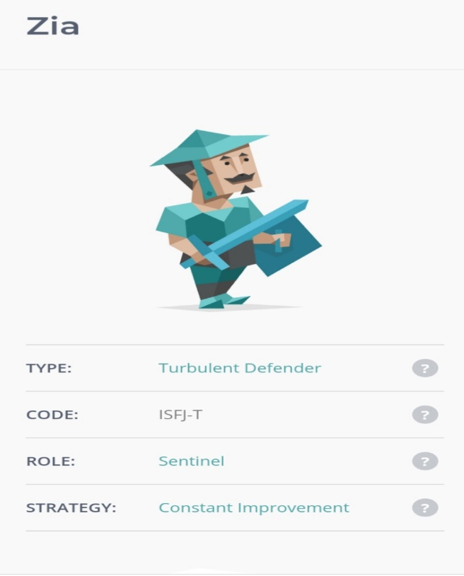
Source - https://www.16personalities.com/profiles/0a81556197fc5

Career Motivation Test
This test shows how motivated we are in different fields of the working environment. It tells us whether we want to work for financial rewards, higher pay, commissions or other benefits. It also tells us if we are motivated to work as a part of life, accomplishments or just for satisfaction etc (Leitch, 2017). No matter how we feel about employment, everyone has their own motivations and feelings. Motivation in general can be intrinsic and extrinsic, and they can invigorate a person to do things they want to do in life internally or externally.
This online motivation test was less appealing to me, and there was not much to reflect on about this, or how it would help me enhance my career development. This test lasted for twenty minutes with over one hundred questions, and with four possible answers to choose from. My result at the end of the test was ‘FINANCIAL REWARD’, which means I am motivated to work for a good salary due to the quantity of work I do. The result speculates I am a person who would not work for peanuts. This is true in a sense, but circumstances can change for me. I was given a snapshot report from the website which is in the appendix.

Reflective Report
This second part of the report is based on my experiences at the university on how I prepared for the mock interview, including preparation of a CV and cover letter. It also covers what happened after the interview by getting feedback from two interviewers. In addition to self-awareness, we also done online activities such as tests to show us our motivation and career personalities which I will reflect on one of them.
123Test
The 123Test are series of online tests about peoples’ personality, IQ or career assessment. The test assigned by Moodle were picture tests on certain work activities. Each of the pictures are work related that associates with specific types of personalities. These sort of personalities are derived from Dr. John Holland and are called the Holland Codes. The six personality types are Realistic, Investigative, Artistic, Social, Enterprising and Conventional (McKay, 2019). All six are part of Holland’s model which are basically three-letter codes that comprises of a person’s three main types of personality out of six choices.
My result and personality type was mostly ‘CONVENTIONAL’, and then ‘REALISTIC’ and ‘ARTISTIC’. This means my six letter personality is known as ‘CRASIE’.
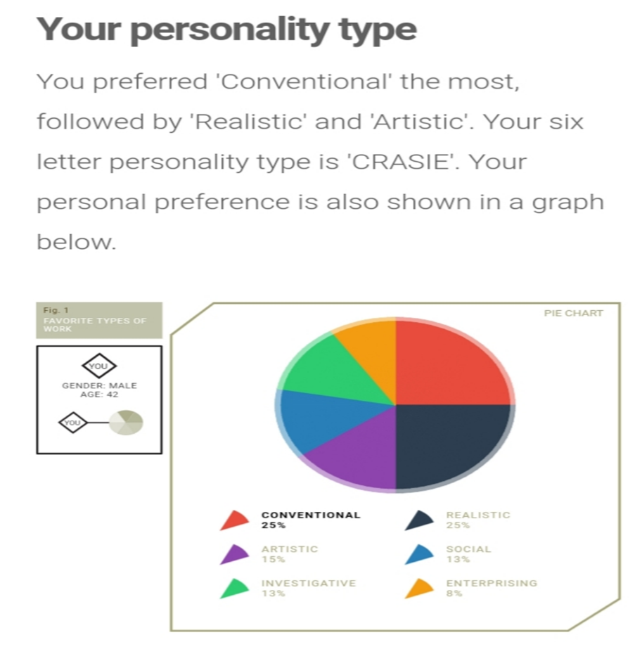
Source - https://www.123test.com/career-test/id=HQP3X76AXXHD&version=#
The above result suggests some occupations that fit my Holland Code ‘CRASIE’. Some examples are Glass Blower, Shoemaker, File Clerk, Stonemason and Baker etc. I found this test astonishing and made me self-aware of what career personality I have which I acknowledged.
Job Description & Application
I signed up and searched for jobs on www.indeed.co.uk. It is a number one job site in the world where more than 250 million people visit every month and new jobs are added every second. It is user-friendly, easy to browse and straightforward without clutter on the site (Doyle, 2019).
After browsing the job site, I came across a job advert that caught my attention. The job role I was interested in was “Front of House Customer Service Assistant” at one of the Samsung support centres in Birmingham, UK. The recruiters were looking for a full-time candidate and they offered a permanent position with an hourly salary of £8.21.
The role as the job title specifies is dealing with customer services and my tasks will include performing diagnostics and fault-findings on the front, software repairs, booking customers in and working as a level one technician. As I am keen on technology and have personal skills, and having some familiarity with Samsung and Android devices, I immediately applied for this job role. Samsung did not require the candidate to have any prior knowledge for this job and they have mentioned handing out training material frequently to assist me.
However, I have previous experience in cash-handling and customer service and will know how to handle complaints and make customers happy. This job was something different to me that can enhance my career.
CV Building
Good CVs makes people stand out and shows that a person is capable for an applied job. Before I prepared myself for the mock interview, I believed creating a good CV is important to get the job I wished for. I thought of adhering to a traditional CV rather than modern fancy ones. My CV had plain and simple formatting, and without any unkempt layouts and fancy coloured palettes. However, the only bad aspect of this style of CV is that it will look identical to numerous other CVs from other applicants (Theodorou, 2020). I took my chances and hoped for the best.
My CV followed a chronological order and starts from the most recent work experience to the oldest. It had my education and skills section with additional bullet points in the hope the employer will read my CV easily, and to recognize my abilities for the job. The good aspect of the CV was that everything was accurate and honest without unnecessary bragging.
Job Cover Letter
As a job applicant, I needed to write a convincing cover letter. This is important because it gives me the chance to add information already stated on my CV as well as adding my personal skills. My cover letter will act as an introduction to my past relevant accomplishments. It will allow the employers to compare mine with other candidates with similar qualifications (Staff Writer, 2020). I had to make sure the cover letter for the employer is tailored well for the job I was applying for. There was no negative information on my cover letter, only honesty.

Preparing for the Job Interview
A job interview is used by an employer and organization to select the most suitable worker for their business. The selection procedure in interviews is the vital step which also gives the opportunity for the employers and job applicants to meet and get to understand each other (Akrani, 2011). Prior to the mock interview, there were certain rules and procedures we were made aware of by the lecturer. Basically, they are the do’s and don’ts to prepare oneself in a job interview. A short activity has been assigned to us in the classroom by our lecturer to think of some of the do’s and don’ts in job interviews.
A list of do’s I thought of were:
- Be well dressed
- Maintain courtesy
- Keeping eye contact
- Keep a smile all the time
- Arrive to the interview on time
- Learn about the trade
- Sit with an open stance
- Show passion for the job role
- Ask the employer questions about the company
A list of don’ts I thought of were:
- Avoid being over-confident
- Avoid slang words
- Keep answers short and to the point
- Avoid cross-armed and cross-legged positions
- Do not chew gum or sweets
- Do not mention about money
- Avoid ‘I don’t know’ answers
Before the interview day, I was studying on what I have learnt from previous lessons. I felt nervous about it, but I knew I had to prepare myself and get inside that interview room. I ensured I got plenty of sleep. I was doing some breathing exercising for ten minutes prior to the interview to help reduce anxiety. I was wearing black trousers, plain shirt and shoes to look distinguished. However, no blazer or a tie were worn. Other things I thought of before I left home was how to make a good first impression to the recruiters to show that I care and have respect for the company. Grooming was important so I ensured my hair was combed neatly, had a clean shave and my fingernails were trimmed, which in return will have a great influence at the interview (Winston, 2017).
When I was called in the room, I shook hands and greeted both interviewers politely with a smile, and handed my CV, cover letter and job description. I felt quite nervous even though it did not hinder me drastically because I knew this is my moment. The mock interview lasted for ten minutes and during that time, I was asked questions by both interviewers on my suitability for the customer service assistant job. I felt I was the right candidate due to my keenness, motivation and aspiration despite not having previous work experience in the technology trade. I wanted to try something new by showing passion for the role at Samsung.
Before I left, I shook hands with both recruiters and was told I will receive feedback on my performance in a fortnight. This is when I will know how well and poor I did, and where I could have improved or where I made a mistake during the interview. After waiting a fortnight, I was handed two feedback papers for each person. I will reflect on my outcome by referring to them as recruiter A and recruiter B (Refer to appendix).
The feedback papers consisted of a score card where 5 means excellent, 4 is very good, 3 is good/average, 2 is poor and 1 is very poor. These scores were decided on my first impression and verbal behaviours, and then added finally to my overall preparation where all the points were added up and given as a final score. In addition to this feedback, they have added further comments on my performance.
Recruiter A
This recruiter gave me a decent score on my performance, but I could have done better. For my first impression from recruiter A, I got:
- Excellent score for being punctual.
- Good or average score for shaking hands, smiling and greeting.
- Very good score for handing genuine copies of my CV, cover letter and job description.
- Good score for maintaining eye contact
- Good score for being dressed properly.
- Good score for my posture and normal hand and facial movements.
For the verbal behaviour part, I got:
- Poor for not knowing enough about Samsung
- Good for answering questions fully, but briefly.
- Poor for not utilizing the STAR format for behavioural questions.
- Good for understand the company’s needs and for proving I am the right candidate by my qualifications and skills.
- Good for understanding my position of the job role and referring to my previous skills at work.
- Very good for showing my enthusiasm to work for Samsung.
- Good for focusing on my strengths and avoiding any weaknesses.
- Very good for displaying my politeness.
- Poor for failing to reference items on my CV.
- Good for answering questions in good time without long pauses.
- Poor for not asking relevant questions.
- Poor for unclear speech.
- Good for avoiding empty or slang words.
In total, I scored 60 out of a 100, a grade of 60percent which I believe is decent enough but needs to be improved much more according to this feedback. Recruiter A mentioned on the comments that I should do more research about the Samsung company I am applying for. The recruiter also stated that I needed to ask more questions to the panel despite asking only one question that was thought to be irrelevant. In addition to that, my answers were believed to be short and I needed to speak with more confidence and explain a bit more in detail from questions.
Recruiter B
Recruiter B’s feedback was positive, and I was content, but I believe it is still not good enough as compared to recruiter A. The feedback for my first impression from this recruiter was:
- Excellent for being punctual.
- Poor for failing to shake hands but offered a greeting and a smile.
- Excellent for submitting all the paperwork.
- Very good for keeping eye contact.
- Very good for dressing appropriately.
- Very good for posture and body movements.
For verbal behaviour:
- Good for showing knowledge about Samsung.
- Good for answering questions, yet briefly.
- Good for utilizing the STAR format for behavioural questions.
- Very good for understanding company’s needs.
- Very good on understand the position and for pointing out previous skills at work.
- Very good for showing enthusiasm.
- Very good for focusing on strengths and avoiding weaknesses.
- Very good on politeness.
- Very good for referencing specific details from CV.
- Good for responding to questions immediately without rushing.
- Good for asking questions.
- Very good for speaking clearly with a reasonable voice tone.
- Very good for not using slang or empty words.
I have earned a total score of 74, a grade of 74percent. Recruiter B commented that I could have provided deeper responses to questions with adding few examples on why I am suitable for the job. I also got praised for pointing out my weakness, a slight speech problem, which I have challenged and is not a hindrance to my progress and the recruiter was okay with that.
What have I learnt from this and how do I improve myself further?
After analysing both feedbacks, I learned that both interviewers gave different scores and comments, and with that in mind, I respect both their inputs. My score ratio means I might have been hired but I need to improve. I knew I made mistakes in certain areas and should have prepared better.
After learning from my errors, I should know be able to improve myself for future interviews because it made my self-awareness increase. The improvements I could make are:
- Wearing a blazer and tie.
- Practicing my speech in front of a mirror.
- Asking relevant questions.
- Show more confidence and character.
- Utilize the STAR tool which stands for Situation, Task, Action and Result (Doyle, 2019).
- More research on organizations.
Conclusion
This discursive and reflective report has given me a life lesson on clearness and clarity for the future. The past events and activities done at university had some influence on me and made me self-aware of how to promote myself in the real world in order to achieve the things I desire. I now realize that no one in this world, can help me but myself If I made the effort. Sometimes true friends are the ones who help whilst the rest walk away and forget you, but is better to go it alone (Richardson, 2017). My last thoughts will be to strive and struggle and accept failure as part of life to succeed the next time round.

References
Akrani, G. (2011) “Importance of Interview for Employers and Job Seekers”, KALYAN CITY LIFE [online] Available at: https://kalyan-city.blogspot.com/2011/07/importance-of-interview-for-employers.html [Accessed: 10th January 2020].
Baker, B. (2012) “The Johari Window: How to Build Self-Awareness & Achieve Success”, StartOfHappiness [online] Available at: https://www.startofhappiness.com/using-the-johari-window-for-self-awareness/ [Accessed: 18th January 2020].
Davis, T. (2019) “What Is Self-Awareness, and How Do You Get It?”, Psychology Today [online] Available at: https://www.psychologytoday.com/us/blog/click-here-happiness/201903/what-is-self-awareness-and-how-do-you-get-it [Accessed: 20th November 2019].
Doyle, A. (2019) “Tips for Using Indeed.com to Job Search”, thebalancecareers [online] Available at: https://www.thebalancecareers.com/tips-for-using-indeed-com-to-job-search-2061909 [Accessed: 28th January 2020].
Doyle, A. (2019) “How to Use the STAR Interview Response Technique”, thebalancecareers [online] Available at: https://www.thebalancecareers.com/what-is-the-star-interview-response-technique-2061629 [Accessed: 27th January 2020].
Fisher, S. (2019) “Here Are Some Places to Find Free Personality Tests”, The Balance Everyday [online] Available at: https://www.thebalanceeveryday.com/free-personality-tests-1358039 [Accessed: 07th January 2020].
Harris, K. (2017) “The Johari Window: A Communication Tool to Improve Relationships”, HubPages [online] Available at: https://youmemindbody.com/mental-health/Johari-Window [Accessed: 1st January 2020].
Leitch, C. (2017) “A Quick Guide to Career Motivation Tests”, CareerAddict [online] Available at: https://www.careeraddict.com/career-motivation-tests [Accessed: 27th January 2020].
Mulder, P. (2017) “Johari Window Model”, toolshero [online] Available at: https://www.toolshero.com/communication-skills/johari-window-model/ [Accessed: 8th January 2020].
Mercedes. (2020) “ISFJ Personality Type (The Silent Heroes)”, Life Reaction [online] Available at: https://www.lifereaction.com/isfj-personality-defender/ [Accessed: 15th January 2020].
McKay, D R. (2019) “Finding Your Career With the Holland Code”, thebalancecareers [online] Available at: https://www.thebalancecareers.com/the-holland-code-526166 [Accessed: 25th January 2020].
Richardson, B. (2017) “What Should the Conclusion Do in a Reflective Essay?”, CLASSROOM [online] Available at: https://classroom.synonym.com/should-conclusion-reflective-essay-19551.html [Accessed: 25th January 2020].
Staff Writer, L. (2020) “Why Cover Letters Are Important for Job Seekers”, LiveCareer [online] Available at: https://www.livecareer.com/resources/cover-letters/basics/cover-letter [Accessed: 20th January 2020].
Tracy, B. (2020) “Defender Personality ISFJ-A / ISFJ-T (What’s the difference?”, 16 Personalities [online] Available at: https://www.16personalities.com/isfj-personality [Accessed: 10th January 2020].
Theodorou, M. (2020) “The 20 Best CV Examples for Your Inspiration”, CareerAddict [online] Available at: https://www.careeraddict.com/best-cv-examples [Accessed: 15th January 2020].
Woods, E. (2017) “What Are Self Awareness Tools?”, Raising Self Awareness [online] Available at: https://raisingselfawareness.com/self-awareness-tools/ [Accessed: 06th January 2020].
Winston, B. (2017) “What Is the Importance of Appearance on a Job Interview?”, bizfluent [online] Available at: https://bizfluent.com/info-8648973-should-always-wear-suit-interview.html Accessed: 2nd January 2020].

APPENDIX
JOB DESCRIPTION
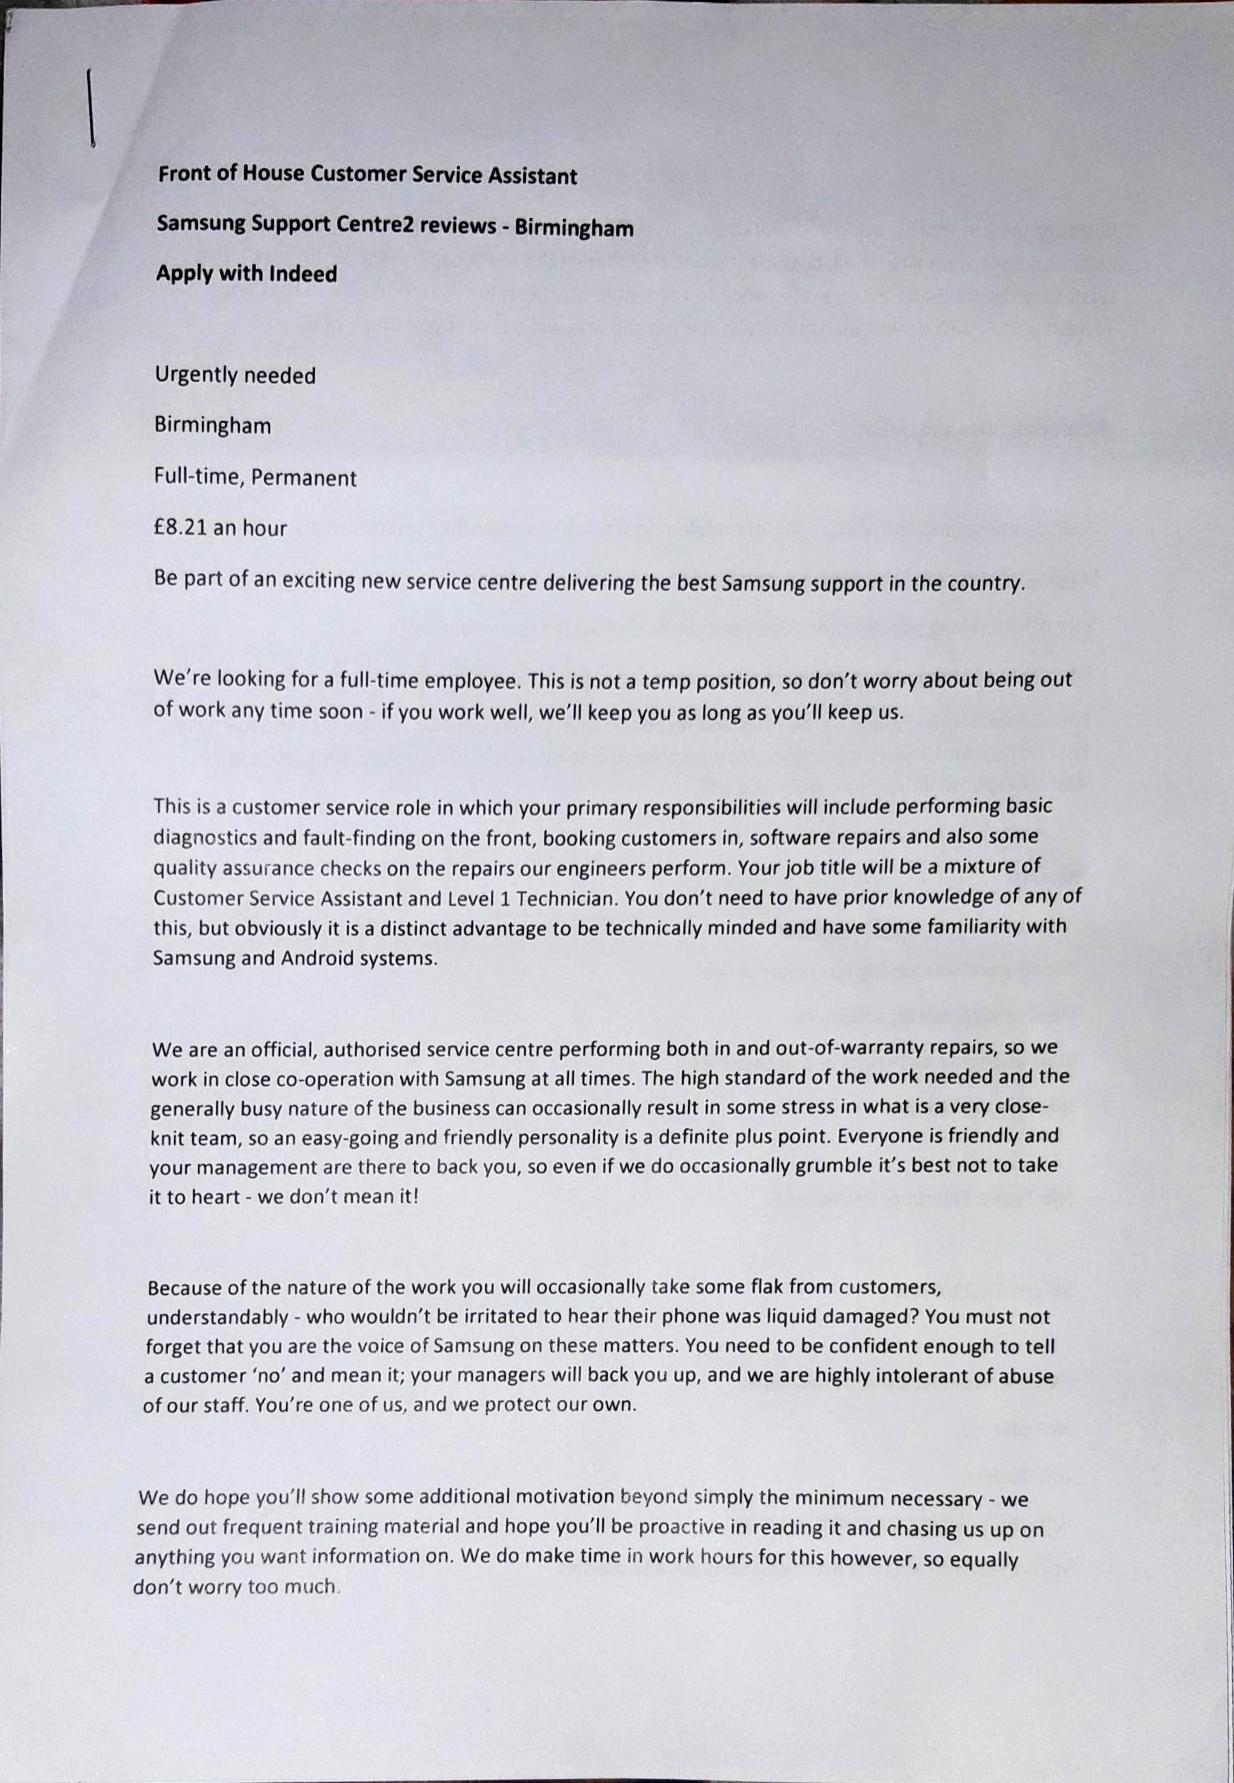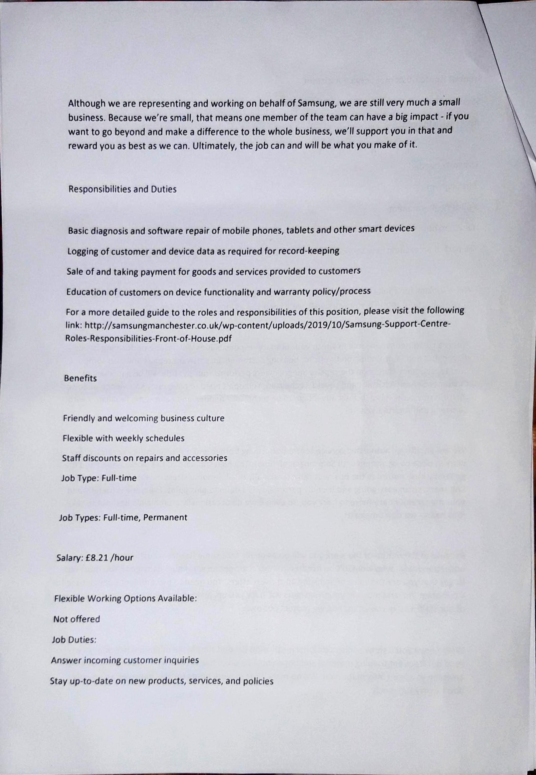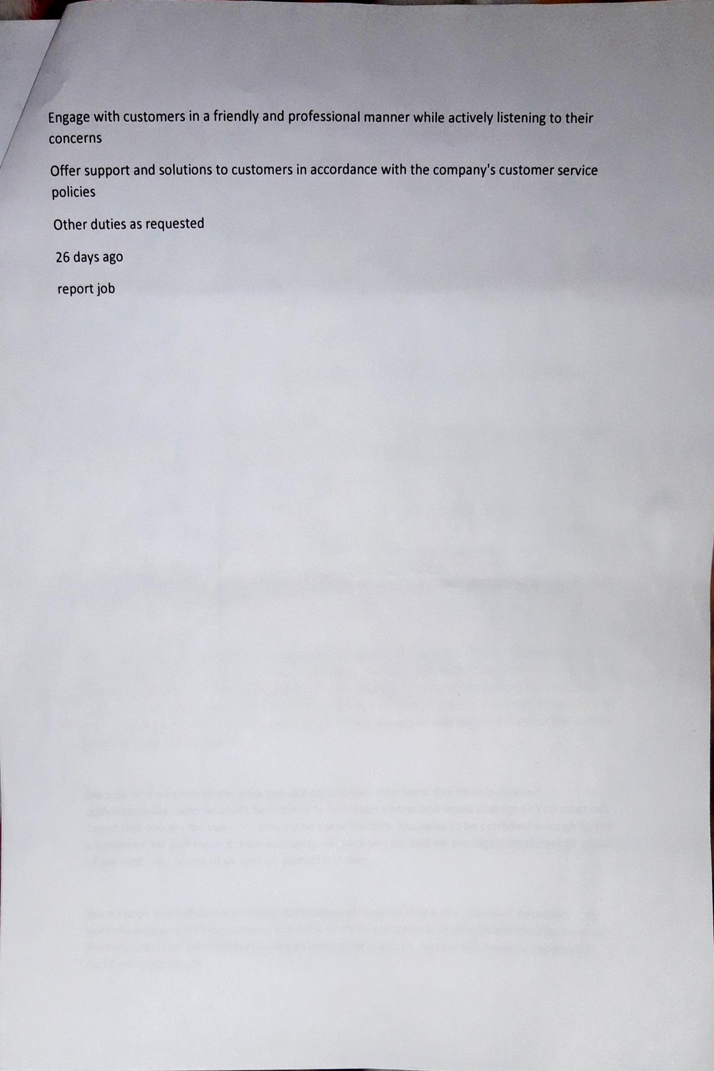
COVER LETTER & CV
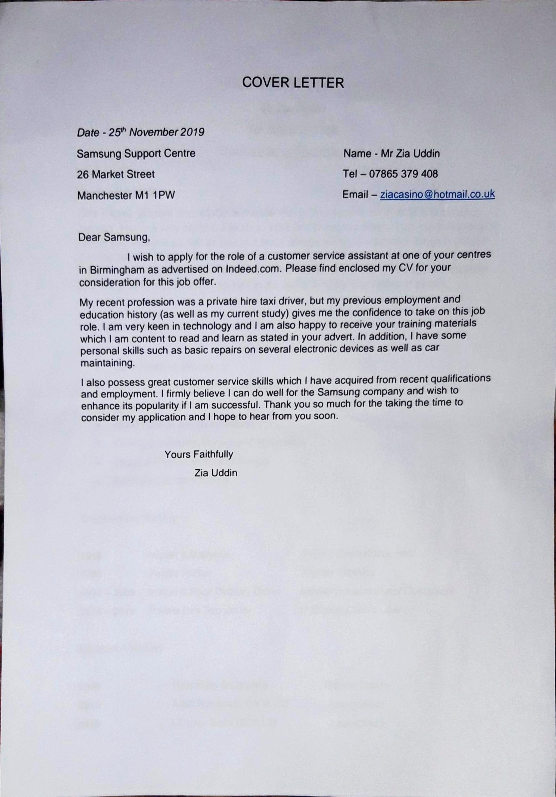
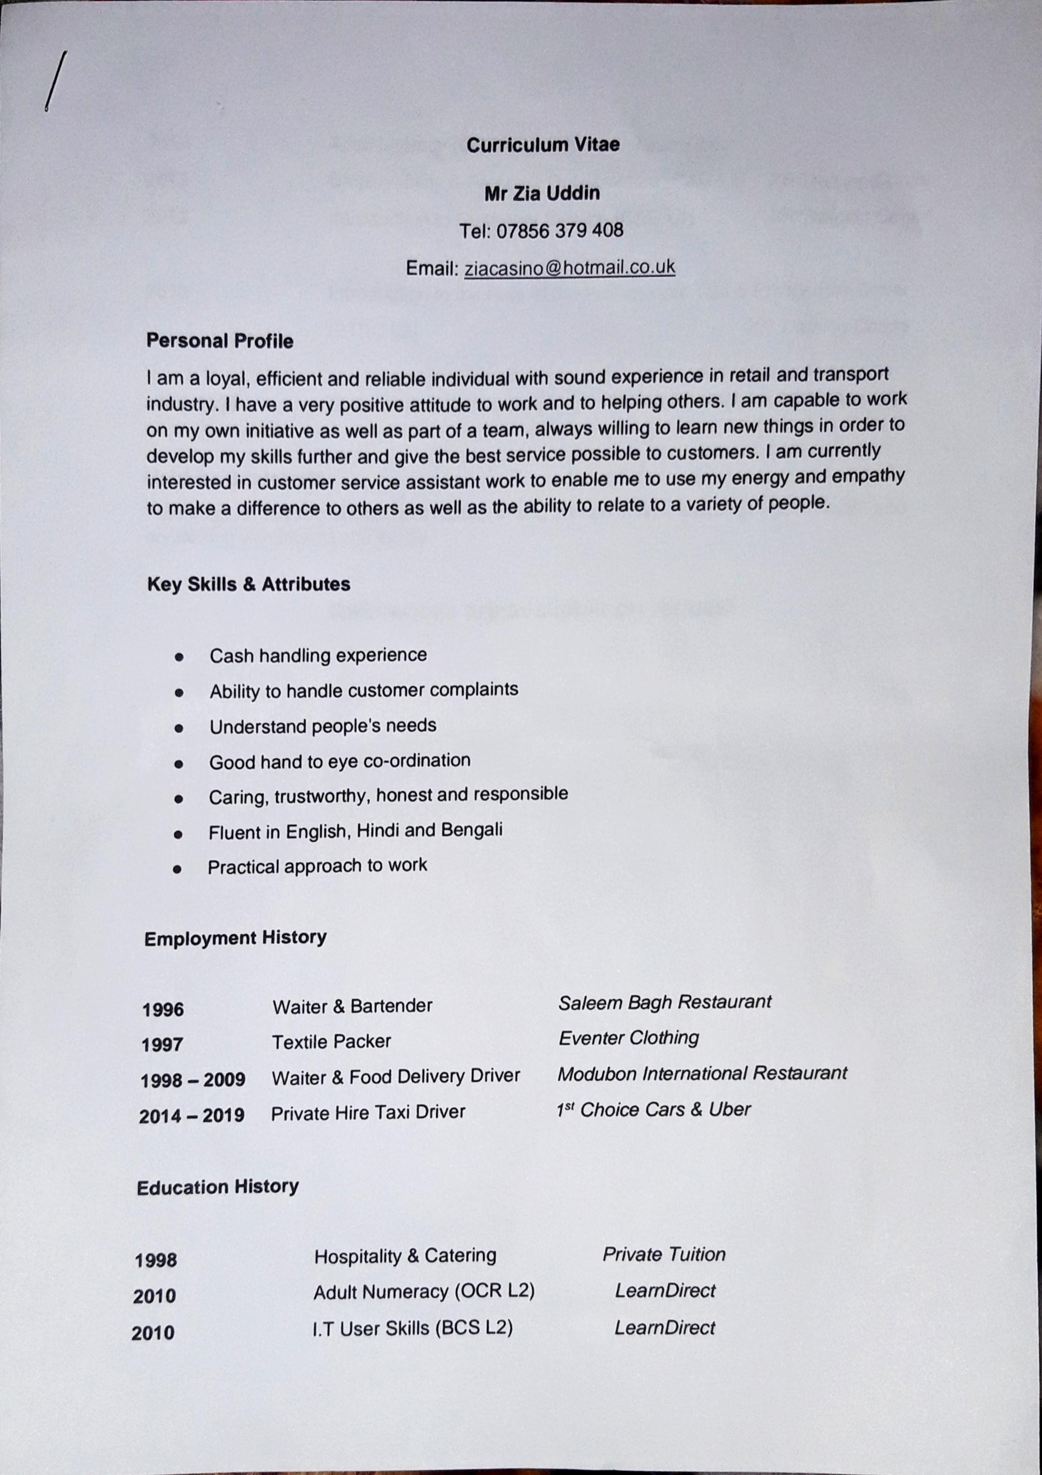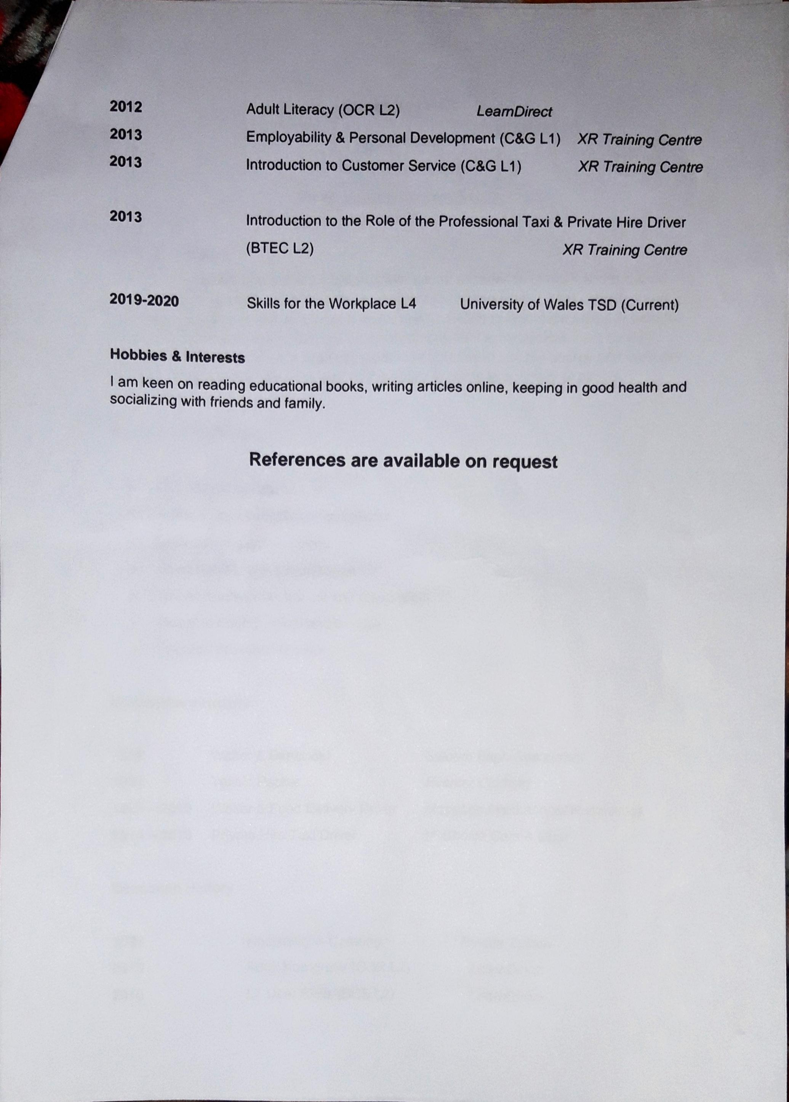

FEEDBACK FROM INTERVIEW
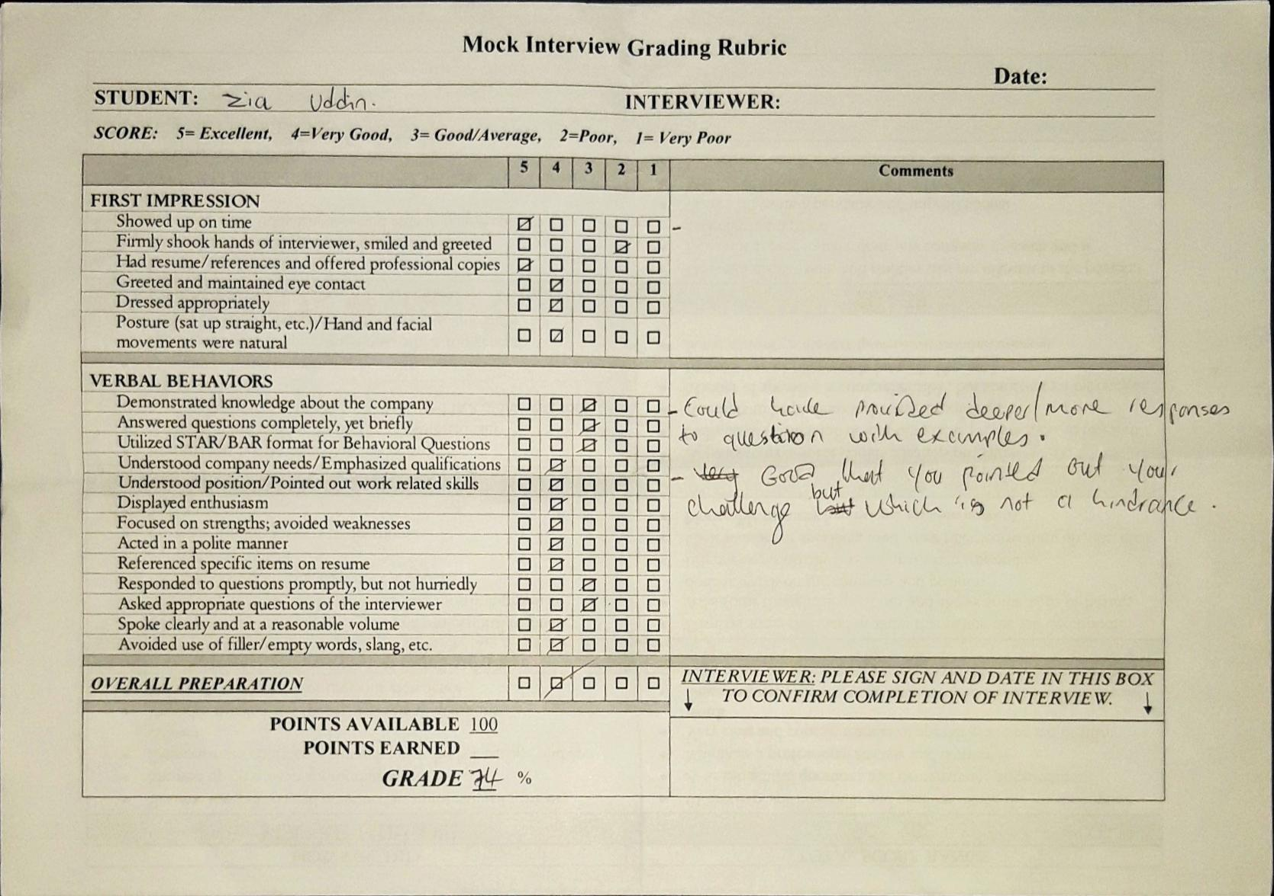
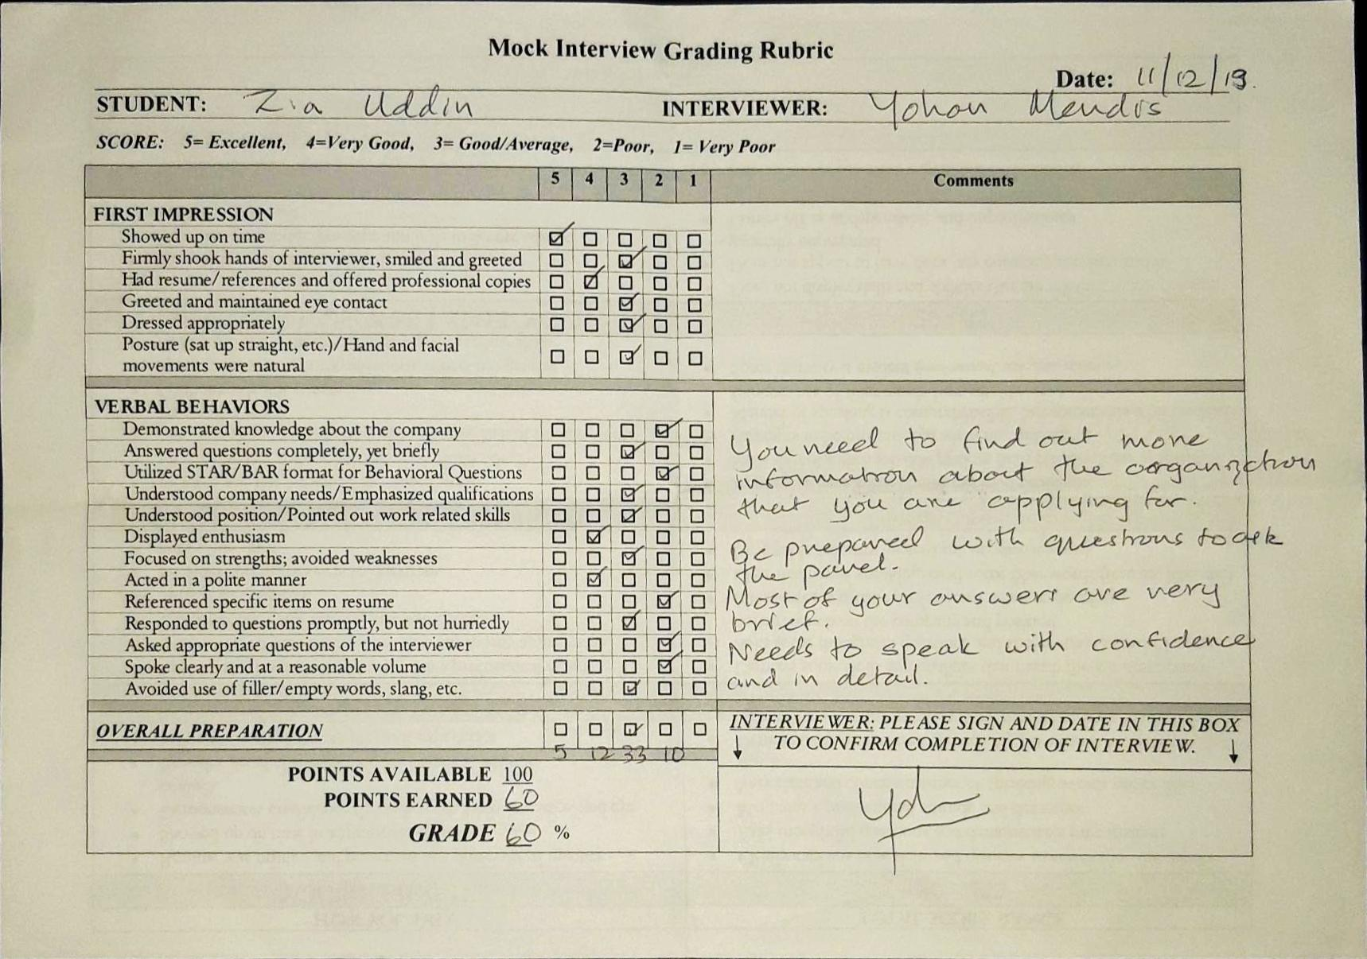
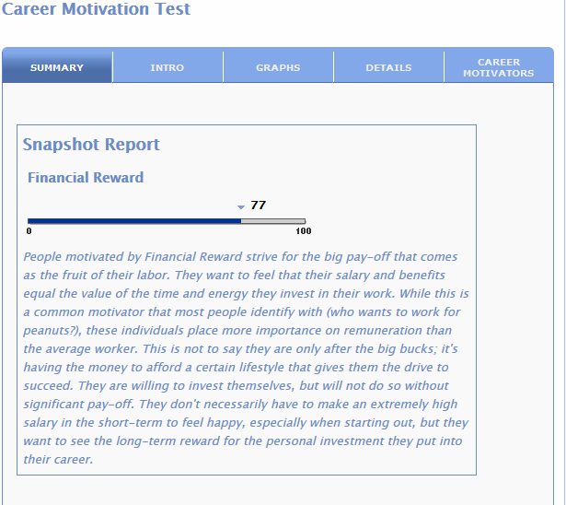

16PERSONALITIES TEST RESULTS
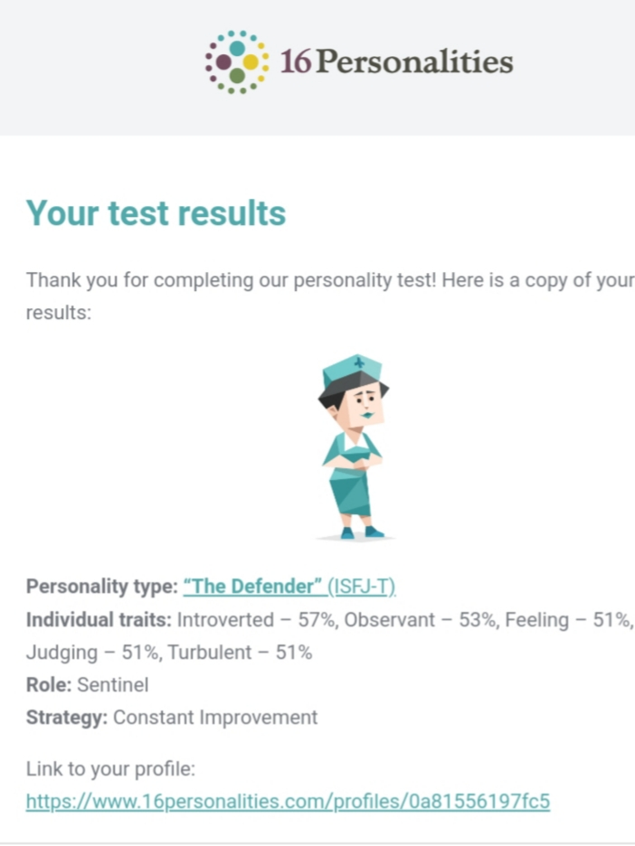
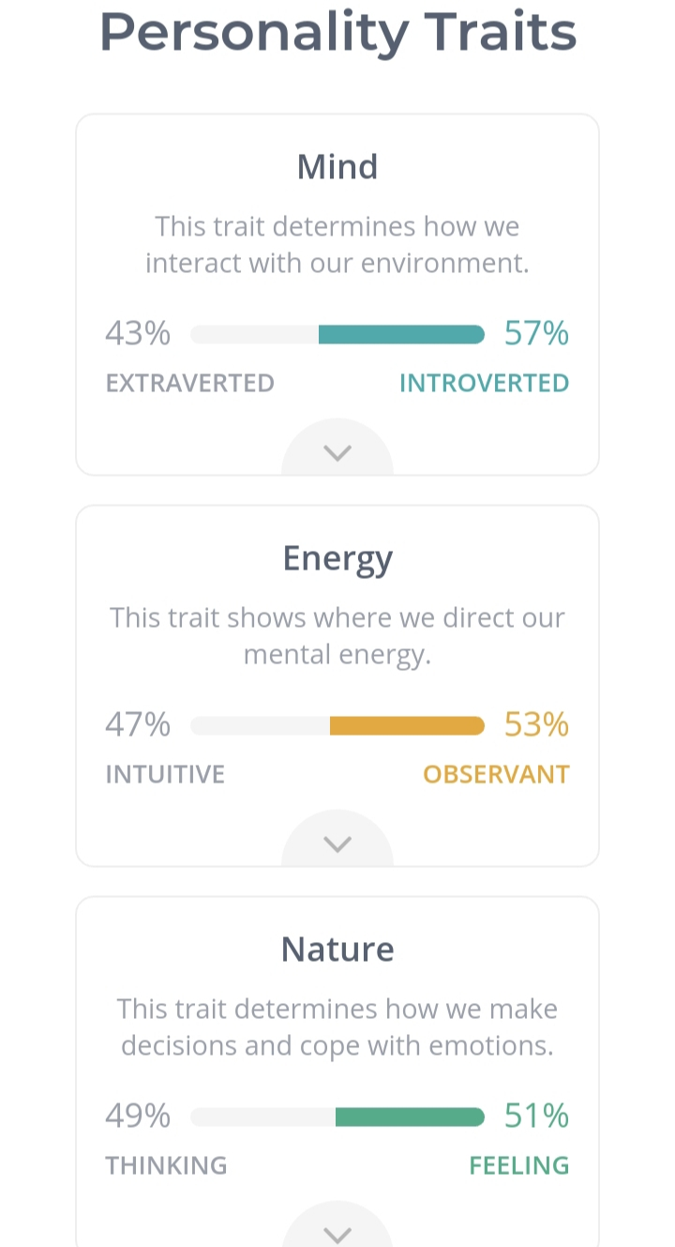
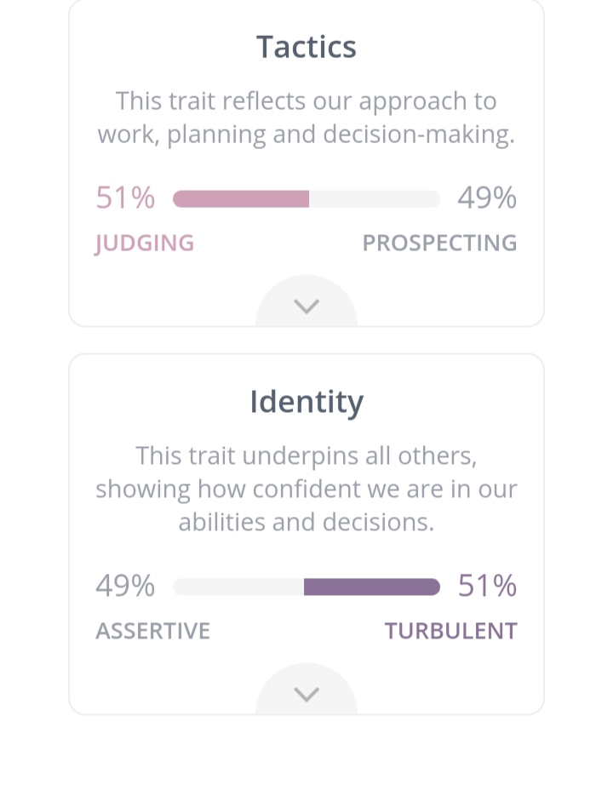
123TEST (CAREER APTITUDE TEST)
https://www.123test.com/career-test/id=HQP3X76AXXHD&version=#


