

BA Business Management
Introducing the Modern Workplace
LCBB4003
Component 1: Coursework: Essay
Student Name:Mihaela Ruxandra Iancu
Student ID:2133740

Executive Summary
The following report highlighted three major elements which affect organisational performance such as organisational structure, organisational culture and employee motivation. At first, all three elements were discussed based on their importance. Tesco was chosen as the organisation for research and a detailed analysis was done based on its performance so far. This analysis further helped to discover the impacts of organisational structure and culture on the performance of the company. Several motivational strategies were also discussed which are currently exercised by the management of Tesco.

Table of Contents
Introduction 4
Importance of Organisational Structure 4
Importance of Organisational Culture 6
Importance of Individual Motivation 8
Impact of Organisational Structure on Tesco’s Performance 9
Impact of Organisational Culture on Tesco’s Performance 11
Employee Motivational Strategies Used in Tesco 11
Conclusion 12
Reference List 13

Introduction
Organisational structure, organisational culture and employee motivation are three fundamental elements which govern its performance. Each of these elements contains several types with different characteristics. Leaders use these types based on their own objectives. To understand the importance of these elements from an organisational perspective, Tesco is chosen for research. The primary goal of the report is to understand the importance of all three elements observing them from the viewpoint of Tesco. Further, the report will find out the influence of all three elements on the performance of Tesco.

Importance of Organisational Structure
An organisational structure can be referred to as the path through which commands are distributed within an organisation. Generally, this structure consists of different levels of management, product lines and divisions. The organisation structure defines job titles within an organisation along with the rules and responsibilities. Four fundamental elements of the operations of any organisation such as command, accountability, leadership and responsibility are reflected through this organisational structure (Edward, 2023). Primarily, an organisational structure looks to cluster its workforce and objectives in small groups. To simplify the methods of achieving them. In this way, it also organises the information flow, sheds light on the management’s priorities, allocates the resources effectively and channels the decision-making authority properly. Based on the size and scope of an organisation several key elements become associated with its organisational structure. Some of these key elements are-
Chain of command- The organisation structure of any business sets its chain of command which emphasises the proper direction of flow of command. Setting this hierarchy ensures that the command comes from the proper authorities and is aligned with the primary objectives of the organisation.
Work specialisation- The biggest advantage of an organisational structure is a clear description of the roles and responsibilities associated with any kind of job. It not only helps the managers of an organisation to use their talented workforce in the best way possible but also helps the employees to perform at their best.
Centralisation and Decentralisation- The organisation structure also helps set the management's decision-making processes. Fundamentally, ‘top-down management’ follows the centralisation process whereas ‘bottom-up’ management follows the decentralisation process (Campbell, 2022). The centralisation process always supports authoritarian management where business operations and objectives are always aligned ensuring a higher chance of success. On the other hand, the decentralisation process supports participative management where employees are also included in the decision-making process of the company ensuring high innovations.
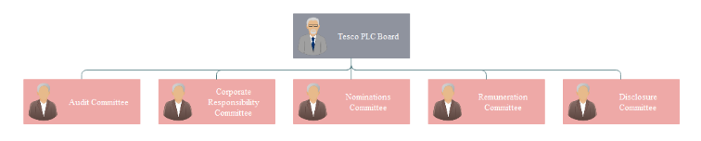
Figure 1: Tesco’s organisational structure at the corporate level
Source: (Meng, 2024)
Organisational structures have four major types: functional, divisional, flat and matrix. The divisional organisational structure is mostly preferred by large organisations since it divides the business into different regions for operational purposes. On the other hand, small and medium organisations prefer either functional or flat organisational structures due to their simplicity and high manoeuvrability. There is also a matrix structure where multiple commanders exist in the same chain for overseeing different operations. Tesco has been chosen for this report which maintains a clear hierarchy within its organisation. Due to its large size and scope, the company has properly adopted a divisional organisational structure with proper governance even at the store level.

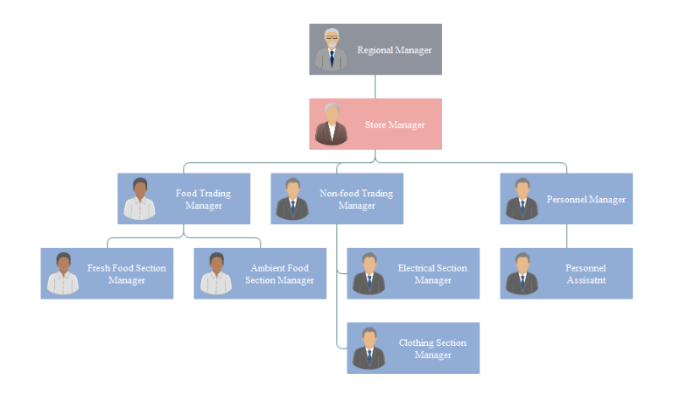
Figure 2: Tesco’s organisational structure at store level
Source: (Meng, 2024)

Importance of Organisational Culture
In general, the word culture is used to define the values, norms, beliefs, achievements and customs of an individual or a group. Similarly in the context of an organisation, its culture can be defined by the values and beliefs of its workforce which are implemented in its behaviour and practice (‌Cadden et al., 2020). The culture of an organisation includes its vision, mission, leadership and the expectations of its employees. It shows the overall engagement level of every member of the organisation which is highly required in the case of performance management. Organisational culture identifies the nature of the driving force of work within an organisation and based on its positivity or negativity, it predicts the business performance. A strong organisational culture helps the leaders to make correct decisions and fuel the workforce based on the primary objectives of the organisation. Based on their characteristics, organisational culture is generally categorised into four types, which are-
Clan culture- This culture follows a ‘human relation model’, where leaders always try to form efficient teams or plans where employees are highly valued and also prioritised in the decision-making process of the organisation (Oh and Han, 2020).
Market culture- This organisational culture focuses on promoting competition within its workforce to find out most effective talents. In this way, an organisation can find its best employees and reward them for further motivation.
Adhocracy culture- This is a more modern type of culture where participation and innovations are emphasised highly. This influences participative or democratic leadership within an organisation.
Hierarchical culture- It is the most highly used organisational culture which supports authoritarian decision-making. In this culture, organisation objectives are more prioritised than the employees' career progression.
Among these four types of organisational culture, Tesco follows a hierarchical organisation culture to perform its daily operations at an optimum level. Being one of the largest supermarket chains in the UK the primary objective of this organisation is to fulfil its daily missions which require an authoritarian leadership fueled by a hierarchical organisational culture.
The concept of organisational culture can be further clarified using Hofstede’s Cultural Dimension, a major theoretical concept of organisational culture. This theory mentions five dimensions such as- power distance, masculinity versus femininity, individualism versus collectivism, long-term orientation and uncertainty avoidance index (Isfahani et al., 2020). These factors help to distinguish one organisation's culture from another. It also assists the manager in understanding the effects of the current culture on the workforce and making modifications if necessary.
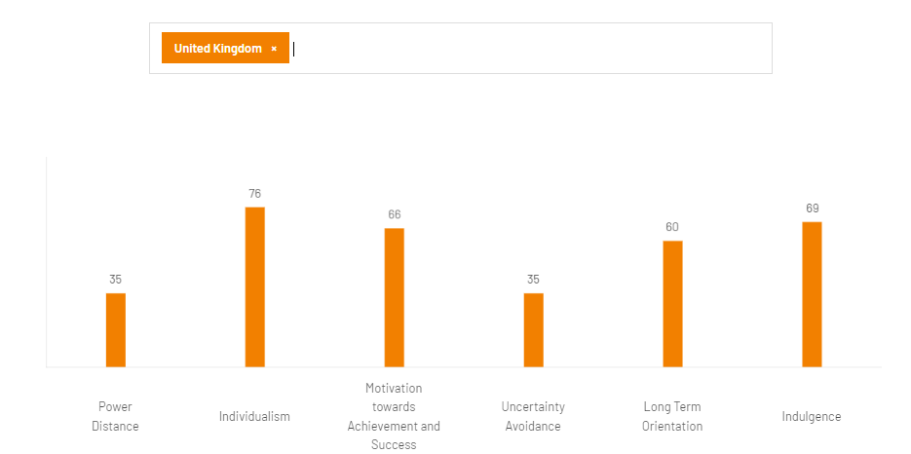
Figure 3: Common organisational culture in the UK (using Hofstede’s country comparison tool)
Source: (Hofstede Insights, 2023)

Importance of Individual Motivation
Organisational motivation is the process which increases the enthusiasm and engagement of an individual towards his roles and responsibilities within an organisation. Nowadays employee motivation has become a primary concern for the management of every organisation (‌Watters, 2021). Employees are the primary workforce of any organisation and at the same time, they are individual goal seekers who try to find positive reinforcements such as rewards, recognitions and others. Hence these become the primary areas of concern for the management since by using these tools, they can properly motivate their employees. In this context, several motivational theories are exercised in different organisations.
Vroom’s Expectancy Theory has its own view towards maximising the rewards of the employees. According to Vroom, the two elements that successfully increase the levels of motivation within an employee are- a) an individual's belief that his efforts will be rewarded and b) his belief that he will be highly valued within the organisation based on the rewards (Watters, 2021). These two elements are called expectancy and valence. This theory is often used by Tesco management at the store level, where the employees receive rewards for high sales and at the same time valued as efficient employees by the store managers.
Adam’s Equity Theory focuses on another aspect of employee motivation which is related to the quality of the reward. Equity theory states that an employee can feel inequity if he finds his reward to be inferior to his efforts (Watters, 2021). Additionally, an employee will also remain unsatisfied if he feels that his fellow employee is getting the same reward with less effort. Hence the management needs to be aware of these factors and provide proper rewards for proper efforts. In Tesco, the store-level managers are responsible for maintaining employee motivation through the application of Adam’s Equity Theory. They possess the authority to provide small rewards to their employees based on their weekly and monthly performances.

Impact of Organisational Structure on Tesco’s Performance
Following a divisional hierarchy has helped the business of Tesco in many ways. The combination of both soft and hard elements of McKinsey’s 7S Model reflects the usefulness of the core structure of the company along with its values, shared beliefs, systems and strategy. Every element of this structural concept has an impact on the performance of the organisation.
Strategy- The primary objective set by the Tesco leadership is to focus on the benefits of its customers, communities and planet which is supported by its motto of ‘every little helps’. McKinsey’s 7S Model has helped the business to develop a cost-leadership business strategy which is helpful for them to maintain their sustainable strategy despite remaining profitable.
Structure- A divisional hierarchical organisational structure has helped Tesco to balance its operations among 4859 stores globally. To employ nearly 354,000 employees all around the world, the board had to simplify its organisational structure, by eliminating the position of deputy store manager in 2015.
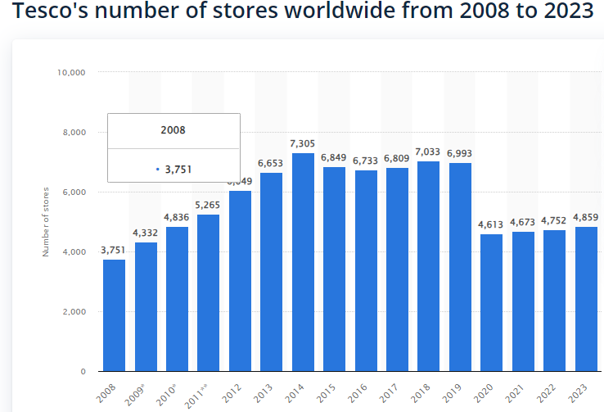
Figure 4: Number of stores of Tesco
Source: (‌Bedford, 2023)
Systems- McKinsey’s 7S Model focuses on system development for both positive internal and external conditions of an organisation. Former CEO of Tesco, Dave Lewis performed exceedingly well in this context. He brought a revolutionary change in the performance appraisal system within the organisation which ensured a high level of job satisfaction for its employees.
Style- Style refers to the leadership used by any organisation and Tesco uses participative leadership style which represents collaboration, empathy, responsiveness, innovation and resilience. These elements have altogether helped to build strong and efficient teams that can handle day-to-day operations efficiently.
Staff- Tesco has always developed policies for the benefit of its employees. These policies include proper training, rewards and recognition, performance evaluations and many other factors. Apart from this, the company should focus on building online recruitment and remote onboarding programmes as these will broaden the employee pool of the organisation.
Skills- Skill development among the employees is one of the key objectives of the organisational structure of Tesco. The management has built an effective training and development programme which is highly efficient in finding proper talent for this organisation.
Shared values- The core values of Tesco incorporate its vision and missions to make it highly transparent towards its consumers. In this way, the organisation maintains its popularity globally.

Impact of Organisational Culture on Tesco’s Performance
The hierarchical culture of Tesco has always prioritised its customers more than any other factor. The core purpose of the company embedded in its organisational culture is to serve its customers, communities and the planet in a better way each day (Tesco, 2022). The managers of Tesco always put their efforts into notifying their employees about these purposes every day and keeping track of their behaviours. The core values embedded in Tesco’s culture hugely influence its three major stakeholders,
Customers- The core values and beliefs of the organisation have made its culture customer-friendly. It has helped the management to understand the purchasing behaviour of its customers (Tesco, 2022). It helps in the development of effective products, pricing, place and promotional strategies for the company.
Communities- The development of community is another major goal of Tesco which is one of the main reasons behind the popularity of Tesco. The organisational strategies have always helped Tesco to create numerous employments, influence local suppliers and help local causes through community programmes.
Planet- Tesco’s culture focuses on its corporate social responsibilities which make nature its top priority. Its objective of maintaining sustainable operations and sustainable products helps in reducing environmental impacts. The company included the zero carbon goal back in 2009 as the first company in the UK and is looking to become carbon neutral within 2035.

Employee Motivational Strategies Used in Tesco
Tesco uses several motivational strategies to ensure high engagement of its employees with its operations as well as their job satisfaction level. Some of these strategies are-
Colleague Briefing Session- Tesco management has developed this quarterly briefing session for the employees so that they do not miss the major notifications of the company. It is also supported by an online forum where the management always updates information such as organisational performance, CSR activities, upcoming events and other important information about the company.
Rewards and Recognitions- Tesco uses different financial and non-financial benefits such as monthly incentives, employee share scheme plans, staff housing, voluntary benefits and many more.
360-degree Feedback Programme- Tesco leadership has always focused on building 360-degree feedback programmes to develop personal development plans for its employees. It has not only helped the employees to develop their weak skills but also helped the management to trigger the hidden talents within its employees.

Conclusion
In the end, it can be concluded that both organisational structure and culture influence the performance of an organisation. For example- a divisional hierarchical structure has helped Tesco to properly distribute its rules and regulations among its 4859 stores all around the world. On the other hand, the organisational culture of Tesco has helped it to incorporate its mission and vision into its values. Furthermore, the employee motivational strategies of the company have helped to channel the positive elements of the structure and culture within the employees to ensure their productivity and loyalty.

Reference List
‌Bedford, E. (2023) Tesco’s Global Number of Stores 2018 | Statistic. [online] Statista. Available from: https://www.statista.com/statistics/238667/tesco-plc-number-of-outlets-worldwide/ (Accessed 18 April 2024).
‌Cadden, T., Millar, K., Treacy, R. and Humphreys, P. (2020) The mediating influence of organisational cultural practices in successful lean management implementation. International Journal of Production Economics, 229, p.107744. https://doi.org/10.1016/j.ijpe.2020.107744
Campbell, A. (2022) Organizational structure: Your guide to configuring and growing teams. [online] www.betterup.com. Available from: https://www.betterup.com/blog/organizational-structure (Accessed 18 April 2024).
Edward, E.C. (2023) Behavioural organisational factors affecting strategic management practice in urban councils in Zimbabwe. Indonesian Journal Of Business And Economics, 6(1). https://www.researchgate.net/profile/Edward-Chinongwa/publication/372843840_Behavioural_organisational_factors_affecting_strategic_management_practice_in_urban_councils_in_Zimbabwe/links/65bb2a041bed776ae31b1544/Behavioural-organisational-factors-affecting-strategic-management-practice-in-urban-councils-in-Zimbabwe.pdf
Hofstede Insights (2023) Country comparison tool. [online] www.hofstede-insights.com. Available from: https://www.hofstede-insights.com/country-comparison-tool?countries=united+kingdom (Accessed 18 April 2024).
Isfahani, S.L., Teimouri, H. and Abzari, M. (2020) Developing and presenting an organisational culture model based on dimensions of Hofstede model. International Journal of Business Information Systems, 34(2), pp.293-308. https://doi.org/10.1504/IJBIS.2020.108345
Meng, M. (2024) Tesco Company Organisational Structure Chart Example | Org Charting. [online] Orgcharting.com. Available from: http://www.orgcharting.com/tesco-company-organisational-structure-chart-example/ (Accessed 18 April 2024).
Oh, S.Y. and Han, H.S. (2020) Facilitating organisational learning activities: Types of organisational culture and their influence on organisational learning and performance. Knowledge Management Research & Practice, 18(1), pp.1-15. https://doi.org/10.1080/14778238.2018.1538668
Tesco (2022) Culture | Tesco Careers. [online] Tesco-careers.com. Available from: https://www.tesco-careers.com/explore-our-world/our-culture/ (Accessed 18 April 2024).
‌Watters, E.R. (2021) Factors in employee motivation: Expectancy and equity theories. Journal of Colorado Policing, 6(1), pp.4-8. https://www.colochiefs.org/assets/JOCP%20Vol%206%20Iss%201%20Spring%202021%202.pdf#page=5
‌

‌

