

Student Name: Lois Harris Student ID Number: 1907505

Programme: BEng Engineering Programmes (Part-Time)

Module: Advanced Stress & FEA
Module Code: M6X00420

Lecturer: Kelvin Lake
Internal Verifier: Rob Goodson

Assignment Title: Theories of Elastic Failure
Word Count: 3000
Submission Deadline: 27/11/20

Table of Contents

INTRODUCTION
SECTION 1
Discussion of three theories of elastic failure:
  - How were the theories of elastic failure developed using tensile testing?
  - Why were the theories of elastic failure developed?
  - Brittle material or ductile material?
  - Shear strain energy per unit volume (Maxwell-Huber- von-Mises)
  - Maximum principal stress theory (Rankine)
  - Maximum shear stress theory (Guest-Tresca)

SECTION 2

What theory of elastic failure should be used when looking at developing a component made from a chosen material

2.1 Why are mountain bike brake rotator discs still carbon?
2.2 What type of material is carbon?
2.3 Potential benefits of Tresca theory over Von-Mises
2.4 Factor of safety

SECTION 3

Summary of research paper from Science Direct – Creep Analysis in Functionally Graded Rotating Disc Using Tresca Criterion and Comparison with Von-Mises Criterion

3.1 Introduction of the paper
3.2 Literature review
3.3 Mathematical Analysis
3.4 Summary of conclusions
3.5 Supporting evidence from sections one and two

REFERENCES

Introduction
The subject of this paper is theories of elastic failure. This research paper will be split into three distinct sections. The first will discuss three of the theories of elastic failure in detail; including information regarding how and why they have been developed. It will provide detail on how tensile testing of a material is conducted and what the limiting factors of these theories are. In addition to this, the paper will demonstrate how the theories of elastic failure can be used with factor of safety. Within section two, it will be determined when looking at developing a component made from a specific material, what theory of elastic failure should be used. This will consider some of the characteristics and limitations of the theories identified in section one. Within the final section, a research paper from Science Direct discussing the theory of elastic failure from section two has been chosen. Here, the paper will be summarised; with the findings related to the discussion of section two. A conclusion of the findings of this research paper will finish.
Section 1
1.1 Before you can begin to design any component for manufacture; you must first consider the properties of its material. The physical properties of materials are found by collecting results of experiments conducted within laboratories. Commonly, the value of the stress at yield or at fracture is easily determined by conducting a simple tensile test. (Hearn, 1997) Material specifications will often include tensile properties to ensure quality. Tensile testing is also commonly used to aid in developing new materials, as it allows comparison of results. Tensile properties can be used to predict the behaviour of a material under loading other than uniaxial. The most common testing machines are universal testing machines which test the material in tension, compression or bending. Its function is to create the stress-strain curve. Generally, machines are either electromechanical or hydraulic. An electromechanical machine uses a variable speed electric motor, a gear reduction system and between one and four screws to move the crosshead. This loads the specimen in either tension or compression. These machines are capable of a wider range of test speeds and longer crosshead displacements. Conversely, the hydraulic machine is based on either a single or dual acting piston that moves the crosshead. Usually, these are considered most cost effective for generating higher forces. (Davis, 2004)
1.2 One of the issues regarding these types of laboratory tests is that the material has only been subjected to the simplest stress conditions. In reality, far more complex stress systems are likely to occur. However, the strength of materials under these conditions are generally unknown. To avoid failure, a method was needed to determine allowable working stresses. Failure can be defined as a change in the normal constitutive behaviour of a material, usually in response to excessive loads or deformations that cause irreparable changes in the microstructure. (Kelly, 2013) Such methods are now referred to as the theories of elastic failure. There are several theories that have been developed over the last two hundred years, they differ in terms of their criterion of failure, however their purpose is the same. That being to predict (from the results of the simple tensile test) when elastic failure will occur under any condition of applied stress. The accuracy of the theory of elastic failure can be determined by analysis of the correlation between the estimated component life and that achieved under service load conditions. (Hearn, 1997)
1.3 When using any of the theories of elastic failure, the material will need to be identified as either brittle or ductile. The dictionary definition of brittle is “hard but liable to break easily” whereas ductile is “able to be deformed without losing toughness”. The main differences between these two material properties are shown in the table below. (Swansea University, 2017)
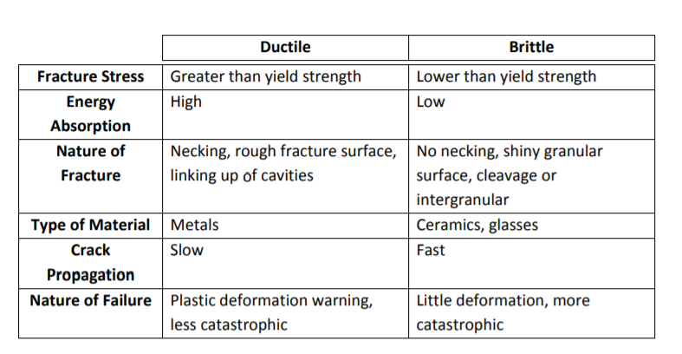

1.4 Shear strain energy per unit volume (Maxwell – Huber – Von Mises) theory – Studies of elastic theory are thought to have begun with Robert Hooke in the 17th century. He explored the fundamental concepts of deformation of spring and the displacement of a beam. Only in the 19th century was quantitative and mathematical theory of elasticity developed. This theory was initially proposed by Huber in 1904, and later developed further by Von Mises in 1913. (Simscale Software Company, 2020) The strain energy of a stressed component can be divided into two categories: volumetric and shear strain energy. Volumetric strain can be associated with volume change and no distortion. Conversely, shear strain causes distortion of stressed elements. Hence, this theory is often referred to as the distortion energy theory. This theory states that failure occurs when the maximum shear strain energy component in the complex stress system is equal to that at the yield point in the tensile test. (Hearn, 1997)
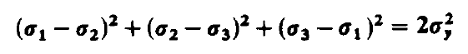

This theory is the most used of the several theories of elastic failure developed. Many papers including (Hearn, 1997) and (Swansea University, 2017) agree that this is the most reliable, when using ductile materials largely due to the verification from comparison of results to laboratory testing. Initially, it was preferred due to the ease of calculation compare to for example the Tresca theory. (Kelly, 2013) Although, some would argue this is becoming less relevant now as Computer Aided Engineering (CAE) has become more widely adopted, and Finite element analysis (FEA) programs can be utilised for this application. It is said, (The Gate Academy) that this theory can be implemented to provide a safe and economic design. Nevertheless, the theory is not perfect for all applications. As previously stated, the results are most accurate for ductile materials, therefore another theory may be more suited when this criterion is not fulfilled. Additionally, this theory is not suitable for materials under hydrostatic stress condition (The Gate Academy). The theory has assumed properties in tension and compression are similar. Although, this is not true for concrete, cast iron and soils, (Hearn, 1997) hence supports the claims of (The Gate Academy)
1.5 Maximum principal stress theory (Rankine) theory – William John Macquorn Rankine was an engineer, polymath educator, and researcher. He is regarded as a pioneer of thermodynamics (Scottish Engineering Hall Of Fame, n.d.). In 1857, he developed the maximum principal stress theory – originally a stress field solution that predicted active and passive earth pressure. It was widely used to test soil samples before starting a mine. The theory considered that the soil was cohesionless, the wall frictionless and the soil-wall interface to be vertical. (Collins, 1981) Hence, the theory assumes that failure occurs when the maximum principal stress in the system reaches the elastic limit stress in simple tension. The criterion failure is given as:
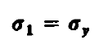

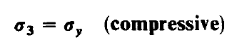
It is possible that the least principal stress σ3 is compressive – if this value reaches the value of the yield stress in compression before the value of σy was reached in tension, then the material failure would occur in compression. As a result, the criterion becomes: (Hearn, 1997)

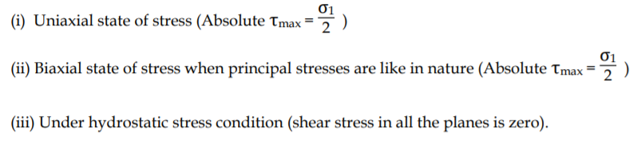
This theory has been found to be fairly accurate whilst using brittle materials. However, it is advised that this theory is not used for ductile materials. In a tension test, failure for a ductile material will occur due to shear on planes at 45-degree angle to the specimen axis, not because of the direct stress applied. This suggests that direct stress alone does not establish a valid failure criterion to satisfy all loading conditions (Hearn, 1997). These conclusions are supported by (The Gate Academy) as it also advises that this theory can be used for the safe design of components made from brittle materials as they are weak in tension, whereas it cannot be used for ductile materials as they are weak in shear. The paper identifies some specific state of stress conditions where the theory could be successfully implemented for brittle materials.

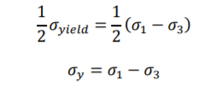
1.6 Maximum shear stress (Guest-Tresca) theory – Named after Henri Tresca who was a French scientist. It is thought that he developed one of the main criteria used today for determining elastic failure in ductile materials. There is evidence to suggest that he was involved in the design of the prototype metric bar as the first standard length for the metric system, although this cannot be confirmed by a reputable source. This theory states that the failure occurs when the maximum shear stress in the complex stress system is equal to the yield point in the simple tensile test. Both (Hearn, 1997) and (Swansea University, 2017) support this. Since the maximum shear stress is equal to half the greatest difference between the two principal stresses. Then, the maximum shear stress in simple tension is equal to half the stress at the yield, the criterion of failure is: (Swansea University, 2017)

Both papers reiterate the fact that σ3 is algebraically the smallest value, therefore the sign of the value and the fact that one stress may be zero must be accounted for. Several papers including (Hearn, 1997), (Swansea University, 2017) and (The Gate Academy) agree that this theory produces an accurate correlation with experimental results, especially for ductile materials. (The Gate Academy) suggests that the maximum shear stress theory and the maximum principal stress theory will give the same results for ductile materials under both uniaxial and biaxial state of stress – providing that the principal stresses are like in nature. The same paper suggests that it is suitable for ductile materials and gives and over safe design. This is where the type of component being designed, and the consequences of its failure need to be considered carefully. It will have a great influence on the theory of elastic failure that is most suitable for use. If there are high consequences of failure, then some degree of over safety in the design will be desirable. Although, if the consequences are not as great, the design may become too conservative and therefore uneconomical. Today many engineers will use an FEA program. It is advantageous as the computer can do the calculation for you; however, the results are only accurate if the most suitable theory of elastic failure has been selected by the user.
Section 2
2.1 The majority of brake rotator discs used on mountain bikes today are steel; when carbon fibre is becoming the preferred material of choice for so many other components, it begs the question why disc brakes are not the same. Hydraulic brakes work on the conversion principle where friction between the calliper pads and rotator surface is converted to heat which extracts rotational momentum from the front and rear axles. Theoretically, carbon fibre should provide a better heat resistance when blended with ceramic materials. It would also drastically reduce the weight of the rotator disc; with a composite material being approximately half the weight. Despite this, the major issue with using carbon fibre for this application would be achieving the geometric requirements. On average, a rotator disc would be between one hundred and forty to two hundred millimetres in diameter and between one and a half to two millimetres in thickness. As the brake callipers rely on a very small margin of pad movement, achieving this would be very difficult. This type of composite material can be used in other industries such as the automotive. This is because rotational speeds of the disc are much higher, therefore they can quickly reach the optimum operating temperature, needed to generate the spike in energy transfer. (Branquinho, 2019)
2.2 When developing a component such as this, you must first understand the material that is being used. Steel can be defined as an alloy as it is made from iron and carbon. The percentage of carbon can vary and using different types and amounts of alloying element can determine the hardness, ductility, and tensile strength of steel. The material properties can also be altered through methods such as annealing, tempering and hardening. (Engineering Student, n.d.) Assuming that the steel used for this application would be ductile, when developing the component, the theory of elastic failure likely to be used is the Von-Mises theory. This theory predicts that failure would occurs when the maximum shear strain energy component in the complex stress system is equal to that at the yield point in the tensile test. (Hearn, 1997) Section one of the paper explained that this is generally the most reliable and well used theory. This is as a result of its verification from comparison to experimental data. This theory is also most likely to be selected if the finite element analysis was conducting using some form of computer aided engineering, again due to its accuracy.
2.3 Despite this, as an engineer, it is important to consider some key factors when developing a component. Such factors including manufacturing methods, cost, and safety. From the research carried out in section one, several papers agreed that the Tresca theory would also produce accurate result for ductile materials; predicting that failure would occur when the maximum shear stress in the complex stress system is equal to the yield point in the simple tensile test. The Von-Mises and Tresca differ as the criterion involves maximum shear strain and maximum shear stress, respectively. When selecting the most appropriate theory to use, understanding the type of loading the component would be placed under in working conditions is critical. A characteristic of Tresca theory however can give an over safe design. In some instances, this may be a disadvantage as it may make the design more complex and hence more expensive. However, in this case, an over safe design maybe beneficial. It is important to consider the consequences of failure – in this case failure could result in serious injury or even death. Therefore, it is suggested that the Tresca theory is used as it relates more closely to the loading of working conditions and also provides a suitable factor of safety for the component and its application.
2.4 Factor of safety – There are several assumptions and problems which need to be overcome when using any of the theories of elastic failure. Such calculations can be made to agree with experimental data, within a reasonable margin of error – providing that an appropriate factor of safety has been applied. A factor of safety can be used to take account of various factors that are almost impossible to estimate or assess. Such examples include:
- Calculations are based on static loading conditions – whereas they are far more likely to see dynamic or fluctuating loading which is likely to increase the maximum stress values experienced.
- Materials’ mechanical properties assume equal strengths in all directions. This is untrue in the major of cases and therefore cause weaknesses in the material.
- Manufacturing processes such as welding can leave residual stresses within the component. This will reduce the service life of the component.
- Through theorical methods, you can only reasonably estimate the maximum service stresses of a component. It needs to be remembered that as the design and systems become more complex, they can become more expensive and time consuming to solve, and even then, calculations will not provide a solution which is perfectly reflective of reality.
The definition of the factor of safety will differ based whether the material’s tensile strength or yield stress is being considered – see definitions below:
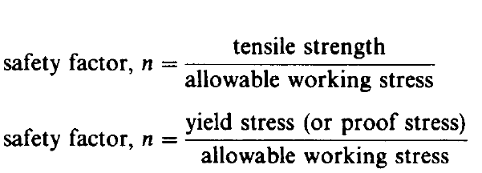

(Hearn, 1997)
Section 3
Summary of research paper from Science Direct - Creep Analysis in Functionally Graded Rotating Disc Using Tresca Criterion and Comparison with Von-Mises Criterion (K. Khanna, 2017)
3.1 The purpose of this paper was to develop a mathematical model to analyse steady state creep stresses and strain rates in a variable thickness rotating FGM disc that yields according to Tresca criterion. The results were then compared with those estimated using Von-Mises criterion. Firstly, FGM is a type of metal matrix composite material. It is obtained by mixing ceramic and metal in proportions, with spatial variation of reinforcement along certain dimensions of the structure. The disc analysed in this paper was made from Al–SiCp, where the distribution of SiCp reinforcement decreases non-linearly along the disc radius. Literature prior to this paper suggested that stresses in variable thickness rotating discs were much lower than uniform thickness discs. However, there was limited work that dealt with the analysis of creep in rotating discs and variable thicknesses. Creep analysis can be defined as the tendency of a solid material to move slowly or deformation permanently under the influence of persistent mechanical stresses.
3.2 Other literature also indicated that Tresca could be used to deal with more complex issues of the rotating disc problem, including imposed displacement and the thermal and acceleration effects. This is supported by the report that claims that experimental creep results for a steel disc indicate the results are much closer to analytical results based on Tresca compared to Von Mises. This information supports what is detailed in section two of this paper with regards to the stresses experienced in working conditions. These findings also correlate to the information in sections one and two of this paper which explained that for ductile materials such as steel, using the Tresca criterion would provide an over-safe design. The literature review is suggesting that using Von Mises theory for this type of application may not provide the factor of safety desired for components like gas turbine rotators and automotive brakes.
3.3 In this paper, the disc thickness is small compared to its diameter therefore the plan stress condition is assumed. The axial stress (σz) is said to be zero. Once again this is supported by the research in sections one and two of this paper, as this value is algebraically the smallest value therefore can be negative or zero. The material of the disc is also assumed to yield according to Tresca criterion. In a rotating disc, the tangential stress is greater than the radial stress which is greater than the axial stress (σθ >σr >σz), therefore the effective stress (σ) under the plan stress condition is given by σ =σθ. Similarly to section two, considerations are given based on the loading seen in working conditions, such that the component would be under stress. The results obtained by using the mathematical model in the paper were validated by comparing with the experimental results estimated for a rotating steel disc in prior literature. The comparison showed agreement and therefore validated the results using the mathematical model. To further validate these results, it would have been useful to compare to several experiments: rather than just one. This would have proven the results to be truly repeatable and reliable.
3.4 To summarise the conclusions made from the paper:
- The Tresca criterion gives slightly lower values of tangential stress compared to the Von-Mises criterion, except for some portion near the inner and outer radii of the disc.
- The radial stress estimated using Tresca criterion is slightly higher than those estimated using Von-Mises, except for regions towards the outer radius where both give almost equal stress.
- The effective stress estimated using Tresca criterion is slightly higher than those estimated using Von-Mises, though the difference observed is higher near the inner radius than noticed towards the outer radius.
- The tangential and radial strain rates obtain using Tresca are higher over the entire disc radius compared to those using the Von-Mises criteria, with the maximum difference observed at the inner disc radius.
- Using both theories of elastic failure, the values for the strain rates are higher in the FGM disc with a higher SiCp gradient.
- Overall, the study highlights that using Tresca criterion in the design of this component yields a much safer design than predicted by using Von-Mises criterion.
3.5 Overall, the conclusions made from this paper are supported by the research carried out in section one and two of this paper. It was suggested that Tresca produces an accurate correlation with experimental results. This is supported during the validation of results where the results from the analysis model and experiments show good correlation. The conclusions also support the idea that the Tresca theory gives and over safe design, as the values for effective stress and strain rates are higher using the Tresca criterion. To further prove the validity of the analysis model created, the calculations should be repeated for a steel disc using the maximum principal stress theory (Rankine) as section one suggests that it would give the same results for ductile materials under both uniaxial and biaxial state of stress. The Rankine theory could also be used for the FGM disc as this theory is suitable for brittle materials such as this composite.

References

Branquinho, L. .. (2019, October 9th). Why are brakes still steel and not carbon fibre? Retrieved from Bike Perfect: https://www.bikeperfect.com/features/why-are-brakes-still-steel-and-not-carbon-fibre
Collins, J. A. (1981). Failure of Materials in Mechanical Design: Analysis, Prediction, Prevention. Wiley.
Davis, J. R. (2004). Tensile Testing, 2nd Edition. ASM International.
Engineering Student. (n.d.). Retrieved from engineeringstudent.co.uk
Hearn, E. J. (1997). Mechanics of Materials 1. Oxford ; Boston : Butterworth-Heinemann.
K. Khanna, V. G. (2017). Creep Analysis in Functionally Graded Rotating Disc Using Tresca Criterion and Comparison with Von-Mises Criterion. 5th International Conference of Materials Processing and Characterization (pp. 2431-2438). Elsevier.
Kelly, P. (2013). Solid Mechanics Part I: An Introduction to Solid Mechanics. Department of Engineering Science, University of Auckland.
Scottish Engineering Hall Of Fame. (n.d.). William John Macquorn Rankine. Retrieved from Scottish Engineering Hall of Fame: http://www.engineeringhalloffame.org/profile-rankine.html
Simscale Software Company. (2020, October 9th). What is Von Mises Theory. Retrieved from Simscale: https://www.simscale.com/docs/simwiki/fea-finite-element-analysis/what-is-von-mises-stress/
Swansea University. (2017). Advanced Structural Analysis. Retrieved from https://engweb.swan.ac.uk/.pdf
The Gate Academy. (n.d.). Theories of Failure. Retrieved from The Gate Academy: http://thegateacademy.com/files/wppdf/Theories-of-failure.pdf

