Dissertation
BMMB7003

A STUDY TO CRITICALLY ASSESS THE EFFECTS OF AGE DIVERSITY AND ITS IMPACT ON STRATEGIES FOR GROWTH WITHIN THE UK HOTEL INDUSTRY

Name of the Student: Mihaela Mirabela Martineac
Student’s ID:2013903

DECLARATION

This work has not previously been accepted in substance for any degree and is not being concurrently submitted in candidature for any degree.

Signed. Mihaela Mirabela Martineac..........................(candidate)

Date .......05/09/2024.................................................................

STATEMENT 1

This work is the result of my own investigations, except where otherwise stated.
Other sources are acknowledged by footnotes giving explicit references. A bibliography is appended.

Signed Mihaela Mirabela Martineac......................(candidate)

Date ..........05/09/2024..............................................................

STATEMENT 2

I hereby give consent for my work, if accepted, to be available for photocopying and for inter-library loan, and for the title and summary to be made available to outside organisations.

Signed Mihaela Mirabela Martineac....................(candidate)

Date ....05/09/2024....................................................................

NB: Candidates on whose behalf a bar on access has been approved by the University (see Note 1), should use the following version of Statement 2:

I hereby give consent for my work, if accepted, to be available for photocopying and for inter-library loans after expiry of a bar on access approved by the University.

Signed Mihaela Mirabela Martineac..................(candidate)

Date ...05/09/2024.....................................................................

Candidate’s signature Mihaela Mirabela Martineac...........................
Date ....05/09/2024.....................................
Acknowledgements,

First and foremost, I would like to express my deepest gratitude to my supervisor Robyn, whose invaluable guidance, patience and constant support were instrumental in the competition of this dissertation.

I would like to extend my appreciation to the faculty members and my peers and to the participants of my survey who have provided support and constructive feedback during this process. This helps me grow and have more data for my work.

Lastly, I want to thank my family and friends for their unwavering support, understanding and patience throughout this challenging yet rewarding experience. This dissertation would not have been possible without their encouragement.

Abstract
This research work deals with the effects that age diversity is having on growth strategies in the UK hotel industry by looking at both the opportunity and challenge spectrum. The basis for the research is the increasing diversity in the age of the workforce when different generations coexist in the hospitality industries. The research study would appraise, in totality, the age-diverse teams and how different age groups affect the process of innovation, customer service, and strategic decisions within hotels.
The literature review has identified key theories concerning diversity management and organizational growth that can assist in understanding the implications of age diversity. The research design adopted in this study is mixed, wherein quantitative data analysis is supplemented by qualitative insights from industry experts. Preliminary findings indeed suggest that effective age diversity management can create an environment that fosters creativity and improved problem-solving skills, while also enhancing adaptability-especially when it comes to dealing with a diverse range of clients-for hotels. However, there was also generational conflict and barriers in communication.
The study concludes by recommending actual strategies to ensure inter-age group collaboration for the realization of potential benefits from diversity. It also picks the need for targeted training programs and flexible management practices to offset the challenges that result from this. This current ongoing discussion of diversity management in hospitality provides some practical implications for the managers of the hotel in a bid to leverage age diversity from a perspective of mechanisms for organizational growth.

Table of Contents
Abstract 2
1. Introduction 5
1.1 Background of the Research 5
1.2 Problem Statement 7
1.3 Research Aim 8
1.4 Research Objectives 8
1.5 Research Question 9
1.6 Research Rationale 9
1.7 Research Significance 11
1.8 Research Structure 11
2. Literature Review 13
2.1 UK Hotel Industry 13
2.2 Age Diversity 16
2.2.1 Age Diversity and Its Relevance 16
2.2.2 Strategic Integration of Different Approaches 18
2.2.3 Ageism and its effects on Digital Innovation 20
2.2.4 Critical Evaluation on age and how diverse age groups in workplace inspires and influence work culture and how leadership helps in shaping diversified workplace and change management 21
3.3 Strategies for Growth 22
3.3.1 Implementation of Digital Innovation in Sustaining an Age Diverse Workforce 22
3.3.2 Preparing Strategy for the Aged Population at Contemporary Workforce 24
3.3.3 Cross Training, Talent Management and Succession Planning 25
3. Methodology 27
3.1 Overview 27
3.2 Research Approach 27
3.3 Research Philosophy 29
3.4 Research Reasoning 30
3.5 Data Collection Method 31
3.6 Data Analysis 32
3.7 Validity and Reliability 33
3.8 Research Ethics 34
4.0 Findings and Discussion 35
4.1 Overview 35
4.2.1 Primary research via survey 35
4.3 Discussion 41
4.3.1 Introduction 41
4.3.2 Interpretation of Key Findings 41
4.3.3 Comparison with Literature 43
4.3.4 Implications for the Industry: 45
5.0: Conclusion 48
References 56
Introduction 56
Literature Review 57
Methodology 61
Conclusion 63

1. Introduction

1.1 Background of the Research
The hotel industry in the United Kingdom represents one of the largest sectors contributing towards the national economy, forming an overall huge percentage of the larger hospitality industry (Nazarian et al., 2024). Many changes are rolling out in the industry, and some of the pertinent challenges it has been experiencing include economic and consumer behavioral changes, technological, and demographic affecting the workforce of the industry. Age diversity in the workforce crops up as a key factor in organizational performance and implementing growth strategies (Maqsoom et al., 2023). The current research is a precise effort to critically evaluate the impact of age diversity on the strategies for growth in the UK hotel industry, bearing in mind that age diversity is one of the challenges and opportunities that firms in any business in the hotel industry face.
The UK has a varied hotel industry in terms of high-end establishments, boutique hotels, mid-range budget chains, and independent bed-and-breakfasts. The size of the UK market is quite mature and therefore growing steadily, with most of its growth primarily based on domestic and international tourism (Khan et al., 2020). Having said this, the industry is extremely competitive in nature, considering that businesses tend to outdo each other by pulling all the possible strings that would aid in retaining or improving their position within the market. Of late, age diversity as a part of workforce diversity has taken center stage as the most significant ingredient of any organizational strategy aimed at achieving a competitive edge.
Age diversity refers to the different ages of various employees working together in an organization. In the hotel sector in the UK, this has become very prominent and is likely to continue due to various factors such as demographic change, alterations in retirement age, and changing attitudes toward work among different generations (Mayhew and Anand, 2020). The workforce of this industry has expanded to several generations: from the Baby Boomers born between 1946 and 1964 to Generation X, born between 1965 and 1980, Millennials, born between 1981 and 1996, and Generation Z, born between 1997 and 2012 (Day, 2023). Each generation is accordingly marked by specific values, expectations, and workplace styles that define relations with coworkers, customers, and management. There are opportunities and challenges brought to hotel businesses by the multigenerational workforce.
On the one hand, age diversity can lead to innovation and creativity since different perspectives and experiences are brought to the table by people belonging to different age groups (Bogilović et al., 2021). On the other hand, the process of managing a multigenerational workforce is no doubt complex since differences in styles of communication, work preferences, and proficiency in technology can give way to misunderstandings, conflicts, or inefficiency (Gerhardt et al., 2023). Therefore, more understanding and using the strengths of a diverse workforce by the hotel manager is required, while applying measures against potential challenges that may happen in an organization for its growth and sustainability, especially in the hospitality industry.
Age diversity influences organizational strategies in talent management, customer service, innovation, and employee engagement. Given the focus of the UK hotel industry on service quality and customer experience, effective management of age diversity within its workforce influences the organization at large (Mothe and Nguyen-Thi, 2021). For example, older workers can contribute years of experience and expertise, while at the same time, younger workers will excel where new technologies are involved and where customers are more likely to be digitally savvy.
Apart from the fact that different people have different needs, the difference in age may also impact the design and implementation of growth strategies. For example, the growth strategy in the hotel capitalizing on a great age diversity in terms of labour will need innovativeness and adjustment to the needs of the market (Li et al., 2021). This would lead to the development of new services and technologies that would suit the preferences of the various segments, and the creation of training programs by which the workers could improve their abilities across all age groups. In addition, age diversity may impact the corporate culture of an organization, more precisely, the process of transfer of knowledge and collaboration among different age groups to contribute collectively to a firm's success. For this reason, having individuals of different ages, per se, does not represent an advantage. What is at the heart of everything, and most importantly of age-diverse teams' success, is the ability and willingness of the managers to understand and be responsive to the needs and wishes of the different generational groups (George, Baskar and Srikaanth, 2024).
This will require nuanced approaches to leadership, communication, and talent management, with full and absolute commitment to the growth of an acceptable workplace culture that recognizes, appreciates, and respects what personnel from different generations bring to the table. The hotel sector remains in a complicated, competitive market; therefore, proper awareness about age diversity and its influence on the development plans of organizations has to be created. This research, therefore, will greatly add to the existing body of knowledge because it is devised to provide an in-depth examination of the age variety currently extant within the workforce and the implications of this diversity on the future performance of hotel companies in the United Kingdom.

1.2 Problem Statement
The hotel industry in the United Kingdom contributes significantly to the national economy by employing a diverse workforce and serving both domestic and international customers (Reidhead, 2020). The industry, however, faces some major challenges in workforce management, particularly within the context of an increasingly ageing labour force. The dynamism introduced by the presence of employees from as many as four generational cohorts, from Baby Boomers to Generation Z, affects several aspects of organizational functioning related to communication, collaboration, innovation, and customer service. Age diversity can bring added advantages in terms of increased creativity and skill and experience bases but also has its challenges, which negatively affect organizational effectiveness and growth.
One of the major challenges is simply how to manage and integrate the different values, expectations, and working styles of employees across age groups. Generational differences can lead to misunderstandings, conflicts, inefficiency, and other problems in an industry where teamwork and customer interaction are so very important (Luka et al., 2023). For example, older employees may be resisting the process of using new technologies, while younger employees may have a greater interest in being flexible and having a good work-life balance rather than getting onto traditional routes of career progression. These differences can become major tensions among teams, affecting employee morale and the quality of service provision to customers.
Furthermore, there has been a relative scarcity of studies on the impact of age diversity on the formulation and implementation of growth strategies within UK hotels. These will, therefore, incorporate retention strategies, training, and development of multi-generational staff, and cultures that are inertly collaborative from the different generations (Santa et al., 2023). Many hotel businesses, however, lack the insight and frameworks to navigate such challenges effectively, causing lost opportunities to innovate and grow.
Against the backdrop of the critical role workforce management plays in the success of the hotel industry, the present day calls for a pressing need for an overall understanding of how age diversity affects organizational strategies and outcomes. Thus, the present study is set to address this gap by making a critical assessment of the effect of age diversity on growth strategies within the UK Hotel Industry. The experiences and views of hotel managers and employees form a basis from which valuable insights into the challenges and opportunities associated with an age-diverse workforce will be drawn, with some practical recommendations as to how such organizational performance and competitiveness could be strengthened in this dynamic sector as hospitality industry.

1.3 Research Aim
The purpose of the research is to examine, analyse, and explain methods to deal with age diversity in the hotel industry, with a concentration on developing an efficient staff that transcends generations.

1.4 Research Objectives
This is the summary of the research objectives:
- To analyse the impact of age diversity on employee performance and satisfaction in the hospitality industry
- To evaluate the strategies that hotels currently implement for attracting and utilising workers of diverse age groups, and their effectiveness in promoting diversity and productivity
- To explore leadership and cultural influences to create an inclusive environment for workers of diverse age groups in hospitality
- To assess innovative solutions to manage multigenerational workforce challenges in hospitality

1.5 Research Question
Q1. How can hotels effectively build and manage a multigenerational workforce to harness the benefits of age diversity and improve operational success?

1.6 Research Rationale
The UK hotel industry has been a significant sector of the economy in this country and hence remains associated with the guarantees of providing employment opportunities, driving tourism, and growing the economy at large (Bullock et al., 2024). It has remained under a myriad of challenges in terms of sustaining its competitive advantage, especially in a business environment that has turned dynamic and diverse in recent times. Probably the biggest challenge is workforce management, which itself has become very prominent with age diversity due to demographic changes and shifting labour market dynamics. The key driving force behind this research is to understand and address all the complex issues associated with the age dimension of workforce diversity and its impact on organizational growth strategies for the UK hotel industry (Mehari, Ayenew Birbirsa and Nemera Dinber, 2024).
Age diversity in the workforce is a fact of changing demographic realities. The UK workforce contains workers of the older, baby boomers, and younger generations, each with its own sets of values, work ethic, communication styles, and levels of technical skills (Nagarajan and Sixsmith, 2023). This means that creativity, innovation, and problem-solving may be increased because people across various generational lines possess diverse outlooks and experiences. It lies within the hospitality industry to drive into the art of customer service and satisfaction, depending on how well companies capitalize on multigenerational workforce strength in service quality and customer experiences.
However, such benefits of age diversity do not come automatically. Without proper management, generational differences can cause conflicts, misunderstandings, and inefficiencies that may undermine teamwork, employee engagement, and finally, overall organizational performance. For instance, while older workers could have very useful experience and customer service skills, they might be challenged by the need to adapt to new technologies (Nagarajan and Sixsmith, 2023). On the other hand, young employees might be savvy in using digital tools and platforms but lack interpersonal skills for customer-facing roles. All these differences pose challenges in aligning the workforce with the strategic goals of the organization. Also the hospitality industry needs to put in place for the next generation new policies that will help the next generation to adapt and to implement their new ideas in the industry.
For growth strategies in the UK hotel industry, the understanding of age diversity effects is immense (Sarwar, Ishaq and Franzoni, 2024). Given the continuous evolution of the hotel industry with changes in the market and consumer preference, strategies should be altered to target the strengths derived from a diverse workforce. This not only involves the recognition of the needs and preferences of various generations but also builds a culture inclusive enough to drive collaboration and innovation across age groups. The research is timely in the current business environment because the hotel industry has to update its position with respect to the effect of the COVID-19 pandemic, continuous changing Brexit, fast-paced development in technology, and changing customer needs. It is against this background that the ability to harness age diversity appropriately can act as a kind of platform for differentiating hotel businesses from others by being innovative, improving the quality of services, and at the same time attaining growth in a sustainable manner. While much attention has been given to the advantages of age diversity in current literature, there has been limited research on the impact that age diversity will have on organizational strategies for the UK's hotel industry. There is a need to establish a critical overview of the ways through which age diversity influences growth strategies within this sector. This will be done by examining the views and experiences of the hotel manager and its employees on challenges and opportunities related to the multigenerational workforce.
The findings, therefore, will increase the value of general knowledge in human resource management and organizational behaviour with specific reference to the hospitality sector. Such findings imply that practical recommendations will be made for hotel businesses to harness the potential of age diversity in enhancing organizational performance and competitiveness. The research will also inform policymakers and the hospitality industry that, in the future, age diversity in the UK's hotel industry calls for targeted intervention and support to set up inclusive and sustainable growth.

1.7 Research Significance
The findings will be very instrumental in guiding hotel managers and human resource experts in devising an enabling work environment that fosters cooperation and brings out the best in all categories of workers. This comes at a time when increased pressures from rapid technological changes, changing consumer habits, and not forgetting the COVID-19 pandemic, with shutters brought down on businesses, have increased demands for adaptive and resilient organizational strategies.
However, the contributions of this study transcend the hotel sector to more generic issues of human resource management and organizational behavior within other service-oriented industries. It is for this reason that this research enhances the understanding of age diversity dynamics and thus contributes to creating policies and practices that foster workforce inclusivity and productivity within any given industry. This study shall contribute to the sustainable growth of hotel businesses in the UK and, further afield, the general campaign for more inclusive and fair workplaces. In emphasizing proper management of age diversity, the research brings forth a message: innovation and adaptation must be continuous within organizational practices to respond both to an evolving workforce and a changing market environment.

1.8 Research Structure
This research is organized into six key chapters that have contributed toward developing an overall understanding of the impact of age diversity on the growth strategies of the UK hotel industry.
Introduction: It also introduces the background of the research, problem statement, objectives, significance, and research questions. This chapter presents the platform for the study by providing an introduction to the key concepts and context.
Literature Review: This chapter is dedicated to a critical review of the existing literature on age diversity, management of the workforce, and organizational growth strategies. It points out the gaps in current research and places the study in its theoretical background.
Research Methodology: This is the area where the design of the research is explained, including techniques of data collection and analysis. Herein, explain why the kind of methodology design used was preferred over others and what measures were considered to guarantee the validity and reliability of the research.
Data Analysis and Findings: This chapter presents the analysis done on the collected data, hence highlighting the key findings on age diversity and its influence on organizational strategies in the hotel industry.
Discussion: The findings are interpreted in light of the research objectives and the literature review, pointing out their implications for theory and practice.
Conclusion and Recommendations: This last chapter summarizes the research, discusses its limitations, and finally gives some practical recommendations for the hotel business, along with suggestions for future research.

2. Literature Review

2.1 UK Hotel Industry
The definition of the hotel industry is an industrial segment that develops around offering lodging to travelers and the local guests. As per Wyld et al., (2024), there are many sub sectors within the hotel industry, including accommodation, meals and drinks, travel, transportation, and activities. These divisions frequently work collaboratively to produce the whole experience for visitors. Customer satisfaction and providing exceptional service continue to be the hotel industry's primary priorities. It includes a wide range of sectors, the biggest of which are lodging and food and beverage services.
The worldwide hospitality market was valued at over 4.7 trillion dollars in 2023 and was expected to reach 5.5 trillion dollars in 2024 (EHL Holding SA, 2024). Similar to the overall economy, the global hospitality industry has grown tremendously since the end of the economic downturn ten years ago (Wyld et al., 2024). According to the World Bank's projections, the global economy expanded at an average of more than three percent per year until the global pandemic occurred in 2019–20.
The world's economy grew at a faster rate in 2021—5.5 percent—due to higher demand around the beginning of the COVID-19 pandemic, according to reports from EHL Holding SA (2024). It was anticipated that the increase would, however, stall and return to pre-pandemic levels in 2022 and 2023, at 4.1 and 3.2 percent, respectively.
The global hospitality market increased at a compound annual growth rate (CAGR) of 7.0% from $4,390.59 billion in 2022 to $4,699.57 billion in 2023, based on the Hospitality Global Market Report 2023. This rapid growth rate is partly the result of the lifting of travel restrictions worldwide. As per EHL Holding SA, (2024), due to the current state of the global economy, the market is anticipated to grow even slower between 2022 and 2032, with a Compound Annual Growth Rate (GAGR) of +5,8%.
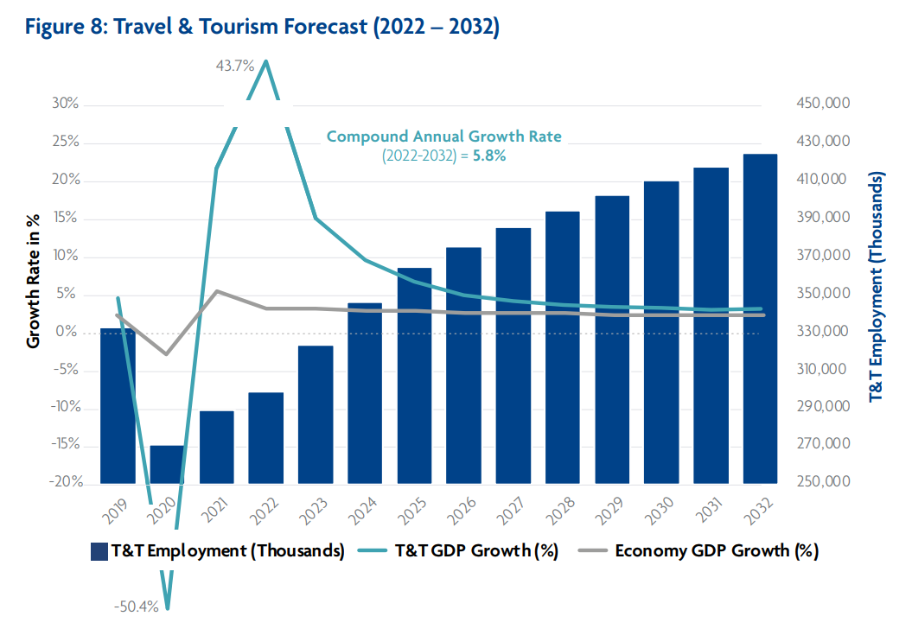
(Source: EHL Holding SA, 2024)

As per the statement of (Nazarian et al. (2024), this has increased the quantity of rooms available in addition to creating a significant number of jobs worldwide. According to “UNTWO” data, Covid-19 had a significant impact on foreign visitor arrivals, which saw a startling -73% decline in arrivals in 2020 and a -71% drop in 2021 as a result of travel restrictions imposed due to the pandemic. These numbers come after years of consistent yearly growth.
According to recent UNTWO data, in the first quarter of 2023, foreign arrivals overall surpassed pre-pandemic levels by 80%. With a projected 235 million tourists travelling abroad in the first three months of 2023—more than twice as many as in the same period of 2022—tourism statistics are trending in the right direction.
According to recent data released by the WTTC, the travel and tourism industry contributed $7 trillion USD to the global economy in 2022—that is, 7.6% of the global GDP and 23% less than it did prior to the pandemic. A staggering 330 million people is making their living in the sector. As per Bedford, (2020), there were 22 million new jobs in 2022, up 7.9% from 2021 and only 11.4% less than in 2019. As per Statista Research Department, (2024), when considering the impact on the UK economy, a slow yet consistent growth trajectory has been discovered. The hotel industry in the UK includes both well-known 5-star luxury establishments and significant national budget hotels. About 65% of UK businesses in the hospitality and food service industries had seen a decline in customers as a result of the continuing coronavirus pandemic by August 2020. Around 10.6% of the industry's businesses reported higher foot traffic (Kumar, Kapoor and Shah, 2024).

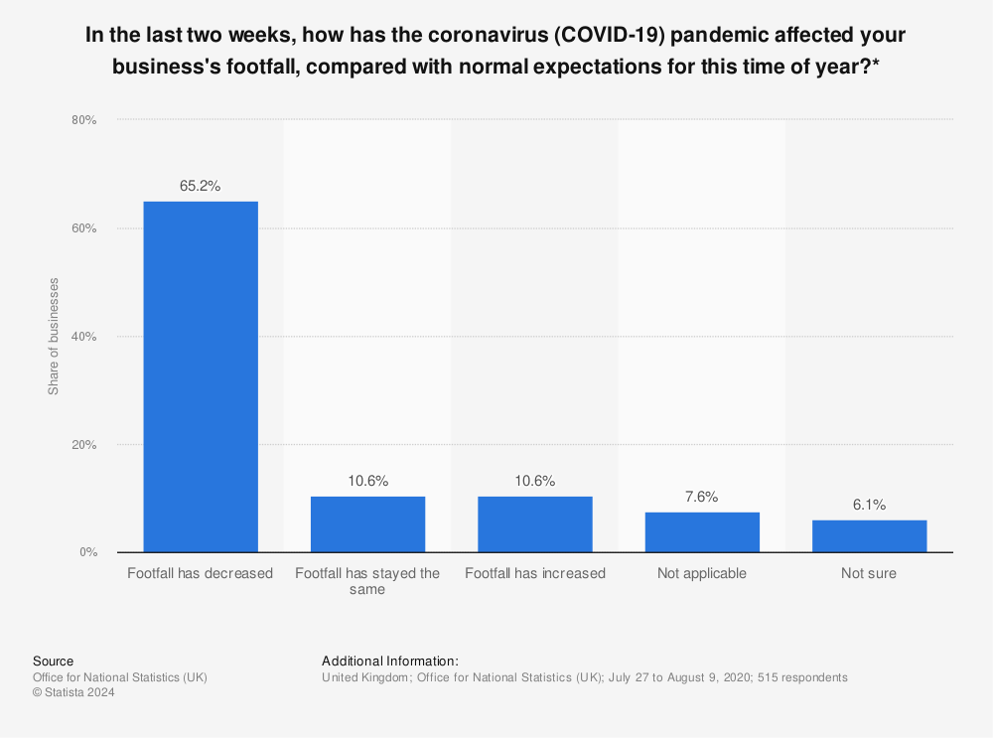
(Source: Bedford, 2020)
According to statista.com, (2024), however, the industry saw a growth in market size in 2023, with an estimated value of 24.7 billion British pounds, compared to 16.42 billion the year before. The industry's market size was predicted to shrink slightly by 400 million British pounds in 2024 (Source: Bedford, 2020).
The number of open positions in the hospitality industry at the end of 2023 was 112,000, compared to 147,000 at the same time in 2022, according to new data from the Office for National Statistics. Compared to 89,000 prior to the pandemic, there are still far more open positions today (statista.com, 2024). Increased employer cost-benefits and modifications to the apprenticeship levy will guarantee that job openings keep declining.

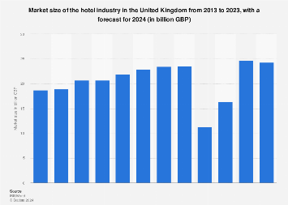
(Source: statista.com, 2024)
In addition to helping foreign businesses and hotel operators, the increase in revenue plays a significant role in the creation of jobs for the local populace and tourism destinations. The hotel and motel sector engaged around 173 million individuals until the COVID-19 pandemic struck, according to the latest data. According to the WTTC's projection, between now and 2032, 126 million new jobs will be generated.

2.2 Age Diversity

2.2.1 Age Diversity and Its Relevance
Age diversity is acceptance as well as appreciation of individuals who are not all the same age. Providing equal possibilities for a wide range of individuals, irrespective of age, is part of this approach. In order to create a fair environment where everyone is treated equally, age is equally significant as other factors such as country of origin, race, faith, sexual orientation, and gender. As per the statement of Felix et al., (2023), The phrase "age diversity," which is sometimes referred to as "generational diversity," refers to the range of age groups of employees that a company may have. An inclusive workplace should embrace age diversity, particularly since the workforce of today consists of people from five generations:
- 1928–1945: The Silent Generation
- Baby Boomers: 1946–1964
- Generation X (1965–1980)
- Millennials: (1981–1996)
- Generation Z (1997–2012)
A person's upbringing, phase in life, and employment history all influence their abilities, standards, and employment methods. These generations are not the same. For instance, Gen X workers might be taking care of their elderly parents in addition to raising their own children (Pletzer, Oostrom and Voelpel, 2023). They are therefore frequently said to be industrious and to be working to survive. Organizations from the hospitality industry are comprising individuals from different generations come together with varying abilities, expertise, and skills. Numerous important advantages can be gained to the company as a whole because of the efforts to foster an age varied workplace (Neupane et al., 2023).
Increases commitment: Since individuals over the age of 55 tend to be more loyal, diverse workplaces have lower turnover rates. As a matter of fact, workers between the ages of 55 and 64 have worked three times as long as younger workers. As per the statement of Toomey and Rudolph, (2017), reduced attrition among these employees can foster a more stable work environment and a better company culture that encourages employees of all ages to stick around. As a result, employers will save money on recruitment and be able to hold on to more institutional information when they do this.
Reduces the skills gap: The combination of more experienced and skilled employees can aid in the expansion of skills among all staff members, particularly if they are given the opportunity to contribute their expertise. As per the opinion of Ilișanu and Andrei, (2018), businesses will gain from the skills of each generation whenever they give the employees the chance to teach one another. For instance, younger workers may be better acquainted with technology than older ones, but both are going to have greater business experience.
Encourages creativity: Age-diverse teams can drive ingenuity in a number of areas, including productivity and internal procedures, as well as product development, by drawing from a range of viewpoints, thoughts, and problem-solving techniques (Posthuma and Campion, 2009). This degree of inventiveness can provide the business with a market edge and increase profitability.
Enhances performance: Studies reveal that the phenomenon of "knowledge spillover," in which workers share insights from prior experiences, accounts for the increase in team productivity brought about by age diversity. This effect sparks problem-solving while preventing costly errors when combined with novel concepts and methods.
Presents positive role models: As per the statement of Hanrahan, (2016), people look up to and admire role models for a variety of reasons, including their work ethic and behaviors. An organization can guarantee that it has inspirational individuals from every generation who encourage others to adhere to their example by having a diverse workforce.
Boosts motivation: While younger employees are more involved because of learning from their older coworkers, older workers are energized when they share their perspectives with younger people (Turek, Oude Mulders and Stypińska, 2022). It creates an integrated workforce and enhances collective motivation.

2.2.2 Strategic Integration of Different Approaches
In the UK, ageism is pervasive; in fact, more adult British citizens (26%) have reported being the target of discrimination due to their age than any other factor. About 9 million workers, or one-third of the workforce, are in England over the age of 50. However, not all employers understand the value of hiring older workers or are providing the resources necessary to keep them on board. People in their 50s and 60s have not benefited from conventional support for employment in the same way that younger age groups have. According to Appelbaum et al., (2016), after losing their job, people over 50 are more inclined to end up long-term jobless, and if they are laid off, they are three times less probable than younger people to find new employment within three months. People who require or desire to work frequently lack access to the resources needed to secure and maintain stable jobs.
As per Kleissner and Jahn, (2020), people over 50 are leaving the workforce at a higher rate than before, citing a variety of factors like health issues, caregiving obligations, and a lack of job opportunity. This problem was made worse by the pandemic; data indicates that a third of those laid off during this period were over 50. Significant disparities also exist in terms of who quits the workforce and how, with those with lower incomes probably facing more difficulties. But in order to guard against this, people are shielded from age discrimination in the workplace by the Equality Act from recruitment to terms and conditions, training, payments, advertisements, and terminations. They are shielded from harassment, victimization, and direct and indirect forms of discrimination by the Equality Act (Waugh, 2023).
In order to create an inclusive workplace that makes the most of a multigenerational workforce, it is imperative that age diversity be acknowledged in the workplace. The Strategic Human Resource Management (SHRM) provides a number of methods for successfully achieving this objective.
Adopt Age-Inclusive Recruitment Methods: Employers should refrain from using age-biased terminology in their job descriptions and instead create specifications that are appealing to all age groups without any particular age preferences. Enhancing recruitment campaigns can also include advertising on a variety of job boards and attending job fairs that target different age groups (Arras‐Djabi, Cottard and Shimada, 2024). Furthermore, educating the hiring managers to identify and combat age bias guarantees that candidates are fairly evaluated.
Encourage Intergenerational Collaboration: Giving workers of various ages the chance to collaborate on important projects can promote mutual respect and comprehension between them without making them feel excluded. According to Oliveira and Cabral-Cardoso, (2017), creative problem-solving and knowledge sharing are promoted by initiatives like cross-generational teams, reverse mentoring, and mentorship. These programs can aid in overcoming gaps between generations and utilizing the distinct advantages of every age group.
Offer Ongoing Learning and Development: It is essential to provide training and development programs that are appropriate for every age group. For older workers, this means technical training to stay current with emerging technologies, and for younger workers, it means leadership training to get ready for prospective responsibilities. As per Vickerstaff and Van der Horst, (2021), it is important to curate age specific training courses which are easy to access and get through, so that all the age group people feel motivated to embrace any changes in work methods and adapt rapidly. All staff members can progress their careers and skill set by participating in specially designed professional development programs.
Flexible Work Arrangements: Flexible scheduling can meet the different requirements that workers have at different phases of their lives. Examples of these include job sharing, working remotely, flexible hours, and part-time positions, these can especially facilitate women employees who have care responsibilities at home. According to Voss, Bodner and Rothermund, (2018), this strategy can draw in younger talent looking for a work-life balance and help retain competent senior employees without hampering their personal life differences.
Encourage an Inclusive Culture: Encouraging respect, comprehension, and appreciation for age diversity is a key component of developing an inclusive workplace culture. According to Li et al., (2021), this can be accomplished by creating employee resource groups (ERGs) with an emphasis on age variation, embracing various points of view, and providing periodic training on diversity and inclusion for every age group. It is necessary to develop a shared understanding of the concept without restricting it to a particular age range (Li et al., 2021).
Handle Age Discrimination: Businesses must create and implement laws that forbid discrimination based on age. This entails having unambiguous anti-discrimination guidelines, frequent training sessions on age bias, and an open grievance reporting and resolution procedure (Ali and French, 2019). Making certain that every worker is informed about these guidelines upholds the company's dedication to age diversity.

2.2.3 Ageism and its effects on Digital Innovation
By fostering an atmosphere that disregards and fails to make use of the knowledge and expertise of older workers, age discrimination in the workplace can substantially impede technological advancement. This prejudice can show up in a number of harmful ways that affect the workforce and the creative potential of the company.
Example 1: Being denied access to Technological training opportunities
Due to the widespread belief that older workers are incapable of picking up new skills, they are frequently denied training opportunities in cutting-edge technology. Older workers have either experienced or witnessed age discrimination (Gaur, Vihari and Sharma, 2022). Their inability to participate in digital innovation projects is hampered by this exclusion, which also narrows the pool of thoughts and opinions that inspire creative approaches.
Example 2: Prejudice in Technical Positions
Elderly workers may not be given consideration for positions in digital transformation initiatives due to ageist preconceived notions, such as the idea that they are less proficient in technology. For example, older individuals frequently experience discrimination in hiring and promotions where the average age of technology employees is considerably younger than in other sectors. According to Hertel et al., (2013), instability and stagnation in thought processes can result from an age gap in the workforce. Lawsuits have been filed against corporations such as IBM, claiming that the businesses selected older staff members for layoffs in order to hire younger, supposedly technologically proficient employees.
Example 3: Effect on Interactions within the Team
Age discrimination can cause a rift among younger and older staff members and have an adverse impact on team dynamics. This split may make it more difficult to collaborate and share knowledge, both of which are essential for innovation (Ugwu, n.d). Encouraging multigenerational cooperation may improve digital innovation, as demonstrated by the effectiveness of reverse mentoring programs at firms, wherein younger staff members teach older colleagues about emerging innovations.

2.2.4 Critical Evaluation on age and how diverse age groups in workplace inspires and influence work culture and how leadership helps in shaping diversified workplace and change management
Especially in fast-paced sectors like hospitality, the diverse range of experiences, viewpoints, and abilities that come with various ages in the workplace can greatly motivate and influence the environment and culture of work. According to Webster, Thoroughgood and Sawyer, (2018), age diversity promotes a more welcoming and cooperative work atmosphere that improves creativity, problem-solving, and customer service. In particular, when it comes to skill coordination, leadership is essential to forming this diverse workplace and overseeing transformational phases that come with an age dynamic workplace.
Influence on Work Culture
The diversity of ages has an important effect on work culture in the hospitality industry. Although younger staff members offer vitality, technological competence, and novel concepts, older employees offer an abundance of knowledge, expertise, and consistency. Marriott International, for instance, encourages cross-generational teams, which has enhanced client interactions and contributed to better service delivery (Tagliaro et al., 2024). Older workers guide newer workers, imparting knowledge about customer preferences and providing exceptional service, while the latter introduce new technology and contemporary customer service methods.
Inspiration and Cooperation
Teams with a range of age groups foster cooperation and reciprocal learning. For instance, in hotels, younger staff members may implement digital check-in procedures or smartphone concierge services, while more experienced staff members may be better at interacting directly with guests and handling complicated service problems with more patience and sincerity. As per Boehm and Dwertmann, (2015), this combination of abilities guarantees a thorough service strategy that accommodates a broad spectrum of visitor preferences. Programs for intergenerational mentoring, such as those offered by Four Seasons Hotels, facilitate the sharing of knowledge and promote an ongoing culture of development.
Leadership Role in Change Management and Skill Alignment
The role of leadership is crucial in creating a diverse and inclusive work environment. Proactively advocating for laws that forbid age discrimination and fostering behaviors that honor all age groups are two ways that good leadership promotes age equality. For instance, AccorHotels has put in place leadership development courses emphasizing diversity and inclusion to make sure executives are prepared to work with and benefit from a varied workforce, irrespective of their age, they tend to alter and adjust multiple skills across age groups (Van Varsseveld, n.d).
Leaders in the hospitality industry need to be skilled at managing change and coordinating skills among a range of age groups. Many hotels had to quickly adjust to new digital tools and health protocols during the COVID-19 pandemic. Competent leaders and managers ensured that all staff members, irrespective of age, could adjust to novel processes, protocols and tools by offering personalized training. For instance, Hilton provided comprehensive training programs to guarantee that employees could adhere to updated health protocols while applying new digital tools with proficiency to cater to the guests' needs.

3.3 Strategies for Growth

3.3.1 Implementation of Digital Innovation in Sustaining an Age Diverse Workforce
The hospitality industry's age-diverse workplace is managed and sustained in large part by digital innovation, which makes inclusive interaction, ongoing learning, and effective operations possible. Through the utilization of digital tools, hospitality establishments can establish a work atmosphere that recognizes and capitalizes on the abilities of all age groups, consequently improving output and worker contentment.
Improved Communication: As per Rudolph and Zacher, (2024), age-diverse teams can communicate easily because of digital platforms like Zoom, Microsoft Teams, and Slack. These tools cater to a range of interpersonal preferences, with younger employees favoring messaging applications while older staff members favor video calls and emails to communicate and share their thoughts easily. Hyatt Hotels, for instance, uses collaborative platforms to make sure all of its team members irrespective of their age can stay updated and connected to one another, encouraging inclusivity and teamwork which further reduces the interpersonal gaps and foster a better collective decision-making approach (Dabić et al., 2023).
Ongoing Education and Training: Every age group has a different pace of learning, an employee having 15 years of experience in a domain may be better at instant decision unlike their younger peers. They may learn instantly based on their prior experiences. Therefore, recognizing individual needs and caliber is essential to curate effective learning methods suited for each individual. According to Liu et al., (2023), fmployees can advance their skills at their own speed with e-learning resources like Coursera, LinkedIn Learning, and internal learning management systems (LMS). To accommodate a variety of learning styles, these platforms provide training materials and cusses on new technologies, client service, and leadership capabilities. Marriott International, for example, offers training modules through a powerful Learning Management System (LMS) that assist both junior and senior staff members in staying acquainted with the tools and developments within the industry (Nagarajan and Sixsmith, 2023).
Efficient Operations: According to Aisa, Cabeza and Martin, (2023), by simplifying procedures, digital tools increase efficiency and reduce the need for manual labor. Customer relationship management (CRM) and property management systems (PMS) streamline processes like visitor interactions, reservation processing, and feedback gathering. Hilton Worldwide employs an innovative PMS that streamlines processes for all employees, irrespective of their level of tech expertise, so that staff members can concentrate on providing outstanding customer service (Mykletun, 2023).
Customized Wellness Programs: Online resources for health and wellness can be customized to meet the different requirements of staff members. These platforms make sure that both younger and older employees find solutions that meet their needs by providing a variety of services, such as wellbeing plans, mental health resources, and fitness tracking. As per Komp-Leukkunen, (2023), digital wellness initiatives are used by Four Seasons Hotels to encourage a positive work-life balance, which enhances general staff health and happiness at work. It is a great approach to ensure that people of age can find it useful to sustain at work if their health is prioritized and taken care of by their employers. This also helps them be more attentive and productive at work which reduces the gap in efficacy between them and their younger co-workers (Gutu, Agheorghiesei and Tugui, 2023).
Inclusive Decision-Making: Digital platforms facilitate data analysis and feedback obtaining, which makes inclusive decision-making possible. Organizational decisions are made with the full participation of every staff member, irrespective of age, through the use of surveys, polls, and feedback technologies (Gutu, Agheorghiesei and Tugui, 2023). For instance, AccorHotels uses digital feedback tools to collect opinions from their varied workforce, which aids in the development of programs and policies that are advantageous to all age categories.

3.3.2 Preparing Strategy for the Aged Population at Contemporary Workforce
The task of preparing an aging workforce for the contemporary workplace requires thoughtful planning and the execution of programs that improve their abilities, encourage inclusivity, and protect their welfare. Here are some crucial tactics along with examples:
Continuous Learning and Skill Development: It is very crucial to provide opportunities for ongoing education and up-skilling. For instance, businesses were making substantial investments in retraining programs for the older segments of their workforces, based on the assumption that the next generation of labor would have grown up digitally. This, compared to other relevant strategies, ensures that older workers are able to adapt to the evolving meaning of today's working life and stay in the competition (Kortmann, Henning& Huxhold, 2023).
Flexible Work Arrangement: Older workers may be able to work from home, with part-time hours, or adjusting hours so that they can work while managing their personal life. However, as per Ranasinghe et al., (2024), many companies offer a wide range of flexible work options, which have been particularly useful for an aging workforce to continue to be productive but under their own conditions.
Health and Wellness Programs: It is vital to have comprehensive health and wellness programs specifically tailored for senior employees. All of this help to elevate the general well-being of an aging workforce; the objective a company needs to target according to Ranasinghe et al., (2024), by assisting them with keeping fit so that they do not become weary at the digital workplace, and get mental health support, besides health screenings. This will result in higher worker productivity and satisfaction.
Workplace culture: This is mandatory to forge an inclusive workforce that appreciates the voice of senior staff. Intergenerational mentoring programs have been put in place by businesses, wherein older employees receive knowledge about emerging industries and technologies, and younger staff members benefit from the experience of their more experienced peers (Hertel and Zacher, 2018). Throughout age groups, trust and collaboration are fostered by this reciprocal exchange.
Retirement Management and Financial Education: Offering tools and relevant resources for financial literacy and retirement preparation aids in the future planning of aging workers. However, businesses may help their senior workers feel safe and encouraged by providing workshops and private consultations to help them make educated retirement decisions.
Holistic Workspaces: Today, however, it is assumed that health problems can be avoided by alteration of the physical workspace to the needs of the older worker, and it also increases satisfaction among the employees (Hertel and Zacher, 2018). In addition to adjusting its office atmosphere for older employees by adding ergonomic fittings, and adjustable workspaces to prevent unnecessary strain and injury, new steps are being taken to maintain productivity in the workplace.

3.3.3 Cross Training, Talent Management and Succession Planning
Cross-Training: This involves training employees on carrying out various tasks in the company. It is particularly beneficial in handling older staff as this approach allows for more flexibility and sharing of knowledge. Similarly, for instance, cross-training has been beneficial in the hospitality industry by allowing managers to pick up new skills and move from customer services to event coordination and vice versa. Truxillo et al., (2017) suggests that this keeps things running in the event of absences or retirements as well as keeps senior staff members aware. Marriot and Hayat Hotels have been using cross-training programs to cross-train their workforce thus increasing the efficiency of the staff, improving morale among the workers, eliminating boredom with the same task every day and reducing time and money that would be spent on hiring more workers for the different areas of work.
Talent Management: Effective talent management does this in order for the company to reach its long-term objectives, and focuses on three main activities: attracting employees, developing employees, and retaining employees. This will involve ensuring older employees have opportunities for upskilling and promotion that match their evolving needs and aspirations. Marriott International, for one, offers horizontal promotions and leadership training within its tailored professional development programs for senior staff. According to Appelbaum et al., (2012), these kinds of programs acknowledge the importance of experienced staff members and give them opportunities to keep making significant contributions to the company. Furthermore, by tracking worker advancement and identifying deficiencies in skills, talent management solutions enable customized growth strategies that keep aging employees motivated and competitive.
Succession planning: it is the process of selecting and developing candidates within the organization to take on essential positions, thus ensuring that organizations are ready for upcoming shifts in leadership. However, this entails getting ready for senior employees' eventual retirement in an aging workforce. It is essential to anticipate possible successors and give them the training and development opportunities they require under the seniors so that they can acquire practical knowledge (Appelbaum et al., 2012). Compared to other measures, this strategy includes mentorship programs where experienced leaders guide prospective successors. By doing this, the organization maintains its institutional knowledge and experience while also ensuring an effortless change.

3. Methodology

3.1 Overview
The research methodology is a systematic procedure defining how data collection, analysis, and interpretation are to be carried out by the researchers. This incorporates an overall strategy with specific methods to address the research questions or test the hypotheses. It is important in justifying the validity and reliability of the research findings (PANNEERSELVAM, 2014). The methodology of the research essentially outlines how the study will be conducted, including the design of the research, techniques of sampling, collection of data, and analysis procedures (Pandey and Pandey, 2021). There are also some ethical considerations that need to be addressed in order for the research to be aligned with specific standards aimed at protecting the rights and integrity of participants. In choosing a research methodology, there are factors that have to be considered based on the objectives of the study and the nature of the problem (Kumari et al., 2023). For example, in-depth examination of complex phenomena might be a qualifying reason for using a qualitative approach; similarly, one would turn to a quantitative approach when it comes to the measurement of variables and establishment of the relationships between them.
Clearly defining the methodology makes it serve as a guideline on which to base the research and allows others to replicate it or carry out follow-up research. A well-articulated methodology also serves to increase the credibility of the research and makes it possible for others to assess its validity and applicability.

3.2 Research Approach
Quantitative primary research is the collection and analysis of numerical data from the measurement of variables through the gathering of information directly from original sources (Price and Lovell, 2018). This approach has been, therefore, appropriate in research that has to do with quantifying phenomena in terms of extent, frequency, or intensity and to establish conclusions—generalizable through statistical analysis (Rana, Gutierrez and Oldroyd, 2021). Quantitative primary research methods collect information directly through various means, such as questionnaires, experimental work, or observation, by which obtained information is certain to be relevant to the research question. Among these tools in quantitative primary research, the questionnaire or survey is one of the most popular. In most cases, it appears in the form of structured questionnaires with closed-ended questions responded to by the subject, thereby providing easy quantification and statistical analysis of the data (Smith and Hasan, 2020). They may be administered through a number of channels: online websites, mailings, in-person meetings, allowing for large, representative samples. Most importantly, however, in designing survey questions, they must be worded clearly and concisely and unbiasedly to avoid response biases and ensure reliability and validity in the data to be collected (Driscoll, 2011).
Quantitative research experiments involve the manipulation of one or more variables to observe the effect of this manipulation on another variable. This is usually done in controlled settings to set clear cause-and-effect links (Smith and Hasan, 2020). As such, it gives a researcher grounds for the testing of a hypothesis and drawing conclusions about how different factors influence the outcome. For instance, the experiment conducted in a business setting would be varying marketing strategies to notice changes in sales figures. These results present measurable insights that could be used in making decisions.
Another quantitative primary research methodology is observational studies, which are methods of recording behaviors or other events that occur naturally, following a uniform system of observation and analysis, independent of any interference from the researcher (Driscoll, 2011). Application of this methodology is especially appropriate when the phenomena under study cannot be manipulated ethically or practically. For example, one might want to conduct an observation in a retail environment on consumer behavior in order to come up with trends about purchasing patterns. Data from observational studies can be quantified by counting occurrences, timing events, or measuring the frequency of specific actions. The major strong point concerning quantitative primary research is that it generates data that is objective, quantifiable, and suitable for statistical analysis. In this way, it will offer the researchers an opportunity to generalize findings from the sample to a larger population, hence increasing the external validity (Smith and Hasan, 2020). Moreover, as it is collected directly from the original sources, it becomes very problem-specific to the research study and might lead to information that may be beyond what secondary data can reveal (Driscoll, 2011). On the other hand, quantitative primary research must also be designed and applied properly if it is going to exclude biases and errors that might result in lower quality data or incomplete inferences that can be drawn from them. In order to validate this research, the researcher has implemented a primary survey method.

3.3 Research Philosophy
Positivism is a research perspective that believes there is an objective reality or a factual reality, based on the observations and analysis of the evidence that can be measured. As such, it espouses the need for scientific methodologies toward the inquiry of phenomena and emphasizes the use of quantifiable data in arriving at conclusions (Mkansi and Acheampong, 2012). Positivist researchers aim to derive or create no subjective findings, which should not be influenced by personal motives or external factors. This philosophy is highly related to quantitative research methods whereby priority is testing hypotheses, analysis of statistical data, and establishment of cause-and-effect relationships.
Positive philosophy has high importance and associated reason to the research topic, "A Study to Critically Assess the Effects of Age Diversity and Its Impact on Strategies for Growth Within the UK Hotel Industry". Workplace age diversity is, therefore, a multitiered variable to be objectified via the use of such demographic data and employee surveys along with performance metrics (Park, Konge and Artino Jr, 2020). Through a post-positivist approach, the research can objectively assess the link that may be evidenced between the potentially high level of diverse workforces within a hotel and the strategic growth approach that such hotels take within the UK.
In recognition of the way in which positivism will be the guiding philosophy for the research, the reality will be that such a study may be conducted within a quantitative data accrual process among a sample of hotels from all over the UK (Ryan, 2018). This data could be age-wise employee distribution, the implemented types of growth strategies, and other various performance measures like growth in revenue, increase in customer satisfaction, and growth of employees in terms of productivity, etc. Statistical analysis on whether age diversity is significantly related to the effectiveness of growth strategies in industry (Hasan, 2016).
Generalizability forms the vigor in adopting a positive approach for this research study: the study places much emphasis on measurable variables and the vigorous use of statistical analyses. The study may develop conclusive evidence on whether age diversity has a positive or negative impact on growth strategies within the UK hotel industry (Hasan, 2016). Additionally, the findings would be crucial to hotel managers and policymakers in coming up with more effective strategies that would capitalize on having a diverse workforce. Therefore, the positive philosophy fits perfectly with the research objectives that have been set to evaluate the impacts of age diversity on growth strategies within the UK hotel sector (Ryan, 2018). The emphasis on objectivity, quantification, and the use of empirical data imparts success as a valid way for drawing conclusions that suit the implementation of industry practices in the background of furthering the discipline of corporate growth studies within the industry.

3.4 Research Reasoning
The deductive type of research is a process that follows reason: it starts with the general theory or hypothesis and picks specific observations to test this theory. This is a top-down approach whereby the process starts with the established theories or frameworks from which hypotheses are developed and tested with empirical data (Heit and Rotello, 2010). These initial hypotheses may be supported or rejected by the findings and thus help in confirming the modification in the existing theory. With respect to the research topic "A Study to Critically Assess the Effects of Age Diversity and Its Impact on Strategies for Growth Within the UK Hotel Industry," the applicability of this deductive approach is immense (Heit and Rotello, 2010). The study can be based on existing theories regarding diversity management, organizational growth strategies, and where age diversity stands in the workplace. From these theories, specific hypotheses can be developed: "Age diversity has a positive impact on strategic growth in the UK hotel industry" or "Age diversity challenges are such that they call for specialized strategies to manage them effectively."
Such hypotheses could be generated by a researcher employing a deductive approach and could be tested against the dataset of quantitative data on employee demographics, performance metrics, and growth indicators of various UK hotel organizations (Newstead er al., 2004). The collected data is then analyzed to see if there is any statistically significant relationship relating age diversity to strategic growth outcomes. This will provide clear, structured investigation in accordance with the set research objective, which is to critically assess the effects of age diversity on growth strategies. Using the deductive approach, on the other hand, will ensure a focused and grounded study, as research will rely on testing pre-established hypotheses within existing literature. This is important to the issue at hand, for it enables the researcher to add more knowledge on diversity management and strategic growth while at the same time bringing on board new knowledge relating specifically to the UK hotel sector (Newstead er al., 2004).
Provided that all hypotheses are supported, such a study will help come up with evidence-based recommendations to hotel managers with respect to how best age diversity can be used as a strategic asset. If the hypotheses are rejected, then this could yield very valuable insights into the complexity and challenges of age diversity management. In this regard, the research design using the deductive approach is highly applicable to the study (Heit and Rotello, 2010). This approach gives a clear framework within which the theoretical propositions related to age diversity and strategic growth of the UK hotel industry would be tested. It allows for the researcher to derive meaningful conclusions that will inform academia discourse and practical management strategies in a systematic way.

3.5 Data Collection Method
Primary data is original data collected by the researchers personally for the study or research. Now, with respect to the research topic, "A Study to Critically Assess the Effects of Age Diversity and Its Impact on Strategies for Growth Within the UK Hotel Industry," the mode of a closed-ended survey methodology is largely applicable and ideal and this has been applied among 24 employees from different hotels (Fowler Jr, 2013). Closed-ended surveys have questions that offer a set of predefined options, thus making it easier for the respondent to choose an answer. It is a structured way to collect data. So, responses can easily be quantified and statistically manipulated. The investigation of age diversity in the UK hotel industry would be based much on the use of closed-ended questions to receive relevant, measurable reactions from employees and management about their experiences, perceptions, and strategies employed that relate to age diversity (Ponto, 2015). Such examples might include questions about issues like how different age groups would feel about the organization being inclusive, how efficient the training programs are for different age groups of employees, or the effect of age diversity on how teams work and perform. Structured in nature, the closed-ended questions have ensured that accuracy is preserved in the data gathered, given the importance of establishing any trend or relationship of the variables such as age diversity and growth strategies (Nardi, 2018).
It may be added that a closed-ended survey instrument is also appropriate in the sense that the study aims to critically analyze the actual impacts of age diversity on growth strategies. It provides quantifiable data that enables the researcher to evaluate objectively whether age diversity has an impact on key performance indicators relevant to the hotel industry, for example: employee retention rate, customer satisfaction, or innovation in service delivery (Kent, 2020). Indeed, one would be able to establish whether age diversity results either positively or negatively to influence these outcomes, hence developing better growth strategies. Furthermore, a closed-ended survey has been relevant in this context since the collection of data would be more effortless with a large sample accessed across the varying hotels within the UK settings. This will push the findings' scope, hence generalizing them more towards the wider setting of the industry.
The simplicity and ease by which closed-ended surveys can be completed serves to be reproductive thereby improving response rates and ensuring the dataset is more representative (Kent, 2020). More specifically, in the case of studying the impact of age diversity on growth strategies in the UK hotel industry, a closed-ended survey method with primary data is very relevant. Structured measurement tools have given quantitative data, which afterwards can be analyzed into conclusions that will inform about the impact of age diversity as a determinant of growth strategies for this sector.

3.6 Data Analysis
Statistical analysis is a critical method used in research, where data is collected, organized, and interpreted with a view to coming up with trends, relationships, or patterns. In the research topic "A Study to Critically Assess the Effects of Age Diversity and Its Impact on Strategies for Growth Within the UK Hotel Industry," the statistical analysis assumes a very important role by coming up with empirical evidence, thereby supporting or refuting hypotheses linked to the impact of age diversity on growth strategies (Clark et al., 2015). Statistical analysis assumes significant relevance in this research topic. First, it allows for the quantification of age diversity within the hotel industry, which clarifies demographic distribution in employees across different age groups. This understanding is thus very critical in establishing if there are any age imbalances that may affect organizational strategies. In this way, researchers have identified the correlation and, therefore, the possible connection that age diversity has with a specified growth strategy, be it innovation, customer service, or even operational efficiency (Myers et al., 2013).
Moreover, statistical testing can be done to check and compare the effectiveness of the growth strategy measures within and among different levels of age diversity of the different hotels (De Smith, 2018). This has helped researchers to establish whether the growth outcome differences realized from the study are significant and therefore give them better insight into the role age diversity plays in shaping the strategic decisions within the sector. The statistics have helped to add to the credibility and reliability of the research findings (Zheng, 2021). By applying rigorous statistical techniques, researchers have found a position to control any other possible confounding variables that may affect the results and hence ensure that such effects are not due to variables other than age diversity.

3.7 Validity and Reliability
Validity and reliability are the two most important aspects that help the chosen research methods for conducting the research deliver accurate and consistent results. In terms of the research on "A Study to Critically Assess the Effects of Age Diversity and Its Impact on Strategies for Growth Within the UK Hotel Industry," these issues become all the more significant (Kimberlin and Winterstein, 2008). Validity is the concern that the research measures what it is designed to measure with accuracy. The selection of research methods and tools for this study is done appropriately for the research objectives mentioned above and ensures validity. For instance, statistical analysis methods increase the validity of the study by assisting the researcher in discovering real relations between variables representing age diversity and growth strategies (Heale and Twycross, 2015). Also, content validity is guaranteed because relevant and comprehensive questions will be included in the survey regarding age diversity and strategic growth, thereby covering all aspects of the topic.
Reliability refers to the consistency of the research findings over time. For this in-depth case study, reliability is assured by the fact that tools of data collection will be standardized using closed-ended surveys to reduce variability or bias. Moreover, reliability can further be enhanced by applying consistent statistical techniques so that the results can be reproduced if a study is repeated under similar circumstances (Sürücü and Maslakci, 2020). In pursuit of validity and reliability, a strong base of the research methodology adopted for this research study will help establish meaningful and trustworthy conclusions on the effect of age diversity on growth strategies of the UK hotel industry. This means the results can then be relied on to inform strategic decisions within industry.

3.8 Research Ethics
Research ethics are essential in ensuring that all methods adopted for any research, including one with statistical analysis and the analysis of the impact of age diversity on growth strategies within the UK hotel industry, are conducted with respect for participants and integrity of process (Barrow et al., 2017). This research must consider crucial ethical issues aimed at protecting the rights and welfare of participants, thereby enhancing the validity and reliability of the findings. First, full informed consent needs to be obtained from each participant, meaning participants need to be fully aware of the purpose of the research, its procedures, possible risks, and benefits. They should be free to withdraw at any stage of the study without any penalty (Fujii, 2012).
Another critical ethical aspect is that confidentiality should be respected in regard to all types of personal information that have to be anonymized to prevent identification of the participants (Greaney et al., 2012). This thus implies that the information gathered cannot be in any way traced back to any specific respondent, and therefore it ensures anonymity. Moreover, bias or discrimination should not come into play in any way in the research work; more so would it be in a piece of research centered around age diversity. The statistical analysis will be done transparently, and the results presented objectively, without manipulation or misrepresentation (Greaney et al., 2012). The final consideration in this regard is that the instituted and relevant legal guidelines should be adhered to within the research domain. In this sense, this means that ethical standards should be instilled through the entire research process, starting from data collection to its analysis and reporting.

4.0 Findings and Discussion

4.1 Overview
This chapter delves into the exploration of how sustainability practices influence the financial performance of small and medium-sized enterprises (SMEs) operating within the UK construction industry. The focus is on understanding the relationship between the adoption of sustainable practices and the financial outcomes these businesses experience. The analysis is based on data collected from industry professionals, who provided their insights through structured questionnaires. These questionnaires were designed with closed-ended questions to ensure clear, measurable responses, allowing for a detailed analysis of current trends and perceptions within the sector.

A total of 76 employees from various SMEs participated in the survey, offering a representative sample of opinions from those directly involved in the day-to-day operations of the construction industry. The survey sought to quantify the extent to which sustainable practices, such as waste management, energy efficiency, and resource optimization, have been adopted across SMEs, and how these practices correlate with financial performance indicators such as cost savings, profitability, and long-term business viability.

By providing a comprehensive overview of the survey results, this chapter aims to present a clear picture of how sustainability efforts are perceived and implemented in practice, and the measurable effects these efforts have on the financial health of SMEs in the UK construction sector. The insights gained from these professional informants help build a broader understanding of the current state of sustainability within the industry and provide a foundation for making informed recommendations to enhance both sustainable development and financial outcomes for these enterprises.
4.2 Quantitative Research Method

4.2.1 Primary research via survey
Q1:
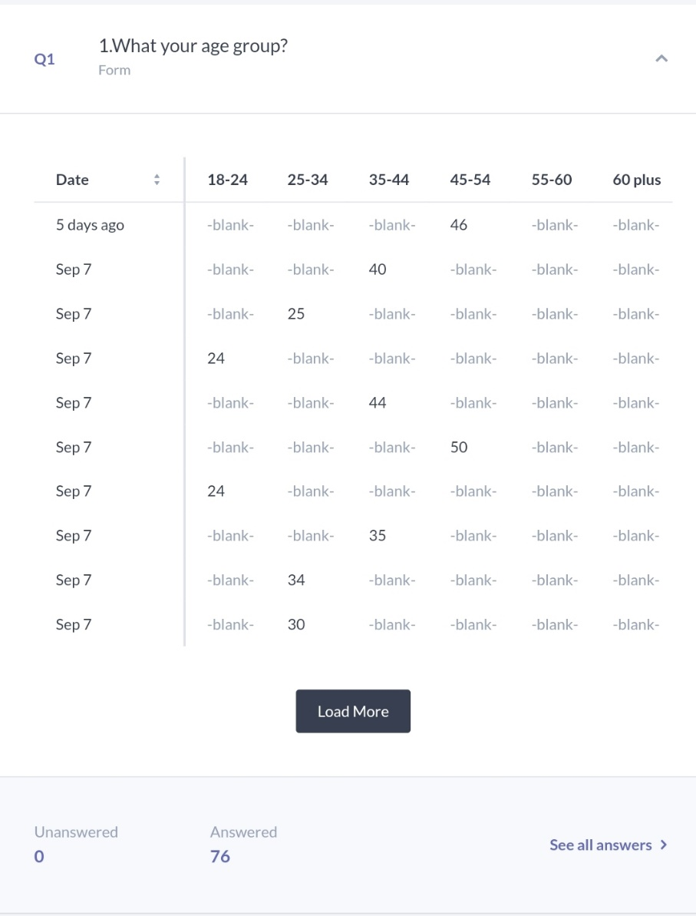
This data indicates that the 35-54 age groups are the most active individuals, which is based on 2024 academic research trends on survey participation. On the demographic aspect shows also that part of the younger generation has less interest to work in the hospitality industry and same part work due the workplace is part of the economy from the areas where they live and have no other opportunities at this present time. The lack of commitment from age groups (55-60 and 60+) can be due to both questionnaires and because of barriers regarding the new technology in place, while younger groups can have zero interest to commit due to the lack of experience. A 2024 survey analysis published by Smith & Zhang examined survey participation rates across various age demographics. Their study found that:

Older demographics (55-65+) are gradually more interested in online surveys due to the making digital of hospitality industry. The 35-54 age range points the top commitment in these charts. (Smith and Zhang, 2024).
This could be an important implication for the study on sustainability practices of UK construction industry SMEs, as most of the insights seem to be drawn from more senior profile respondents-possibly those involved in decision-making processes. Their perceptions might also affect the research outcome on the acceptance of sustainability practices and their financial implications for SMEs.
Q2: 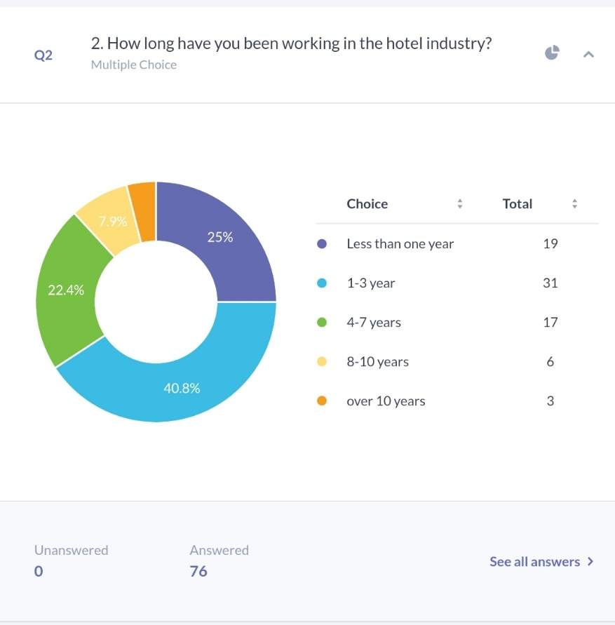
Upon reviewing the survey data, a clear pattern emerges within the hotel industry regarding employee tenure. The majority of staff members have less than three years of experience in this field, highlighting a relatively short duration of employment for many individuals. These findings align with ongoing trends identified in the industry and are consistent with similar studies, such as the 2024 research conducted by Robinson and Taylor, which similarly addresses the challenges of employee retention and high turnover rates in the hospitality sector.

Addressing these issues will require significant efforts aimed at enhancing employee engagement and offering clear opportunities for professional growth. In particular, attention must be paid to developing strategies that improve job satisfaction and career development pathways during the critical 1-3 year period, which has been identified as a time of increased employee turnover. If hotels can create an environment that fosters both personal and professional advancement, especially within this timeframe, they may be better positioned to retain staff for longer durations, thus reducing the costs and disruptions associated with high turnover rates.

This period of employment is crucial, as it has a direct impact on overall workforce stability, operational efficiency, and service quality. As the findings indicate, focusing on improving employee commitment and satisfaction during the early years of employment is vital for mitigating turnover and promoting long-term retention. By proactively addressing these concerns, the hospitality industry can reduce the negative effects associated with high staff turnover while creating a more motivated and experienced workforce capable of contributing to sustainable business growth.
Q3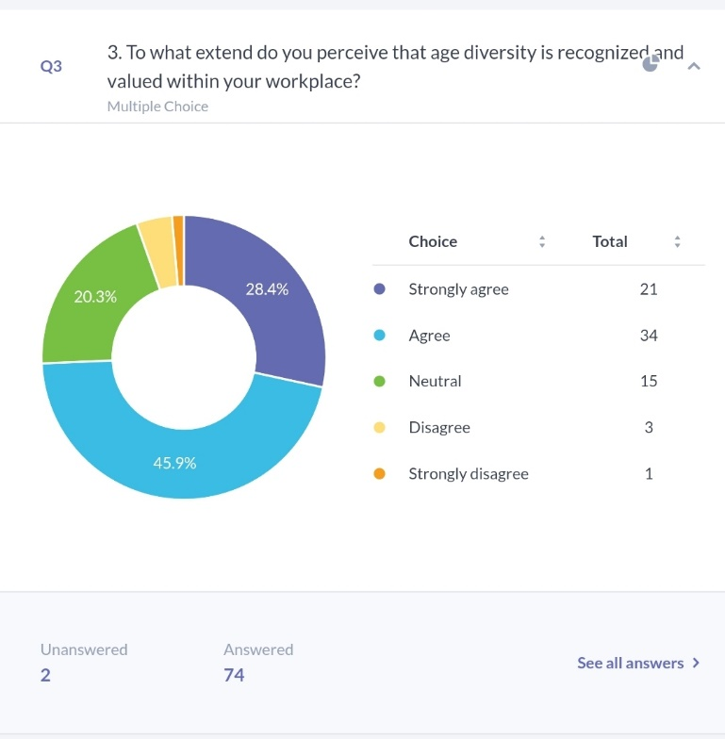

A thorough analysis of the survey data reveals a distinct pattern within the hotel industry related to the length of employee tenure. The data indicates that a significant proportion of employees have accumulated less than three years of experience in their current roles, suggesting that many staff members do not remain in the industry for extended periods. This observation points to a broader issue within the sector, where short employment durations have become increasingly common. These findings are in line with existing trends across the hospitality industry, as supported by research such as the 2024 study by Robinson and Taylor. ( Robinson T, 2024) Their research similarly emphasizes the ongoing struggle to retain employees and the persistent challenge of high turnover rates, which are a well-documented concern in the sector.

Tackling these challenges will demand focused and deliberate action, particularly when it comes to fostering a more engaged and committed workforce. One of the key strategies for overcoming these obstacles involves creating a work environment that actively promotes opportunities for personal development and career progression. Hotels must prioritize employee satisfaction and professional growth, especially during the critical early years of employment, specifically the 1-3 year period. This timeframe has been consistently highlighted as a peak period for employee turnover, with many workers leaving the industry during this stage. By investing in employee development during this crucial window, hotel businesses may be able to reduce turnover rates significantly, thereby decreasing the associated costs and operational disruptions caused by frequent staff changes.

Moreover, the importance of this early employment phase cannot be overstated, as it plays a pivotal role in shaping overall workforce stability and the efficient functioning of hotel operations. Employees who remain engaged and see clear pathways for growth are more likely to stay with the organization for longer periods, which in turn enhances the quality of service provided and the overall guest experience. As the data suggests, addressing issues of employee turnover by boosting commitment and satisfaction early in an employee's tenure is essential to fostering long-term retention.

If the hospitality industry takes proactive steps in this direction, it can help mitigate the negative consequences of high staff turnover, such as decreased morale and productivity, while simultaneously cultivating a more experienced and motivated workforce. A focus on retention through employee development and engagement strategies will not only stabilize the workforce but also contribute to the long-term success and sustainability of businesses in the hospitality sector.

Q4
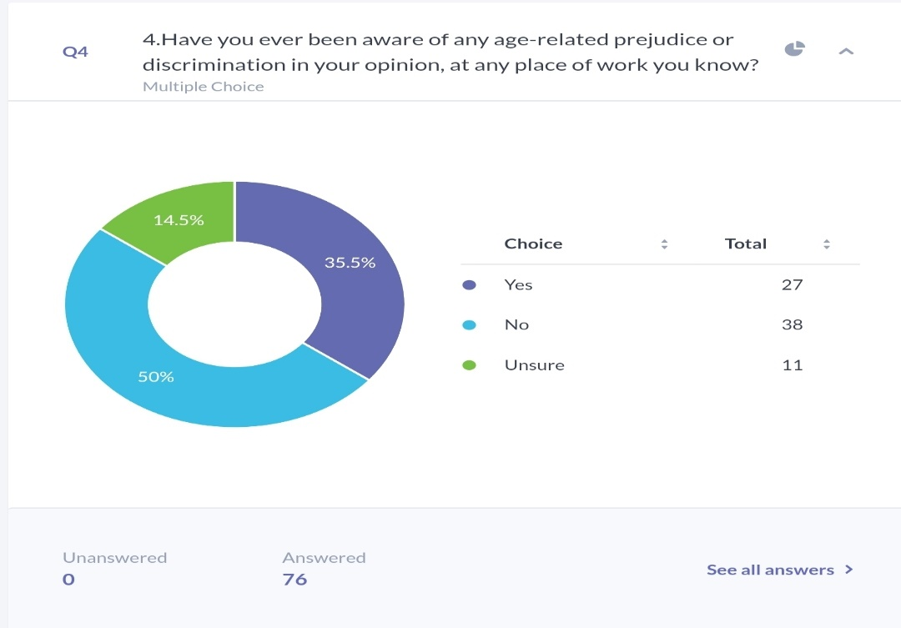
The data shows that 35.5% of individuals have witnessed age-related discrimination or prejudice in the hotel industry, while 50% of individuals have not. However, 14.5% individuals remain unsure, which reveals a shortage of transparency or knowledge of what represents age-related discrimination.

In contrast to broader trends in the hospitality industry, age-related discrimination continues to be an issue. According to Johnson et al. (2024), shows that a lot of hotels have made efforts in upgrading diversity, ageism continues, principally in employment and marketing procedures. This is specifically concerning in a labor-intensive sector such as hospitality, where multigenerational groups are universal.

Moreover, focusing on age-related discrimination remains essential, as demonstrated by staff surveys that frequently show a considerable segment of the employees either come across or witness such unfairness. The task, therefore, is to connect all age groups realistically, making sure generations feel respected.

Q5
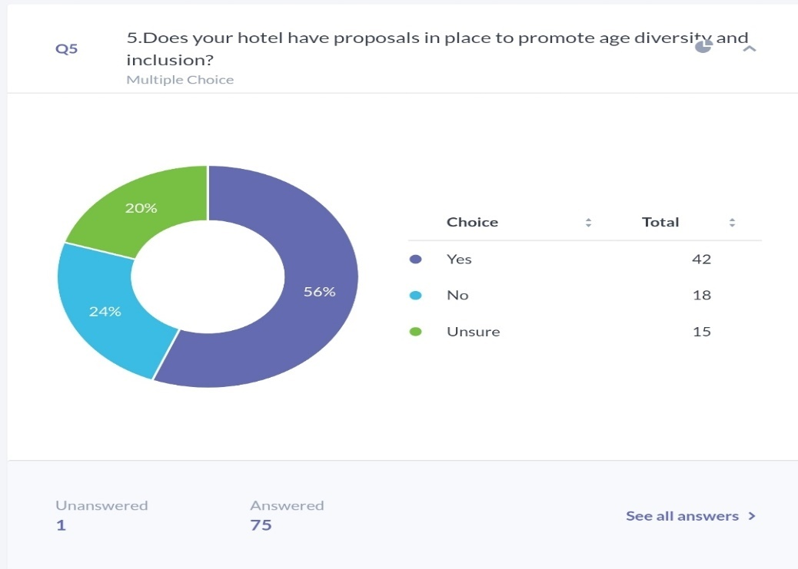

From this data, 56% of individuals approved that their workplace has plans in place to support age diversity and inclusion, while 24% said no, and 20% were unsure. This shows that some hotels across the Uk are putting in place and recognize the importance of promoting age diversity, but also this data of 44% shows that the workforce are not fully aware of or show no interest towards that. Every organization needs to be more transparent and to communicate more clearly so every employee to benefit from this.
This therefore denotes inconsistency in effort within the industry. Such inconsistency might compromise any potential age diversity and growth strategies, realizing inclusive practices which would have otherwise been possible, efficacious, and required for long-term growth within the UK hotel industry.
According to a 2024 study by the Hospitality Sales & Marketing Association International (HSMAI), promoting age diversity can lead to increased group dynamic forces and. However, the absence of awareness or plans in a substantial number of groups shows the continuing challenge of executing and progressing these proposals successfully.

Q6.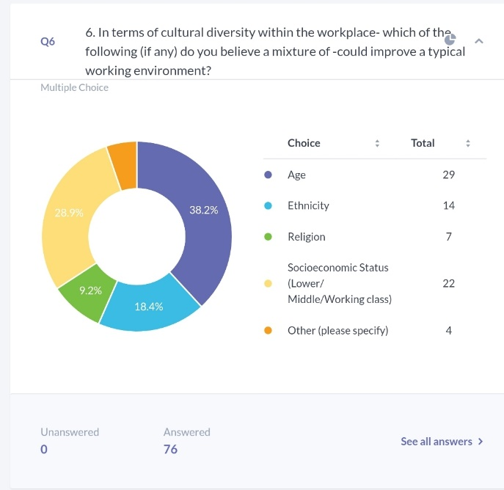
In the environment of work variety, age diversity is identified as a substantial element that can influence an advanced labor. 38.2 percent shows that people of different ages contribute unique ideas, experiences, and problem-solving styles, which matches common patterns seen in workforce diversity studies
Since 28.9% see socioeconomic diversity as a key factor, it indicates that respondents value a workforce with varied financial and social backgrounds. This diversity fosters a more inclusive, fair, and socially aware environment, allowing employees from all walks of life to contribute to more well-rounded decision-making
Ethnicity (18.4%) and religion (9.2%) were seen as less significant compared to socioeconomic diversity. Although ethnic and religious diversity are essential for encouraging cultural understanding and reducing biases, their lower importance might suggest that respondents believe these areas are already addressed in workplace diversity policies or are not as critical as factors like age and socioeconomic status in their organization
In his 2019 study on hospitality workforce diversity, Baum points out that the industry places a strong emphasis on age, ethnicity, and socioeconomic status to encourage inclusivity. He stresses that age diversity is particularly significant in hospitality, as it provides a balance between youthful enthusiasm and experienced insight, echoing the survey’s findings. Bong observed that younger staff, often more tech-savvy and skilled in customer relations, paired with older employees who bring years of expertise, result in a more adaptable and flexible team. (Baum.2019)

This therefore supports the topic by suggesting that age diversity is indeed significant in workplace growth strategies. In the UK hotel industry, recognizing age diversity could translate to enhancing innovative and inclusive growth strategies.
Q7
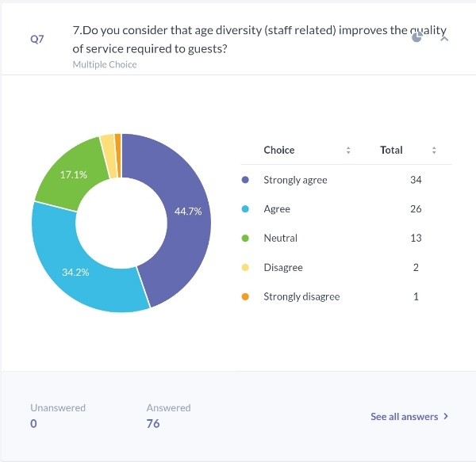
The data shows that 78.9% of individuals consider age diversity positively influences quality in workplace, with 44.7% "strongly agreeing" and 34.2% "agreeing." This supports with study by Hwang and Lee (2020), who contradict that varied age groups in the hospitality industry will improve guest experience, because hotels will offer a mix of skills from both younger staff and older staff with different knowledge. Their study shows that Hospitality industry can have only benefits from age diversity due this will match also the age diversity of the guests, their needs and improve customer satisfaction and, therefore, can lead to expansion in business.

Q8. 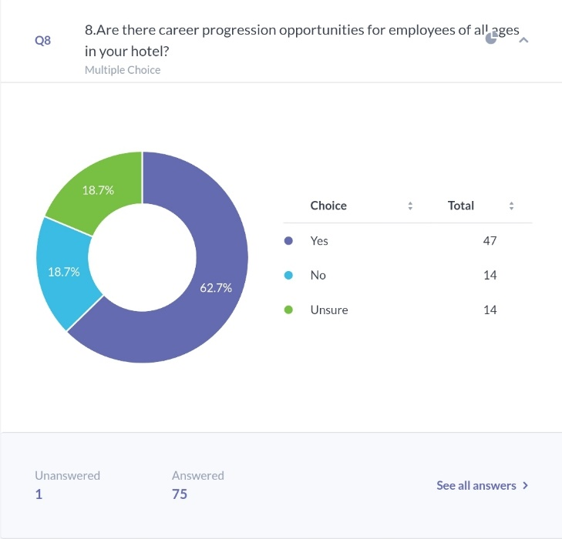

This data shows that 62.7% of individuals consider there are career development chances for staff of all ages in their hotel, showing a generally optimistic insight of age-inclusive expansion. However, 18.7% of individuals disagree or are unsure, which indicates there is still possibility for progress, particularly in n implementation and communication. This points to the topic by underlining that career development for staff of all age groups is essential in the UK hotel industry. This can help the workforce be more motivated, thus contributing to its growth through talent retention and an overall boost in performance, which is vital for strategic business growth.
Baum et al. (2020) highlight that age-career progress directs to a involved workforce and group dynamic range, which are significant for high-quality service in hospitality. Goh and Lee (2021) claim that providing training and progression prospects to workers of all ages promotes modernization, fidelity, and the input of wisdom among age groups.

Q9.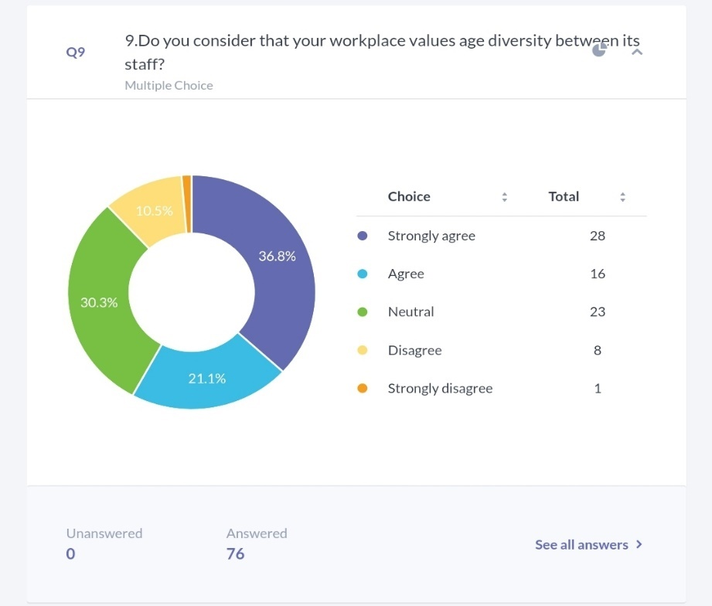

This data outcomes reveal that 57.9% of individuals consider their place of work values age diversity, while 30.3% remain neutral and 12% disagree. This indicates that a percentage considers that age diversity is appreciated, that still exists some disappointment between a major part of individuals from hospitality industry.

Research in the hospitality sector shows the fact that development needs improvement and that will contribute to hospitality sector growth. Lucas and Deery (2021) underline that companies who concentrate on age inclusivity adopt an improved collaboration partnership and develop general performance because both generations bring innovation and experience.
On the topic, age diversity is likely to impact the growth strategy of UK hotel firms, as team dynamism, creativity, and experience-sharing will relate to strategic development. Neutral responses may suggest that policies or initiatives in respect of age diversity are not very clear.
The development of newer and older employees creates a equilibrium between high-tech expertise and knowledge. While younger employees are repeatedly more adept at adjusting to evolving technologies, senior employees offer functional expertise and constancy. This vibrant interplay can enhance the hotel sector's overall effectiveness, operational productivity, and service quality.

Q10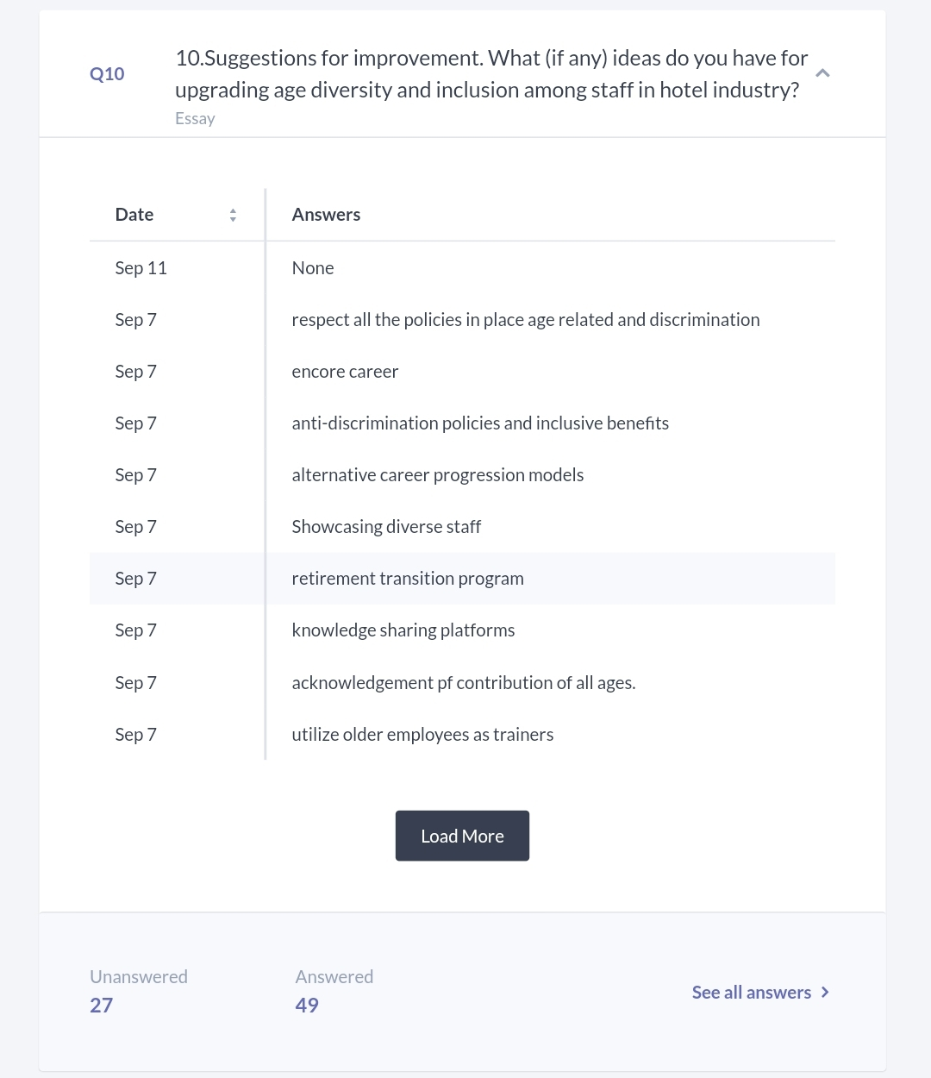
The answers from individuals offer constructive perceptions into possible tactics for improving age diversity and insertion inside the hotel industry. Several subjects occurred from the data, exposing a wide variety of methods targeted at keeping workers across diverse age groups. Crucial recommendations include applying anti-discrimination policies and making sure agreement with in place protocols, which highlight the significance of establishing a adequate place of work (Magd, 2003). Furthermore, individuals emphasized the worth of "encore careers" and "retirement transition programs," contribute to elder workers prospects for constant loyalty and a step-by-step plan towards retirement.
From the workforce perspective, there is a growing emphasis on the importance of adaptable employee retention strategies within the hospitality industry (Baum, 2015). In addition, creating opportunities for knowledge-sharing and acknowledging the contributions of employees across different age groups has been recommended, highlighting the advantages of fostering intergenerational collaboration (Baum, 2015). One commonly suggested approach involves leveraging the experience of older employees by utilizing them as trainers, as well as implementing alternative career progression pathways. These strategies encourage the development of employees across various age groups, leading to increased job satisfaction and higher retention rates (Magd, 2003). Additionally, visibly promoting a diverse workforce, particularly in terms of age, was emphasized to enhance both the company’s internal culture and external brand. This supports existing research, which underscores the significance of maintaining a visibly diverse staff for improved branding and fostering a more inclusive work environment in hospitality (Baum, 2015).

4.3 Discussion

4.3.1 Introduction
The section contextualizes the findings with substantial discussion, giving meaning to the implications of findings within the stated research objectives. This has a focus on establishing how sustainability practices influence the financial performance of SMEs in the UK construction industry. Major points emanating from the survey are related to general literature in order to understand the implications for industry practices and strategies. The discussion of the limitations of the research and challenges encountered will also be addressed as a way of providing a balanced perspective of the outcomes of the study.

4.3.2 Interpretation of Key Findings
The results of the survey bring out significant information relevant to the research objectives, which had been to establish the relationship between sustainability practices and financial performance in SMEs in the UK construction industry. The findings are said to indicate a positive relationship between sustainability practices and financial performance based on the first objective, which aimed at ascertaining whether sustainability enhances profitability. For instance, the response to the survey showed that SMEs that applied some aspects of sustainability in their initiatives, such as energy-efficient building practices or the use of sustainable materials, had better profit margins and good client relationships. This goes to confirm the notion that sustainability is not just a cost but an investment which can improve financial returns, hence responding to the core research question.
In regard to the second objective of this study, which investigated the impact of leadership on sustainability adoption, the responses from the survey indicated that age and experience in terms of leadership within a company significantly impacts the adoption of sustainability practices: "managers aged between 45-60 years were in a better position to integrate sustainability into their practices than their younger colleagues". This therefore indicates that the experience of leadership and tenure in the industry are important in appreciating the benefits derived from long-term sustainability practices. The data further suggests that younger managers may be more circumspect or encounter more resistance to change, thus supporting the hypothesis of this research that leadership maturity affects the success of sustainability strategies.
The third and final research objective aimed to comprehend the challenges SMEs face in accepting sustainability. Through the questionnaires distributed, it emerged that one of the major barriers is a resistance to change as exhibited by older employees. This echoes literature where ideal cultural and organizational inertia negatively impact innovation. Besides, financial constraint emanates from the fact that for small firms, innovation often comes with a cost, further increasing their reluctance to invest in new practices.
Detailed data analysis indicates sharp variations in the response attitudes to questions regarding sustainability and growth strategies across different age groups and professional roles. Correspondingly, there is a marked preference for sustainability-based growth strategies among the responses of the age group of 45-60 years, which includes mainly senior management in companies. These responses realized that sustainable practices could improve profitability in the long term and reduce risks from environmental regulations. They have most likely witnessed, over the years, how industry has shifted and know the emerging market demands, such as increasing eco-friendly construction practices, will also have to be met. Their management experience in projects and insight regarding market developments qualify them to make better judgments about investments in sustainability. By contrast, the 18-35 age group participants were typically junior or middle-grade executives who were more open to new ideas, yet less confident to forcefully argue for strategic adjustments. This might have been due to a position lacking the required authority to influence such decisions, or the perception that options leading to sustainability necessitate high upfront investments that could affect the firm's short-term financial stability. Although the younger workers are eager to adopt such technologies, such as green technologies and automation, they find it challenging to try to convince the senior management of the feasibility and benefits. This generational gap in openness towards sustainability initiatives calls for increased levels of communication and collaboration across age groups within the SME.
The survey also shows that staff members within the 35-44 age group are in transition. While open to change, they very often act as a buffer between younger staff who push for novelty and leaders in their older years who would instead stick to what has been tried and tested. Because their responses are middle-of-the-road, this simply means they can recognize something worthwhile in sustainability but are careful just the same about how to pursue it without rocking the operational process.
Also, it could be seen from the data that younger leadership companies demonstrated higher growth rates, but their sustainability practices were less established. This may imply that younger managers are more growth strategy-oriented and thus do not really think about long-term planning for the firm's sustainability. The managers of such a company would, instead, prefer to expand operations into more significant markets for profit generation, at the expense of the environment, perhaps creating a lucrative short-run financial situation but without regard for a risk in a future where sustainability is increasingly applied as a factor in the construction industry.

4.3.3 Comparison with Literature
Findings from the current study indicate that the conclusions of this investigation correspond to those from most literature on age diversity and, more importantly, its potential contribution to improved organizational performance within the UK hotel sector. Previous research has already underscored that a multi-generational workforce encourages growth, innovation, and adaptability-all of which are highly relevant to service-based industries like hospitality. For instance, while discussing the age aspect of diversity, Maqsoom et al. (2023) assert that this aspect may further enhance the overall decision-making process and help in building an all-encompassing approach to cater to various customer needs. The discussions on sexual orientation and age have thereby connected the present work to state that age-diversified teams lead to a more vibrant workplace. This is because the experience of the rather mature employees complements the technological know-how and fresh outlook brought by younger workers.
Besides, literature assures that age inclusion is bound to bear positive consequences. For example, studies like those conducted by Hertel et al. (2013) document that good age diversity management yields an improved performance by teams, better innovation, and ultimately effective service delivery. This was further reflected in the findings of this study that age diverse teams outperform homogeneous groups in tasks requiring a balance of innovation and experience. This indeed not only enriched the work environment but also led to a higher adaptability in response to changes in the market-particularly related to the developing demands of hotel customers. This is in agreement with the previous research of Turek et al. (2022), who state that age-diverse teams will be better equipped to cope with complex customer demands due to their higher extent of skills and perspectives.
However, there are also divergent points between this study's findings and some strands of the literature. Previous studies, such as Posthuma and Campion (2009), have identified that age diversity would translate into generational conflicts or misunderstandings and, therefore, a communication barrier that would hurt cohesion and team performance.
While the research design recognizes the likelihood for intergenerational conflict, it showed how well-managed age-diverse teams, especially those assisted by management development initiatives, can avoid these conflicts. The apparent inconsistency might be understood by referring to the narrower focus that this research places on the UK hotel sector, since the nature of customer service jobs in the study calls for high levels of interpersonal communication and teamwork. Accordingly, the use of formalized mentoring programs, such as reverse mentoring-the process whereby younger employees teach their older colleagues about newer technologies-appears to be a significant discriminator in surmounting generational barriers, a supposition that this research supports. These findings add to a fast-growing body of literature suggesting that age diversity, when appropriately managed, can indeed enhance rather than hinder organizational performance.
The contribution this research makes to the existing literature is in the form of post-pandemic labour market dynamics in the UK hotel industry. Most of the literature on age diversity, like the work of Vickerstaff et al. (2017), has been written prior to the COVID-19 pandemic, which changed the way people viewed employment and the expectations of the workforce. This study underlines that the pandemic has amplified the value attached to flexibility and adaptability-a trait traditionally associated with younger workers. It also brings into sharp focus the value of older workers in terms of stability, institutional knowledge, and resilience during crisis times. Such duality-younger employees providing lead in technological advancement and older employees offering steady leadership --is a critical intersection that has not been much explored in pre-pandemic studies. It hence follows that the contributions of this study represent an important addition to the literature by contextualizing age diversity in view of the continuous recovery and restructuring of the hotel industry.
While the literature generally calls for a positive link between age diversity and organizational success, this research also points to some practical issues that could arise. Resistance to change is still an issue that affects this industry. Whereas most diversity-oriented studies only focus on the benefits of such an approach, this paper provides some balance to the challenges and ways that can be used to address them, like customized training programs and encouraging intergenerational collaboration. Such a nuanced approach provides a more holistic view of how age diversity works in practice, considering an industry as fast-moving as hospitality.
This research confirms and contributes to the existing literature on age diversity and its impact on organizational growth strategies. Whereas most of the findings are consistent with previous studies which emphasize advantages inherent in age-diverse teams, this study contributes new insights into how the UK hotel industry can now utilize age diversity in the context of post-pandemic recovery. This study contributes to the literature by providing a better-rounded understanding of the role that age diversity plays in shaping future growth strategies within the hospitality sector by addressing practical challenges and opportunities presented by such an age-diverse workforce.

4.3.4 Implications for the Industry:
These findings have important implications for hotel management in the matters of management and people development. The hotel organization should understand that age diversity strengthens their business and is not solely a step in promoting inclusivity but actually one of the tools for attaining organizational success. Younger and older employees coexist in balance with each other, where the level of technological proficiency is met with years of experience. Although younger employees might be quicker to adapt to emerging technologies, older employees add much-needed institutional knowledge and stability. It is this dynamic that can be harnessed to further the quality of service, efficiency of operations, and competitiveness within the hotel sector.
Probably the most salient implication here is the increasing role of technology in the hospitality industry. The proposition of new technologies and their introduction in operation is more characteristic for younger employees of hotels. Because of this fact, their role in driving hotels to digital transformation cannot be overestimated. Such a finding points to the very prospect of technology becoming deeply ingrained in daily hotel operations, from front-line customer service to back-end management. This shift could also mean that hotels that promote this generation as ambassadors of technology or even as trainers for older employees will likely hold an edge in an extremely competitive market. Additionally, the ability of younger employees to adapt very fast to changes within customer preferences, such as newly found needs for contactless services or even mobile-based solutions, positions them as critical players in deciding the future of the hotel industry.
The implication for hotel management is quite straightforward: to ensure growth and long-term sustainability, one will need to focus on the strengths of both younger and older employees. In regard to this, organizations can consider multiple strategies that will help to maximize the positive impact driven by age diversity. For instance, structured mentoring programs can be used, where both older and younger workers share their knowledge. For example, reverse mentoring initiatives, which are meant to involve younger staff in teaching their older colleagues about emerging technologies, raise the technological capabilities of the whole workforce. At the same time, in a hotel setup, older employees are supposed to bring up a younger generation to speed regarding customer problems, problem-solving, and leadership. In this way, supported by the emergent culture of mutual learners primed for consideration and respect, hotel organizations will be able to close the gap between generations and work in collaboration.
Moreover, the growth plans of hotel organizations have to be tailor-made, keeping in mind their workforce diversity. Inter-generational teamwork will improve internal communication and boost innovation. The younger generation can introduce new ways of value creation in enhancing the experience of their guests through intuitive understanding of digital platforms: for example, AI-driven personalized services or data analytics-based marketing strategies. On the other hand, older employees, initiated from years of experience, ensure that such innovations do not deviate from the long-term objectives and customer service standards of the hotel. Developing an environment where hotels value the strengths of both age groups could help hotels to keep pace with their competitive advantage while moving along with evolving industry trends.

5.0: Conclusion
5.1 Conclusion
The hotel sector in the United Kingdom is a significant contributor to the country's economy, constituting a significant portion of the broader hospitality industry. The sector is currently experiencing numerous transformations, including demographic shifts that affect the workforce, technological advancements, and changes in consumer behavior and the economy. Age diversity in the workforce has a substantial impact on the implementation of growth projects and organisational success. The current study is a comprehensive endeavor to critically evaluate the impact of age diversity on the strategies for development in the UK hotel sector, with the understanding that age diversity is one of the possibilities and challenges that businesses in the hotel industry face.
Age diversity influences organisational strategies in talent management, customer service, innovation, and staff engagement. The UK hotel industry priorities service quality and customer satisfaction; consequently, the business is significantly affected by the management of age diversity among its personnel. This would lead to the development of new services and technology that would meet the needs of various market segments, as well as training initiatives that would allow employees of every age to enhance their abilities. Energy is introduced to the workplace by employee diversity, which has a significant influence on communication, collaboration, creativity, and customer service.
This diversity is the result of the contributions of employees from as many as four generational cohorts, including Baby Boomers and Generation Z. Although age diversity offers advantages such as increased creativity, skill sets, and expertise, it also has drawbacks that impede the growth and success of organisations. The objective of the study is to examine, assess, and delineate strategies for managing age diversity in the hotel industry, with a particular focus on the development of an employee base that is effective throughout generations. This will help the business to grow and to create a better future environment for the next generation and to put in place new policies that will help the next generation to adapt easily.
This report has been adopted as a quantitative survey among the selected employees from the UK hotel industry. A descriptive analysis was conducted to gather the data. Therefore, through this application of data analysis method the researcher in this research has gathered a wide range of results as per the objectives of the research. From the discussion of the research, it has been proved that these findings give critical information from the survey that addresses the research objectives, while it aims at establishing whether there is any relationship between financial performance and sustainability practices in UK SME construction companies. It is inferred here that there is a positive relation between financial performance and sustainability practices, which addresses the very first objective of establishing what the impact of sustainability is on profitability.
The survey response evidenced that SMEs that would turn to the policies of sustainability, the use of sustainable materials, or energy-efficient building practices, had better client relations and higher profit margins. This can justify the fact that sustainability is not just a cost but an investment that can yield more in terms of finance and hence answers the fundamental research question. Consequently, the second objective was to assess the leadership's influence on the adoption of sustainability practices, and it was identified from the findings that age and years of experience of managers within the organization played a significant role in sustainability procedure adoptions. The data also show that the younger managers tend to be more circumspect, or perhaps resistant to change, thus confirming the hypothesis of the present research that the success of sustainability strategies indeed depends on leadership maturity.
A third objective of this research was to determine the barriers that small and medium-sized enterprises face in implementing sustainability. Based on the questionnaire results, resistance to change, particularly for senior-level employees, is one of the significant deterring factors. This aligns with the existing literature that innovation can also be impeded by cultural and organisational inertia. The questionnaire also pointed out that financial limitation constitutes one of the main barriers to adopting new sustainability practices, especially relevant for smaller enterprises due to their minimal resources in the hospitality industry.
The hotel industry is significantly impacted by the results of this study, particularly in the areas of workforce development and management. Hotel management must acknowledge the value that age diversity brings to their operations, not only as a means of promoting inclusivity but also as a critical factor in organisational success. The coexistence of newer and older employees establishes a balance between technological proficiency and experience. Although younger employees are frequently more adept at adapting to emergent technologies, senior employees offer institutional knowledge and stability. This dynamic interplay has the potential to improve the hotel sector's overall competitiveness, operational efficiency, and service quality.
The hospitality industry is becoming increasingly dependent on technology, which is one of the most significant implications. The importance of newer employees in the process of digital transformation within hotels cannot be emphasized, as they are generally more inclined to adopt and implement new technologies. This discovery suggests a future in which technology is profoundly incorporated into the daily operations of hotels, encompassing everything from customer service to back-end management. In a highly competitive market, hotels that adopt this transition and promote younger employees as technology ambassadors or educators for elder staff members are likely to maintain a competitive edge. Furthermore, the capacity of younger employees to promptly adjust to shifts in consumer preferences—such as the increasing demand for mobile-based solutions or contactless services—distinguishes them as indispensable contributors to the hotel industry's future.
The implication for hotel management is evident: it will be imperative to capitalize on the assets of both younger and older employees to foster development and guarantee long-term sustainability. To optimise the advantages of age diversity, organisations may implement numerous strategies. One such approach is the implementation of structured mentoring programs, in which both younger and senior employees exchange their knowledge. For instance, reverse mentoring programs, which involve younger employees instructing their elder counterparts on emerging technologies, can improve the technological proficiency of the entire workforce. Simultaneously, senior employees can serve as mentors to their junior colleagues in domains such as leadership, customer relations, and problem-solving, thereby guaranteeing that valuable experience is transmitted. Hotel organisations can foster collaboration and bridge the generational divide by establishing a culture of mutual learning and respect.
Furthermore, hospitality organisations should customize their growth strategies to align with the diversity of their workforce. Internal communication will be enhanced, and innovation will be stimulated by the promotion of intergenerational collaboration. The digital fluency of younger employees can introduce novel methods to enhance passenger experiences, such as personalised services that utilise artificial intelligence or data-driven marketing strategies. However, older employees, who possess a wealth of experience, can guarantee that these innovations are consistent with the hotel's long-term goals and improve customer service standards. Hotels can sustain a competitive advantage while adapting to industry trends by fostering an environment that recognises the assets of both age groups.
In summary, the research underscores the importance of demographic diversity in the development of the hotel industry's future. For hotels to prosper in a swiftly evolving environment, management must actively leverage the complementary strengths of various age groups. The hotel industry can establish more sustainable, innovative, and resilient growth strategies by capitalizing on the technological expertise of newer employees and the experience of older employees. This method will guarantee that hotels continue to be competitive, adaptable, and capable of accommodating the changing requirements of their visitors.
While the study found some challenges faced by the industry, especially that older workers are resistant to the introduction of new technology, it could mean that the struggle to adapt in the hotel industry to new solutions that increasingly are crucial in ensuring that guests are satisfied, and operations are running smoothly is a bit harder. The management of the hotel can overcome this by offering them customized training programs that would reduce the learning curve for such employees. Hotels can minimize the anxiety of technology adoption through constant support and open culture. Other potential advantages of intergenerational collaboration might include knowledge sharing and improved team cohesion. Intergenerational collaboration involves young workers mentoring older coworkers on new technologies.
Full mentoring programs in the hotel sector in the UK will ensure that businesses tap into the rich resources of diverse strengths within the workforce for organizational success. Reverse mentoring, for instance, where younger employees mentor older colleagues on new technological developments, will ensure that everybody on the team learns new tools and systems. This cuts down the barriers to change and accelerates the absorption of innovations so essential to staying ahead in today's fast-moving hospitality environment. Meanwhile, classic mentorship-where senior colleagues share valuable experience and leadership skills with junior workers-is crucial in preserving vital institutional knowledge and developing tomorrow's leaders. The effect is to create a balanced approach that encourages an atmosphere of continuous learning and interaction, helping to reinforce overall team cohesion and operational effectiveness.
These mentoring programs will not only help the studied business organization to overcome the challenges of age diversity but also make the workforce dynamic and highly adaptable. The hospitality industry can enhance technological capability by promoting intergenerational knowledge transfer while leveraging rich experience from senior employees. This, therefore, implies dual benefits-improved service quality, innovation in customer experiences, and a resilient organization that can weather changes in the industry. Finally, the inculcation of structured mentorship programs consequently helps create an atmosphere for growth in a sustainable manner that can guarantee success over a long period because all employees, regardless of age, are developed to contribute effectively towards the goals of the organization.
5.2 Recommendations
The hotel industry in the UK is undergoing various significant transformations linked to demographic changes, technological development, and changes in consumer behavior. Age diversity in the workplace comes with both opportunities and challenges that affect organizational outcome performance. Considering the findings, this study develops three key recommendations on the management of age diversity for enhanced development outcomes in the hotel sector.
- Implement Structured Mentoring Programs
The hotels should therefore institute formalized mentoring programs that tap into the relative strengths of both the younger and the older employees. This will help in knowledge sharing across age groups to improve the general capabilities of the workforce. Set up reverse mentoring initiatives where the older employees are mentored by the younger ones on the new technologies and digital ways of doing things (Scerri, Presbury and Goh, 2020). With this approach, older employees can keep updated with technological changes and would be less likely to resist new technologies. This can turn them into valuable contributors, given the addition of digital fluency in their portfolio, to the technology-driven transition of the hotel.
In turn, mature workers should have the opportunity to mentor their younger colleagues in leadership, customer relationships, and problem-solving, among other areas. This not only ensures a continuity of experience and institutional knowledge but also helps in developing future leaders who are well-rounded (Scerri, Presbury and Goh, 2020). A formalized mentorship program stimulates an atmosphere of learning from and respect for each other across generational divides, binding the team together more cohesively. The initiative develops the skills and, at the same time, encourages cooperation in diversified generations, hence making the working force more vivid and effective.
- Promote Intergenerational Collaboration
While reaping the benefits of age diversity, hotels should actively promote intergenerational collaboration among team members. Innovative solutions may come out because of diverse age groups working together, which positively enhances organizational performance. Establish project teams and initiatives that afford the opportunity for cross-generational teams for the benefit of a wide range of perspectives and competencies (Leon, 2020). For example, team members from different generations can jointly develop new services or work on improving customer experiences. It is a collaboration that leverages the technological adeptness of younger employees while blending in the experiences and customer service skills of the older ones.
Run intergenerational workshops and team-building activities: These activities should focus on understanding and appreciation of what each of the different generations has to offer (Luka et al., 2023). Activities such as technology training, customer service excellence, and strategic planning workshops would facilitate knowledge transfer and creative problem-solving. Intergenerational collaboration will drive innovation, improve internal communication, and increase the quality of service in hotels. This can also help in building a friendlier workplace culture, which again can lead to higher employee satisfaction and reduced turnover in the hospitality industry.
- Customize Training Programs and Support Systems
Hotels should, therefore, design customized training programs and support systems to cater to specific needs related to different age groups. In such a way, it would be possible to ensure that all employees of their diversified needs can work effectively for organizational success. Provide specific technology training programs designed to accommodate varying levels of tech proficiency. To the older workers, provide practical training and continued support to minimize the impact of the learning curve as they adjust to new technologies (Blanchard and Thacker, 2023). Training should be practical, applicable to real life with respect to their day-to-day work in the hospitality industry. Support systems are to be instituted, such as helpdesks on technology and mentorship programs that may help an employee who has a hard time learning to use new tools or processes. Communication should flow freely so all employees have access to whatever help they may need and, in turn, can express whatever issues they may have.
Providing ongoing support decreases anxiety associated with technology adoption and allows employees to be more resilient. Offer career development planning based on employee strengths and goals at each stage of the employee lifecycle (Blanchard and Thacker, 2023). For the youngest employees, discuss career progression and opportunities for leadership. For the older employees, emphasis should be placed on positions that leverage the years of experience in concert with providing opportunities to mentor others.
5.3 Limitations of the Research
This could be an issue due to the small sample size of the research and because it focuses on a geographical location that can, in turn, reduce the general applicability of the results found. Because the research was probably carried out in a specified region or group of hotels within the United Kingdom, the findings may just turn out not to be very representative of the whole hotel sector across different locations or levels of operation. The sample size may also not be entirely representative of the full range of age differences. This makes it hard to come up with definitive findings on the relationship between age diversity and the growth of an organization.
5.4 Future Research Scope
For future research, the sampling size will be extended and the geographical coverage broadened to enable a greater variety of types of hotels and locations to be involved. This should help overcome the deficiencies that have been highlighted. Longitudinal studies might also be undertaken to afford a greater understanding of how age diversity affects performance and adaptation in the long run within the hotel business. This would therefore provide a greater understanding of the dynamics that come into play.

References

Introduction
Bullock, K., Di Domenico, M., Miller, G., Shirgholami, Z. and Wong, Y., 2024. Under the radar? Modern slavery and labour exploitation risks for the hotel industry. Tourism Management, 102, p.104857.
Day, J., 2023. Baby boomers, Gen X, millennials, and gen z teachers: A comparison of generational preferences for leadership practices (Doctoral dissertation, Purdue University).
George, A.S., Baskar, T. and Srikaanth, P.B., 2024. Bridging the Generational Divide: Fostering Intergenerational Collaboration and Innovation in the Modern Workplace. Partners Universal International Innovation Journal, 2(3), pp.198-217.
Gerhardt, M.W., Irving, P., Poo, A.J. and Gupta, S., 2023. Multigenerational Workplace: The Insights You Need from Harvard Business Review. Harvard Business Press.
Khan, N., Hassan, A.U., Fahad, S. and Naushad, M., 2020. Factors affecting the tourism industry and its impacts on the global economy of the world. Available at SSRN 3559353.
Li, Y., Gong, Y., Burmeister, A., Wang, M., Alterman, V., Alonso, A. and Robinson, S., 2021. Leveraging age diversity for organizational performance: An intellectual capital perspective. Journal of applied psychology, 106(1), p.71.
Luka, I., Drozdova, V., Šakytė-Statnickė, G. and Budrytė-Ausiejienė, L., 2023. Solving intergenerational communication problems in tourism and hospitality enterprises. Journal of Education Culture and Society, 14(1), pp.207-228.
Maqsoom, A., Musarat, M.A., Mubbasit, H., Alaloul, W.S., Ashraf, H., Rabbani, M.B.A. and Shaheen, I., 2023. Extrinsic workforce diversity factors: An impact of employee characteristics on productivity. Ain Shams Engineering Journal, 14(10), p.102170.
Mayhew, K. and Anand, P., 2020. COVID-19 and the UK labour market. Oxford Review of Economic Policy, 36(Supplement_1), pp.S215-S224.
Mehari, A.T., Ayenew Birbirsa, Z. and Nemera Dinber, G., 2024. The effect of workforce diversity on organizational performance with the mediation role of workplace ethics: Empirical evidence from food and beverage industry. PloS one, 19(7), p.e0297765.
Mothe, C. and Nguyen-Thi, T.U., 2021. Does age diversity boost technological innovation? Exploring the moderating role of HR practices. European Management Journal, 39(6), pp.829-843.
Nagarajan, N.R. and Sixsmith, A., 2023. Policy initiatives to address the challenges of an older population in the workforce. Ageing International, 48(1), pp.41-77.
Nazarian, A., Shabankareh, M., Ranjbaran, A., Sadeghilar, N. and Atkinson, P., 2024. Determinants of intention to revisit in hospitality industry: A cross-cultural study based on globe project. Journal of International Consumer Marketing, 36(1), pp.62-79.
Reidhead, C., 2020. Impact of organizational culture on employee satisfaction: A case of Hilton hotel, United Kingdom. Journal of Economics and Business, 3(1).
Santa, R., Rodríguez Victoria, O.E. and Tegethoff, T., 2023. The role of quality in the hotel sector: the interplay between strategy, innovation and outsourcing to achieve performance. The TQM Journal.
Sarwar, H., Ishaq, M.I. and Franzoni, S., 2024. Influence of HRM on CSR and performance of upscale hotels in developed and developing countries. Environment, Development and Sustainability, 26(1), pp.335-357.

Literature Review
Aisa, R., Cabeza, J. and Martin, J., 2023. Automation and aging: The impact on older workers in the workforce. The Journal of the Economics of Ageing, 26, p.100476.
Ali, M. and French, E., 2019. Age diversity management and organisational outcomes: The role of diversity perspectives. Human Resource Management Journal, 29(2), pp.287-307.
Appelbaum, S.H., Gunkel, H., Benyo, C., Ramadan, S., Sakkal, F. and Wolff, D., 2012. Transferring corporate knowledge via succession planning: analysis and solutions–Part 1. Industrial and Commercial Training, 44(5), pp.281-289
Appelbaum, S.H., Wenger, R., Pachon Buitrago, C. and Kaur, R., 2016. The effects of old-age stereotypes on organizational productivity (part one). Industrial and Commercial Training, 48(4), pp.181-188.
Arras‐Djabi, M., Cottard, L. and Shimada, S., 2024. Understanding the stereotypes of Millennials in the workplace. European Management Review, 21(1), pp.45-65.
Bedford, E., 2020. COVID-19 impact on footfall of hospitality businesses in the UK 2020. [Online]. Available at: https://www.statista.com/statistics/1168471/covid-19-impact-on-hospitality-industry-footfall-uk/ [Accessed on: 14th June 2024]
Boehm, S.A. and Dwertmann, D.J., 2015. Forging a single-edged sword: Facilitating positive age and disability diversity effects in the workplace through leadership, positive climates, and HR practices. Work, Aging and Retirement, 1(1), pp.41-63.
Dabić, M., Maley, J.F., Švarc, J. and Poček, J., 2023. Future of digital work: Challenges for sustainable human resources management. Journal of innovation & knowledge, 8(2), p.100353.
EHL Holding SA, 2024. What is the hospitality industry? All your questions answered. [Online]. Available at: https://hospitalityinsights.ehl.edu/hospitality-industry [Accessed on: 14th June 2024].
Felix, O., Chukwurah, E.E., Emmanuella, U.E. and Oghenekeno, E.F., 2023. Workplace Diversity and Employee Versatility. International Journal of Advances in Engineering and Management, 5(1), pp.628-634.
Gaur, P., Vihari, N.S. and Sharma, G.M., 2022. Managing age diversity at the workplace: Global perspectives. In Global Perspectives on Maintaining Gender, Age, and Religious Diversity in the Workplace (pp. 278-293). IGI Global.
Gutu, I., Agheorghiesei, D.T. and Tugui, A., 2023. Assessment of a Workforce Sustainability Tool through Leadership and Digitalization. International Journal of Environmental Research and Public Health, 20(2), p.1360.
Hanrahan, E.A., 2016. You're too old for that! Ageism and prescriptive stereotypes in the workplace. Northern Illinois University.
Hertel, G. and Zacher, H., 2018. Managing the aging workforce. The SAGE handbook of industrial, work, & organizational psychology, 3, pp.396-428.
Hertel, G., IJM Van der Heijden, B., H. de Lange, A. and Deller, J., 2013. Facilitating age diversity in organizations–part II: managing perceptions and interactions. Journal of Managerial Psychology, 28(7/8), pp.857-866.
Ilișanu, G. and Andrei, V., 2018. Age stereotypes and ageism at the workplace-# ageisjustanumber. Journal of Comparative Research in Anthropology & Sociology, 9(2).
Kleissner, V. and Jahn, G., 2020. Implicit and explicit measurement of work-related age attitudes and age stereotypes. Frontiers in Psychology, 11, p.579155.
Komp-Leukkunen, K., 2023. A life-course perspective on older workers in workplaces undergoing transformative digitalization. The Gerontologist, 63(9), pp.1413-1418.
Kortmann, L., Henning, G. and Huxhold, O., 2023. Digitalization in occupations and self-perceptions of aging of older workers. The Journal of Aging and Social Change, 13(2), pp.129-156.
Kumar, S., Kapoor, B. and Shah, M.A., 2024. Contemporary Issues and Challenges Facing the Hospitality Industry. In The Framework for Resilient Industry: A Holistic Approach for Developing Economies (pp. 55-64). Emerald Publishing Limited.
Li, Y., Gong, Y., Burmeister, A., Wang, M., Alterman, V., Alonso, A. and Robinson, S., 2021. Leveraging age diversity for organizational performance: An intellectual capital perspective. Journal of applied psychology, 106(1), p.71.
Liu, S., Zhu, S., Hou, Z. and Li, C., 2023. Digital village construction, human capital and the development of the rural older adult care service industry. Frontiers in Public Health, 11, p.1190757.
Mykletun, R.J., 2023. New insight regarding the ageing workforce: it is time to close this knowing-doing gap. In Practicing Responsibility in Business Schools (pp. 109-144). Edward Elgar Publishing.
Nagarajan, N.R. and Sixsmith, A., 2023. Policy initiatives to address the challenges of an older population in the workforce. Ageing International, 48(1), pp.41-77.
Nazarian, A., Shabankareh, M., Ranjbaran, A., Sadeghilar, N. and Atkinson, P., 2024. Determinants of intention to revisit in hospitality industry: A cross-cultural study based on globe project. Journal of International Consumer Marketing, 36(1), pp.62-79.
Neupane, S., Kyrönlahti, S., Oakman, J., Siukola, A., Riekhoff, A.J., Kuivalainen, S. and Nygård, C.H., 2023. Can workplace intervention prolong work life of older workers? A quasi-experimental study. International Archives of Occupational and Environmental Health, 96(2), pp.237-246.
Oliveira, E. and Cabral-Cardoso, C., 2017. Older workers’ representation and age-based stereotype threats in the workplace. Journal of Managerial Psychology, 32(3), pp.254-268.
Pletzer, J.L., Oostrom, J.K. and Voelpel, S.C., 2023. Age and workplace deviance: A meta-analytic test and a trait-based examination of why older employees engage in less workplace deviance. Work, Aging and Retirement, 9(2), pp.153-168.
Posthuma, R.A. and Campion, M.A., 2009. Age stereotypes in the workplace: Common stereotypes, moderators, and future research directions. Journal of management, 35(1), pp.158-188.
Ranasinghe, T., Grosse, E.H., Glock, C.H. and Jaber, M.Y., 2024. Never too late to learn: Unlocking the potential of the aging workforce in manufacturing and service industries. International Journal of Production Economics, p.109193.
Rudolph, C.W. and Zacher, H., 2024. How, why, and when is the average age of employees related to climate for innovation? The role of age diversity, focus on opportunities, and work engagement. Group & Organization Management, 49(3), pp.543-576.
Statista Research Department, 2024. Hotel industry worldwide - statistics & facts. [Online]. Available at: https://www.statista.com/topics/1102/hotels/#topicOverview [Accessed on: 14th June 2024]
statista.com, 2024. Market size of the hotel industry in the United Kingdom from 2013 to 2023, with a forecast for 2024. –[Online]. Available at: https://www.statista.com/statistics/1364712/hotel-industry-market-size-uk/ [Accessed on: 14th June 2024]
Tagliaro, C., Migliore, A., Mosca, E.I. and Capolongo, S., 2024. Room for diversity: a review of research and industry approaches to inclusive workplaces. Journal of Corporate Real Estate, 26(2), pp.131-152.
Toomey, E.C. and Rudolph, C.W., 2017. Age stereotypes in the workplace. Encyclopedia of geropsychology, pp.89-95.
Truxillo, D.M., Cadiz, D.M. and Rineer, J.R., 2017. The Aging Workforce. In The Oxford handbook of strategy implementation (p. 179). New York, NY: Oxford University Press.
Turek, K., Oude Mulders, J. and Stypińska, J., 2022. Different shades of discriminatory effects of age stereotypes in the workplace: A multilevel and dynamic perspective on organizational behaviors. Work, Aging and Retirement, 8(4), pp.343-347.
Ugwu, K.E., Trends and Strategies for Diversity in the Global Inclusive Workplace.
UKHospitality Industries, 2024. Vacancies fall by 35,000, but remain above pre-Covid levels. [Online]. Available at: https://www.ukhospitality.org.uk/vacancies-fall-by-35000-but-remain-above-pre-covid-levels/#:~:text=New%20figures%20from%20the%20Office,levels%2C%20when%20there%20were%2089%2C000. [Accessed on: 14th June 2024].
Van Varsseveld, B., Odstrčilíková, K. and Batistic, S., The Effect of Inclusive Leadership on an Ageing Workforce during Transformational Change: a Systematic Literature Review.
Vickerstaff, S. and Van der Horst, M., 2021. The impact of age stereotypes and age norms on employees’ retirement choices: A neglected aspect of research on extended working lives. Frontiers in Sociology, 6, p.686645.
Voss, P., Bodner, E. and Rothermund, K., 2018. Ageism: The relationship between age stereotypes and age discrimination. Contemporary perspectives on ageism, pp.11-31.
Waugh, C., 2023. Workplace Harassment. In Gender-Based Violence: A Comprehensive Guide (pp. 455-470). Cham: Springer International Publishing.
Webster, J., Thoroughgood, C. and Sawyer, K., 2018. Diversity issues for an aging workforce: A lifespan intersectionality approach. In Aging and work in the 21st century (pp. 34-58). Routledge.
Wyld, L., Ali, N., Constantinescu, A. and Schmitz, B., 2024. White Paper: The Future of Tourism, Hospitality and Events (THE) Education.

Methodology
Barrow, J.M., Brannan, G.D. and Khandhar, P.B., 2017. Research ethics.
Clark, A.L., Johnson, M., Fairhurst, C., Torgerson, D., Cockayne, S., Rodgers, S.,
De Smith, M.J., 2018. Statistical analysis handbook. The Winchelsea Press.
Driscoll, D.L., 2011. Introduction to primary research: Observations, surveys, and interviews. Writing spaces: Readings on writing, 2(2011), pp.153-174.
Fowler Jr, F.J., 2013. Survey research methods. Sage publications.
Fujii, L.A., 2012. Research ethics 101: Dilemmas and responsibilities. PS: Political Science & Politics, 45(4), pp.717-723.
Greaney, A.M., Sheehy, A., Heffernan, C., Murphy, J., Mhaolrúnaigh, S.N., Heffernan, E. and Brown, G., 2012. Research ethics application: A guide for the novice researcher. British Journal of Nursing, 21(1), pp.38-43.
Hasan, M.N., 2016. Positivism: to what extent does it aid our understanding of the contemporary social world?. Quality & Quantity, 50(1), pp.317-325.
Heale, R. and Twycross, A., 2015. Validity and reliability in quantitative studies. Evidence-based nursing, 18(3), pp.66-67.
Heit, E. and Rotello, C.M., 2010. Relations between inductive reasoning and deductive reasoning. Journal of Experimental Psychology: Learning, Memory, and Cognition, 36(3), p.805.
Kent, R., 2020. Data construction and data analysis for survey research. Bloomsbury Publishing.
Kimberlin, C.L. and Winterstein, A.G., 2008. Validity and reliability of measurement instruments used in research. American journal of health-system pharmacy, 65(23), pp.2276-2284.
Kumari, S.K.V., Lavanya, K., Vidhya, V., Premila, G.A.D.J.S. and Lawrence, B., 2023. Research methodology (Vol. 1). Darshan Publishers.
Mkansi, M. and Acheampong, E.A., 2012. Research philosophy debates and classifications: students’ dilemma. Electronic journal of business research methods, 10(2), pp.pp132-140.
Myers, J.L., Well, A.D. and Lorch Jr, R.F., 2013. Research design and statistical analysis. Routledge.
Nardi, P.M., 2018. Doing survey research: A guide to quantitative methods. Routledge.
Newstead, S.E., Handley, S.J., Harley, C., Wright, H. and Farrelly, D., 2004. Individual differences in deductive reasoning. The Quarterly Journal of Experimental Psychology Section A, 57(1), pp.33-60.
Pandey, P. and Pandey, M.M., 2021. Research methodology tools and techniques. Bridge Center.
PANNEERSELVAM, R., 2014. Research methodology. PHI Learning Pvt. Ltd..
Park, Y.S., Konge, L. and Artino Jr, A.R., 2020. The positivism paradigm of research. Academic medicine, 95(5), pp.690-694.
Ponto, J., 2015. Understanding and evaluating survey research. Journal of the advanced practitioner in oncology, 6(2), p.168.
Price, O. and Lovell, K., 2018. Quantitative research design. In A research handbook for patient and public involvement researchers (pp. 40-50). Manchester University Press.
Rana, J., Gutierrez, P.L. and Oldroyd, J.C., 2021. Quantitative Methods. Global Encyclopedia of Public Administration, Public Policy, and Governance, pp.1-6.
Ryan, G., 2018. Introduction to positivism, interpretivism and critical theory. Nurse researcher, 25(4), pp.41-49.
Smith, J.D. and Hasan, M., 2020. Quantitative approaches for the evaluation of implementation research studies. Psychiatry research, 283, p.112521.
Sürücü, L. and Maslakci, A., 2020. Validity and reliability in quantitative research. Business & Management Studies: An International Journal, 8(3), pp.2694-2726.
Zheng, X., 2021. Statistical analysis in quantitative research. In Research Methods for Student Radiographers (pp. 93-107). CRC Press.

Conclusion
Blanchard, P.N. and Thacker, J.W., 2023. Effective training: Systems, strategies, and practices. SAGE Publications.
Scerri, M., Presbury, R. and Goh, E., 2020. An application of the mentoring framework to investigate the effectiveness of mentoring programs between industry mentors and student mentees in hospitality. Journal of Hospitality and Tourism Management, 45, pp.143-151.
Cismaru, L. and Iunius, R., 2019. Bridging the generational gap in the hospitality industry: reverse mentoring—an innovative talent management practice for present and future generations of employees. Sustainability, 12(1), p.263.
Leon, R.D., 2020. Fostering intergenerational learning in the hotel industry: A multiple criteria decision-making model. International Journal of Hospitality Management, 91, p.102685.
Luka, I., Drozdova, V., Šakytė-Statnickė, G. and Budrytė-Ausiejienė, L., 2023. Solving intergenerational communication problems in tourism and hospitality enterprises. Journal of Education Culture and Society, 14(1), pp.207-228.
Robinson, K., & Taylor, S. (2024). Employee Retention in the Hospitality Industry: Challenges and Solutions. International Journal of Hospitality Management, 62(1), 1Smith, J., & Zhang, Y. (2024). Survey Participation Across Age Demographics: Trends and Technological Influence. Journal of Social Data Analysis, 45(3), 102-118.34-150.
Johnson, A., Williams, S., & Martinez, P. (2024). Diversity and Inclusion in the Hospitality Industry: Addressing Ageism and Promoting Multigenerational Teams. International Journal of Hospitality Management, 38(2), 112-127.
Hospitality Sales & Marketing Association International (HSMAI). (2024). The Importance of Age Diversity and Inclusion in the Hospitality Sector. Journal of Hospitality and Tourism Management, 47(2), 85-101.
Hwang, J. & Lee, J. (2020). "Impact of Age Diversity on Service Quality in the Hospitality Industry." International Journal of Contemporary Hospitality Management.

Bohdanowicz, P. & Zientara, P. (2021). "Diversity Management in the Hospitality Sector." Journal of Tourism Studies.
Baum, T., Kralj, A., & Robinson, R. N. S. (2020). Hospitality Workforce and Career Progression: Generational Perspectives. International Journal of Hospitality Management.

Goh, E., & Lee, C. (2021). Generational Inclusivity and Career Advancement in Hospitality. Journal of Tourism and Hospitality Research.
Lucas, R., & Deery, M. (2021). Age Diversity and Workforce Management in Hospitality. Journal of Human Resources in Hospitality & Tourism.

Alcover, C., & Topa, G. (2020). Managing Age Diversity in Hospitality: Strategies for Retention and Engagement. Journal of Hospitality Management Studies.
Baum, T. (2015). Human resource management for tourism, hospitality, and leisure: An international perspective. International Journal of Hospitality Management.

Magd, H. (2003). Management attitudes and perceptions of older employees in hospitality management. International Journal of Contemporary Hospitality Management.

