Task 1

Student name : Rasheda Khanam
Student ID Number: 2109776
Module: Academic and Employability Skills
Module Code: BMSW 4001
Module Coordinator: Giridhar Katti
Assignment Title: Evaluation of blended learning and Classroom
Learning on student attainment (report) Task 1
Lecturer Name: Buddhi Pathak

TABLE OF CONTENT

Introduction...............................................................................................3
Classroom learning.............................................................................3
  - What is the classroom learning? ..............................................................3

  - Advantages of traditional classroom learning in the HE sectors..............4
1.3 Disadvantages of traditional classroom learning in the HR sectors..........4

Blended learning…………………………………………….5
  - What is the blended learning?..................................................................5

  - Advantages of blended learning in the university education......................6
2.3 Disadvantages of blended learning in the university education. ...............6

Evaluation of both forms of teaching and learning in the past and present……………………………………………………………………….….7
  - The Past Studies (Until year 2017) .........................................................7

  - Recent Studies (from year 2018 to present date) ………………………...8
Blended Learning in my own experience………………..…8
Conclusion………………………………………………………………………..…9
Recommendation…………………………………………………………….…9
References……………………………………………………………….....…10-11
Appendix ……………………………………………………………………..……11

Introduction
Learning can be attained through quite a few different approaches. Common approaches include Classroom based learning, e-learning and blended learning.
Classroom based learning is the well-established and most common form of learning. However, the e-learning has gained popularity through a steady development over last 40 years. Different author has different opinion about e-learning, based on the sector it is applied to. In Higher Education sector e-learning mainly refers to online learning. (Nicholson, 2007, pp.1-11) (Campbell, 2004)
A relatively newer form of learning has become a sought-after way of attaining education during a time when people are almost forced to stay indoors due to COVID-19. In fact, not only in United Kingdom, but also across the globe the ‘Blended Leaning’ has become one of the most common way of learning. Researchers believes that this trend will continue even after the post COVID-19 period when teaching and learning returns to physical classroom. (Singh, 2021, pp.15-23)
In this assignment my focus will remain in classroom-based learning (CBL) and Blended learning (BL). Later in this assignment I will concentrate on the pros and cons of both types of learning, conduct a comparative study and finally form my opinion based on the facts and finding.

Classroom learning

2.1 WHAT IS THE CLASSROOM LEARNING?

As the name suggest classroom-based learning is based on a setting where a tutor provides lectures to students face to face in designated space (ideally a room) and most likely on a scheduled, specific time slot. In the classroom-based learning, both teachers and students need to be physically present. It facilitates a direct interaction between the educators and learners.

2.2 ADVANTAGES OF TRADITIONAL CLASSROOM LEARNING IN THE HE SECTORS

More interaction, better interpersonal and communication skills:
As mentioned earlier, in a classroom setting students get to interact with their peers and teachers face to face. This allows the students to gain education and social skills from each other. When communicating face to face social skills sets like facial expression, eye contact, body language etc can be learned and applied in real life with ease. (Alan et al.2004)

Controlled environment: potentially more guidance:
Under the classroom-based settings the students stay under the full supervision of the trainer the whole time they are taking the lesson. Teachers can observe the student’s behaviour and ensure that they are concentrating and that the learners are understanding the lecture. (Sharma and Garg, 2016, pp.32-34)

Discipline and life Lesson:
Classroom based lessons almost compels the students to become punctual. The location, day, time of the classes is pre-scheduled, in some cases years in advance. This helps the students to learn or become better at maintaining a tight schedule to attend the classes on time, manage time to ensure that they are free on those scheduled class times. (Tanner, 1978)

Safety and Practical approach of laboratory-based lesson:
Some specialised field of study requires mandatory physical presence and continuous careful observation both for the safety of the learner and to measure the progress of the experiment. In some sensitive fields of study, often there are no room for even a marginal error, and those kinds of sensitive studies require continuous supervision. Classroom based learning facilitates all above with ease. (Akuma and Callaghan, 2019, pp.64-90)

2.3 DISADVANTAGES OF TRADITIONAL CLASSROOM LEARNING IN THE HE SECTORS

Less Flexibility
Classroom based study does not allow any flexibility in timing and location. When things go wrong or in case of emergency in personal life the students are forced to choose between their education and other priority. If they are not able to attend the lesson, they will not be able to attend the class anymore. (Jun and Ling, 2011, pp. 251-261)

Time and Travel Considerations:
Classroom based training demands students to be physically present in the location and time given. Students who live far from the campus they will have to spend lots of time travelling, which otherwise they could have spent in studies or something that matters to them. Time is especially a very precious commodity for people who are carer or has children to look after. Also travelling far could be expensive and inconvenient for people. Some students will find it financially very challenging; some may even find it physically demanding due to their ill health.

Blended learning

3.1 WHAT IS THE BLENDED LEARNING?

Blended learning brings together the traditional classroom-based learning experience and the modern delivery element of e-learning (also known as online learning). Blended learning is also called "hybrid learning". Blended learning not only utilizes the classroom-based settings but also enhances the learning experiences by making right use of the strength of new technology. (Snart, 2010)
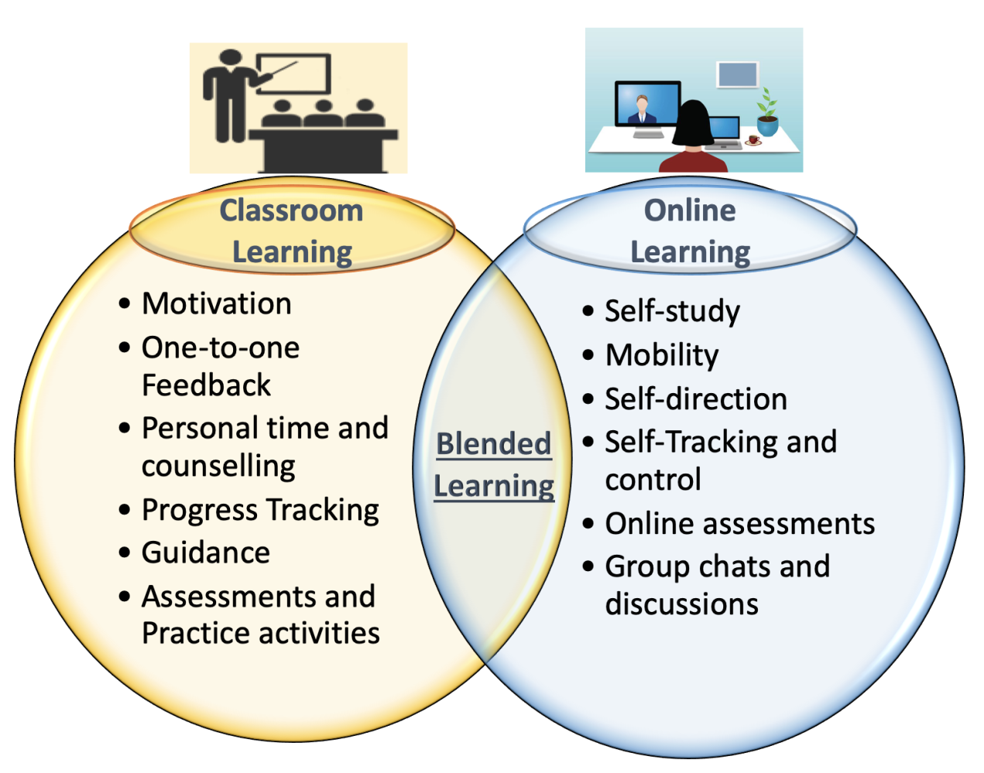
Blended learning combines of two learning approaches . (Online, website: https://designinginstructionwithk.com)

3.2 ADVANTAGES OF BLENDED LEARNING

Audience based teaching and ease of learning:
Every classroom is unique and may require different approaches to teach the same subject. For example, different video or audio tapes can be made or different tools can be utilised for different classrooms depending on their knowledge and understanding of the subject.

Well engaged student base:
Blended learning can be quite engaging due to its innovative nature. A Higher student engagement can be achieved through a balanced approach to blended learning. (Sahni, 2019, pp.1-14)

Provides more flexibility and independence to students:
While blended learning does have a classroom-based element attached to it, nevertheless it also allows a lot more flexibility and freedom to students. It allows the students to have more control over when to study, where to study, and at what pace they want to study. They can access their study materials as and when they need it and study in their own convenience.

3.4 DISADVANTAGES OF BLENDED LEARNING

Skills set required:
Students require reasonable IT skill set to adapt to the blended learning model. However not every student is as equipped as required by the blended Learning model in every batch. This lack of IT knowledge could become a barrier for some.

Level of focus required:
Some students require more attention than others and some also requires more motivations than others. Some element of Blended learning is designed and structured in such a way that students need to be self-motivated to complete those modules themselves on their own accord and own time. In online settings this can be challenging.

Accessibility to technology:
Technology can be expensive and not every student will be able to afford Laptop, computer, internet connection and any other devices necessary to do the coursework. Also, technology is well and good when they are functional, however, sometimes dysfunctional, or non-compatible technology can bring everything to standstill.

EVALUATION OF BOTH FORMS OF TEACHING AND LEARNING IN THE PAST AND PRESENT

Reading through different books and literatures, it would be safe to say that there is no single evaluation method that will fit for every purpose. However, as most literature suggests, to begin with, it is fundamental to consider the Purpose, who is involved, how and when will it take place, what is being evaluated. (Pombo and Moreira, 2012, pp.201–211), (Walmsley, 2004), (Walker and Beats,2008), (Ugur, Akkoyunlu and Kurbanoglu, 2011, pp.5-23).
Examples below outlines/summarises the outcome of some of the comparative studies completed by Scholars in different fields, on both blended and classroom-based teaching and learning, in past and present. In my discussion hence forth, past refers to year up until 2017 and present refers to year 2018 to present date.

The past Studies (until year 2017)

- In 2011 Lopez-Perez, M.V., Perez- Lopez, M.C. and Rodriguez-Ariza, L (2011) conducted a study on 1431 students. He has divided them in 17 groups for the purpose. It is observed that students who has participated in BL settings achieved better marks and their dropout rates were much lower. (Lopez-Perez, Perez-Lopez, and Rodriguez, 2011, pp.818-826)

- Smyth et al. (2012) conducted a study on Postgraduate 1st year nursing and midwifery student in Ireland. Study highlighted that while the students enjoyed the benefits of accessibility and flexibility of the blended learning over classroom-based study, the students also came across challenges like poor social interaction, poor internet connection to utilize the blended system. However, the overall feelings of the participants remain positive in blended learning. (Smyth et al. 2012, pp.464-468)

- Another report published in 2017 by Vo, Zhu, and Diep, 2017 confirms that the performance of STEM-disciplined student has significantly improved due to the implementation of Blended Learning method. (Vo, Zhu, and Diep, 2017, pp.17-28)

Recent studies (from year 2018 to present date):

In recent years the Covid 19 pandemic has force blended the blended learning into the lives of millions of students across the globe. As the classroom-based setting became difficult if not impossible students throughout the globe forced to use some form of e-learning in one way or another. More and more research has been focusing on which learning method can facilitate more learners and teachers to access education. In fact, more and more studies are being carried out on how to improve the blended learning experience and its quality rather than investigating or assessing the suitability of blended learning in higher educations.

- In their recent publication in 2018, Dziuban et al, 2018, has discussed in detail about effectiveness of learning methods. They have found that BL either increases or at least maintains the access for majority of the groups under experiment. (Dziuban et al. 2018, pp.1-16)

- Report published by Zhang, et al., 2020 shows that Blended learning has significant impact on inclusivity too. This study conducted on 11000 participants aged between 16 and 70. The study concluded that blended learning is more effective comparing with traditional classroom model for inclusive education. (Zhang et al, 2020)

- Blended learning is also becoming a very essential part for the tutor’s day to day life. More and more of the tutors are using Blended method to teach their students. This year a report published in journal of Educational Technology Systems by Saboowala, R. and Manghirmalani Mishra, P., 2021 has given the opinion that blended Learning method is an effective learning strategy and as the technology advances it will open opportunity for teachers from different educational field to connect with the world. (Saboowala and Manghirmalani, 2021, pp.9-23)

Blended Learning in my own experience:

Until getting admitted to this course, I only had experience of classroom-based study. I have found that my university has designed this course using the blended learning.
Blended learning gave me great flexibility in terms of place where will I be when I attend the lecture. I am a mother and I have a family. There were times when I was not able to attend my class physically. Thanks to blended learning, I have not missed a single lecture. I have attended those lectures seamlessly through internet.
Blended Learning helped me through the unprecedented situations. Sometimes due to adverse weather condition (e.g., snow and road blockage) I was not able to travel to my fixed classroom location. On those occasions my tutor has given me online code to attend the classes online and I was able to attend the classes as if I were in the classroom settings.
It also helped me to manage my pace of study too. The materials are designed in such a way that I was able to work on them whenever and wherever I wanted to.
For me, in short, Blended Learning given me the perfect opportunity, to balance work, study, and personal life, that I would not get from classroom-based learning alone.

Conclusion
Considering all the above mentioned, it would be safe to say that every report or book written has given its different opinion about both Blended learning and Classroom learning whether it be the impact, experience, achievement, the suitability, or the future trend. However, for each report the purpose, who was involved, how and when the event took place and what was being evaluated were different.
Most study conducted around student Satisfaction and engagement found a common theme. Student Satisfaction and student engagement were significantly higher in Blended learning set up comparing with the Classroom Based Learning. There is no common theme of any relationship between Blended learning and poor achievement if not greater achievement.

Recommendation
After studying all these literatures referenced in this report and from my personal experience that I have gained through my own course participation, I firmly believe that Blended learning has a great potential to become one of the most successful teaching and learning method. Blended learning can combine the best of both worlds, the flexibility of learning in own pace and space, self-drive, self-direction from Blended learning and face to face interaction with both teacher and fellow students from Classroom-based learning.

References:
Akuma, F.V. and Callaghan, R. (2019) Teaching practices linked to the implementation of inquiry-based practical work in certain science classroom: Journal of research in science teaching, 56(1), pp.64-90. [Assessed 15 Nov 2021].
Alan, S.et al. (2004) Social Skills Training for Schizophrenia (2nd edition): The Guilford Press. [Assessed 13 Nov 2021].
Campbell, L. (2004) What does the “e” stand for? (Report). Melbourne: Department of Science and Mathematics Education. The University of Melbourne. [Assessed 10 Nov 2021].
Dziuban, C. et al. (2018) Blended learning the new normal and emerging technologies: International journal of educational technology in Higher education. 15(1), pp.1-16 [Assessed 23 Nov 2021].
Jun, L. and Ling, Z. (2011) August. Improving flexibility of teaching and learning with blended learning. A case study analysis: In International Conference on Hybrid Learning, pp.251-261. Springer, Berlin, Heidelberg. [Assessed 15 Nov 2021].
Lopez-Perez, M.V., Perez-Lopez, M.C., and Rodriguez-Ariza, L. (2011) Blended learning in higher education: Student’s perceptions and their relation to outcomes. Computers & education, 56(3), pp.818-826. [Assessed 20 Nov 2021].
Nicholson, P. (2007). A history of e-learning: In Computers and education, pp.1-11. Springer, Dordrecht. [Assessed 10 Nov 2021].
Online website: https://designinginstructionwithk.com/2019/06/23/blended-learning-why-it-is-the best-learning-approach/ [Assessed 23 Nov 2021].
Pombo, L, and Moreira, A. (2012). Evaluation Framework for Blended Learning Courses: A puzzle piece for the Evaluation process. Contemporary Educational Technology, 3(3), pp201-211. [Assessed 20 Nov 2021].
Saboowala, R. and Manghirmalani, Mishra, p. (2021) Readiness of in-service teachers toward a blended learning approach as a learning pedagogy in the post- COVID-19 Era: journal of Educational Technology Systems, 50(1), pp.9-23. [Assessed 23 Nov 2021].
Sahni, J. (2019) Does blended learning enhance student engagement? Evidence from higher education: Journal of E-learning and Higher Education, pp. 1-14 [Assessed 18 Nov 2021].
Sharma, S. and Garg, S. (2016) Web based learning: A research on assessing its effectiveness in contrast to traditional classroom learning environment. In 2016 International Conference on Computational Techniques in Information and Communication Technologies (ICCTICT), pp.32-34. IEEE. [Assessed 13 Nov 2021].
Singh, H. (2021) Building effective blended learning programs. In Challenges and Opportunities for the Global Implementation of E-Learning Frameworks, pp.15-23. IGI Global. [Assessed 10 Nov 2021].
Smyth, S. et al. (2012) Students’ experiences of blended learning across a range of postgraduate programmes: Nurse education today, 32(4), pp.464-468. [Assessed 23 Nov 2021].
Snart, J.A. (2010) Hybrid Learning: The Perils and Promise of Blending Online and Face-to Face Instruction in Higher Education: The Perils and Promise of Blending Online and Face- to-Face Instruction in Higher Education. ABC-CLIO. [Assessed 18 Nov 2021].
Tanner, L.N. (1978) Classroom Discipline for Effective Teaching and Learning. [Assessed 15 Nov 2021].
Tosun, S. (2015) The effects of blended learning on EFL student’ vocabulary enhancement: procedia-Social and Bahavioral Sciences, 199, pp.641-647. [Assessed 23 Nov 2021].
Ugur, B. Akkoyunlu, B., &Kurbanoglu, S. (2011) Students’ opinions on blended learning and its implementation in terms of their learning styles: Education and Information Technologies, 16, pp.5-23. [Assessed 20 Nov 2021].
Vo, H.M., Zhu, C. and Diep, N.A. (2017) The effect of blended learning on student performance at course-level in higher education: A meta-analysis: Studies in Educational Evaluation, 53, pp.17-28 [Assessed 23 Nov 2021].
Walker, R. & Beats, W. (2008) Instructional design for class-based and computer-mediated learning: Creating the right blend for student-centred learning. In R. Donnelly & F. McSweeney (Eds), Applied e-learning and e-teaching in higher education, information society reference. New York: Hersey. [Assessed 20 Nov 2021].
Walmsley, L. (2004) How quality assurance can learn from distributed learning. Learning and Teaching in Action, 3(2). [Assessed 20 Nov 2021].
Zhang, Y. et al. (2020) Blended Learning Environments in Inclusive Education at the University: International Journal of Emerging Technologies in Learning (I JET), 15(21), pp.145-161. [Assessed 23 Nov 2021].

