2218482 Michael Leather
Exploring Humanities – Assignment 2.
Task.
To Individually select a text or image and critically analyse it, considering the Items Context, content and the wider historical and/or socio-cultural significance in 1000 words.

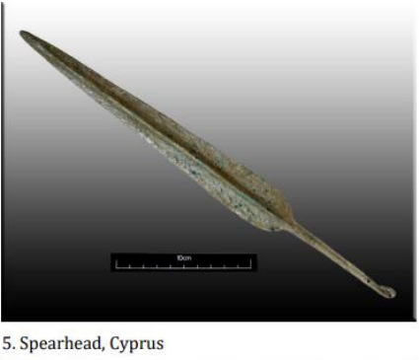
Fig 1.
The Artifact
I have chosen the image of the Bronze age Cypriot spear head, although a diagram elsewhere with a similar shape describes it as a dagger, although both daggers and spears heads could have been formed in the same way, just different sizes.¹ It is Bronze age (2300 – 700 BCE)² because of the colouring within the artifact. The green patina indicates the presence of copper and because this hue is not all over, indicates that there is the presence of other substances, (Tin being an obvious one as it makes up 10 to 12% of the formation of Bronze. Cypriot because Cyprus was famous in antiquity for its copper resources. In fact, the very word copper is derived from the Greek name for the island, Kupros.³
The design of the spear head can be described as a large ovate blade with a midrib running along the centre of it. It has a short tail (Tang) with a button at the end of it, (seen more prominent in fig 2.).

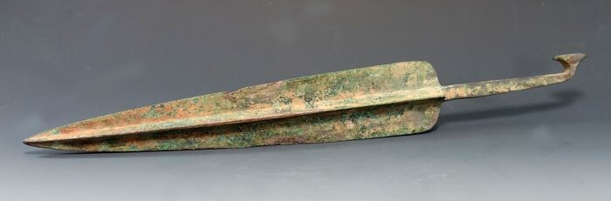
Fig 2.

The button helps to secure the spear head into the shaft which is done by splitting a shaft, sliding the tang in with some cutlers resin, (A wax with sawdust, crushed charcoal and/or animal dung back in the Bronze age) and then wrapping the shaft with rawhide/leather/sinue to secure the head within.⁴ It is my hypothesis that the spearhead was cast, rather than handmade due to the uniformity of the shape. I further speculate that the cast was 2 part cast which when both parts were put together and sealed, left the opening to the mould through which the molten liquid was poured and subsequently resulted in the formation of the button at the neck of the cast when it solidified. It would explain the splayed shape on the button in Fig 2. The artifact is asexual in its use as there is no evidence to support it in male dominated usage.
This particular design I believe falls in the early to middle era of the Cypriot bronze age, (Fig 4). because later spear heads developed a socket fixing to the spear shaft as shown in Fig 3.
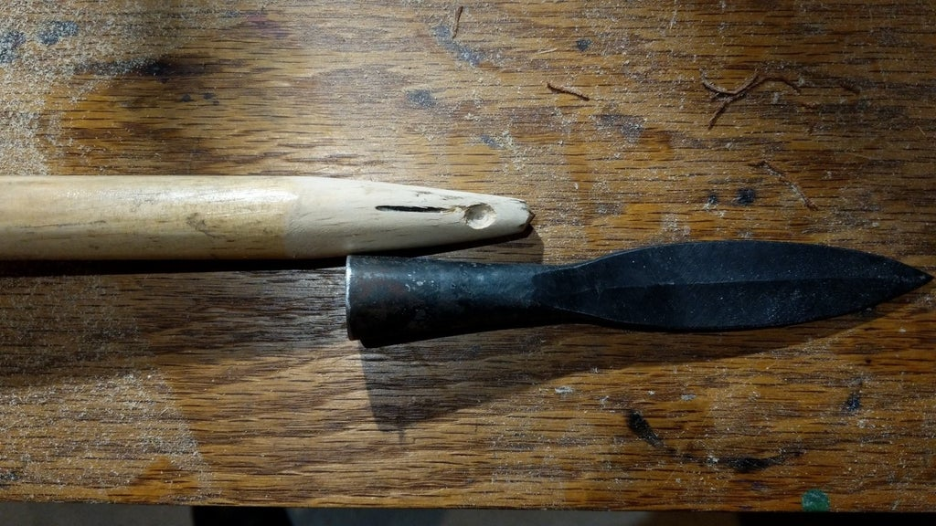
Fig 3.
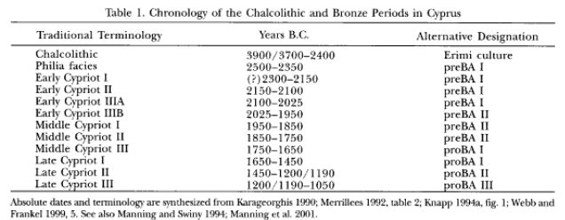
Fig.4

The design of the spear head is also not one for throwing as the balance with any kind of shaft attached is not conducive to a controlled flight. This would have demanded a much smaller, shorter head. This is more of a thrusting spear, more than likely used for hunting and protection, rather than battle, as there is no indication that there was any conflict on the island during this period. These spearheads were found in tombs rather than settlements as they rare intact whereas any found in settlements would have had damage because on becoming so, they would have been discarded or remelted.
It is likely that the tomb it was excavated from was from that of a person from the more prominent classes on Cyprus as the cost of this artifact in bronze would have made it cost prohibitive to the general masses.

Socio-Economic and Cultural Impact

In looking into the socio–cultural aspects surrounding the spear heads production, I have looked further afield to an article that shows an illustration of same shaped artifacts found in tombs along the Euphrates Valley in the early 3rd Millenium.⁵ With this in mind and the fact that there is little archaeological evidence in Cyprus to support the existence of settlements during the early neolithic period⁶ , it is likely that migrant settlers occupied the island from Anatolia and the surrounding areas as there is evidence that they were in contact. This is supported by the material records from the mid to late 3rd Millennium.⁷ It is also worthy of note that as Syria, or part of Asia Minor as it was known then, was the source of tin from areas called Ashur and Mari. So, with the migration of settlers west along the Euphrates valley, because of weak floods and famine ⁸, into Syria, and with the knowledge to already produce bronze, and because of the strategic and geographical location of Cyprus with its known deposits of copper, (This would have been made evident during the copper age with travellers carrying their trinkets etc,), made migration to and the settlement onto Cyprus inevitable.

This transformed the Islands fortunes as
“ There was a massive increase in the population and expansion of settlement into new, previously unoccupied areas […]. Alongside this there is evidence for increasingly complex hierarchical settlement pattern, culminating in the rise of urban complexes along the southern coast by the 13th Century BCE. During the LBA, (Late Bronze Age), […] the island was a nexus of wide-ranging international trade networks around the eastern basin of the Mediterranean incorporating Egypt, Syro - Palestine and the Aegean. The Cypriot role in this trade appears to have been based upon increased exploitation of the island’s copper resources. The copper trade allowed for the emergence of an economic and possible political elite, which controlled access to luxury imports and prestige goods.

Although the LC, (Late Cypriot), period remains one of the more intensively researched aspects of the Cypriot prehistory, in particular the metal trade and evidence for foreign relations especially with the Aegean, numerous issues remain unresolved. ”.
Steel, Louise, 2014, pp 149-150

Bibliography
- Louise Steel, 2004, Cyprus Before History, Illustration 5.7 p 137. Duckworth Press,
- https://www.britannica.com/topic/history-of-Europe/The-Metal-Ages Accessed 26 Sept 2022
- https://www.metmuseum.org/toah/hd/cyco/hd_cyco.htm Accessed 26 Sept 2022
- https://www.bladesmithsforum.com/index.php?/topic/35370-socketed-spear-heads-vs-tang-spear-heads Accessed 27 Sept 2022
- Pelternberg, Edar., 2013, Journal of Near Eastern Studies, “Conflict and Exclusivity in Early Bronze Age Societies in Middle Euphrates Valley”, Vol 72 (2), P233-252, fig 4.
University of Chicago Press,
- https://www.metmuseum.org/art/collection/search/244162 Accessed 28 Sept 2022
- Knapp, A Bernard, 2013, The Archaeology of Cyprus, p264, Cambridge University Press.
- Liverani, Mario., 2014, The Ancient Near East. History Society and Economy, p173, Routledge.
Illustrations
Fig 1. Available from Assignment 2 PDF Week 2 Ancient Civilizations Sept 2022
Fig 2. Available at Auction House https://www.lot-art.com/auction-lots/
Fig 3. Available at, https://www.instructables.com/Spear-Head-Mounting/
Fig 4. Available at American Journal of Archaeology, “Death, Prestige & Copper in the Bronze Age Cyprus”, Vol 109, No 3(July 2005) pp341 - 401

