
APPENDIX GA36d

LEVEL 7 ASSESSMENT SPECIFICATION
Student name: | Albert YS CHIU | Student ID number: | 2235236
Programme: | DBA
Module: | Quantitative Research Methods
Module code: | HKBM7004 | Contribution to Overall Module Assessment (%): | 100%
Lecturer: | Dr Andrew Chan | Internal Verifier: | Dr Chammy Lau
Assignment Title: | Project Report | Word count (or equivalent): | 7500 words  (+/-10%)
Submission deadline: | 27 December 2023 | Return date of provisional marks & written feedback: | 17 January 2024
Submission method: | All written assessments, where practical and possible, must be submitted via Turnitin unless otherwise instructed by the Lecturer. (Please DO NOT put this assessment specification into Turnitin or it will match many similarities with other students’ submissions.)  Alternative submission method (if applicable):  Late submission of the assessment will result in a late penalty mark. Penalties for late submission: Up to one week late, maximum mark of 50%. Over one week late, 0%. Only the Extenuating Circumstances Panel may approve a change to submission dates.
Academic honesty / referencing: | Academic honesty is required. In the main body of your submission, you must give credit to authors on whose research and ideas your work is based. Append to your submission a reference list that indicates the books, articles, etc. that you have used, cited or quoted in order to complete this assessment.

Table of Content
1. Introduction 3
1.1 Background 3
1.2 Research Aims and Objectives 4
1.3 Contributions 5
2. Literature Review 5
2.1 Development of InsurTech 6
2.2 Insurance Mortality Protection Gap 7
2.3 The Use of InsurTech Insurance to Narrow the Mortality Protection Gap 10
2.4 Theoretical Background 11
3. Analytical Framework and Hypotheses 13
3.1 Conceptual Framework 13
3.2 Hypothesis 14
4. Methodology 15
4.1 Survey Instrument and Expert Review 15
4.2 Data Collection and Sampling Technique 16
5. Result and Discussion 17
5.1 Descriptive Statistic 17
5.2 Inferential Statistics 20
6. Conclusion 24
6.1 Limitations 24
6.2 Importance of Narrowing the Huge Protection Gap 25
6.3 Use InsurTech form Virtual Insurers to Address the Protection Gap 26
References: 28
Appendix A – Survey Questionnaire 32

1. Introduction

Title: Can Online Insurance Improve the Insurance Mortality Protection Gap ? – A Case Study for Hong Kong Virtual Insurers.

1.1 Background

Life insurance is specifically designed to offer financial assistance to dependents or beneficiaries in the unfortunate event of the policyholder's unexpected demise. The Insurance Mortality Protection Gap (MPG) serves as a metric that quantifies the disparity between the desired amount of insurance coverage and the actual coverage held by individuals. Typically, the evaluation of insurance MPG is performed at a national or regional level, providing an indication of the extent of under-insurance within a population.

Several reputable organizations, such as the Geneva Association, the Swiss Re Institute, the Insurance Authority and the World Bank Group have released reports indicating a widening MPG in recent times. In particular, the insurance regulator in Hong Kong, the Insurance Authority, issued its inaugural report titled "Mortality Protection Gap Study 2021". The report indicated the total MPG of Hong Kong in 2019 reached HKD 6.9 trillion, this translates into individual MPG of HKD 1.9 million per working adult in Hong Kong, or 5.7 times their average annual income. The report recommended Hong Kong citizen to review their insurance coverage regularly to reassess their MPG due to different financial needs and changes in life stages.

The term "InsurTech" pertains to the use of advance technology in the insurance sector. Previous studies have indicated that InsurTech is revolutionizing the insurance industry by enhancing the insurance product distribution, faster and better customer experience. In Hong Kong, insurance companies that adopt InsurTech and exclusively distribute their insurance products online would be licensed as "Virtual Insurers". There are currently four licensed Virtual Insurers in Hong Kong since 2019.

Existing research primarily centers on explaining the factors contributing to wider Insurance MPG and proposing potential remedies to bridge the gap. Numerous quantitative studies have quantified the magnitude and trajectory of the Insurance MPG, examining its manifestations in specific regions like Korea, Japan, the US, Finland, Malaysia, Singapore and Turkey. Additionally, there are researches dedicated to exploring the evolution of InsurTech and development over the past two decades and its transformative impact on the insurance industry.

There has been limited researches examine the correlation between Insurance MPG and InsurTech. Various reviews from esteemed institutions such as the World Bank and insurance regulators concur that InsurTech can serve as an possible low-cost solution for reducing the Insurance MPG. A real case example in China explores the impact of InsurTech on micro-insurance, providing evidence of its potential to address the Insurance MPG.

1.2 Research Aims and Objectives

Limited research has been conducted to investigate the impact of establishment of Virtual Insurers on the insurance MPG of Hong Kong citizens. This project intents to get a better understanding on the following research questions:

- Does Hong Kong consumers understanding their own Insurance MPG?
- As the adoption of InsurTech increases, what are the factors influence Hong Kong consumers when purchasing insurance through online InsurTech platform? Do consumers prefer a self-service online process or guidance from insurance intermediaries?
- How Hong Kong consumers’ decision to purchase life insurance policy through on-line platform in addressing their insurance MPG?

The adoption of InsurTech by Virtual Insurers allows Hong Kong consumers to purchase life insurance through online platform. This quantitative research project would review how this new emerging distribution channel influences the insurance MPG in Hong Kong. It also aims to provide insights into the perceptions of InsurTech among Hong Kong citizens and evaluation how this may narrow their insurance MPG.

This quantitative research project develops a survey instrument to collect 48 usable samples through convenience sampling. The participants are invited to complete a questionnaire with 28 questions covering (a) attitude towards life insurance sales process; (b) perceived ease of use to buy insurance online; (c) perceived usefulness (price consciousness); (d) trust (acceptance of perceived risks) on online insurance platform; and (e) awareness of their insurance MPG.

1.3 Contributions

The findings of this project demonstrate that the adoption of InsurTech has a beneficial effect on reducing the insurance MPG by enhancing the availability and affordability of insurance products, and better customer experience during the sales journey. These research findings offer valuable insights for insurers, InsurTech companies, government officials and regulators, and researchers who are interested in addressing the issues related to insufficient insurance coverage and improving the efficacy of life insurance policies. The project provides conclusions on some practical implications and outlining potential avenues for future research.

2. Literature Review

In the long history, insurance plays a vital role in securing financial stability and safeguarding individuals and their families. InsurTech is a word emerged from "insurance" and "technology", it refers to the utilization of new innovative technology, such as Internet of Things (IoT), online/mobile applications, blockchain, artificial intelligence (AI), machine learning, and big data analytics, etc. to transform the insurance industry (Chang, 2023). InsurTech can to improve the insurance operation processes and provide better customer satisfaction (Chang, 2023; Stoeckli et al., 2018). In particular, it accomplished by streamlining workflow, lowering operational costs, enhancing customer experience, developing new business models, reducing insurance premium, driving new products innovations, exploring unreached markets and insurance needs.

2.1 The Development of InsurTech

InsurTech was started in early 2000s when internal and online insurance platforms caught extensive media attention. Initially, these platforms only provided customers with insurance quotes, but the functions expanded gradually which included comparison of different insurance quotes, able to buy policies and submit claims online, allow customer to review their insurance policy information online and make changes on their policy through designated insurance platform.

InsurTech can transform the insurance industry by addressing customer needs, enhancing efficiency and lowering operational costs. Traditional insurance companies have recognized the benefits of incorporating technology into their operations and use it to provide better customer service. InsurTech has a potential to reforming the insurance market (Agarwal et al., 2022) through new insurance product distribution and improving the customer satisfaction in the sales journey or claim processes. Insurance companies is utilizing digital channels, IoT devices, AI, smart contract and big data analytics to perform real-time risk assessment and offer personalize insurance products to their customers. This simplifies the insurance underwriting process and provides quicker turnaround time and offers better customer experience. As the insurance industry evolves and customer expectations change, InsurTech undoubtedly can deliver greater value to consumers.

In addition, insurance regulators no longer use reactive manual inspections, they have transited to proactive monitoring or supervision technology using open market big data. To adapt to technological progress in the insurance sector, regulators frequently create regulatory sandboxes and other InsurTech platforms that encourage innovation, which enable further development on different InsurTech in insurance value chain.

In 2019, the insurance regulator in Hong Kong introduced the concept of "Virtual Insurers". These entities operate under a unique regulatory license, requiring them to utilize InsurTech and exclusively distribute and market its insurance products online with no support from insurance intermediaries.

2.2 Insurance Mortality Protection Gap

For Life insurance, the Mortality Protection Gap (MPG) is the difference between the recommended level of life insurance coverage and the actual amount an individual is being covered. (Klein, 2020; Swiss Re, 2020). In other words, MPG measures how much a person is "under-insurance" or insufficient financial protection to dependents or beneficiaries against the risk of unexpected events (Premkumar, 2022; Insurance Authority, 2021).

The insurance benefits should be adequate to support the on-going financial needs of the family and settle any outstanding debts (Swiss Re, 2020).

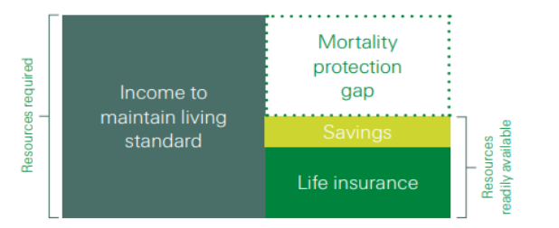
Figure 1: Graphical illustration of Insurance Mortality Protection Gap (Swiss Re, 2015)

MPG is typically measured at a national or regional level to gauge the extent of uninsured portion within a jurisdiction / population. This measure offers valuable information to policymakers, regulators, market practitioners and researchers on risk exposure and identifies any need for government’s support to address the issue.

There are four key business reports issued by esteemed organizations on the measurement of MPG, these publication provide significant insights on the evolving trend of MPG globally, in Asia markets as well as in Hong Kong.

The International insurance think tank, the Geneva Association, is specialized in insurance and risk management. It released a report titled "Understanding and Addressing Global Insurance Protection Gaps" in 2018 (The Geneva Association, 2018). The report examines the underlying factors of MPG and analysed the MPG in different jurisdictions using GPD levels, which represents various stages of economic growth. It provides some possible insights and solutions to insurers, government officials and regulators, but also presents potential business opportunities arising from MPG.

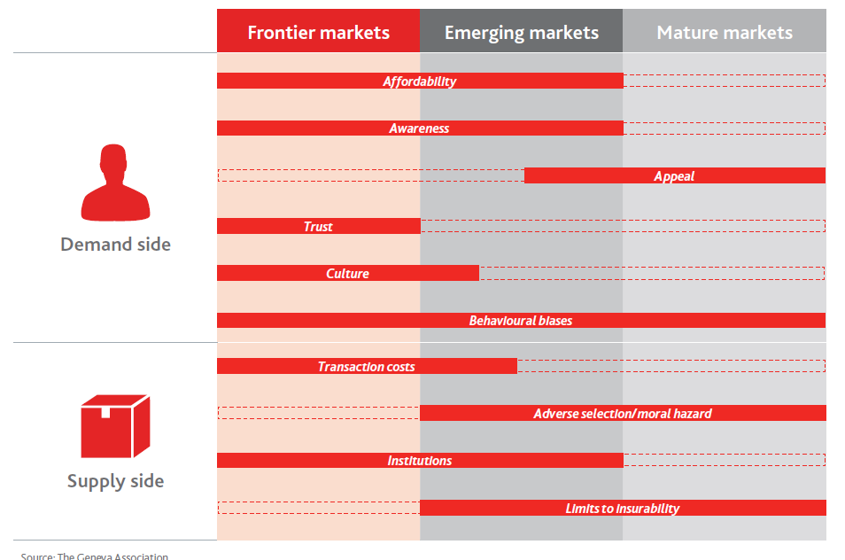
Figure 2: The Challenges Faced by Different Markets on Insurance Protection Gaps (The Geneva Association, 2018)

The International Finance Corporation (IFC)is a member of the World Bank Group, it published a paper in 2019 titled "How Insurtech Can Address the Underinsurance Challenge in Emerging Markets" (Holliday, 2019). The publication highlights the exponential growth of the InsurTech sector, which led to disruption of the conventional insurance industry and created new opportunities in developing counties where the insurance penetration is low and the MPG is huge.

The Swiss Re Institute is a research arm of a global reinsurance company. It published a report titled "Closing Asia's Mortality Protection Gap" (Swiss Re, 2020) in 2020, which highlighted the vulnerability of Asia to negative occurrences such as fatalities, health emergencies, and environmental calamities. It estimated the Asia-Pacific region has a MPG of USD 83 trillion in 2019, which has doubled since 2010 with USD 42 trillion. The MPG is increasing with 4% in Asia per year. However, the arising of MPG presents significant business opportunities in Asia, which may generate a demand for extra life insurance premiums of USD 292 billion annually. It is reconsidered as a comprehensive review on preferences and attitudes of Asian region consumers in related to their MPG. The report covered over 14,000 consumers and 10 making in the region. The data in the report provide good source for tracking the trend of MPG.

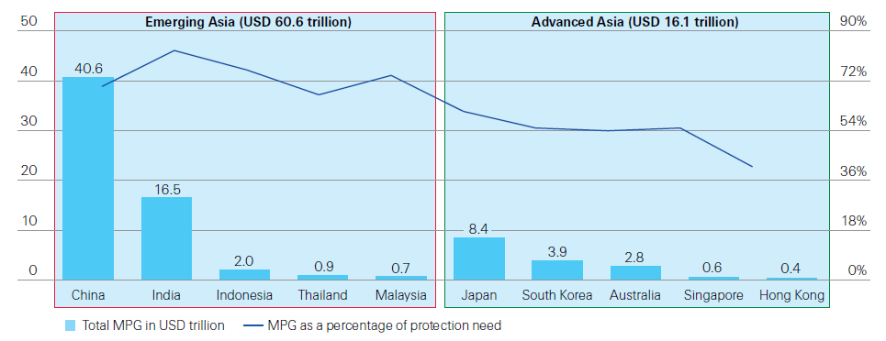
Figure 3: The Mortality Protection Gap by Markets in Asia
(Swiss Re, 2022)

The insurance regulator of Hong Kong released its inaugural report titled "Mortality Protection Gap Study 2021" (Insurance Authority, 2021) in 2021. The report estimated the MPG in Hong Kong is roughly HKD 6.9 trillion in 2019, which translated to MPG of HKD 1.9 million for each employed adult, this was about 5.7 times of their average annual income. The report urges the citizen of Hong Kong to assess their MPG and insurance needs regularly due to the different stage of life and financial circumstances.
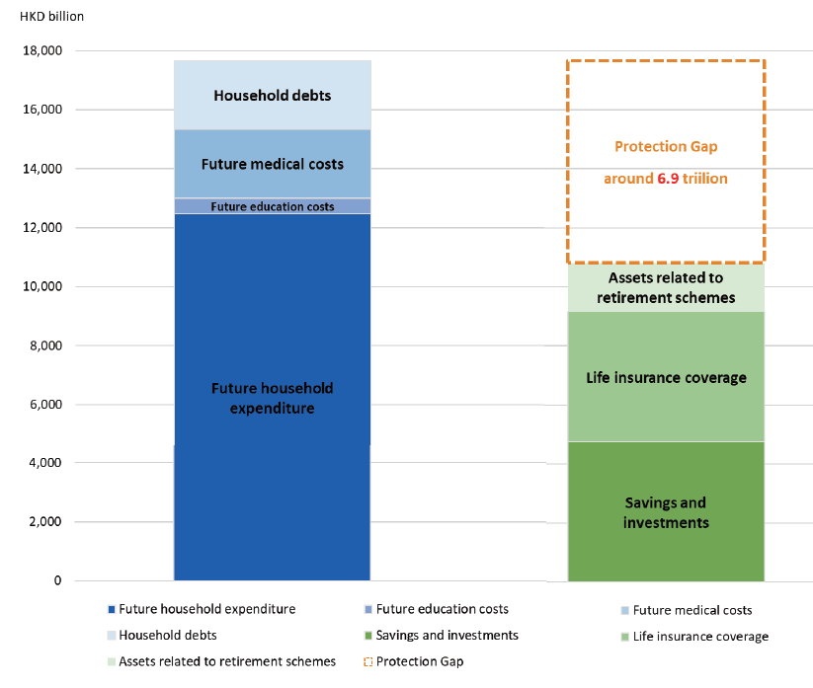
Figure 4: Protection Gap identified in Mortality Protection Gap Study
(Insurance Authority, 2021)

2.3 The Use of InsurTech Insurance to Narrow the Mortality Protection Gap

The World Bank conducted a case study in China, which highlighted the successful reduction of MPG through the implementation of micro-insurance sold via InsurTech (Holliday, 2019). A separate example emphasized that the adoption of InsurTech in analytics of data can enhance the underwriting and claims processes (Rozar, 2017). Furthermore, InsurTech can enhance various processes such as product pricing, marketing and sales, and distribution (Bruce et al., 2018), it also improves customer satisfaction and process optimization (Pillay, 2018).

There are many quantitative research on development of Insurance MPG in the United States (Rutledge, 2018; Romero, 2016), Asia (Swiss Re, 2020), Korea & Japan (Jung et al., 2020), Pakistan (Khan et al., 2022), India (Premkumar, 2022), Hong Kong (Insurance Authority, 2021) and Finland (Ropponen et al., 2023). Researchers have made suggestions on various strategies to manage the MPG and attract more consumers to purchase insurance policies by offering value-added services (Klein, 2020). Cheaper insurance premium benefit from InsurTech (Holliday, 2019) and offer tax incentives or penalties for underinsurance (The Geneva Association, 2018) are additional strategies. Building consumer trust and confidence in insurance is crucial (The Geneva Association, 2018; Holliday, 2019; Klein, 2020), enhancing financial literacy among individuals (Klein, 2020; Dalkilic & Kirkbesoglu, 2015; Mahdzan & Victorian, 2013), employing behavioral economics principles to encourage individuals to pay attention to their MPG (The Geneva Association, 2018; Addis, 2014; Thaler & Sunstein, 2008), offering affordable and flexible product to different demographic groups (The Geneva Association, 2018; Holliday, 2019) are some of the actions. InsurTech can play a big role to support all these initiatives to narrow the MPG.

2.4 Theoretical Background

In order to comprehend the impact of InsurTech on MPG, it is crucial to analyze pertinent theories, concepts and prior researches. Previous studies indicate that the adoption of cutting-edge technologies can bolster effectiveness, decrease expenses, enhance the precision of risk assessment, and provide customized products that cater to individual requirements (Bacinello et al., 2019).

Previous research has demonstrated that consumer adoption of online insurance is influenced by factors such as consumer perception, trust, and attitudes. Many studies have utilized Theory of Planned Behavior (TPB) or Technology Acceptance Model (TAM) to explore the impact of these factors.

TPB is an extension of the Theory of Reasoned Action (TRA), it a social psychological theory that seeks to explain and predict human behavior by taking into account an individual's intentions, attitudes, beliefs, and perceived control over their actions (Conner & Armitage, 1998; Brahmana et al., 2018). This theory can be applied to understand how individuals' behaviors and decision-making change when they choose to purchase insurance through online platforms instead of traditional insurance intermediary sales channels (Klein, 2020). A key limitation of TPB is that it assumes individuals are rational and make deliberate decisions based on available information, thereby disregarding unconscious motives. In addition, TPB fails to account for factors like demographic variables and personality. The assumption of TPB that perceived behavioral control consistently predicts actual behavioral control, which may not always hold true (Marangunić & Granić, 2018).

Regarding TAM, it is a theoretical framework that seeks to explain and predict the acceptance and adoption of new technologies by individuals or organizations. TAM has transformed into a significant framework in understanding the factors that influence human behavior in terms of accepting or rejecting a technology (Marangunić & Granić, 2018). TAM suggests that an individual's intention to use a technology is primarily influenced by three key factors: perceived usefulness, perceived ease of use and attitude towards using it (Davis, 1985).
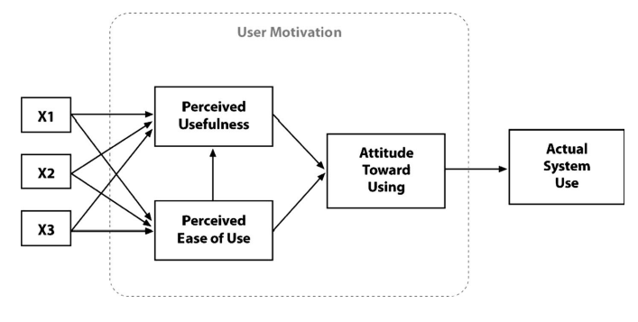
Figure 5: Technology acceptance model (Davis, 1985)

Perceived usefulness refers to an individual's belief that using a particular technology will enhance their performance or productivity in achieving specific goals. If a person believes that a technology will be beneficial and provide value in fulfilling their needs, they are more likely to have a positive attitude towards using it. Perceived ease of use refers to an individual's perception of how effortless or convenient it is to use a technology. Factors such as user-friendliness, simplicity, and clarity of instructions contribute to the perceived ease of use. If a technology is perceived as easy to use, individuals are more likely to develop a positive attitude towards adopting it. These two factors directly influence an individual's attitude towards using a technology, which affects their intention to adopt and use it (Sharp, 2007; Marangunić & Granić, 2018). In both frameworks, TPA and TAM, the intention of consumers to engage in online insurance is considered as a precursor to actual adoption. Various factors that affect the adoption of online insurance are examined within this underlying mechanism, investigating their role in shaping behavioral intentions.
In addition, consumers' intention to adopt online insurance is positively impacted by their trust in the insurance product, the service provided, and the company offering the insurance (Lim et al, 2009). Trust plays a crucial role in influencing customer satisfaction in financial services, particularly in the context of online insurance services. Technology can address customers' trust-related expectations by ensuring security and system integrity (Balasubramanian et al, 2003; Khare et al, 2012), which enhance the intention of the consumers to use the online insurance service.

Existing studies have provided a conceptual understanding of consumers' adoption of online insurance, predominantly focusing on behavioral intention. While the Virtual Insurers were established in 2019 in Hong Kong, and there is a growing trend on on-line life insurance transactions, it remains a huge MPG as reported by the Insurance Authority in Hong Kong. The current literature did not provide any information regarding the impact of the establishment of Virtual Insurers on the size of MPG in Hong Kong. Thus, this project aims to extend previous research by reviewing the factors influencing Hong Kong consumers to purchase online life insurance product offered by Virtual Insurers, and how this may change the MPG in Hong Kong insurance market.

3. Analytical Framework and Hypotheses

3.1 Conceptual Framework

The conceptual model employed in this project is illustrated in Figure 6. The model focuses one dependent variable associated with the adoption of online insurance which affect the consumer decision to buy insurance online. The analysis examines five individual traits (a) attitude; (b) perceived ease of use; (c) perceived usefulness (price consciousness); (d) trust (acceptance of perceived risks); and (e) awareness of their insurance MPG, which influence the decision the consumers adopt. Additionally, the analysis controls for the impact of four consumer demographic variables: sex, age, income and education.

The proposed conceptual framework suggests that online insurance adoption (through the establishment of Virtual Insurers in Hong Kong) is expected to have an impact on narrowing the insurance MPG. This relationship may be mediated by consumer behavior and their acceptance to technology platform.
Hong Kong Consumers

Attitude Toward Life Insurance Sales Process

Perceived Ease of Use of Insurance Online Platform

Perceived Usefulness (Price Consciousness)

Trust (Acceptance of Perceived Risks)

Awareness of insurance MPG

Decision to Purchase Life Insurance online, which can Narrow Mortality Protection Gap
Virtual Insurer/ Insurance (Use of InsurTech)

Figure 6: Proposed Conceptual Framework between Use of InsurTech and Mortality Protection Gap in Hong Kong

3.2 Hypothesis

- Hypothesis 1 (H1) : | Attitude Toward life Insurance sales process has a positive influence to the decision of purchase life insurance online.
- Hypothesis (H2) : | Perceived ease of use of insurance online platform has a positive influence to the decision of purchase life insurance online.
- Hypothesis (H3) : | Perceived Usefulness has a positive influence to the decision of purchase life insurance online.
- Hypothesis (H4) : | Trust (Acceptance of Perceived Risks) has a positive influence to the decision of purchase life insurance online.
- Hypothesis (H5) : | Awareness of insurance MPG has a positive influence to the decision of purchase life insurance online.

4. Methodology

This project utilizes a quantitative research design to gather and analyze data. A cross-sectional survey has been conducted to collect 48 useable samples about their personal preferences for purchasing life insurance policy through an online platform and their awareness of insurance mortality gap.

4.1 Survey Instrument and Expert Review

Based on earlier work by Nasrin & Dahana (2022) and Hanaysha et al (2023), a structure questionnaire was prepared to collect data for this project. The questions in questionnaire were reviewed by three subject matter experts with legal, insurance, risk and corporate communication background, which provided their feedbacks on the language, structure, and formatting of the questionnaire, which helps to improve the clarity and relevancy of the questions, the alignment with the research objectives, the quality of the data collected and minimizes the risk of misinterpretation.

The language of four questions in the survey instrument was revised to provide more clarity, six questions in the original questionnaire were removed as it considered duplicated or not relevant to research topic. Three more questions were added to collect more demographic information, and a new section on attitude towards personal service versa on-line self-service and people interaction was added in the questionnaire for completeness.

The questionnaire consists of two sections:
- Demographic information: Participants were asked to provide their gender, age, income, educational background, experience on online shopping and buying insurance online, and they are Hong Kong citizen.
- 27 Questions related to online insurance and MPG: Participants were asked to rate their perception and experience regarding online insurance and its potential impact on their insurance MPG. The questionnaire was sub-divided into five topics :
- Attitude towards Life Insurance Online Sales Process
- Convenience to Buy Life Insurance Online (Perceived Ease of Use)
- Price Consideration (Perceived Usefulness)
- Privacy, Payment and Service Concerns
(Trust/ Acceptance of Perceived Risks)
- Understand your Life Insurance Needs (Awareness of MPG)

Participants were asked to provide ratings for each questions using a scale ranging from 1 (representing strongly disagree) to 5 (representing strongly agree).

4.2 Data Collection and Sampling Technique

A convenience sampling technique was employed to gather data from general public in Hong Kong. Participants are selected based on their availability and accessibility. They may be individuals who have recently purchased insurance policies or have experience with online insurance platforms. A structured questionnaire was distributed to the participants through on-line Google form through personal network between 16-24 December 2023. Participants have been informed that their involvement in the study is voluntary, and they have the right to decline participation without any consequences.

Upon agreement to participate, participants were asked to complete the structured questionnaire above. The collected data were analyzed using descriptive statistics and inferential statistics to examine the relationship between the personal preference for online insurance platform and the awareness of insurance mortality gap.

Total 52 samples were collected from Google form, 4 samples were removed from the analysis due to unqualified answers (two samples selected “Strongly Disagree” for all questions in the survey, two samples are not a Hong Kong citizen). So there are only 48 usable samples for further analysis.

Due to the small sample size and non-random sampling technique was used, there is a limitation on result from this project may not provide a representative sample of the population, and the findings may not be generalizable to a broader Hong Kong population. In addition, the project use Google form as medium for complete questionnaire, which is potential bias because if a participant with low digital literacy or have no access to internet would not able to participate in this survey.

The usable sample data were analyzed with JAMOVI statistical package. The participants’ general characteristics were summarized using descriptive statistics. Multiple regression analyses were employed to assess the relative influence of the 5 factors (i.e. Attitude towards Online Sales Process, Perceived Ease of Use, Perceived Usefulness, Trust/Perceived Risk, Awareness of MPG) on the dependent variable (i.e. participant’s decision to purchase insurance online to narrow their MPG).

This research project adheres to ethical guidelines, ensuring participant confidentiality, informed consent, and voluntary participation. All data collected will be anonymized and used solely for research purposes.

5. Result and Discussion

5.1 Descriptive Statistic

The sample comprised of 20 responses (42%) from females and 28 responses (58%) from males. Half of respondents (50%) were aged between 41-50. 63% respondents have monthly income of HK$ 70,000 or above. 96% of the respondents have a University Degree or above. Only two respondents did not have on-line shopping experience.

 | Sample Size | Percentage
Gender  Female  Male | 20  28 | 42%  58%
Age Group  21-30  31-40  41-50  51 or above | 1  10  24  13 | 2%  21%  50%  27%
Monthly Income (HK$)
$20,001 - $40,000  $40,001 - $70,000  $70,001 - $100,000  $100,001 or above | 4  14  9  21 | 8%  29%  19%  44%
Education Level:  Diploma  University Degree  Master Degree or above | 2  28  18 | 4%  58%  38%
TOTAL | 48

Table 1: Demographic Information of the Survey Respondent

The mean scores and other Descriptive Statistic are presented in Table 2. Responds were measured using a 5-point scale, where a higher number denotes a higher agreement with the statement. The mean scores of the 5 factors ranged from 2.63 to 3.90. There is a very diverse answer from the respondents as most questions have answer range from 1 to 5.

Items | Mean Score* | Median | SD | Minimum | Maximum
Attitude towards Life Insurance Online Sales Process
A2. I enjoy online interactions more than face-to-face interactions. | 3.17 | 3 | 1.10 | 1 | 5
A3. I like to deal with many things by myself. | 3.56 | 4 | 1.07 | 1 | 5
A5. I have good knowledge on insurance and do not need any advice from insurance agent. | 2.90 | 3 | 1.23 | 1 | 5
Convenience to Buy Life Insurance Online (Perceived Ease of Use)
C1. I find it easy to locate information that I need from online insurance platforms. | 2.94 | 3 | 0.93 | 1 | 5
C3. I know how to solve most of the problems that arise during online insurance application. | 2.94 | 3 | 1.00 | 1 | 5
C4. I consider myself an expert online buyer. | 2.81 | 3 | 0.94 | 1 | 5
C5. I am able to do transactions through the Internet by myself. | 3.90 | 4 | 0.93 | 2 | 5
C6. The online purchasing process from the online insurance platform is fast. | 3.46 | 4 | 0.99 | 2 | 5
Price Consideration (Perceived Usefulness)
P1. I am willing to make an extra effort to find a lower price insurance product. | 3.67 | 4 | 1.05 | 2 | 5
P2. The money saved by finding lower prices is typically worth the time and effort. | 3.46 | 4 | 1.13 | 1 | 5
P4. I will buy insurance products and coverages online to take advantage of the low prices. | 3.25 | 3 | 0.93 | 1 | 5
P5. Compared to traditional insurance companies, online purchase of insurance charge me less for similar products/coverages. | 3.29 | 3 | 0.99 | 1 | 5
Privacy, Payment and Service Concerns (Trust/ Acceptance of Perceived Risks)
T1. I trust online life insurance platforms. | 3.52 | 2 | 0.99 | 1 | 5
T2. I feel comfortable to provide my credit card information to online life insurance platforms. | 3.60 | 2 | 1.09 | 1 | 5
T3. I think many online life insurance platforms have security control in place to protect my privacy. | 3.31 | 2 | 1.01 | 1 | 5
T4. I have confident that I would be able to get the life insurance benefits from the online insurance platform when I file a claim. | 2.88 | 3 | 1.28 | 1 | 5
T5. I am able to evaluate or understand the life insurance coverage and limitations of online insurance products accurately. | 2.63 | 3 | 0.91 | 2 | 5
T6. I have full control on life insurance coverage(s) bought online, and will create problems later on. | 2.92 | 3 | 0.87 | 1 | 5
T7. The advantages of purchasing life insurance through an insurer’s website will outweigh the disadvantages. | 3.00 | 3 | 0.94 | 1 | 5
Understand your Life Insurance Needs (Awareness of MPG)
M1. I think it is important to conduct a Financial Need Analysis/Risk Assessment to understand my life insurance need. | 3.58 | 4 | 1.13 | 1 | 5
M2. I can conduct a Financial Need Analysis/Risk Assessment online myself. | 3.88 | 4 | 0.98 | 1 | 5
M3. I understand how much insurance coverage I need. | 3.75 | 4 | 1.00 | 2 | 5
M4. I want to narrow my insurance coverage gap to provide more protection to myself and my family. | 3.73 | 4 | 1.11 | 1 | 5
Decision to Buy Life Insurance Online
D1. How likely are you going to buy insurance online | 3.69 | 4 | 0.89 | 1 | 5

Note*: A 5-point scale was used, where 1 = Strongly disagree and 5 = Strongly agree.

Table 2: Descriptive Statistic on the Survey Questions Result ( n =48 )

5.2 Inferential Statistics

From the Scale Reliability Statistics, one construct (Attitude towards Life Insurance Online Sales Process) with Cronbach's α value lower than 0.5, which is considered unacceptable from internal consistency perspective, this construct should be remove from further review. The questions under this construct should be further reviewed before the launch of full scale survey to ensure the results are more creditable.

The liner regression test indicate three constructs (Perceived Ease of Use, Perceived Usefulness and Awareness of MPG) has a p value lower than 0.05, which indictor these three constructs has statistically significant result linked with consumers’ decision to buy insurance through InsurTech from an on-line platform. Therefore, the data support H2, H3 and H5 in Section 3.2.

 | Scale Reliability Statistics | Linear Regression
 | Cronbach's α | R² | P | Stand. Estimate
Attitude towards Life Insurance Online Sales Process | 0.469 | 0.0589 | 0.096 | 0.243
A2. I enjoy online interactions more than face-to-face interactions. | 0.116
A3. I like to deal with many things by myself. | 0.399
A5. I have good knowledge on insurance and do not need any advice from insurance agent. | 0.560
Convenience to Buy Life Insurance Online (Perceived Ease of Use) | 0.812 | 0.122 | 0.015 | 0.350
C1. I find it easy to locate information that I need from online insurance platforms. | 0.790
C3. I know how to solve most of the problems that arise during online insurance application. | 0.746
C4. I consider myself an expert online buyer. | 0.809
C5. I am able to do transactions through the Internet by myself. | 0.767
C6. The online purchasing process from the online insurance platform is fast. | 0.757
Price Consideration (Perceived Usefulness) | 0.706 | 0.119 | 0.035 | 0.138
P1. I am willing to make an extra effort to find a lower price insurance product. | 0.545
P2. The money saved by finding lower prices is typically worth the time and effort. | 0.374
P4. I will buy insurance products and coverages online to take advantage of the low prices. | 0.543
P5. Compared to traditional insurance companies, online purchase of insurance charge me less for similar products/coverages. | 0.666
Privacy, Payment and Service Concerns (Trust/ Acceptance of Perceived Risks) | 0.753 | 0.0392 | 0.177 | 0.198
T1. I trust online life insurance platforms. | 0.736
T2. I feel comfortable to provide my credit card information to online life insurance platforms. | 0.709
T3. I think many online life insurance platforms have security control in place to protect my privacy. | 0.666
T4. I have confident that I would be able to get the life insurance benefits from the online insurance platform when I file a claim. | 0.736
T5. I am able to evaluate or understand the life insurance coverage and limitations of online insurance products accurately. | 0.704
T6. I have full control on life insurance coverage(s) bought online, and will create problems later on. | 0.697
T7. The advantages of purchasing life insurance through an insurer’s website will outweigh the disadvantages. | 0.795
Understand your Life Insurance Needs (Awareness of MPG) | 0.730 | 0.140 | 0.009 | 0.374
M1. I think it is important to conduct a Financial Need Analysis/Risk Assessment to understand my life insurance need. | 0.568
M2. I can conduct a Financial Need Analysis/Risk Assessment online myself. | 0.570
M3. I understand how much insurance coverage I need. | 0.574
M4. I want to narrow my insurance coverage gap to provide more protection to myself and my family. | 0.723

Table 3: Inferential Statistics on the Survey Questions Result ( n =48 )

From the Correlation Matrix, three constructs are correlated with the Decision at a significant level with p-value lower than 0.05.

Correlation Matrix
 |  | Mean A | Mean C | Mean P | Mean T | Mean M | Decision
Mean A | Pearson's r | —
 | df | —
 | p-value | —
Mean C | Pearson's r | 0.527 | —
 | df | 46 | —
 | p-value | < .001 | —
Mean P | Pearson's r | 0.407 | 0.438 | —
 | df | 46 | 46 | —
 | p-value | 0.004 | 0.002 | —
Mean T | Pearson's r | -0.053 | -0.206 | 0.177 | —
 | df | 46 | 46 | 46 | —
 | p-value | 0.722 | 0.161 | 0.23 | —
Mean M | Pearson's r | 0.445 | 0.403 | 0.163 | -0.46 | —
 | df | 46 | 46 | 46 | 46 | —
 | p-value | 0.002 | 0.004 | 0.026 | 0.001 | —
Decision | Pearson's r | 0.243 | 0.35 | 0.138 | -0.198 | 0.374 | —
 | df | 46 | 46 | 46 | 46 | 46 | —
 | p-value | 0.096 | 0.015 | 0.035 | 0.177 | 0.009 | —

Table 4: Correlation Relationship between the Five Factors from Survey Questions

Looking at the linear relationship between the demographic factors and the decision to purchase insurance on-line, it seems that the decision to purchase insurance on-line has no direct relationship between gender, age group, income or education level as the p-value is over 0.05.

Model Coefficients - Decision
Predictor | Estimate | SE | t | p | Stand. Estimate
Intercept ᵃ | 4.164 | 1.492 | 2.792 | 0.008
(1) Gender:
Male / Female | -0.168 | 0.279 | -0.604 | 0.55 | -0.186
(2) Age Group:
31-40 – 21-30 | -0.894 | 1.132 | -0.79 | 0.435 | -0.99
41-50 – 21-30 | -0.776 | 1.102 | -0.704 | 0.486 | -0.86
51 or above – 21-30 | -0.528 | 1.126 | -0.468 | 0.642 | -0.584
(3) Personal Monthly Income (HK$):
$20,001 - $40,000 – $100,001 or above | 0.387 | 0.563 | 0.687 | 0.496 | 0.429
$40,001 - $70,000 – $100,001 or above | 0.37 | 0.33 | 1.119 | 0.271 | 0.409
$70,001 - $100,000 – $100,001 or above | 0.487 | 0.384 | 1.267 | 0.213 | 0.539
(4) Education Level::
Master Degree or above – Diploma | 0.662 | 0.703 | 0.941 | 0.353 | 0.733
University Degree – Diploma | 0.644 | 0.689 | 0.935 | 0.356 | 0.713
(5) Online shopping experience:
Yes / No | -1.195 | 0.731 | -1.636 | 0.111 | -1.324
ᵃ Represents reference level

Table 5: Linear Regression Result on Demographic Factors

In addition, the Independent Sample T-tests were conduct on gender and previous online shopping experience, there is no statistical significant difference between male and female respondents in making their decision to buy insurance from on-line platform. It is also interesting that respondents with previous online shopping experience, does not show any statistical significant in their on-line insurance buying decision.

Independent Samples T-Test
 |  |  | Statistic | df | p
Decision |  | Student's t | 0.402 | 46 | 0.69
Note. Hₐ μ _{Female} ≠ μ _{Male}
Decision |  | Student's t | 1.31 | 46 | 0.197
Note. Hₐ μ _{No} ≠ μ _{Yes}

Table 6: Independent T-test on Gender and Previous On-line Shopping Experience

6. Conclusion

The average score for answer in the survey is 3.28, which indicate an almost neutral position from the respondents. There are a few questions score mark below 3 points (e.g. T5 - I am able to evaluate or understand the life insurance coverage and limitations of online insurance products accurately; T4 - I have confident that I would be able to get the life insurance benefits from the online insurance platform when I file a claim; and C1 - I find it easy to locate information that I need from online insurance platforms.), those are the common pain points for e-commence / on-line insurance sales process.

As we can see from the demographic information, the respondents are well education with high income level, but they still have hesitation to purchase insurance from the on-line platform. Perhaps the types of different insurance coverage, term and conditions, various restrictions on health condition, complicated insurance contracts, different operation models / business strategies of Virtual Insurers, etc. may be part of the reasons. Further research on this area would provide more insight into these areas.

6.1 Limitations

Due to limited time and resources, the small sample size and limited generalizability are potential limitations of this quantitative research design. Although the questionnaire was designed based on previous research work conducted by other scholars, a deeper review on the questions which takes into account of Hong Kong specific situation would be able to improve the overall result and insight from the project.

Additionally, because this project specifically examines the insurance market in Hong Kong, the findings may not be easily applicable to other jurisdictions. Nonetheless, the insights gained from this case study could offer valuable information for conducting future research in regions that share similar characteristics.

As mention in Section 4.12, the utilization of a non-random sampling technique (i.e. convenient sampling) in this project also limit the representativeness of the results, making it difficult to generalize the findings to the broader population in Hong Kong. Furthermore, the use of Google Forms for submitting the questionnaire introduces a potential bias against individuals with high digital literacy. Having said that, the aim of this quantitative research project is to get better insights to the research topic, all these limitations should be considered and addressed in the final research project. Potential enhancements may include:
- Bigger sample size;
- Consider other random sampling methods or reach out to different segments/ networks / communities to obtain more diverse samples;
- The questions covered in the survey to be reviewed by a larger focus group;
- Personal interview with subject matter experts;
- If convenience sampling is being used, the researcher can specify the inclusion criteria to encompass more diverse characteristics from the participants; monitor the participants’ demographics during the recruitment process to identify any potential gaps or underrepresentation.
- Collaborate with community leaders, interest groups, or online forums to reach individuals who may not typically be involved in research studies.
- Further revise the questionnaire with clear and inclusive language that accommodates different literacy levels. Also can consider to include graphic representations and interactive messages which may appeal to a diverse audience.
- Be cautious in generalizing the findings to the broader population and acknowledge the limitations of sampling method in terms of representativeness.

6.2 Importance of Narrowing the Huge Protection Gap

The primary objective of "life insurance" is to safeguard individuals against unforeseen circumstances by offering financial assistance to their dependents in the event of the unexpected death of the key income earner. A significant MPG indicates that a high number of dependents may be vulnerable to maintain their living standard in unexpected events such as illness, accidents, or the death of the breadwinner. This situation could potentially impose substantial social costs on the overall economy, in Hong Kong or elsewhere. The huge MPG is a matter of concern on a global scale. However, inadequate emphasis has been placed on addressing this issue, particularly in developing economies (Klein, 2020).

As indicated in Section 2.2, Swiss Re (Swiss Re, 2020) has estimated that Hong Kong's MPG amounts to USD 0.4 trillion, with 41% of the total protection needs remaining unmet. The study from Insurance Authority (Insurance Authority, 2021) also indicated that the estimated MPG for Hong Kong is HKD 6.9 trillion (equivalent to USD 0.88 trillion), and each working adult in Hong Kong has an average MPG of HKD 1.9 million, approximately 5.7 times their annual income. This represents a significant new business opportunity for the insurance industry. If we can find a low-cost solution to narrow the MPG for citizens of Hong Kong and other jurisdiction, it will improve the overall financial stability in the community, and lower the government spending on social welfare.

6.3 Use InsurTech form Virtual Insurers to Address the Protection Gap

In recent years, Hong Kong has witnessed significant technological progress, and this progress may have implications for the availability of appropriate life insurance coverage that meets the evolving needs of its population (Chiu et al., 2017).

actively promotes initiatives to foster InsurTech as a critical element of its strategy to enhance Hong Kong's status as a global financial center.

The Hong Kong insurance regulator, Insurance Authority, actively promotes initiatives to foster InsurTech as a key component of its goal to bolster Hong Kong's position as an international financial hub (Insurance Authority, 2023a). The regulator has been assisting market participants in addressing any regulatory issues related to development of InsurTech in Hong Kong (Insurance Authority, 2023b), including the setup of Virtual Insurers that exclusively utilize digital distribution channels. This is aligned with the regulatory objective of fostering InsurTech development in Hong Kong and promoting greater inclusion in long-term insurance (Insurance Authority, 2023).

The outcomes of this research project can provide some insight to multiple stakeholders, including government agencies, Virtual Insurers, policyholders and general public. The findings can contribute into business strategies adopted by industry leaders to incorporate InsurTech into their operations and bridge the MPG. Hong Kong citizen can also enjoy a better and quicker risk assessment result generated from InsurTech, enabling them to obtain suitable coverage tailored to their specific needs at competitive prices. Policymakers can refine the regulatory requirements to facilitate the adoption of InsurTech while safeguarding consumer rights.

References:

Addis. (2014). The mortality protection gap. In Rough Notes (Vol. 157, Issue 3, p. 72). Rough Notes Co.
Agarwal, S., Bhardwaj, G., Saraswat, E., Singh, N., Aggarwal, R., & Bansal, A. (2022). Insurtech Fostering Automated Insurance Process using Deep Learning Approach. 2022 2nd International Conference on Innovative Practices in Technology and Management (Vol. 2, pp. 386-392).
Baranauskas, G., & Raišienė, A. G. (2021). Reflections on the customer decision-making process in the digital insurance platforms an empirical study of the baltic market. Applied sciences, 11(18), 8524.
Bowtie. (2023). Corporate Website of Bowtie Life Insurance Company Limit. Available at: https://www.bowtie.com.hk/ [Accessed: 11 October 2023].
Brahmana, R., Brahmana, R. K., & Memarista, G. (2018). Planned behaviour in purchasing health Insurance. The South East Asian Journal of Management.
Braun, A., Schmeiser, H., Schreiber, F., & Steinmann, L. (2014). Term Life Insurance in Germany: The Consumers' Perspective-A Need for Preferences-Orientated Product Design?
Bruce, D., Avis, C., Byrne, M., Gosrani, V., Lim, Z., Manning, J., Popovic,D., Purcell, R., Qin, W. (2018). Improving the success of InsurTech opportunities. British Actuarial Journal, 23, E31.
Chang. (2023). Do InsurTech startups disrupt the insurance industry? Finance Research Letters, 57, 104220.
Chuen, D. L. K., & Deng, R. H. (2017). Handbook of blockchain, digital finance, and inclusion: cryptocurrency, fintech, insurtech, regulation, Chinatech, mobile security, and distributed ledger. Academic Press.
Dalkilic, N., & Kirkbesoglu, E. (2015). The role of financial literacy on the development of insurance awareness. International Journal of Economics and Finance, 7(8), 272-280.
Denuit, M., Robert, C. (2021). From risk sharing to pure premium for a large number of heterogeneous losses, Insurance: Mathematics and Economics vol. 96, p116–126.
FutureCIO. (2020). “Hong Kong: no market for virtual insurance?”. Available at: https://futurecio.tech/hong-kong-no-market-for-virtual-insurance/ [Accessed: 12 October 2023].
Hatami, A. (2015): The future of banking: four scenarios
Holliday, s. (2019). How Insurtech Can Close the Protection Gap in Emerging Markets, EMCompass Note 70, International Finance Corporation, World Bank Group.
Huebner, S. S. (1959). The economics of life insurance: human life values, their financial organization, management, and liquidation.
Igor, B., Turuev., Evgeniya, O., Shashkina. (2023). Methodological approach to the assessment of the national banking sector transformation under the influence of fintech. RUDN Journal of Economics, 31(2), 299-315.
Insurance Authority. (2021). Mortality Protection Gap Study 2021. Available at: https://ia.org.hk/en/infocenter/files/Mortality_Protection_Gap_Report_eng.pdf [Accessed: 11 October 2023].
Insurance Authority. (2023a). Public Website of Insurance Authority - Promotion of Insurtech development. Available at:https://www.ia.org.hk/en/digital_onboarding/promotion_of_insurtech_development.html [Accessed: 12 October 2023].
Insurance Authority. (2023b). Public Website of Insurance Authority - Insurtech Corner. Available at: https://www.ia.org.hk/en/aboutus/insurtech_corner.html [Accessed: 12 August 2023]
Jung, M., Ko, W., Muhwava, W., Choi, Y., Kim, H., Park, Y. S., Jambere, G. B. & Cho, Y. (2020). Mind the gaps: age and cause specific mortality and life expectancy in the older population of South Korea and Japan. BMC Public Health, 20, 1-12.
Kerényi, Á., & Müller, J. (2019). Brave new digital world? Financial technology and the power of information, Financial and Economic Review, 18(1), 5-32.
Khan, S. A., Cresswell, K., & Sheikh, A. (2022). The protection gap under a social health protection initiative in the COVID-19 pandemic: A case study from Khyber Pakhtunkhwa, Pakistan. medRxiv, 2022-11.
Khare, A., Dixit, S., Chaudhary, R., Kochhar, P., & Mishra, S. (2012). Customer behavior toward online insurance services in India. Journal of Database Marketing & Customer Strategy Management, 19, 120-133.
Klein, R. (2020). Life Insurance Protection Gaps - What they are and why they exist. International Insurance Society.
Landefeld, J. S., & Seskin, E. P. (1982). The economic value of life: linking theory to practice. American Journal of Public Health, 72(6), 555-566.
Luo, C., Chen, Q., Zhang, Y., & Xu, Y. (2021). The effects of trust on policyholders’ purchase intentions in an online insurance platform. Emerging Markets Finance and Trade, 57(15), 4167-4184.
Mahdzan, N. S., & Victorian, S. M. P. (2013). The determinants of life insurance demand: A focus on saving motives and financial literacy. Asian social science, 9(5), 274.
Meara, Richards, S., & Cutler, D. M. (2008). The gap gets bigger: Changes in mortality and life expectancy, by education, 1981 - 2000. Health Affairs, 27(2), 350–360. https://doi.org/10.1377/hlthaff.27.2.350
Nyman, J. A. (2001). The demand for insurance: Expected utility theory from a gain perspective (No. 313).
Pillay, T. (2018). The influence of insurtech on the existing insurance business model (Doctoral dissertation, University of Pretoria).
Premkumar, M. D. (2022). Influence of the Marketing Strategies on the Mortality Protection Gap of the Life Insurance Policyholders: A Mediation Analysis. International Transaction Journal of Engineering, Management, & Applied Sciences & Technologies, 13(7), 1-8.
Redzuan, H., Yakob, R., & Isa, Z. (2016). Underinsurance in Malaysia: The application of the Monte Carlo simulation. Journal Pengurusan, 47(1), 131-142.
Romero, J. (2016). The Mortality Gap. Econ Focus, (3Q/4Q), 18-21.
Ropponen, O., Kuusi, T., & Valkonen, T. (2023). Mind the Gap–Assessing the Size and Determinants of the Life Insurance Gap. Journal of the Finnish Economic Association, 4(1).
Rozar, T. (2017), Who do you trust – How InsurTech is bridging the industry’s trust gap, presentation at the Presidents’ Forum of the International Actuarial Association, Chicago, 7 October 2017
Rutledge, M. S. (2018). How is the mortality gap affecting Social Security progressivity? Society of Actuaries, (No. ib2018-16).
Stigler, G. J. (1958). The economies of scale. The Journal of Law and Economics, 1, 54-71
Stoeckli, E., Dremel, C. & Uebernickel, F. (2018). Exploring characteristics and transformational capabilities of InsurTech innovations to understand insurance value creation in a digital world. Electron Markets 28, 287–305.
Swiss Re (2015). Asia-Pacific 2015 Mortality protection gap, Swiss Re.
Swiss Re (2020). Closing Asia’s mortality protection gap, Swiss Re Institute.
Thaler, R.H. and Sunstein, C.R. (2008) Nudge: The Gentle Power of Choice Architecture, New Haven, CT: Yale University Press.
The Geneva Association. (2018). Understanding and Addressing Global Insurance Protection Gap. Available at: https://www.genevaassociation.org/sites/default/files/research-topics-document-type/pdf_public/understanding_and_addressing_global_insurance_protection_gaps.pdf [Accessed: 12 August 2023].
Zarifis, A., & Cheng, X. (2022). A model of trust in Fintech and trust in Insurtech: How Artificial Intelligence and the context influence it. Journal of Behavioral and Experimental Finance, 36, 100739.

Conner, M., & Armitage, C. J. (1998). Extending the theory of planned behavior: A review and avenues for further research. Journal of applied social psychology, 28(15), 1429-1464.
Marangunić, N., & Granić, A. (2015). Technology acceptance model: a literature review from 1986 to 2013. Universal access in the information society, 14, 81-95.
Davis, F. D. (1985). A technology acceptance model for empirically testing new end-user information systems: Theory and results (Doctoral dissertation, Massachusetts Institute of Technology).

Sharp, J.H. (2007). Development, extension, and application: a review of the technology acceptance model. Inf. Syst. Educ. J. 5(9), 1–11
Lim, S. H., Lee, S., Hur, Y., & Koh, C. E. (2009). Role of trust in adoption of online auto insurance. The Journal of Computer Information Systems, 50(2), 151.
Balasubramanian, S., Konana, P., & Menon, N. M. (2003). Customer satisfaction in virtual environments: A study of online investing. Management Science, 49(7), 871-889.
Khare, A., Dixit, S., Chaudhary, R., Kochhar, P., & Mishra, S. (2012). Customer behavior toward online insurance services in India. Journal of Database Marketing & Customer Strategy Management, 19, 120-133.

Nasrin, M. S., & Dahana, W. D. (2022). Influencing factors of the extent, timing, and pattern of online insurance adoption. International Journal of Electronic Commerce Studies, 13(3), 119-146.
Hanaysha, J. R., Chen, C. L., Rahim, N. F. A., Salamzadeh, Y., & Hasouneh, L. O. (2023). Determinants of Online Purchase Intention Toward Life Insurance in Malaysia: Moderating Role of Trust. Jindal Journal of Business Research, 12(2), 233-250.
Teoh, J. K., Goh, Y. N., & Lim, C. N. (2023). An Examination of the Factors Affecting Malaysian Consumer’s Renewal of Car Insurance Through Online. International Journal of Business and Technology Management, 5(3), 57-68.
Yung, E., & Chan, A. (2002). Business Traveler Satisfaction with Hotel Service Encounters. Journal of Travel & Tourism Marketing, 11(4), 29–41.

Appendix A – Survey Questionnaire

Questionnaire on Personal Preferences for Purchasing Life Insurance Policy through an Online Platform

Purpose of the Study
This study aims to examine the factors that impact individuals' decisions to purchase life insurance policies through an online platform.

Confidentiality and Data Retention
The data gathered from this questionnaire will be handled with utmost confidentiality and anonymity. Any personal data collected will be deleted after a period of six months from the completion of the assignment. The research findings will be presented in an anonymous format.

Informed Consent
You are invited to participate in a study conducted by Albert CHIU for his assignment under the Doctor of Business Administration Program. If you agree to be part of the research study, kindly complete this online survey.

Profile of Survey Participant
(1) Gender: Male Female
(2) Age Group: below 20 21-30 31-40 41-50
51 or above
(3) Personal Monthly Income (HK$): below $20,000 $20,001 - $40,000
$40,001 - $70,000 $70,001 - $100,000
$100,001 or above
(4) Education Level:: Primary School or below DSE Diploma
University Degree Master Degree or above
(5) Do you have any experience on shopping online (e.g. Amazon, Taobao, etc.) : Yes No
(6) Are you a Hong Kong Citizen and live in Hong Kong: Yes No

Survey Questions

There are total 28 survey questions relate to your personal preferences/ expectation about purchasing life insurance policy through an online platform.

Please indicate your response by using a 5-point scale:
1 : Strongly disagree
2 : Disagree
3 : Neither agree or disagree
4 : Agree
5 : Strongly agree

 | Item ID | Attitude towards Life Insurance Online Sales Process
1* | A1 | I am mostly outgoing and enjoy direct conversation with an insurance agent.
2 | A2 | I enjoy online interactions more than face-to-face interactions.
3 | A3 | I like to deal with many things by myself.
4* | A4 | I am talkative and often seek external interactions.
5 | A5 | I have good knowledge on life insurance and do not need any advice from insurance agent.
 |  | Convenience (Ease of Use) to Buy Life Insurance Online
6 | C1 | I find it easy to locate life insurance information that I need from online insurance platforms.
7* | C2 | The life insurance information shown in the online insurance platforms is unclear and difficult to understand for me.
8 | C3 | I know how to solve most of the problems that arise during online life insurance application.
9 | C4 | I consider myself an expert online buyer.
10 | C5 | I am able to do transactions through the Internet by myself.
11 | C6 | The online purchasing process of life insurance from the online insurance platform is fast.
 |  | Price Consideration
12 | P1 | I am willing to make an extra effort to find a lower price life insurance product.
13 | P2 | The money saved by finding lower prices is typically worth the time and effort.
14* | P3 | I prefer dealing directly with an insurance agent as he/she provides price information in detail.
15 | P4 | I will buy life insurance products and coverages online to take advantage of the low prices.
16 | P5 | Compared to traditional insurance companies, online purchase of life insurance charges me less for similar products/coverages.
 |  | Privacy, Payment and Service Concerns
17 | T1 | I trust online life insurance platforms.
18 | T2 | I feel comfortable to provide my credit card information to online life insurance platforms.
19 | T3 | I think many online life insurance platforms have security control in place to protect my privacy.
20 | T4 | I have confident that I would be able to get the life insurance benefits from the online insurance platform when I file a claim.
21 | T5 | I am able to evaluate or understand the life insurance coverage and limitations of online insurance products accurately.
22 | T6 | I have full control on life insurance coverage(s) bought online, and will create problems later on.
23 | T7 | The advantages of purchasing life insurance through an insurer’s website will outweigh the disadvantages.
 |  | Understand your Life Insurance Needs
24 | M1 | I think it is important to conduct a Financial Need Analysis/Risk Assessment to understand my life insurance need.
25 | M2 | I can conduct a Financial Need Analysis/Risk Assessment online myself.
26 | M3 | I understand how much life insurance coverage I need.
27 | M4 | I want to narrow my life insurance coverage gap to provide more protection to myself and my family.
 |  | Your Decision to Buy Life Insurance Online
28 | D1 | Are you willing to buy life insurance through online platform?

Note: * represents reversed items.

