Laptop Trainer Notes

Prior to the Laptop training, you will need:
- Order the laptops etc from ICT devices
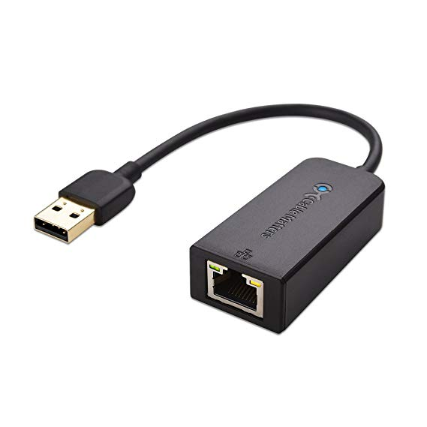
- The room will need to be set up by ICT as each person has to log on for the first time with them plugged in to a wired network.

- Alternatively you can order Ethernet adaptor cables, and take the internet cables from the classroom computers, and attach them to the laptops via USB

- Gwent Laptops need setting up in a Gwent station, but can be set up on WiFi rather than a wired network. (We used Newport Central Police Station)
- Gwent Laptops work differently to SWP ones to set up (please use separate presentation)

Some useful teaching information
- The software updates take a while to go through, so it is worth getting everyone to log on, then leave the updates happen whilst you do the background information, policy of use etc.
- Promote using the windows button over Citrix for Microsoft word, outlook etc as it is more reliable.

Creating the PIN
- The ‘Create your PIN pop up’ can happen at any point. If it doesn’t come up, then either restarting the computer will usually make it come up. If not, follow this process:

Click on the yellow documents folder  C:\ press enter > click on programme files > Microsoft > MDOP MBAM > click on
This will make the page pop up to set the PIN.

- This PIN (password) will NEVER change – they must remember it! If they do forget it, they can press the esc key on the Bitlocker page, it will tell them a website to go onto via a desktop and follow the instructions. Alternatively, they can call ICT.

Email Signatures
- Email signature templates are available on BOB (just search email signatures and select the SWP one)

Check SIM is working
- Always get the officers to connect to their SIM card to ensure that it has been activated. If when they select EE it doesn’t connect - that can mean it hasn’t been activated. Leave it try and connect for up to 10 minutes, if not they will need to phone the ICT Helpdesk who will then contact EE.

iPatrol for Windows
 When it comes to the part of the session to download iPatrol from the software centre it can take a long time before it appears in the software centre.
If iPatrol has not downloaded by the end of the session. In the search bar type in control panel > configuration manager > Actions tab > Click on Machine Policy Retrieval & Evaluation cycle and press run now > then click on application deployment evaluation cycle and press run now.
This will speed up the download, but try and leave the laptop plugged in until it has downloaded
Once downloaded, you will need to go into the windows button and it will be at the top (recently added) this can then be pinned to the taskbar to save them looking for it. To do this right click it, press more, pin to task bar.
iPatrol will work offline, but it needs to be logged on first. Therefore, always recommend to log on and minimise before leaving the station just in case they are in an area with no signal on their laptops.
The software is just for digital witness statements and PPN’s, and work the same as on a mobile phone. The witness signs the screen as they do when we practise with the pens in the session.

One Notes
With each group, it is worth starting a Notebook of Laptop Notes. It is worth asking the students to make a note of
- The procedure for using screens
- The gpupdate process

Differences with Gwent and South Wales Police Laptops
 | SWP Laptops | GWP Laptops
Intranet | BOB | The Beat
Connecting to the internet | Cisco any connect   | Standard network connect  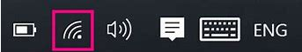
Work drives | H: Personal drive  R: Shared drive | I: Personal drive  U: Shared drive
Evidence Management | Evidence.com – use internet page | Photoweb – use internet page
Command and Control System | Control Works – add on citrix | Storm – add on citrix

