 | Student No: | Sakiba Islam (2210233)
 | Module Title: | Hotel Placement- Operating hotel facilities
 | Module Code: | BMIH4006
 | Lecturer: | Lisa knight

Component One:

Housekeeping is an essential service in the hospitality sector since it guarantees guests' comfort, cleanliness, and order (Hayes & Ninemeier, 2019). It comprises managing the laundry and communal areas, as well as maintaining and cleaning guest rooms. Working effectively in a housekeeping team requires a range of key skills that I have explored during my learning journey.

As one of their primary skills, the housekeeping staff must pay close attention to detail. I learned that the smallest mistake can have a significant effect on the satisfaction of my guests as I researched this topic. The term "attention to detail" refers to the thoroughness with which a room is cleaned and maintained, from the dusting and vacuuming to the replenishment of amenities (Hayes & Ninemeier, 2019). If a guest's toiletries aren't replaced, for example, they may get a negative impression of the hotel and feel less satisfied. The housekeeping staff also requires the ability to effectively manage their time. Housekeepers are often pressed for time as they rush to have each room ready for guests, especially during peak occupancy. By understanding the necessity of prioritising tasks, organising work appropriately, and managing time effectively, housekeepers can ensure that rooms are cleaned swiftly and to the highest standard. My education has equipped me with a toolkit of time-saving techniques that will serve me well as I strive to achieve my professional goals in the housekeeping industry. Some examples of these methods are using checklists and the Pomodoro Technique (Jones, Hillier & Comfort, 2016).

Effective communication skills are also necessary for a career in housekeeping. Housekeepers need to be able to effectively convey information to their peers, superiors, and clients. Thanks to the ease of communication, tasks are completed properly, and any issues or unique requests from guests are quickly addressed. During my training, I participated in role-playing activities and observed real-life occurrences to enhance my communication skills and gain an understanding of the importance of effective communication in providing exceptional guest service (Jones, Hillier & Comfort, 2016). As I contemplate the practical applications of my academic understanding, I am encouraged. For instance, because I am well-versed in different cleaning techniques and the proper use of cleaning equipment, I will be able to get my work done swiftly and efficiently. Knowledge of industry best practises, such as the correct handling of hazardous goods and adherence to health and safety requirements, will allow me to keep a safe working environment for myself, my coworkers, and the guests.

Furthermore, my interactions with guests will be guided by my theoretical knowledge of customer service standards and guest expectations. If I pay attention to detail and try to guess what they would like, I can give them something very special. In addition, I can help the tourism sector do its part for the environment by introducing green cleaning practises in the housekeeping department. My knowledge of eco-friendly methods and environmental concerns makes this a reality.

Important skills for the housekeeping staff are given a lot of attention in the hospitality industry. When deciding where to stay, guests care most about how clean the facility is. A hotel's reputation, guest satisfaction, and repeat business are all boosted when rooms are clean and well-maintained (Hinkin & Tracey, 2019). The housekeeping team is essential for upholding these standards and ensuring a positive guest experience. Second, the housekeeping staff's ability to work together effectively is crucial to the smooth operation of the hotel. Every member of the team relies on every other member to get their work done efficiently and on time. By developing the aforementioned crucial skills, such as attention to detail, time management, and communication, the housekeeping staff may work together efficiently and make positive contributions to the establishment's success. Finally, the housekeeping staff improves the hotel's overall image (Newman & Cavana, 2017). Guest satisfaction is crucial to the hotel's success since it can generate both online reviews and word-of-mouth recommendations. The key skills required of a housekeeping crew are ones I possess, so I can help the hospitality industry thrive by maintaining high standards, going above and beyond for guests, and so on.

Superior interpersonal, organisational, and detail-oriented skills are essential for success in this industry. By putting my theoretical knowledge to work in the field, I will be able to finish work promptly, provide excellent guest service, and promote sustainability programmes. Understanding the importance of these skills in the hospitality industry reinforces the housekeeping team's responsibility to ensure guest satisfaction, maintain cleanliness, and protect the company's reputation.

Word Count | 743

Component Two:

Problem | Why did it happen? | What are you going to do? | How will you prevent this from happening in the future? | What measures would you introduce to improve team effectiveness?
Inconsistent cleaning standards across rooms | Varying levels of training, differences in understanding, inadequate supervision | Conduct a thorough evaluation of current cleaning practices and standards. | Enhance training programs to ensure consistent understanding and execution of cleaning standards. | - Conduct regular training sessions to reinforce cleaning standards and techniques.  - Establish a mentorship program where experienced team members can support and guide new or struggling members.
Lack of communication within the team | Absence of clear communication channels, lack of effective communication protocols | Implement a regular communication system within the housekeeping team (Hinkin & Tracey, 2019). | Establish a clear communication structure and ensure that all team members are aware of their roles and responsibilities. | - Conduct regular team meetings to foster effective communication, discuss challenges, and address concerns.  - Encourage open and transparent communication among team members.
Insufficient time management | High volume of check-ins, inadequate allocation of resources | Review and optimize the room assignment process to ensure adequate time for thorough cleaning (Kasavana & Brooks, 2018). | Improve scheduling and resource allocation to allow sufficient time for each room cleaning. | - Conduct regular assessments of workload and time requirements, make necessary adjustments to ensure proper time management.
Lack of attention to detail | Insufficient emphasis on attention to detail, oversight in training | Reinforce the importance of attention to detail through training and team meetings. | Develop a comprehensive checklist for each room to ensure all cleaning tasks are completed and checked off (Kasavana & Brooks, 2018). | - Implement quality control measures, including regular inspections and audits, to ensure adherence to high cleaning standards and attention to detail.
Inadequate training and development opportunities | Lack of ongoing training and professional development for team members | Identify training needs and develop a training plan to address gaps in knowledge and skills. | Establish a structured training and development program, including workshops, seminars, and online courses, to enhance team members' skills and knowledge (Hayes & Ninemeier, 2019). | - Provide opportunities for cross-training and job rotations to broaden team members' skill sets and enhance their understanding of different roles within the housekeeping department. Foster a culture of continuous learning and improvement.

Component Three:

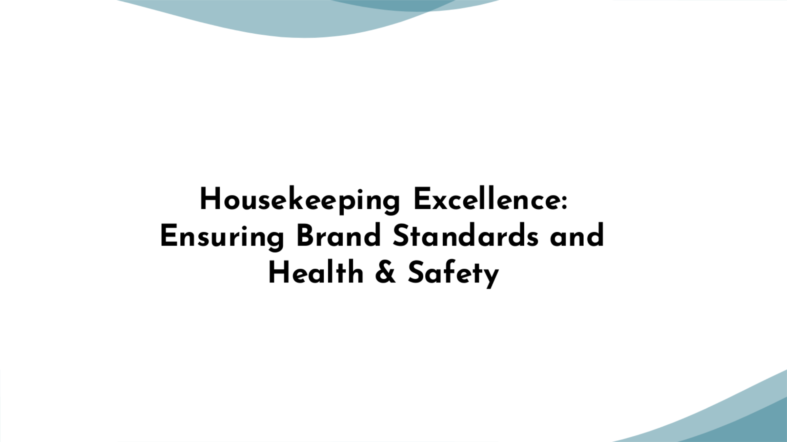

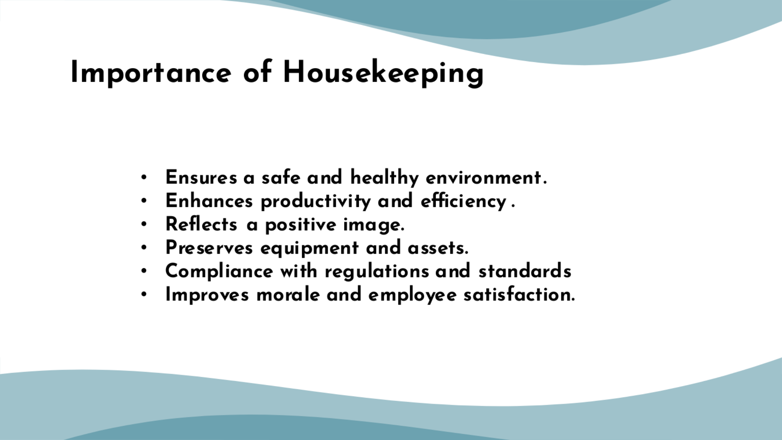

Training Notes:
Housekeeping keeps everyone safe and healthy. Regular cleaning and tidying help prevent accidents, injuries, and germs and diseases.A tidy workstation boosts productivity. Employees can quickly find what they need when everything is organized. Cleanliness promotes positivity and attentiveness.Organizational image is enhanced through housekeeping. Visitors, clients, and stakeholders like clean, well-maintained facilities. It shows professionalism, detail, and quality (Upneja & Ruhland, 2014).Cleaning and maintaining equipment and assets extends their lives. Unmanaged dust, filth, and debris can damage. Effective housekeeping reduces equipment repairs and replacements.Many industries have strict hygiene rules. These regulations are essential for legal compliance and employee and customer safety (Raghubalan & Raghubalan, 2016). Housekeeping helps companies satisfy these standards.Housekeeping boosts employee morale. A tidy workplace fosters a happy culture. Well-maintained workspaces motivate and value employees, increasing job happiness and productivity.

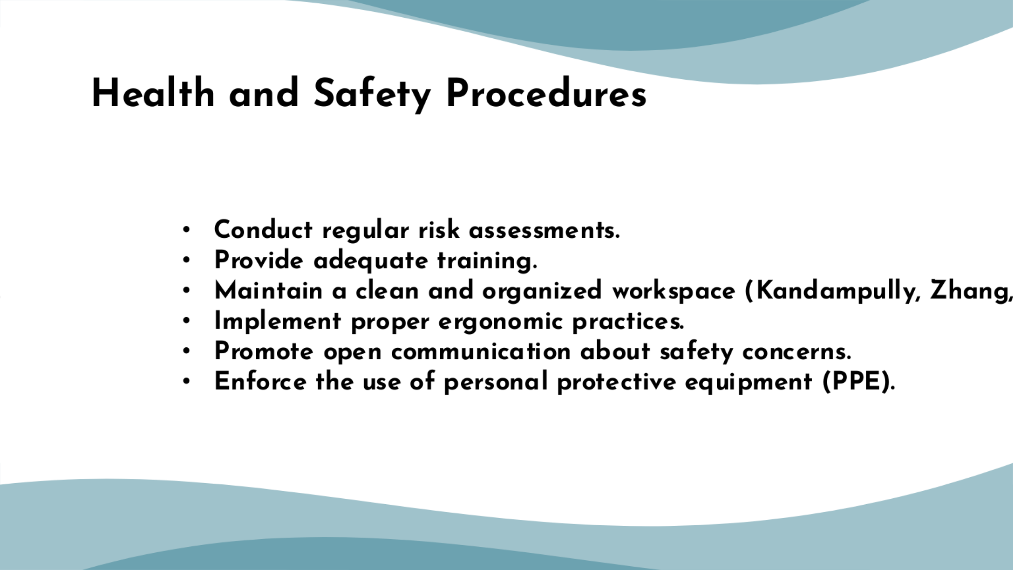

Training Notes:
Regular risk assessments help discover and assess potential threats. To detect hazards, workplace, equipment, and process assessments should be thorough. These assessments help firms avoid hazards and protect staff and visitors. Employee safety training is crucial. Training should encompass emergency procedures, equipment handling, and PPE. Organizations can prevent workplace accidents and increase safety by training staff. Health and safety depend on a tidy workplace. Regular cleaning and tidying help prevent accidents, injuries, and germs and diseases. De-cluttering boosts productivity and efficiency (Kandampully, Zhang, & Bilgihan, 2015)
. Ergonomics prevents occupational injuries and musculoskeletal problems. Adjustable workstations, good posture, and ergonomic tools and equipment reduce bodily strain. Safety communication encourages employees to report hazards. This promotes safety awareness and enables for early problem solutions. Safety goggles, helmets, gloves, and masks protect workers from job risks. Consistent PPE compliance requires clear policies and procedures.
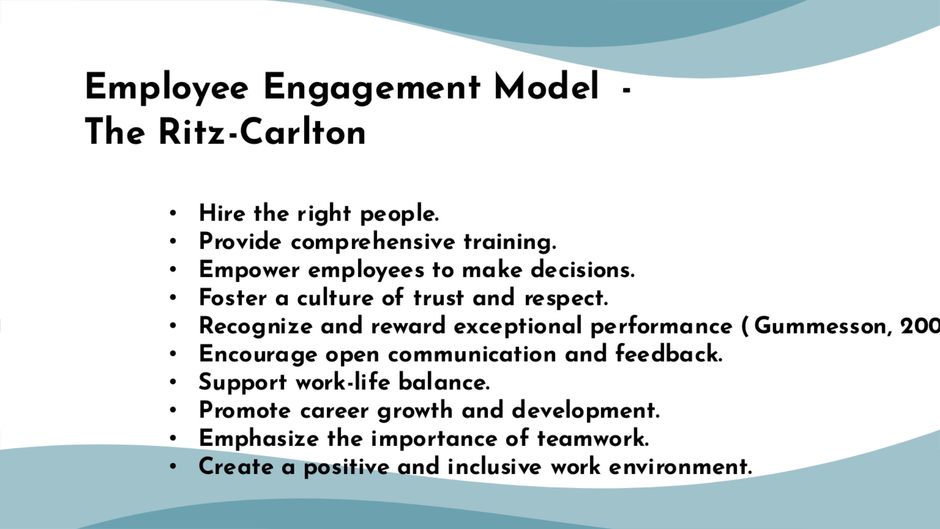

Training Notes:
The Ritz-Carlton's employee engagement model focuses on careful employee selection based on core values and customer-centric mindset. Comprehensive training equips employees with the Ritz-Carlton service philosophy (Lai & Hitchcock, 2017)
. Empowerment allows employees to make decisions and resolve guest issues on the spot. Trust and respect are fostered through open communication, while recognition programs reward exceptional performance. Open dialogue and feedback channels enable continuous improvement. Work-life balance is supported through flexible scheduling. Career growth and development opportunities are provided, emphasizing teamwork and a positive, inclusive work environment that values diversity and promotes a sense of belonging.

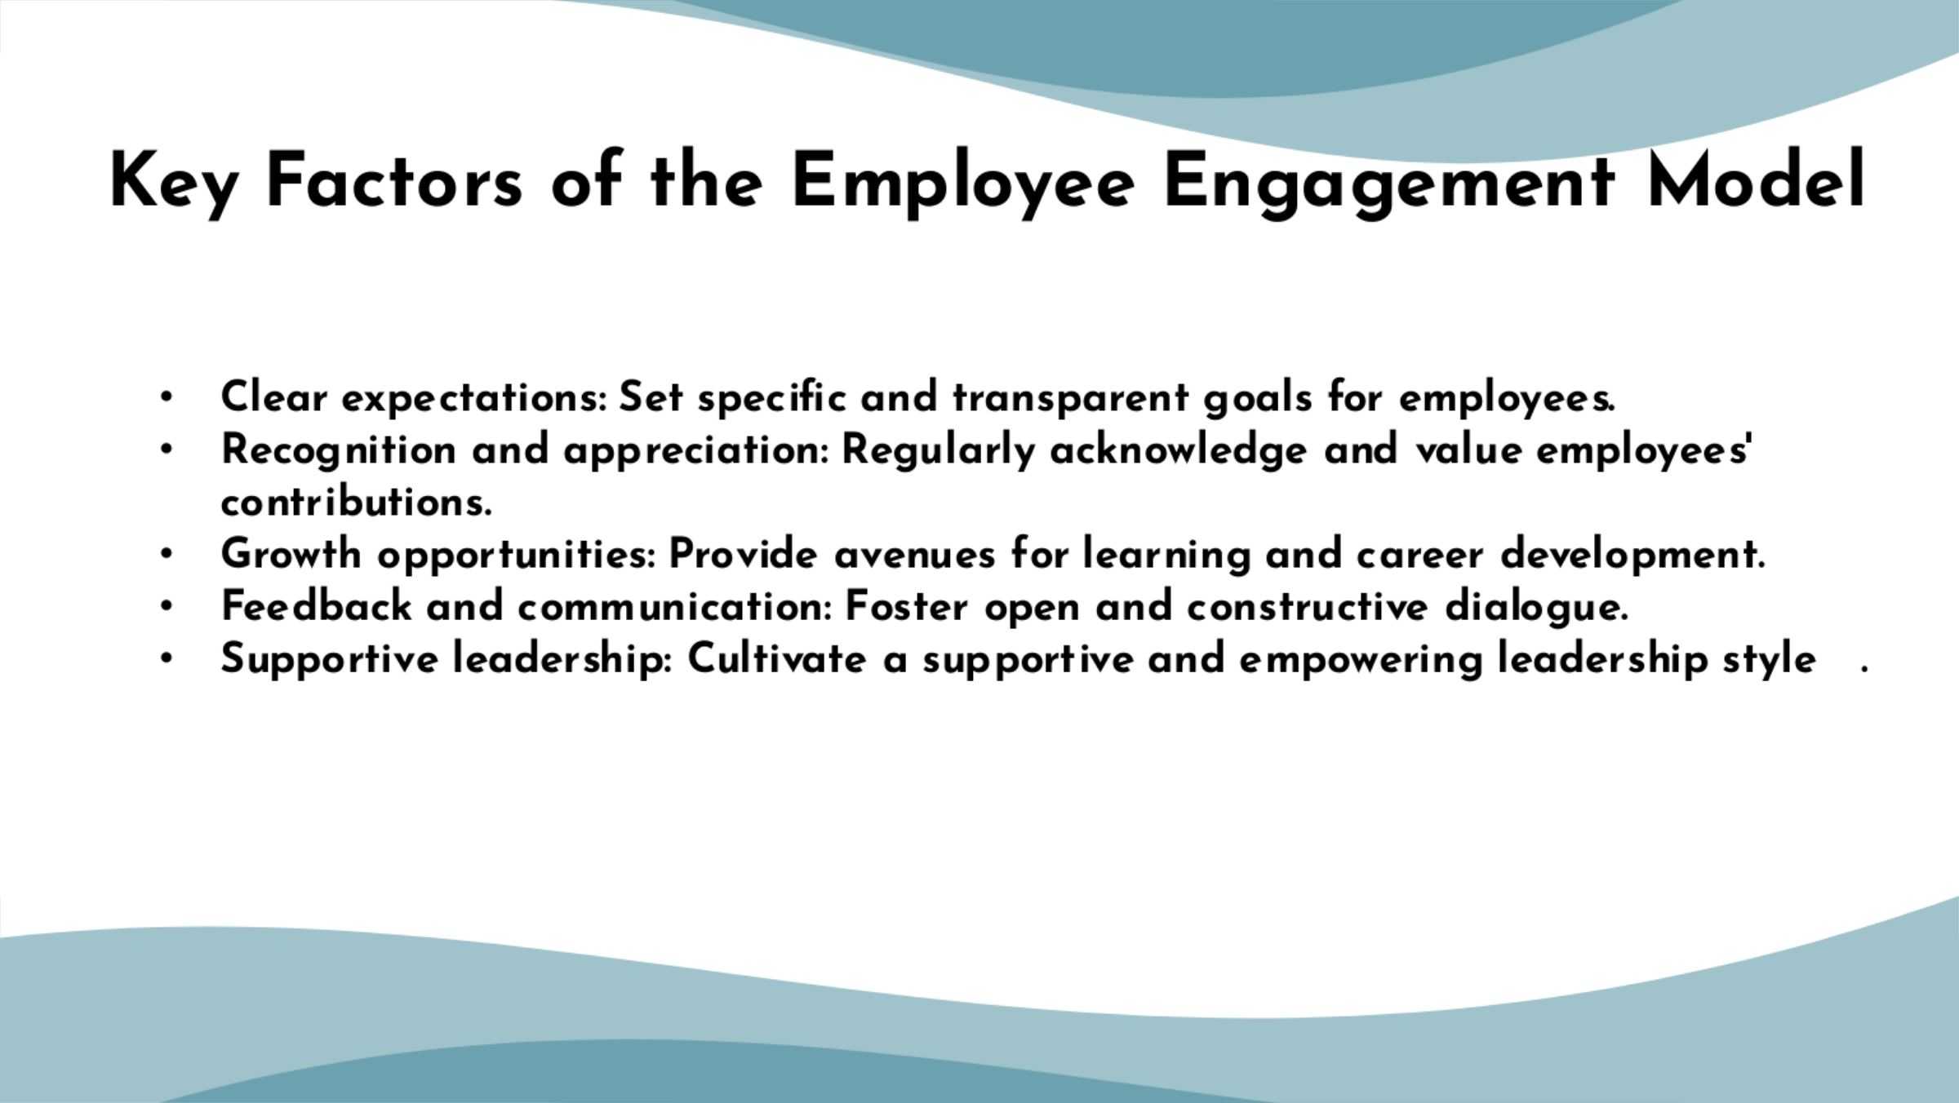

Training Notes:
Clear expectations, recognition and appreciation, opportunities for growth, constructive feedback and communication, supportive leadership, work-life balance, fairness and transparency, employee involvement, team collaboration, purpose and alignment, support for well-being, and trust and integrity are the key components of the model for employee engagement (Aksu & Köksal, 2005)
.
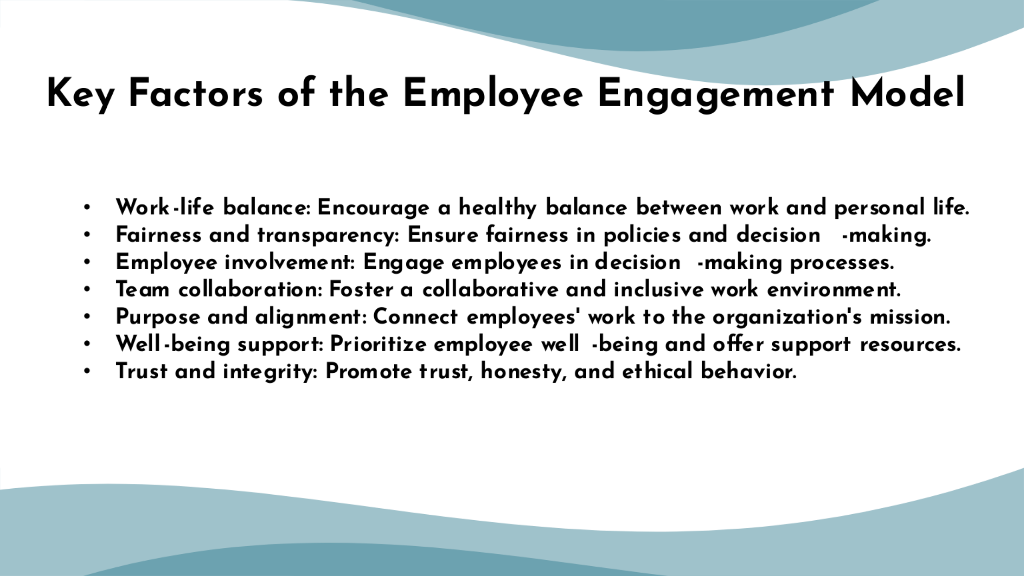

Training Notes:

Creating a work environment that encourages a healthy work-life balance, fairness and transparency, employee involvement, team collaboration, purpose and alignment, well-being support, as well as trust and integrity, is crucial for fostering a positive and productive workplace (Pizam & Mansfeld, 2009). By focusing on these areas, we can create a work environment where employees feel valued, supported, and motivated to perform at their best. Through implementing these factors, we can enhance employee engagement, foster a positive culture, and drive success within our organization.

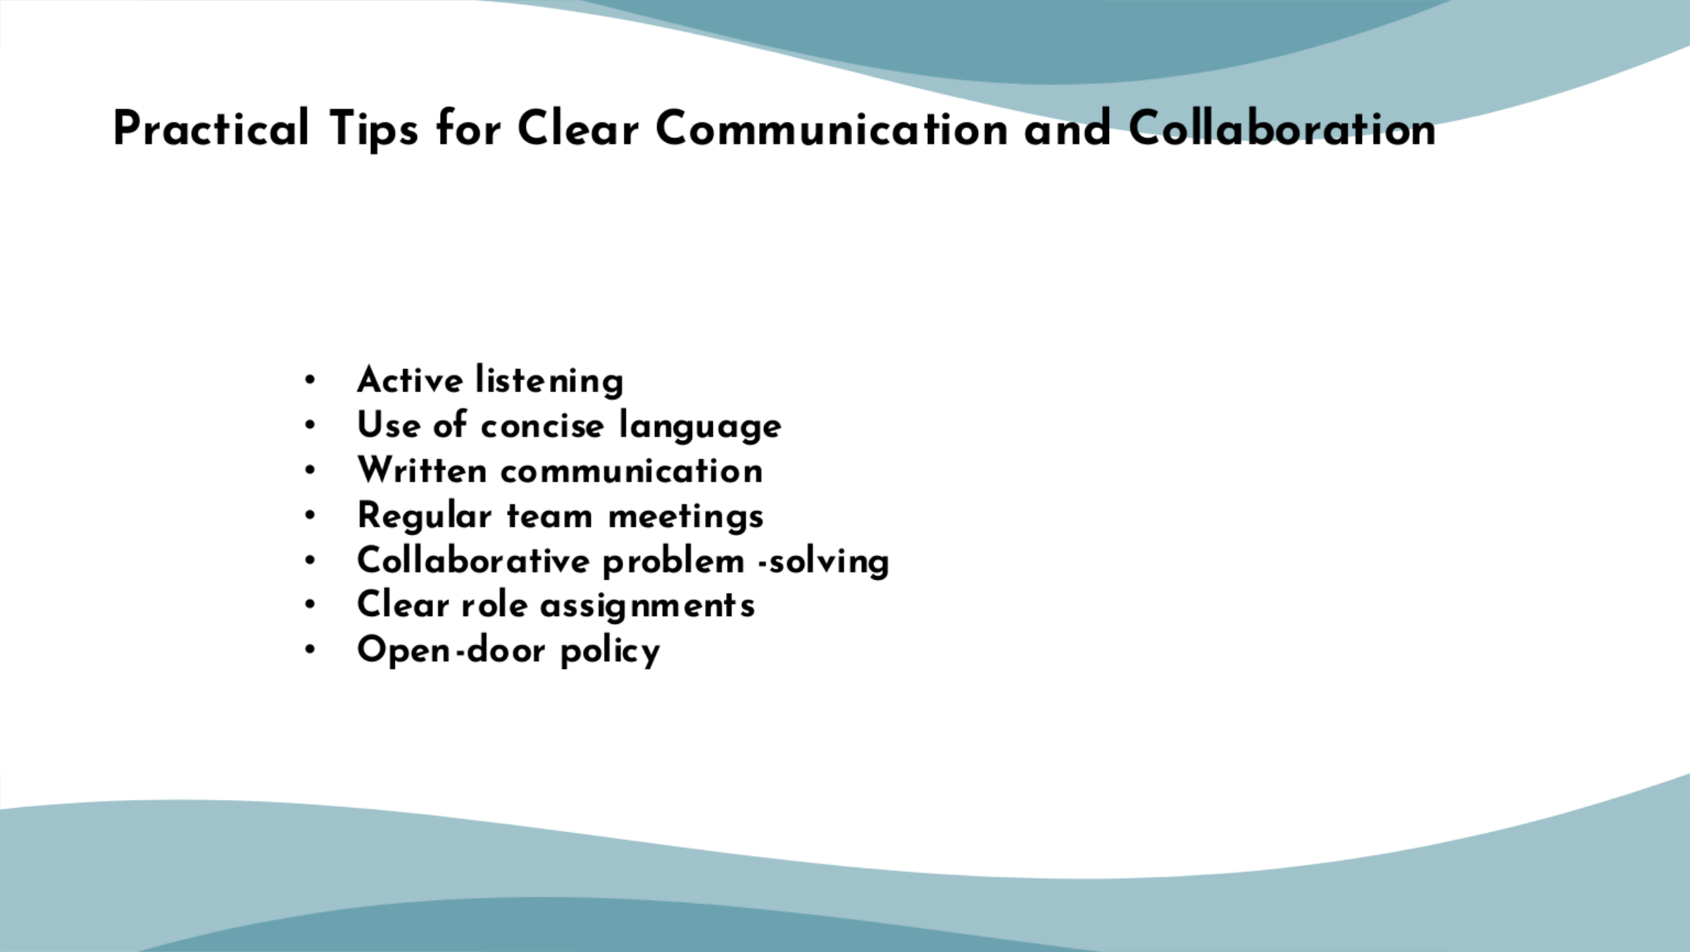

Training Notes:
Clear communication and teamwork require active listening. Team members pay attention to verbal and non-verbal cues when actively listening, ensuring a complete knowledge of duties and directions. Thus collaboration and misunderstandings will improve (Kimes & Wirtz, 2003).
Clear communication also requires concise language. Avoid jargon and technical terminology while communicating with teammates. They can better communicate and ensure understanding by utilizing basic language (Kimes & Wirtz, 2003).
Task lists, checklists, and logbooks aid clear communication. They make it easy to communicate, document, and share information with team members. Written communication prevents misunderstandings and gives a dependable reference.
Regular team meetings improve communication and collaboration. These sessions discuss team goals, tasks, and issues. They promote open communication, criticism, and alignment.
Teamwork requires problem-solving. Encouraging team members to work together to solve problems creates a supportive, knowledge-sharing environment. Teamwork helps the team overcome challenges.
Clear roles help teams work together. Clearly defining each team member's roles and tasks ensures that everyone knows their role and contributes to team success. Clarity improves workflow and task completion.
Open-door policies encourage transparency and communication. It encourages team members to discuss issues, comments, and questions with supervisors or coworkers. This policy fosters open communication and prompt problem-solving.

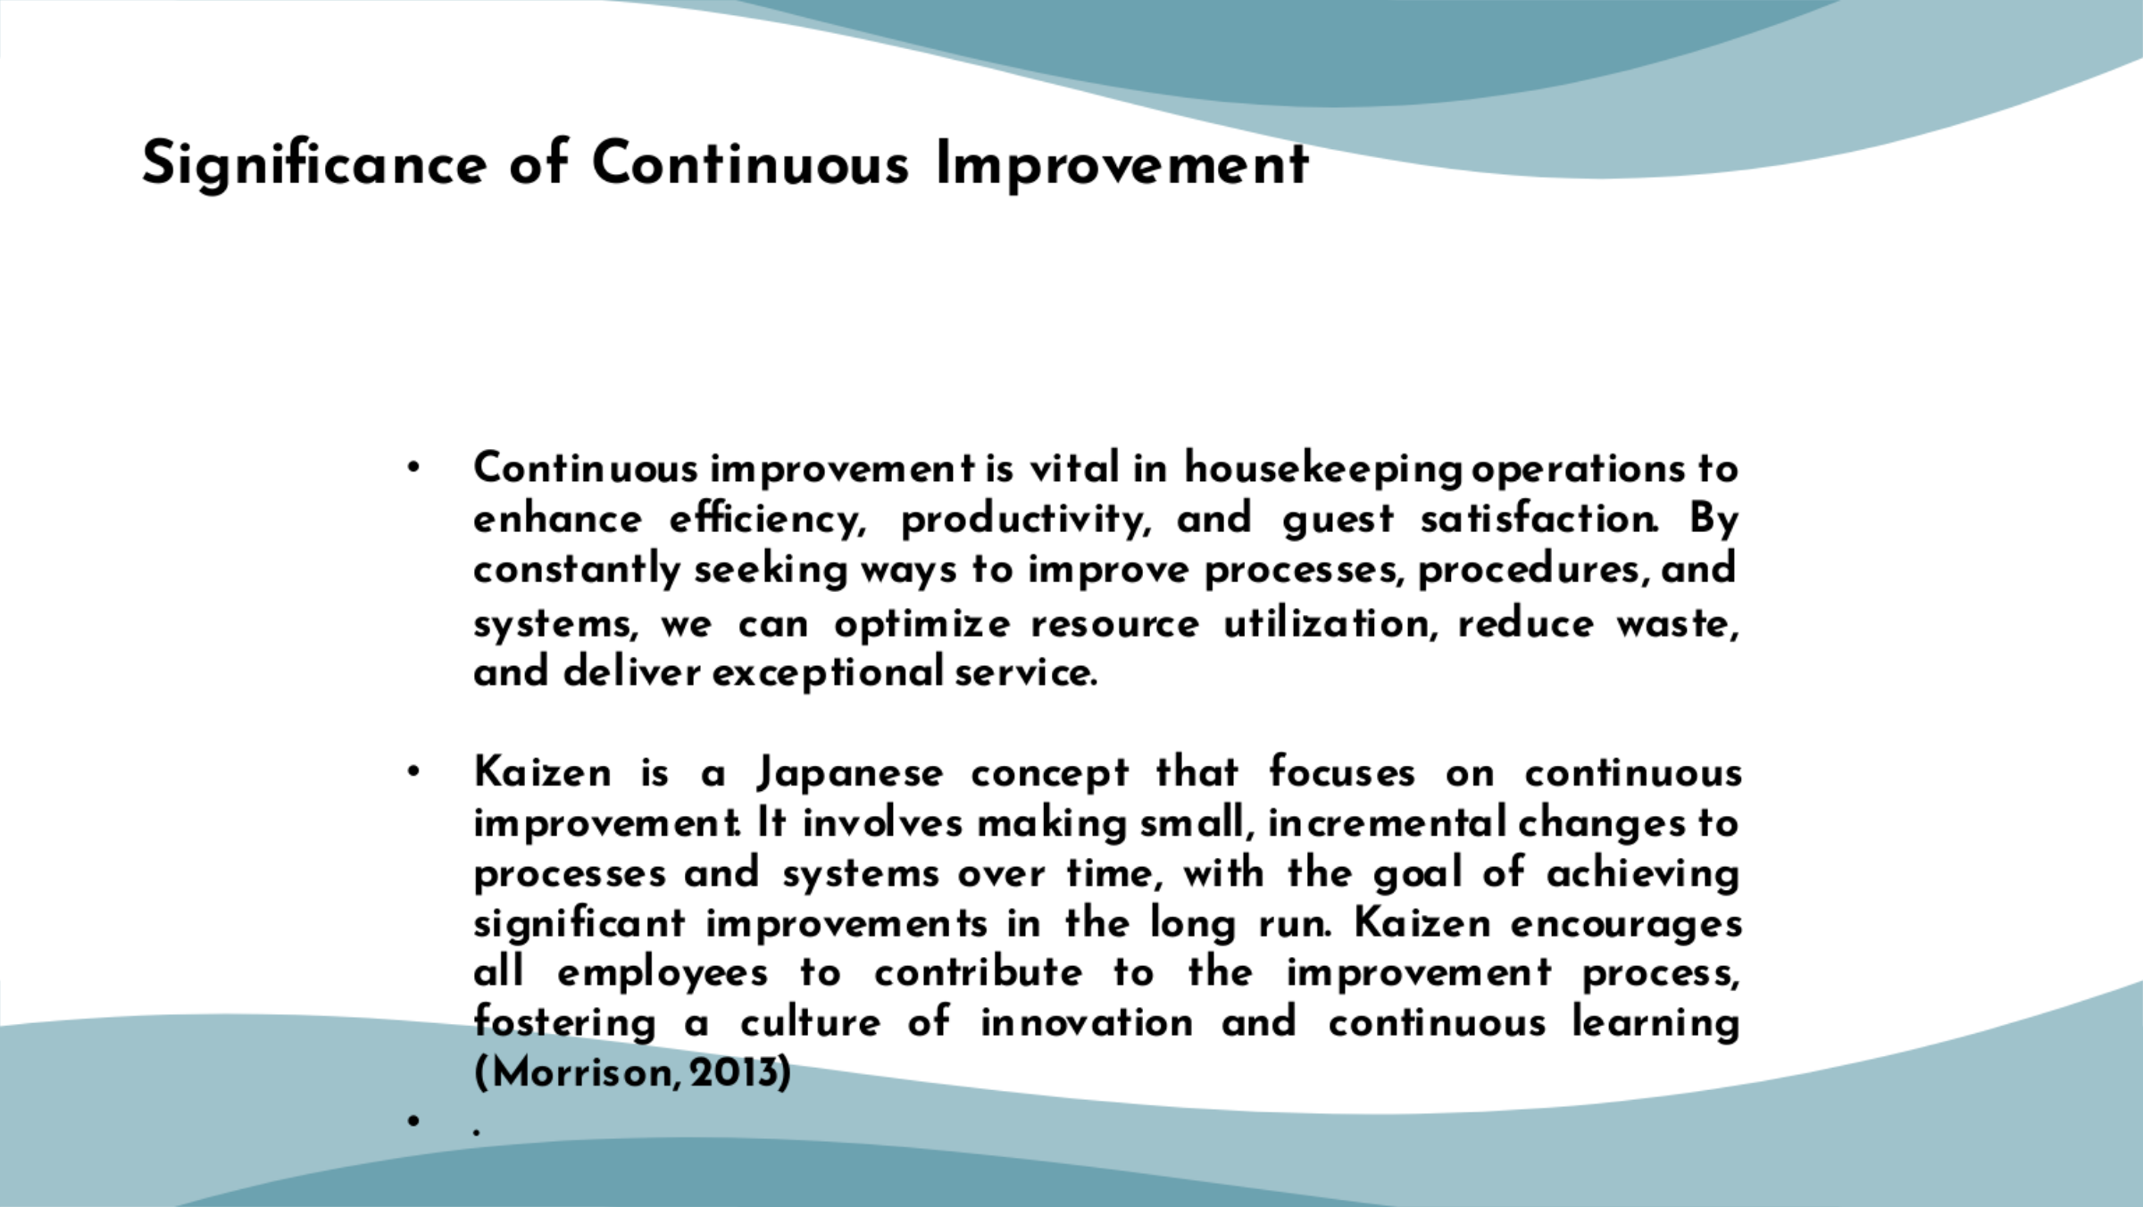

Training Notes:
To increase effectiveness, productivity, and guest pleasure in housekeeping operations, continuous improvement is essential. We can maximize resource usage, eliminate waste, and provide great service by continually looking for ways to improve processes, procedures, and systems. The Japanese idea of kaizen emphasizes ongoing development. It entails making gradual, minor adjustments to systems and processes with the intention of creating large long-term gains (Morrison, 2013)
. Kaizen promotes a culture of creativity and continuous learning by encouraging all employees to participate in the process of improvement.
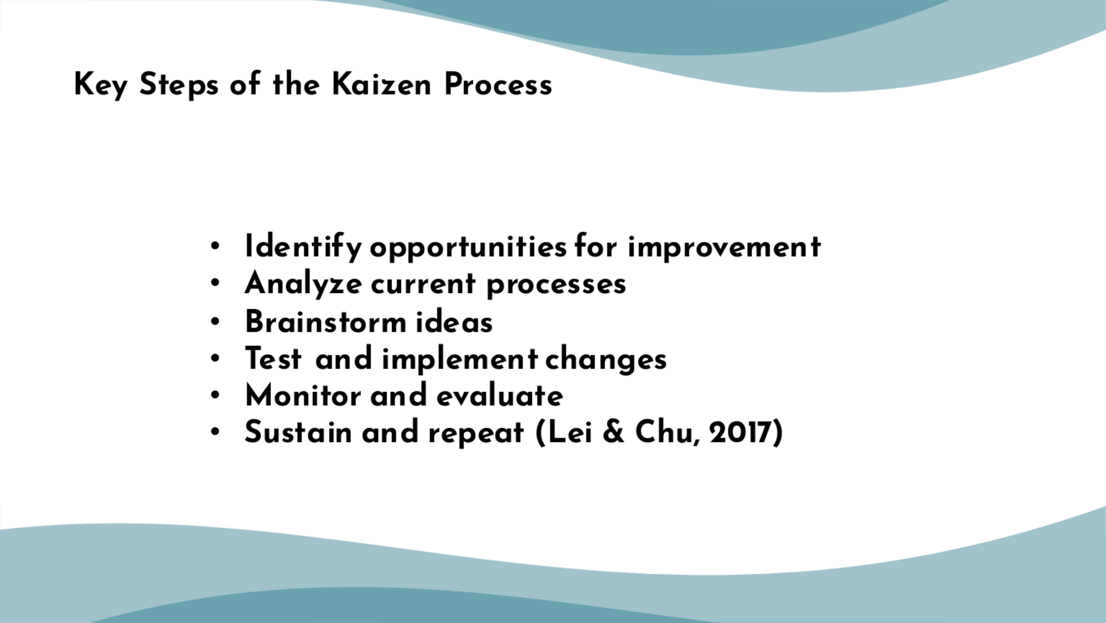

Training Notes:
Engage our team to find ways to optimize processes, waste, and efficiency.Analyze present processes: Assess their strengths, limitations, and areas for development.Encourage team members to brainstorm process improvements. Create a welcoming space for ideas.Test and implement: Choose the best ideas and test them in small batches. Scale up successful changes (Lei & Chu, 2017)
.Monitor and evaluate: Assess the effects of changes by monitoring and evaluating them. Team members and guests can evaluate the improvements.Continue Kaizen in our housekeeping department and make continual improvement a habit. Encourage team members to discuss ideas and seek improvements (Bridger, 2018)
.

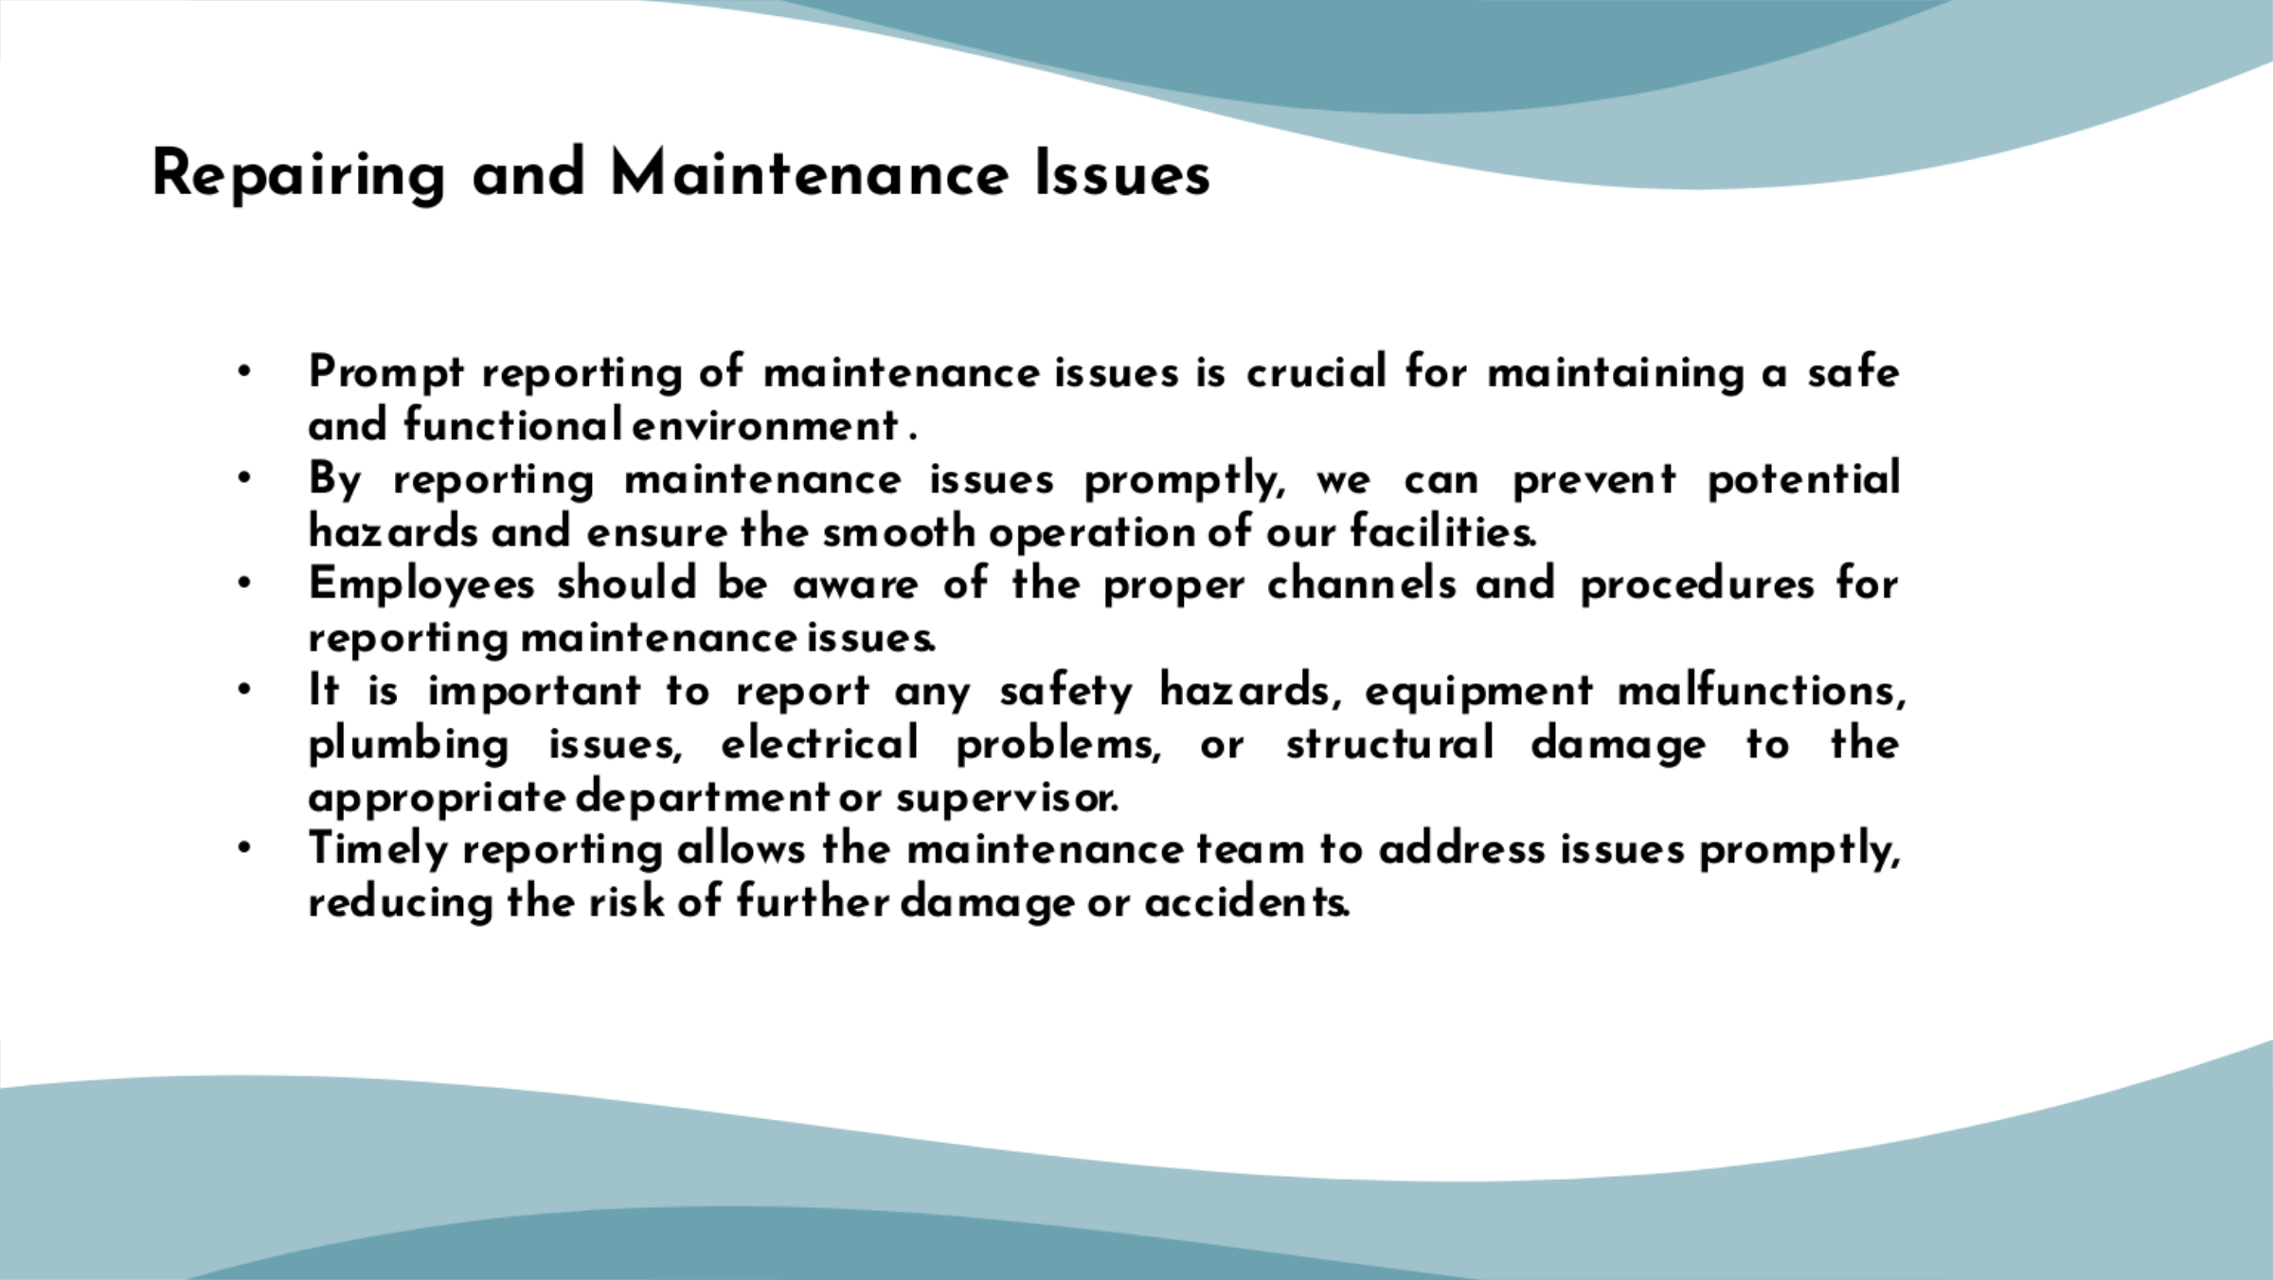
Training Notes:
- Reporting maintenance issues promptly is vital for our hotel's operations and the well-being of our guests and employees (Cottrell, 2019). We must maintain a safe and functional environment at all times.
- When maintenance issues occur, it is important that we follow the correct procedures and report them to the appropriate department or supervisor.
- Examples of maintenance issues that should be reported include safety hazards, equipment malfunctions, plumbing problems, electrical issues, or any structural damage.
- By reporting issues in a timely manner, we can prevent further damage, ensure guest satisfaction, and maintain the overall functionality of our facilities.

References

Aksu, A. A., & Köksal, C. D. (2005). Perceived organizational support and continuance intention of hotel front-line employees. Tourism Management, 26(1), 85-95.
Bridger, E. (2018) Employee engagement: a practical introduction. 2nd ed. HR Fundamentals. London: CIPDand Kogan Page.
Choi, T. Y., & Chu, R. (2001). Determinants of hotel guests' satisfaction and repeat patronage in the Hong Kong hotel industry. International Journal of Hospitality Management, 20(3), 277-297.
Cottrell, S. (2019) The Study Skills Handbook. 5th ed. London: Red Globe Press.
Gummesson, E. (2006). Many-to-many marketing as grand theory: A Nordic school contribution. European Journal of Marketing, 40(3/4), 244-256.
Hayes, D., & Ninemeier, J. (2019). Hotel Operations Management. Routledge.
Hinkin, T., & Tracey, J. B. (2019). Work Behavior and Attitudes in Housekeeping Operations: The Influence of Organizational Climate and Leadership Style. Journal of Hospitality & Tourism Research, 43(2), 244-267.
Jones, P., Hillier, D., & Comfort, D. (2016). Sustainability in the Hospitality Industry: Principles of Sustainable Operations. Routledge.
Kandampully, J., Zhang, T., & Bilgihan, A. (2015). Customer loyalty: A review and future directions with a special focus on the hospitality industry. International Journal of Contemporary Hospitality Management, 27(3), 379-414.
Kasavana, M. L., & Brooks, R. M. (2018). Managing Front Office Operations. American Hotel & Lodging Educational Institute.
Kimes, S. E., & Wirtz, J. (2003). Has revenue management become acceptable? Findings from an international study on the perceived fairness of rate fences. Journal of Service Research, 6(2), 125-135.
Lai, Y. H., & Hitchcock, M. (2017). Customer perceived value in the hotel industry: A systematic review. International Journal of Contemporary Hospitality Management, 29(9), 2296-2332.
Lei, S. I., & Chu, R. (2017). Proactive employee behavior: Effects of internal marketing and customer orientation in the hotel industry. Journal of Hospitality & Tourism Research, 41(5), 631-652.
Leiter, M. P. and Bakker, A. B. (2010) Work Engagement : A Handbook of Essential Theory and Research.Hove [England]: Psychology Press.
Morrison, A. M. (2013). Marketing and managing tourism destinations. Routledge.
Mullins, L. and Dossor, P. (2013) Hospitality Management and Organisational Behaviour. 5th ed. Harlow:Pearson.
Newman, P., & Cavana, R. Y. (2017). Hotel Housekeeping: A Training Manual. Goodfellow Publishers Limited.
Pizam, A., & Mansfeld, Y. (2009). Tourism, crime and international security issues. John Wiley & Sons.
Quick, L. (2020) Managing Events. Real Challenges, Real Outcomes. London: SAGE Publications Ltd
Raghubalan, G. and Raghubalan, S. (2016) Hotel Housekeeping - Operations And Management. 3rd ed.India: Oxford University Press.
Smith, P., & Lockwood, A. (2018). Hotel Management: Principles and Practices. Routledge.
Upneja, A., & Ruhland, S. K. (2014). Hotel performance and the influence of the human resource management system. International Journal of Hospitality Management, 42, 180-190.

