3.1 Chapter overview

This chapter will address the most beneficial research methods to investigate and examine the public's holiday choices in regard to all-inclusive holidays and how informed these decisions are.

3.2 Research Onion

The researcher of this study will collect primary research by following Saunders, et al (2009) ‘Research Onion’ for identifying the methods of data collection and data analysis techniques.
Research can be defined as ‘something that people undertake in order to find out things in a systematic way, thereby increasing their knowledge’ (Saunders, et al.,2009). However, Saunders et al., (2009) also suggests that it can only be classified as research if it is collected and interpreted in a systematic way. Therefore, the strategy of this study will follow the format for research set out by Saunders, et al., (2009). ‘The Research Onion’.

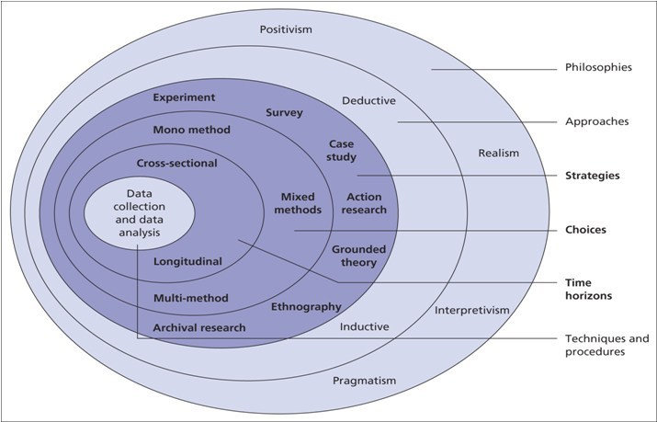

Figure 2 - The Research Onion. Source: (Saunders, et al., 2009)

3.2.1 Philosophy
When conducting research, it is crucial to be aware of the philosophical commitments. It is important to adopt the right philosophy as it will have a substantial impact on the understanding and examination on the research study (Johnson and Clark, 2006). Dudoyskiy (2019) suggests that research philosophy is how research is collected, analysed and used with regards about a specific phenomenon. The two dominant research paradigms are interpretivist and positivist. The interpretivist paradigm according to Collis and Hussey (2003, p.53) is believed to be concerned with understanding human behaviours and focuses on the meaning, rather than measurement of social phenomena. Positivist however refers to quantitative date and is described as being constant which relies on deductive logic (Levin, 1998).
Interpretivist can also be referred to as quantitative research which suggests that this approach is a way to ‘enter the world’ of the research participants to understand their feelings, compared to the positivism approach which is referred to as quantitative research approach of generating scientific ‘facts’ (Saunders et al., 2012). Therefore, the author of this thesis will adopt the interpretivism approach while underpinning this by incorporating elements of quantitative data throughout the study.

3.2.2 Approach

Saunders et al., (2012), notes that research that involves of both quantitative and qualitative data may consist of a combination of a deductive and inductive approach. Veal (2011) suggests that a deductive approach is observational research which tests a hypothesis to either approve or disprove it. Whereas, an inductive approach starts with a question that analysis data to answer or fail to answer the set objectives, where then a hypothesis is generated from these findings. Therefore, an inductive approach will aid in achieving the set objectives by researching consumer thoughts about all-inclusive holidays. This study will be exploratory to identify problems within the topic area and to produce direction for further work. By mainly taking a qualitative approach, the research is concerned with a subjective assessment of attitudes, opinions and behaviours of respondents (Kothari, C., 2004).

3.2.3 Strategy

The researcher will use a mixed method approaches which will consist of both quantitative and qualitative data collection. The researcher will gather data through online surveys, and interviews of people who have participated in all-inclusive holidays. These methods will ensure the researcher gathers data from all different angles to support and draw conclusions. For this reason, the idea of ‘triangulation’ plays a major role in this paper. The qualitative data gathered will be reinforced by the data found from the online surveys.
According to Kumar (2014:171), there are two main ways of collecting data, primary and secondary. Interviews and questionnaires will be the source for primary data, whilst academic journal and books, with the support of the university database will be the main source of secondary data.
Lambert (2012: 102) notes that the advantage of distributing surveys is that it is a well-known method and people will comply if the questionnaire is clear. However, he identifies that once you distribute the questionnaires, they cannot be changes and ‘response rate’ may be low. Therefore, the researcher will issue the questionnaire over a variety of social media platforms. The need for additional primary research such as interviews is to explore the attitudes, opinions and feelings of the interviewees of the topic of in depth, compared to statistics gathered from questionnaires. However, Lambert (2012: 102) identifies that this method can be very overwhelming due to the higher amount of responses and qualitative data gathered. Although the research approach is interpretative, this quantity of qualitative data makes it difficult to separate the valuable and non-valuable data. Therefore, researcher will go into the interviews with set questions they need to ask to support the data found from the online surveys.

3.2.4 Time horizon

Due to time constraints, this thesis will include cross-sectional research as this method will have a higher capability in achieving the aim of this study within the timeframe. In contrast to longitudinal research that is conducted over a longer period (Saunders et, al. 2012).

3.2.5Collection and analysis

3.2.5.1 Collection

The researcher of the paper will collect a mixture of both primary and secondary research. The purpose of analysing the data is to gain a better understanding of the topic and to interpret what it means (Denscombe, 2014). The researcher will follow a rigid procedure to complete a set of pre-conceived questions through a number of interviews. Furthermore, once the researcher has the participants permission, the interviews will be recorded, and the findings will be transcribed onto a word document to be analysed. In addition, the investigator will use a variety of platforms to distribute online surveys to reach respondents.

3.2.5.2 Questionnaire design

The questionnaire consists of a total of 24 questions that include; demographics, impacts of all-inclusive holidays, positive and negative, motivational factors and trends. The questionnaire will include a mix of open-ended and closed-ended questions.

3.2.5.3 Pilot study

The questionnaire was distributed to ten participants who agreed to analyse and provide feedback before making it available to all participants. By using a pilot study, it allows for any faults to be reviewed and corrected which will remove any unreliable results and mitigate the confusion that participants may have with the questions (Bowles and Metcalf, 2002; Thrusfield, 1986). Thus, the researcher was able to adjust questions to become more concise and easier to complete for participants. Questions that involve multiple tick boxes on mobile phones were making it difficult for the user, therefore, a suggestion was to make the questionnaire mobile-friendly as most participants were likely to use their mobile phones.

3.3 Sampling
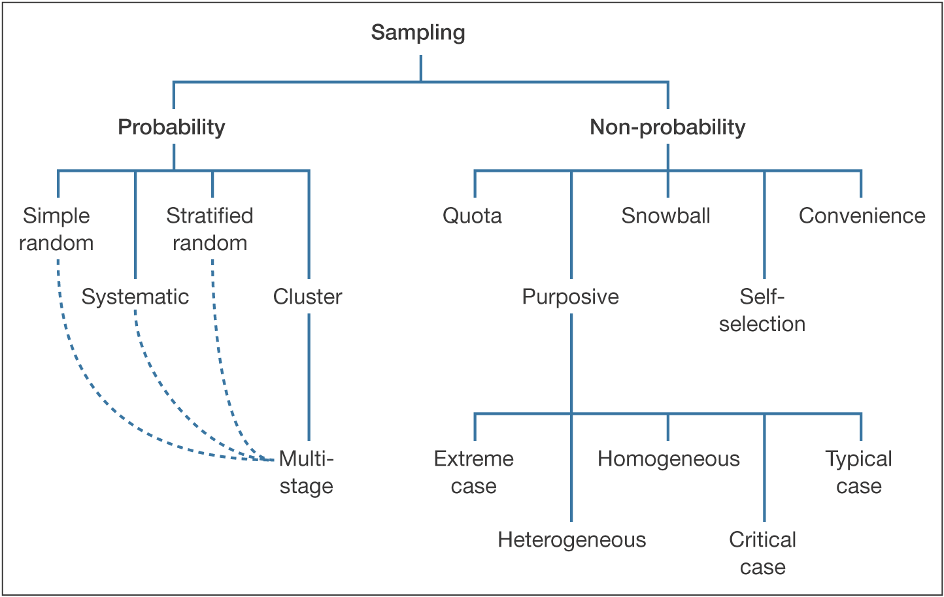
Figure 3 - Saunders, Lewis and Thornhill, Research Methods in Business, 4th Edition © Pearson Education Limited 2007
The online survey will be accessible on most social media platforms to reach all ages, different backgrounds and to receive a higher and fast response rate. Therefore, the sample will be random and will follow the ‘Probability’ route. Whereas, interviews will be focused on participants who have participated in all-inclusive holidays, therefore, the sampling method will follow the ‘Non-probability’ route and use the purposive method.

3.3.1 Analysis

The researcher will process the findings and seek for growing themes and patterns, especially by using a statistical analysis technique (Veal, 2011). A variety of charts and graphs will be used to display the primary data. This method will enable the reader to view numerical data visually (Bonita et al 2006).

3.4 Reliability and validity

Robson (2002) suggests that when undertaking research, it is crucial to understand and identify the ‘threats’ so the researcher can limit bias and ‘participant errors. Validity is concerned with accuracy of the data found and presented. Similarly, Gravetter et, al (2011) states that;
“Any component of a research study that introduces questions or raises doubts about the quality of the research process is a threat to validity”
Therefore, the researcher must have a strong research method and design to minimise the threats to achieve the set objectives of the research (Saunders, al 2009). Whereas, reliability is concerned with the quality of something that is trustworthy. Reliability can be defined as;
“Whether a research instrument is neutral in its effect and consistent across multiple occasions of use. This is frequently translated as the question ‘would the research instrument produce the same results on different occasions (all other things being equal)?” – Denscombe, 2014
To mitigate the uncertainty of the study being valid and reliable, and to create a dependable thesis, triangulation will be used.

3.5 Limitations

One limitation that this study will face is the lack of time enabled to execute the paper. The limitations of this project will be mitigated by improving time management in the form of a ‘Gantt Chart’.

3.6 Ethical considerations

Saunders et al., (2012), proposes that whether research is conducted face to face, online or any other way, the ethical awareness increases where studies involve human participants. This research is relatively low risk due to the research topic. Before collecting data, it is crucial to consider the relevance and be able to justify it so the respondents do not feel like their time is being wasted, which may be unethical. Privacy is crucial when conducting primary research. Therefore, all information provided will be kept anonymous and consent must be given before the researcher undertakes the interviews (Kumar,2014: 281). The research undertaken in this project will follow ethical guidelines throughout in addition to obtaining formal research ethics committee approval at the university (Appendix A).

