ACDA 5021
Systems Engineering
Fault Tree Analysis Student Name:- Alun Morris
20th April 2026 Student Number:- 2314593

Fault Tree Analysis: Making a Hot Drink with Milk and Sugar

Contents
What is Fault Tree Analysis 2
Example: Making a Hot Drink 3
Explanation of logic gates used in Hot Drink example 3
Calculating Probabilities 4
Analysis of the results 5
A note on Human factors 5
Conclusion 6
References: 6

Academic integrity declaration
I declare that:
- the assignment submitted has been written by me alone.
- the assignment submitted has not been previously submitted to this university or any other.
- that all content, including primary and/or secondary data, is true to the best of my knowledge.
- that all quotations and references have been duly acknowledged according to the requirements of academic research.
I understand that to knowingly submit work in violation of the above statement will be considered by examiners as academic misconduct.

What is Fault Tree Analysis
Fault tree analysis (FTA) was first conceived in 1961 to study the Minuteman intercontinental missile launch control system and was widely used thereafter in avionics and nuclear safety. The concept involves converting a physical system into a structured, logical top-down diagram to help understand how complex systems can fail. A fault tree analysis diagram starts with the top event, which represents the undesired outcome (failure) and systematically breaks down all the contributing causes leading to the event using logic diagrams [1]. An example of the logic symbols used in FTA diagrams can be seen at Figure 1. By using FTA, it is possible to identify failure pathways and quantify the likelihood of those failures.

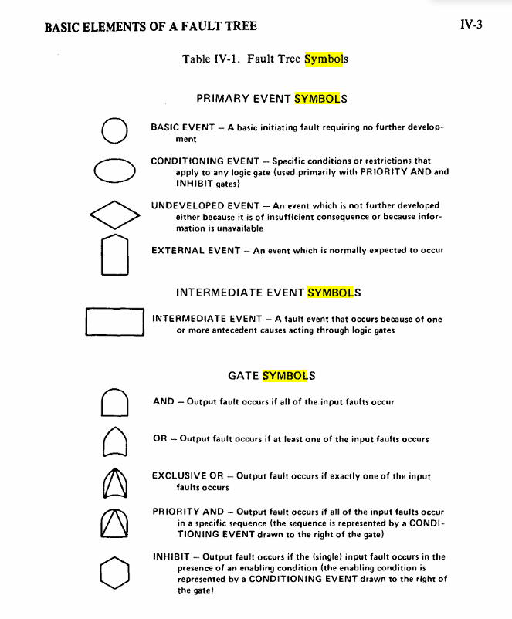
Figure 1: Fault Tree Logic Symbols [2].

Example: Making a Hot Drink
Although it was previously stated that the top event in FTA is an undesired outcome, for the purpose of providing an intuitive example, this assignment will instead use fault tree analysis to calculate the probability of success for making a hot drink with both sugar and milk.
The first step once the TOP event is identified is to break down the system by identifying the major subsystems and / or components involved in the making a hot drink process. For example, a key subsystem for a hot drink would be hot water. Hot water can then be further broken down into subsystems such as the water heating system and power to the system. The process of breaking down each system can continue further and further depending on the granularity required and the complexity of the system. For this example, a pre-constructed fault tree has been provided (see Figure 2).
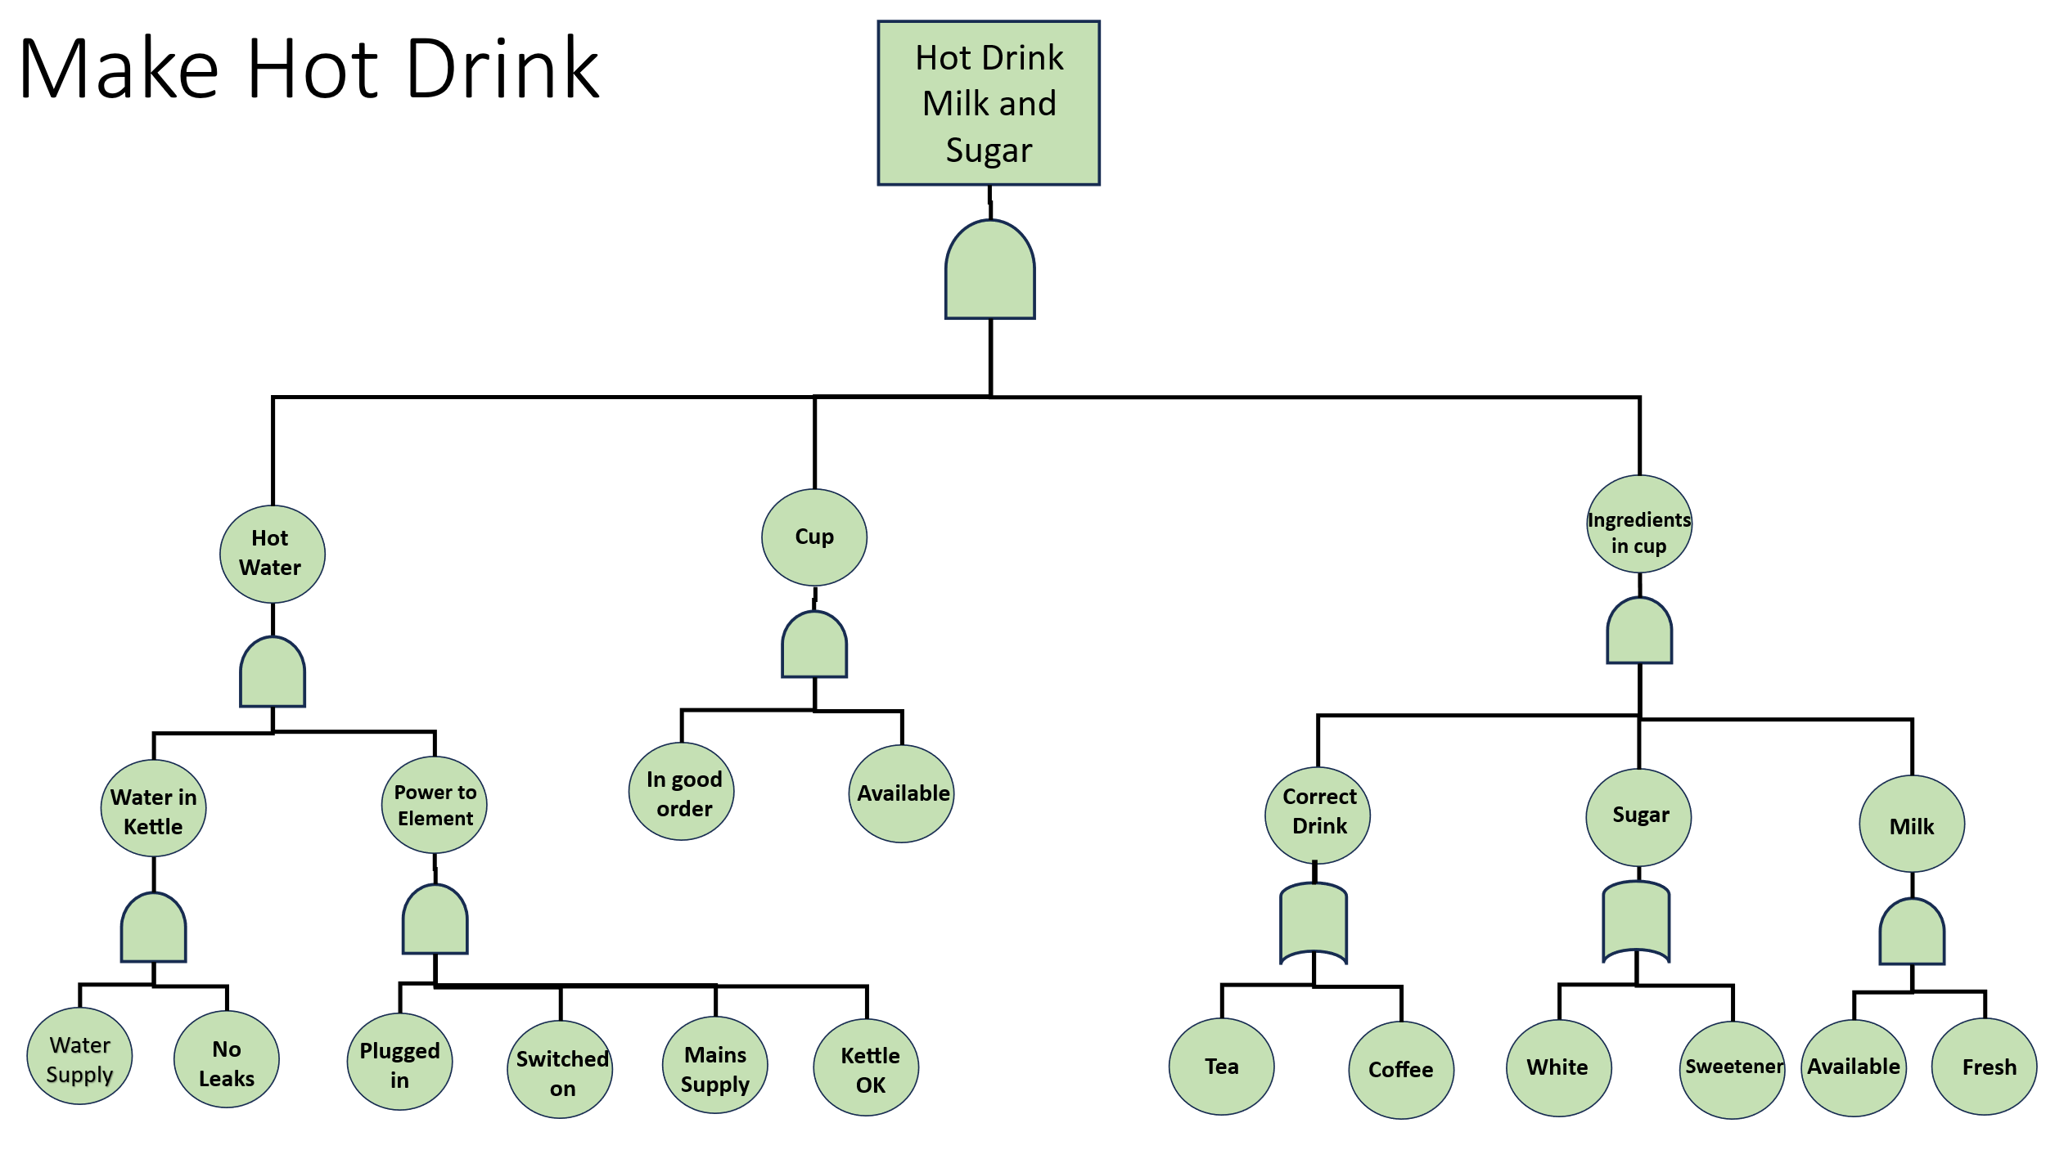
Figure 2: Fault Tree Analysis – Make Hot Drink

Explanation of logic gates used in Hot Drink example
There are two types of logic gates (Figure 1) used in the Make Hot Drink FTA (Figure 2), the AND gate and the OR gate. Basic events connected by an AND gate only occur if all input events occur simultaneously. For example, if we look at the “Power to Element” event. This can only occur if all four of the depicted sub-events occur: “Plugged in” AND “Switched on” AND “Mains Supply” AND “Kettle OK”. Any one of these events not occurring would lead to a failure state of “Power to Element”. On the other hand, consider an OR gate example: “Correct Drink”. An OR gate means that the output can occur if either of the input events occur. In this case as either Tea OR Coffee are considered a hot drink then producing either one would result in the correct drink event which eventually leads to the TOP event.
It should be noted that while fault tree analysis usually focuses on failure it is possible for the events leading up to failure to contain multiple success events such as “Correct Drink” AND “Sugar” events being successful however, “Milk” Fresh failing would lead the “ingredients in cup” event failing. Therefore, when calculating the probabilities both success and failure states would likely be included.

Calculating Probabilities
For real world fault tree analysis detailed levels of statistical calculations would be employed to calculate the probability of the basic events at the lowest level of the fault occurring. For example, in [3] which discusses the use of FTA to determine the failure points of water supply a combination of manufacturer reported failure rates, risk analysis against Monte Carlo simulations and subject matter expert input was used to assign probabilities to each basic event. For the “Make Hot Drink” example used in this report, a table of predefined probabilities for each basic event was provided.
Basic Event | Probability
Tea availability | 0.98
Coffee availability | 0.98
Chance of leaky Kettle | 0.001
Chance of water supply failure | 0.01
Kettle reliability | 0.99
Plug in operation reliability | 0.89
Switch on reliability | 0.89
Mains supply failure chance | 0.01
Cup availability | 1
Cup reliability | 0.99
Milk availability | 0.95
Milk freshness | 0.95
Sugar availability | 0.88
Sweetener Availability | 0.99

Table 1: Make Hot Drink basic event probabilities.
With the basic event probabilities assigned we can then go on to calculate the AND gate probabilities using the following equation [3]:
$$P\left(AND\right)= \prod{P_{i}}$$
For example, water in kettle only occurs if:
- Water Supply available
- No leaks in kettle
The data provided claims a chance of water supply failure to be 0.01 and the chance of a leaky kettle to be 0.001. These probabilities are given for a failure event, but we can calculate the chance of the water in kettle event succeeding. To convert these into success probabilities for use in the AND calculation, each failure probability is subtracted from 1. Water supply available = 1 – 0.01 = 0.99 and no leaks in kettle = 1 – 0.001 = 0.999.
Water in Kettle (AND) = 0.99 x 0.999 = 0.989 ($≈$98.9%) chance for success.
OR gate probabilities can be calculated with the following equation [3]:
$$P\left(OR\right)=1-\prod{(1-P_{i}})$$
For example, for Correct Drink to occur either of the following events need to occur:
- Tea
- Coffee
Tea availability is 0.98 and coffee availability is 0.98 therefore, Correct Drink (OR) = 1 – (1 – 0.98) x (1 – 0.98) = 0.9996 ($≈$99.9%) chance for success.
Event | Probability | Probability ($≈$%)
Water In Kettle | 0.989 | 98.9
Power to Element | 0.776 | 77.6
Hot Water | 0.767 | 76.7
Cup | 0.99 | 99
Correct Drink | 0.999 | 99.9
Sugar | 0.998 | 99.8
Milk | 0.902 | 90.2
Ingredients in cup | 0.899 | 89.9
Hot drink milk and sugar | 0.683 | 68.3
Table 2: Events Probabilities

Analysis of the results
By observing the results after calculating the probabilities of each event in Table 2 it is evident that a critical failure point in the Hot drink system lies in the hot water sub system which leads back to the power to element system. This enables prioritisation of improvements to increase overall system reliability. Such as improving the on switch of the kettle by using better components.

A note on Human factors
Human factors can be included in fault tree analysis. Let’s say the operator (Bill, whose tea and coffee preference is “hot”) is fatigued when operating the system reducing their ability to operate the kettle on switch down to 75% of normal and select a suitable cup down to 90% of normal.
Switch on reliability = 75% of 0.89 = 0.66
Select a suitable cup = 90% of 0.99 = 0.891
Event (Bill is fatigued) | Probability | Probability ($≈$%)
Water In Kettle | 0.989 | 98.9
Power to Element | 0.576 | 57.6
Hot Water | 0.57 | 57
Cup | 0.891 | 89.1
Correct Drink | 0.999 | 99.9
Sugar | 0.998 | 99.8
Milk | 0.902 | 90.2
Ingredients in cup | 0.899 | 89.9
Hot drink milk and sugar | 0.457 | 45.7
Table 3: Bill is fatigued
Using the data provided that measures the impact of operator fatigue on the system and recalculating the event probabilities (Table 3) the fault tree analysis method can be used to observe a 22.6% decrease in the system’s ability to produce a hot drink with milk and sugar. In the real world this data could be applied to improve aspects of the system such as making the on-button operation simpler or looking at factors outside of the system such as Bill’s comfort at work or the length of their shifts.

Conclusion
Fault Tree Analysis is a powerful tool for breaking down complex systems into a clear, logical structure to understand how failures occur within the system. By using logic gates and their associated equations for calculating probabilities of failure it is possible to quantify the failure events which could be useful for identifying critical failure areas and risk.
In this report the FTA method was applied to something as simple as making a hot drink but even then, it was revealed how many events could fail and ultimately lead to failure in a simple system. This highlights the importance of identifying failure modes in more complex systems and how fault tree analysis can be useful as a tool not only for identifying failure events but as an aid to the thought process involved in discovering causes of failure within a system.

References:
[1] W. S. Lee, D. L. Grosh, F. A. Tillman, and C. H. Lie, “Fault Tree Analysis, Methods, and Applications ߝ A Review,” IEEE Transactions on Reliability, vol. R-34, no. 3, pp. 194–203, Aug. 1985, doi: https://doi.org/10.1109/TR.1985.5222114.
[2] Vesely, W. E.; Goldberg, F. F.; Roberts, N. H.; Haasl, D. F. “Fault Tree Handbook,” Dtic.mil, 1981. https://apps.dtic.mil/sti/html/tr/ADA354973/
[3] A. Lindhe, L. Rosén, T. Norberg, and O. Bergstedt, “Fault tree analysis for integrated and probabilistic risk analysis of drinking water systems,” Water Research, vol. 43, no. 6, pp. 1641–1653, Apr. 2009, doi: https://doi.org/10.1016/j.watres.2008.12.034.
‌

‌

‌

